
Safe and effective use of interpreters
Practice note for Maternal and Child Health services
November 2021
OFFICIAL

To receive this publication in an accessible format phone email Maternal Child Health and Early Parenting at <mch@health.vic.gov.au>.
Authorised and published by the Victorian Government, 1 Treasury Place, Melbourne.
© State of Victoria, Australia, Department of Health, November 2021.
ISBN 978-1-76096-678-2
Available from the Maternal and Child Health Service Framework page on the Health.vic website <https://www2.health.vic.gov.au/primary-and-community-health/maternal-child-health>

Contents
Introduction 4
Culturally responsive practice in health care 4
Purpose of the guidance 5
Language service provision 5
Supportive documents 5
Assessing the need for an interpreter 6
Determining the client’s preferred language 7
If the use of an interpreter is refused 7
Choosing the mode of interpreting 8
Family, friends and children should never be used as interpreters 9
Working with interpreters 9
Booking an interpreter 9
Hints and tips for working with an interpreter 11
If the Interpreter is not fulfilling their role 12
Documenting consultations that involve the use of an interpreter 13
Managing family members during MCH consultations 15
Appendix A – Language Loop Services Directory 17
Appendix B – TIS Services Directory 18

Introduction

Culturally responsive practice in health care
Cultural responsiveness refers to health care services that are respectful of, and relevant to, the health beliefs, health practices, cultural and linguistic needs of communities. That is, communities whose members identify as having particular cultural or linguistic affiliations by virtue of their birthplace, ancestry or ethnic origin, religion, preferred language or language spoken at home. Culture impacts people’s understanding of health, wellbeing, disease and illness. It has an effect on the way parents and carers communicate, make decisions, undertake their lifestyle, social behaviours, diets and how they manage their health. Cultural responsiveness means being open to new ideas that may conflict with the ideas, beliefs and values of one’s own culture, and means being able to see these differences as equal.
The Maternal and Child Health (MCH) service program standards and guidelines provide direction on culturally responsive practice. Such practice is important for the engagement of clients from culturally and linguistically diverse (CALD) backgrounds and Aboriginal and Torres Strait Islander Communities
The MCH service guidelines 2019, outline ten principles. Four of these principles support culturally responsive practice:
- Universal access
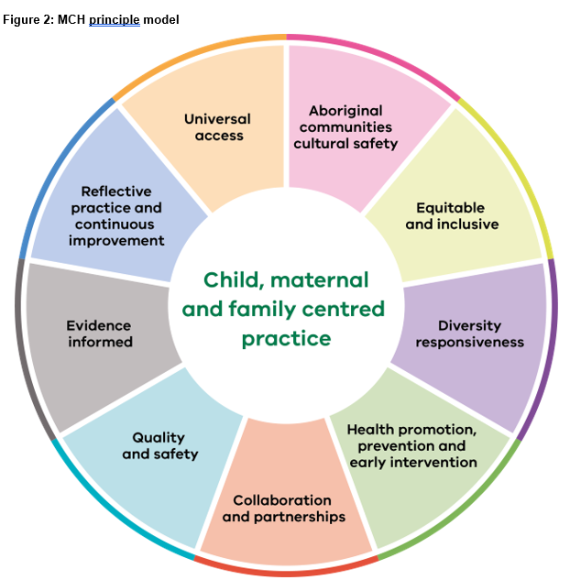
- Aboriginal communities cultural safety
- Diversity responsiveness
- Equitable and inclusive.

The MCH Program Standards define cultural competence as a set of behaviours, attitudes and policies that can together enable services to work effectively in cross cultural situations in service delivery from an individual level, to integrating culture into the delivery of the service.
The standards also include culturally responsive service delivery under Standard 1, Criteria 1-3. Criteria 3 prescribes the MCH service to provide a culturally competent service to the child and family, including a service appropriate to Aboriginal and Torres Strait Islander communities. Culturally responsive practice is essential for the engagement of Aboriginal and Torres Strait Islander and CALD families within the MCH service.

Purpose of the guidance
This clinical practice guidance is to support MCH services to strengthen service delivery for children and their families. In applying culturally responsive practice, MCH nurses who have engaged clients within the MCH service need to effectively communicate with them. CALD clients may, present with complex communication requirements (due to their pre or post arrival experiences), which could result in a need to engage a professional interpreting service. This guidance will inform MCH nurses of strategies and approaches to ensure the safe and effective use of interpreters.
Interpreting services are required as a duty of care to enable CALD clients to make informed decisions about their own health and their children’s health and life choices. This has significant implications for duty of care and informed consent for health and community services. Evidence suggests that language services are not always offered, identified, or required, when they should be. The health and wellbeing benefits to people with no or low English proficiency are much higher when they are provided with interpreting services. Interpreter services are also available for people using Auslan. Effective communication is critical to achieving positive health outcomes for clients and delivering quality health and human services.
This guidance also addresses managing a family member during MCH service consultations, when the mother/carer is not free to meet on their own.

Language service provision

Supportive documents
The Department of Health (DH) and the Department of Families, Fairness and Housing (DFFH) offer two supportive documents for use in using interpreters:
- Language services policy, 2017.
- Supplementary guidelines on, How to work with interpreters and translators: a guide to effecitively using language services, 2017.
<https://www.dhhs.vic.gov.au/publications/language-services-policy-and-guidelines>
These documnents help identify when language services should be offered to clients based on legislative requirements and best practice service delivery. The department encourages organisations to develop local language service policies and procedures consistent with their policy and guidelines.
The department allocates funding for interpreters for departmental programs and funded services. Language Loop (formerly VITS) provides on-site, telephone and video remote interpreting services for the Universal and Enhanced MCH programs <https://languageloop.com.au>. See Appendix A.
Translating and Interpreting Service (TIS National) provides interpreting serivces for the MCH Line <https://www.tisnational.gov.au/en/Agencies/Charges-and-free-services/About-the-Free-Interpreting-Service> See Appendix B.
There are no costs to families for use of interpreters within MCH services.

Assessing the need for an interpreter
The need for an interpreter should be determined prior to an appointment, wherever possible.
Assessing how well a person can understand English is the first step in identifying the need for an interpreter. Remembering that a stressful or unfamiliar situation where new language, acronyms or nursing/medical terminology is used may affect a client’s ability to communicate effectively.
Engaging an interpreter is recommended if:
- The client requests an interpreter
- The client cannot comprehend or respond to basic questions in English such as explain their health or their child’s health
- The MCH nurse is experiencing difficulty understanding their client, or the client can only respond in a limited way such as a few word answers
- The client relies on family or friends to communicate
- The client prefers to speak in their own language
- The client speaks English as an additional language, and is in a stressful, complex or unfamiliar situation.
To determine a client’s level of English language proficiency, the following questions may be useful:
- Why are you here today?
- What languages do you speak?
- In which country were you born?
- How long have you lived in Australia?
- If the client has recently arrived, or appears to be having difficulty answering the questions you could also ask: are you learning to speak English, how is that going for you?
- If the client cannot respond to these questions fluently, or if the responses are difficult to understand, an interpreter is recommended.

Determining the client’s preferred language
A client’s preferred language and dialect cannot be determined reliably from country of birth information.
The following steps may help to determine a client’s preferred language:
- If a client speaks sufficient English, it may be possible to ask for their preferred language and dialect, especially if they have used interpreters previously.
- Use visual aids that list languages and dialects. The client may be able to point to the language they speak. The free Victorian government web link below allows the development of language specific posters in the workplace to assist clients in identifying their chosen language.
<https://healthtranslations.vic.gov.au/bhcv2/bhcht.nsf/pages/find_your_language>

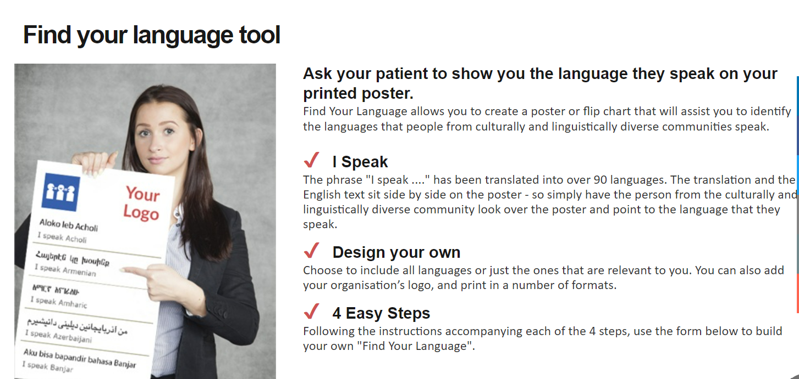

Contact (Language Loop or TIS) who may be able to assist you to identify the language through a telephone interpreter.

If the use of an interpreter is refused
The use of an interpreter is not just for the benefit of the client but also to assist the MCH nurse to offer a quality health service.
If a client refuses the offer of an interpreter, it is important to clarify and address the reasons, which may include that the client:
- Has misunderstood why an interpreter is needed
- May feel confident communicating in English
- May know the interpreter assigned to the interview and feel uncomfortable
- May be concerned that an interpreter could pose a risk to their right to confidentiality, privacy, or safety
- May be uncomfortable with the gender, religious or ethnic background of the interpreter
- May not know that the interpreting service will be provided free of charge to the client
- May be in a situation where they are being coerced into not using an interpreter
These concerns should be addressed, by asking open ended questions (through a telephone interpreter if necessary) and exploring ways to ask the client about interpreter use when they are in a situation in which they can freely answer the question. The client should be advised that the interpreter is also for the benefit of the MCH nurse, as limited or incomplete communication may result in not being able to best help and support the client or understand their questions and needs.
The DH/DFFH language services policy, p. 16, 2017, states
every reasonable effort must be made to use an accredited interpreter before a family member or friend of the client is asked to assist. They may assist in communicating with a client where an interpreter is required but is not available and a matter must be dealt with in a restricted timeframe. The decision to do so, and the circumstances justifying that decision, must be documented in the client’s file or relevant record. Any individual under the age of 18 must never be asked to act in the place of an accredited interpreter. As soon as practicable the services of a professional interpreter should be engaged to ensure the information has been accurately conveyed especially in the case of medical or complex situations.
If the client continues to refuse the interpreter offer, this should be noted in the clients notes in the Child Development Information System (CDIS). In CDIS, it can be helpful to add interpreter required, declined by client or partner, in the edit field on the client’s details page. A flagged alert on the client page should also be completed in the Risk-Family/Parental category.

Choosing the mode of interpreting
There are three ways of providing interpreting services. Professional interpreters adhere to a code of conduct that includes a strict confidentiality requirement and confidentiality requirements are the same for all three interpreting options.
- Onsite (face-to-face)
- Telephone (available 24 hrs a day, seven days a week)
- Telehealth video conferencing remotely (both Language Loop and TIS provide this service)
For all clients, including CALD clients, MCH nurses should carefully assess the needs of the client and ensure a safe, quality consultation occurs. Face to face appointments, or combined telehealth and face to face consultation for clients with limited English allows for a more holistic review of the client. Assessing the nature of interactions within a family and a client’s non-verbal communication such as movements and body language, can create a clearer clinical picture and interpretation of client and family’s needs.
Onsite interpreting requires booking in advance, and there is a minimum of a one-hour consultation fee. A local interpreter may not be suitable or available and video interpreting may be more suitable for clients in regional and rural areas, including where the client may know the local interpreter.
Telehealth Video interpreting can be used to provide face-to-face communication between a client and an on-site or off-site interpreter. It can be used for spoken languages as well as for clients with hearing impairments requiring an Auslan interpreter.

Family, friends and children should never be used as interpreters
It is never appropriate to use family members, friends, or children as interpreters in clinical contexts including MCH nurse consultations. The language services policy states that ‘family members should not be used as interpreters’
The role of family, carers and other support persons in advocating for and supporting a client is valued and understood as separate from the role of an accredited interpreter and does not replace the requirement for an accredited interpreter. Their role as emotional support rather than communications support should be emphasised.
In situations of suspected or actual family violence, using perpetrators, children or any other family members as interpreters presents an unacceptable risk and should not be undertaken.
The reasons are that family members:
- May not have the required language competence
- May lack impartiality and put the client at greater risk of adverse outcomes - for example, in the case of family violence using a family member to act in the role of an interpreter may further jeopardise the safety of the client
- Are not bound by the same standards of conduct as accredited interpreters
- May find it difficult to remain impartial, maintain confidentiality and/or accurately convey information, which can compromise the duty of care to the client.
However, family, friends, and children can have an important and helpful role supporting and advocating for the client which should be acknowledged, valued and understood as completely separate from and complementary to the role of an interpreter.

Working with interpreters

Booking an interpreter
MCH services must be registered with Language Loop and / or TIS (National Translating and Interpreting Service), in order to use their interpreting services. This can be done online or by telephone. Language Loop general business enquiries can be made on (03) 9280 1941 and TIS on 1300 575 847.
Immediate phone interpreting 24hrs a day can be accessed through Language Loop on (03) 9280 1955, and TIS on 13 14 50. These numbers can also be used to book in-person interpreting services as well as telehealth video conferencing services, both Microsoft Teams and Zoom can be used as consultation platforms.
Bookings for onsite interpreters are made via the Language Loop and TIS online accounts or by telephone. Each service is required to quote their account or pin number and enter a password (provided by Language Loop and TIS). Use of the online booking facility enables better planning and centralised management of interpreter bookings. The online booking facility should be used to make bookings, confirm current bookings and avoid double booking.
You will require the following information to book an interpreter:
- Client’s name (however consideration should be given to not disclosing the name of the client to protect confidentiality in small communities and around sensitive topics)
- Language/dialect required
- Preferred gender of the interpreter (if relevant)
- Date and time the interpreter is required, allowing time if needed before the client consultation begins to brief the interpreter if there are complex conversations that will occur
- Type of appointment – for example, a medical appointment
- Address of the service requiring the interpreter (for onsite interpreting services) or the clients home address for home visits
- Name and telephone contact details of the staff member who will be conducting the interview
- Nature of the matter to be discussed – for example, an aged care health assessment
- Anticipated length of the interview
- The interpreter’s name, if a specific interpreter is required for continuity of care reasons or in some smaller communities the interpreter may be known to the client. This may present difficulties for the client and/or the interpreter, especially in sensitive situations. Checking in with the client pre consult especially in smaller communities, to ensure that they don’t know the interpreter and are happy to work with the interpreter, can help avoid any issues occurring at the consultation.
For some clients, the gender of the interpreter will be important. Prior to booking an interpreter, you should ask the client if they have a preference.
Always display a universal interpreter sign in the office and on your website so clients are aware interpreting services are available.
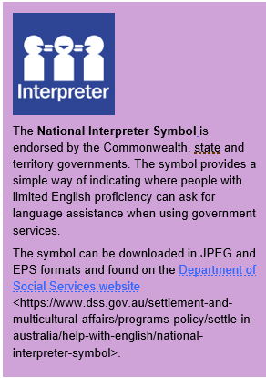
The sign can be downloaded at the following link.
https://www.vic.gov.au/national-interpreter-symbol

Always ask the client if they have a national interpreter card, Victorians with limited English can use these cards to tell people they need an interpreter and for which language. These cards can be applied for online at the following web address and cover 32 languages.
https://www.muliticutural.vic.gov.au/projects-and-initiatives/improving-language-services/victorian-interpreter-card
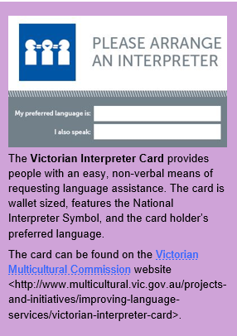

Hints and tips for working with an interpreter

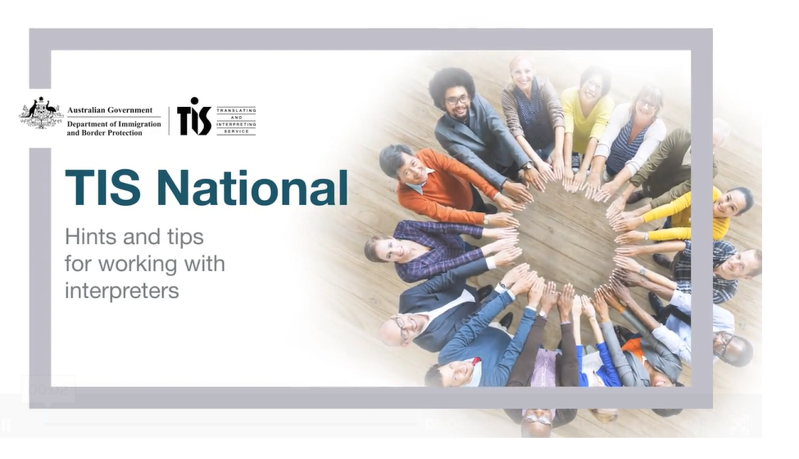
Considerations for getting the most out of an interpreting session during a consultation include:
- Requesting the interpreter service and interpreter who will be attending the MCH and client consultation, rings and reminds the client of their upcoming appointment a few days prior
- Allowing time prior to the consultation to brief the interpreter so they understand what the consultation entails. Note that a one-hour minimum consultation is Language Loop’s booking requirements. MCH nurses may consider additional consultation time due to the repetition and clarification needed in communication, especially in more complex consultations
- Be sure to have a private area organised where the consultation can take place and ensure the interpreter is also in a private and quiet environment
- Arrange seating in a triangular form to allow for easy communication between the interpreter and the client
- It is ideal to position yourself so that the non-English speaking client is directly facing you and the interpreter is sitting to the side
- Introduce yourself and the interpreter, and confirm with the client that they are consenting to work with the interpreter
- Brief the client and interpreter on the main topics you will be discussing and confirm with the client that consent is required to continue
- Ensure the interpreter knows if you are using a telephone, what type of telephone you are using and if they are on speaker phone
- Always speak in the first person and speak directly to the non-English speaker
- Allow the interpreter to clarify information if necessary
- Use clear language, short sentences, and speak more slowly rather than loudly
- Avoid using jargon, slang, idioms or proverbs
- Include a pause after each sentence so that the call participants do not talk over each other or cut each other off
- If it is a long call, the interpreter may require a few minutes break on the half-hour
- Clearly indicate the end of the consultation/conference call to everyone involved.
After commencing the consultation and initial introductions the following should be addressed by the MCH nurse:
- The confidential nature of consultations and what the MCH service can offer clients
- That if the client or interpreter becomes uncomfortable with the consultation or needs further clarification on anything discussed that they should ask. It is important to remember that different cultural beliefs and practices can lead to differing interpretations of information.

If the Interpreter is not fulfilling their role
Should the MCH nurse feel that the interpreter is not effectively fulfilling the requirements of their role, or the client is not engaging with the interpreter or expresses dissatisfaction, or there seems a mis match between questions, answers and responses, the MCH nurse should seek further clarification.
Checking with both the interpreter and client on how they feel the consultation is going at frequent intervals can help identify issues early in the consultation. This may include requesting feedback from the client and interpreter about how they feel the MCH nurse is communicating, for example the speed of their speech and length of talking before pausing for translation could be a concern.
The MCH nurse should assume and insist that everything said by the client, and any family member present is interpreted.
Reframing questions, correcting any misinformation, addressing concerns, checking with the interpreter if there are cultural barriers interfering with communication, may be required. Some concepts expressed may have no linguistic or conceptual equivalent in other languages.
If the consultation continues to not meet the needs of the client, the MCH nurse should end the consultation and reschedule with client permission. A new interpreter should be engaged for future consultations and documented in the client history. The MCH nurse should contact their coordinator/manager and inform them about the interpreter service provided so they can provide feedback on the service delivery as outlined below.

Providing feedback to Language Loop
Should a MCH nurse or non-English speaking client find anything untoward during an appointment with a Language Loop interpreter, Language Loop ask that this information is provided in writing and sent to, feedback@languageloop.com.au.
Include in the information:
- Either or both the, booking number (if the appointment was pre-booked) or the five-digit client PIN used (if it was on-demand telephone interpreting)
- The language the attending interpreter spoke
- The date and time of the incident.
Language Loop attempts to respond back within five to ten working days, depending on the complexity of the feedback. If the matter is urgent, the Client Service Teams can be contacted on (03) 9280 1955 and choose Option 2’.

Providing feedback to TIS
Should a MCH nurse or non-English speaking client find anything untoward during an appointment with a TIS interpreter, TIS ask that feedback is provided online via the feedback portal and or the complaints form, or in writing.
The complaints form can be accessed at:
<https://www.homeaffairs.gov.au/help-and-support/departmental-forms/online-forms/complaints-compliments-and-suggestions>
Written complaints can be addressed to:
Department of Home Affairs
GPO Box 241
MELBOURNE VIC 3001
Alternatively, contact the client liaison number on 1300 655 820.

Documenting consultations that involve the use of an interpreter
The following documentation points relate to the Child Development Information System (CDIS) used in the Universal and Enhanced MCH programs.
- Ensure that the client is flagged as requiring an interpreter (via client details > update client details > Ticking Yes for Primary Care giver-interpreter required > Enter language
- It is helpful to add interpreter requirements in the edit field on the client details page (e.g. dialect, declined interpreter etc)

- When scheduling an appointment, the interpreter required field will now be ticked by default to prompt staff to book an interpreter. The interpreter icon will appear on the booking in the calendar

- The interpreter booking should be made at least three days prior to the consultation so an interpreter is confirmed before the SMS appointment reminder is generated and sent to the client. It should be noted in the SMS that an interpreter will be available for the consultation
- To make the appointment with Language Loop ring (03) 9280 1955 or TIS call 13 14 50
- For the MCH Line, TIS can be telephoned whilst the caller is placed on hold, then all parties are connected via a conference call. Some callers phone TIS first and TIS interpreters ring the MCH Line on behalf of the caller; the consultation is then conducted via a conference call
- To book Language Loop online go to (languageloop.com.au) and enter Username and Password
- Complete the fields and save- Specify the mode of delivery in the booking (i.e. telephone, zoom, team meeting) or in person at the centre or at the clients home) If making a teleconference booking, add the booking invite into the comments field
- You will receive a booking reference number via the booking method used
- Copy the reference number
- Edit the calendar booking, add a note and paste the reference number to the note section. (e.g. F2F Haka Chin phone interpreter booking 888444). This information is not recorded in the CDIS history
- A follow up email will be received to confirm the name of the allocated interpreter (or inability to fulfill interpreter request) The calendar note can be updated to include the interpreter’s name.
To complete a zoom or teams consultation-log in to the zoom or Microsoft teams link (created by the language loop staff)
To complete phone consultation, ring the pre-booked interpreter phone line (03 9280 1955), the Interpreter service will then ring the client and merge the calls.
When completing a consultation, tick interpreter field in family present section. Interpreter name (and mode of delivery) can be added to free text field.
Arrange a new appointment with client and arrange a new interpreter booking via phone or the online platform. Staff can request to book the same interpreter if they are available for continuity.
The following documentation points relate to MCH services in Victoria where CDIS is not the client management system.
Documented in the client record should be the following:
- Permission for use of the interpreter by the client
- The use of an interpreter
- The language used by the interpreter
- The type of service for example video conferencing or for a hearing-impaired client
- The booking interaction or reference number for the interpreter service.

Managing family members during MCH consultations
When undertaking the maternal health and wellbeing check and MARAM family violence screening and assessment at the 4-week KAS consultation or any other consultation, the mother should be free to meet the nurse on their own. This can be very difficult if they are accompanied by a person who insists on being present in the consultation.
The MCH nurse should offer an additional family consultation with the mother on her own. This consultation may be offered face to face at the service, as a telehealth consultation, or if safe and appropriate as an outreach visit. It is essential when attempting to book or conduct this additional consultation or any further consultations with women who have limited English, that an interpreter is used.
If an additional consultation is required and is repeatedly declined, or a partner insists on being present at the consultation, the MCH nurse must clearly document this in the client records. MCH nurse documentation should always be clear, concise, and accurate, especially where family violence is suspected.
Where family violence may be a concern and the mother has declined an additional family consultation and is unwilling to engage in the process of safety planning, the MCH nurse can manage this in two ways, based on risk.
1. Where there is no indication of an immediate family violence risk, the MCH nurse should:
- Let the mother know that you are open to talking to them about their experience in the future, with the assistance of an interpreter
- Let the mother know that they can contact TIS for free interpreting any time and get assistance to discuss family violence concerns with the police and specialist family violence services
- Continue to monitor and assess the risk and impact of family violence and provide support to meet their immediate and ongoing needs through KAS or additional family consultations in a manner that does not present a safety risk to the mother or carer and/or child/ren
- Offer support and referrals to specialist family violence services or provide them with the contact details as required, including how to make a report to police. This needs to be language specific.
- The Better Health Channel https://www.betterhealth.vic.gov.au/healthyliving/family-violence
- Link to Health Translations – provides information in 64 languages https://healthtranslations.vic.gov.au/bhcv2/bhcht.nsf/PresentEnglishResource?Open&x=&s=family_violence
- Share information in accordance with the Information Sharing Schemes for the purpose of child wellbeing and safety and/or facilitating assessment or management of family violence
- Consider discussing the idea of safety planning to determine an appropriate course of action
- Consider referral to the Enhanced MCH program to provide additional MCH support.

- Where there is an immediate risk of family violence
- If you have concerns about the immediate risk to a child or children and a mother or carer is not willing to receive assistance, you should seek support from a specialist family violence service, call Victoria Police on 000 and notify Child Protection
- You should also seek advice from your MCH coordinator or manager, as appropriate and in accordance with your organisation’s policies and procedures
- You must continue to ensure that accurate documentation is maintained, including
  - Recording Family Violence screening was repeatedly attempted and unable to be completed
  - Client notes of the whole family have a flagged risk under Family -Parental factors, Family Conflict, noting potential family violence, father insists on attending clinical consultations
  - Seeking support from a specialist family violence service and notifying Victoria Police
  - Identifying the mother’s family GP and flagging concerns directly with the GP, using the Family Violence Information Sharing Scheme (FVISS)
  - All notifications to Child Protection.

Appendix A – Language Loop Services Directory
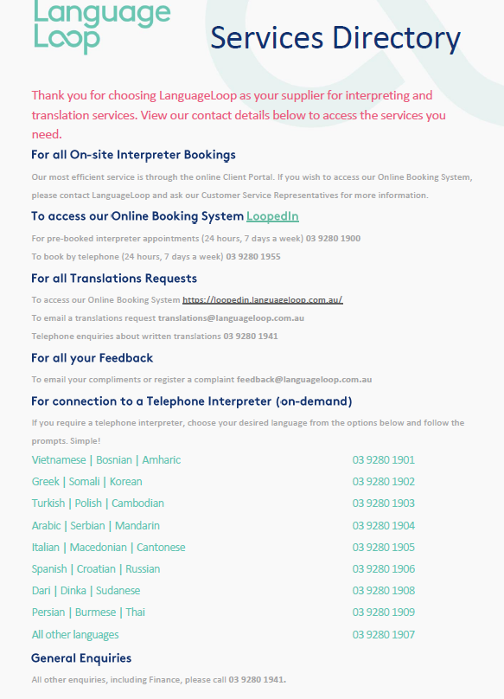

Appendix B – TIS Services Directory

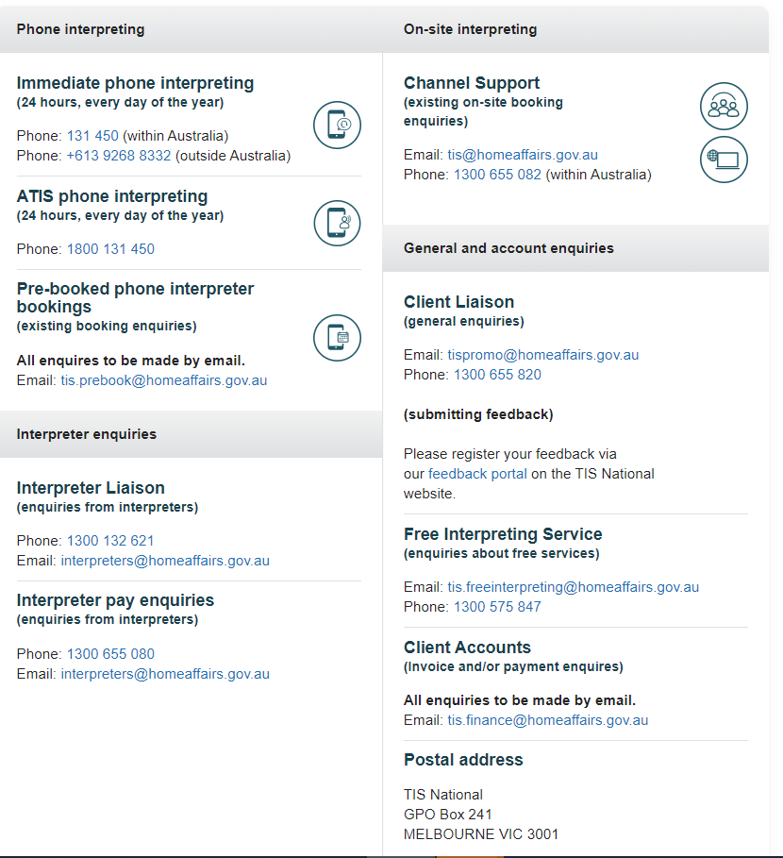

https://www.health.vic.gov.au/publications/cultural-responsiveness-framework-guidelines-for-victorian-health-services, 2009. P.12.
https://www.dhhs.vic.gov.au/publications/language-services-policy-and-guidelines, 2017.p.9.
https://www.health.vic.gov.au/maternal-child-health/maternal-and-child-health-service-framework, p.4 &13
https://www.health.vic.gov.au/publications/maternal-and-child-health-service-guidelines, p 5-8.
https://www.health.vic.gov.au/publications/maternal-and-child-health-program-standards :NHMRC, Cultural competency in health: A guide for policy, partnership and participation, 2005, p 4, 13-16.
https://www.dhhs.vic.gov.au/publications/language-services-policy-and-guidelines, 2017.p.7
https://www.dhhs.vic.gov.au/publications/language-services-policy-and-guidelines ,how to work with interpreting and translation services, 2017, p.8.
https://www.dhhs.vic.gov.au/publications/language-services-policy-and-guidelines ,how to work with interpreting and translation services, 2017, p.7.
https://www.dhhs.vic.gov.au/publications/language-services-policy-and-guidelines, 2017, p 16-17.
https://www.dhhs.vic.gov.au/publications/language-services-policy-and-guidelines , p.18.
https://www.tisnational.gov.au/en/About-TIS-National/Videos/Hints-and-tips-for-working-with-interpreters-video
https://refugeehealthta.org/access-to-care/language-access/best-practices-communicating-through-an-interpreter/
https://www.health.vic.gov.au/publications/additional-family-violence-consultation-practice-note-for-maternal-and- child-health
https://www.betterhealth.vic.gov.au/healthyliving/family-violence
https://healthtranslations.vic.gov.au/bhcv2/bhcht.nsf/PresentEnglishResource?Open&x=&s=family_violence

