
Statewide radiotherapy services framework
2021

To receive this document in another format, phone (03) 9456 3687 using the National Relay Service 13 36 77 if required, or email cancerplanning@health.vic.gov.au
Authorised and published by the Victorian Government, 1 Treasury Place, Melbourne.
© State of Victoria, Australia, Department of Health, July 2021.
ISBN 978-1-76096-419-1 (pdf/online/MS word)
Available at Statewide radiotherapy services <https://www2.health.vic.gov.au/about/health-strategies/cancer-care/radio-therapy/statewide-radiotherapy-services >

Contents
Acknowledgements 4
Purpose 5
Background 5
Statewide radiotherapy services 5
Framework principles 6
Key elements of a statewide radiotherapy service 8
1. Service description and referral infrastructure 8
2. Guidelines for referrers including appropriate indications 8
3. Triage of referrals to a statewide service 9
4. Multidisciplinary meeting presentation 9
5. General and technical patient and referrer information 10
6. Consultation and information flow between referrer and service provider 11
7. Evaluation of the statewide radiotherapy service 11
Operational considerations of a statewide radiotherapy service 12
Research and clinical trials associated with statewide RT treatment services 13
General research considerations 13
Research operational considerations 13
Broader considerations of statewide radiotherapy services 14
Conclusion 15
Appendices 16

Acknowledgements
The Department of Health acknowledges the members of the Statewide Radiotherapy Referrals Working Group who contributed to the development of this framework.
Thank you to Shane Brasier, Sid Davis, Hany Elsaleh, Farshad Foroudi, Katherine Fox, Kate Francis, Gerry Hanna, Colin Hornby, Graham Pitson, Amanda Smith, Nilgun Touma and Nigel Anderson.

Purpose
The Victorian Government has made funding announcements for two specialist radiotherapy (RT) treatment machines to date – a magnetic resonance linear accelerator (MR-linac) to be located at the Olivia Newton-John Cancer, Wellness and Research Centre (Austin Hospital) and a Gamma Knife at the Peter MacCallum Cancer Centre in Parkville. These were funded on the basis of providing a statewide service to all Victorians whose cancer (or, in some cases, non-cancer) would most benefit from this specialty radiation treatment technology.
This document provides principles and a high-level process for referring patients who would be most appropriately treated on specialist RT treatment equipment, irrespective of where they live in Victoria or from which local health service they would otherwise be receiving their cancer care.

Background
Historically, developments in RT treatment equipment have generally occurred at a measured rate. However, in more recent years the rate of development has accelerated with increased computerisation and other associated technological developments. This has led to a significant increase in the variety of RT treatment machines available. Some of these machines focus on treating a specific anatomical area, while others focus on a specific facet of treatment delivery such as the imaging or precision delivery. Other equipment developments have focused on specific forms of radiation such as proton beams or kV beams for intraoperative use.
Specialist RT treatment machines consequently add a layer of complexity to the RT equipment landscape, which is underpinned by the mainstream ‘workhorse’ linear accelerator. It is accepted, however, that it is impractical for every public RT treatment facility to have one of every type of specialty RT machine in their treatment fleet, requiring additional skills and training. The workforce at smaller facilities is insufficient to support all the various pieces of specialist equipment available with the requisite expertise, and some specialty treatment machines are hugely expensive (such as protons). Even those specialist RT machines based on ‘conventional’ medical equipment such as the MR-linac, which is the fusion of two existing pieces of standalone machinery (an MRI and a linac), are significantly more expensive than either piece alone. So, when health investment is also considered, it is neither surprising nor unreasonable that it has been assessed as not cost-effective to have reproduced in many RT departments around the state, multiple instances of expensive specialist treatment equipment that is more idealised for some cancers than others.

Statewide radiotherapy services
There are several underlying principles that must be considered when implementing a statewide service for the specialist RT equipment.
As a statewide service, the facility operating the specialist RT equipment will, for non-local cases, be akin to a contracted service providing only a component of the patient’s care on behalf of another health service from which the patient may also have had or be currently receiving active cancer care.
Specifically, specialist RT treatment machines are intended to:
- serve the whole population of Victoria equitably
- provide a treatment service for the purposes of patients accessing a specific piece of RT equipment that is operated under the auspices of a particular facility
- provide a specific course of treatment on RT specialist equipment for the care of people with appropriate cancers and certain non-cancer conditions deemed to most benefit from it
- foster leadership in RT treatments that cost-effectively utilise the unique RT equipment in Victoria
- promote access to clinical trials–based research related to the improvements that can be leveraged from the specialist RT equipment.

Framework principles
This intention of this framework is to consider those statewide RT treatment services already funded and operating or being commissioned in the medium term, as well as other RT specialty treatment equipment that may be implemented as a statewide service in the future.
The concept of specialist RT equipment that serves the whole of Victoria requires some variation to the more typical operation of RT providers within health services. RT providers commonly receive and retain any patient that may be referred to them for care by another health service when the radiation therapy cannot be delivered locally. Referrals for radiation therapy may serve patients with certain conditions better by directing them to a statewide service not being operated at a particular facility.
Similarly, a direct referral from a local GP to a health service the GP knows may sometimes overlook a closer public RT service that could appropriately deliver the required cancer care.
The framework seeks to encompass and include the following seven principles of statewide services:
- All cancer patients within Victoria, irrespective of their residential address or any other RT service providers nearby, should have equal access to the specialist RT treatment machine.
- A statewide service implemented for specialist RT treatment equipment is not intended to treat all cancer cases referred. By virtue of the technology incorporated into each specialist RT treatment machine, some cancers are expected to benefit more than others from a specific piece of equipment, and an indications list will be developed for each statewide service implemented. This is to ensure those patients most likely to benefit from that technology are appropriately referred and prioritised.
- The originating health service – if a cancer service – will continue to manage the patient’s overall cancer care as much as possible. Referrals both to, and back from, the RT facility with the specialist equipment are to be supported by participating health services.
- The holistic needs of the patient receiving the cancer care must continue to be managed. This is especially so where chemotherapy is also a component of care.
- Aspects of care that can be appropriately delivered as close to home as practicable while receiving, and then following, treatment on the specialist RT equipment, should be considered.
- Appropriate patient information transfer (including image or RT plan data) to support ongoing care at both the specialist RT service and at the original referring service after the RT has been delivered is an integral part of every statewide service.
- The implementation of a statewide service will consider all aspects of specialist RT treatment provision including clinical research opportunities, system and service delivery processes, as well as clinical care and the documentation of patient outcomes. It is anticipated that both clinician- and patient-reported outcomes will be documented and collected.
Figure 1 shows how a statewide RT service could be implemented.
Figure 1: Implementing a statewide radiotherapy service
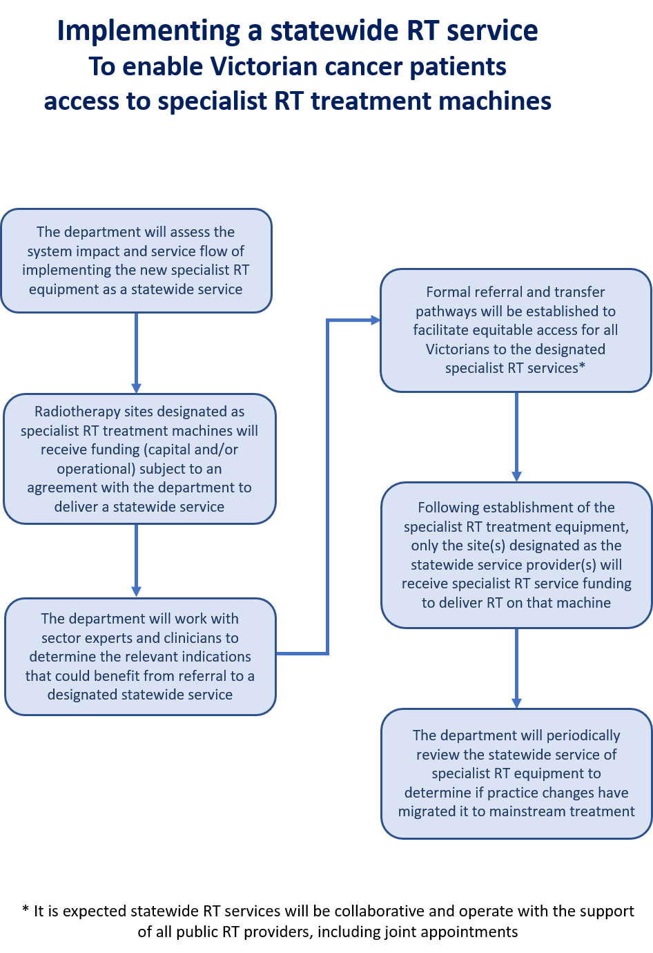

Key elements of a statewide radiotherapy service
To ensure best practice patient care and referrals to specific specialist RT treatment machines are appropriate, the statewide service requires some fundamental components to be successful.
The following elements are expected to exist/occur as part of being a designated statewide service:
- service description and referral infrastructure
- guidelines for referrers including appropriate indications
- triage of referrals to a statewide service
- multidisciplinary meeting (MDM) presentation
- general and technical patient and referrer information
- consultation and information flow between referrer and service provider
- evaluation of the statewide RT service (processes, patient experience and outcomes).

1. Service description and referral infrastructure
Specialist RT treatment machines are presumed to be located at substantial tertiary RT ‘hub’ services. This is intentional because the service needs a minimum size to support a specialist treatment machine while maintaining an appropriate patient throughput on standard linac treatment machines. Larger RT services have more clinical staff, dedicated research support and permanent staff resources allocated to education and development. Tertiary services also have all the expected associated support services, which include tumour stream–specific MDMs, radiation-dedicated nurses (including nurse coordinators), allied health staff with radiation oncology expertise (such as speech pathology) and patient accommodation for regional and rural patients.
Referrals to a specialist RT treatment machine should be able to be made in the most straightforward manner possible. A webpage that provides some basic information on what statewide services exist, the specific equipment at each location and the intended conditions for that specialist RT equipment is one such enabler of an uncomplicated referral process.
The webpage will be hosted by the Victorian Department of Health and will appropriately direct referrers via links to portals at each facility that operates a specialist piece of RT equipment.
Victoria has also funded and implemented a secure statewide RT data-sharing service that will permit an existing RT facility to transfer RT planning data to a statewide RT service to undertake plan comparisons or to access scans that can be used for planning, or for assessing previous RT treatment data and so on.

2. Guidelines for referrers including appropriate indications
Specialist RT treatment equipment such as an MR-linac or protons can generate considerable interest from patients and clinicians. While the interest is welcome, there is a need to ensure access for patients with those indications that will optimally benefit from the technology.
Many cancers treated with RT in Victoria are already receiving the ideal mode of radiation therapy, so it is important that the ‘magnet effect’ of some new equipment offering the promise of better outcomes (for certain cancers) doesn’t generate unnecessary referrals that preclude the more ideal indications receiving timely treatment on an RT specialist treatment machine.
Introducing a statewide referrals system therefore requires developing and promoting a range of expected disease indications for each specialist treatment machine. Having a list of indications and their associated clinical guidelines for those tumours considered most appropriate for each specialist machine is important to assist with case triage. However, there may be some cases with a particular clinical scenario where treatment on a statewide machine means optimal treatment of a cancer not on the indications list for that particular specialist RT machine.
For each statewide RT service offered, a group of clinical experts familiar with the technology and expected range of tumour types likely to benefit need to review the evidence and determine the range of conditions best suited to maximising the treatment benefits of a specific piece of specialist RT equipment. A summary of the resultant clinical guidelines and an indications list will be provided on the statewide RT referrals website, while the complete information for each statewide RT service is provided as an appendix to this document and will also be included as part of the online referral information of the facility operating the specialist equipment.

3. Triage of referrals to a statewide service
In the context of specialist RT treatment machines, referrals to a facility that is operating a statewide service will likely come from a variety of sources. The treating facility will already have some referral pathways in place for its existing RT services and these will certainly remain one mechanism for patient referrals. However, in serving the whole population of Victoria, referrals to a facility operating a specialist RT treatment machine could come more broadly from other cancer centres, radiation oncology providers, individual cancer specialists, GPs and potentially even self-referrals from cancer patients.
The broad range of potential referrers requires that a timely and robust triage of patient referrals occurs.
- Has the appropriate information been provided?
- Has the case been presented to an MDM or does one need to be organised? (see point 4 for information on MDMs)
- Is there some potential clinical urgency that requires an expedited consultation?
- Is there any comorbidity that should be considered when accepting a case?
- Are there any contraindications related to the specialist RT machine – for example, a patient with a metal artificial hip that might be referred to the MR-linac?
As such, a checklist should be implemented to ensure the referral process is as efficient as possible. In conjunction with the triage checklist, a contraindications (or potential issues) document related to the technical aspects of the treatment also needs to be developed by the facility operating the specialist RT statewide service.

4. Multidisciplinary meeting presentation
Victoria’s optimal care pathways <https://www.cancervic.org.au/for-health-professionals/optimal-care-pathways> for the various tumour streams all include the step of a presentation of radical treatment cases at an MDM. For many high-dose palliative cases, this would also be expected as the standard of care and is consistent with the nominal departmental benchmark of 80 per cent of cancer cases being presented to an MDM.
As part of a statewide service being offered for specialist RT treatment machines, it is expected that all cases treated will be presented at an MDM. These cases may have already been presented to an appropriate MDM prior to referral (indeed the MDM could be the pathway for the referral to the specialist RT equipment). However, if not, then the facility operating the specialist RT treatment machine must ensure the case is presented to an MDM conducted at their facility.
An ‘appropriate MDM’ is defined as one held for a specific tumour stream, comprising clinicians with relevant subspecialty experience in surgery, RT and medical oncology in attendance. Therefore, if prior to a referral to the service operating the specialist RT treatment a patient has been presented to an MDM that is not appropriate such as a general solid tumour MDM, or an MDM where only a partial range of clinical expertise is present, this would not qualify as an appropriate MDM. In such situations that case should be presented to a tumour stream–specific MDM at the facility to which the patient has been referred.
Facilitation of the MDM using software that other sites/providers can access such as QOOL-Vic will ensure adding cases for review, a record of the multidisciplinary team’s decision and the transfer of information for the cases referred is seamless. QOOL-Vic has specifically been identified in the Victorian cancer plan 2020–2024 as the statewide software platform to support cancer services, importantly, statewide ones. This is therefore recommended as part of the infrastructure of a statewide RT service, which is addressed in a subsequent section.

5. General and technical patient and referrer information
All public RT services already have information resources for patients such as brochures and videos to supplement the verbal information provided to patients at the time the treatment is prescribed. These are freely available during RT planning and treatment appointments. Nonetheless, for specialist RT equipment, which by definition is uncommon even in the radiation oncology community, it is important that such information is available prior to patients being consulted by the radiation oncology.
In addition to general RT patient information, specific information about the specialist RT service needs to be available to inform prospective patients and referrers about the treatment equipment and how it is most suited to the published indications that are matched to that specific treatment technology. This will help engender appropriate expectations related to the specialist statewide RT treatment machines.
It is also important to note that non-radiation oncology referrers often have limited knowledge or understanding of routine RT. So, in addition to the clinical guidelines and indications list provided for referrers, it is equally important that some general information specific to the specialist RT machine is available.
A specialist RT service site will also need to develop a technical checklist to ensure suitability of the patient to a specific piece of specialist equipment. For example, if a referrer is informed that an MR-linac-based treatment involves 30 minutes in a tunnel-like enclosed space, that can be useful information when assessing the suitability of a claustrophobic patient. Furthermore, information pertinent to the Victorian MR-linac should be available online because any patient or referrer who undertakes a google search will likely come across some information that does not relate to the Victorian service and that may not be helpful. An example of this is the Australian MRI Linac being developed under the auspices of the University of Sydney and Ingham Institute in Liverpool, NSW, which most often comes at the top of an MR-linac google search. However, this is a research-based ‘open’ magnet system that is very different from the commercially available MR-linacs currently operating clinically and could give a prospective patient the completely wrong impression of the Victorian machine and clinical treatment environment.

6. Consultation and information flow between referrer and service provider
Providing a statewide RT service necessitates that the facility operating the service receives all necessary information related to the patient being referred. There is an onus on the referrer to proactively provide as much information as possible to the facility providing the specialist RT service, supported by the specialist RT service guides and templates.
A referral portal should therefore have the ability to upload documents (pdfs, jpgs, other formats). Ideally patients will have been seen in an MDM where the imaging and pathology is available online and be seen at a facility that is using the statewide MDM platform to permit information sharing.
Also for public RT providers, there is a statewide patient RT planning data-sharing server that will permit relevant RT imaging and plans to be provided to the treating site and/or back again to a referring public RT provider.
Additionally, after completing the specialist RT treatment, there is an expectation that referrers, when undertaking ongoing patient follow-up, report (to the treating centre) via predetermined minimum datasets with respect to each follow-up consult. This will support ongoing evaluation of clinical outcomes associated with each technology, help acquire valuable data on the efficacy of statewide services and enable government reporting on the investment related to the new technologies.
Figure 2: The information flow from clinical follow up of patients must be a two way

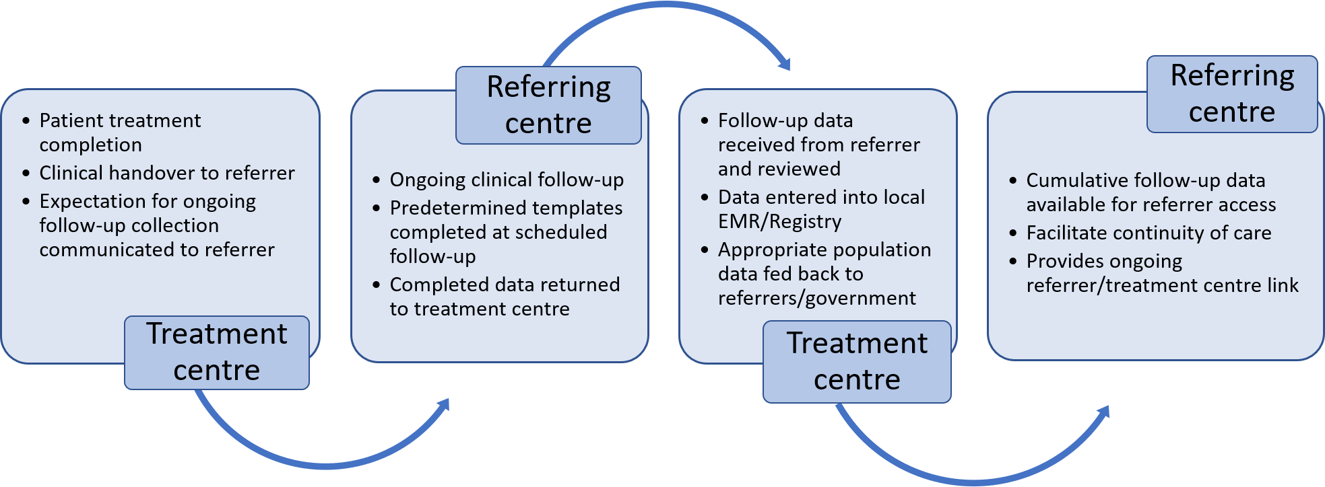

7. Evaluation of the statewide radiotherapy service
Establishing a statewide RT service necessitates that the effectiveness of the service is routinely evaluated.
There has been significant investment by government in the specialist RT machines, and it is important to determine how well the service is performing in relation to the intended outcomes. For example, is equitable access for all Victorians being achieved? Are the expected indications being treated at the service? Are the outcomes for patients any different? Is the wraparound care of a patient referred across institutions being realised? And, are patients satisfied with the service? These are the sort of questions that need to be asked regularly and the answers provided via intentional evaluation.
It is anticipated that in the first six months of operation, a new statewide RT service will be bedded down. A light-touch evaluation at approximately three months from clinical commencement is warranted to ensure the planned processes and supports (for example, MDMs) are working as expected. It is recommended that this three-month review be followed by a more formal evaluation six months after the commencement of the service, including a review of the early data gathered.
A full evaluation of the service should be undertaken at 12 months and annually thereafter to ensure the impact of the service is documented and that any issues are discovered and resolved. Patient experiences and clinical and administrative data collected as part of the service should also be reviewed as part of the evaluation.

Operational considerations of a statewide radiotherapy service
There are several operational conditions and processes that need to be implemented to ensure the success of a statewide specialist RT service. At a minimum these include:
- joint appointments of radiation oncologists – this will involve formal credentialling by the specialist RT provider of radiation oncologists from other RT services who will be referring patients (this would permit them to review patients at the facility with the specialist equipment and, if appropriate, would facilitate their role as the prescribing radiation oncologist and approver of the plan)
- a statewide referral webpage that links to a referral portal at the facility with the specialist RT equipment that the patient is being directed to
- MDM software that permits transfer of information and MDM discussions/decisions.
- an RT patient planning data-sharing server (including any imaging used for planning)
- training for a broader cohort of clinical staff that will interact with patients and clinicians not involved in the discipline of radiation oncology
- published patient and referrer information (brochures, videos), including expectations of referrers to complete ongoing patient follow-up beyond a course of specialist RT
- patient accommodation and/or transport as required to support patients from across the state
- educational opportunities to inform referring clinicians, particularly targeting those forums that represent the majority of referrals (for example, presentation to an MDM).
The existence of these enablers is assumed in implementing a statewide service and have been agreed by Victoria’s four public RT service providers.

Research and clinical trials associated with statewide RT treatment services
Clinical trials and other forms of research such as health services research are expected to form part of a statewide service. As such, access to clinical trials should be open to all suitable patients regardless of the location of the specialist RT treatment equipment and their eligibility not be impeded by either the referring or treatment facility.
Should a specific trial not be available at the statewide service facility to which a patient is referred, mechanisms should be available to ensure the patient can appropriately access both the relevant trial and the specialist RT treatment.

General research considerations
As part of establishing a statewide service, joint appointments and credentialling of staff from other facilities has already been noted as an important consideration both for continuity of care and sector education. As an extension of this principle, when considering clinical trials that involve a statewide service, the opportunity for including a broader group of investigators should be explored.
In general, there are well-understood and documented processes in place for clinical research. Multi-institutional agreements and ethics approvals are already possible through established practices, so providing a specialist RT statewide service can leverage off this environment by instigating these collaborative research processes ‘up-front’ at the commencement of the service.
In principle, patient registries should also be established for each specialist RT treatment machine operating a statewide service. To that end the intention for statewide services is to expand the data elements in the Victorian Radiotherapy Minimum Data Set to include the core additional clinical items that a registry might capture so that individual machine/patient registries will ultimately not be required for statewide specialist RT treatment services.
Collecting data across multiple locations at (potentially) unrelated service providers needs to be facilitated. Data elements common to all sites need to be agreed and collected (whether for the Victorian Radiotherapy Minimum Data Set, a specific patient registry or formal research proposal).
Health services research intentionally planned as part of establishing a statewide service is also important from a performance perspective. Data/registries must be designed to support health services research because such research can provide significant feedback on service referrals from a specific region of the state and/or utilisation for an indicated condition relative to other treatments being delivered and ultimately may permit outcome comparisons.

Research operational considerations
Some of the practical aspects of research at statewide services need to be addressed and agreed among the participating facilities.
Research grant applications, if successful, will flow funds to a specific principal investigator location and assign the associated accountability to that facility. How is the research funding received and shared between the sites involved in a patient’s care?

Broader considerations of statewide radiotherapy services
The introduction of specialist RT treatment equipment raises issues that need to be considered in the context of implementing a statewide service:
- The provision of statewide RT services should be underpinned by statewide MDM access. The department’s statewide MDM software (QOOL-Vic) is required to facilitate a highly secure and truly statewide service supporting the associated referrals from other RT services and may need to be implemented by the health service if it has not already done so. Notably, QOOL-Vic provides instant access to cancer pathology reports from pathology providers around Victoria and access to MDM notes from any previous MDMs conducted using the software irrespective of the location the MDM occurred in the state.
- New technology attracts the attention of cancer patients who may be pursing every avenue of treatment to improve their chances of a cure. This will undoubtedly lead to enquiries from patients in other jurisdictions. Clear guidelines around clinical need and the implementation of the disease indications list are an important part of triaging interstate referrals.
- The importance of patient and referrer education is significant for specialist RT services. Information brochures and patient videos are standard RT items that are routinely produced for radiation therapy and will also form part of the education for specialist RT treatments. However, getting the optimal referrals requires more than these general RT information sources. Providing interactive user referral suggestions that direct cases to specialist RT treatment machines based on the cancer type/subtype as part of the statewide MDM software or as an online tool on the department’s webpage, could proactively help optimise the web-based referrals as well as educate both referrers and the public. This again highlights the importance of having developed a list of disease indications considered to be optimally suited to the specialist RT machine in question.
- Furthermore, the requirement for referrers to provide ongoing contributions to patient follow-up will in itself necessitate ongoing education around those specialist technologies. Educational forums for referring clinicians (such as grand rounds and symposiums), particularly for those from the radiation oncology community that are likely to represent most referrals, should be planned as part of any new statewide service.
- The enduring success of statewide RT services will depend on the support each individual RT service provides, whether they are operating a specialist treatment machine or referring patients to facilities where those machines are located. As such, a Statewide RT Service Operations Committee will need to be established with government and health service representatives to provide ongoing oversight of the service. This committee will be responsible for problem solving process issues, ensuring constant broad clinician engagement, auditing patient information flow to/from referrers to the service facilities and supporting evaluation of the statewide service.

Conclusion
This statewide RT framework sets out high-level consideration for a statewide RT service. The seven principles outlined are the foundation on which patient-centred statewide services should be instigated, and the key elements of statewide services are articulated to ensure quality and consistency.
The framework is not intended to comprehensively set out the specifics of every process – for example, ensuring a patient is returned back to a referring health service for their ongoing cancer care. However, it does set out some important referral enablers such as the webpage for specialist RT equipment and the referral links included there, as well as the use of the department’s statewide MDM software QOOL-Vic. This software both provides a mechanism for patient information to be transferred to a statewide service as well as a mechanism for referrals support.
The government anticipates that developing a statewide specialist RT service will improve access to these unique treatment services for all Victorian cancer patients but especially for those underserved populations that might otherwise not be referred due to remoteness, ethnicity, socioeconomic or other factors.

Appendices
  - A list of clinical indications for the Victorian state MR-linear accelerator, developed by a team of specialist radiation oncologists, can be found at Recommendations for Clinical Indications for Victorian MR-linac

  - A list of clinical indications for the Victorian state Gamma Knife, developed by a team of specialist radiation oncologists, can be found at Recommendations for Clinical Indications for Victorian Gamma Knife

The term ‘facility’ typically refers to a physical or organisational structure that may operate a number of clinical services. When referring to a statewide RT service it is not intended to encompass all the clinical services operating at a facility.

