
Symptom and Urgent Review Clinic (SURC)
Framework and toolkit
OFFICIAL

Symptom and Urgent Review Clinic (SURC)
Framework and toolkit

To receive this publication in an accessible format phone (03) 9456 3332, using the National Relay Service 13 36 77 if required, or email the Cancer Support, Treatment and Research unit <cancerplanning@health.vic.gov.au>.
Authorised and published by the Victorian Government, 1 Treasury Place, Melbourne.
© State of Victoria, Department of Health, December 2021.
ISBN 978-1-76096-553-2 (pdf/online/MS word)
Available at the department’s cancer webpage <https://www2.health.vic.gov.au/about/health-strategies/cancer-care/cancer-projects>.

Contents
Introduction 5
Policy context 5
Background 7
Symptom and Urgent Review Clinics – background 7
Defining Symptom and Urgent Review Clinics 7
Oncology/haematology 24-hour triage rapid assessment and access toolkit 7
Scope – inclusions 8
Scope – exclusions 8
Governance 10
Corporate governance roles and responsibilities 10
Clinical governance 13
Partnering with consumers 15
Preventing and controlling healthcare-associated infection 16
Immunisation 16
Medication safety 18
Credentialling and scope of clinical practice 19
Pharmacy 19
Comprehensive care 20
Communicating for safety 21
Recommendations for communication 21
Recognising and responding to acute deterioration 23
Clinical processes 23
Organisational requirements 24
Appendix 1: SURC toolkit 25
SURC patient information tri-fold brochure 26
SURC patient information sheet 28
Patient Experience Survey 30
Supportive care template 35
GP letter – commencement of new treatment 36
Appendix 2: Patient pathways 37
Physical presentation to SURC pathway 38
Phone triage pathway 39
Pathology and radiology pathway 40
SURC to emergency department urgent review pathway 41
SURC to inpatient admission pathway 42
Triage to SURC from emergency department pathway 43

Introduction
The global incidence of cancer is increasing. Although cost-effective and patient-centred, cancer treatment delivered in ambulatory settings places a significant burden on patients and carers. In these settings, patient and carers are expected to be knowledgeable and proactive in recognising and managing treatment-related side effects and cancer symptoms. Nurse-led models targeted at providing cancer patients and carers with knowledge to support self-care and self-management of symptoms have reduced symptom distress and severity.

Policy context

Department of Health
Under the Improving Cancer Outcomes Act 2014 the Victorian Government is committed to preparing a statewide cancer plan every four years. The Department of Health prepares the plan which identifies the objectives and priorities for cancer and how the objectives will be achieved

Victorian cancer plan 2020–2024
The Victorian cancer plan 2020–2024 sets the following goals and priorities:
Goal/priority | Description
Short-term goal | Increase access by 20 per cent for symptom and urgent review clinics for chemotherapy patients to avoid emergency presentations in vulnerable patients
Long-term goal | Ensure Victorians have the best possible experience of the cancer treatment and care system
Cancer plan priority | Improve patient’s experience of care
COVID-19 recovery and cancer care reform | Alternative models of care – progress the statewide use of nurse-led symptom urgent review clinics to better support and triage vulnerable patients receiving systemic anti-cancer therapy, avoiding acute emergency presentations and delivering return on investment for the health system
System support | Innovation: supporting and systematic scaling-up of innovative practice
Cancer plan principle | Person-centred care with equitable access

National Safety and Quality Health Standards
The document is designed to align with the Australian National Safety and Quality Health Standards (NSQHS). The aim of the NSQHS are to protect the public from harm and improve the quality of healthcare. The NSQHS standards form the structure of the SURC framework.

Background

Symptom and Urgent Review Clinics – background
The Symptom and Urgent Review Clinic (SURC) model was first developed and piloted at Western Health in 2013. Subsequent to this the Department of Health has funded 12 additional sites to pilot a model adapted to local need. A number of these sites have been successful at embedding a SURC model into standard of care within their units.
The SURC framework outlines governance, models of care and funding structures to help Victorian health services establish and deliver safe, high-quality SURC models. The framework contains a set of tools and templates tested within these models to help when implementing a SURC model.
The framework aims to assist health services to develop a SURC model that meets local needs.

Defining Symptom and Urgent Review Clinics
SURC is a nurse-led model of care located within or in close proximity to the day oncology environment. It is designed to deliver:
- chemotherapy and self-care education to patients at the outset of treatment
- a dedicated telephone line for patient assessment and management during treatment, either via incoming patient phone calls and/or outgoing SURC nurse phone calls
- a dedicated physical space for patients to attend for assessment by nursing staff when telephone assessment indicates and/or when patients are referred for physical SURC assessment by other health professionals (such as direct referrals from specialist clinics or triaged from the emergency department).
Medical staff support the model for patient presentations that fall outside the nursing scope including:
- physical assessment outside nursing scope
- ordering diagnostics
- prescribing
- referral to other medical specialities
- facilitating inpatient admission.

Oncology/haematology 24-hour triage rapid assessment and access toolkit
The United Kingdom Oncology Nursing Society (UKONS) toolkit <https://www.eviq.org.au/clinical-resources/telephone-triage-toolkit/3639-rapid-assessment-access-toolkit> risk assessment tool uses a Red, Amber and Green scoring system to identify and prioritise the presenting problems of patients contacting advice lines for assessment and advice. The Australian version of the toolkit was agreed through a national collaborative working group of senior nursing representatives across Australia and published on eviQ in 2019. The SURC model has adopted this tool for patient assessment.
In addition to the triage tool, UKONS has developed national guidelines for the initial management of patients who have a cancer diagnosis and present as an unplanned admission with a complication of their disease or cancer treatment. The acute oncology initial management guidelines <https://www.sundownsolutions.co.uk/sites/UKONS/EN/index.aspx> have not undergone an Australian review but can be used to support local implementation after consultation with internal stakeholders at each site.

Scope – inclusions
Sites considering a SURC model should undertake an analysis of the service to determine:
- gaps that a SURC model could potentially address
- services that may work alongside the SURC model such as an existing cancer support nurse or nurse practitioner models
- if allocated resources match the scope (depending on size of the service and staff available for SURC model, initial implementation may focus on tumour streams identified as higher risk).

New patients starting anti-cancer treatment
The model is designed to provide patients starting treatment with dedicated pre-treatment education and assessment of supportive care needs. Nurse-led models targeted at providing cancer patients and carers with knowledge to support self-care and self-management of symptoms reduce symptom distress and severity.

Patients receiving systemic cancer therapies
In-scope systemic cancer therapies include cytotoxic chemotherapy, targeted therapy and immunotherapy that are delivered:
- in the day oncology unit
- via the oral route
- in combination with radiotherapy.

Scope – exclusions

UKONS triage tool exclusions
The UKONS triage tool provides guidance for patient presentations that should automatically be referred to the emergency department including chest pain, a body temperature of 37.5°C or higher, multiple concurrent cancer symptoms or treatment-related toxicities.

Patient cohort exclusions
- Patients receiving cytotoxic and biologic treatments prescribed to treat diseases other than cancer
- Patients who are no longer receiving active systemic cancer therapies
- Cancer clinical trial patients – these patients should refer any treatment-related toxicities to their allocated study coordinator
- Patients presenting with acute surgical presentations
- Palliative care patients – a statewide community palliative care program <https://www2.health.vic.gov.au/hospitals-and-health-services/patient-care/end-of-life-care/palliative-care/palliative-care-access> is in place in Victoria. Patients should be referred to community palliative care services to manage cancer disease-related symptoms.

Governance

Corporate governance roles and responsibilities
Developing a high-quality SURC service and improving outcomes for local cancer patients requires a multidisciplinary approach. A SURC steering committee should be established. Potential representation from the following stakeholders should be considered.
Primary steering group committee members who are critical to the project success from SURC model development through implementation to a sustainability model
Stakeholder representative | Responsibilities
Nurse unit manager – day oncology unit | Provide day-to-day oversight of the nurse-led model within the day oncology unit  Create clear delineation of SURC role and lines of accountability  Manage training and development for succession planning
Divisional manager – cancer services | Project leadership  Commitment to a strategic direction for cancer services that includes a SURC model  Operational oversight of the model including budgeted staff
Director – medical oncology/haematology | Provide professional and clinical/medical oversight to the model
Consumer participant(s) | Maintain patient focus of the model  Input into patient promotional resources and marketing
Quality manager | Project support – improvement methodology
Integrated Cancer Services | Support and funding to undertake quality initiatives
Secondary steering committee members who may be co-opted for input at certain points in the SURC model development and implementation
Stakeholder representative | Responsibilities
Nurse unit manager – inpatient ward(s) | Facilitate direct patient admission to the ward as required  Promote SURC model to patients on discharge for ongoing support
Executive nurse | Professional oversight of nursing scope of practice
Patient flow / bed management | Managing patient flow from SURC via expedited admission of SURC patients as required
Nurse unit manager – emergency department  and  Medical director – emergency department | Develop relationship for inter-department referral of patients presenting with cancer symptoms and treatment-related toxicities. For example:  - patients presenting to emergency within SURC scope to be triaged to SURC  - patients presenting to SURC out of scope to have expedited pathway to emergency
Pharmacy | Provide input into the model development in terms of delivering patient care within the SURC model
Pathology | Access to timely pathology tests and results for patients presenting to SURC that mimics the turnaround times for patients presenting to emergency
Radiology | Access to timely radiology procedures and reporting for patients presenting to SURC that mimics the turnaround times for patients presenting to emergency
GP liaison | Develop a model that links to GPs for shared care of patient cancer symptoms and treatment-related toxicities
Business analysts | Procure patient data to help evaluate the model for its impact on emergency department presentations and inpatient admissions
Information technology | Develop information systems that support delivery of the model and reporting on activity

Funding
This section details the Commonwealth and state government funding arrangement available for delivering a SURC model.
Admitted and non-admitted funding programs outlined in the Department of Health’s Policy and funding guidelines 2020–2021 fund most SURC encounters. SURC services are included in health services’ acute throughput targets and specialist clinic grants.

Funding opportunities
- Admitted services – WIES (weighted inlier equivalent separation)
- Non-admitted services – WASE (weighted ambulatory service event) tier 2 classification system. Refer to Tier 2 non-admitted services 2021–2022 <https://www.ihpa.gov.au/publications/tier-2-non-admitted-services-2021-22> for more information.

Admitted services
Patients presenting to SURC may satisfy the criteria for same-day inpatient funding as long as the following criteria are met.
Criteria | Admission type
The patient attends the hospital, as a day patient, with the intention to receive at least one procedure listed on the AAPL. | B: Day-only Automatically Admitted Procedures
The patient attends the hospital as a day patient, with the intention to receive a procedure listed on the NAQAL because they have specific circumstances that require the treatment to be administered in an inpatient setting. | C: Day-only Not Automatically Qualified Procedures
The patient has received a minimum of four hours of continuous active management, in a ward other than an emergency department SSU, consisting of regular observations or continuous monitoring with no intention for overnight or multi-day admission. | E: Day-only Extended Medical Treatment
More information about eligibility for inpatient admission <https://www2.health.vic.gov.au/about/publications/policiesandguidelines/vaed-criteria-for-reporting-2021-22> can be found on the department’s website.

Non-admitted services
Tier 2 is built around the concept of non-admitted care clinics. For the purposes of activity-based funding, the term ‘non-admitted care clinics’ can be used interchangeably with the term ‘non-admitted patient service units’. A service unit is a recognised clinical team of one or more healthcare providers within a hospital, multipurpose service or community health service that provides non-admitted patient services and/or non-admitted patient support activities. Non-admitted care clinics may otherwise be referred to as:
- outpatient clinics
- ambulatory care clinics.

A non-admitted patient service event is an interaction between one or more healthcare provider(s) with one non-admitted patient that must contain therapeutic/clinical content and result in a dated entry in the patient’s medical record.
The interaction may be for assessment, examination, consultation, treatment and/or education.
Source: The Independent Hospital Pricing Authority <https://www.ihpa.gov.au/publications/tier-2-non-admitted-services-2021-22>
Patients who contact SURC for care coordination such as information about appointments and/or appointment changes do not fit this criteria.
Interactions provided by a clinical nurse specialist are eligible for either of two tier 2 codes:
- Code 40.48 – SURC encounters for patients with a haematological condition
Definition: Assessment, diagnosis, planning, management, follow-up screening and testing of patients with diseases of the blood. Treatment of disorders affecting the structure and function of the immune system.
- Code 40.52 – SURC encounters for patients with an oncology condition
Definition: Assessment, management and treatment of malignancy and neoplasm-related conditions.
SURC encounters that require medical intervention are eligible to be classified within a medical tier 2 coded clinic:
- Code 20.42 – Assessment, identification, monitoring and research of oncology-related conditions. Interactions provided by medical staff (where medical staff are consulted in relation to the patient presentations that fall outside the nursing scope).
Most SURC encounters will be eligible to attract tier 2 funding.

Clinical governance

Risk management
Effective risk management requires a commitment to health and safety from all involved in delivering SURC.
Safeguarding and minimising risks to patients calls for a structured approach to safety that is both reactive and proactive. Safe services rely on staff and their awareness of systems that prioritise safety for all. Safe services are supported by mechanisms that identify issues early and respond when things go wrong.
Risk management for patients and staff should be approached systematically and integrated within broader risk management systems that scan for, monitor, review and manage risk. This includes early identification of risks and defined escalation processes with clear pathways, processes, accountabilities and oversight.
A robust SURC risk register, assessment and management plan requires input from nurses, physicians, pharmacists and health service executives.
Clinical incidents, near misses and adverse events should be entered into the RiskMan reporting system, or equivalent. They should be reviewed, investigated and managed by a multidisciplinary quality and safety team to drive ongoing improvements in quality and safety.
An open disclosure process is in place to enable the workforce to communicate openly with patients in the event of an unexpected outcome. Open disclosure training and support should be provided to SURC nurses in line with the Australian open disclosure framework.

Key performance indicators
Monitoring processes helps assess the effectiveness of approaches, identify areas of risk, help deliver a quality service and support continuous improvement. Measures should be set to reflect the goals and encompass safety, effectiveness, person-centredness and connectedness dimensions.
SURC services should be incorporated into health service planning and demand management strategies. Data and key performance indicators are to be monitored, analysed and reported within the health service processes and regularly communicated to all stakeholders. SURC services should review their data and identify ways that it can be connected to give enhanced insights into issues and trends within their service.
Examples of key performance indicators are:
- the percentage of new and current patients receiving systemic anti-cancer therapies who access the SURC model
- the number of patients who report they would have otherwise presented to an emergency department
- the number of patients admitted directly from SURC
- patient satisfaction with the SURC model.

Workforce
- Delivering a SURC model requires specialist qualifications and competencies to ensure the care provided is of the highest standard. Clinical staff must meet standards set by the Australian Health Practitioner Registration Agency.
- All staff must meet organisational code of conduct standards.
- Staff are recruited at the appropriate level to reflect the autonomy of providing care within a SURC model.
- Nursing staff should have a specialist qualification in cancer nursing.
- Medical staff should be at the level of at least basic physician trainee with access to specialist medical oncology or a haematologist for clinical supervision.
- Nursing staff employed into the SURC service should undertake communication skills training at least every second year.
- Staff are to work within their scope of practice and professional frameworks and delegate according to their professional standards.
- Staff participate in ongoing Aboriginal and Torres Strait Islander cultural awareness and competency activities.
- Staff attend voluntary assisted dying education.
- Staff training and competencies are tailored to delivering a SURC model.
The organisation must support staff to develop and consolidate their skills (including continuous quality improvement training), to work within their roles and responsibilities and, where appropriate, manage performance of the individuals.
The workforce model adopted will depend on existing service delivery models within the health service.

Nursing staff
The level of autonomy and scope of the SURC nurse role established within the model will determine the nursing classification. The Nurses and Midwives (Victorian Public Sector)(Single Interest Employers) Enterprise Agreement 2020–2024 <https://otr.anmfvic.asn.au/articles/update-14-public-sector-eba-implementation-update> is a reference point when establishing the classification grade for SURC nurse roles.

Medical supervision of the SURC model
In some health services, the medical model will include junior medical staff (basic physician trainees) involved in the day-to-day medical management of patients presenting to SURC who require medical input into their care. In this case, policies that set clear limits on the scope of clinical practice of junior clinicians with oversight by senior clinicians should be established.

Partnering with consumers
Patient and consumer participation in service design and delivery is a recognised pillar of person-centred care and delivers best patient outcomes.
SURC requires a trusting and mutually respectful relationship between the patient and their carers and health professional.
When developing a SURC model, consider the following:
- The SURC model is designed, implemented and reviewed in consultation with patients and carers.
- Patients are provided with information about their healthcare rights.
- Patients and carers are encouraged to be actively involved in their decisions about care.
- Health literacy is considered when designing and delivering patient information and education materials developed for SURC.
- SURC-specific patient information includes ongoing care needs, health service contact details and feedback avenues.
- SURC considers patients’ domestic cultural practices and discusses these at any opportunity within the SURC encounter.
Patient feedback about SURC service delivery is monitored at regular intervals. The Victorian Health Experience Survey (VHES) is conducted every two years and includes a number of questions directly relevant to delivering a SURC model. An abridged patient satisfaction survey has been developed that lifted questions directly out of the VHES. You may wish to use this patient experience survey tool as a measure for patient satisfaction before and after implementing SURC. Appropriate ethics approval for capturing patient feedback is suggested. This ensures compliance with good clinical practice guidelines stating patient consent should be obtained for collecting data that is not routinely captured as standard of care and is required if you want to share or publish patient feedback data external to your organisation.
Generic SURC-specific patient proforma materials have been developed that can be tailored to each health service (Appendix 1).

Preventing and controlling healthcare-associated infection
Providing a SURC model supports patients to self-manage cancer symptoms and treatment-related side effects in the home. This helps to prevent hospital presentations and reduces the risk to patients of acquiring a healthcare-associated infection.
Cancer, cancer treatments and the use of central lines place cancer patients at high risk of acquiring an infection in hospital. Surveillance of healthcare-associated infection and acquired central line associated blood stream infection should be included in the broad health service healthcare-associated infection surveillance program.
The principles of preventing and controlling prevention to prevent the risk and effectively manage infections should be adopted by all nurses working within the SURC model who are seeing patients via a face-to-face consultation.
Using standard precautions in line with best practice guidelines as part of routine practice help minimise the risks of infection.
Centers for Disease Control and Prevention standard precautions <https://www.cdc.gov/oralhealth/infectioncontrol/summary-infection-prevention-practices/standard-precautions.html> include:
- hand hygiene consistent with the ‘five moments’ for hand hygiene
- using appropriate personal protective equipment when there is a risk of blood or bodily fluid exposure
- respiratory hygiene and cough etiquette
- the safe use and disposal of sharps
- cleaning surfaces before setting up for a procedure in the home
- cleaning equipment between patient visits
- aseptic techniques
- waste management.
Routine hand hygiene auditing should include auditing of hand hygiene practices of staff who work within the SURC model of care.

Immunisation
Due to disease or treatment, many cancer patients are immunocompromised and have an increased risk of morbidity and mortality from many vaccine-preventable diseases. The SURC workforce should be fully vaccinated according to health service immunisation policy to protect themselves and patients.
Recommended vaccinations are:
- hepatitis A (if providing health care in Aboriginal and Torres Strait Islander communities, and in some jurisdictions)
- hepatitis B
- influenza
- MMR (if non-immune)
- pertussis (as dTpa)
- varicella (if non-immune)
- BCG (if working with drug-resistant cases of tuberculosis)
- any other required immunisation(s).

Medication safety
Medication safety is central to the SURC model, enabling:
- upfront patient education about the treatment plan
- understanding of patient/carer supportive care needs
- early patient reporting of toxicities enabling early intervention in toxicity management as well as a review of the treatment plan for dose delay and/or reduction of subsequent cycles
- strategies such as reach-out activities to patients at higher risk of emergency presentation associated with tumour type, age, frailty, social isolation, comorbidities and cultural diversity.
The Australian Commission on Safety and Quality in Health Care (ACSQHC) includes chemotherapy in the list of medications associated with high potential for medication-related harm. Health services must identify high-risk medication and ensure chemotherapy is stored, prescribed, dispensed and administered safely.
Included in the ACSQHC recommendations for safe administration of chemotherapy is dedicated patient education to ensure:
- patients are educated to assist staff in the proper patient identification process and understand the importance of process
- patients are provided with written information about the medications they are receiving
- during each medication administration, nurses routinely educate patients and their carers about the medication and potential side effects
- patients and carers are encouraged to ask questions about their medications
- patients are instructed who and when to call with concerns or questions about their medication.
SURC models that include delivering patient education help health services to meet this requirement. Sites with existing structures in place for delivering pre-chemotherapy education, using the SURC model to ensure the SURC nurse formally introduces themselves at Cycle 1 and provides SURC-specific contact details, is an approach that improves the patient/carer identification of SURC as an additional support for medication advice and support.
Many models piloted have established strategies to proactively identify patients at higher risk of developing treatment-related toxicities and cancer symptoms and providing additional support. More commonly this is via an outreach telehealth model, but other strategies include booking patients into SURC within a nominated timeframe after treatment for assessment and intervention as needed (for example, administration of intravenous fluids).
The Cancer and Aging Research Group has developed a validated tool for doing this. The Chemo-Toxicity Calculator <https://www.mycarg.org/?page_id=934> is recommended for patients over the age of 65 years. There are no validated tools to assess risk of toxicity in the under 65-year-old patient population; however, there is evidence within the literature for:
- tumour streams more likely to attend:
  - lung
  - adjuvant breast
  - upper gastrointestinal
  - uro-genital
- factors associated with increased emergency department presentations:
  - culturally diverse groups
  - lower socioeconomic status
  - comorbidities and tumour burden
  - social isolation.

Credentialling and scope of clinical practice
Organisations should ensure regular assessment of qualifications, competence and clinicians’ scope of practice to safely prescribe, prepare, dispense and administer systemic cancer therapies.
Nurses employed to a SURC role should have a demonstrated understanding of:
- local policies and procedures for administering anti-cancer medications
- Clinical Oncology Society of Australia (COSA) guidelines for the safe prescribing, dispensing and administration of systemic cancer therapy
- the Cancer Nurses Society of Australia’s position statement on the minimum education requirements for nurses to be involved in the oncology and non-oncology setting.
They should also undertake the following training as a minimum standard:
- eviQ Antineoplastic Drug Administration Course (ADAC) <https://education.eviq.org.au/courses/antineoplastic-drug-administration-course-adac/antineoplastic-drug-administration-course> (or a similar recognised course)
- management and care of central venous access devices <https://education.eviq.org.au/courses/clinical-and-community-practice/central-venous-access-devices>
- the eviQ Oncology/Haematology 24 Hour Triage Rapid Assessment and Access Toolkit <https://www.eviq.org.au/clinical-resources/telephone-triage-toolkit/3639-rapid-assessment-access-toolkit>
- organisational specification of their role and the cancer service where they work
- an annual ADAC reassessment of clinical competency <https://education.eviq.org.au/modules/adac-reassessment-of-clinical-competency> refresher course to ensure contemporary knowledge in relation to administration of systemic cancer therapies.
Variation in the size of the unit, the existing clinical supervision model and clinical personnel available are important considerations when establishing a SURC model.

Pharmacy
In units with established processes for pharmacy to undertake medication reviews, including a review of patients’ current medications, prescription review and provision of medicine-related information by a pharmacist, SURC provides an opportunity to extend this model to include advice on pharmaceutical management of toxicities to SURC personnel and patients.
In units with an identified gap in pharmacy services for systemic cancer therapies administration, the SURC model may help address this gap. One of the piloted models identified a gap in pharmacy services to patients on oral systemic cancer therapies and included additional pharmacy FTE into the SURC model to address this gap.

Comprehensive care
Comprehensive care ensures patients receive care that is coordinated across the total healthcare team and:
- aligns with the patient’s expressed goals of care and healthcare needs
- considers the impact of their health issue on their life and wellbeing
- is clinically appropriate.
It is intended that the risks of harm to patients during health care are prevented and managed. Clinicians should identify patients at risk of specific harm during health care by applying the screening and assessment processes required by this standard.
The Victorian cancer plan identifies supportive care as a priority action for health services. Supportive care screening and providing supportive care resources is a key principle within the optimal care pathways <https://www2.health.vic.gov.au/about/health-strategies/cancer-care/cancer-services-framework/optimal-care-pathways>.
A SURC model addresses the comprehensive care standard and the Victorian cancer plan objectives in three ways:
- It defines SURC inclusion and exclusion criteria as well as clearly articulated pathways for patient presentations via telephone and/or physical presentation. A suite of generic pathways has been developed that can be tailored once the organisational model has been defined and agreed among the key stakeholder group (Appendix 2).
- It uses the Department of Health’s model <https://www2.health.vic.gov.au/about/health-strategies/cancer-care/cancer-services-framework/supportive-care> to ensure patients’ supportive care needs are assessed using a validated supportive care screening tool such as the NCCN Distress Thermometer and Problem List for Patients <https://www.nccn.org/docs/default-source/patient-resources/nccn_distress_thermometer.pdf?sfvrsn=ef1df1a2_4> and Supportive Care Needs Assessment Tool for Indigenous People <http://www.scnatip.org/>.
- It addresses identified supportive care needs by referring to internal and external providers. WeCan <https://wecan.org.au/> is an Australian supportive care website that helps people affected by cancer find the information, resources and support services they may need following a diagnosis. The site provides easy access to many excellent resources, services and information developed by other organisations that specialise in cancer and community support close to home. The SURC model may assist patients to access supportive care close to home by creating links with community providers local to the health service.
A generic oncology supportive care screening form and referral list has been developed that can be tailored to individual organisations if there is not an existing form.

Communicating for safety
Communication is critical to the safe delivery of patient care and occurs across the continuum of care.
Points in a SURC program at which clear communication is critical are:
- patient identification at the time of the SURC encounter including telehealth, physical presentation and patient education
- the transition of care between SURC and other departments within the hospital
- the transition of care from management in SURC to community providers such as general practitioners and allied healthcare providers (a generic template is available for communication with GPs at the start of treatment GP letter – commencement of new treatment)
- the handover of critical clinical information or risks that emerge during the course of care.
Clinical handover is the transfer of professional responsibility and accountability for some or all aspects of care for a patient, or group of patients, to another person or professional group on a temporary or permanent basis.

Recommendations for communication

The health service and SURC
- Established formal communication pathways exist between departments and clinicians.
- There is a structured clinical handover tool for transferring patient responsibility and care.
- An escalation of care protocol – what is expected and required (roles and responsibilities) of each member of the SURC and health service involved in the handover process – is in place.
- The doctor accountable for a patient’s care is identifiable at the point of care.

Patients and carers
- Patients and carers take part in treatment decisions and receive clear written and verbal information about their care.
- Patients and carers understand how and when to communicate critical information.
- Patients and carers receive written and verbal information about how to directly escalate care.

Documentation
- Clinicians have access to the patient’s medical record at the point of care.
- The medical record is current and complete.
- Critical information, alerts and risks are clearly accessible.
- Clinicians have access to contemporary pathology reports at the point of care.
- Policies and procedures are available at the point of care.
Developing electronic medical record systems within organisations provides an opportunity to build templates for SURC-specific documentation that enables SURC presentation data to be analysed for potential quality improvement activities. As a minimum dataset, reporting on SURC activity should include:
- patient demographics
- encounter type – telephone triage/physical presentation/patient education
- encounter details – date/time/duration
- tumour stream
- current cancer treatment plan
- triage assessment
- treatment provided
- other action(s) taken
- outcome of encounter.
Where electronic medical record data does not capture SURC presentations, collect data via other means – for example, a REDCap database or Excel spreadsheet. Tracking patient engagement with the model throughout a pilot period is an ideal opportunity to inform organisational support for sustainability models.

Recognising and responding to acute deterioration
Early recognition of clinical deterioration, followed by prompt and effective action can improve clinical outcomes. Systems should be developed to recognise deterioration early and to respond appropriately in the home.
Elements that describe the essential features of the systems of care for recognising and responding to clinical deterioration include clinical process and organisational requirements.

Clinical processes

Measurement and documentation of observations
- A basic physiological assessment should be made over the phone or at first physical presentation to the SURC to determine the initial referral pathway, for example:
  - patients reporting chest pain or shortness of breath and/or a body temperature of 37.5°C or higher should be directed to an emergency department rather than the SURC
- Observations include:
  - respiratory rate
  - oxygen saturation
  - heart rate
  - blood pressure
  - temperature.
For patients accessing telephone triage, physiological assessment of blood pressure, pulse rate and oxygen saturation may not be available. However, targeted questioning to determine if the patient is short of breath, has a fever or feels like their heart is racing should be included in the assessment.
The frequency of monitoring during the SURC encounter should be established for each treatment. Observations from previous treatments should be available at the point of care to identify changes in the patient’s condition.

Escalation of care
Escalation protocols include:
- increased monitoring requirements
- reporting to the nurse in charge of the day oncology unit or medical team
- indications for calling the internal emergency number
- managing a patient transfer.

Clinical communication
Adopt a formal communication protocol such as ISBAR <https://www.safetyandquality.gov.au/publications-and-resources/resource-library/isbar-revisited-identifying-and-solving-barriers-effective-clinical-handover-project-toolkit> or the department’s guidelines for clinical handover <https://www2.health.vic.gov.au/hospitals-and-health-services/patient-care/older-people/resources/clinical-handover/handover>.
Discuss the wishes of the patient for advance care planning, resuscitation and other active treatment.

Organisational requirements

Organisational supports
SURC is incorporated into health services’ formal policy frameworks for recognition and response systems.

Education
Nurses should receive annual education about the SURC escalation protocol. They should know who to call for emergency assistance if they have any concerns about a patient, and know that they should call under these circumstances.
Nurses should be able to:
- systematically assess a patient
- understand and interpret abnormal physiological parameters and other abnormal observations
- identify and manage infusion-related reactions
- initiate appropriate early interventions for patients who are deteriorating
- respond with basic life support in the event of severe or rapid deterioration, pending the arrival of emergency assistance
- communicate information about clinical deterioration in a structured and effective way to the medical officer and paramedics, and to patients, families and carers.

Evaluation, audit and feedback
- Evaluate SURC recognition and response systems.
- Conduct a clinical debrief with clinicians involved following each incident.
- Review incidents of patient deterioration including current policies and procedures and compliance with policy.
- Feed clinical review findings back to the SURC team.

Technological systems and solutions
Consider including new technological solutions based on evidence of efficacy and cost, as well as possible additional safety and quality risks.

Appendix 1: SURC toolkit
Health services can use the following example communication materials with their own services. You can transcribe the suggested text into your service-branded templates or contact the department if you would like Word versions.

SURC patient information tri-fold brochure
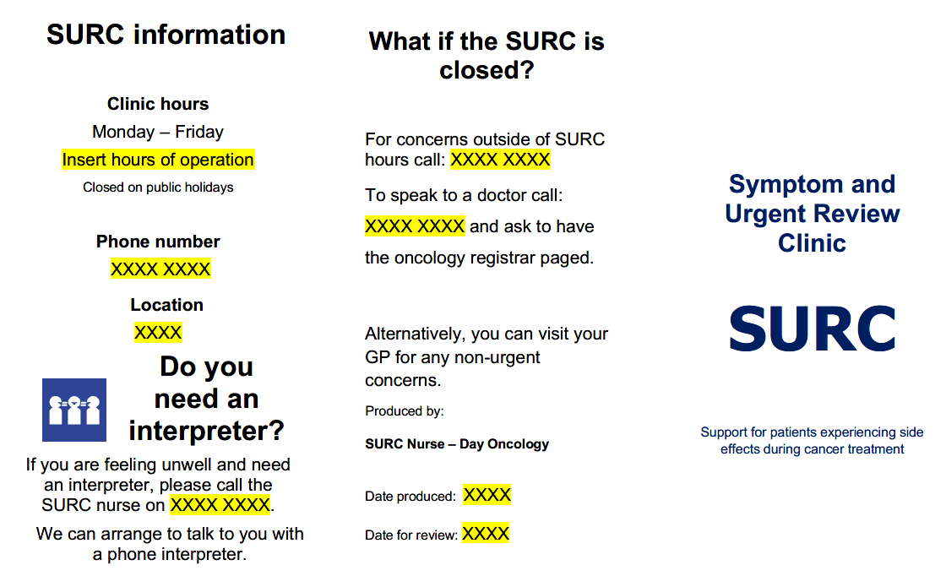
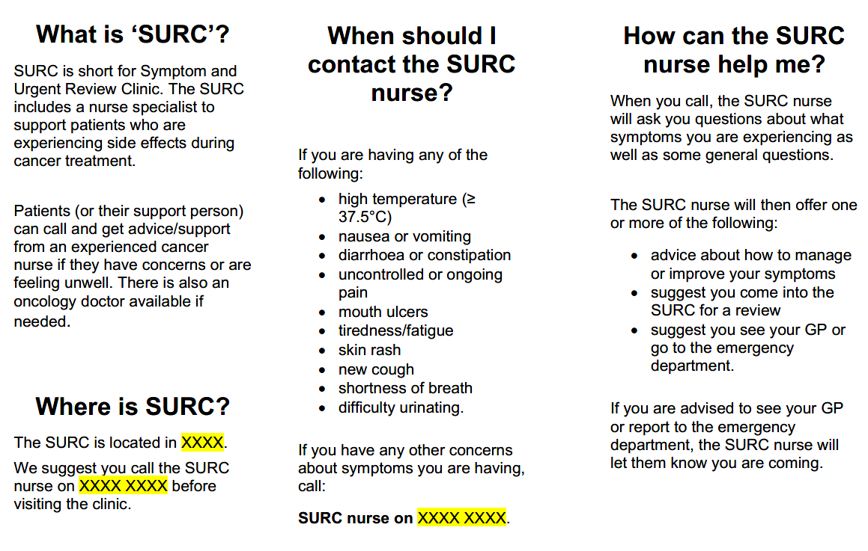

SURC patient information sheet

Symptom and Urgent Review Clinic (SURC)

Support for people experiencing side effects during cancer treatment

Telephone: [insert number]
Hours of operation: Monday–Friday, 8.30 am – 4.30 pm [change times to suit]

Note: This document should not replace the advice of your relevant healthcare professional.

What is ‘SURC’?
SURC is short for Symptom and Urgent Review Clinic. The Oncology SURC includes a nurse specialist to support patients who are experiencing side effects during cancer treatment.
Patients (or their support person) can call and get advice/support from an experienced cancer nurse if they have concerns or are feeling unwell. There is also an oncology doctor available if needed.

Where is SURC?
The SURC is located in [insert location details]. We suggest you call the SURC nurse before attending the clinic.

When should I contact the SURC nurse?
If you are experiencing any of the following:
High temperature (37.5°C or over) | Nausea and/or vomiting
Diarrhoea or constipation | Uncontrolled or persistent pain
Mouth ulcers | Tiredness/fatigue
Skin rash | New cough
Shortness of breath | Difficulty urinating
Or if you have any other concerns about symptoms you may be experiencing.

How can the SURC nurse help me?
When you call, the SURC nurse will ask you questions about what symptoms you are experiencing as well as some general questions.
The SURC nurse will then offer one or more of the following:
- advice over the phone about how to manage or improve your symptoms
- advice to come into the SURC for review
- advice to see your GP or attend the emergency department.
If you are advised to see your GP or report to the emergency department, the SURC nurse will notify them prior to your arrival.

What if SURC is closed?
For concerns after hours or on public holidays, please call [insert number].

For more information, contact the Day Oncology department on [insert number].
If you are feeling unwell and need an interpreter, please call the SURC nurse on
[insert number]
We can arrange to talk to you with a phone interpreter.

Patient Experience Survey

Principal Researcher: [insert name]

Improving the patient experience while receiving cancer treatment

Patient interviews – participant information sheet

Invitation
You are invited to participate in a survey as part of a project to improve the patient experience for patients receiving treatment for cancer at [health service name]. We are interested in hearing about your experience so we can identify ways to improve our service.
Here is some background information.
- What is the purpose of these discussions?
At [health service name] we continuously strive to improve our service to provide a positive patient experience. We value the opinions of our patients and hope to use their feedback to help shape our services to meet their needs and expectations.
- Why have I been invited to participate in a discussion?
You have been invited to take part in a survey because you are currently receiving treatment for cancer in the Day Oncology Unit/Chemotherapy Day Unit at [hospital name].
- What if I don’t want to take part in a discussion, or if I want to drop out later?
Participation is entirely your choice. Whether or not you decide to take part, your decision will not disadvantage you in any way and will not affect your relationship with the hospital, any health staff or any other aspect of your health care. If you decide to participate, you may withdraw your comments at any time without giving a reason. To withdraw please contact:
Name: [insert name]
Title: [insert title]
Phone: [insert number]
Email: [insert email address]
- What will a discussion involve?
We will be approaching you when you present to the unit for cancer treatment.
If you wish, a family member, friend or carer is welcome to take part in the survey too because they have supported you on your journey through the health system and can also offer insights.
The survey will take approximately 20 minutes. The questions will ask you about your experience receiving cancer treatment in the day oncology unit and any treatment you sought in relation to cancer symptoms or treatment-related side effects. We want to know how the health system works and communicates information to you and how you (and your family, friends and carers) feel about your experience.
The survey can be completed directly onto the paper form. Hospital staff will transfer your information into an electronic database for analysis.
Some participants may find it distressing to talk about their experience. If this is the case the researchers will arrange counselling, independent of the research team.
- Will taking part in the discussion cost me anything, and will I be paid?
You will not be paid to provide your views.
- How will my confidentiality be protected?
Your participation in this survey is voluntary and anonymous. Your responses to this survey will be stored securely at [hospital name] for seven years. When the results of this survey are presented or published we will not use any details that may identify you.
- What happens with the results?
Your experience will be used in our project to improve our service. In order to educate staff and make changes, we also expect to present the information to staff and, if we are successful at implementing a meaningful change, to present at professional conferences. Publication in academic and professional journals may follow.
While we may talk about aspects of your experience, individuals will not be identified in any reports, presentations or papers arising from the project.
- Who should I contact if I have concerns about the conduct of this discussion?
This research study has been reviewed and approved by our Research Ethics Committee.
If your questions have not been satisfactorily answered or if you have concerns before, during or after the phone discussion at home, you can contact our patient representatives at [insert email or phone number].
Thank you for taking the time to consider sharing your experience with [health service name].
This information sheet is yours to keep.

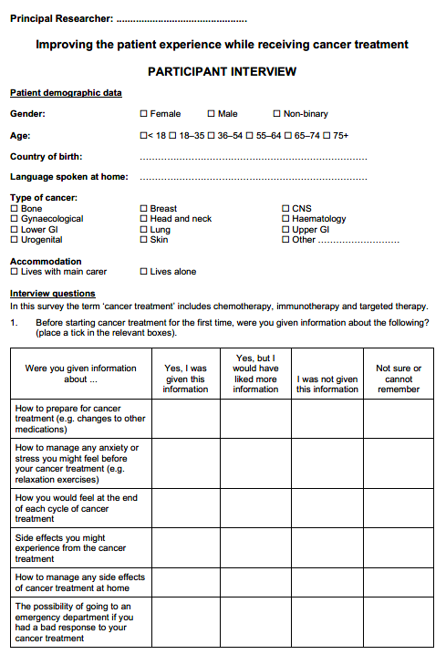

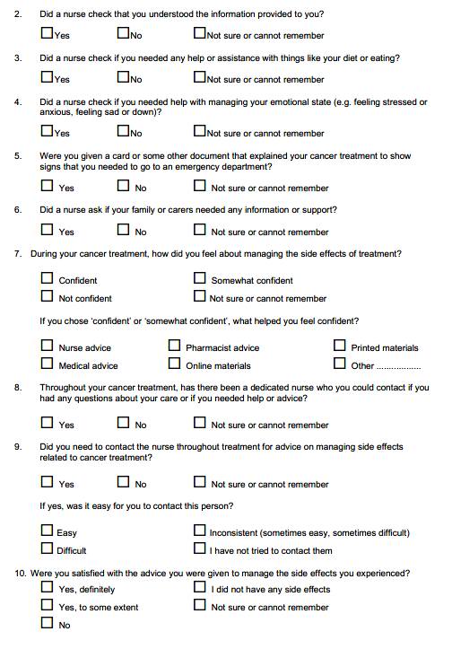

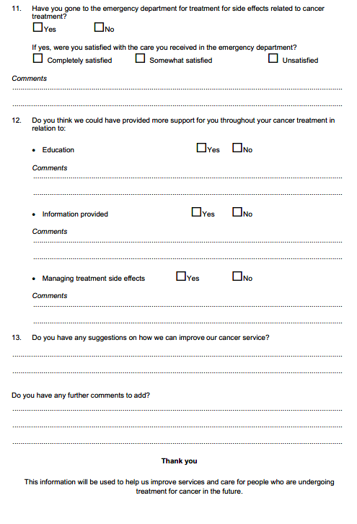

Supportive care template
Below is an example of a distress checklist produced by the National Comprehensive Cancer Network. For permission to use the checklist in your health service, please refer to the NCCN website <https://www.nccn.org/guidelines/submissions-licensing-and-permissions/permissions-distress-tool> for more information.
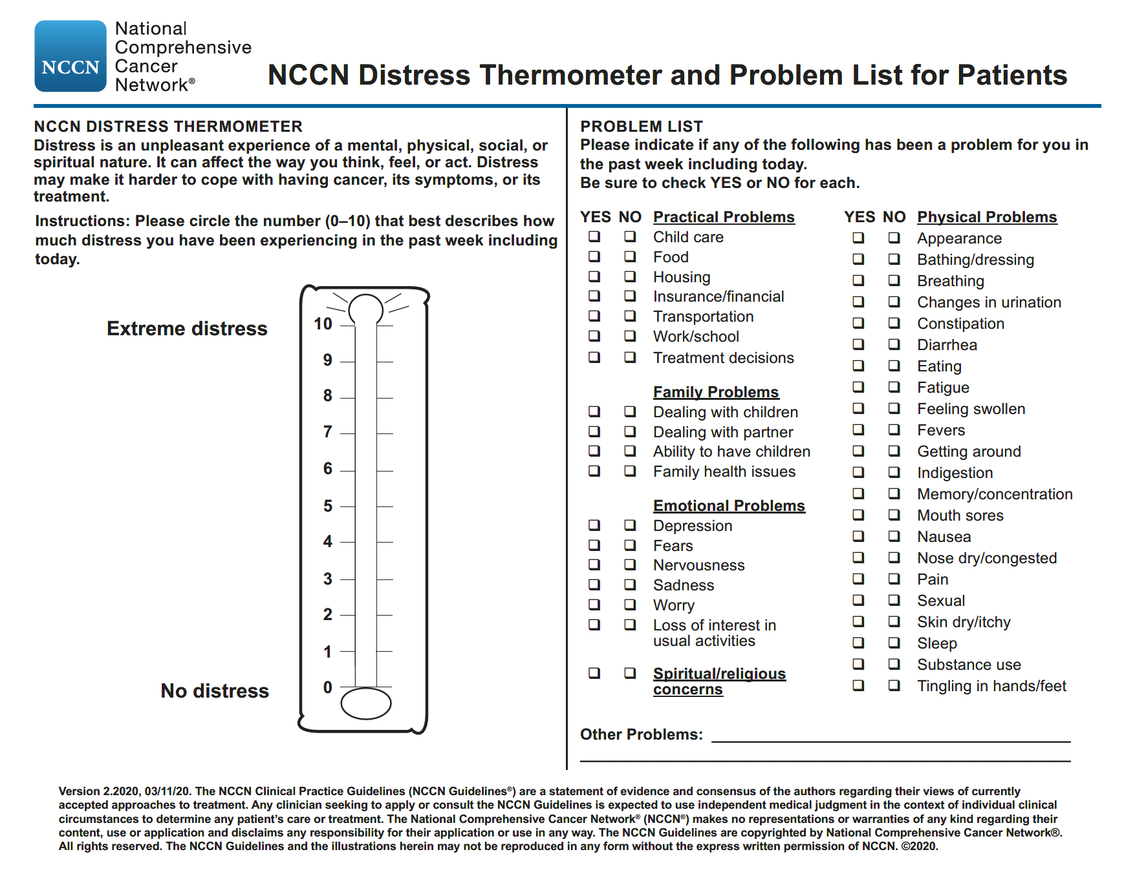

GP letter – commencement of new treatment
Dear Doctor [insert name]
Thank you for ongoing care of [insert patient’s name], a [insert patient’s age]-year-old M/F/non-binary, with recently diagnosed [insert patient’s diagnosis].
[Insert patient’s name] attended the Day Oncology Unit at the [insert centre name] today where he/she/they have commenced a new anti-cancer treatment regimen:
[insert name of drugs, frequency]
Further information about the treatment regimen including the side effect profile can be found at: [insert eviQ link].
If eviQ information is not available for specific diagnosis:
- Please note: Drug information for the specific diagnosis of this patient is not currently available. Information included is for the correct drug regimen but for an alternative diagnosis.
When different drug combination on eviQ, needing supplemental drug information:
- Please note: This patient is receiving a treatment regimen consisting of different drugs detailed in the eviQ information [__ instead of __]. Please view the supplemented drug information for [insert drug name].
Additional section for patients prescribed immunotherapy agents
[Insert patient’s name] has commenced a treatment regimen that includes an immune checkpoint inhibitor. If you suspect your patient is experiencing an immune-related adverse event, please notify the SURC nurse or the on-call oncology registrar at [insert health service name].
More information about immune-related adverse events can be found on the eviQ website <https://www.eviq.org.au/clinical-resources/health-professional-fact-sheets/3457-information-to-assist-gps-immunotherapy>.
If you would like any more information about our clinic, please contact the Symptom and Urgent Review Clinic (SURC) at the [insert centre name].
Phone: [insert number]
Hours of operation: [insert]

Kind regards
SURC Nurse

Appendix 2: Patient pathways
Please copy pathway images for use in your toolkit.
Source documents are available in JPEG and Microsoft Word on request from the department.

Physical presentation to SURC pathway

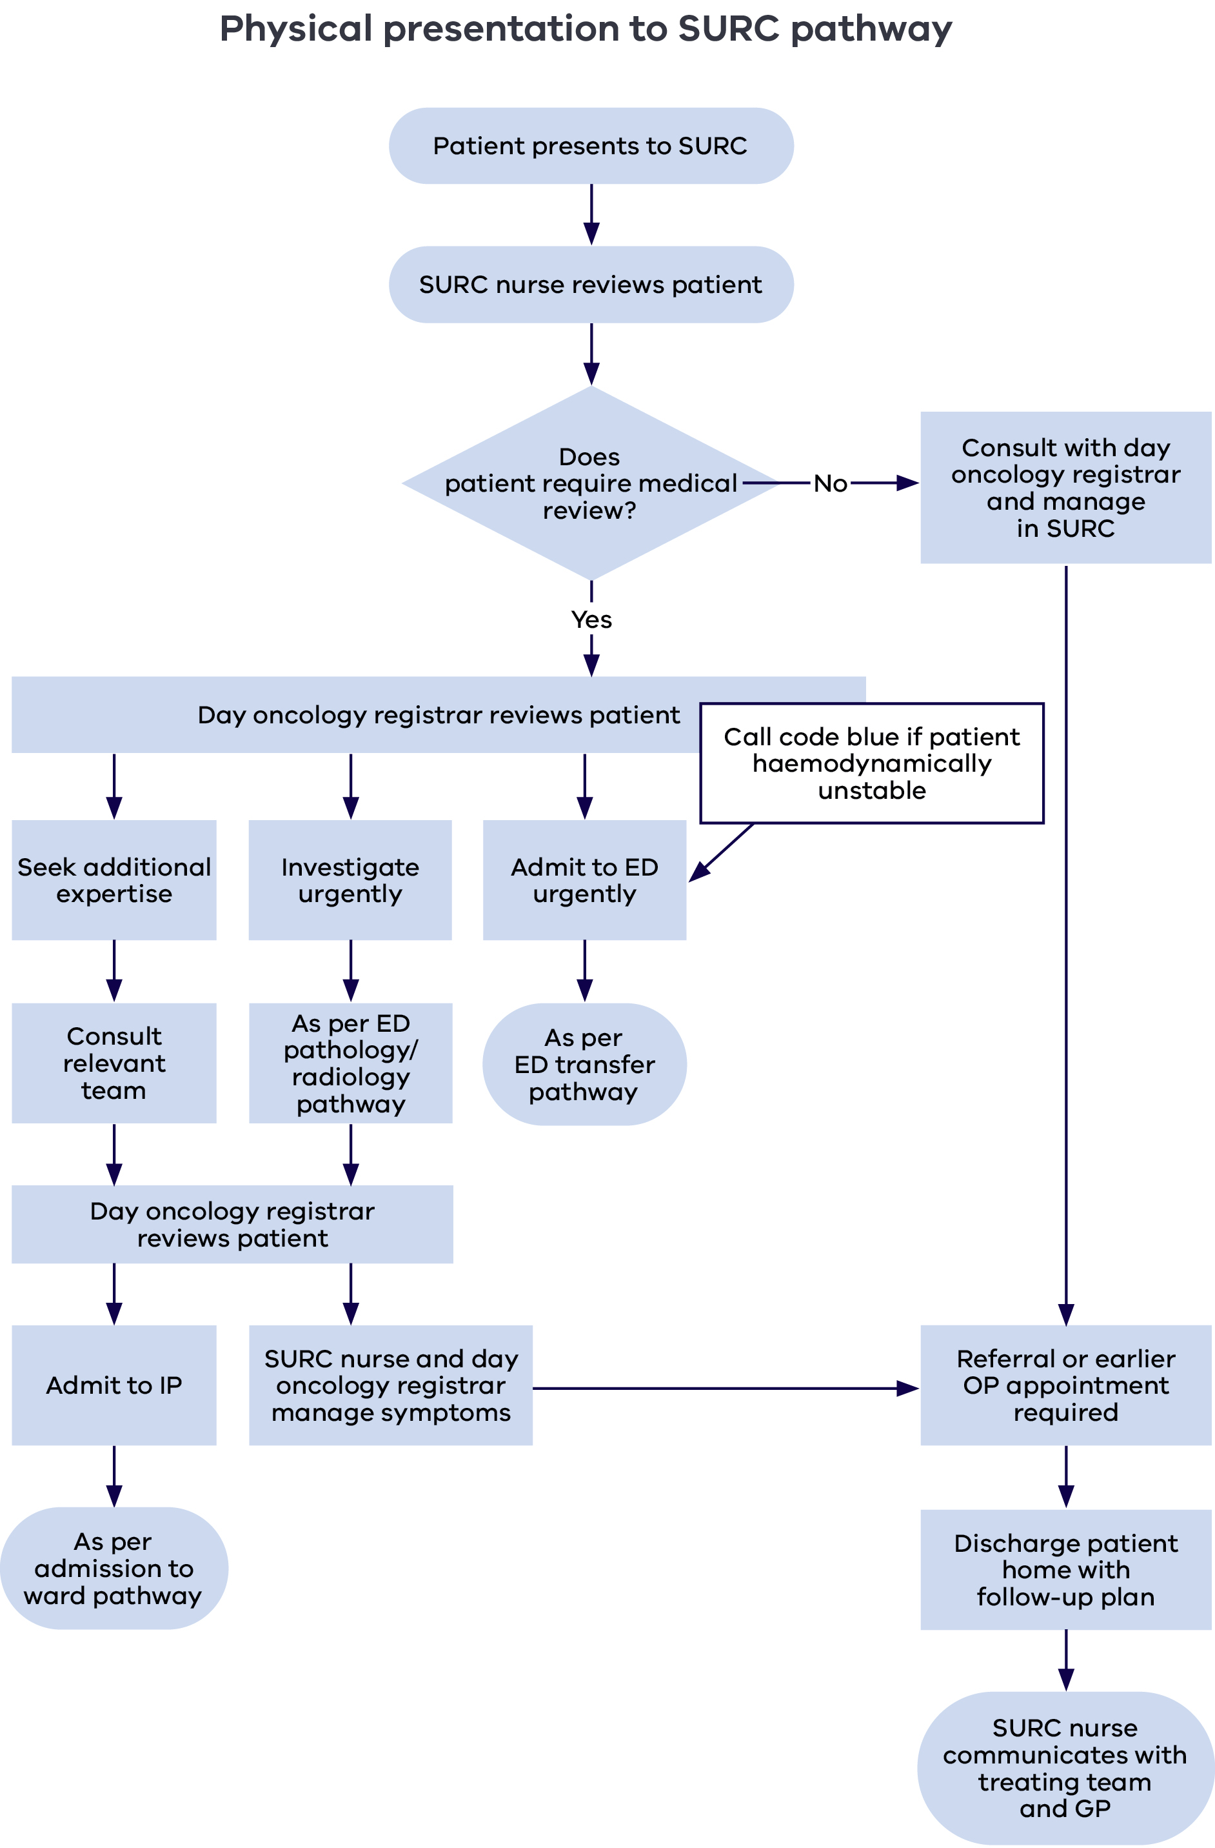

Phone triage pathway

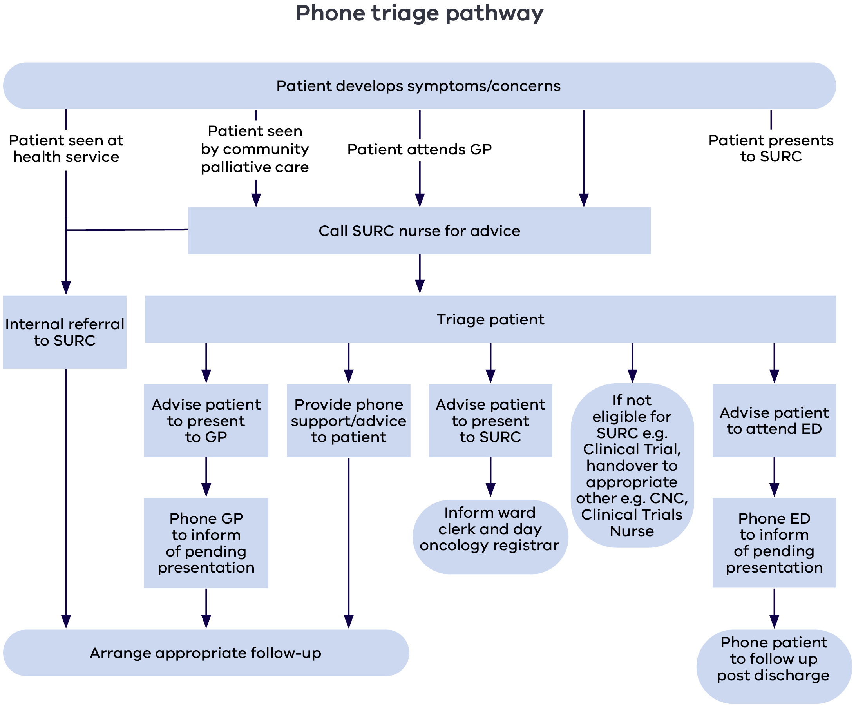

Pathology and radiology pathway

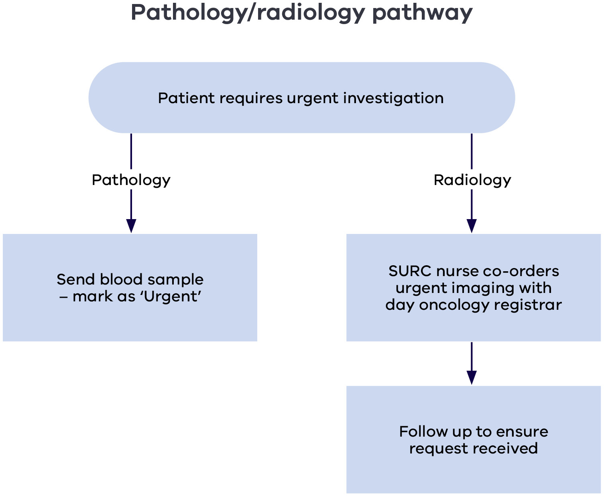

SURC to emergency department urgent review pathway

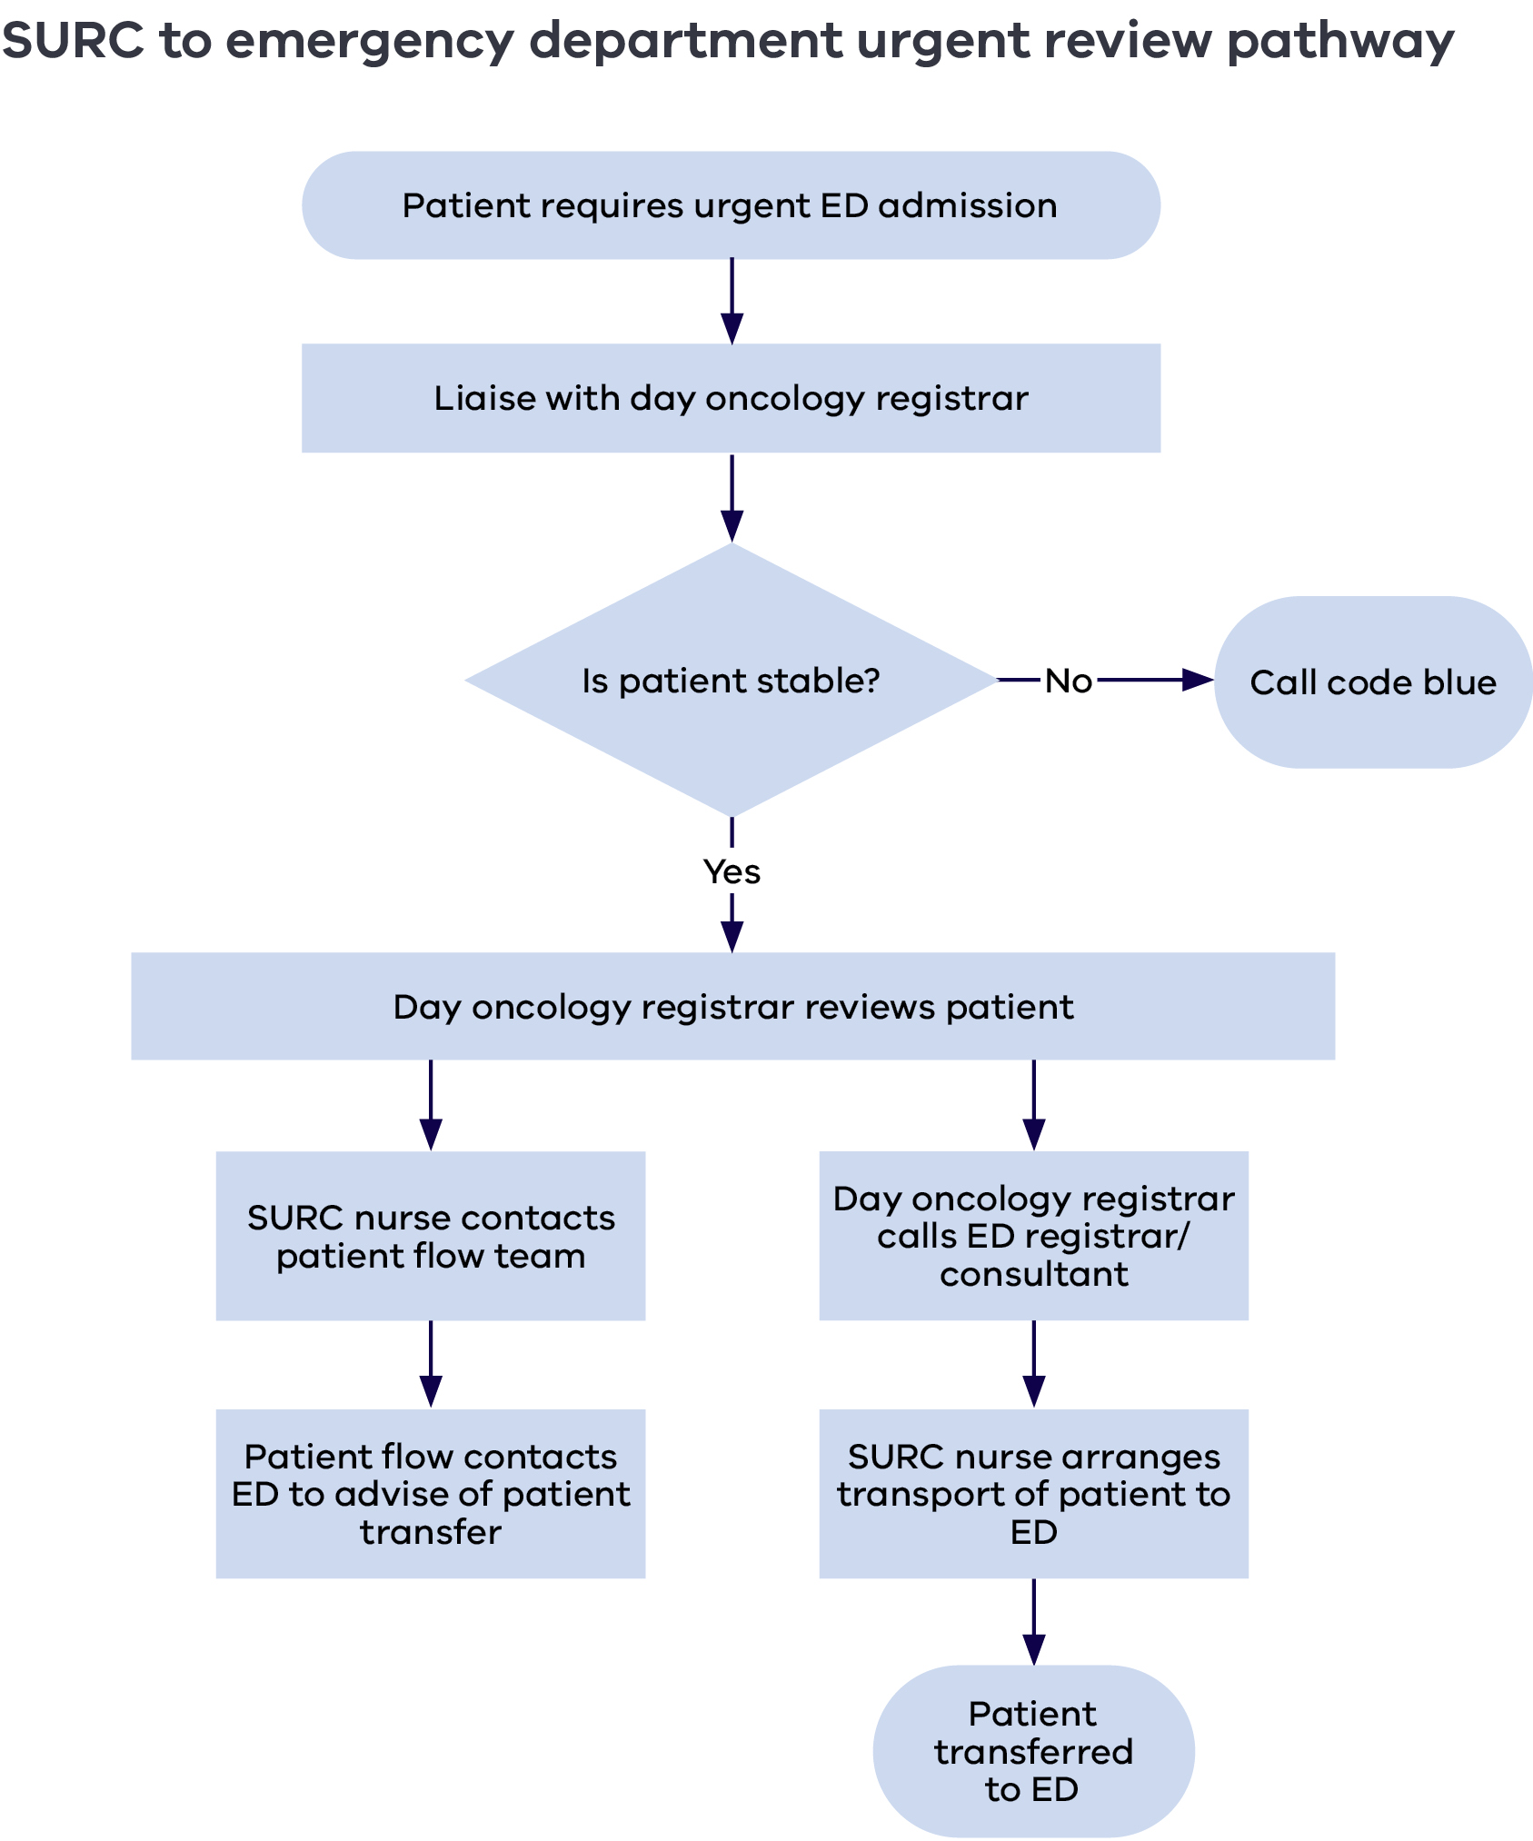

SURC to inpatient admission pathway

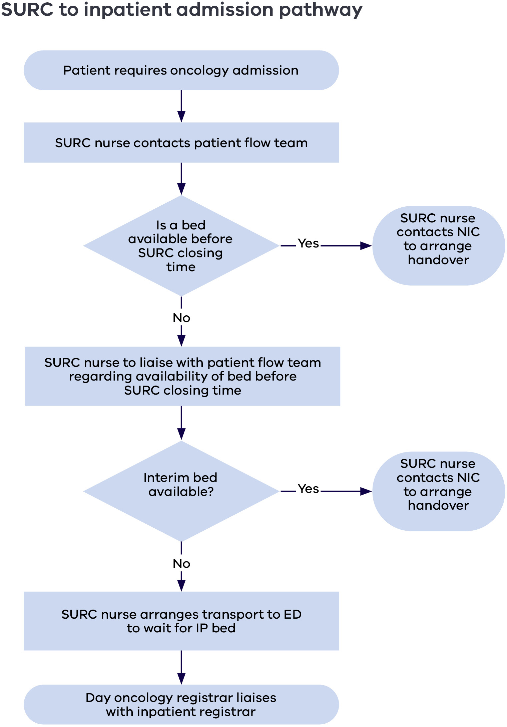

Triage to SURC from emergency department pathway

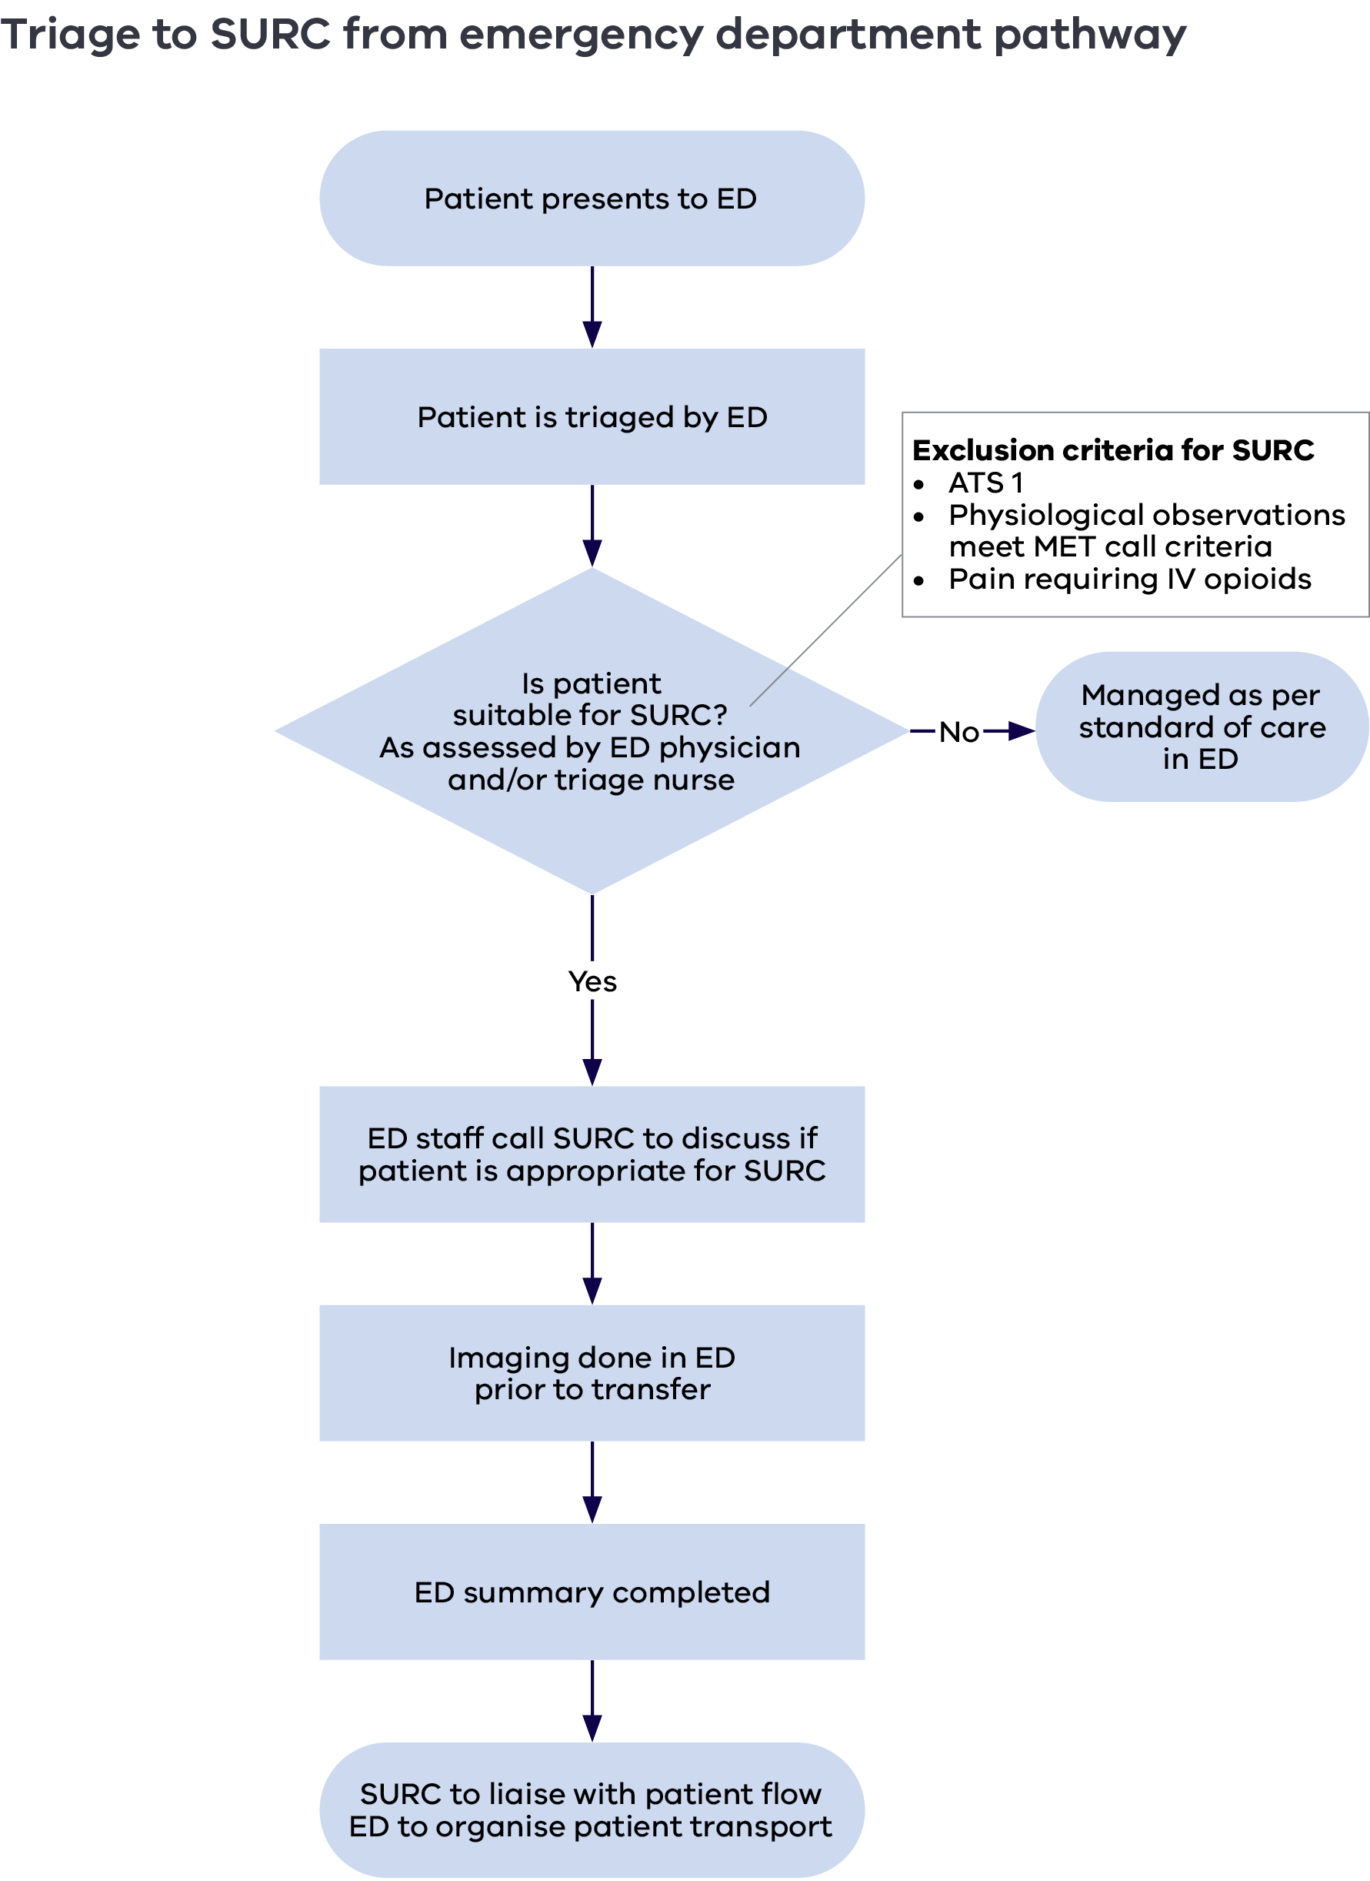

Northfield S, Button E, Wyld D, et al. 2019, ‘Taking care of our own: a narrative review of cancer care services-led models of care providing emergent care to patients with cancer’, European Journal of Oncology Nursing, 40:85–97.
Traeger L, McDonnell TM, McCarty CE, et al. 2015, ‘Nursing intervention to enhance outpatient chemotherapy symptom management: patient-reported outcomes of a randomized controlled trial’, Cancer, 121(21):3905–13.
3. Coolbrandt A, Milisen K, Wildiers H, et al. 2015, ‘A nursing intervention aimed at reducing symptom burden during chemotherapy (CHEMO-SUPPORT): a mixed-methods study of the patient experience’, European Journal of Oncology Nursing, 34:35-41; Daly B, Michaelis LC, Sprandio JD, et al. 2020, ‘From theory to practice: implementation of strategies to reduce acute care visits in patients with cancer’, American Society of Clinical Oncology Educational Book, 40:85–94.
Ibid.
Australian Government Department of Health (2018) Australian immunisation handbook
Ibid.
Dufton PH, Drosdowsky A, Gerdtz MF, et al. 2019, ‘Socio-demographic and disease-related characteristics associated with unplanned emergency department visits by cancer patients: a retrospective cohort study’, BMC Health Services Research,19(1):647.
Australian Commission on Safety and Quality in Health Care (2010) National Consensus statement: essential elements for recognising and responding to clinical deterioration, Australian Government, Canberra.

