

Blood Matters on the Bench and Beyond
Issue 10 – April 2022
OFFICIAL

Welcome to the Blood Matters newsletter for Scientists. It will be distributed throughout the year to share information that may be helpful to you, and to let you know of upcoming activities which may be of interest.

Blood Matters online events 2022
We have been thrilled with the level of interest and participation in Blood Matters online events since they began in 2020. These have become a regular fixture in our education calendar, continuing to support scientists and our multidisciplinary network of transfusion professionals.

Blood management in the time of crisis


Wednesday 25 May 2022
12.00pm – 1.00pm
Virtual education session via Webex
Registration is required – Click here to register
Blood supply from a national perspective  - Logistics of blood supply  - Response to supply shortages  - Disaster/contingency planning | Stuart Chesneau  Chief Strategic Supply and Growth Officer  Business Growth & Innovation  Australian Red Cross Lifeblood
Role of Lifeblood Transfusion Medicine Specialists in time of shortage  - How provision of blood and blood products is prioritised  - How to select best alternatives  - How scientists/clinicians can help Lifeblood with triaging of orders | Dr Kobie Von Wielligh  Transfusion Medicine Specialist  Pathology Services  Australian Red Cross Lifeblood
Including time for questions at the end of the meeting.
This education session is aimed at transfusion scientists but would be of interest to all clinical staff.

2021/22 ‘STOP the waste’ festive season campaign results
The 2021/22 ‘STOP the waste’ festive campaign has once again been extremely successful. We would like to pass on our thanks for the diligence and dedication in celebrating the donor’s gift this festive period.

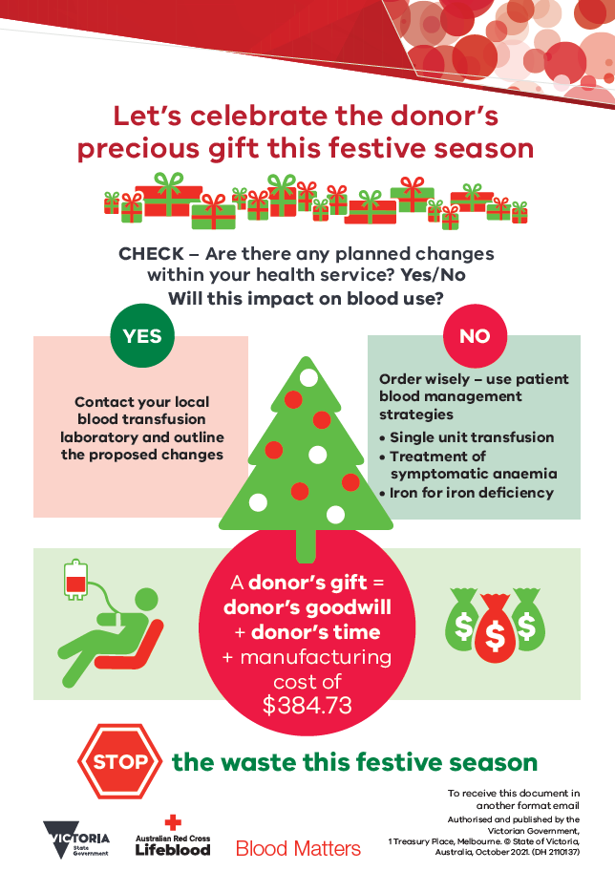
The last two festive periods have seen record low RBC wastage rates in Victoria. An outstanding wastage rate of 1.2% was achieved twice during this most recent festive period, with an average wastage rate of 1.3%. The awareness of all stakeholders has been a major factor in the success of the ‘STOP the waste’ festive campaign. This is a remarkable result, and we celebrate your achievement in keeping wastage to a minimum.
Extra care was required this year with shortages being experienced across the blood supply, so the record low wastage rates have had more impact than ever on maintaining the sufficiency of the blood supply.
Your continued support of the ‘STOP the waste’ festive campaign is appreciated.
As we continue into 2022, please remember to monitor changes to activity within your organisation which may impact on blood use and adjust your inventory accordingly.

Changing blood groups in the Australian population
The distribution of ABO RhD blood groups in Australia, based on blood donor and blood sample pathology data, written by Rena Hirani, Natalie Weinert and David Irving from Australian Red Cross Lifeblood has recently been published in The Medical Journal of Australia (MJA).
The distribution of blood groups in Australia has changed since the data published on the Lifeblood website, which reflects the groups of first-time blood donors in 1993-1994. This change echoes the changes in the demographic of the Australian population over time. Of particular interest, the proportion of RhD positive first-time blood donors has increased from 81% to 83.8%.
Hirani et al’s findings can support supply planning of blood and blood products, and also highlights the challenge of meeting the increasing demand for RhD negative red blood cells.
“As 85.9% of patients blood-typed by pathology services during 2019 were RhD positive, diversifying blood holdings to encompass more RhD positive stock would be adequate for meeting clinical requirements” (Hirani, 2022).
Blood group prevalence:
 | Typed by pathology services  2019 | Typed by first-time blood donors  2019 | First-time blood donors 1993-94 (for comparison) | Change in general population
O RhD positive | 38.4% | 37.8% | 40% | ↓
O RhD negative | 6.5% | 8.7% | 9% | ↓
A RhD positive | 32.0% | 29.6% | 31% | ↑
A RhD negative | 5.6% | 5.3% | 7% | ↓
B RhD positive | 11.8% | 12.4% | 8% | ↑
B RhD negative | 1.5% | 1.6% | 2% | ↓
AB RhD positive | 3.7% | 3.9% | 2% | ↑
AB RhD negative | 0.5% | 0.6% | 1% | ↓
Read the full article at: The distribution of ABO RhD blood groups in Australia, based on blood donor and blood sample pathology data - Hirani - - Medical Journal of Australia - Wiley Online Library

AB cryoprecipitate shortages
With AB cryoprecipitate on frequent medical officer approval only (MO) due to inventory shortages, it is a good time to start/refresh the conversation about giving group A cryoprecipitate to patients of unknown blood group.
This is common practice around the world, and literature supports the safety of using group A cryoprecipitate.
Time to stop worrying about ABO incompatible cryoprecipitate transfusions in adults - Khan - 2021 - Transfusion - Wiley Online Library
This change will also result in pressure on AB FFP supply being eased (as less demand for AB cryoprecipitate results in less AB plasma needed for cryo manufacture and less cryo-depleted plasma as a by-product).
It may also a good time to also investigate using group A (low titre anti-B) FFP for patients of unknown group.
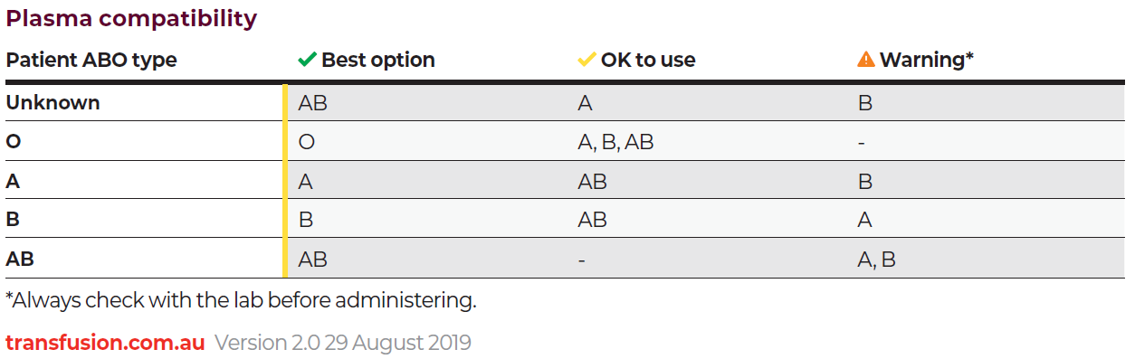


National certification of the medical scientist profession
The Australian Council for Certification of the Medical Laboratory Scientific Workforce has simplified its acronym to CMLS. Join now at www.cmls.org.au.

Why become certified?
- Demand recognition of our professional standing as part of Australia’s health service workforce.
- Certification will be the best benchmark available to assure competent professional practice.
- With a certified workforce there will be more obligation on the employer to ensure staff have professional development opportunities afforded to them.
- As a nationally certified medical scientist you can demonstrate your ongoing commitment to professional development and self-improvement and be recognised as passionate, progressive and pro-active.
Click here to view a short video about the certification scheme
A Blood Matters education session was held in May 2021 which included information about the certification scheme. Click here for to view meeting recording (the certification presentation begins at time point 20:38).
Blood Matters is committed to providing support and education to assist in the early stages of this scheme.

How can Blood Matters help you?
The Blood Matters team are here to assist health services and laboratories through education and providing resources.
If you have suggestions for tools and resources that could assist in day to day activities and towards achieving accreditation please let Rae French or any of the Blood Matters team know by email to at rfrench@redcrossblood.org.au or bloodmatters@redcrossblood.org.au or phone 03 9694 3524.

To receive this document in another format, phone 03 9694 0102, using the National Relay Service 13 36 77 if required, or email Blood Matters <bloodmatters@redcrossblood.org.au>.
Authorised and published by the Victorian Government, 1 Treasury Place, Melbourne.
© State of Victoria, Australia, Department of Health, October 2021.
ISSN 2652-7278 – Online (pdf / word)
Available at Blood Matters <https://www2.health.vic.gov.au/hospitals-and-health-services/patient-care/speciality-diagnostics-therapeutics/blood-matters/transfusion-science-blood-stewardship>

