

Blood Matters on the Bench and Beyond
Issue 11 – July 2022
OFFICIAL

Welcome to the Blood Matters newsletter for Scientists. It will be distributed throughout the year to share information that may be helpful to you, and to let you know of upcoming activities which may be of interest.

Blood Matters online events 2022
Blood Matters online events have become a regular fixture in our education calendar, continuing to support scientists and our multidisciplinary network of transfusion professionals.
We are planning more virtual education sessions for 2022, communication will be sent soon as we have finalised details.

Blood Matters 20th anniversary celebrations


Friday 12 August 2022
10.00am – 3.00pm
Hybrid event. In-person allocation exhausted, availability for virtual participation
Registration is required, click here to register
Blood Matters invite all Victorian and Tasmanian transfusion scientists to join us virtually as we celebrate the achievements of the program and the network over the past 20 years.
Please see email attachment for the program.

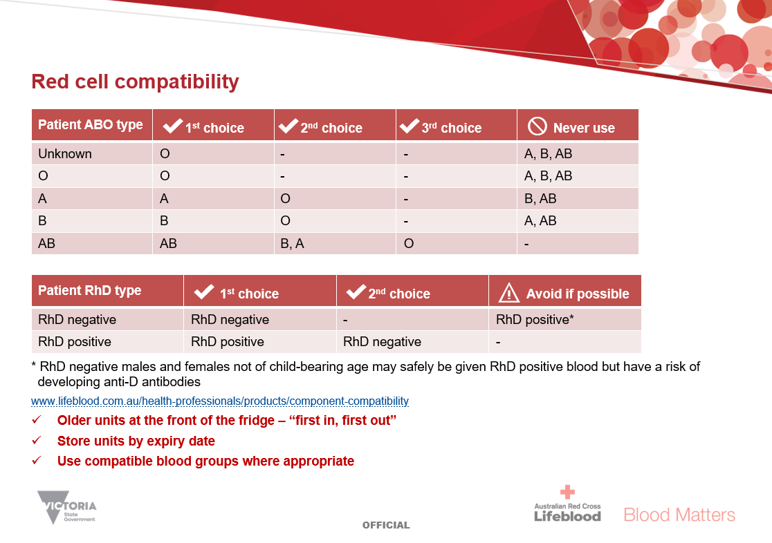
Blood Matters resource available – blood group compatibility charts
Blood Matters have developed blood group compatibility charts for use within health services. These may be helpful as a quick reference to assist staff with blood group compatibility and aid in wastage reduction especially for staff who rotate into the transfusion laboratory or new staff.
There are separate charts for RBC, platelets and FFP/cryoprecipitate which are intended to be displayed in the appropriate area (i.e., on blood fridge, platelet shaker or freezer).
If you would like to a copy for display within your laboratory, please contact Rae at rfrench@redcrossblood.org.au

Record low RBC Victorian wastage rates
The Blood Matters Wastage Project began in 2014 to reduce RBC wastage and assist health services to reach national wastage targets set by governments. The Victorian RBC wastage rate was 7.0% in February 2014 and reduced to 1.7% over the course of this project.
The combined efforts of transfusion laboratories and health services has since seen RBC wastage reduce even further, with a record low RBC wastage rate of 1.1% achieved by Victorian health services in April 2022.
We are incredibly appreciative for your diligence and dedication in supporting our precious resource, gifted so generously by our donors.

Ongoing inventory restrictions
We understand the pressure faced by health services when blood and blood products are on restrictions.
Blood Matters hosted a Webex education session on 25th May discussing the challenges and logistics of the ongoing supply issues.
Blood management in the time of crisis features presentations by Stuart Chesneau (Chief Strategic Supply and Growth Officer at Lifeblood) and Dr Kobie Von Wielligh (Transfusion Medicine Specialist at Lifeblood).
Click here to view meeting recording.

Victorian Immunohaematology Discussion Group (VIDG)
Thank you to all of you who have completed the evaluations after our online education sessions. It is always gratifying to receive such valuable feedback, enabling us to optimise these sessions to best meet your needs. The suggestions for future topics are most welcome to help us plan our future education sessions.
There are often requests for case studies, trouble-shooting difficult antibodies and hands-on bench assistance/discussion. This is indeed a very worthwhile focus, and beneficial to many scientists across the sector.
Rather than duplicate education and resources, we collaborate with our transfusion colleagues.
I encourage you to join VIDG to get your extra dose of bench immunohaematology. The virtual networking and discussion which occurs between peers within the group is always enjoyable and energising.

VIDG is an excellent group to be a part of, with a wealth of expertise and friendly faces on hand. They are currently holding monthly meetings on-line, and membership continues to be free for the upcoming financial year
Email vidgsecretary@gmail.com to receive membership information. A current membership form is also attached to this email.


National certification of the medical scientist profession
The Australian Council for Certification of the Medical Laboratory Scientific Workforce has simplified its acronym to CMLS. Join now at www.cmls.org.au.

Why become certified?
- Demand recognition of our professional standing as part of Australia’s health service workforce.
- Certification will be the best benchmark available to assure competent professional practice.
- With a certified workforce there will be more obligation on the employer to ensure staff have professional development opportunities afforded to them.
- As a nationally certified medical scientist you can demonstrate your ongoing commitment to professional development and self-improvement and be recognised as passionate, progressive and pro-active.
Click here to view a short video about the certification scheme
A Blood Matters education session was held in May 2021 which included information about the certification scheme. Click here for to view meeting recording (the certification presentation begins at time point 20:38).
Blood Matters is committed to providing support and education to assist in the early stages of this scheme.

How can Blood Matters help you?
The Blood Matters team are here to assist health services and laboratories through education and providing resources.
If you have suggestions for tools and resources that could assist in day to day activities and towards achieving accreditation please let Rae French or any of the Blood Matters team know by email to at rfrench@redcrossblood.org.au or bloodmatters@redcrossblood.org.au or phone 03 9694 3524.

To receive this document in another format, phone 03 9694 0102, using the National Relay Service 13 36 77 if required, or email Blood Matters <bloodmatters@redcrossblood.org.au>.
Authorised and published by the Victorian Government, 1 Treasury Place, Melbourne.
© State of Victoria, Australia, Department of Health, October 2021.
ISSN 2652-7278 – Online (pdf / word)
Available at Blood Matters <https://www2.health.vic.gov.au/hospitals-and-health-services/patient-care/speciality-diagnostics-therapeutics/blood-matters/transfusion-science-blood-stewardship>

