

Blood Matters on the Bench and Beyond
Issue 14 – May 2023
OFFICIAL

Welcome to the Blood Matters newsletter for Scientists. It is distributed throughout the year to share information that may be helpful to you, and to let you know of upcoming activities which may be of interest.

Blood Matters online events 2023
Blood Matters online events have become a regular fixture in our education calendar, continuing to support scientists and our multidisciplinary network of transfusion professionals.


Safeguarding and utilising blood components by Ambulance Victoria.

Blood by air and blood by road.

Tuesday 20 June 2023
11.00am – 12.00pm (AEST)
Registration in required, Click here to register
Andrew Allan, MICA Flight Paramedic Educator and Ben Meadley, Improvement Lead – MICA from Air Ambulance Victoria discussing pre-hospital transfusion in Victoria
- Decision to transfuse
- Provision of blood components
- Supply and storage of blood components
- Prehospital blood component research
- The future of blood component administration at AV

Emergency use of group O RBC in Victoria
Blood Matters in collaboration with Safer Care Victoria have developed resources and support tools to assist Victorian health services with appropriate utilisation of emergency use group O red blood cells, in line with the national statement.
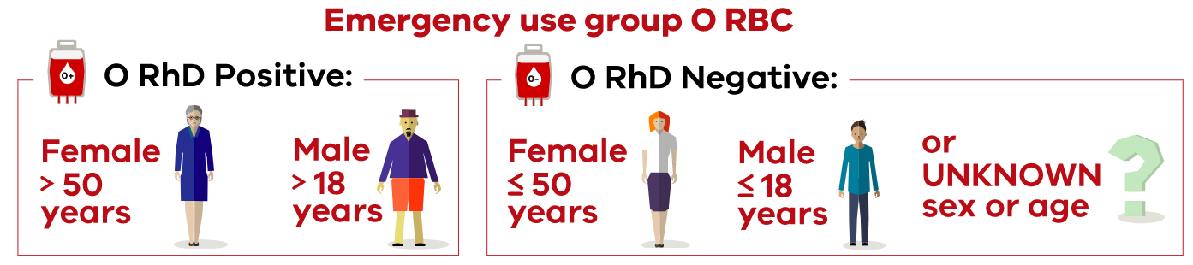
The resources and support tools developed to assist health services implement the recommendations are available for download from the Blood Matters webpage <https://www.health.vic.gov.au/patient-care/emergency-use-of-group-o-red-blood-cells>.

Key messages – for emergency use RBC (O RhD negative and O RhD positive)
- The risk of serious morbidity or mortality resulting from traumatic haemorrhage should be prioritised over potential risk of alloimmunisation.
- Emergency use group O RBC are to be used only in an emergency to save a patient’s life and when the patient’s blood group is not yet confirmed.
- A pretransfusion specimen must be obtained as soon as possible, and where feasible prior to transfusion of any emergency use group O RBC. This will enable the transfusion service to provide units compatible with the patient’s group and minimise group O RBC use.
Each health service should evaluate their own requirements for emergency use group O RBC and hold appropriate emergency inventory for their site. Regular review and audit of emergency group O RBC use and inventory appropriateness is encouraged.
Should you have any questions please contact the Blood Matters team at: Bloodmatters@redcrossblood.org.au

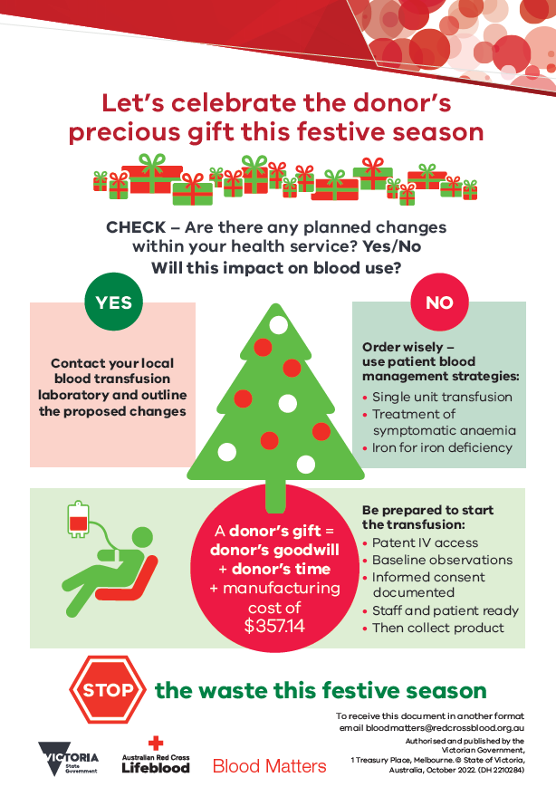
‘STOP the waste’ festive campaign 2022/23 summary
The 2022/23 ‘STOP the waste’ festive campaign has once again been extremely successful. Thank you for your diligence and dedication in celebrating the donor’s gift this festive period.

The average Victorian red cell wastage rate over this festive season was 1.4%.

The ongoing success of the ‘STOP the waste’ festive campaign is a result of your continued support and greatly appreciated.

As we continue into 2023, please remember to monitor changes to activity within your organisation which may impact on blood use and adjust the inventory accordingly.

This is of particular importance as O RhD negative RBC use decreases when emergency use group O RBC recommendations to include O RhD positive RBC are implemented across health services.

National Pathology Accreditation Advisory Council (NPAAC) standards updated
Australian Commission on Safety and Quality in Health Care (ACSQHC) has published an updated edition (fifth edition, 2022) of the NPAAC Requirements for transfusion laboratory practice standard. This standard outlines practice standards that assure the safety, quality and efficacy of transfusion testing, associated transfusion laboratory practice, and non-transfusion related blood group immunohaematology testing.
The Standards have been revised with amendments to pretransfusion testing of patients, minor amendments to cross-references to other standards, delineation of footnote references and explanatory notes and updates to referencing and referencing style.

FFP audit is now open
Is fresh frozen plasma (FFP) used at your health service in accordance with the National Blood Authority Patient Blood Management Guidelines and indications for use published at: Lifeblood? Now is the time to find out. The FFP audit, developed in conjunction with Australian Red Cross Lifeblood (Lifeblood), the National Blood Transfusion Committee and Blood Matters is now live.
Data submission will be using the Lifeblood Audit tool Lifeblood audit site.
This is a retrospective audit of the medical records of up to 30 FFP transfusion episodes (or all transfusion episodes if less than 30) occurring between 1 April 2022 and 31 March 2023.
Please complete the audit and email the data to Blood Matters by 1 July 2023. If FFP has not been given to a patient at your health service between 1 April 2022 and 31 March 2023, please email Blood Matters at: Bloodmatters@redcrossblood.org.au to advise of this.
Full instructions and audit guide can be found at Blood Matters Audits.

AB cryoprecipitate inventory shortages
AB cryoprecipitate has regularly been on Medical Officer (MO) approval due to inventory pressures. Only 4.2% of Australians are group AB, while 8.0% of cryoprecipitate issued in Victoria (May 2022 – April 2023) is group AB. Furthermore, clinical FFP and cryoprecipitate are only made from male donors – so AB cryoprecipitate donors are a very small proportion of the total donor population.
A timely reminder to review your local critical bleeding protocol for inclusion of A cryoprecipitate to patients of unknown group.
Ideally cryoprecipitate should be ABO compatible with the recipient’s red cells; however, ABO-incompatible cryoprecipitate can be used with caution, particularly with large volumes. If a large volume of ABO-incompatible cryoprecipitate is used, the recipient may develop a positive direct antiglobulin test and, very rarely, mild haemolysis.
AABB (Association for the Advancement of Blood & Biotherapies, formerly American Association of Blood Banks) and The Canadian Society for Transfusion Medicine (CSTM) Standards state that “Adult recipients can be transfused with any ABO group of cryoprecipitate” .
Antibody titration is not usual practice for cryoprecipitate as the plasma volume and anti-A/B antibody levels are too low in cryoprecipitate to be of concern ^{1,}.
Reducing demand for AB cryoprecipitate will subsequently improve the supply of group AB FFP, while also ensuring availability for those patients who have no alternative but to receive this group.

Upcoming conferences

Blood 2023

5-8 November 2023, Melbourne Convention and Exhibition Centre
Transfusion Practitioner Study Day - 4 November 2023
This event is the combined Annual Scientific Meeting of:
- Australia and New Zealand Society of Blood Transfusion (ANZSBT).
- Haematology Society of Australia and New Zealand (HSANZ).
- Thrombosis and Haemostasis Society of Australia and New Zealand (THANZ).
Abstract submission and early bird registration open
- Abstract submission closes 31 May 2023.
- Early bird registration closes 10 August 2023.
For more information visit the Blood 2023 website.

National Immunohaematology Continuing Education (NICE) 2023

25 – 27 August 2023, Tweed Heads, NSW

The NICE conference has been held annually for almost 40 years and is a scientific meeting where immunohaematology enthusiasts meet, share information, experiences and opinions. All attendees must present a ten-minute scientific talk, including question time.
For all enquiries and further information, email NICE2023comm@gmail.com


National certification of the medical scientist profession
The Australian Council for Certification of the Medical Laboratory Scientific Workforce has simplified its acronym to CMLS. Join now at www.cmls.org.au.

Some changes to CMLS certification came into effect on 1st April 2023. Rather than the CMLS Board directly processing applications for certification or renewal, professional bodies operating CMLS approved CPD schemes will be able to issue certification on behalf of the Council for their members meeting the criteria.
The Council member organisations remain committed to the certification of the medical laboratory workforce and to the standards which they have established. This change has been made to simplify the process and increase the participation in certification at minimal cost to the individual.

Why become certified?
- Demand recognition of our professional standing as part of Australia’s health service workforce.
- Certification will be the best benchmark available to assure competent professional practice.
- With a certified workforce there will be more obligation on the employer to ensure staff have professional development opportunities afforded to them.
- As a nationally certified medical scientist you can demonstrate your ongoing commitment to professional development and self-improvement and be recognised as passionate, progressive and pro-active.
Click here to view a short video about the certification scheme
A Blood Matters education session was held in May 2021 which included information about the certification scheme. Click here for to view meeting recording (the certification presentation begins at time point 20:38).
Blood Matters is committed to providing support and education to assist in certification of the medical scientific workforce.

How can Blood Matters help you?
The Blood Matters team are here to assist health services and laboratories through education and providing resources.
If you have suggestions for tools and resources that could assist in day to day activities and towards achieving accreditation please let Rae French or any of the Blood Matters team know by email to at rfrench@redcrossblood.org.au or bloodmatters@redcrossblood.org.au or phone 03 9694 3524.

To receive this document in another format, phone 03 9694 0102, using the National Relay Service 13 36 77 if required, or email Blood Matters <bloodmatters@redcrossblood.org.au>.
Authorised and published by the Victorian Government, 1 Treasury Place, Melbourne.
© State of Victoria, Australia, Department of Health, May 2023.
ISSN 2652-7278 – Online (pdf / word)
Available at Blood Matters <https://www2.health.vic.gov.au/hospitals-and-health-services/patient-care/speciality-diagnostics-therapeutics/blood-matters/transfusion-science-blood-stewardship>

Blood Component Information, An Extension of Blood Component Labels, Australian Red Cross Lifeblood, June 2020 https://www.lifeblood.com.au/health-professionals/learn/resource-library Accessed 4/5/23
Hadjesfandiari, N, Levin, E, Serrano, K, Yi, Q-L, Devine, DV. Risk analysis of transfusion of cryoprecipitate without consideration of ABO group. Transfusion. 2021; 61: 29– 34. https://doi.org/10.1111/trf.16125
Khan, J. and Dunbar, N.M. (2021), Time to stop worrying about ABO incompatible cryoprecipitate transfusions in adults. Transfusion, 61: 1-4. https://doi.org/10.1111/trf.16228

