

Practice Note: Group Delivery from Another Service Provider
Contents
Summary 1
Step One: The Primary Provider refers the client(s) to the Collaborative Provider 2
Step Two: The Collaborative Provider temporarily transfers in the client(s) and adds them to the appropriate group(s) 3
Step Three: The Primary Provider transfers in the client(s), and re-establishes any specific program enrolments as necessary 5

Summary
There may be circumstances where it is appropriate or required for clients of one MCH service provider (Primary Provider) to receive group services delivered by a different MCH service provider (Collaborative Provider).
Examples:
- A family is enrolled at their local council MCH service provider (Primary Provider) and is receiving KAS and other services. Due to workforce shortages, their Primary Provider is unable offer them any group sessions. An agreement has been made with a neighbouring MCH provider (Collaborative Provider) to offer group sessions to the Primary Provider’s families.
- An Aboriginal family is enrolled at their local Aboriginal MCH service provider (Primary Provider) and is receiving KAS and other services. The Primary Provider does not offer group sessions, so an agreement has been made with the local council MCH provider (Collaborative Provider) to offer group sessions to the Primary Provider’s families.
It is possible for families to attend group sessions at a Collaborative Provider whilst simultaneously being enrolled and receiving KAS and other services from their Primary Provider.
At a high level, the steps in CDIS to achieve this are:
- The Primary Provider refers the client(s) to the Collaborative Provider
- The Collaborative Provider temporarily transfers in the client(s), and adds them into the appropriate group(s)
- The Primary Provider transfers in the client(s), and re-establishes any specific program enrolments as necessary
Following this process, the family records will be located back with their Primary Provider for regular service delivery, whilst simultaneously being included in group(s) with the Collaborative Provider.
This document walks through the above three steps in detail.

Step One: The Primary Provider refers the client(s) to the Collaborative Provider
- Ensure that there is an appropriate agreement in place between the Primary Provider and the Collaborative Provider, for the provision of group services.
- Complete routine MCH services & client management, ensuring all client files are up to date, and KAS consultations are scheduled.
- Liaise with the Collaborative Provider so respective client schedules are understood (i.e., Group sessions should not conflict with any scheduled KAS consultations).
- Complete the external referral process summarised below, for all clients that will be enrolled in a group run by the Collaborative Provider. Refer to ‘Child Development Information System external referral process’ (docx) for more information if required:
  - From within the Client record, Select Menu Clinical Activity > Referrals, then click + External
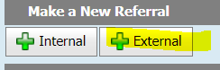
Image 1 – From Referrals select + External

  - On the External Referral screen that pops up, click Select Referee
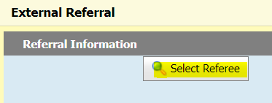
Image 2 – From External Referrals Screen Select Referee

  - On the Referee Search screen that pops up, in the Organisation field type the name of the MCH service e.g., Bendigo MCH and Search
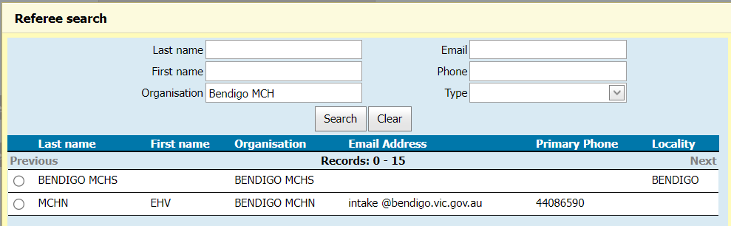
Image 3 – From Referrals Search Screen enter the organisation name and click Search

  - Select the radio button for the appropriate Collaborative Provider, click on Use Service Provider, and fill in the remaining details as per the referral process and discussions you have had with the Collaborative Provider.
  - Advise the collaborative provider of the completed referral, which is now pending for them to transfer the client in.
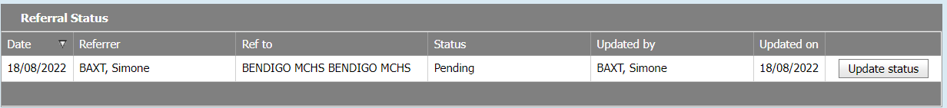
Image 4 – Referral Status

Step Two: The Collaborative Provider temporarily transfers in the client(s) and adds them to the appropriate group(s)
- Ensure the groups have been created as per CDIS guidelines: ensure that all dates, sessions & facilitators are scheduled and ready for clients to be added. Refer to ‘Child Development Information System’ initial group set up process’ (docx), and ‘Child Development Information System groups process’ (docx) as required.
- Following the Transfer process (refer to ‘CDIS transfer process (docx)’ for more information as required). Transfer in clients, ensuring not to cancel scheduled KAS appointments, and be aware of any Programs the client is enrolled in.
- Locate the CDIS record and transfer them into your MCH Service.
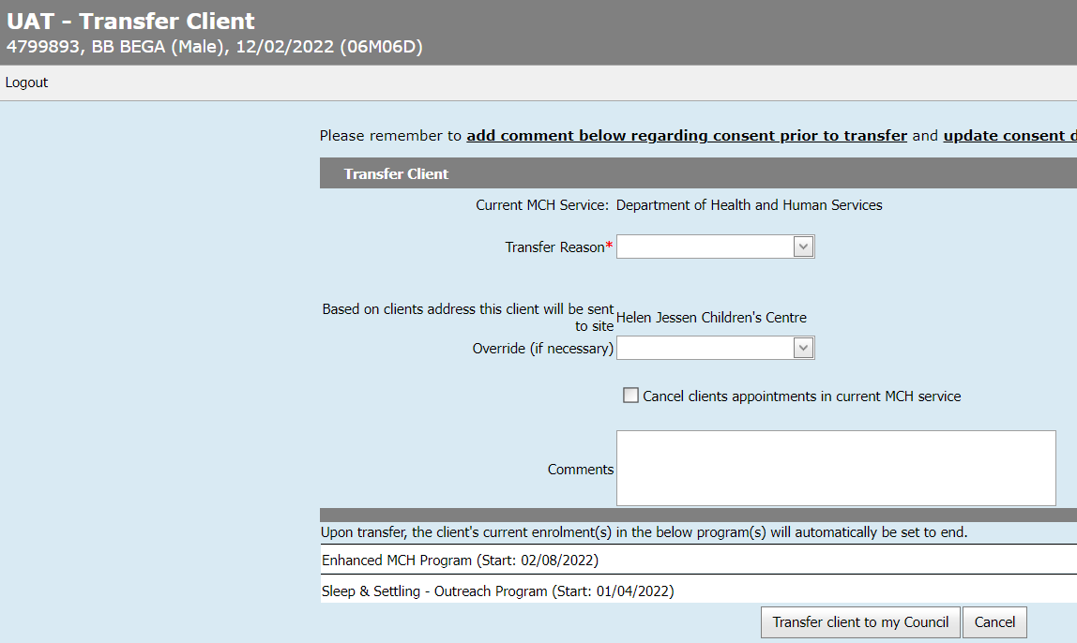
Image 5 – Client Transfer screen overall view

- Select the appropriate Transfer reason.
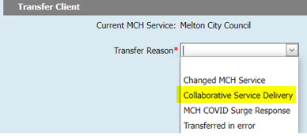
Image 6 – Selecting Transfer Reason as Collaborative Service Delivery

- If known at this time, select the appropriate site using the Override (if necessary) drop down. This will help with reporting. This can also be ignored and completed later within a client record, using Open / Change / Close.
- Do NOT click the checkbox to Cancel client appointments in current MCH service.
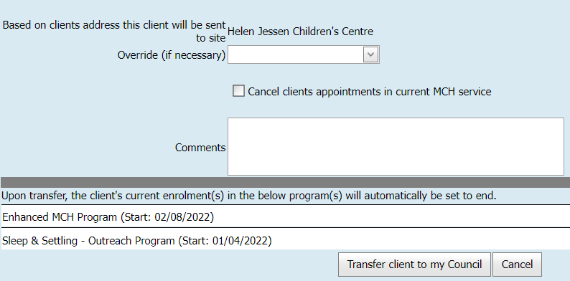
Image 7 – Client Transfer screen; client appointments section

- Review any programs listed. Add appropriate notes to area for Comments, such as arrangements made between providers, and include the detail of the programs listed below the comments. You can copy, paste and edit this easily.
Image 8 – Client Transfer screen; Programs review

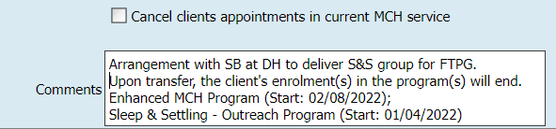
Image 9 – Client Transfer screen; Adding Programs to Comments section

- NB: For all programs listed, enrolment will be ended - not just Integrated Programs. Care must be taken with notes made in the Comments field and robust communication back to Primary Provider, so that Programs can be re-opened when the clients return to the Primary Provider.
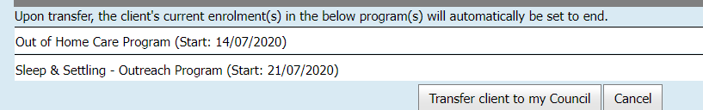
Image 10 – Client Transfer screen; Transfer client to my council

- Following the transfer, add clients directly to the relevant group(s): this can be achieved directly, or via group waitlist as per CDIS guidelines
- When group administration is completed:
- Update the status of the client referral to completed:
  - From within the Client record, select Menu Clinical Activity > Referrals
  - Find the pending referral and update the status appropriately.
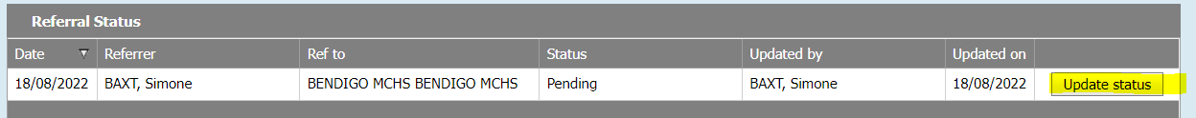
Image 11 – Referral screen and updating status of referral

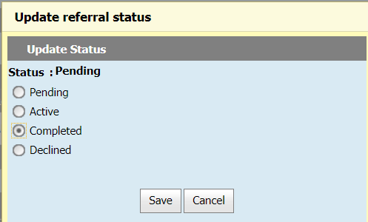
Image 12 – Updating status of referral
- Correspond with the Primary Provider so that they can transfer in the CDIS record(s), to continue primary service delivery (KAS, programs, etc).
- The CDIS record does not / should not remain with the Collaborative Provider, for longer than it takes to add the client to the relevant group(s); Group & group outcomes can be documented at any time, even after the CDIS file has been transferred in by the Primary Provider. The facilitator can continue to: Add clients from the waitlist into a group, send group SMS to clients (and this client will receive the SMS), record attendance, individual group notes and generic session notes to group sessions as well as access historic group attendance information.
- When the CDIS record is with the Primary Provider, the Collaborative Provider delivering the group service will not be able access the Client Details, history or notes. Communicate with the Primary Provider if any client info is required.

Step Three: The Primary Provider transfers in the client(s), and re-establishes any specific program enrolments as necessary
- The client record should be transferred (pulled) into the Primary Provider following communication of group enrolment by the Collaborative Provider.
Follow the Transfer process: Refer to ‘CDIS transfer process (docx)’ for more information.
- Locate the CDIS record and transfer them into your MCH Service
Image 13 – Transfer Screen

- Select the appropriate Transfer reason: Collaborative Service Delivery
Image 14 – Selecting Transfer Reason as Collaborative Service Delivery

- Select the appropriate site using the Override (if necessary) drop down^. (If you cannot recall the site, once you have finished transferring the client you can check the client’s history, and update this from within their record by selecting menu Client Details > Open / Change / Close Client.)
- Do NOT click the checkbox to Cancel client appointments in current MCH service.
Image 15 – Client Transfer screen; client appointments section

- ^ Ensure the primary is updated as necessary. Open the client record, select menu Client Details > Open / Change / Close Client, and update their site. Repeat for all family members transferred in.
- To ensure Programs are re-established, ascertain if the client was a lead or non-lead.
For integrated Programs, determine the Program lead. Re-open the Program for the lead and subsequently re-enrol all members.
- Review client’s Summary page to view the Programs list and ascertain the Programs requiring re-activation and validate the lead client. You can also review client history / notes to confirm the Programs to be re-established.
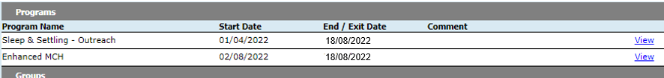
Image 16 – Client record; Program Enrolments

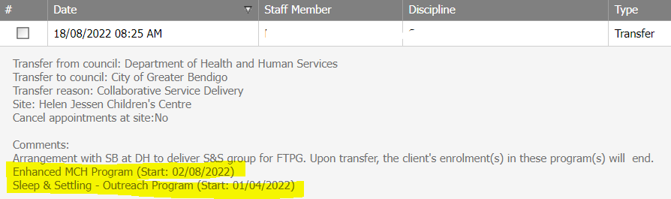
Image 17 – Client History/Notes; Program Enrolments

- To re-activate an Integrated Program, within the lead client’s record select menu Clinical Activity > Programs. Select Edit for the Program you want to re-open
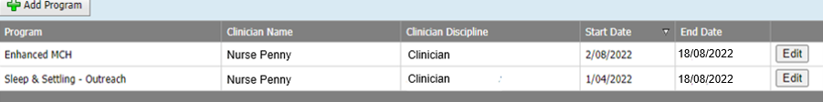
Image 18 – Client Record; Programs Screen

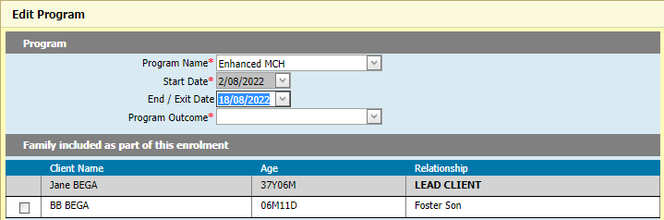
Image 19 – Programs Screen; Edit Program
- For End/Exit Date, select the drop-down box and click Clear, then tick the appropriate family members to be re-enrolled. Save the screen with no end date, and the Program will be re-opened.
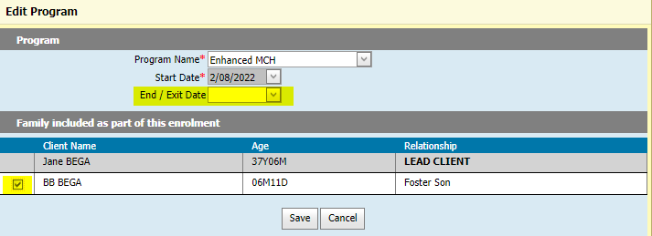
Image 20 – Programs Screen; re-enrolling/clearing End Date for Integrated Program

- Repeat for all programs, validating on the Programs page that the programs are now open (i.e., they no longer have an end date)
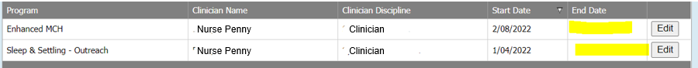
Image 21 – Client Record; Programs Screen after clearing end date

- For non-integrated programs, re-enrolment / re-opening programs follows a similar process. You can check the history for indicative notes on programs that were closed when the record was transferred into a collaborative council. You can also check the Summary Page.
- From within the client’s record select menu Clinical Activity > Programs. Select Edit,
Image 22 – Client Record; Programs Screen

- Select the drop-down list for End/Exit Date opening the calendar, and select Clear,
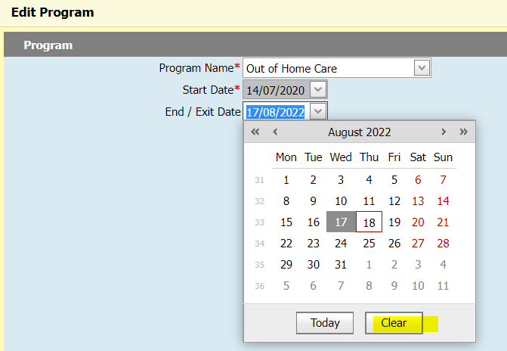
Image 23 – Programs Screen; re-enrolling/clearing End Date for Non-integrated program

- Click Save the field with no end date, the Program will be re-opened.
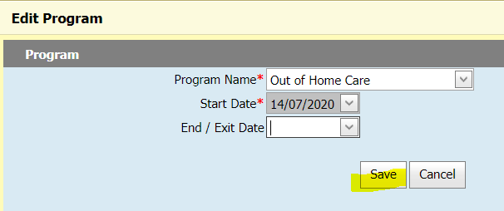
Image 24 – Programs Screen; saving changes after clearing end date

Image 25 – Client Record; Programs Screen after clearing end date

Note: The removal of the end date will return the client to the Program Active List, and if they are open for service, their record will be highlighted green for 7 days following the transfer.
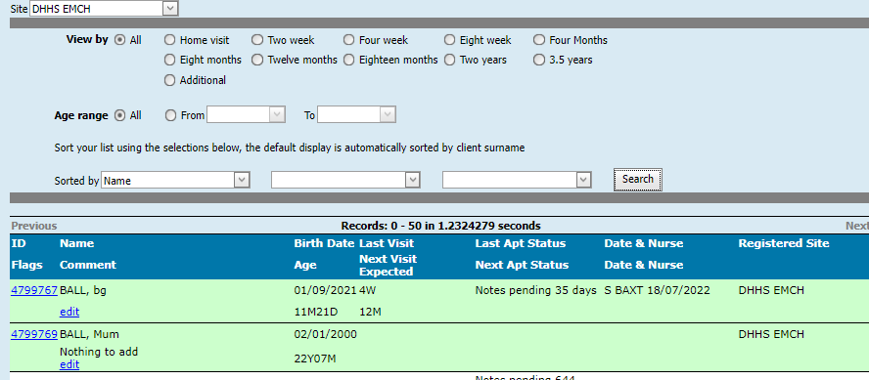
Image 26 – Programs Active List and transferred records being Green for 7 days

Any documents (docx) referred to in this Practice Note are available by accessing CDIS Menu Help & Support > Child Development Information System, then searching for the document name on the web page.
There are short video tutorials (i.e., vimeos) available on the same page/site, as well as on the MAV web site. Access MAV’s site via CDIS Menu Help & Support > Maternal and Child Health Information, then search for a topic such as group or referrals.
To receive this document in another format, phone 1300 650 172, using the National Relay Service 13 36 77 if required, or email Community Based Health Services, Policy & Improvement Branch <mch@health.vic.gov.au>.
Authorised and published by the Victorian Government, 1 Treasury Place, Melbourne.
© State of Victoria, Australia, Department of Health, April 2023.

Except where otherwise indicated, the images in this document show models and illustrative settings only, and do not necessarily depict actual services, facilities or recipients of services. This document may contain images of deceased Aboriginal and Torres Strait Islander peoples.
In this document, ‘Aboriginal’ refers to both Aboriginal and Torres Strait Islander people. ‘Indigenous’ or ‘Koori/Koorie’ is retained when part of the title of a report, program or quotation.
ISBN 978-1-76131-172-7 (pdf/online/MS word)
Available at health.vic – Child Development Information System <https://www2.health.vic.gov.au/primary-and-community-health/maternal-child-health/child-development-information-system>

