
Innovation practice guide for maternal and child health services

To receive this publication in an accessible format email Maternal and Child Health and Parenting <MCH@health.vic.gov.au>.
Authorised and published by the Victorian Government, 1 Treasury Place, Melbourne.
© State of Victoria, Australia, Department of Health and Human Services. Originally published by the Department of Education and Training. Reissued June 2019 due to machinery of government changes.
ISBN 978-1-76069-970-3
Available from the Maternal and Child Health Service Framework page on the Health.vic website <https://www.health.vic.gov.au/maternal-child-health/maternal-and-child-health-service-framework>

Contents
Introduction 5
What is innovation? 5
What is good practice in innovation? 5
Aim of the innovation practice guide 5
Who should use this guide? 6
Structure of the guide 6
Development of the guide 7
Planning 8
Problem identification 8
Design 8
Partnerships 8
Capability 9
Toolkit: program logic 10
Resources 10
Implementation 11
Governance 11
Capacity building 11
Monitoring 12
Toolkit: Community capacity-building 12
Resources 12
Evaluation 13
Purpose 13
Measurement 13
Data collection 13
Dissemination of learnings 14
Continuous improvement 14
Toolkit: Simple evaluation framework (example) 15
Resources 15
Sustainability 16
Objectives 16
Presentation 16
Communication 16
Toolkit: Thinking about scalability 18
Resources 18
Bibliography 20
Appendix 1: Text-equivalent descriptions of figures 21

Introduction

What is innovation?
Innovation in the Maternal and Child Health (MCH) Service is defined as:
‘The application of knowledge to behaviours, approaches or ways of working within the MCH context which are perceived as a new way of working for the service, an enhancement beyond current MCH practice or service provision, implemented by means of planned and coordinated action by individuals, teams or organisations’
Innovation occurs across the MCH Service at varying scales. At a local level, this may include reflective practice and individual initiatives. Innovation can involve incremental change to practice (such as substituting one engagement technique for another) or more substantial shifts (for example, the development of new service models or the integration of new technological platforms).
Innovation provides an avenue through which new ideas can be trialed, tested and tracked to identify desirable and sustainable changes to practice. It offers a mechanism to provide an adaptive and flexible approach to meeting community requirements.

What is good practice in innovation?
The literature on innovation spans diverse sectors, including health, education and information technology. Innovation can be considered from diverse perspectives; for example, a concentration on processes, types of innovations, or the degree of novelty in the design. In the context of MCH specifically, much of the literature has examined innovative practice in developing nations with a particular focus on addressing inequality and poor health outcomes. As such, this Guide draws on literature from the broader health sector which examines contexts comparable to Victoria.
What is considered ‘good practice’ differs by sector and perspective. Drawing on the research base for the health sector, this Guide focuses on effectiveness and sustainability as key elements for good practice in innovation.
Effectiveness relates to determining whether the innovation is having a positive impact on the target population, while sustainability refers to the ability to maintain the health outcomes from the innovation.
For the MCH sector, good practices in innovation are considered to be those that:
- contribute to achieving the objectives of the MCH Service
- achieve outcomes valued by stakeholders (families, other agencies, and/or community)
- open up avenues for future action, either in the same region or in others
- introduce new, versatile and transformable procedures that can be adapted for use by other parts of the MCH Service.
Sustainability is dependent on the ability to embed the innovation into the practice of staff. This can be facilitated by communicating the ‘value proposition’ to those involved, but relies on integrating sustainability considerations across the project cycle, including elements in planning, implementation and evaluation.

Aim of the innovation practice guide
The Innovation Practice Guide outlines characteristics of good practice in innovation, as associated with effectiveness and sustainability. It is intended to provide a bank of ideas and lessons learned that can be drawn on in shaping innovations.
This Guide provides a broad view of innovation in a MCH context and shares the common experiences and challenges when working within innovation in this environment. The sharing of good practice through the Guide aims to:
- inspire the MCH sector to identify potential innovations
- support the MCH sector in designing and implementing innovations
- contribute to the ongoing evidence base by developing evaluation and monitoring capabilities.
The Guide also aims to help the MCH sector to make their innovations more sustainable by providing practical guidance that can be applied when designing and managing innovations. While not all of the Guide explicitly references sustainability, it has been developed through a ‘sustainability lens’ that promotes steps to embed innovations into every day practice.
This Guide does not provide a comprehensive step-by-step process for the development and implementation of innovations, nor does it recommend a single best practice model. Rather, it draws on existing research and literature to highlight important characteristics of successful innovations, providing suggestions for how they may be integrated.

Who should use this guide?
This Guide is intended as a starting point for those working in MCH services who are interested in understanding how innovations might be designed and implemented in their context. It might also be used by community-based organisations who collaborate with MCH services in the delivery of programs and activities.

Structure of the guide
The Guide is comprised of four sections that provide guidance to help you understand what is involved in an effective and sustainable innovation and how it might be designed and planned to improve success.
The elements involved in planning, establishing and maintaining an innovation, as covered in this Guide, can be seen in the diagram below. Each section provides more detail and guidance on the steps involved.
Figure 1: Structure of the practice guide
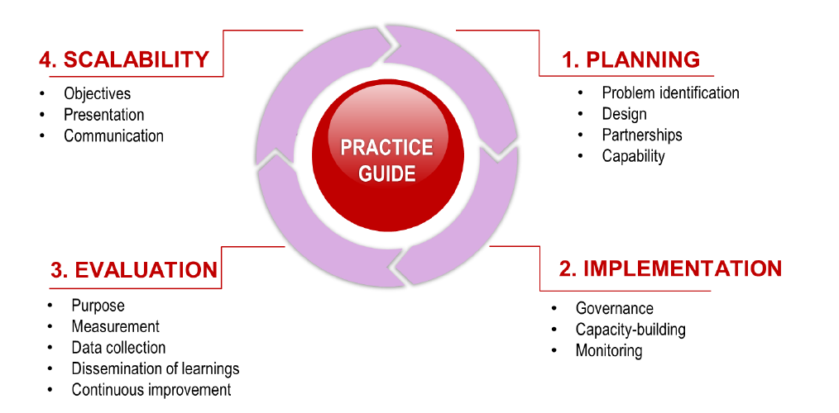

Development of the guide
The development of the Guide was supported by ACIL Allen Consulting and included a workshop with 10-12 MCH service leaders, supported by the Department and the Municipal Association of Victoria. The workshop gathered the views of service providers on the content and usability of the Guide. Through this process, it was identified that the Guide needed to:
- focus on the key learnings of the Maternal and Child Health Services Innovation Fund that would help developing evidence-informed practice, particularly in relation to planning and evaluation
- contain useful tools or resources to support the MCH sector when designing and implementing innovations.

A note on the reissued version
Due to machinery of government changes, this document was reissued in 2019 without revision to meet accessibility requirements. While the content is still relevant, some references to departments, agencies and other publications are out of date.

Planning
Planning lays the foundation for an innovation that is clear about its objectives, and tailored to the problem and target population. It is an essential step in ensuring an innovation can be implemented and evaluated effectively. Taking the time to plan your innovation makes it more likely that you will gain support from your stakeholders and be able to undertake your innovation as intended.

Problem identification
Innovations are most effective when targeted at persistent problems or issues identified through data and evidence. Often, these problems may be common, observable and well understood within the MCH Service.
When exploring your innovation:
- invest time to better understand and define the problem or issue
- involve stakeholders identifying and exploring the problem or issue
- use collaborative techniques to determine what solutions are relevant to the target population and that problem or issue.

Design
Developing simple innovations helps to test new ideas and ways of working. Sometimes those developing innovations attempt to address every issue or apply multiple techniques to target a problem. This creates challenges in later stages when trying to determine whether the innovation had positive outcomes, or which activities were effective.
Keep innovations simple and focused. Trial your innovation on a small scale, such as one site or location, in the first instance to test whether it is showing promising results. If an innovation is shown to have a positive impact on a small scale, it can then be trialled in different contexts, variables, and populations to see how transferable the innovation is.
It is important to consider evaluation and monitoring in the design phase for your evaluation. This includes determining the purpose, defining the measures, and identifying data collection requirements. Detail on these elements is provided in the ‘Evaluation’ section.
Sustainability also starts in the design phase. To improve sustainability, consider:
- What does sustainability looks like for the innovative practice? Define what will be sustained, for what purpose, and what resources would be required to support it.
- How will activities be maintained? Design activities that can continue after the project ends, either because they can be appropriately resourced or because they replace or strengthen existing activities.
- Who will take ongoing responsibility? Develop a transition plan that reflects a gradual transfer of responsibility, as appropriate, throughout the innovation.

Partnerships
Partnerships for MCH innovations bring together different stakeholders with a shared interest in service delivery. Try to:
- identify the full spectrum of relevant stakeholders, including their roles and functions in supporting the innovation
- leverage existing partnership arrangements (either formal or informal) to help you get your project up and running.
Partnerships can also help in resolving some of the complexities in operating across agencies, by allowing partners to use their own internal position and relationships to help make things happen. Where innovations are undertaken as a clear partnership between two areas or agencies, consider developing a co-ownership model with shared involvement and accountability.
Secure the buy-in of stakeholders as early as possible (particularly leadership) to build commitment to the innovation’s implementation and sustainability, including required support and resources. This will help in identifying and mobilising champions to overcome barriers that may emerge as the innovation is developed and rolled out.

Capability
After designing the innovation, it is important to determine the underpinning knowledge and skills required to successfully conduct the trial. This includes matching capability requirements directly to the activities of the innovation. For example, a technical change to MCH service delivery will require nursing capabilities, whereas the development of resources or partnership arrangements will benefit from generic project management skills.
Consider the following questions:
- Does the capability exist in-house or does the expertise need to be brought in?
- Can the activities be absorbed within existing resources or is additional support required?
- Will this impact on the ability to embed the innovation into practice, if the resources are non-ongoing?
- What are the procurement processes and timeframes for acquisition of resources?
Generally, acquiring appropriate resources (either human or physical) takes time – planning needs to account for a mobilisation period. There should also be a plan to strengthen capability throughout the project, with a focus on those individuals that will maintain the innovation beyond the project.

Toolkit: program logic
The use of a program logic can provide a visual representation of the innovation’s activities, outputs and the outcomes it seeks. In addition to supporting good planning, implementation and evaluation, logic models also help communication about projects. This can help build stakeholder buy-in, and support staff in understanding what the innovation is and what it seeks to address.
An example program logic is provided below. When developing your program logic, it is important to think about the relationships between each element – for example, how inputs support activities, and activities produce outputs. These relationships may be identified through logical linkages, or through evidence and research.
Figure 2: Program logic example
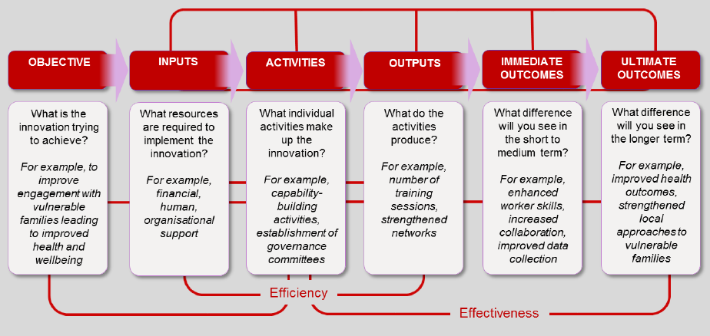
Source: adapted from WK Kellogg Foundation, 2004.

Resources
Innovation 101 <https://innovation.govspace.gov.au/innovation-101> provides responses to frequently asked questions, such as ‘Are there different kinds of innovation?’ and ‘How does innovation fit with service improvement?’.
International Association for Public Participation <https://www.iap2.org.au/Resources/Search-Resources> represents stakeholders, their interests and engagement strategies. This is a useful tool for identifying potential partnerships and parameters of relationships.
Strategic Grants <https://www.strategicgrants.com.au/images/Grant_resources/Application-Writing-Examples.pdf> provides guidance on writing grant applications, supported by examples of good and bad practice.
Victorian Children and Families Research Strategy <http://www.strongfamiliessafechildren.vic.gov.au/15641/documents/57604> defines the research priority areas, which is useful when aligning innovations to broader strategic objectives.

Implementation
Effective implementation can make the difference between simply completing an innovation and maintaining the innovation’s impact. This will include working with partners, building capacity of stakeholders and monitoring activities.

Governance
A governance function can provide strategic direction and oversight for innovations. It also creates a platform for the ongoing engagement of stakeholders, encouraging continued participation in the project.
The first step in considering governance is the assessment of existing governance structures to identify whether there is an opportunity to leverage established arrangements, rather than establishing a stand-alone group. In the MCH sector, local areas often have existing bodies for children’s health and wellbeing with key stakeholder representatives. Wherever possible, these structures should be used to fulfil the governance function. Consider:
- What existing bodies are there in my local area?
- Do they share key stakeholders with my innovation?
- Is there an opportunity to leverage their established arrangements for governance?
If there are no existing governance structures that can be used, consider establishing an Advisory Group or Steering Committee. Where possible:
- involve key stakeholders, generally with representation at a level that can make decisions and authorise activities
- set collective priorities and objectives, ensuring the alignment between the innovation and broader environment
- develop clear Terms of Reference that capture the implementation of the project with a view to sustainable operations.
These steps will help share accountability for implementation and results, and strengthen linkages between different types of stakeholders (for example, service providers and government agencies). If established well, the life of governance structures can often extend beyond the term of a project, supporting ongoing collaboration, maintenance of momentum and transition to sustainable practice.

Capacity building
Capacity building plays a central role in both achieving objectives and the ongoing sustainability of an innovation. While planning considerations focus primarily on acquiring capability to support implementation, the activities of the innovation will play a role in growing the capacity of staff, partners and the community.
Capacity building can support the gradual transfer of responsibility from the project manager to partners or practitioners, as part of the transition from an innovation to everyday practice. Capacity building activities should focus on:
- increasing the understanding of stakeholders about why the innovation is being progressed
- developing skills to conduct and maintain the key activities of the innovation (for example, staff skills to use new information technology, or information sharing processes between partners)
- building understanding of data collection and analysis, to support monitoring and continuous improvement.

Monitoring
The development of a monitoring mechanism facilitates the oversight of an innovation’s progress. This allows for the identification of risks and the development of mitigation strategies, increasing flexibility and the opportunity to respond to change when implementing the innovation.
Monitoring can assist in:
- keeping implementation on track
- identifying changing community requirements
- ensuring the ongoing relevance of the innovation.
Monitoring can be conducted through regular project reporting mechanisms (such as a fortnightly or monthly report) that provides information to show whether implementation is on track or at risk. If possible, it is beneficial to connect the governance structure with the monitoring function.

Toolkit: Community capacity building
Community capacity building is particularly relevant for innovations that will eventually be led by the community (for example, community-led parent networks, or volunteer-facilitated activities). The Australian Institute of Family Studies (2013) identifies six key principles for community capacity-building:
- Focusing on community needs: look at the collective needs
- Developing bottom-up practice: empower communities to identify their own solutions
- Applying a strengths-based approach: leverage existing skills and knowledge
- Using inclusive practice: partner with community organisations
- Investing resources: dedicate both time and financial resources to supporting activities.
- Aiming for sustainability: consider how the service will sustain their own capacity to work with families

Resources
VicHealth’s Making decisions about interventions <https://www2.health.vic.gov.au/public-health/population-health-systems/evidence-and- evaluation/guidelines-on-evidence-and-evaluation> outlines step-by-step considerations for evidence-informed policy and practice, including the use of program logic in implementation and the connection to monitoring and research.
The Resource guide for enhancing potential sustainable impact <https://www.pciglobal.org/wp-content/uploads/2014/10/PCI_Sustainability_Resource_Guide.pdf> helps in understanding how a sustainability lens can be applied to projects, with general principles applicable across all sectors and programs. Produced by Project Concern International.
Victorian Public Sector Innovation <http://www.vic.gov.au/publicsectorinnovation/innovation-themes.html> provides an overview of key themes that enable successful innovation in the public service, that are helpful to consider throughout implementation.

Evaluation
Evaluation provides the evidence for the effectiveness of particular activities or innovations, directly contributing to the knowledge base and supporting decision-making on future directions. Rather than a stand-alone phase at the conclusion of a project, evaluation should be considered in the planning stages and can be considered from a continual improvement focus.

Purpose
Evaluation can look at a number of elements, including process design, outcomes achieved and cost efficiency. The two primary categories of evaluations are formative and summative. Identifying what it is you want to know will help determine the type of evaluation – in most instances, both will be useful to understanding your innovation.
Formative evaluations are conducted during the development and implementation of innovations, and help in understanding how to improve your innovation. Key research questions for formative evaluations include:
- Is the innovation being implemented as intended?
- Are the activities appropriate for the innovation?
- What are the opportunities for improvement?
Summative evaluations are conducted once the innovation is well established and help in understanding the extent to which objectives are being achieved. Key research questions for summative evaluations include:
- Have desired outcomes been achieved?
- How well did the innovation achieve its intended objectives?
- What can be learned that will inform future directions?

Measurement
It is important to establish early on what you are going to use to measure progress and success, referred to as an indicator. There are two kinds of indicators:
- Process: Related to activities and outputs. For example, the number of people engaged through an outreach program, or feedback on the quality of a training initiative.
- Impact: Related to the difference an innovation has made. For example, change in behaviours or attitudes, or the establishment of partnerships.
Indicators should be meaningful, measurable and few in number (where possible).

Data collection
Evaluation activities should not be burdensome. The aim is to gather data easily, reliably and at regular intervals. Establish in the planning phase what evaluation activities will be done and when.
The indicators discussed above should be clearly linked to data sources – this will guide how you are going to measure. Design of the indicators should identify clearly:
- What data is available?
- What the data provides information about?
- What additional tools will be required to collect further information?
- How will the indicators be used?
Generally, evaluation will include different data sources that capture quantitative and qualitative information. Some quantitative information may come through existing MCH systems (such as CDIS), whereas qualitative information will likely need to be collected through surveys, case studies, interviews or focus groups.

Dissemination of learnings
Evaluation helps to generate new knowledge for the MCH sector. Be open to negative or neutral outcomes or impacts from your innovation – these are still valuable learnings. You may need to capture your learnings in a record or report, which should include:
- an overview of the project
- the evaluation method
- key findings
- discussion of challenges, success factors, practice insights and lessons learned.
Sharing these learnings is also important. When communicating the learnings, consider your messaging from the following angles:
- What was the visible impact? Think of observable outcomes, supported by evidence.
- What are the potential advantages of this innovation over other approaches?
- How could the innovation be adapted for other contexts without compromising objectives?
In many instances, stakeholders will also be interested in the resourcing impact, recurrent costs and potential sustainability of the innovation. Collecting data on expenditure and resourcing, as well as outcomes, will form the evidence base and support evidence-informed practice.

Continuous improvement
Evaluation also plays a role in continuous improvement, supporting informed decision-making on the continuation and direction of innovations. Continuous improvement is often implemented using the four-phased cycle of:
- Plan – identify the objectives and actions of the innovation (for example, using the program logic in the ‘Planning’ section).
- Do – implement the innovation, including resource allocation and activities.
- Check – monitor and measure the effectiveness of the innovation, using the steps discussed above, to identify opportunities for improvement or amendment.
- Act – incorporate improvements into the innovation, while planning for the next steps.
Considering your innovation from a continuous improvement perspective will allow you to amend your innovation, adapting to changing circumstances and new community requirements. It emphasises that innovations need not be static; rather, they can be adapted dynamically when armed with the right information.

Toolkit: Simple evaluation framework (example)
Research question (complete this field) | Indicator | Data source
 | Process:  Number of training sessions | Training records
 | Impact:  Improvement of participant knowledge and skills | Training participant feedback form
 | Process:  Establishment of formal agreements | Document review
 | Impact:  Improvement in perceptions of collaboration and relationship quality | Interviews with key stakeholders
 | Process:  Number of parents completing all KAS consultations | KAS records
 | Impact:  Improvement in health indicators | Focus groups with families

Resources
The Evaluation toolkit <https://www.ncemch.org/toolkits/evaluation.php> is intended to help locate resources to support the documentation and measurement of outcomes. Designed by the National Center for Education in Maternal and Child Health at Georgetown University, USA.
Evaluation Step-by-Step Guide <http://www.dhs.vic.gov.au/data/assets/pdf_file/0011/769943/Evaluation-Step-by-Step-Guide.pdf>provides a walkthrough for the key stages of evaluation. Developed by the Victorian Department of Health and Human Services.
Evaluation Report Template <https://som.flinders.edu.au/FUSA/SACHRU/PDF/EvalReportTemplate.pdf> provides a ‘how-to’ for writing an evaluation report, including structure, key considerations and the description of findings. Produced by the South Australian Community Health Research Unit.

Sustainability
If innovations are shown to effectively address the intended issue and produce positive outcomes, the next question is – how do they become more widely adopted and increase their impacts? This process, known as scaling, relies on the ability of an innovation to be expanded to reach a greater proportion of the population without compromising the effectiveness.

Objectives
The process for scaling is different to planning or implementing an innovation, and the first question to be asked is ‘Why’? Consider:
- Are looking to trial your innovation with a new target audience?
- Expand the model to different partners?
- Generate change at the policy level?
After identifying the objectives for scaling the innovation, look at what you are planning to scale – is it the full innovation, or selected activities only? Determine what is fixed, and what can be changed. This will impact on the kinds of partnerships and resources that are required to support the innovation.
Depending on the responses to the first two questions, you will also need to consider ‘where?’. Is the innovation to be applied in a different context? What impact is this likely to have on the design and implementation of the innovation?
Lastly, you will need to consider ‘how?’. There are different strategies to scaling, discussed further in the sections below. This can include disseminating ideas, building networks, forming partnerships or expanding your organisation’s capacity to implement the innovation more broadly.
The answers to these questions could be captured in a scaling plan that outlines the objectives, the activities to be scaled, the strategies to be used and the process to be followed.

Presentation
When looking at scale, the way the innovation is presented or conceptualised will impact how stakeholders respond. Are you promoting your innovation:
- As a new program or service, additional to existing arrangements?
- As a different way of working, to replace existing practices?
If your innovation is seen as ‘additional’, focus on building partnerships and acquiring resources to support capability and capacity to integrate your innovation in new areas.
If your innovation is seen as a new way of working, consider more informal strategies to spread the ideas. Examples would include leveraging opportunities to share good practice, engaging in communities of practice, producing articles for peer-reviewed or trade journals, and using local influence to engage others in the principles and ideas.

Communication
Scaling up innovation depends on generating interest in the innovation and communicating the evidence and applicability to other contexts. To have an innovation picked up from a single trial or context and rolled out in other areas requires a level of confidence that there is sufficient proof (evidence) the innovation has achieved the outcomes observed and reported.
Aligning the innovation with other strategies or objectives will assist in articulating the value proposition, allowing stakeholders to clearly see how it may complement their own activities. This can occur on different levels – ranging from local area or local Council, to state-based or Federal strategic priorities.

Toolkit: Thinking about scalability
Moore and Riddell (2015) produced a typology that can support small scale innovators when considering ‘what next?’. They identify three approaches that highlight the different avenues to be considered. An overview of their typology is provided in the diagram below.
Figure 3: Typology of scalability
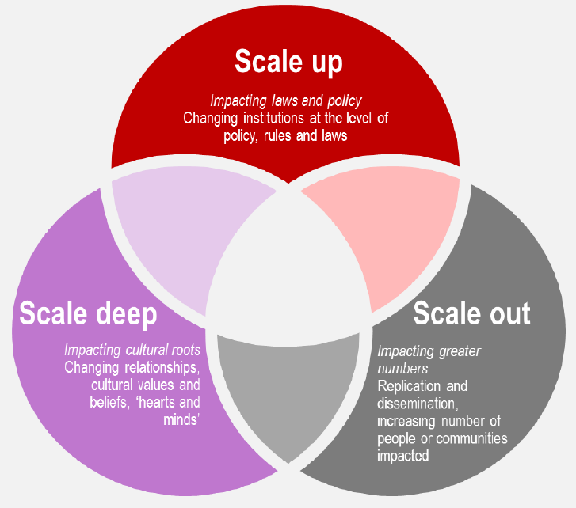
For the MCH context, innovators will benefit from thinking about ‘scaling out’ or ‘scaling deep’. There are different strategies for each:
- Scaling out: replication (spreading the innovation to different geographic areas), or principles (disseminate principles to support adoption in new contexts)
- Scaling deep: shifting norms (spreading cultural ideas using stories to change beliefs), and transformative learning (building communities of practice).

Resources
Increasing the scale of population health interventions: a guide <http://www.health.nsw.gov.au/research/Publications/scalability-guide.pdf> provides advice on the developing of scaling plans and the steps to take in scaling innovations. Developed and published by NSW Health.
‘What works – Scaling up innovations’ <http://whatworksscotland.ac.uk/wp-content/uploads/2015/06/WWS-EB-evidence-review-Scaling- Up-Innovations-June-2015.pdf> explores what gets scaled up, the timing, barriers and enablers for local innovations, including key messaging. Developed and published by What Works Scotland.
The Edge <http://www.health.nsw.gov.au/research/Publications/scalability-guide.pdf> provides a free social platform for the ‘finding, sharing, curating and creating’ innovative ideas in health and care. The platform supports the dissemination and discussion of innovations in the health sector. Developed and published by New South Wales Health

Bibliography
Australian Institute of Family Studies. 2013. Applying community capacity-building approaches to child welfare practice and policy. CFCA Paper No 13. Available at: https://aifs.gov.au/cfca/publications/applying-community- capacity-building-approaches-child-wel/understanding-community, accessed 2 June 2017.
Evaschwick, C. and Ory, M. 2003. Organizational Characteristics of Successful Innovative Health Care Programs Sustained Over Time. Family & Community Health. 26(3):177–193.
Fleizser, A; Semenic, S; Ritchie, J; Richer, M and Denis, J. 2015. The sustainability of healthcare innovations: a concept analysis. Journal of Advanced Nursing. 71(7): 1484-98.
Milat AJ; King L; Bauman AE; and Redman S. 2013. The concept of scalability: increasing the scale and potential adoption of health promotion interventions into policy and practice. Health Promotion 28(3): 285–298.
Moore, M. and Riddell, D. 2015. Scaling out, Scaling up, Scaling deep: Advancing systemic social innovation and the learning processes to support it. J.W. McConnell Family Foundation.
O’HIarlaithe, M; Grede, N; de Pee, S and Bloem, M. 2014. Economic and Social Factors are Some of the Most Common Barriers Preventing Women from Accessing Maternal and Newborn Child Health (MNCH) and Prevention of Mother-to-Child Transmission Services: A Literature Review.
Wiltsey Stirman, S; Kimberly, J; Cook, N; Calloway, E and Charns, M. 2012. The sustainability of new programs and innovations: a review of the empirical literature and recommendations for future research. Implementation Science. 14:7-17.
W. K. Kellogg Foundation. 2004. Using Logic Models to Bring Together Planning, Evaluation and Action: Logic Model Development Guide. Available at www.wkkf.org.

Appendix 1: Text-equivalent descriptions of figures

Figure 1: Structure of the practice guide
The guide is divided into four parts.
1. Planning
- Problem solving
- Design
- Partnerships
- Capability
2. Implementation
- Governance
- Capacity building
- Monitoring
3. Evaluation
- Purpose
- Measurement
- Data collection
- Dissemination of learnings
- Continuous improvement
4. Scalability
- Objectives
- Presentation
- Communication

Figure 2: Program logic example
The figure shows six boxes along a horizontal axis labelled:
- Objective
  - What is the innovation trying to achieve? For example, to improve engagement with vulnerable families leading to improved health and wellbeing
- Inputs
  - What resources are required to implement the innovation? For example, financial, human, organisational support
- Activities
  - What individual activities make up the innovation? For example, capability-building activities, establishment of governance committees
- Outputs
  - What do the activities produce? For example, number of training sessions, strengthened networks
- Immediate outcomes
  - What difference will you see in the short ot medium term? For example, enhanced worker skills, increased collaboration, improved data collection
- Ultimate outcomes
  - What difference will you see in the longer term? For example, improved health outcomes, strengthened local approaches to vulnerable families
Inputs, activities and outputs are linked by a line with the label ‘Efficiency’. Activities and ultimate outcomes are linked by a line with the label ‘Effectiveness’.

Figure 3: Typology of scalability
The figure comprises three intersecting circles.
The first is labelled ‘Scale up’ and contains the text: Impacting laws and policy: changing institutions at the level of policy, rules and laws.
The second is labelled ’Scale out’ and contains the text: Impacting greater numbers: replication and dissemination, increasing number of people or communities impacted.
The third is labelled ‘Scale deep’ and contains the text: Impacting cultural roots: changing relationships, cultural values and beliefs, ‘hearts and minds’.

