

Bans on smoking and vaping at childcare centres, kindergartens, preschools, and schools
Factsheet for occupiers

By law, smoking and the use of e-cigarettes (vaping) is banned within the grounds of, and within four metres of an entrance to, all childcare centres, kindergartens, preschools, and schools.

Where does the ban apply?
Smoking and vaping is banned within the grounds of all Victorian childcare centres, kindergartens, preschools, and primary and secondary schools in Victoria. This includes all Government, independent and Catholic schools.
Smoking and vaping is also banned within four metres of any part of a pedestrian access point (entrance) to the premises.
Childcare centres, kindergartens and preschools are defined broadly to refer to all children’s service premises within the meaning of the Children’s Services Act 1996, and all education and care service premises within the meaning of the Education and Care Services National Law (Victoria), with the exception of family day care service premises.
The diagram below shows an example of where the smoking and vaping ban applies at a childcare centre.
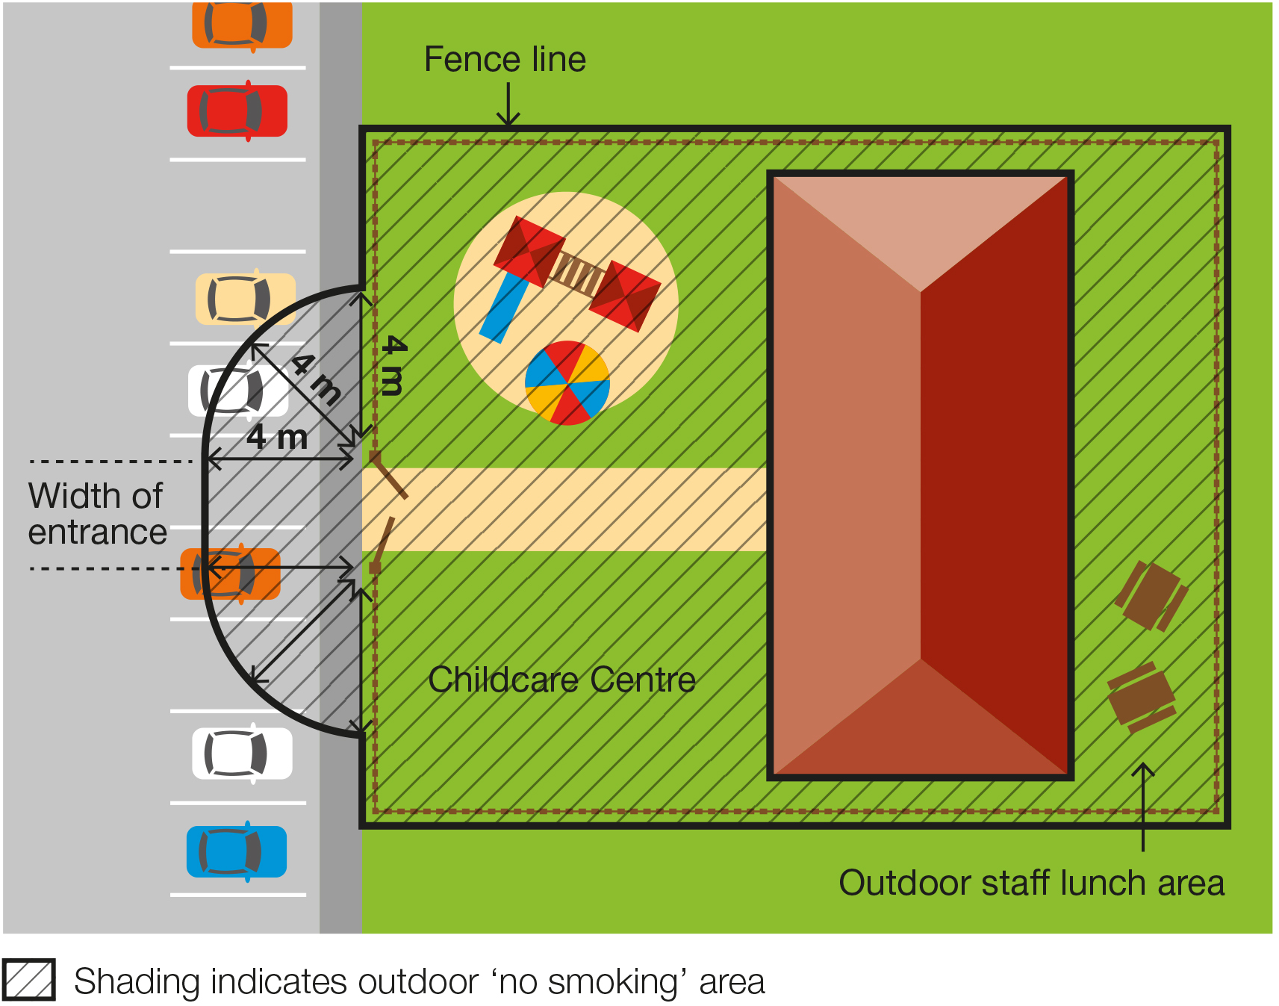

The diagram below shows an example of where the smoking and vaping ban applies at a school.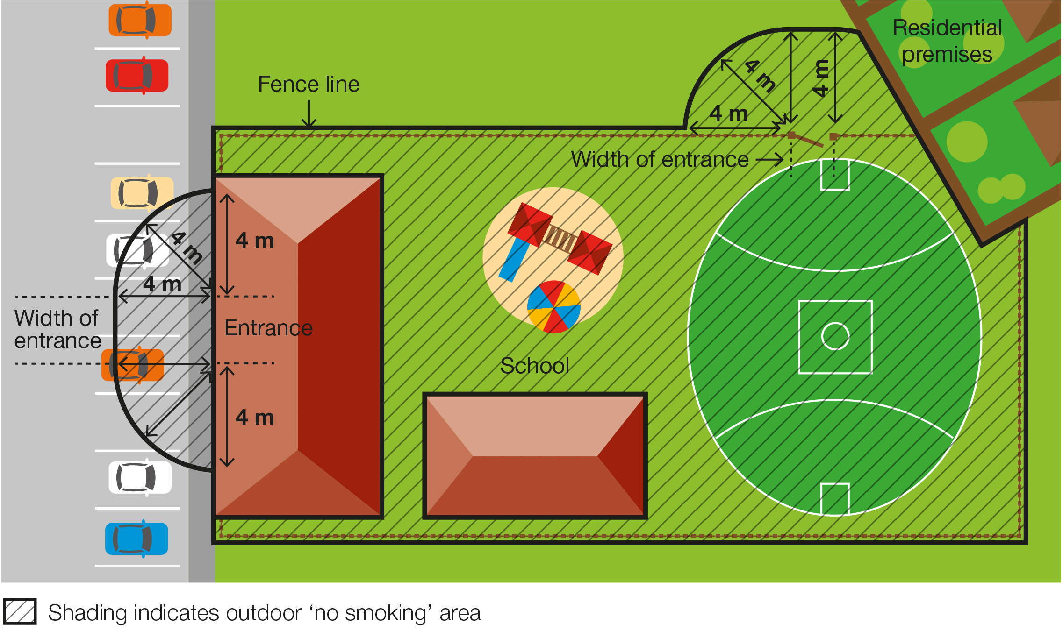

When does the ban apply?

Childcare centres, kindergartens, and preschools
The smoking and vaping ban applies to childcare, kindergartens and preschools only while they are being used to provide a children’s service or an education and care service.

Schools
The smoking and vaping ban applies at primary and secondary schools, at all times, no matter whether the building or school grounds are being used for education purposes or other purposes. The ban therefore applies when other activities are taking place on the school grounds, such as fetes or sporting events, as well as during school hours.

Why does the ban exist?

To protect children and young people from the dangers of second-hand smoke and the aerosol from e-cigarettes
This ban ensures that children and young people can enter and leave these areas without being exposed to harmful second-hand smoke and the aerosol from e-cigarettes.
Second-hand tobacco smoke is particularly dangerous to children and young people because they have smaller airways and less developed immune systems compared to adults.

To reduce the role modelling of smoking and vaping behaviours around children and young people
Children and young people are more likely to view smoking and vaping as socially acceptable when they regularly see people smoking and vaping.
Banning smoking and vaping in areas used by children and young people will help to de-normalise smoking and vaping behaviour and discourage children and young people from taking up smoking and vaping.

What is a pedestrian access point?
A pedestrian access point in relation to premises means a door or gate by which a person can enter or exit the premises.
It does not include an emergency exit that is locked to entry.
It does include shared doors or gates. For example, where a building is occupied by a childcare centre as well as other organisations, such as private businesses, any shared entrances that are used to access both areas of the building would be subject to the smoking and vaping ban.
Any entrances which lead only to premises not included in the smoking and vaping ban, such as the private offices, would not be subject to the smoking ban.

Where does the ban not apply?
The ban does not apply:
- to private homes that provide family day care services
- to an emergency exit that is locked to entry
- to a person walking through the smoke-free area
- to a person in a motor vehicle that is being driven through the smoke-free area
- to a person in an area that is separated from the smoke-free area by a road
- to a person in an outdoor drinking area located within the smoke-free area
- to a person at a residential premises (at privately owned homes and land).

What if we are already smoke-free and vape-free?
Existing regulations require childcare centres, kindergartens, preschools, and schools to ensure children are provided with an environment free from tobacco smoke and the aerosol from e-cigarettes.
Occupiers face penalties if they fail to protect children from second-hand smoke and the aerosol from e-cigarettes.
Smoking and vaping bans under the Tobacco Act 1987 will complement the existing regulations by introducing penalties applicable to individual smokers and e-cigarettes users and extend the smoking and vaping ban to the area around the entrances of the premises.

How will people know about the ban?
You are required to display ‘No Smoking’ signs in the smoke-free and vape-free area (see below). Use of the ‘No Smoking or Vaping’ signage is voluntary.

Am I or my staff be expected to enforce the ban?
No. Principals, staff, managers, and other occupiers are not expected to enforce the ban and are not empowered to do so.
Compliance with the ban is expected to occur through public education and changed community expectations.
Consultation undertaken by the Department of Health shows strong community support for banning smoking at public places, particularly where children are present.
These factors are likely to result in high levels of voluntary compliance with the smoking and vaping ban.

How will the ban be enforced?
There is strong community support for banning smoking and vaping at public places regularly attended by children. This means most people will voluntarily comply with the smoking and vaping ban and expect others to do so.
Inspectors authorised under the Tobacco Act 1987 may provide information about and, when necessary, enforce the ban. The first priority of the inspector is to make sure smokers and vapers understand the ban.
Inspectors may not be available to respond to every complaint but, where circumstances allow, may attend in response.
Inspectors have been given the power to enter childcare, kindergarten, preschool, and school premises to monitor and enforce the ban. However, this is subject to permission from the occupier (e.g. school principal) and, if permission is provided, the inspector must be accompanied by the occupier or a person acting on their behalf. It is anticipated that the focus for inspectors will be on those smoking within four metres of school entrances, and that the power to enter school premises will be used sparingly.
You and your staff can assist to raise awareness of the ban by providing staff and visitors access to promotional resources.

What penalties might apply?
The maximum penalty for someone breaking this law is five penalty units, with an infringement penalty of one penalty unit.

What resources are available to promote the ban?

Signage
Childcare centres, kindergartens, preschools, and schools are required by law to install acceptable ‘No smoking’ signs at entrances (pedestrian access points) to their premises. Signs are available to order free-of-charge from the tobacco reforms website <www.health.vic.gov.au/public-health/tobacco-reforms>
Electronic versions of the signs can also be downloaded and printed from the website above.
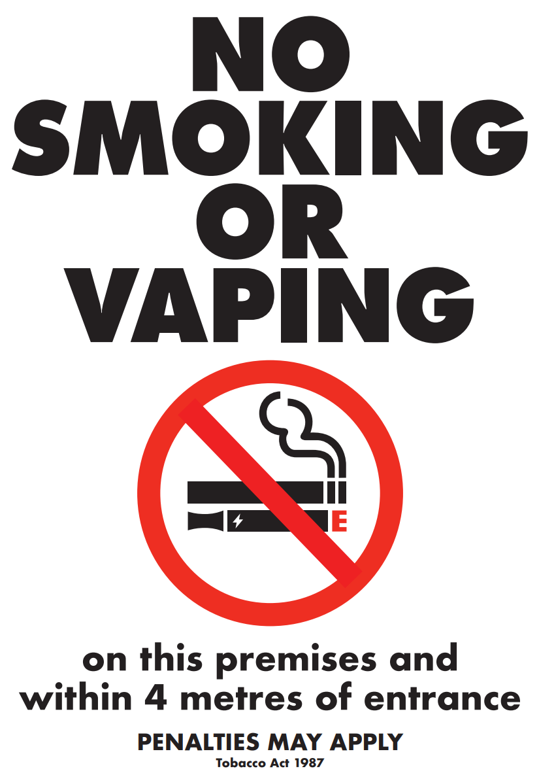
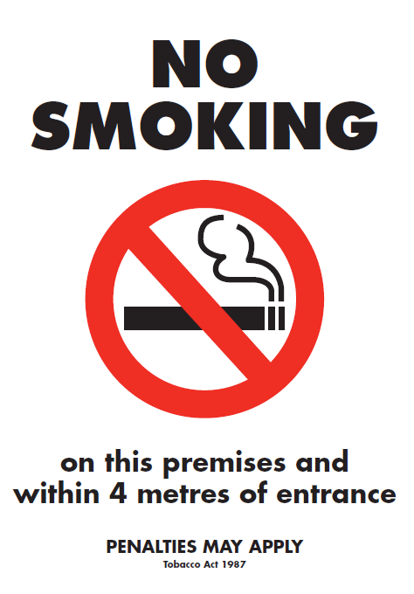

Posters, brochures and palm cards
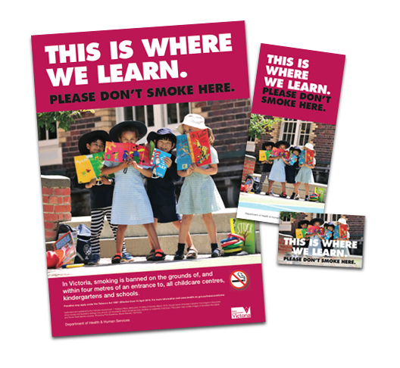
Occupiers can request posters, brochures and palm cards to help educate and inform staff, visitors and the general public of the ban. These are available to order free-of-charge from the tobacco reforms website <www.health.vic.gov.au/public-health/tobacco-reforms>

Definitions of ‘occupier’
Under the Tobacco Act 1987, an occupier in relation to an area or premises, means:
- a person who appears to be of or over the age of 16 years and who is or appears to be in control of the area or premises, whether or not the person is present in the area or on the premises; or
- a body corporate that is or appears to be in control of the area or premises.

How can I find out more?
For more information:
- visit the tobacco reforms website <www.health.vic.gov.au/public-health/tobacco-reforms>
- call the Tobacco Information Line on 1300 136 775
To view the legislation visit the Victorian Government’s legislation website <www.legislation.vic.gov.au> and search Tobacco Act 1987.

DISCLAIMER: Please note that any advice contained in this factsheet is for general guidance only. The Department of Health does not accept any liability for any loss or damage suffered as a result of reliance on the advice contained in this factsheet. Nothing in this factsheet should replace seeking appropriate legal advice.

To receive this document in another format, phone 1300 136 775, using the National Relay Service 13 36 77 if required, or email tobacco.policy@health.vic.gov.au
Authorised and published by the Victorian Government, 1 Treasury Place, Melbourne.
© State of Victoria, Australia, Department of Health, November 2023.
Except where otherwise indicated, the images in this document show models and illustrative settings only, and do not necessarily depict actual services, facilities or recipients of services.
ISBN 978-1-76131-087-4 (pdf/online/MS word)
Available at tobacco reforms website <www.health.vic.gov.au/public-health/tobacco-reforms>

Section 5RD of the Tobacco Act 1987.
For current penalty unit values, visit the Department of Treasury and Finance website <www.dtf.vic.gov.au/financial-management-government/indexation-fees-and-penalties>

