

Ban on smoking and vaping at children’s indoor play centres
Factsheet for occupiers

By law, smoking and the use of e-cigarettes (vaping) is banned within four metres of an entrance to children’s indoor play centres.

Where does the ban apply?
Smoking and vaping is banned within four metres of entrances (pedestrian access points) to children’s indoor play centres.
Children’s indoor play centres are businesses that make the majority of their income by providing indoor play equipment for use by children under 12 years and their parents and carers.
For example, an indoor children’s play centre may charge parents an entrance fee to allow their children to access the play equipment for a set period of time, or to host a child’s birthday party.
The below diagram shows an example of where the smoking and vaping ban applies. 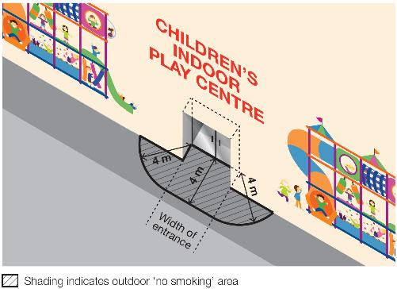

Why does the ban exist?

To protect children and young people from the dangers of second-hand smoke and the aerosol from e-cigarettes
This ban ensures that children and young people can enter and leave children’s indoor play centres without being exposed to harmful second-hand smoke and the aerosol from e-cigarettes.
Second-hand tobacco smoke is particularly dangerous for children and young people because they have smaller airways and less developed immune systems compared to adults.

To reduce the role modelling of smoking and vaping behaviours around children and young people
Children and young people are more likely to view smoking and vaping as socially acceptable when they regularly see people smoking and vaping.
Banning smoking and vaping in areas used by children and young people will help to de-normalise smoking and vaping behaviour and discourage children and young people from taking up smoking and vaping.

What is a pedestrian access point?
A pedestrian access point means a door or gate by which a person can enter or exit the premises.
It does not include an emergency exit that is locked to entry.
It does include shared doors or gates. For example, where a building is occupied by a children’s indoor play centre as well as other organisations, such as private businesses, any shared entrances that are used to access both areas of the building would be subject to the smoking and vaping ban.
Any entrances which lead only to premises not included in the smoking and vaping ban, such as the private offices, would not be subject to the smoking and vaping ban.

Where does the ban not apply?
The ban does not apply to businesses that provide indoor children’s play equipment incidental to their core business. It also does not apply to indoor centres providing sporting and recreational activities to teenagers and adults.
For example, the ban would not apply to a furniture store that provides indoor play equipment to entertain the children of customers, or to an indoor trampolining centre that provides entertainment for children, teenagers, and adults.
The ban also does not apply:
- to an emergency exit that is locked to entry
- to a person walking through the smoke-free and vape-free area
- to a person in a motor vehicle that is driving or being driven through the smoke-free and vape-free area
- to a person in an area that is separated from the smoke-free and vape-free area by a road
- to a person in an outdoor drinking area located within the smoke-free and vape-free area
- to a person at a residential premises (at privately owned homes and land).

How will people know about the ban?
You are required to display ‘No Smoking’ signs in the smoke-free and vape-free area (see below). Use of the ‘No Smoking or Vaping’ signage is voluntary.

Am I or my staff expected to enforce the ban?
No.
Indoor children’s play centre staff, managers and other occupiers are not expected to enforce the ban and are not empowered to do so.
Compliance with the ban is expected to occur through public education and changed community expectations.
Consultation undertaken by the Department of Health shows strong community support for banning smoking at public places, particularly where children are present.
These factors are likely to result in high levels of voluntary compliance with the smoking and vaping ban.

How will the ban be enforced?
There is strong community support for banning smoking and vaping at public places regularly attended by children. This means most people will voluntarily comply with the smoking and vaping ban and expect others to do so.
Inspectors authorised under the Tobacco Act 1987 may provide information about and, when necessary, enforce the ban. The first priority of the inspector is to make sure smokers and vapers understand the ban.
Inspectors may not be available to respond to every complaint but, where circumstances allow, may attend in response.
You and your staff can assist to raise awareness of the ban by providing staff and visitors access to promotional resources.

What penalties might apply?
The maximum penalty for someone breaking this law is five penalty units, with an infringement penalty of one penalty unit.

What resources are available to promote the ban?

Signage
Indoor children’s play centres are required by law to install acceptable ‘No smoking’ signs at entrances to their premises. Signs are available to order free-of-charge from tobacco reforms website <www.health.vic.gov.au/public-health/tobacco-reforms>
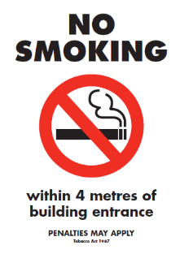
Electronic versions of the signs can also be downloaded and printed from the website above.
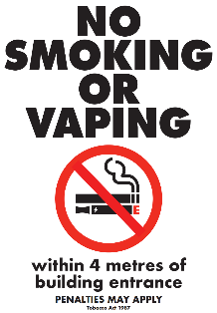

Posters, brochures and palm cards
Occupiers can request posters, brochures and palm cards to help educate and inform staff, visitors and the general public of the new ban. These are available to order free-of-charge from the tobacco reforms website <www.health.vic.gov.au/public-health/tobacco-reforms>
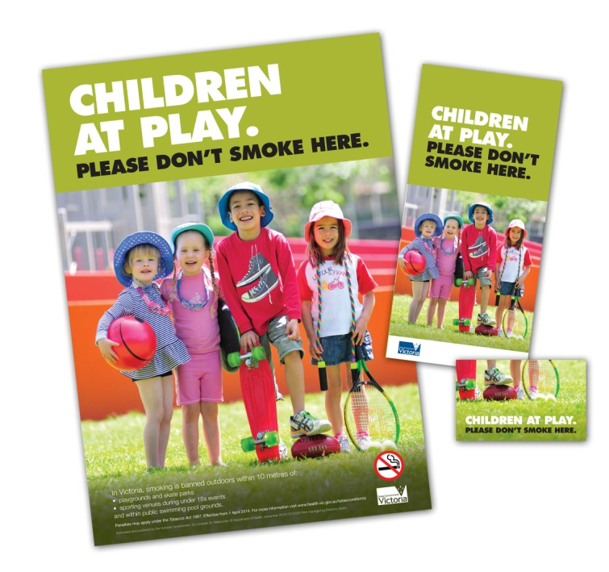

Definitions of ‘occupier’
Under the Tobacco Act 1987, an occupier in relation to an area or premises, means:
- a person who appears to be of or over the age of 16 years and who is or appears to be in control of the area or premises, whether or not the person is present in the area or on the premises; or
- a body corporate that is or appears to be in control of the area or premises.

How can I find out more?
For more information:
- visit the tobacco reforms website <www.health.vic.gov.au/public-health/tobacco-reforms>
- call the Tobacco Information Line on 1300 136 775

To view the legislation visit the Victorian Government’s legislation website <www.legislation.vic.gov.au> and search Tobacco Act 1987.

DISCLAIMER: Please note that any advice contained in this factsheet is for general guidance only. The Department of Health does not accept any liability for any loss or damage suffered as a result of reliance on the advice contained in this factsheet. Nothing in this factsheet should replace seeking appropriate legal advice.

To receive this document in another format, phone 1300 136 775, using the National Relay Service 13 36 77 if required, or email tobacco.policy@health.vic.gov.au
Authorised and published by the Victorian Government, 1 Treasury Place, Melbourne.
© State of Victoria, Australia, Department of Health, November 2023.
Except where otherwise indicated, the images in this document show models and illustrative settings only, and do not necessarily depict actual services, facilities or recipients of services.
ISBN 978-1-76131-089-8 (pdf/online/MS word)
Available at tobacco reforms website <www. health.vic.gov.au/public-health/tobacco-reforms>

Section 5RF(1) of the Tobacco Act 1987.
For current penalty unit values, visit the Department of Treasury and Finance website <www.dtf.vic.gov.au/financial-management-government/indexation-fees-and-penalties>

