
Victorian cancer plan monitoring and evaluation framework: 2023 progress report
A report of progress against selected measures in the Victorian cancer plan monitoring and evaluation framework

Victorian cancer plan monitoring and evaluation framework: progress report
A report of progress against selected measures in the Victorian cancer plan monitoring and evaluation framework

Disclaimer
The information contained in this report has been provided in good faith and reasonable steps have been taken to ensure it is reliable and accurate at the time of publication. However, the Department of Health has obtained the data from various data custodians and does not represent or warrant that the content of this report is accurate, authentic, or complete or that the information contained in this report is suitable for your needs. The information is provided on the basis that the reader will be solely responsible for assessing the information and its veracity and usefulness. To the extent permitted by law, the State of Victoria excludes liability for any loss caused by use or reliance on this report, even if such information is wrong, incomplete, out of date or misleading.
To receive this publication in an accessible format phone 1300 650 172 using the National Relay Service 13 36 77 if required, or email Cancer Planning <cancerplanning@health.vic.gov.au>.
Authorised and published by the Victorian Government, 1 Treasury Place, Melbourne.
© State of Victoria, Department of Health, November 2023
 North symbol from clipart library <http://clipart-library.com/north.html>.
ISBN 978-1-76131-123-9 (pdf/online/MS word)
Available online from Cancer care <https://www.health.vic.gov.au/health-strategies/victorian-cancer-plan>
(1904241 figures)

Acknowledgement of Aboriginal Victorians
We recognise the diversity of Aboriginal people living throughout Victoria.
The Victorian Government proudly acknowledges Victoria’s Aboriginal communities/peoples and the richness and depth of the world’s oldest living culture and pays respect to Elders past and present. We acknowledge Aboriginal people as Australia’s first peoples and as the Traditional Owners and custodians of the land and water on which we live, work and play. We recognise and value the ongoing contribution of Aboriginal people and communities/peoples to Victorian life and how this enriches our society more broadly. We embrace self-determination and reconciliation, working towards equality of outcomes and ensuring an equitable voice.
For many Aboriginal and Torres Strait Islander people, cancer is associated with death and holds negative connotations due to stigma and fear surrounding the disease. As such, it is important to offer culturally safe and responsive health care to ensure a more positive experience and better health outcomes.
The Victorian Government recognises that cancer care for Aboriginal and Torres Strait Islander people should be multidisciplinary, flexible and strengths based. Central to this approach is the need to understand and respect Aboriginal and Torres Strait Islander philosophies of health and wellbeing as holistic concepts and ensure cultural knowledge, values and beliefs are at the core of care delivery. We acknowledge this cannot be undertaken safely and effectively without an understanding of the social, political, cultural and historical determinants of health, allowing for culture, Community and kinship to be embedded in care.
Throughout this report the Victorian Department of Health presents cancer statistics for Aboriginal people living in Victoria. Together we are working with the Victorian Aboriginal Community Controlled Health Organisation Inc. (VACCHO) within a framework of self-determination, where the Aboriginal Community leads the development and implementation of services and programs that are culturally safe in order to improve the cancer outcomes for Aboriginal people living in Victoria.
The Victorian Government notes that, in partnership with the First Peoples’ Assembly of Victoria, Victoria is currently establishing a framework to begin treaty negotiations with Traditional Owners and Aboriginal Victorians. The government will work to ensure relevant actions outlined in this strategy align with treaty negotiations and delivering future treaties in Victoria. This includes corresponding funding, implementation of actions and governance mechanisms. We are deeply committed to Aboriginal self-determination and to supporting Victoria’s treaty process. We acknowledge that treaty will have wide-ranging impacts for the way we work with Traditional Owners and Aboriginal Victorians. We seek to create respectful and collaborative partnerships. We will develop policies and programs that respect Aboriginal self-determination and align with treaty aspirations.
We acknowledge that Victoria’s treaty process will establish a framework for transferring decision-making power and resources to support self-determining Aboriginal communities/peoples to take control of matters that affect their lives. We commit to working proactively to support this work in line with the aspirations of Traditional Owners and Aboriginal Victorians.
As we work together to ensure Victorian Aboriginal communities/peoples continue to thrive, the government acknowledges the invaluable contributions of generations of Aboriginal warriors and matriarchs that have come before us, who have fought tirelessly for the rights of their people and Communities towards Aboriginal self-determination. We are now honoured to be part of that vision.
Contents
Acknowledgement of Aboriginal Victorians 5
Executive summary 8
Introduction 9
The Victorian monitoring and evaluation framework: measuring our success 9
Purpose of the progress report 10
How to read this report 11
Structure of the report 11
About the measures 12
Dashboard: September 2023 14
Progress report: summary of results 15
Victorian cancer plan monitoring and evaluation framework: measures 16
More about the results of the measures 30
Understanding the data 30
Outcome: Improve cancer outcomes 32
Key result: Decrease incidence of preventable cancers 32
Outcome: Equitable outcomes for all Victorians 71
Key result: Equitably reduce cancer incidence 71
Key result: Equitably reduce cancer deaths 77
Key result: Decrease smoking and harmful alcohol consumption 83
Key result: Decrease HPV and viral hepatitis impact 120
Outcome: Detect cancers early 131
Key result: Increase early-stage diagnosis 131
Key result: Increase adherence to Optimal Care Pathways 143
Key result: Improving quality of life 225
Outcome: Best possible experience of care systems 226
Key result: Improve patient experience of health care 226
Key result: Improve patient experience of screening 233
Outcome: Integrated research systems 240
Key result: Innovations and improved evidence of best practice 240
Progress towards achieving cancer plan 2020–2024 goals 249
Short-term goals 249
Medium-term goals 254
Long-term goals 258
Appendix 1: Measures identified for future reporting 261
Abbreviations 265
List of figures 267
List of tables 275

Executive summary
This progress report has been prepared against a set of measures articulated in the Victorian cancer plan monitoring and evaluation framework (2018). This report synthesises key findings to inform development of the Victorian cancer plan 2024–2028 and successive plans to improve cancer outcomes. The report has assessed specific outcomes of the framework across a cancer continuum of prevention, early detection, treatment, wellbeing and support for people affected by cancer, and research.
The department acknowledges the assistance of data custodians who were approached for their data to be included in this progress report.

Introduction
Cancer imposes a considerable burden on the Victorian community. In 2021, 34,974 Victorians were diagnosed with cancer, and 11,581 died from the disease. While significant progress has been made, the number of people being diagnosed continues to increase, with the number of new yearly cancer diagnoses anticipated to be over 51,000 by 2036. As the Victorian population ages the incidence of cancer will continue to grow – in fact, two in five males and one out of three females will develop cancer by the age of 75.
The five-year survival rate for Victorians diagnosed with cancer has increased by 22% over the past two decades. However, these outcomes are not the same for all. Poorer outcomes have persisted for some cancer types and for people living in some regional areas. Aboriginal Victorians have significantly higher cancer mortality rates than non-Aboriginal Victorians. Reducing the burden of cancer requires a comprehensive approach with a focus on reducing these disparities.
Through the Improving Cancer Outcomes Act 2014, the Victorian Government is committed to preparing a cancer plan for Victoria every four years that outlines the status and burden of cancer in Victoria. The Victorian cancer plan 2016–2020, released in July 2016, was the first cancer plan developed under the Act. A second plan, the Victorian cancer plan 2020–2024, was released in September 2020. This progress report continues the momentum towards supporting short-, medium- and long-term targets (goals) articulated in the first and second Victorian cancer plans and monitoring the impacts of efforts to improve cancer outcomes.
Restrictions on movement including stay-at-home orders during 2020 and 2021 were enacted across Australia in response to the global COVID-19 pandemic. Victoria experienced a greater number of lockdowns which endured for extended periods. During these restrictions there were changes in care delivery including the suspension of screening services and outpatient clinics, and surveillance of existing cancers was postponed. As a result, there were an estimated 3,864 (95% confidence intervals 3,019–4,708) fewer diagnoses than expected in Victoria over 2020 and 2021. This progress report is essential for capturing the impact of the pandemic on cancer outcomes.

The Victorian monitoring and evaluation framework: measuring our success
The Department of Health aspires to improve cancer outcomes for all and support all Victorians affected by this illness. To help deliver this vision, the department consulted internally and externally with individuals and organisations across the Victorian cancer sector to develop an outcomes framework. This framework, known as the Victorian cancer plan monitoring and evaluation framework, was published in June 2018 and contains 97 measures. The framework is supported by a data dictionary. It is population-outcomes based and provides a transparent and objective approach to monitoring and reporting on the collective impact of the sector to improve cancer outcomes. Each progress report will continue to report changes over time and will help identify investment and implementation priorities.
Figure 1 shows the outcomes framework cascading upwards from outcome measures, indicators and key results, which link logistically through to each priority set out in the Victorian cancer plan 2016–2020 and successive plans. Each of the cancer plan priority areas describe the components that are key to the success of the goals that have been set to 2040.
The framework enables the department to:
- articulate cancer plan priorities
- focus actions and activities on areas where enduring change is needed most
- assess the impact of cancer services on the lives of Victorians
- drive future monitoring and reporting.

Purpose of the progress report
This report is the second report that synthesises the current status of outcome measures from various Victorian data sources against the department’s outcomes framework (Figure 1). Its purpose is to inform development of the 2024–2028 cancer plan. As this is the second report, there are still some results that are not yet available for every measure. For example, staging data is not available for all cancers. Results will be reported in the future as data becomes available.
The progress report does not provide a review of measure selection and methodology, or improvement of technical documentation of measures. Data presented in this report reflects observations at set points in time. More comprehensive datasets are available for viewing at the referenced data sources.
Figure 1: Outcomes framework logic model
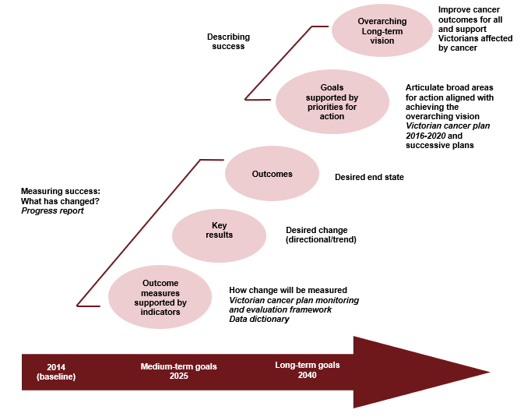

How to read this report

Structure of the report
This progress report provides information at three different levels of detail.
- The dashboard provides a ‘snapshot’ of how each key result area is tracking.
- The summary report sets out how Victoria is progressing on each measure. This includes a:
    - target – where we want to be (from the baseline year, where appropriate)
    - baseline – where we started from (benchmark)
    - trend (if known).
- More about the results of measures includes more detailed information about each measure including, where appropriate:
    - a graph or plot showing up to 12 years of data (from the baseline year, if available)
    - information about the trend
    - commentary on the result and what may be affecting it.
The Victorian cancer plan monitoring and evaluation framework – data dictionary provides more information on each measure including detailed technical specifications. These include:
- the rationale for inclusion
- the definition of the measure (including numerator, denominator and mode of reporting)
- data source(s) and availability (including the baseline year)
- what data breakdowns are available from each data source
- further information including planned changes in guidelines, programs and reporting; comparability with other state, national or international data; and links with measures articulated in the Victorian public health and wellbeing outcomes framework.
This progress report covers the 83 (out of 97) measures articulated in the department’s Victorian cancer plan monitoring and evaluation framework that are currently reportable. Where appropriate, the breakdown for reporting has been age, sex, Aboriginal Victorians, cultural diversity, socioeconomic status (SES), Integrated Cancer Service (ICS) and local government areas (LGAs).
A separate section sets out progress towards several short-, medium- and long-term goals from the 2016–2020 cancer plan.
Appendix 1 provides an indicative workplan for the remaining 14 measures that require further work to develop and report. Please note that in preparing this progress report, the Victorian cancer plan monitoring and evaluation framework – data dictionary (2018) was revised to address minor typographical errors and some emerging inconsistencies between some of the measures themselves and the definition of the measure. Where appropriate, the latter was undertaken in consultation with relevant stakeholders. The revised data dictionary 2023 <https://www.health.vic.gov.au/health-strategies/victorian-cancer-plan> is available online.
In circumstances where the dataset specific to a measure was too large, it was moved to Appendix 2 to assist with readability. Appendix 2 is presented as a separate volume and is available on the department’s website <https://www.health.vic.gov.au/health-strategies/victorian-cancer-plan>.

About the measures
The 97 measures included in the population-outcomes based Victorian cancer plan monitoring and evaluation framework cover a wide range of the cancer continuum of prevention, early detection, treatment, wellbeing and support for people affected by cancer, and research. They range from population-level measures that have many determinants to system-level measures that reflect the delivery of cancer care and the self-reported patient experiences of Victoria’s cancer-specific services. Some of the measures are also reported elsewhere – for example, in the Victorian public health and wellbeing outcomes framework (2016) – and some are currently undergoing development. This means that some measures reported for other purposes may have slightly different targets associated with them. In consultation with a wide range of individuals and organisations across the Victorian cancer sector, other measures have been newly developed for reporting against, and the data is examined here for the first time. These differences mean that measuring progress is not straightforward. Data presented in this report was the best available at the time of publication. Periods of data reporting and data collection methods vary over time, and where this makes comparison problematic, this has been highlighted in footnotes. In addition, there are some circumstances where changes in survey methodologies means there are limitations with trend analysis. The following provides a guide as to how the assessments set out in this progress report have been made.

Overall trend
Wherever possible, data from the baseline year are provided. Data presented in this report has been assessed to determine whether it showed:
- an improving trend (moving in the right direction)
- a deteriorating trend (not moving in the right direction)
- a static or unchanging trend.

Traffic light rating
Each measure has been allocated a traffic light rating (red, amber or green). These provide a snapshot of the key message about progress on each measure. The ratings consider:
- the views and expertise of subject matter experts
- how the most recent result compares with targets or with performance in other jurisdictions if comparable with other states (this is outlined in the data dictionary)
- whether the result is improving over time and, if so, how quickly
- any other relevant contextual information (for example, departmental policies).

Highlight or commentary
More detailed commentary is provided in ‘More about the results of the measures’, which gives key information to support the intent behind the traffic light rating.

About the traffic light ratings
Green (key message: satisfactory result)
A green rating generally describes situations where the result:
- is at or above a target, and either stable or improving over time
- is not quite at target level but is heading to achieve it soon and actions are in place to support this
- represents a good outcome for all Victorians, or the cancer service system, and appears to be either stable or improving over time.
Amber (key message: desired result not yet evident)
An amber rating generally describes situations where a result has both positive and negative elements, for example:
- the result is improving over time but is still some way from target.
- the result compares well with other jurisdictions but is still not at the desired level.
- the result has generally been improving over time, but a recent deterioration needs to be monitored.
- the result has deteriorated but for a known reason that is being addressed and or is considered transient.
- there is little data available to assess progress, but what there is appears reasonably positive.
- it is difficult to interpret whether the trend over time represents improved reporting or improved outcomes.
Red (key message: result is of concern)
A red rating generally describes situations where the result may:
- represent a poor outcome or a high level of risk for an undesirably high proportion of the people it relates to.
- be consistently deteriorating over time.
- be well off target and stable or somewhat deteriorating over time.

Dashboard: September 2023
This dashboard shows the number of measures in each key result by traffic light rating. Key results by traffic light rating for each goal is also presented. Please note that key results where no measures are currently reported are not shown in the dashboard – for example, number 14. ‘Not applicable’ (N/A) is used in circumstances where no data has been identified for specific measures. Some cells have been left intentionally blank.
Measures – key results | Red | Amber | Green | N/A
- Decrease incidence of preventable cancers (8) |  | 7 | 1
- Decrease deaths due to cancer (3) |  |  | 3
- Quality of life (1) |  | 1
- Equitably reduce cancer incidence (3) | 1 | 2
- Equitably reduce cancer deaths (3) | 2 | 1
- Decrease smoking and harmful alcohol consumption (4) | 1 | 1 | 2
- Increase healthier eating and active living (11) | 6 | 1 | 2 | 2
- Decrease obesity (3) | 2 |  | 1
- Decrease ultraviolet (UV) exposure (2) |  | 2
- Decrease human papillomavirus (HPV) and viral hepatitis impact (5) |  |  | 3 | 2#
- Increase early-stage diagnosis (6) |  | 1 | 2 | 3
- Increase adherence to optimal care pathways (14) | 5 | 3 | 2 | 4
- Increase one- and five-year survival (18) | 2 | 11 | 5
- Improve patient experience of health care (6) | 1 |  | 2 | 3
- Improve patient experience of screening (4) | 1 | 1 | 2
- Innovations and improved evidence of best practice (5) |  |  | 4 | 1
# refer to comments for Measures 10.4 and 10.5
Goals – key results | Red | Amber | Green
Short-term goals (5) |  |  | 5
Medium-term goals (5) | 1 | 1 | 3
Long-term (4) |  | 3 | 1

Progress report: summary of results
This section provides a summary result on each measure from the Victorian cancer plan monitoring and evaluation outcomes framework. The table below presents results for the baseline and most recent years and an assessment of the trend for each measure. Note that the seven outcomes broadly align with the five Victorian cancer plan 2016–2020 action areas (page 8 of the Victorian cancer plan monitoring and evaluation framework: report – 2018).
Key: Where results are unavailable, the measure has been categorised to indicate the scope of work required to produce a result for the next report. More information is set out in Appendix 1.
Key | Description
Measure not defined | These measures are currently under development, with final development and sign-off unlikely at the time of publication
No data available | No data was available (including revised data) to report against at the time of publication
Status to be determined | Work is underway to engage the relevant experts to determine how much work is required
Trend | Description
▲ | Upward trend – there has been an increase in the value of the measure by more than 3% between the baseline year and the most recent available data points
▼ | Downward trend – there has been a decline in the value of the measure by more than 3% between the baseline year and the most recent available data points
■ | The value of the measure has not changed, or changed less than 3%, between the baseline year and the most recent available data points
 | There is a large difference in the value but statistically there is no difference
N/A | There is not enough information (or in some circumstances there is no data) available to assess the trend over time
Target | From the baseline year
N/S | No set target for this measure
þ | Target has been met

Victorian cancer plan monitoring and evaluation framework: measures

Action: Victorians are supported to reduce risks of cancer

Outcome: Improve cancer outcomes

Key result: Decrease incidence of preventable cancers
Measure # | Description | Unit of measure | Baseline  (year) | Most recent  (year) | Target | Trend
1.1 | Incidence of preventable cancers | Rate (age-adjusted) (per 100,000) | 339  (2014) | 321  (2021) | 50% decrease from baseline to 2040 | ▼  Downward
1.2 | Lifetime risk of cancer before the age of 85 years | Cumulative risk | 1/2.2  (2014) | 1/2.2  (2021) | N/S | ■  No change
1.3 | Incidence of lung cancer | Rate (age-adjusted, per 100,000) | 43  (2014) | 40  (2021) | N/S | ▼  Downward
1.4 | Incidence of colorectal cancer | Rate (age-adjusted, per 100,000) | 56  (2014) | 47  (2021) | N/S | ▼  Downward
1.5 | Incidence of melanoma | Rate (age-adjusted, per 100,000) | 38  (2014) | 36  (2021) | N/S | ▼  Downward
1.6 | Incidence of female breast cancer | Rate (age-adjusted, per 100,000) | 127  (2014) | 127  (2021) | N/S | ■  No change
1.7 | Incidence of cancer of the cervix | Rate (age-adjusted, per 100,000) | 6.0  (2014) | 6.0  (2021) | N/S | ■  No change
1.8 | Incidence of liver cancer (primary) | Rate (age-adjusted, per 100,000) | 8.3  (2014) | 7.4  (2021) | N/S | No change

Key result: Decrease deaths due to cancer
Measure # | Description | Unit of measure | Baseline  (year) | Most recent  (year) | Target | Trend
2.1 | Death rate due to cancer | Rate (age-adjusted, per 100,000) | 173  (2010) | 138  (2021) | N/S | ▼  Downward
2.2 | Premature death rate due to cancer | Rate (age-adjusted, per 100,000) | 92  (2010) | 70  (2021) | 25% decrease (2025) | ▼  Downward
2.3 | Number of deaths averted | Number (’000) | N/A | 10,529  (2015–2021) | 10,000 lives saved  (2025) | þ  Target has been met

Key result: Increase survivorship quality of life
Measure # | Description | Unit of measure |  | Baseline  (year) |  | Most recent  (year) |  | Target |  | Trend
3.1 | Long-term quality of life |  | Per cent (61-100 scoring) |  | 79.7  (2019) |  | 80.1  (2022) |  | N/S |  | ■  No change

Outcome: Equitable outcomes for all Victorians

Key result: Equitably reduce cancer incidence
Measure # | Description | Unit of measure | Baseline  (year) | Most recent  (year) | Target | Trend
4.1 | Rate ratio of preventable cancer incidence between ICS | Rate ratio  (maximum) | 1.1  (2014) | 1.2  (2021) | N/S | ■  No change
4.2 | Rate ratio of preventable cancer incidence between socioeconomic quintiles | Rate ratio  (maximum) | 1.1  (2014) | 1.1  (2021) | N/S | ■  No change
4.3 | Rate ratio of preventable cancer incidence between Aboriginal and non-Aboriginal Victorians | Rate ratio | 1.4  (2014) | 1.4  (2021) | N/S | No change

Key result: Equitably reduce cancer deaths
Measure # | Description | Unit of measure | Baseline  (year) | Most recent  (year) | Target | Trend
5.1 | Rate ratio of premature death rate due to cancer between ICS | Rate ratio  (maximum) | 1.2  (2014) | 1.3  (2021) | N/S | ■  No change
5.2 | Rate ratio of premature death rate due to cancer between socioeconomic quintiles | Rate ratio  (extreme quintile i.e. lowest to highest) | 1.5  (2014) | 1.9  (2021) | N/S | ▲  Upward
5.3 | Rate ratio of premature death between Aboriginal and non-Aboriginal Victorians | Rate ratio | 2.1  (2014) | 1.9  (2021) | N/S | ■  No change

Outcome: Prevent cancers

Key result: Decrease smoking and harmful alcohol consumption
Measure # | Description | Unit of measure | Baseline  (year) | Most recent  (year) | Target  (year) | Trend
6.1 | Proportion of adults who smoke daily | Per cent | 13.3  (2015) | 10.1  (2022) | N/S | ▼  Downward
6.2 | Proportion of adolescents 12–17 years who currently smoke | Per cent | 5.1  (2014) | 5.0  (2017) | 4.2  (2025) | ■  No change
6.3 | Proportion of adults who consume alcohol at lifetime risk of harm | Per cent | 58.6  (2014) | 59.6  (2019) | 53.3  (2025) | ■  No change
6.4 | Proportion of adolescents 12–17 years who consume alcohol at least monthly | Per cent | 20.6  (2014) | 17.7  (2018) | 18.6  (2025) | þ  Target has been met

Key result: Increase healthier eating and active living
Measure # | Description | Unit of measure | Baseline  (year) | Most recent  (year) | Target  (year) | Trend
7.1 | Mean daily serves of fruit in adults | Arithmetic average | 1.6  (2011) | 1.5  (2019) | N/S | ■  No change
7.2 | Proportion of adolescents 10–17 years who eat the daily recommended serves of fruit | Per cent | 69.5  (2014) | 67.4  (2018) | N/S | ▼  Downward
7.3 | Proportion of children 4–12 years who eat the daily recommended serves of fruit | Per cent | 73.2  (2013) | 72.0  (2021) | N/S | ■  No change
7.4 | Mean daily serves of vegetables in adults | Arithmetic average | 2.3  (2011) | 2.1  (2019) | N/S | ■  No change
7.5 | Proportion of adolescents 10–17 years who eat the daily recommended serves of vegetables | Per cent | 12.8  (2014) | 13.1  (2018) | N/S | ▲  Upward
7.6 | Proportion of children 4–12 years who eat the daily recommended serves of vegetables | Per cent | 2.9  (2013) | 2.9  (2021) | N/S | ■  No change
7.7 | Mean number of times per week that adults eat red meat | No data available (refer to Appendix 1) | No data available (refer to Appendix 1) | No data available (refer to Appendix 1) | N/S | N/A
7.8 | Mean number of times per week that adults eat processed meat | No data available (refer to Appendix 1) | No data available (refer to Appendix 1) | No data available (refer to Appendix 1) | N/S | N/A
7.9 | Proportion of adults who are sufficiently physically active | Per cent | 47.0  (2015) | 51.1  (2019) | N/S | ▲  Upward
7.10 | Proportion of adolescents 10–17 years who are sufficiently physically active | Per cent | 26.0  (2014) | 23.4  (2018) | 31.2  (2025) | ▼  Downward
7.11 | Proportion of children 5–12 years who are sufficiently physically active | Per cent | 62.2  (2013) | 47.3  (2021) | N/S | ▼  Downward

Key result: Decrease obesity
Measure # | Description | Unit of measure | Baseline  (year) | Most recent  (year) | Target  (Year) | Trend
8.1 | Proportion of adults who are overweight or obese (measured) | Per cent | 62.0  (2011–12) | 68.3  (2017–18) | 58  (2025) | ▲  Upward
8.2 | Proportion of adults who are overweight or obese (self-report) | Per cent | 49.2  (2015) | 56.2  (2022) | N/S | ▲  Upward
8.3 | Proportion of children 5–17 years who are overweight or obese (measured) | Per cent | 23.7  (2011–12) | 21.6  (2017–18) | 21.9  (2025) | ▼  Downward

Key result: Decrease UV exposure
Measure # | Description | Unit of measure | Baseline  (year) | Most recent  (year) | Target | Trend
9.1 | Proportion of adults aged 18 years and over who report getting sunburnt during the summer | Per cent (age-adjusted) | 55.2  (2021–22) | N/A | N/S | N/A
9.2 | Proportion of Victorian adults aged 18 years and over wearing a combination of broad-brimmed hats and/or sunscreen with one other key sun protective behaviour | Per cent (age-adjusted) | 37.0  (2021–22) | N/A | N/S | N/A

Key result: Decrease HPV and viral hepatitis impact
Measure # | Description | Unit of measure | Baseline  (year) | Most recent  (year) | Target | Trend
10.1 | Proportion of adolescents 15 years of age fully vaccinated against HPV | Per cent | 75.2 [Female]  27.9 [Male]  (2013) | 79.4 [Female]  74.9 [Male]  (2022) | N/S | ▲  Upward
10.2 | Notification rate of unspecified hepatitis B | Rate (per 100,000) | 29.2  (2014) | 19.4  (2021) | N/S | ▼  Downward
10.3 | Notification rate of unspecified hepatitis C | Rate (per 100,000) | 33.6  (2014) | 18.7  (2021) | N/S | ▼  Downward
10.4 | Proportion of people with hepatitis B diagnosed with liver cancer, whose hepatitis B was diagnosed late | Per cent | 24  (2010–13) | No data available | N/S | N/A
10.5 | Proportion of people with hepatitis C diagnosed with liver cancer, whose hepatitis C was diagnosed late | Per cent | 17  (2010–13) | No data available | N/S | N/A

Outcome: Detect cancers early

Key result: Increase early-stage diagnosis
Measure # | Description | Unit of measure | Baseline  (year) | Most recent  (year) | Target | Trend
11.1 | Proportion of all cancers diagnosed at stages 1 or 2 | Per cent | No data available (refer to Appendix 1) | No data available (refer to Appendix 1) | N/S | N/A
11.2 | Proportion of female breast cancers diagnosed at stages 1 or 2 | Per cent | 84.7  (2014) | 88.1  (2021) | N/S | ▲  Upward
11.3 | Proportion of colorectal cancers diagnosed at stages 1 or 2 | Per cent | 53.0  (2014) | 54.1  (2021) | N/S | ▲  Upward
11.4 | Proportion of cervical cancers diagnosed at stages 1 or 2 | Per cent | No data available (refer to Appendix 1) | No data available (refer to Appendix 1) | N/S | N/A
11.5 | Proportion of lung cancers diagnosed at stages 1 or 2 | Per cent | No data available (refer to Appendix 1) | No data available (refer to Appendix 1) | N/S | N/A
11.6 | Proportion of all solid tumours diagnosed at metastatic stage | Per cent | 19.6  (2014) | 18.5  (2021) | N/S | ■  No change

Action: Victorians with cancer have timely access to optimal treatment

Outcome: Optimal diagnostics and treatment

Key result: Increase adherence to optimal care pathways
Measure # | Description | Unit of measure | Baseline  (year) | Most recent  (year) | Target | Trend
12.1 | Median days from diagnosis to start of primary curative treatment | Number  (overall) | 21  (2014) | 27  (2021) | N/S | ▲  Upward
12.2 | Proportion of patients receiving positron emission tomography (PET) prior to primary treatment where appropriate | Per cent | No data currently available (refer to Appendix 1) | No data currently available (refer to Appendix 1) | N/S | N/A
12.3 | Proportion of patients receiving molecular diagnostics prior to primary treatment where appropriate | Per cent | No data available (refer to Appendix 1) | No data currently available (refer to Appendix 1) | N/S | N/A
12.4 | Proportion of patients with non-metastatic lung, breast, rectal and oesophageal cancers receiving radical radiotherapy as part of their primary treatment | Per cent | 19.4 [lung]  62.9 [breast]  36.6 [colorectal]  32.2 [oesophageal]  (2014) | 24.8 [lung]  65.6 [breast]  38.2 [colorectal]  47.8 [oesophageal]  (2020) | N/S | ▲  Upward
12.5 | Proportion of patients receiving systemic therapy within recommended timelines and where appropriate (overall) | Per cent | 41.8  (2014) | 43.3  (2021) | N/S | ■  No change
12.6 | Proportion of cancer-related pancreatectomies (P) and oesophagectomies (O) taking place at appropriate volume facilities | Per cent | P  91.7  O  75.0 | P  95.4  O  78.5 | N/S | ▲  Upward
12.6 |  | Per cent | 2013–14 | 2021–22 | N/S | ▲  Upward
12.7 | Proportion of patients aged less than 40 years referred to fertility preservation treatment as part of their primary treatment | Per cent | No data currently available (refer to Appendix 1) | No data currently available (refer to Appendix 1) | N/S | N/A
12.8 | Proportion of admitted cancer separations with a Length of stay (LOS) > 1 who have been coded as having malnutrition | Per cent | 8  (2012) | 15  (2022) | N/S | ▲  Upward
12.9 | Proportion of patients who reported being involved in the decisions about their care and treatment as much as they wanted to | Per cent | 77.0  (2018) | 69.8  (2022) | N/S | ▼  Downward
12.10 | Proportion of newly diagnosed patients with evidence of a multidisciplinary treatment plan in the patient records | Per cent | 70  (2014) | 72  (2021) | N/S | ■  No change
12.11 | Proportion of patients with local recurrence of primary tumour within two years of surgical resection or curative radiotherapy of a primary tumour | Per cent | Requires more extensive data validation (refer to Appendix 1) | Requires more extensive data validation (refer to Appendix 1) | N/S | N/A
12.12 | Proportion of patients receiving specialist palliative care within 12 months prior to death | Per cent | 68  (2014) | 65  (2021) | N/S | ▼  Downward
12.13 | Proportion of patients receiving aggressive interventions within 30 days prior to death | Per cent | 10.0 [SACT]  0.2 [Radical radiation]  6.3 [ICU]  (2014) | 11.0 [SACT]  0.2 [Radical radiation]  5.9 [ICU]  (2021) | N/S | ■  No change
12.14 | Proportion of deaths due to cancer that occur in hospitals | Per cent | 72  (2014) | 64  (2021) | N/S | ▼  Downward

Key result: Increase one- and five-year survival
Measure # | Description | Unit of measure | Baseline  (year) | Most recent  (year) | Target | Trend
13.1 | One-year survival from all cancers | Per cent | 82.7  (2010) | 85.3  (2021) | Double the improvement in one-year survival by 2040 from baseline | ▲  Upward
13.2 | One-year survival from lung cancer | Per cent | 45.8  (2010) | 58.1  (2021) | N/S | ▲  Upward
13.3 | One-year survival from pancreatic cancer | Per cent | 31.7  (2010) | 42.7  (2021) | N/S | ▲  Upward
13.4 | One-year survival from ovarian cancer | Per cent | 78.4  (2010) | 83.9  (2021) | N/S | ▲  Upward
13.5 | One-year survival from colorectal cancer | Per cent | 86.5  (2010) | 87.2  (2021) | N/S | ■  No change
13.6 | One-year survival from brain cancer | Per cent | 56.9  (2010) | 60.9  (2021) | N/S | ▲  Upward
13.7 | One-year survival from oesophageal cancer | Per cent | 50.7  (2010) | 53.1  (2021) | N/S | ▲  Upward
13.8 | One-year survival from acute myeloid leukaemia | Per cent | 53.7  (2010) | 55.7  (2021) | N/S | ■  No change
13.9 | Five-year relative survival from all cancers | Per cent | 68.1  (2010–2014) | 70.3  (2015–2019) | Double the improvement in five-year survival by 2040 from baseline | ▲  Upward
13.10 | Five-year relative survival from lung cancer | Per cent | 19.1  (2010–2014) | 25.2  (2015–2019) | N/S | ▲  Upward
13.11 | Five-year relative survival from pancreatic cancer | Per cent | 10.1  (2010–2014) | 12.8  (2015–2019) | N/S | ▲  Upward
13.12 | Five-year relative survival from ovarian cancer | Per cent | 44.2  (2010–2014) | 47.2  (2015–2019) | N/S | ▲  Upward
13.13 | Five-year relative survival from colorectal cancer | Per cent | 68.9  (2010–2014) | 70.6  (2015–2019) | N/S | ■  No change
13.14 | Five-year relative survival from brain cancer | Per cent | 27.3  (2010–2014) | 26.5  (2015–2019) | N/S | ■  No change
13.15 | Five-year relative survival from oesophageal cancer | Per cent | 21.7  (2010–2014) | 25.5  (2015–2019) | N/S | ▲  Upward
13.16 | Five-year relative survival from acute myeloid leukaemia | Per cent | 28.1  (2010–2014) | 32.8  (2015–2019) | N/S | ▲  Upward
13.17 | Five-year survival from all cancers diagnosed at stages 1 and 2  (Note: Currently not ‘all’ cancers at stages 1 and 2 can be reported against this measure) | Per cent | 97.7 [breast]  92.9 [CRC]  97.3 [prostate]  (2010–2014) | 98.2 [breast]  94.0 [CRC]  98.4 [prostate]  (2015–2019) | N/S | ■  No change  [breast, CRC, prostate]
13.18 | Five-year survival from all cancers diagnosed at stages 3 and 4  (Note: Currently not ‘all’ cancers at stages 3 and 4 can be reported against this measure) | Per cent | 64.3 [breast]  45.7 [CRC]  86.7 [prostate]  (2010–2014) | 67.3 [breast]  46.6 [CRC]  84.6 [prostate]  (2015–2019) | N/S | ▲  Upward [breast]  ■  No change  [CRC, prostate]

Key result: Improve quality of life
Measure # | Description | Unit of measure | Baseline  (year) | Most recent  (year) | Target | Trend
14.1 | Health-related quality of life following primary treatment (TBD) | No data available (refer to Appendix 1) | N/A | N/A | N/S | N/A

Action: Wellbeing and support – Victorians with cancer and their families live well

Outcome: Best possible experience of care systems

Key result: Improve patient experience of health care
Measure # | Description | Unit of measure | Baseline  (year) | Most recent  (year) | Target | Trend
15.1 | Proportion of adults admitted to public hospitals due to cancer who report a positive overall healthcare experience | Per cent | 97  (2018) | 98.3  (2022) | N/S | ■  No change
15.2 | Proportion of children and adolescents admitted to hospital due to cancer who report a positive healthcare experience | Per cent | 93  (2021) | N/A | N/S | N/A
15.3 | Proportion of adults admitted to public hospitals due to cancer who report positive transition from care index score | Per cent | Status to be determined | Status to be determined | N/S | N/A
15.4 | Proportion of adults attending emergency departments due to cancer who report a positive overall healthcare experience | Per cent | 80  (2019) | 69.9  (2022) | N/S | ▼  Downward
15.5 | Proportion of people attending hospital outpatients due to cancer who report a positive healthcare experience (TBD) | Per cent | Status to be determined | Status to be determined | N/S | N/A
15.6 | Proportion of people attending primary care due to cancer who report a positive healthcare experience (TBD) | Per cent | Status to be determined | Status to be determined | N/S | N/A

Key result: Improve patient experience of screening
Measure # | Description | Unit of measure | Baseline  (year) | Most recent  (year) | Target | Trend
16.1 | Proportion of women who have a mammogram by BreastScreen Victoria who rate the service as highly satisfactory | Per cent | 90  (2014) | 91  (2022) | N/S | ■  No change
16.2 | Proportion of women who are rescreened at BreastScreen Victoria within 27 months of first screen | Per cent (age-adjusted) | 57.7  (2014) | 35.3  (2018) | N/S | ▼  Downward
16.3 | Proportion of women who are rescreened for cervical cancer within three months of receiving a 27-month cervical screening register reminder letter | Per cent | 31.9  (2015) | 50.4  (2017) | N/S | N/A
16.4 | Proportion of adults who are rescreened by the National Bowel Cancer Screening Program | Per cent | 77  (2014–2015) | 82.6  (2020–2021) | N/S | ▲  Upward

Action: Research – Victoria has a strong and integrated research system

Outcome: Integrated research systems

Key result: Innovations and improved evidence of best practice
Measure # | Description | Unit of measure | Baseline  (year) | Most recent  (year) | Target | Trend
17.1 | Number of new enrolments in cancer intervention clinical trials | Number | 1,552  (2016) | 2,044  (2021) | N/S | ▲  Upward
17.2 | Number of recruiting cancer intervention clinical trials | Number | 410  (2016) | 612  (2021) | N/S | ▲  Upward
17.3 | Number of human research ethics committee approved cancer-related studies | Number | 89  (2014) | 268  (2022) | N/S | ▲  Upward
17.4 | Ratio of eligible patients who receive new SACT medications within 12 months of listing on the PBS to cancer incidence | Status to be determined | Status to be determined | Status to be determined | N/S | N/A
17.5 | Quit ratio of rate of sustained quitting to rate of people who had ever smoked | Ratio | 55.4  (2015) | 61.6  (2022) | N/S | ▲  Upward

More about the results of the measures

Understanding the data

Interpreting survey data
Surveys generally involve systematically gathering information from a representative sample of the population. If the sample selected is a random one, the findings of the survey are generalisable to the population. Confidence intervals are used to reflect the precision of the population estimates. A confidence interval is a range of values within which the ‘true’ score (had every member of the population been surveyed) is expected to lie. By convention, confidence intervals are reported at the 95% confidence level. A narrow confidence interval indicates that the estimate is more precise. A wide confidence interval indicates that the estimate is less precise. In this report, confidence intervals are represented on bar or line graphs as black lines.

Interpreting rates
A rate is a count of the number of events that occur in a defined population at risk of experiencing the event in a given period. For example, the number of deaths due to cancer that occur among Victorian residents in a given year is known as the death rate and is expressed in units of deaths per 100,000 population per year. For the purpose of this report an ‘incidence rate’ is the number of new cancers diagnosed in a specified population during a year, usually expressed as the number of new cancers per 100,000 population at risk. All incidence rates are age-standardised.
An age-standardised rate refers to an average of age-specific rate that has been weighted using a standardised population distribution. These rates are used to reflect the overall numbers that would be expected if a population of interest had an age structure identical to the standard population in Australia. They are used to compare cancer rates and trends over time among populations. In this report, the 2001 Australian population is used as a reference to make comparisons over time possible, even though the population might change.
The term ‘prevalence’ is used to describe the number of people alive after a diagnosis of cancer. It is related to incidence and survival: if incidence and survival are both high, prevalence will be high, whereas if incidence and survival are both low, prevalence will be low.
A ratio is used to compare two rates (the ‘rate ratio’) – for example, comparing death rates for women and men at a given age.

Interpreting relative survival rates
Relative survival is a standard approach used by cancer registries to measure survival of people with cancer compared with that of the general population. It is calculated by dividing observed survival by expected survival, where the numerator and denominator have been matched for age, sex and calendar year. A simplified example of how relative survival is interpreted is shown in Figure 2.
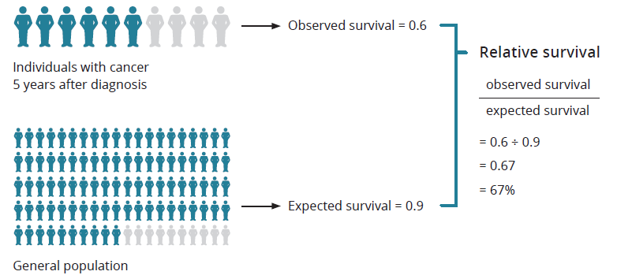
Figure 2: Simplified example of how relative survival is calculated

Outcome: Improve cancer outcomes

Key result: Decrease incidence of preventable cancers

Measure 1.1 – Incidence of preventable cancers
In Australia, at least one-third or approximately 37,000 of all cancers are preventable each year if the population avoided exposure to 13 common risk factors known or strongly suspected to cause cancer. Key preventable causal risk factors include tobacco smoking, excessive exposure to UV radiation, poor diet, being overweight, low levels of physical activity, excessive alcohol use and exposure to infections such as human papillomavirus (HPV). It is therefore important to quantify the proportion of Victorian cancer incidence that might be prevented if exposure to those risk factors occurred at levels that minimise cancer risk. For the purpose of this measure, incidence reflects the number of primary tumours rather than the number of people with cancer.
Figure 1.1: Incidence of preventable cancers in Victoria per 100,000 standardised to the 2001 Australian population, by year of diagnosis, 2014, 2017 and 2021
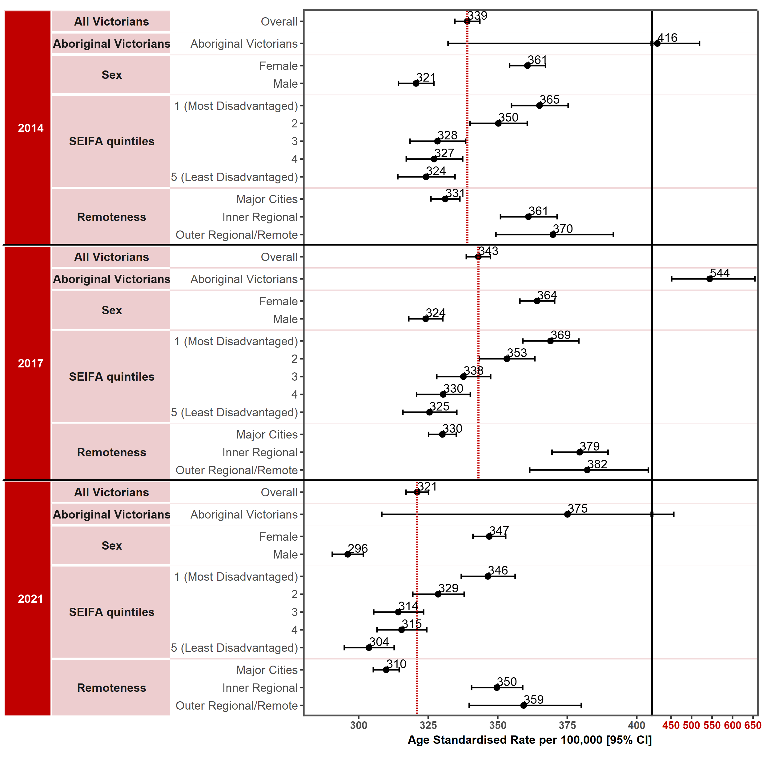
Note: Results by cultural diversity are not presented because the estimated resident population (ERP) does not estimate the population by cultural diversity, hence there is no denominator for this variable.
The Victorian cancer plan monitoring and evaluation framework: data dictionary (2018) lists the specific cancers that have been included in this measure as preventable.
Appendix 2 provides the dataset
Figure 1.1.1: Incidence of preventable cancers in Victoria per 100,000 standardised to the 2001 Australian population, by ICS and year, 2014, 2017 and 2021
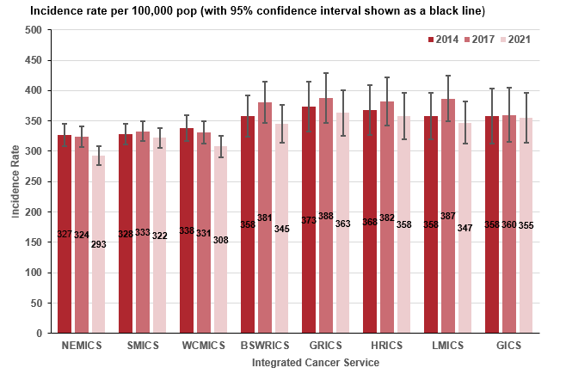

Measure assessment
Traffic light rating: Green (satisfactory result)
Overall trend: Moving in the right direction
Commentary: Figure 1.1 shows that the age-standardised incidence rate overall of preventable cancers combined decreased between 2014 (339 per 100,000 population) and 2021 (321 per 100,000 population). The incidence rate for males was 321 new cases in per 100,000 males in 2014 decreasing to 296 per 100,000 males in 2021. However, the incidence rate for females overall for the same period was noticeably higher than males despite the decrease from 361 new cases per 100,000 females in 2014 to 347 per 100,000 in 2021. This disparity between the sexes may have been the result of population-based screening (for example, the BreastScreen Australia Program and cervical screening) and improvements in technologies and techniques used to identify and diagnose cancers that are specific to females.
Trend data for SES shows that between 2014 and 2021 the age-standardised incidence rate for preventable cancers combined was highest for those living in more socioeconomically disadvantaged areas (SES 1 and 2) compared with those living in the two highest socioeconomic areas (Figure 1.1). Observed differences between 2014 and 2021 by remoteness area show that people living in regional (inner and outer) and remote areas have higher incidence rates compared with Victorians living in major cities (Figure 1.1) Figure 1.1.2: Incidence of preventable cancers in Victoria per 100,000 standardised to the 2001 Australian population, by LGA, 2014, 2017 and 2021.
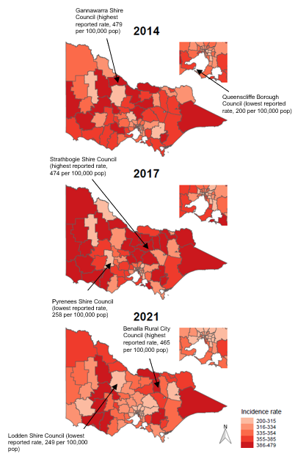
Figure 1.1.2: Incidence of preventable cancers in Victoria per 100,000 standardised to the 2001 Australian population, by Victorian LGA, 2014, 2017 and 2021

Due to the small number of incident cancer cases reported in Victoria between 2014 and 2021, results of analysis by Aboriginal Victorian status should be interpreted with caution. Nevertheless, the higher Aboriginal Victorian incidence rate, which despite decreasing from 416 per 100,000 population in 2014 to 375 per 100,000 population in 2021, may be related to the high prevalence of preventable causal risk factors such as smoking, alcohol consumption and hepatitis B infection, along with lower participation in cancer screening among Aboriginal Victorians.
Figure 1.1.1 shows that, overall, metropolitan ICS had lower rates compared with the regional/rural ICSs, which reported an increase in incidence rates over the analysis period, suggesting that the burden of preventable cancers was inequitably distributed across Victoria.
Figure 1.1.2 visualises the geospatial distribution of the incidence rate of preventable cancers by LGA and shows variations in rates across Victoria between 2014 and 2021, with the highest rates outside of greater Melbourne. In total 59.5% of the 79 Victorian LGAs had higher rates of preventable cancers than the overall rate (339 per 100,000 population) for Victoria in 2014 (Table 1.1b, Appendix 2). Gannawarra Shire LGA reported the highest incidence rate (479 per 100,000 population) and Queenscliffe Borough LGA the lowest incidence rate (200 per 100,000 population) in 2014 (Table 1.1b, Appendix 2). By comparison, 69.6% of the 79 LGAs had higher incidence rates of preventable cancers than the overall rate (321 per 100,000 population) for Victoria in 2021. Benalla Rural City LGA reported the highest incidence rate (465 per 100,000 population) and the Loddon Shire LGA the lowest (249 per 100,000 population in 2021 (Table 1.1d, Appendix 2). Overall, most of the 79 LGAs reported slight fluctuations in the incidence rate between 2014 and 2021, but the most significant was the Alpine Shire (rural LGA), which reported a dramatic decrease from 369 per 100,000 population in 2014 to 294 per 100,000 population in 2021 (Table 1.1d, Appendix 2).
The target set for this measure is that the proportion of Victorians diagnosed with preventable cancers is halved by 2040 from the baseline. Currently Victoria appears to be on track to meet this target; however, further illuminations of risk factors would also help identify various opportunities for prevention.
.

Measure 1.2 – Lifetime risk of cancer before the age of 85 years
Figure 1.2: Lifetime risk of cancer before the age of 85 years by year, 2014, 2017 and 2021
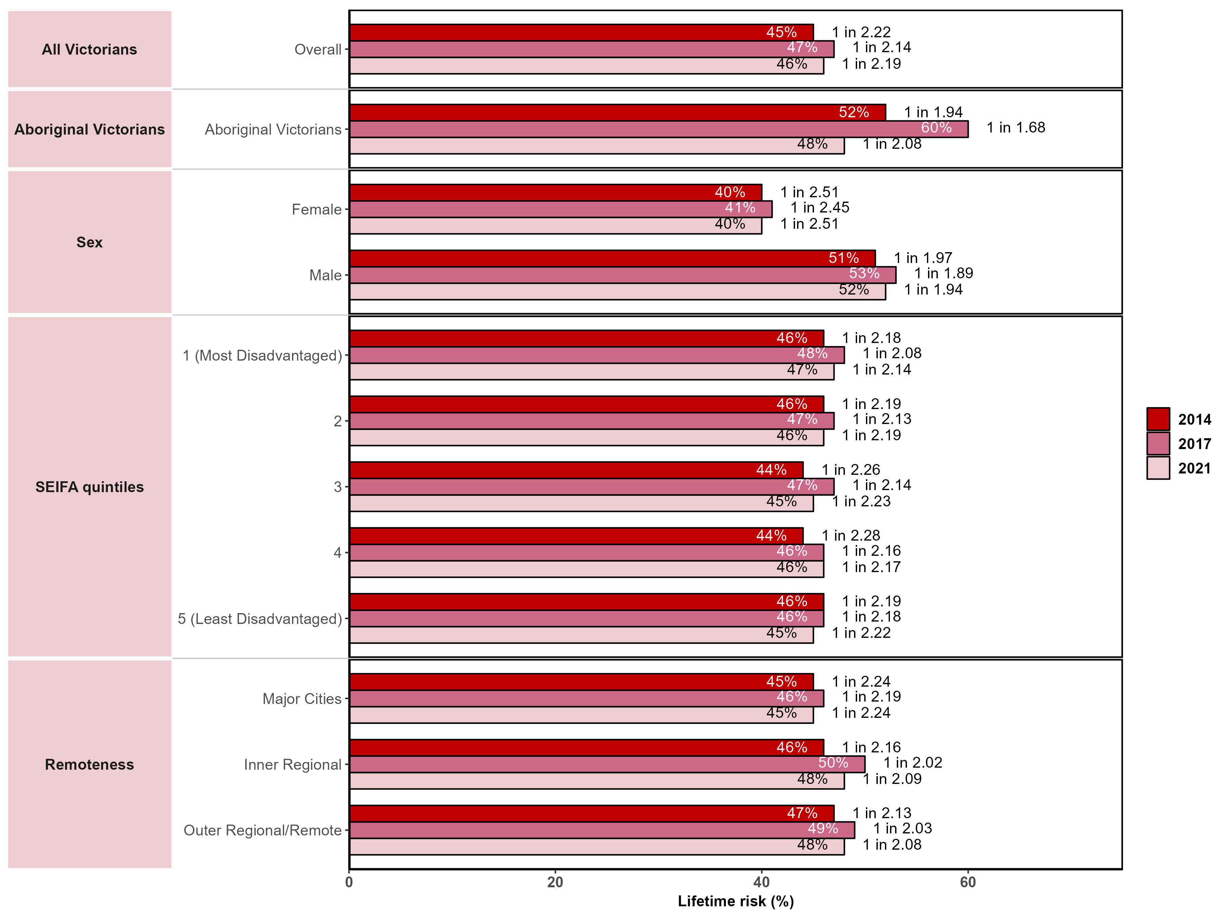
Note: Results by cultural diversity are not presented because the ERP does not estimate the population by cultural diversity, hence there is no denominator for this variable.
Figure 1.2.1: Lifetime risk of developing cancer before the age of 85 years, by ICS and year, 2010–2021
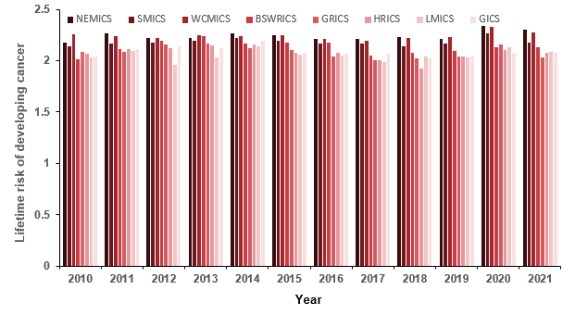

Measure assessment
Traffic light rating: Amber (desired result not yet evident)
Overall trend: Static or unchanging
Commentary: Advancing age is the most important risk factor for cancer overall and for many individual cancer types. Globally the lifetime risk of developing cancer has been estimated and is publicly available in several countries; however, there is variation between the cut-off age group. The purpose of this measure is to estimate the probability (risk) of developing cancer before the age of 85.
In 2017 it was estimated that the risk of an Australian developing cancer by their 85th birthday would be one in two for both males and females. While no target has been set for this measure, Figure 1.2 shows that, overall, between 2014 and 2021 the lifetime risk of a Victorian developing cancer before the age of 85 years was also one in two. Despite the findings showing a decrease in risk between gender, the risk was lower for females overall, amounting to 40% (2014) and remaining the same for 2021 compared with 51% for males (2014) increasing to 52% (2021). The latter is possibly due to increasing age-specific rates of cancers such as prostate and lung cancer in males having an impact on the increasing lifetime risk of developing cancer before the age of 85 years.
Figure 1.2 shows that the lifetime risk of developing cancer for Aboriginal Victorians decreased from 52% in 2014 to 48% in 2021. The lifetime risk of developing cancer before the age of 85 years did not vary significantly between SES and remoteness (Figure 1.2). Figure 1.2.1 also shows very little variation in the lifetime risk of developing cancer before the age of 85 years between ICSs during the analysis period.

Measure 1.3 – Incidence of lung cancer
Figure 1.3: Incidence of lung cancer in Victoria per 100,000 standardised to the 2001 Australian population, by year of diagnosis, 2014, 2017 and 2021
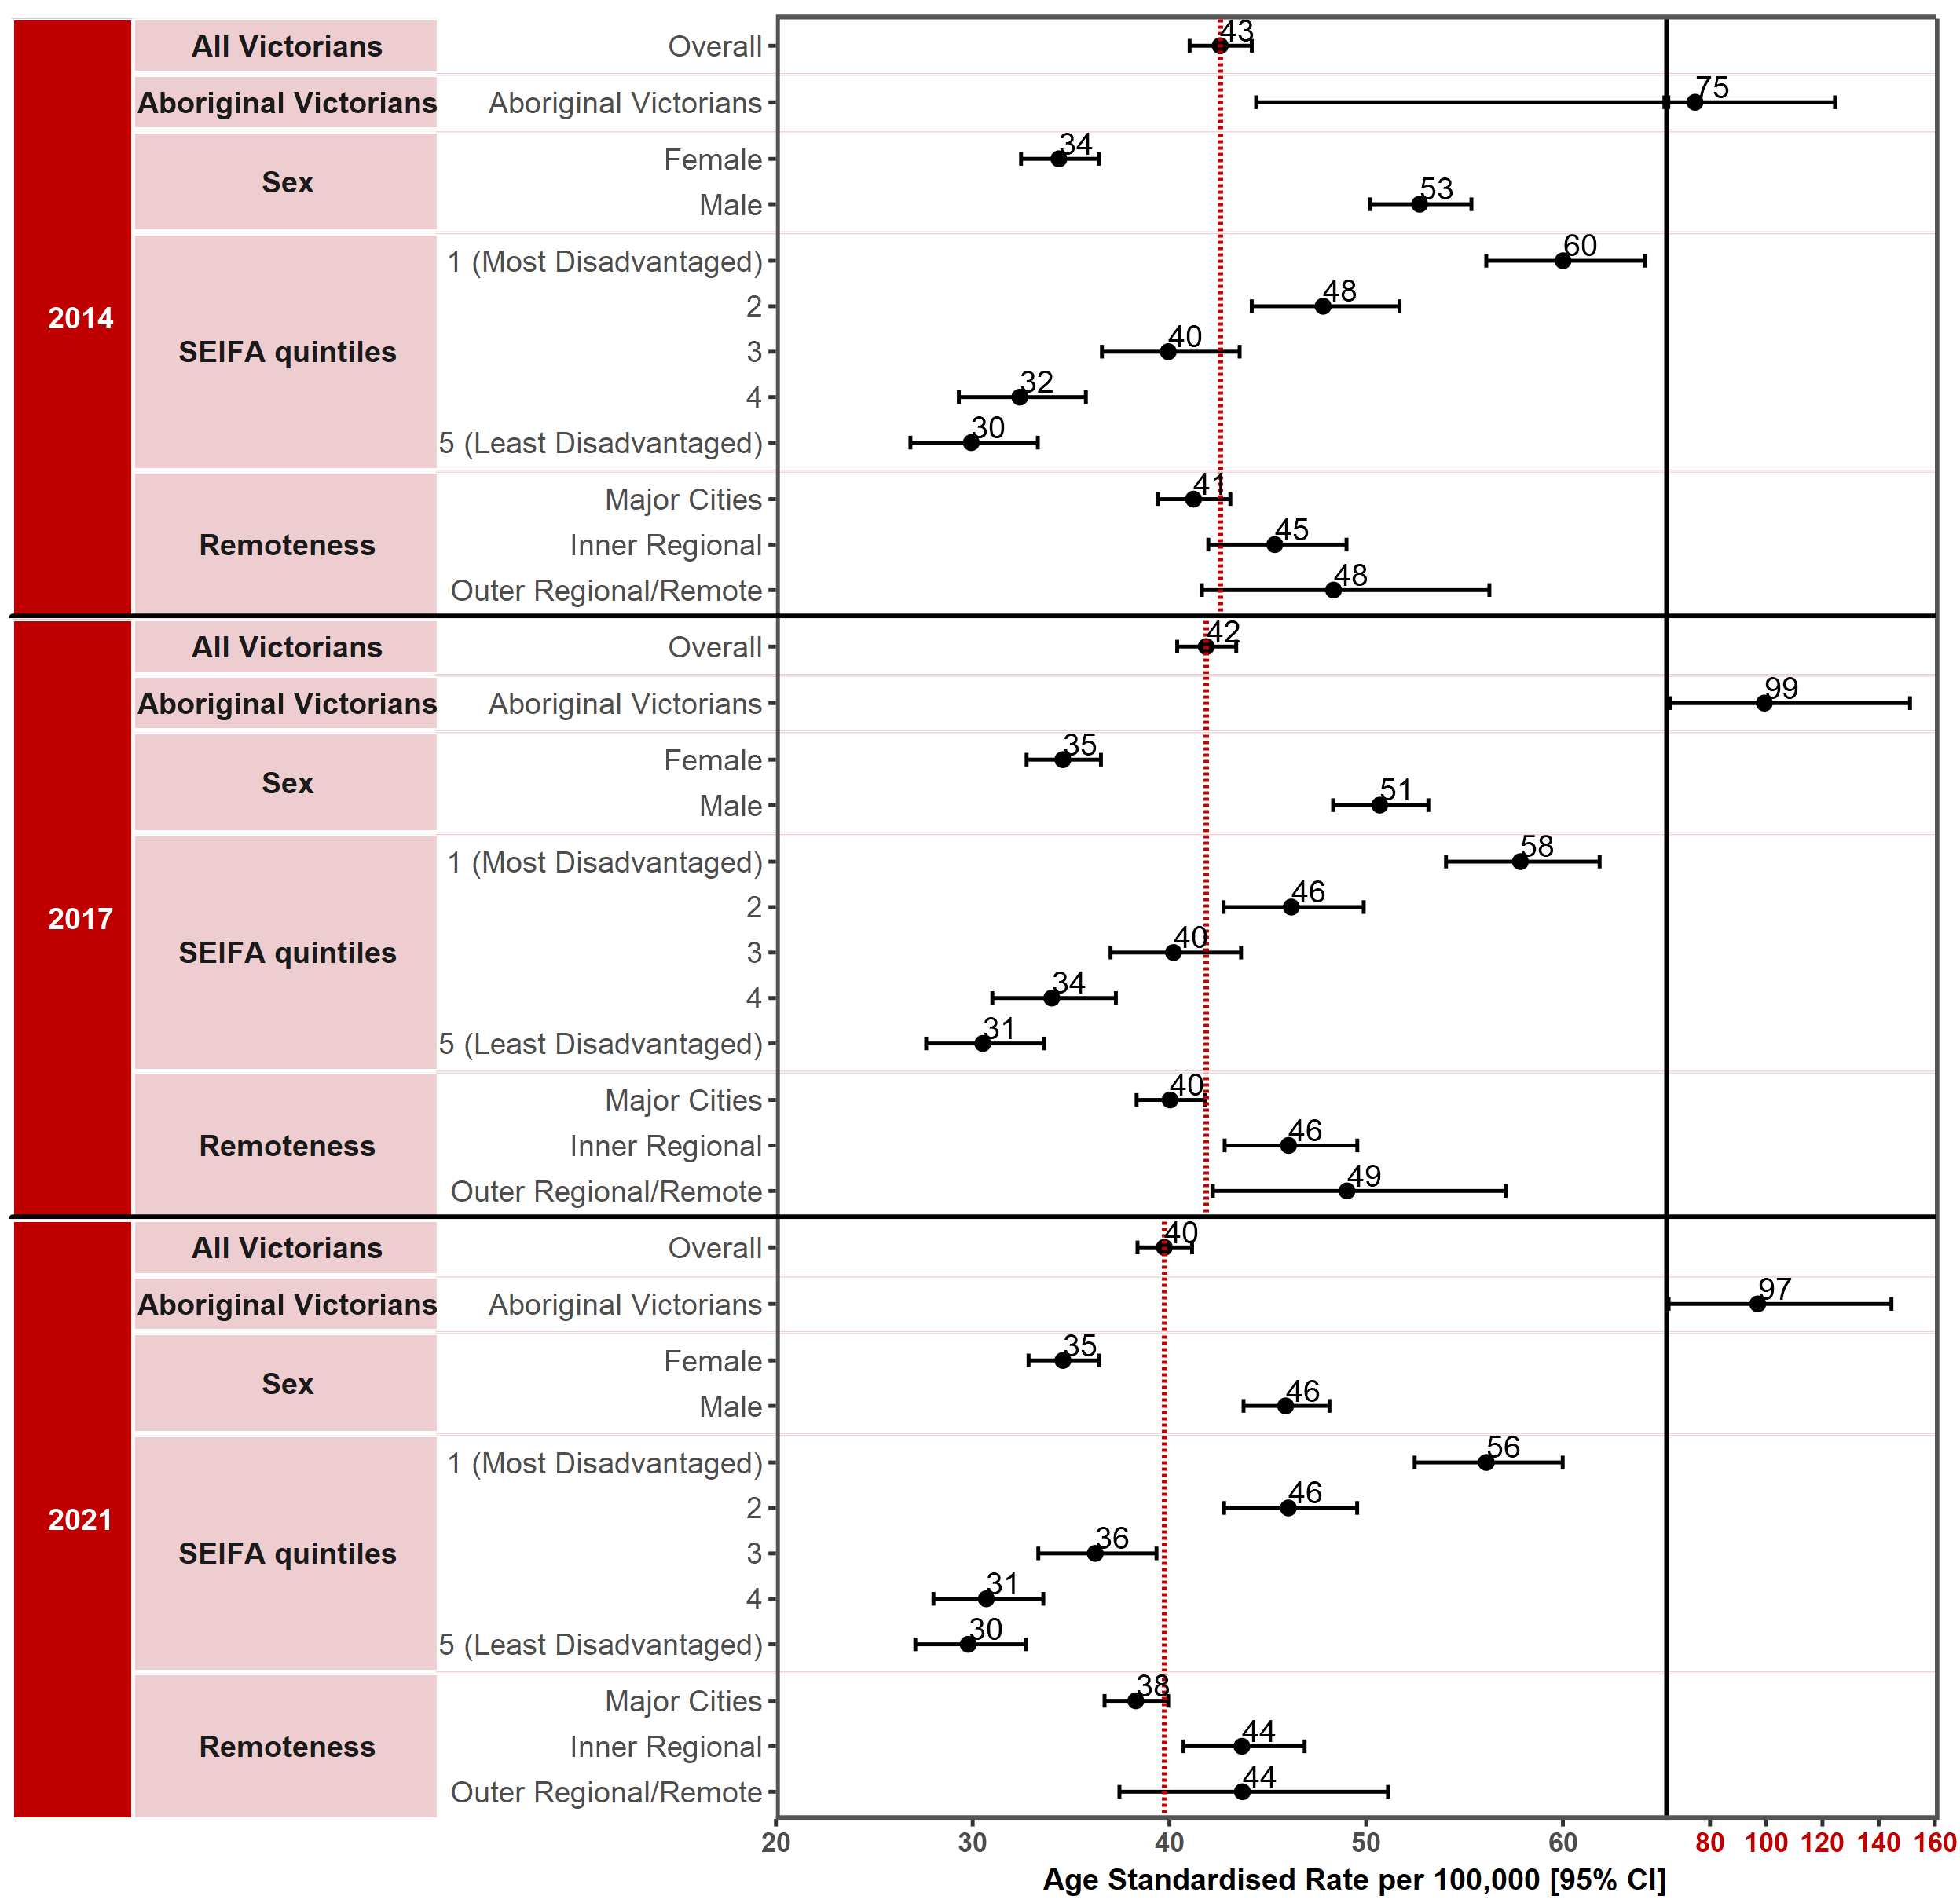
Note: Results by cultural diversity are not presented as the ERP does not estimate the population by cultural diversity, hence there is no denominator for this variable.
Appendix 2 provides the dataset.
Figure 1.3.1: Incidence of lung cancer in Victoria per 100,000 standardised to the 2001 Australian population, by ICS and year, 2014, 2017 and 2021
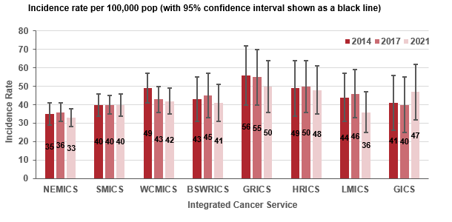

Measure assessment
Traffic light rating: Amber (desired result not yet evident)
Overall trend: Static or unchanging
Commentary: There are two main types of lung cancer – non-small cell lung cancer and small cell lung cancer. It is well documented that there are several risk factors relating to developing lung cancer. Of these, tobacco smoking is the greatest risk factor for non-small cell lung cancer. More recently exposure to dust is a risk factor for lung cancer (small cell lung cancer). Workers exposed to long-term or a repeated high level of exposure to inorganic dust from products containing asbestos or silica due to poor control measures have a higher likelihood of developing lung cancer compared with the general population, particularly if they are a smoker.
Lung cancer is the leading cause of cancer death and the fifth most common cancer diagnosed in Australia. In Victoria the latest statistics show that lung cancer was the fourth most common new cancer (3,253 new cases) in 2021, making up 9% of all new cancer diagnoses and that 89% of lung cancers identified were non-small cell lung cancer. Furthermore, lung cancer remains a leading cause of cancer death in 2021. The number of lung cancer diagnoses increased from 2,437 in 2010 to 3,253 in 2021 (from 1,448 to 1,746 in males and from 989 to 1,507 among females).
The age-standardised incidence rate per 100,000 population overall decreased slightly from 43 in 2014 to 40 in 2021. Among males the age-standardised incidence rate decreased from 53 in 2014 to 46 in 2021, but among females, despite the overall age-standardised incidence rate being less than males, it increased from 34 in 2014 to 35 in 2021 (Figure 1.3). The different pattern of incidence rates observed between males and females is likely due to different trends in cigarette smoking. Smoking uptake increased in the early part of the 20th century and declined in the latter half of that century.
Figure 1.3.2: Incidence of lung cancer in Victoria per 100,000 standardised to the 2001 Australian population, by Victorian LGA, 2014, 2017 and 2021
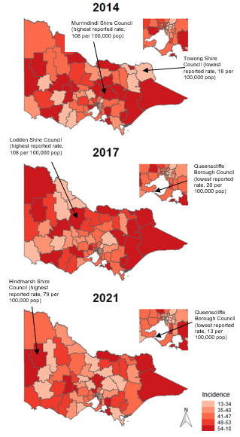
In 2014 the age-standardised lung cancer incidence rate for Aboriginal Victorians was 75 new cases per 100,000 population, which increased to 97 new cases per 100,000 population in 2021. Low SES was associated with an increased risk for developing lung cancer between 2014 and 2021. The lung cancer incidence rate between Victorians was highest in the most disadvantaged socioeconomic quintile (SES 1) between 2014 and 2021, decreasing from 60 per 100,000 population to 56 per 100,000 population (Figure 1.3). A similar pattern was observed for remoteness areas, with those Victorians living in the outer regional/remote areas having a higher incidence rate (48 per 100,000 population in 2014 decreasing slightly to 44 per 100,000 population in 2021) compared with those living in major cities (41 per 100,000 population in 2014 decreasing to 38 per 100,000 population in 2021). Figure 1.3.1 shows that incidence rates were lower for metropolitan ICSs such as NEMICS compared with regional/rural ICSs, although SMICS showed no change between 2014 and 2021. This was contrary to most of the regional/rural ICS, which showed a decreasing gradient in the incidence rate between 2017 and 2021, except for GICS, which showed an increase (Figure 1.3.1).
Figure 1.3.2 shows a geospatial distribution of the incidence of lung cancer by LGA and variations in the incidence rates of lung cancer across Victoria between 2014 and 2021. Overall, 53.2% of the 79 Victorian LGAs had higher incidence rates of lung cancer than the overall rate (43 per 100,000 population) for Victoria in 2014. Murrindindi Shire LGA reported the highest incidence rate (108 per 100,000 population) and Towong Shire LGA the lowest incidence rate (16 per 100,000 population) in 2014 (Table 1.3b, Appendix 2). By comparison, 51.9% of the 79 LGAs had higher incidence rates of lung cancer than the overall rate (40 per 100,000 population) for Victoria in 2021. Hindmarsh Shire LGA reported the highest incidence rate (79 per 100,000 population) and the Queenscliffe Borough LGA the lowest (13 per 100,000 population in 2021; Table 1.3d, Appendix 2). Overall, most of the 79 LGAs reported slight fluctuations in the incidence rate of lung cancer between 2014 and 2021, but the most significant was the Yarriambiack Shire, which reported a dramatic decrease from 41 per 100,000 population in 2014 to 14 per 100,000 population in 2021.

No target has been set for this measure; however, Measure 6.1 ‘Proportion of adults who smoke daily’ shows that in Victoria a continued comprehensive approach to tobacco control is warranted to reduce rates of smoking-related cancer including lung cancer. This is particularly the case because Figure 1.3 shows that disparities still exist in some groups such as regional Victorians and Aboriginal Victorians.
Finally, of note is that at the time of writing, a 2021–22 Federal Budget Measure had tasked the Department of Health and Cancer Australia to work together to establish the feasibility of implementing a national program and to inform a fully costed proposal to government for the detailed design, development and implementation of a National Lung Cancer Screening Program. This national program, due to start in 2025, is likely to lead to an initial increase in lung cancer incidence but with expectations of earlier stage disease and eventual improvements in survival. This increase in incidence is likely to occur over the period of implementation of the next Victorian cancer plan
.

Measure 1.4 – Incidence of colorectal cancer
Figure 1.4: Incidence of colorectal cancer in Victoria per 100,000 standardised to the 2001 Australian population, by year of diagnosis, 2014, 2017 and 2021
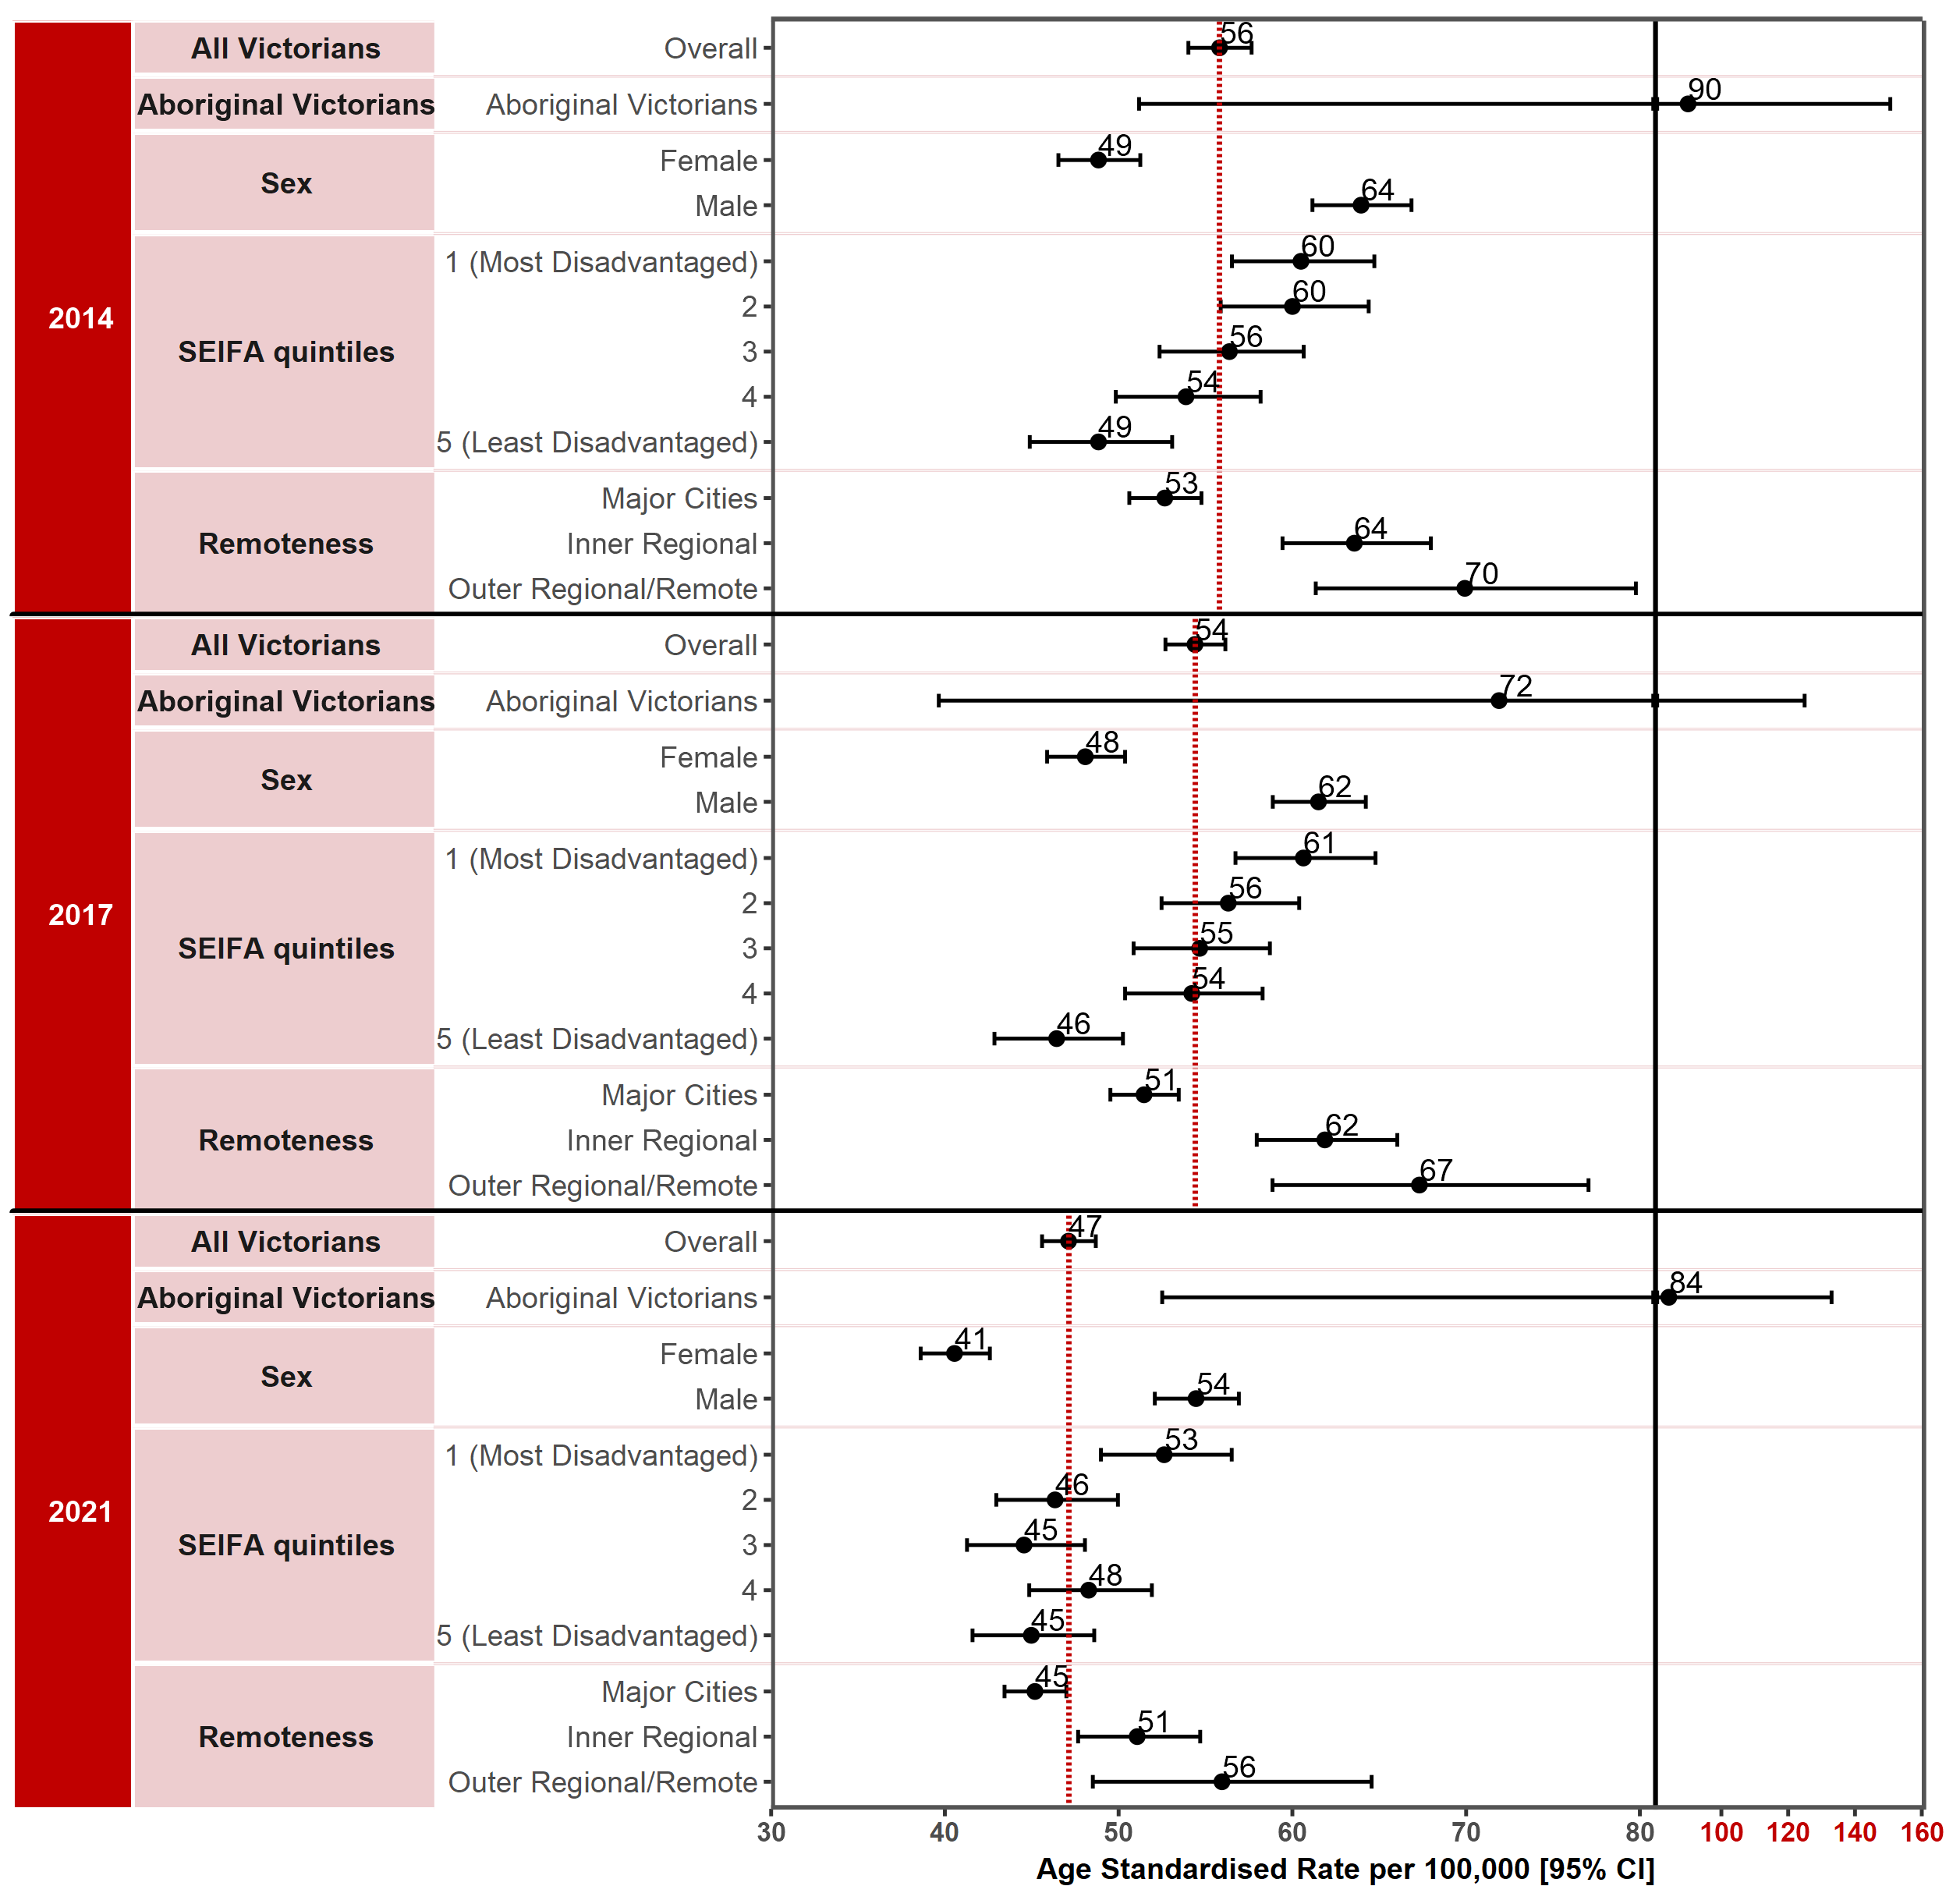
Note: Results by cultural diversity are not presented because the ERP does not estimate the population by cultural diversity, hence there is no denominator for this variable.
Appendix 2 provides the dataset.
Figure 1.4.1: Incidence of colorectal cancer in Victoria per 100,000 standardised to the 2001 Australian population, by ICS and year, 2014, 2017 and 2021
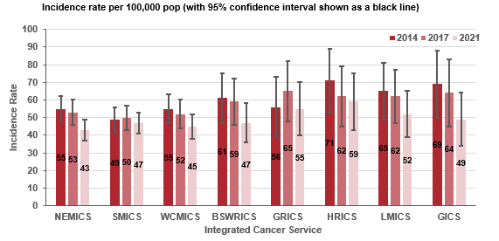
Measure assessment
Traffic light rating: Amber (desired result not yet evident)
Overall trend: Generally moving in the right direction however there is currently uncertainty regarding the impact of the pandemic as to the true direction of trend
Commentary: Colorectal cancer (CRC) (also referred to as bowel cancer) is a common and fatal disease. Globally, CRC incidence shows marked variability and is the third most commonly diagnosed cancer in males and the second in females. In 2020 more than 1.9 million new cases of CRC and more than 930 000 deaths due to CRC were estimated to have occurred worldwide. The number of new cases is predicted to increase to 3.2 million by 2040 (an increase of 63%) and 1.6 million deaths per year (an increase of 73%).
In Australia, CRC is the third most common type of newly diagnosed cancer. In 2021 CRC was also the third most common new cancer in Victoria, with 3,713 cases or 10% of all new cancer diagnoses. Over the study period (2014–2021) the age-standardised incidence rate decreased from 56 (2014) to 47 cases per 100,000 population (2021) (Figure 1.4), including an 11% decline in bowel cancer diagnoses in 2020 due to the COVID-19 pandemic. A higher incidence rate was observed in males (64 per 100,000 population in 2014 decreasing to 54 per 100,000 population in 2021) compared with females (49 per 100,000 population in 2014 decreasing to 41 per 100,000 population in 2021).

Figure 1.4.2: Incidence of colorectal cancer in Victoria per 100,000 standardised to the 2001 Australian population, by Victorian LGA, 2014, 2017 and 2021
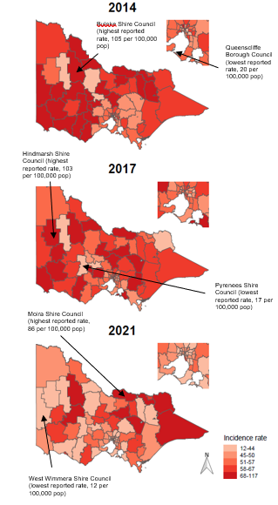
Low SES was associated with an increased risk for developing CRC between 2014 and 2021. The CRC incidence rate between Victorians was highest in the most disadvantaged socioeconomic quintile (SES 1) during the study period (2014 and 2021) (Figure 1.4). Furthermore, for Victorians living in the outer regional/remote areas the incidence rate was higher (70 per 100,000 population in 2014 falling to 56 per 100,000 population in 2021) compared with those living in major cities (53 per 100,000 population in 2014 decreasing to 45 per 100,000 population in 2021). Lower incidence rates were also observed for metropolitan ICSs (NEMICS, SMICS and WCMICS) compared with the regional/rural ICSs, although except for GRICS (which showed an increase between 2014 and 2017 but decreased from 2017 to 2021), each ICS saw a decrease in the incidence rate for CRC between 2014 and 2021 (Figure 1.4.1).
A geospatial visualisation of the incidence rate of CRC across Victoria by LGA between 2014 and 2021 is presented in Figure 1.4.2. Overall, 55.7% of the 79 Victorian LGAs had higher incidence rates of CRC than the overall rate (56 per 100,000 population) for Victoria in 2014. Buloke Shire LGA reported the highest incidence rate (105 per 100,000 population) and Queenscliffe Borough LGA the lowest incidence rate (20 per 100,000 population) in 2014 (Table 1.4b, Appendix 2). By comparison, 50.6% of the 79 LGAs had higher incidence rates of CRC than the overall rate (47 per 100,000 population) for Victoria in 2021. Moira Shire LGA reported the highest incidence rate (86 per 100,000 population) and the West Wimmera Shire LGA the lowest (12 per 100,000 population) for Victoria in 2021 (Table 1.6d, Appendix 2). Overall, most of the 79 LGAs reported slight fluctuations in the incidence rate of CRC between 2014 and 2021.

No target has been set for this measure; however, CRC is one of the few cancers for which a population screening program exists, and this has reduced the incidence. Therefore, the declining incidence rate of CRC in Victoria observed between 2014 and 2021 may partially reflect the efficacy of the Australian National Bowel Cancer Screening Program, which was introduced in 2006 targeting those aged 50–74 years and likely to prevent 300–500 deaths annually. Other factors, such as screening outside of the national program including by colonoscopy, may have contributed to the decline in overall incidence. Furthermore, other factors include detection and removal of precancerous lesions through colonoscopy. However, as Figure 1.4 shows, disparities exist in some subgroups, particularly among Aboriginal Victorians and those living in the most disadvantaged socioeconomic areas (SES 1), which continue to have higher rates of CRC.

Measure 1.5 – Incidence of melanoma
Figure 1.5: Incidence of melanoma in Victoria per 100,000 standardised to the 2001 Australian population, by year of diagnosis, 2014, 2017 and 2021
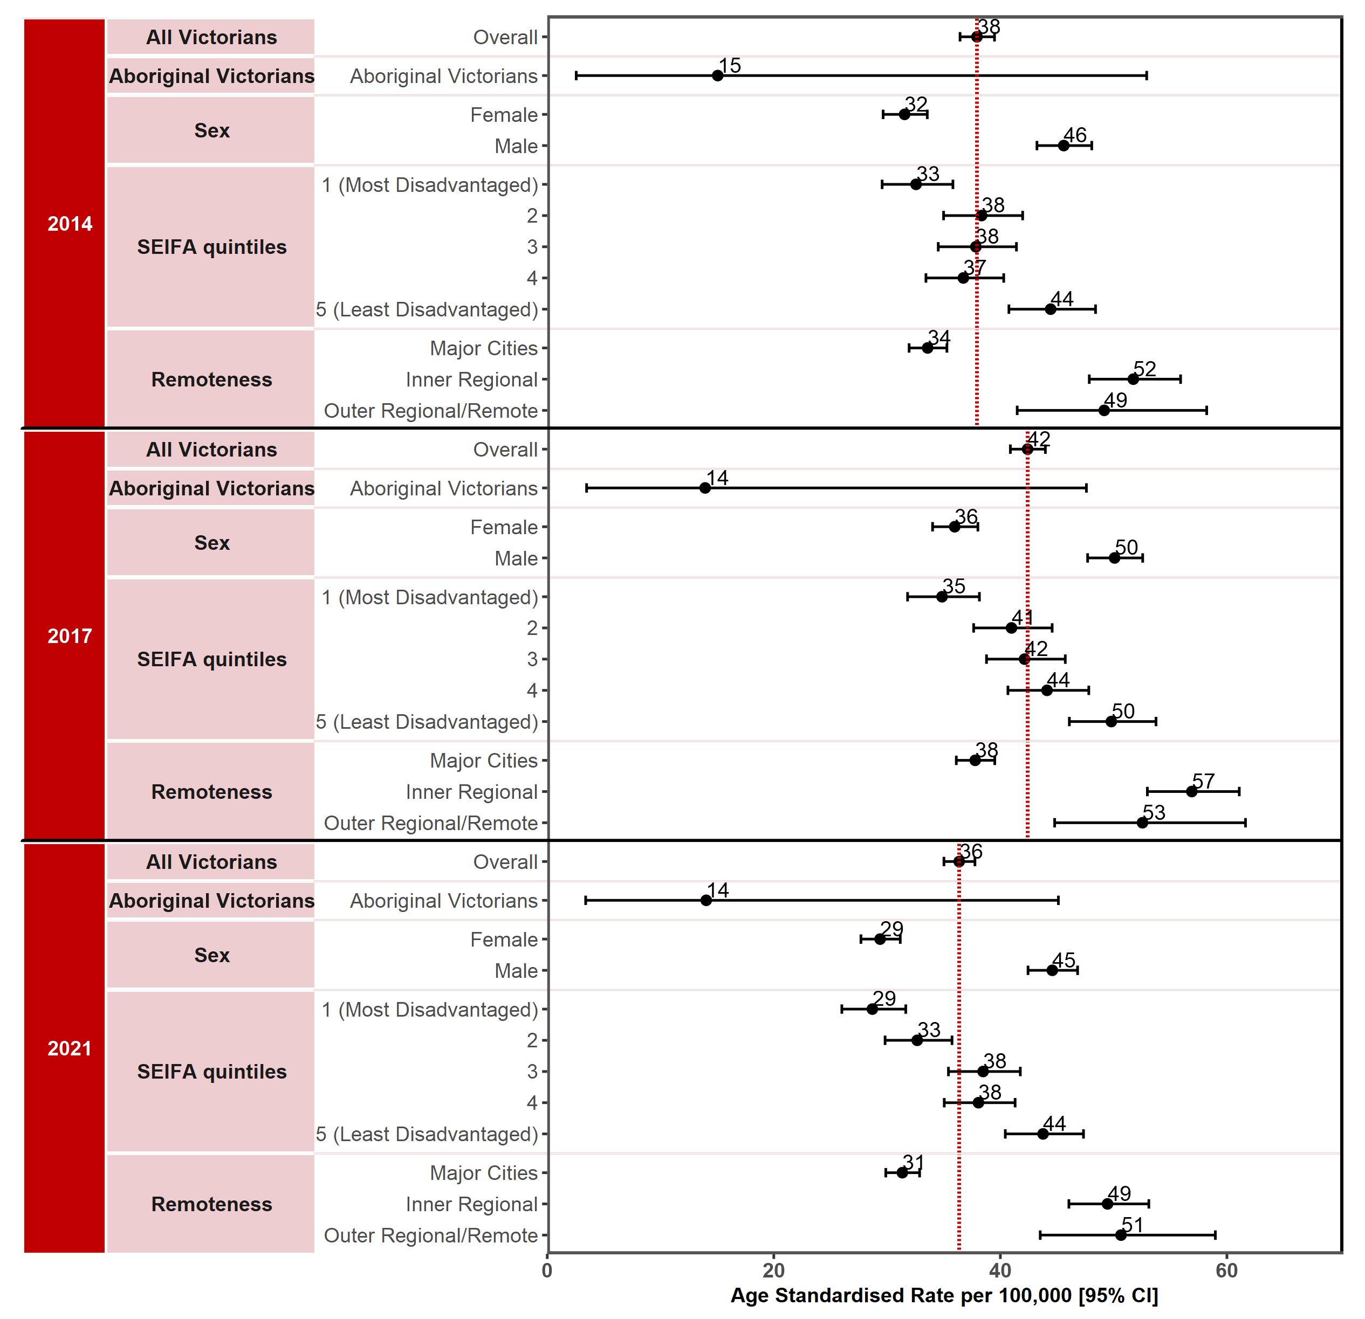
Note: Results by cultural diversity are not presented because the ERP does not estimate the population by cultural diversity, hence there is no denominator for this variable.
Appendix 2 provides the dataset.
Figure 1.5.1: Incidence of melanoma in Victoria per 100,000 standardised to the 2001 Australian population, by ICS and year, 2014, 2017 and 2021
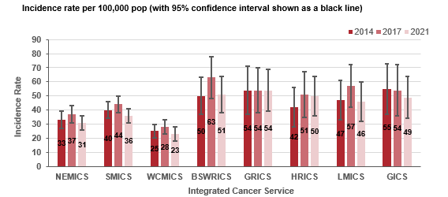
Measure assessment
Traffic light rating: Amber (desired result not yet evident)
Overall trend: Static or unchanging
Commentary: Melanoma is a type of skin cancer that usually occurs on the parts of the body that have been overexposed to the sun. The risk of malignant melanoma corelates with genetic and personal characteristics. The global incidence of melanoma in 2020 was 324,635, with an age‐standardised rate of 3.4 cases per 100,000 population.
Australia has the highest melanoma incidence rate out of the five world regions with the greatest rates. In 2018 melanoma skin cancer was the fourth most commonly diagnosed cancer in Australia.
In 2021, 2,824 Victorians were diagnosed with melanoma, making it the fifth most common cancer and accounting for 8% of all diagnosed cancers. As Figure 1.5 shows, the age-standardised incidence rate per 100,000 population increased steadily from 38 in 2014 to 42 in 2017 but then decreased between 2017 and 2021 to an incidence rate of 38 per 100,000 population, noting that for 2020 there was a 12% decline in melanoma diagnoses likely due to the COVID-19 pandemic.
Among males, the age-standardised incidence rate decreased slightly from 46 in 2014 to 45 in 2021. The age-standardised incidence rate among females also decreased from 32 in 2014 to 29 in 2021. The melanoma age-standardised rate for Aboriginal Victorians during the study period was 15 per 100,000 population (2014) decreasing slightly to 14 per 100,000 population (2021) (Figure 1.5).
Figure 1.5.2: Incidence of melanoma in Victoria per 100,000 standardised to the 2001 Australian population, by Victorian LGA, 2014, 2017 and 2021
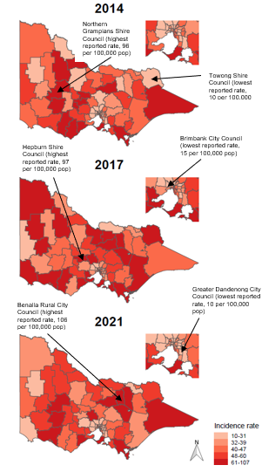
There was a clear association between the age-standardised incidence rate and SES, with lower rates for both 2014 and 2021 observed for SES 1 (most disadvantaged) compared with those for SES 5 (least disadvantaged). In terms of incidence rates by remoteness, lower rates were seen in major cities compared with outer/remote regional areas of Victoria in both 2014 and 2021 (Figure 1.5).
Melanoma incidence rates varied between regions of Victoria when compared between ICS, with lower rates observed in the metropolitan ICSs (NEMICS, SMICS, WCMICS). Except for GICS (decrease) and GRICS (no change), all the other ICSs saw an increase in melanoma rates between 2014 and 2017, which decreased between 2017 and 2021 (Figure 1.5.1).
Figure 1.5.2 shows a geospatial visualisation of the incidence rate of melanoma across Victoria by LGA between 2014 and 2021. Overall, 63.3% of the 79 Victorian LGAs had higher incidence rates of melanoma than the overall rate (38 per 100,000 population) for Victoria in 2014. North Grampians Shire LGA reported the highest incidence rate (96 per 100,000 population) and Towong Shire LGA the lowest incidence rate (10 per 100,000 population) in 2014 (Table 1.5b, Appendix 2). By comparison, 68.4% of the 79 LGAs had higher incidence rates of melanoma than the overall rate (36 per 100,000 population) for Victoria in 2021. Benalla Rural City LGA reported the highest incidence rate (106 per 100,000 population, a significant increase from 24 per 100,000 population in 2014) and Greater Dandenong City LGA the lowest (10 per 100,000 population) in 2021 (Table 1.5d, Appendix 2). Overall, most of the 79 LGAs reported slight fluctuations in the incidence rate of melanoma between 2014 and 2021.
In Victoria early detection and screening of people at high risk of skin cancer, new techniques and products for UVR protection and multiple treatment options have been implemented with the potential to reduce the burden of skin cancer. However, despite no target being set for this measure, the age-standardised rate shows an overall decrease in Victoria between 2014 and 2021. The main factors that predispose a person to developing melanoma seem to relate to recreational exposure to the sun and a history of sunburn. An ongoing focus on reducing morbidity and mortality such as primary (e.g. avoiding excessive exposure to ultraviolet rays) and secondary (e.g. patients’ self-examination and medical examination) prevention strategies should continue to be considered, especially in the most prevalent regions such as regional Victoria, where residents are 44% more likely to be diagnosed with melanoma than Victorians living in major cities.

Measure 1.6 – Incidence of female breast cancer
Figure 1.6: Incidence of female breast cancer in Victoria per 100,000 standardised to the 2001 Australian population, by year of diagnosis, 2014, 2017 and 2021
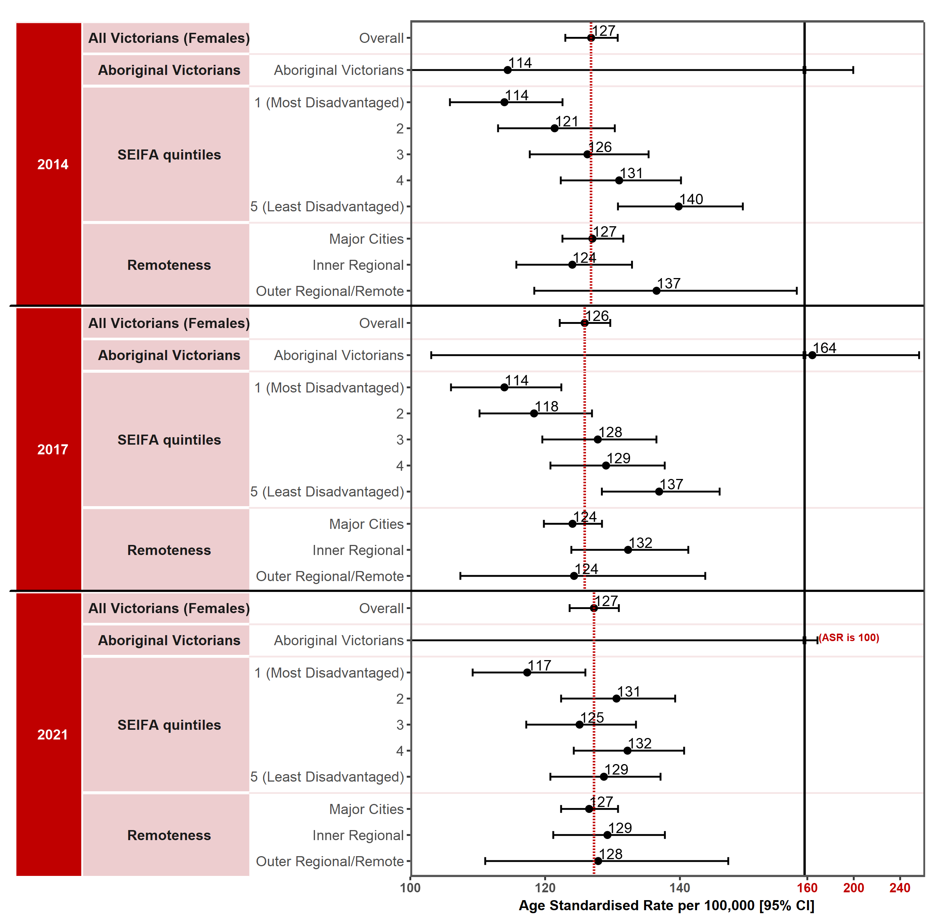
Note: Results by cultural diversity are not presented because the ERP does not estimate the population by cultural diversity, hence there is no denominator for this variable.
Appendix 2 provides the dataset.
Figure 1.6.1: Incidence of female breast cancer in Victoria per 100,000 standardised to the 2001 Australian population, by ICS and year, 2014, 2017 and 2021
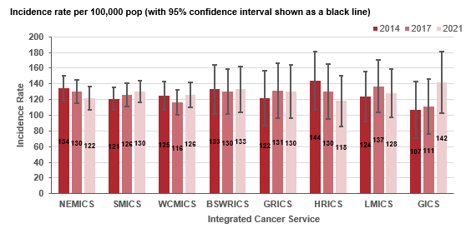
Measure assessment
Traffic light rating: Amber (desired result not yet evident)
Overall trend: Static or unchanging
Commentary: Breast cancer is the most common malignancy in women (although it can occur in males) around the world. In 2020 the World Health Organization GLOBOCAN database estimated there would be 2.3 million newly diagnosed female breast cancer cases, accounting for one in four cancers diagnosed among women globally. In Australia this global trend is also reflected in national cancer statistics, with breast cancer also the most common cancer affecting women including Aboriginal and Torres Strait Islander women. In 2017 the age-standardised rate for breast cancer in females was 124.8 per 100,000 population compared with an age-standardised rate in males of 1.0 per 100,000 population. Because of the disproportionate low incidence rate of breast cancer in men, this measure focuses on breast cancer in Victorian females only.
In Victoria breast cancer is the second most common new cancer, accounting for 13% of all new cases diagnosed in 2021 and 29% in females. Nevertheless breast cancer incidence rates are projected to remain stable over the next decade.
Figure 1.6.2: Incidence of female breast cancer in Victoria per 100,000 standardised to the 2001 Australian population, by Victorian LGA, 2014, 2017 and 2021
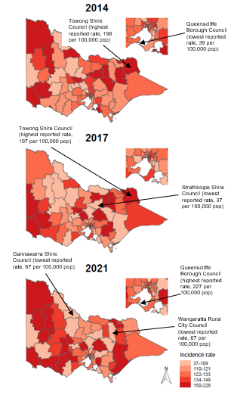
Figure 1.6 shows that the overall age-standardised rate for female breast cancer remained relatively unchanged at 127 per 100,000 population in 2014 through to 2021. Higher incidence rates for Victorian Aboriginal women were observed over the same period, although caution should be taken when interpreting these figures due to the low numbers of cases for this subgroup (18 cases in 2014 increasing to 26 in 2017 but decreasing to 19 in 2021 – refer to Tables 1.6a and c in Appendix 2).
High SES correlated with an increased risk for developing breast cancer in women between 2014 and 2021. The female breast cancer incidence rate between Victorians was highest in the least disadvantaged socioeconomic quintile (SES 5) during the reporting period, although a decrease was observed in the rates from 140 per 100,000 population in 2014 to 129 per 100,000 population in 2021 (Figure 1.6).
Figure 1.6 shows that the gap between Victorians living in the outer regional/remote areas compared with major cities is narrowing. Of note was the significant decrease in the incidence rate for those Victorians living in the outer regional/remote areas, a decrease from 137 per 100,000 population in 2014 to 128 per 100,000 population in 2021. There was a similar trend for ICSs across Victoria, which showed little variation, although each of the ICSs recorded an increase in incidence rates for female breast cancer from 2014 to 2017 except for NEMICS, WCMICS, BSWRICS and HRICS, which recorded a slight decrease. The impact of people not accessing cancer services early on during the 2020 lockdowns may account for the decrease in incidence rates across most of the ICSs between 2017 and 2021 and should be interpreted with caution.
The spatial variation of incidence rates of female breast cancer by LGA is presented in Figure 1.6.2 from 2014 to 2021. Forty-seven% of the 79 LGAs had higher incidence rates of female breast cancer than the overall rate (127 per 100,000 population) in 2014. Towong Shire LGA reported the highest incidence rate (198 per 100,000 population) and Queenscliffe Borough LGA the lowest incidence rate (39 per 100,000 population) in 2014 (Table 1.6b, Appendix 2). By comparison, 54.4% of the 79 LGAs had high incidence rates of female breast cancer than the overall rate (127 per 100,000 population) for Victoria in 2021. Queenscliffe Borough LGA reported the highest incidence rate (227 per 100,000 population) and Gannawarra Shire and Wangaratta Rural City LGAs the lowest (67 per 100,000 population) in 2021 (Table 1.6d, Appendix 2). Overall, most of the 79 LGAs reported very little variation in the incidence rate during the study period. Nevertheless, Mansfield Shire LGA showed one of the most significant changes, with a decrease in the incidence rate from 181 per 100,000 population in 2014 to 91 per 100,000 population in 2021.
While no target has been set for this measure, the overall the age-standardised rate for female breast cancer has decreased and projected incidence rates are expected to remain constant over the next decade.

Measure 1.7 – Incidence of cancer of the cervix
Figure 1.7: Incidence of cancer of the cervix in Victoria per 100,000 standardised to the 2001 Australian population, by year of diagnosis, 2014, 2017 and 2021
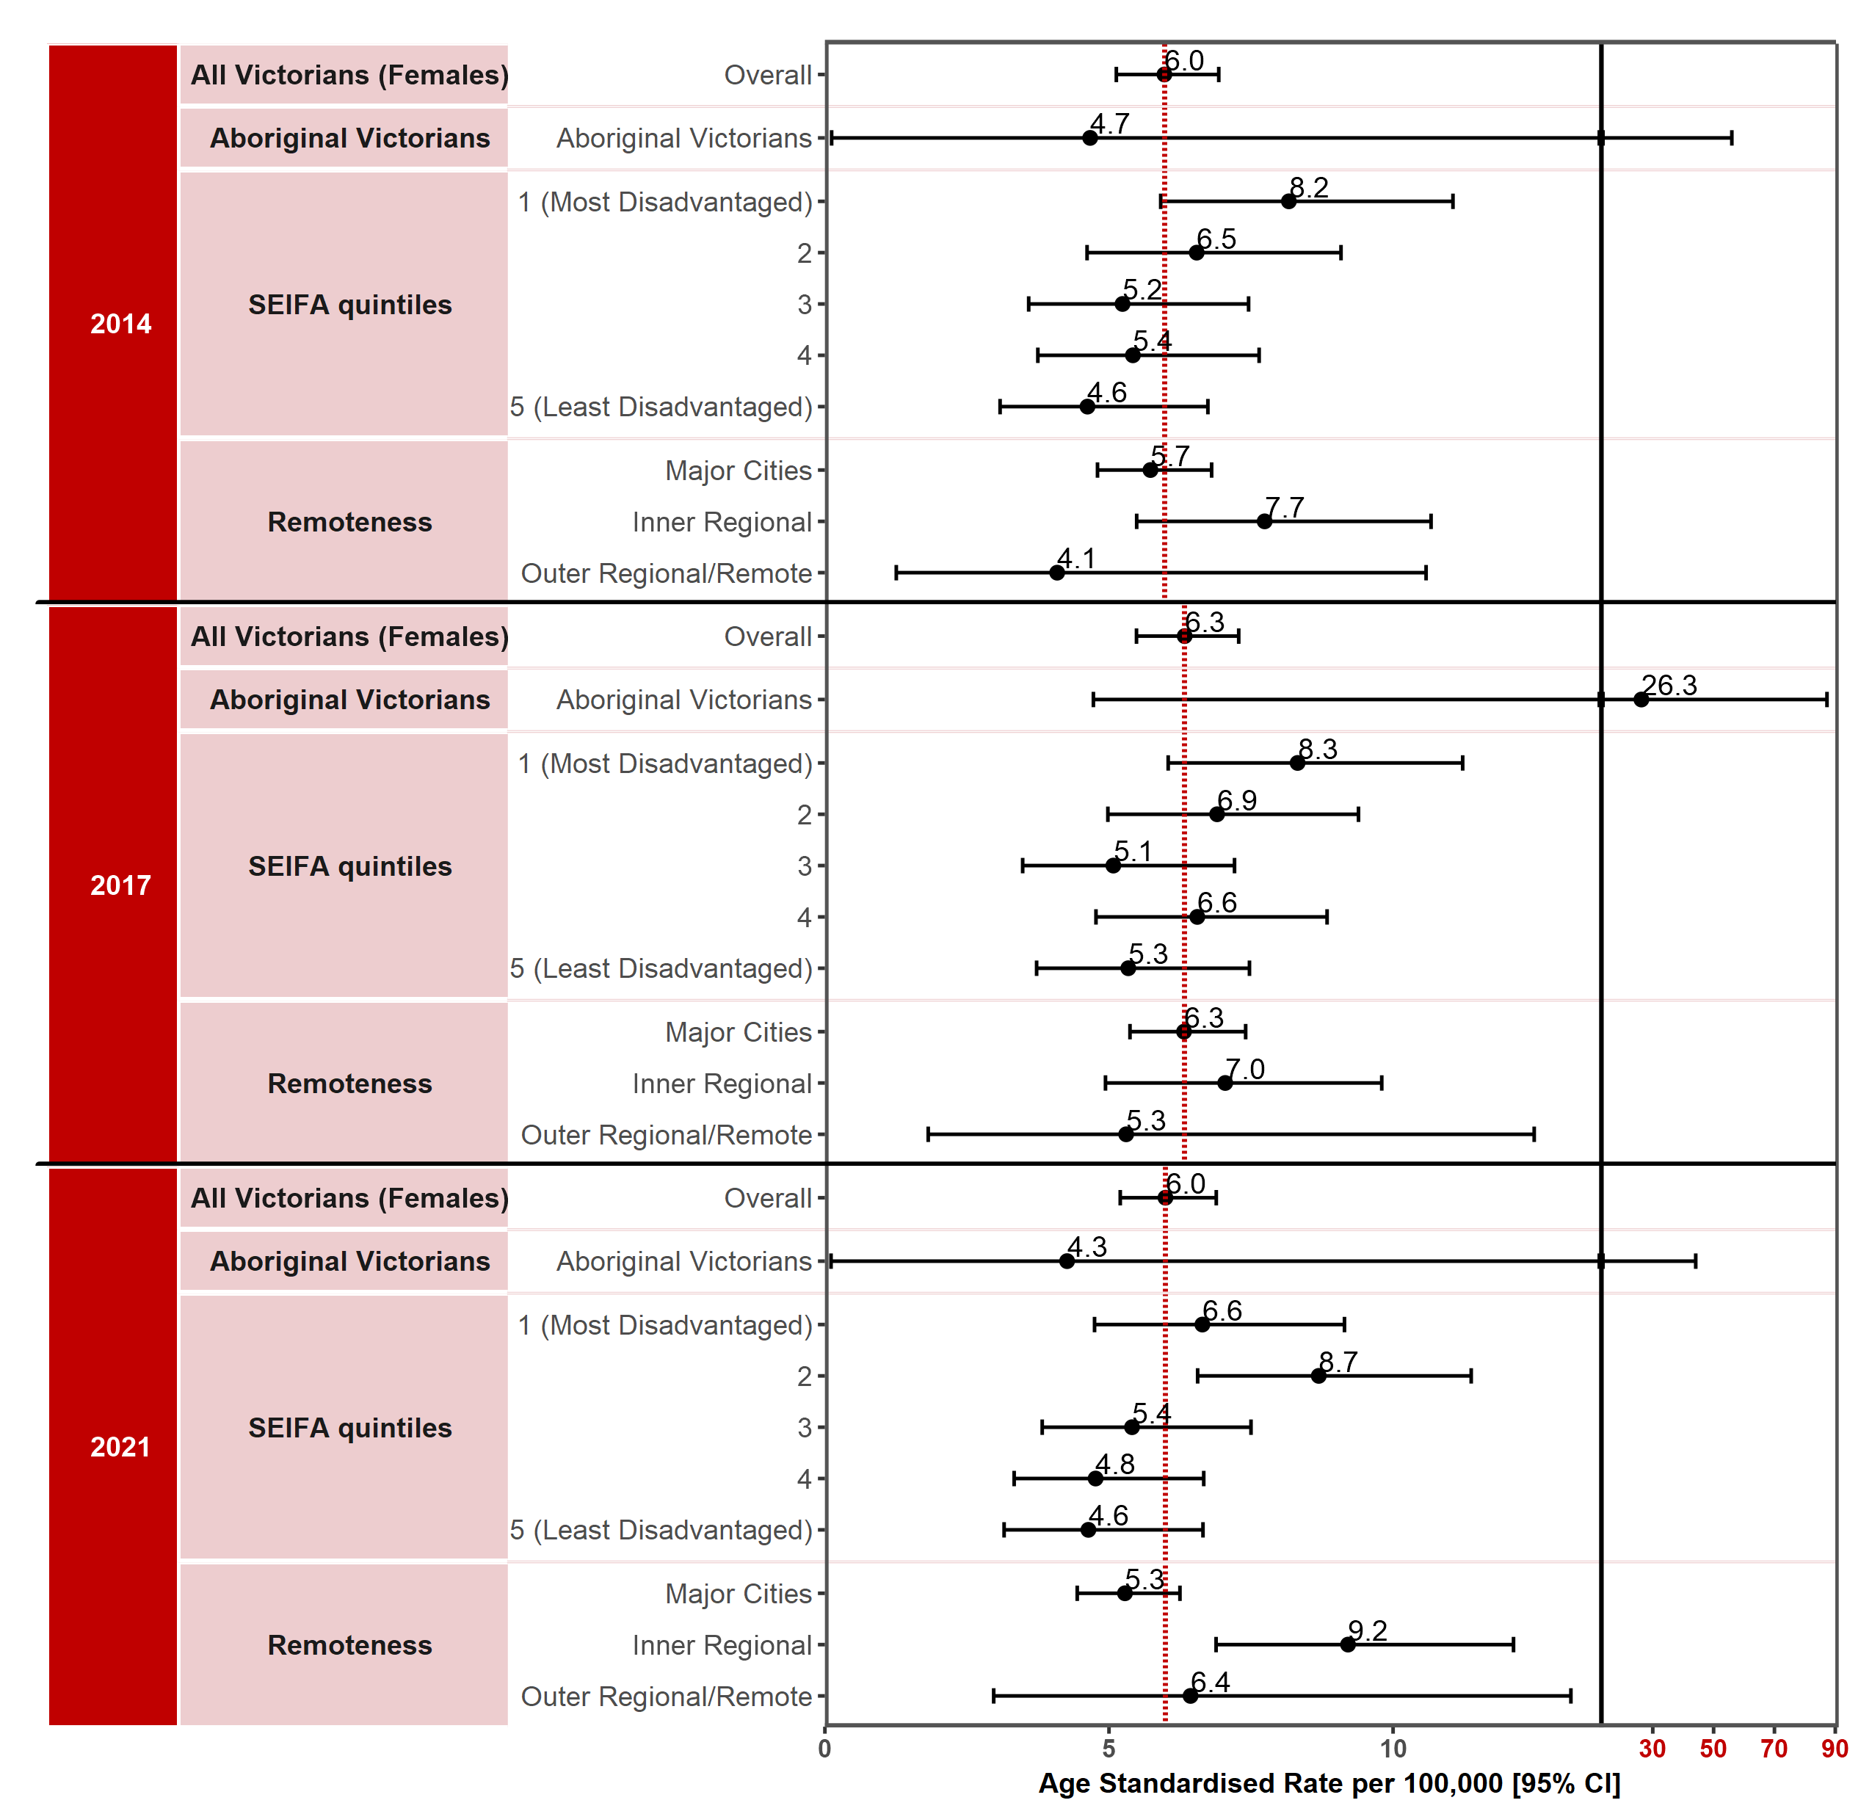
Note: Results by cultural diversity are not presented because the ERP does not estimate the population by cultural diversity, hence there is no denominator for this variable.
Appendix 2 provides the dataset.
Figure 1.7.1: Incidence of cancer of the cervix in Victoria per 100,000 standardised to the 2001 Australian population, by ICS and year, 2014, 2017 and 2021
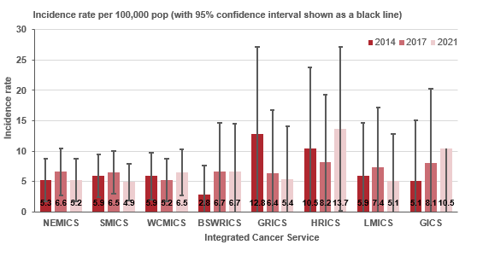

Measure assessment
Traffic light rating: Amber (desired result not yet evident)
Overall trend: Static or unchanging
Commentary: Most cancers of the cervix are preventable. Nevertheless, with an estimated 604,000 new cases and 342,000 deaths in 2020 globally, this disease ranks as the fourth most frequently diagnosed cancer and the fourth leading cause of cancer death in women. HPV is the main cause of cervical cancer, with 12 oncogenic types classified as group 1 carcinogens by the International Agency for Cancer Research monographs. In Australia cervical cancer was the 14th most commonly diagnosed cancer among females in 2015 and in 2019 was estimated to remain the 14th most commonly diagnosed cancer among females.
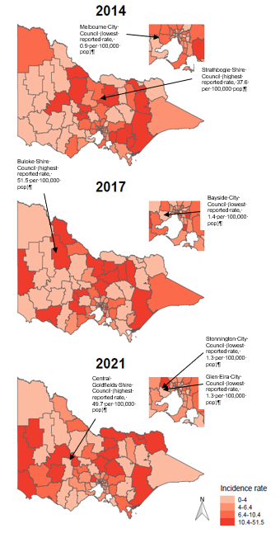
In Victoria the number of annual cervical cancer diagnoses, while low, initially increased from 181 in 2014 to 209 in 2021 (Tables 1.7a and c in Appendix 2). The age-standardised incidence rate per 100,000 females remained largely the same between 2014 and 2021 but increased in 2017 (Figure 1.7). There was an association between the age-standardised incidence rate and SES, with higher incidence rates observed for SES 1 (most disadvantaged) compared with SES 5 (least disadvantaged), which largely remained the same between 2014 and 2021. The age-standardised rate for cervical cancer did not differ significantly by remoteness between major cities and outer/remote areas of Victoria during the reporting period (Figure 1.7). Figure 1.7.1 shows that the incidence rates were similar between ICSs across the state; however, care should be taken when interpreting these results because the wide confidence intervals denote low numbers of cervical cancer cases.
Figure 1.7.2: Incidence of cancer of the cervix in Victoria per 100,000 standardised to the 2001 Australian population, by Victorian LGA, 2014, 2017 and 2021
Figure 1.7.2 visualises the spatial variation of incidence rates of cancer of the cervix by LGA from 2014 to 2021. Forty-three% of the 79 LGAs had equal to or higher incidence rates of cancer of the cervix than the overall rate (6 per 100,000 population) in 2014. Strathbogie Shire LGA reported the highest incidence rate (37.6 per 100,000 population) and Melbourne City LGA the lowest incidence rate (0.9 per 100,000 population) in 2014 (Table 1.7b, Appendix 2). However, 24 LGAs reported zero incidence rates in 2014. By comparison, 45.6% of the 79 LGAs had equal to or higher incidence rates of cancer of the cervix than the overall rate (6 per 100,000 population) for Victoria in 2021. Central Goldfields Shire LGA reported the highest incidence rate (49.7 per 100,000 population) and Glen Eira City and Stonnington City LGAs the lowest (1.3 per 100,000 population) in 2021 (Table 1.7d, Appendix 2). However, there were nine LGAs (Benalla Rural City, Buloke Shire, Corangamite Shire, Horsham Rural City, Macedon Ranges Shire, Mansfield Shire, Pyrenees Shire, Queenscliffe Borough, Yarriambiack Shire) that reported zero incidence rates for both 2014 and 2021. Overall, most of the 79 LGAs reported very little variation in the incidence rate during the reporting period, likely due to the low number of cases. Central Goldfields Shire LGA showed the most change, with an increase in the incidence rate from zero per 100,000 population in 2014 to 49.7 per 100,000 population in 2021.

Despite no target being set for this measure and no change in the overall age-standardised incidence rate for cervical cancer observed between 2014 and 2021, a steady decrease is anticipated in the future, which will be partly attributed to the effects of HPV vaccination and the National Cervical Screening Program that began in 1991. A study published in 2019 estimated that, in Australia, the age-standardised annual incidence of cancer of the cervix would decrease to fewer than six new cases per 100,000 women by 2020 (range 2018–22) and to fewer than four new cases per 100,000 women by 2028 (2021–35). As noted above, the age-standardised incidence rate per 100,000 females reported in 2021 was 6.0 per 100,000 female population. This finding indicates that Australia is on track to be the first country in the world to eliminate cervical cancer by successfully implementing a combined approach to vaccination and screening. Nevertheless, a continued high cervical screening participation rate and increased coverage of HPV vaccination, particularly in lower SES and Aboriginal and Torres Strait Islander communities, is necessary to achieve the Victorian cancer plan’s goal of eliminating cervical cancer as a public health problem in Victoria by 2030.

Measure 1.8 – Incidence of liver cancer
Figure 1.8: Incidence of liver cancer (primary) in Victoria per 100,000 standardised to the 2001 Australian population, by year of diagnosis, 2014, 2017 and 2021
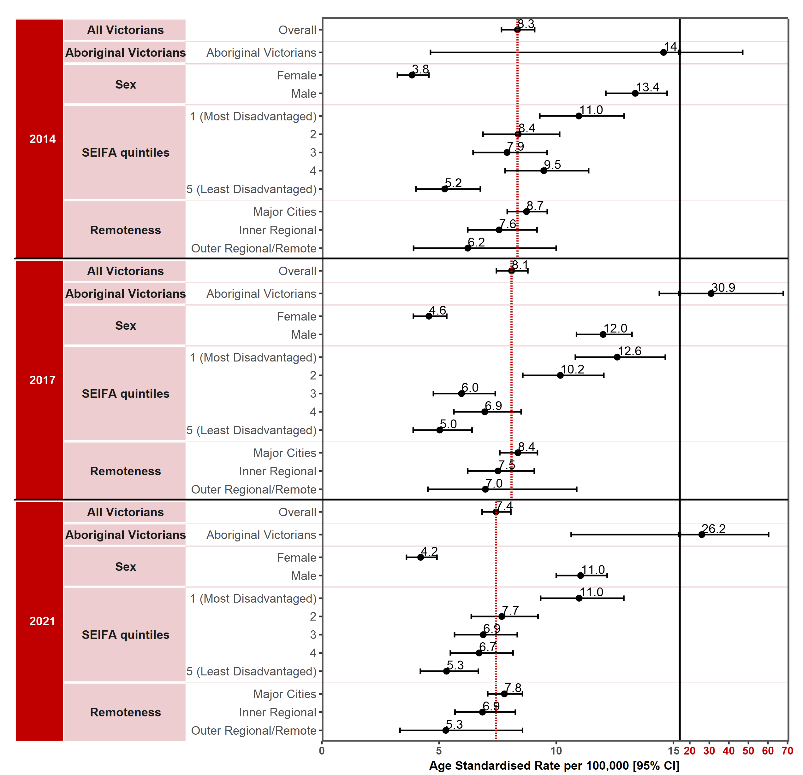
Note: Results by cultural diversity are not presented because the ERP does not estimate the population by cultural diversity, hence there is no denominator for this variable.
Appendix 2 provides the dataset.
Figure 1.8.1: Incidence of liver cancer (primary) in Victoria per 100,000 standardised to the 2001 Australian population, by ICS and year, 2014, 2017 and 2021
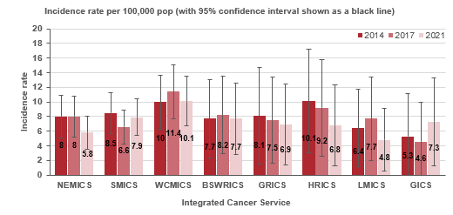
Measure assessment
Traffic light rating: Amber (desired result not yet evident)
Overall trend: Generally moving in the right direction however there is currently uncertainty regarding the impact of the pandemic as to the true direction of trend
Commentary: Liver cancer can be divided into two types: primary liver cancer and secondary liver cancer (that is, cancer that develops elsewhere in the body and spreads to the liver). Globally primary liver cancer was the sixth most commonly diagnosed cancer in 2020. Incidence rates of liver cancer are two to three times higher among men in most world regions. In 2017 liver cancer was the 14th most commonly diagnosed cancer in Australia. In 2018 the age-standardised incidence rate was 8.1 cases per 100,000 population (13 for males and 3.9 for females). Victoria followed a similar trend in that the age-standardised incidence rate ranged from 8.3 cases per 100,000 population in 2014 to 7.4 per 100,000 population in 2021. In addition the incidence rate was also higher for males (13.4 per 100,000 population in 2014 falling to 11 per 100,000 population in 2021) compared with females (3.8 per 100,000 population in 2014 rising to 4.2 per 100,000 population in 2021).
For Aboriginal and Torres Strait Islander Victorians, the age-standardised incidence rates for liver cancer have varied over time. An increasing trend was observed in the liver cancer age-standardised incidence rate for Aboriginal Victorians. However, these results should be interpreted with caution because, while incidence appears to have increased from 14 per 100,000 population in 2014 to 26.2 per 100,000 population in 2021, the 95% confidence intervals are very wide and overlap (Figure 1.8).
Figure 1.8.2: Incidence of liver cancer (primary) in Victoria per 100,000 standardised to the 2001 Australian population, by Victorian LGA, 2014, 2017 and 2021
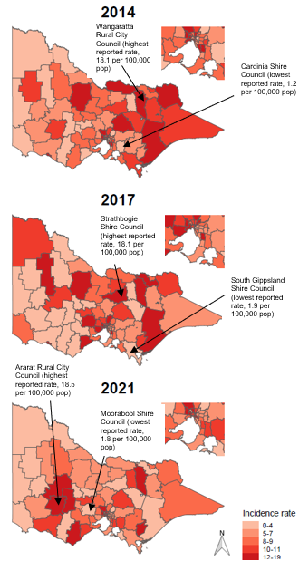
Age-standardised incidence rates for liver cancer continued to be highest in the lowest socioeconomic quintile (SES 1) between 2014 and 2021. Similarly, age-standardised rates for liver cancer were also generally higher in major cities (8.7 per 100,000 population in 2014, falling to 7.8 per 100,000 in 2021) compared with areas outside major cities (Figure 1.8). This trend may be related to increases in migration to Victorian metropolitan areas from hepatitis B and C endemic areas such as the Asia-Pacific region and sub-Saharan Africa before the COVID-19 pandemic. For example, age-standardised incidence rates of liver cancer in Australian-born Victorians compared with other major migrant groups over the five-year period 2016 to 2020 was higher in males and females born in the South-East Asia region compared with people born in the Southern and Central Asia and African regions.
Figure 1.8.1 shows variation between all the Victorian ICSs, although the low numbers may account for the wide confidence intervals, so they should be interpreted with caution.
The spatial variation of incidence rates of liver cancer by LGA are presented in Figure 1.8.2, showing overall higher rates in greater metropolitan Melbourne compared with rural Victoria. In 2014, 46.8% of the 79 LGAs had equal to or higher incidence rates of liver cancer than the overall rate (8.3 per 100,000 population). Wangaratta Rural City LGA reported the highest incidence rate (18.1 per 100,000 population) and Cardinia Shire LGA the lowest incidence rate (1.2 per 100,000 population) in 2014 (Table 1.8b, Appendix 2). However, seven LGAs reported zero incidence rates in 2014. By comparison, 41.8% of the 79 LGAs had higher incidence rates of liver cancer than the overall rate (7.8 per 100,000 population) for Victoria in 2021. Ararat Rural City LGA reported the highest incidence rate (18.5 per 100,000 population) and Moorabool Shire LGA the lowest (1.8 per 100,000 population) in 2021 (Table 1.8d, Appendix 2). Furthermore, there were six LGAs that reported zero incidence rates for 2021. Overall, most of the 79 LGAs reported very little variation in the incidence rate during the reporting period; this was likely due to the low number of cases.

No target has been set for this measure; however, the higher incidence rates in Aboriginal and Torres Strait Islander Victorians suggests that this subpopulation is still a major group among which hepatitis B is endemic and hepatitis C is disproportionately common – both chronic hepatitis B and C, if left untreated, are a leading cause of liver cancer. The Victorian hepatitis B and C plans for 2022–30 continue to address the significant public health burden from hepatitis B and hepatitis C (viral hepatitis) including at-risk population groups. Other risk factors for liver cancer include metabolic and alcohol related causes, especially growing obesity rates with increases in metabolic-associated fatty liver disease that leads to a pathway of fibrosis, cirrhosis and hepatocellular carcinoma.
Key result: Decrease deaths due to cancer

Measure 2.1 – Death rate due to cancer
Figure 2.1: Global cancer death rate from all cancers combined per 100,000 population for both sexes, 2019
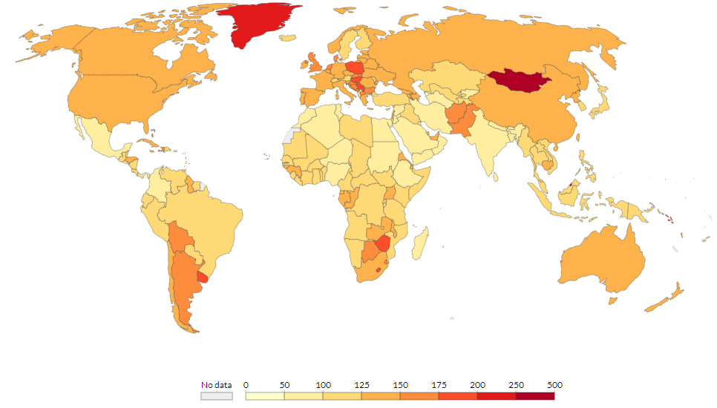
Source: Institute for Health Metrics and Evaluation, Global Burden of Disease (2019). Retrieved from: https://ourworldindata.org/cancer#deaths-from-cancer [Online Resource]
Note: To allow comparisons between countries and over time this metric is age-standardised.
Figure 2.1.1: Victorian death rate for all cancers combined, by sex and year, 2010–2021
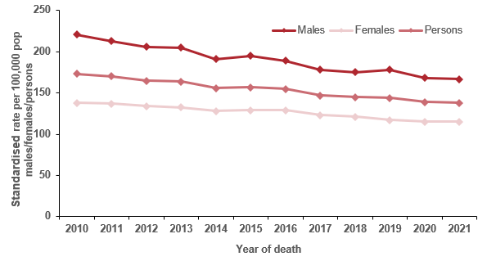
Note: Direct age-standardised rate per 100,000 population, standardised to the 2001 population of Australia.
Table 2.1: Victorian death rate for all cancers combined, by sex and year, 2010–2021
Sex | 2010 | 2011 | 2012 | 2013 | 2014 | 2015 | 2016 | 2017 | 2018 | 2019 | 2020 | 2021
Males (ASR) | 221 | 213 | 206 | 205 | 191 | 195 | 189 | 178 | 175 | 178 | 168 | 167
(95% CI) | (215–226) | (207–218) | (201–212) | (200–211) | (186–196) | (190–200) | (184–194) | (174–183) | (171–180) | (173–182) | (164–172) | (163–172)
Females (ASR) | 138 | 137 | 134 | 132 | 128 | 129 | 129 | 123 | 121 | 117 | 115 | 115
(95% CI) | (134–142) | (133–141) | (130–138) | (129–136) | (124–132) | (125–133) | (126–133) | (119–126) | (117–124) | (114–120) | (112–119) | (112–118)
Persons (ASR) | 173 | 170 | 165 | 164 | 156 | 157 | 155 | 147 | 145 | 144 | 139 | 138
(95% CI) | (170–177) | (166–173) | (162–169) | (161–167) | (153–159) | (154–160) | (153–158) | (144–150) | (142–147) | (141–147) | (136–141) | (136–141)
ASR = age-standardised rate
Figure 2.1.2: Forest plots comparing the age-adjusted mortality (death) rates (and 95% confidence intervals) for deaths by all cancers in the baseline year (2010) and the most recent year where mortality data is available (2021), standardised to the 2001 Australian population
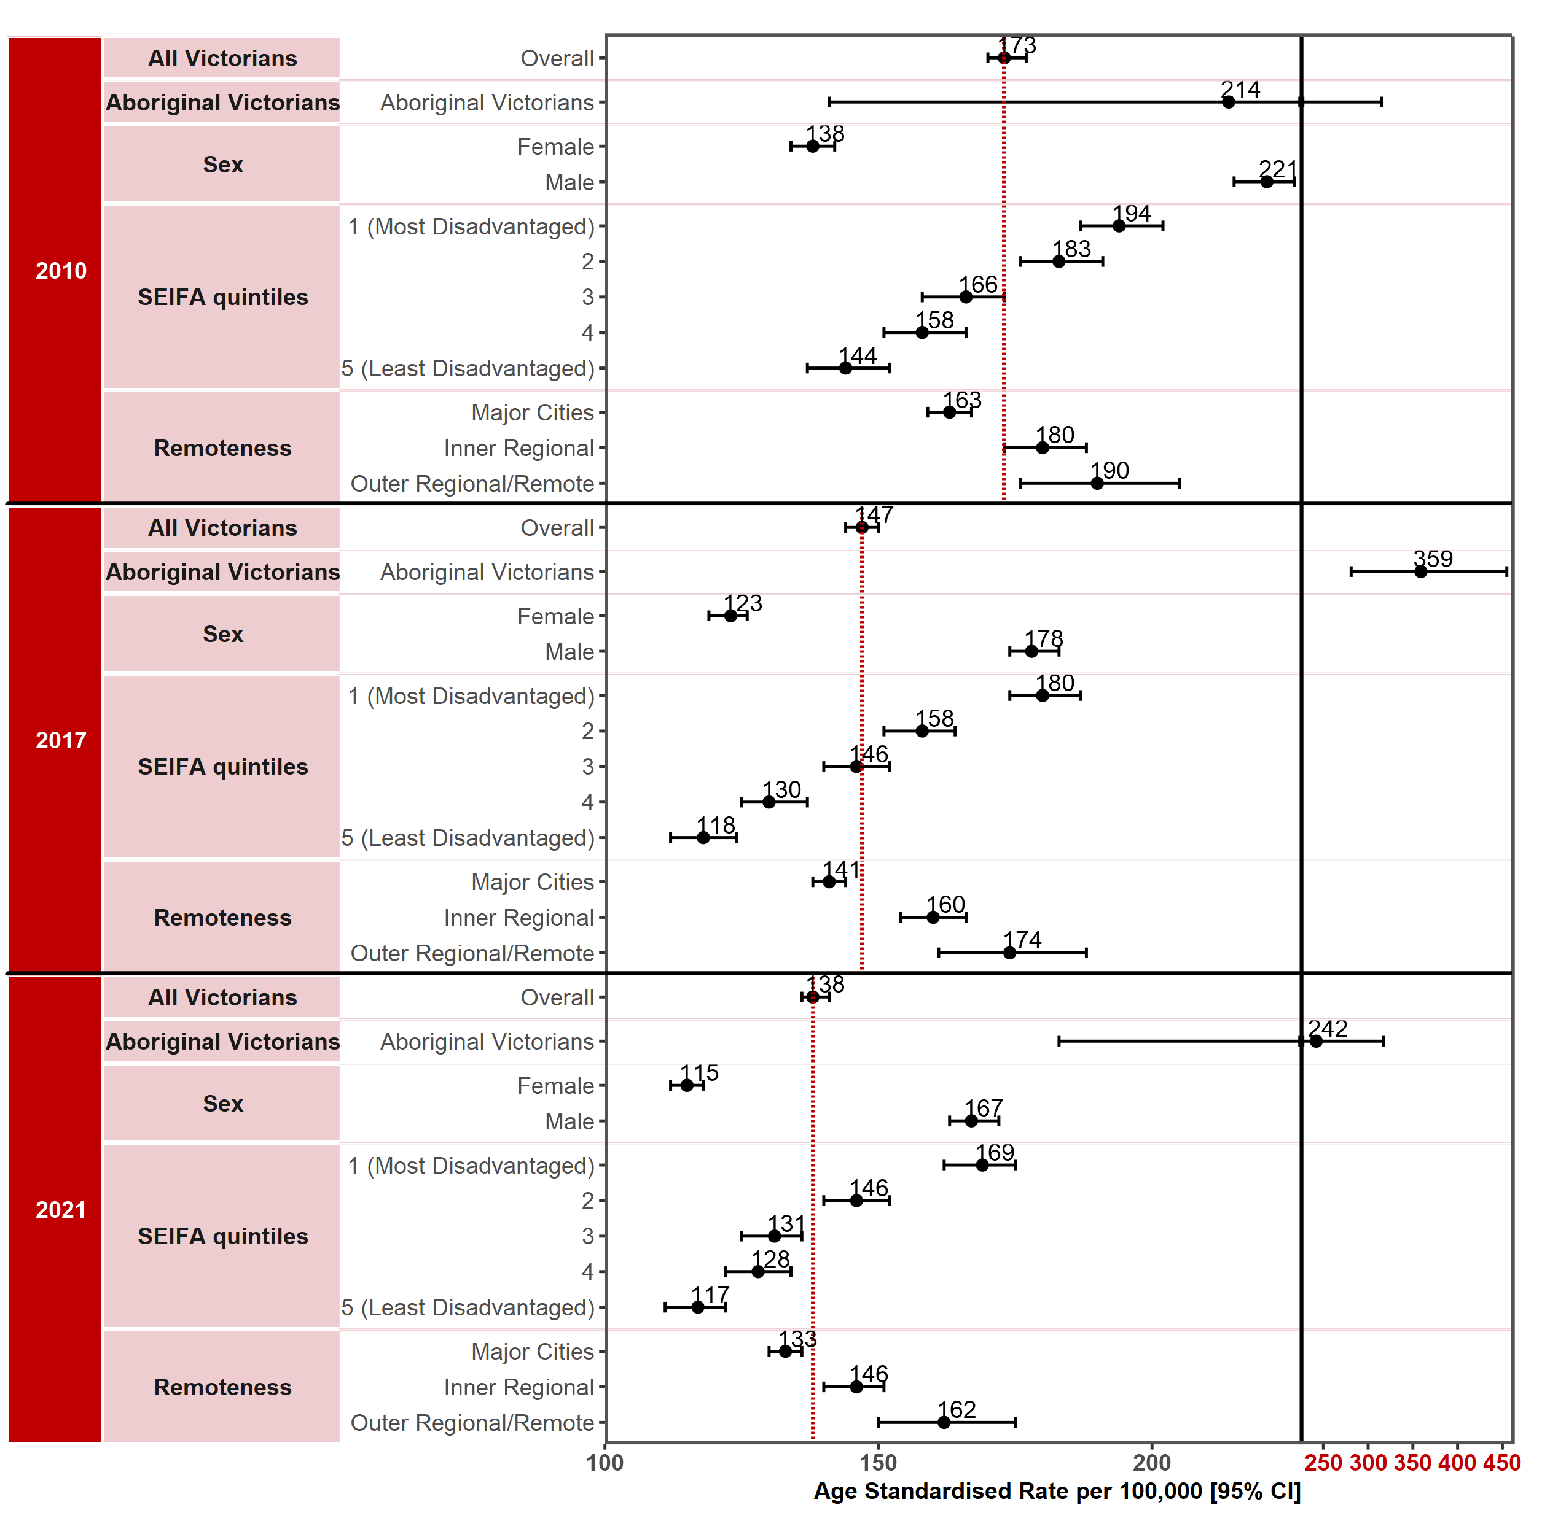
Appendix 2 provides the dataset.
Figure 2.1.3: Victorian death rate for all cancers combined, by LGA, 2010, 2017 and 2021
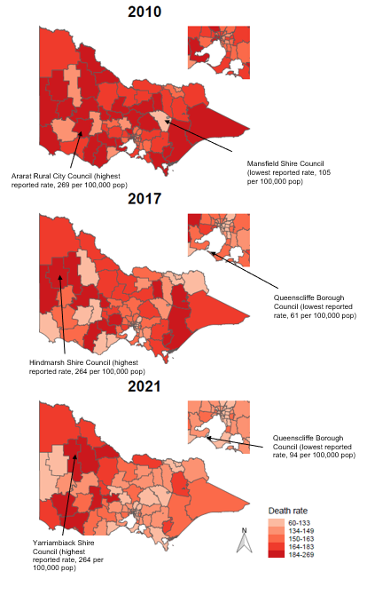

Queenscliffe Borough Council (lowest reported rate, 94 per 100,000 pop)
Queenscliffe Borough Council (lowest reported rate, 61 per 100,000 pop)
Hindmarsh Shire Council (highest reported rate, 264 per 100,000 pop)
Yarriambiack Shire Council (highest reported rate, 264 per 100,000 pop)
Ararat Rural City Council (highest reported rate, 269 per 100,000 pop)
Mansfield Shire Council (lowest reported rate, 105 per 100,000 pop)
Figure 2.1.4: Victorian death rate for all cancers combined, by ICS by year, 2010–2021
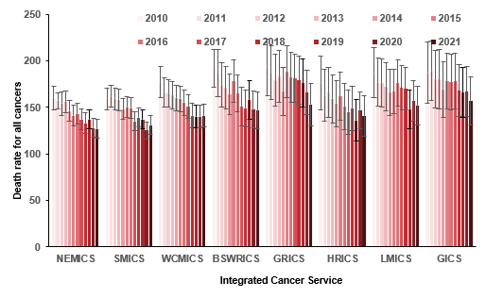

Measure assessment
Traffic light rating: Green (satisfactory result)
Overall trend: Moving in the right direction
Commentary: Cancer remains among the leading causes of death worldwide. Figure 2.1 presents the distribution of all-cancer death rates in 2019 according to world area for both sexes combined. On average, higher income countries tended to fall towards the upper range for death rates; across North America, Europe and Australasia (including Australia), rates in 2019 for most countries ranged from 50 to 150 deaths per 100,000 population.
Cancer is a leading cause of disease burden in Victoria (and is broadly similar to other Australian states and territories), with almost 11,581 cancer-related deaths in 2021. Between 2010 and 2021, the age-standardised death rate for all cancers combined decreased from 173 (2010) to 138 (2021) per 100,000 population. This pattern was slightly more pronounced in males than females (Table 2.1). The decline reflects earlier detection of cancers through screening, reductions in tobacco use (especially in males) and improvements in treatment. However, by 2032, it is projected that deaths from cancers will increase to more than 13,000 per year. These increases are largely attributable to the growth and ageing of the Victorian population. This is due to cancer being strongly related to age, with less than 1% of tumours occurring before age 20 compared with 60% occurring in people older than 65 years.
By comparison, the age-standardised death rate for all cancers combined in this period (2010–2021) was higher among Victorians living in inner regional, outer regional and remote areas and rural LGAs (Figure 2.1.3; Tables 2.1.1c to e) when compared with people living in major cities, although this is declining. A similar disparity was observed among Victorians living in the lowest SES areas (SES 1). Here the age-standardised death rate for all cancers combined was highest (194 per 100,000 population in 2010, 180 per 100,000 population in 2017 and 169 per 100,000 population in 2021) among Victorians living in the lowest SES areas (SES 1) and lowest (144 per 100,000 population in 2010, 118 per 100,000 population in 2017 and 117 per 100,000 population in 2021) among Victorians living in the highest SES areas (SES 5) (Figure 2.1.2). Figure 2.1.4 shows that the death rate trended downwards for most ICSs between 2010 and 2021 but the exception with SMICS shows at increase in the death rate between 2020 and 2021 (Figure 2.1.4).
The age-standardised death rate was also significantly higher for Aboriginal Victorians than for non-Aboriginal Victorians, having increased from 214 per 100,000 population in 2010 to 242 per 100,000 population in 2021. In addition, Aboriginal death rates were more than twice those for Victorians of other descent between 2017 and 2021 (Figure 2.1.2). Although no target has been set for this measure, the results show there are some Victorian populations that continue to experience a greater burden of disease due to cancer.

Measure 2.2 – Premature death rate due to cancer
Figure 2.2: Global map presenting national ranking of all cancers (combined) as a cause of premature death (below 70 years) in 2019
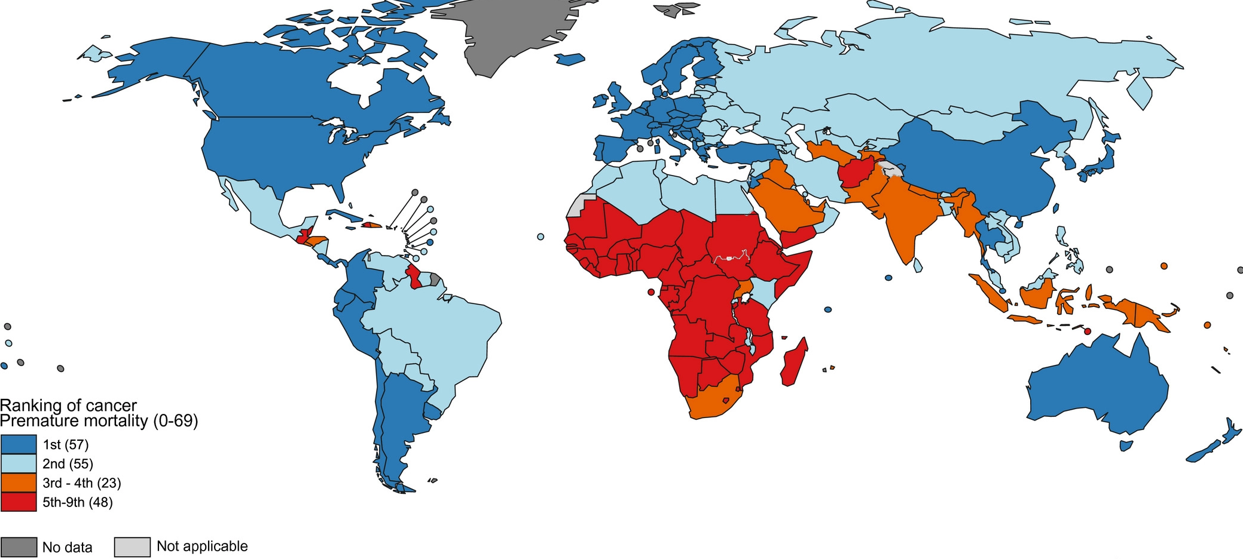
Source: World Health Organization
Figure 2.2.1: Victorian premature death rate for all cancers combined, by sex and year, 2010–2021
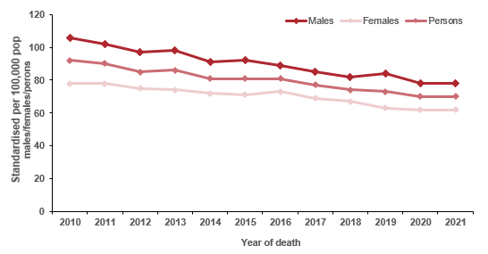

Note: Direct age-standardised rate per 100,000 population, standardised to the 2001 population of Australia.
Table 2.2: Victorian premature death rate for all cancers combined, by sex and year, 2010–2021
Sex | 2010 | 2011 | 2012 | 2013 | 2014 | 2015 | 2016 | 2017 | 2018 | 2019 | 2020 | 2021
Males (ASR) | 106 | 102 | 97 | 98 | 91 | 92 | 89 | 85 | 82 | 84 | 78 | 78
(95% CI) | (102–110) | (99–106) | (93–100) | (95–102) | (88–95) | (89–95) | (86–92) | (82–88) | (79–85) | (81–87) | (75–81) | (75–81)
Females (ASR) | 78 | 78 | 75 | 74 | 72 | 71 | 73 | 69 | 67 | 63 | 62 | 62
(95% CI) | (75–81) | (75–82) | (72–78) | (71–77) | (69–75) | (68–74) | (70–76) | (67–72) | (65–70) | (61–66) | (60–65) | (60–65)
Persons (ASR) | 92 | 90 | 85 | 86 | 81 | 81 | 81 | 77 | 74 | 73 | 70 | 70
(95% CI) | (89–94) | (88–93) | (83–88) | (83–88) | (79–84) | (79–83) | (78–83) | (75–79) | (72–76) | (71–75) | (68–72) | (68–72)
ASR = age-standardised rate
Figure 2.2.2: Forest plots comparing the age-adjusted mortality (death) rates (and 95% confidence intervals) for Victorian premature deaths by all cancers in the baseline year (2010) and the most recent year where mortality data is available (2021), in those younger than 75 years of age at death, standardised to the 2001 Australian population
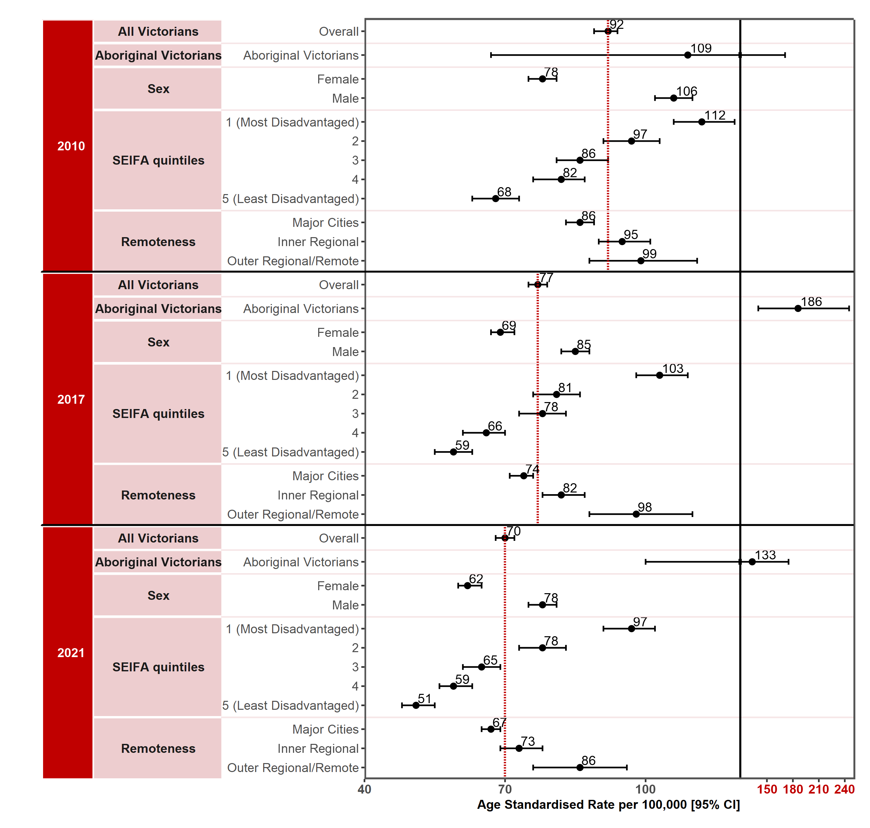
Appendix 2 provides the dataset.
Figure 2.2.3: Victorian premature death rate for all cancers combined, by LGA, 2010, 2017 and 2021
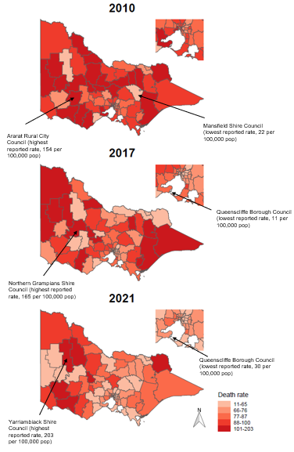
Queenscliffe Borough Council (lowest reported rate, 30 per 100,000 pop)
Northern Grampians Shire Council (highest reported rate, 165 per 100,000 pop)
Mansfield Shire Council (lowest reported rate, 22 per 100,000 pop)
Queenscliffe Borough Council (lowest reported rate, 11 per 100,000 pop)
Yarriambiack Shire Council (highest reported rate, 203 per 100,000 pop)
Ararat Rural City Council (highest reported rate, 154 per 100,000 pop)
Figure 2.2.4: Victorian death rate for all cancers combined, by ICS by year, 2010–2021
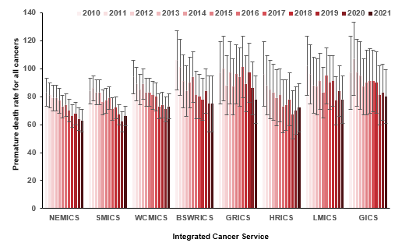

Measure assessment
Traffic light rating: Green (satisfactory result)
Overall trend: Moving in the right direction
Commentary: Globally cancer is expected to rank as the leading cause of death and the single most important barrier to increasing life expectancy in every country of the world in the 21st century. According to World Health Organization estimates in 2019, cancer was the first or second leading cause of death before age 70 years in 112 of the 183 countries including Australia (Figure 2.2).
For the purposes of this report, deaths from cancer among people under 75 years of age are considered premature. Figures 2.2.1, 2.2.2 and Table 2.1 show that, overall, the premature death rate has changed over time from 92 per 100,000 population in 2010 to 70 per 100,000 in 2021, most likely due to preventive and therapeutic interventions. The mortality rate is steadily decreasing for both genders, although the higher premature death rate for males compared with females may reflect the underlying trend in incidence rates of lung cancer – the leading cause of cancer deaths in Victorian males (Figures 2.2.1 and 2.2.2).
While the premature pattern in death rates is steadily declining in Victoria overall, Figure 2.2.2 shows there continues to be considerable variation in the rates of decline across SES quintiles, with higher premature death rates being associated with the most disadvantaged SES quintiles. Variations in remoteness and by LGA of premature death rates between 2010 and 2021 also show that, overall, the rate was higher in outer regional/remote Victorian areas compared with major cities (Figure 2.2.3). In addition, and of concern, is the increase from 109 per 100,000 population in 2010 to 133 per 100,000 population in 2021 in the age-standardised premature death rate for Aboriginal Victorians. This observation may be due to differences in access to and outcomes of cancer control activities such as screening, diagnosis, treatment and follow-up. For Aboriginal Victorians strategies specific to an Aboriginal workforce that provide coordinated support along the cancer journey are required to ensure culture is embedded at each stage.
The Victorian death rate for all cancers combined by ICS showed higher rates in the rural/regional ICS compared with the metropolitan ICSs (NEMICS, SMICS and WCMICS) (Figure 2.2.4). While the death rate for all cancers combined showed a gradual decrease for most ICSs, there were exceptions, namely SMICS and HRICS, which showed an increase between 2020 and 2021.
The target for this measure is a 25% decrease in premature deaths due to cancer by 2025 from the baseline year (baseline 2010 = 92, which means the target in 2025 will be 69). Figure 2.2 shows that, overall, Victoria is moving in the right direction having almost reached the 2025 target in 2021. This suggests that the effectiveness of the health system as it relates to cancer has improved overall outcomes. However, the findings for 2020 should be interpreted with caution because the impact of the COVID-19 pandemic may have resulted in a decrease in registered deaths. Furthermore, findings by Aboriginality and SES show that not all Victorians have benefited.

Measure 2.3 – Number of deaths averted based on expected number of deaths
Figure 2.3: Number of deaths averted in Victoria based on expected number of deaths, by year, 2015–2021
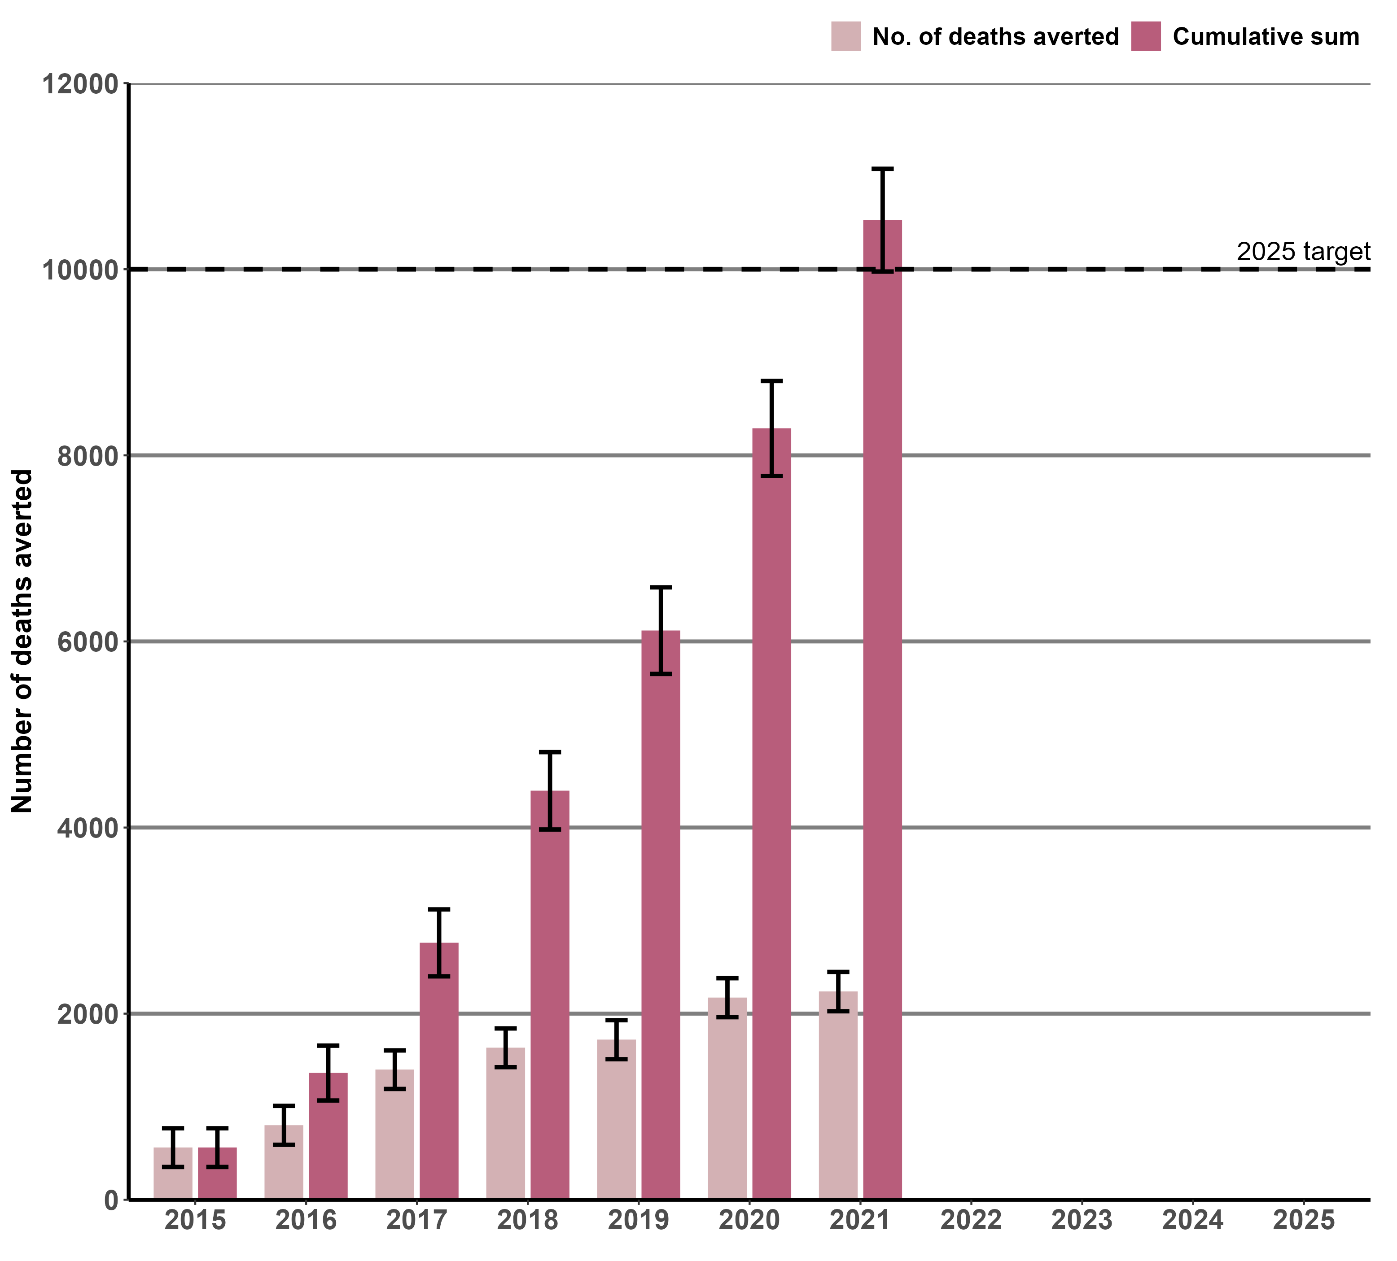
Notes:
At the time of preparing results, the ABS had not yet finalised the 2021 ERP. The VCR mortality dataset was extracted during October 2022.

Measure assessment
Traffic light rating: Green (satisfactory result)
Overall trend: Moving in the right direction; target has been met.
Commentary: The results presented in Figure 2.3 show that since 2015 the number of lives in Victoria that were potentially saved from cancer (or deaths averted) has significantly increased. At the time of writing this observed increase may be artificial due to the Australian Bureau of Statistics (ABS) ERP figure not being finalised because of outstanding mortality data. Nevertheless the overall increase over this period may be due to the collective efforts of higher screening rates for cancers such as breast, colorectal and cervical, cancer prevention strategies such as effective tobacco control and earlier cancer detection (including funding more managed referral pathway support for regional and remote patients) as well as advances in treatment.
The target for this measure is that 10,000 lives are saved by 2025. Figure 2.3 shows that this target for Victoria has been met, with 10,529 lives saved between 2015 and 2021.
Key result: Increase survivorship quality of life

Measure 3.1 – Long term quality of life
Figure 3.1: Proportion of adults who reported how they felt post active therapy, 2019 and 2022
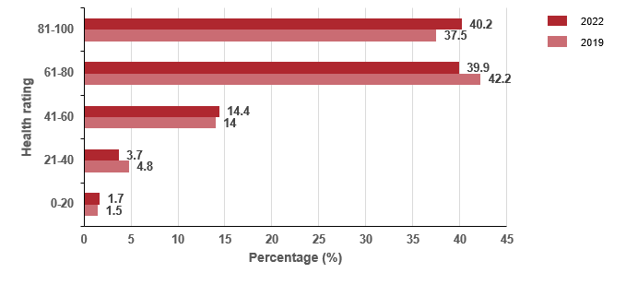

Notes:
Overall question: We would like to know how good or bad your health is today. 0 was the worst health they could imagine and 100 the best health.
Total number of patients who answered the question = 2,618 (2019) and 3,430 (2022)

Measure assessment
Traffic light rating: Amber (desired result not yet evident)
Overall trend: Appears to be moving in the right direction
Commentary: Understanding the patient experience across the pathway of care assists health services and health care professionals to improve ways in which care is delivered. Data presented in Figure 3.1 was captured from a pilot that utilised the cancer chemotherapy patient experience module administered in 2020 for patients that received care in 2019. While no target has been set for this measure, Figure 3.1 shows that in 2019 the majority (61-100; 79.7%) of patients rated their health to be good in terms of how they felt on the day of the survey. This increased slightly to 80.1% (61-100 health rating) in 2022.

Outcome: Equitable outcomes for all Victorians

Key result: Equitably reduce cancer incidence

Measure 4.1 – Rate ratio of preventable cancer incidence between Integrated Cancer Services
Figure 4.1: Rate ratio of preventable cancer incidence in ICS of residence compared with the ICS of residence with the lowest adjusted incidence rate, grouped by year of diagnosis, 2014–2021
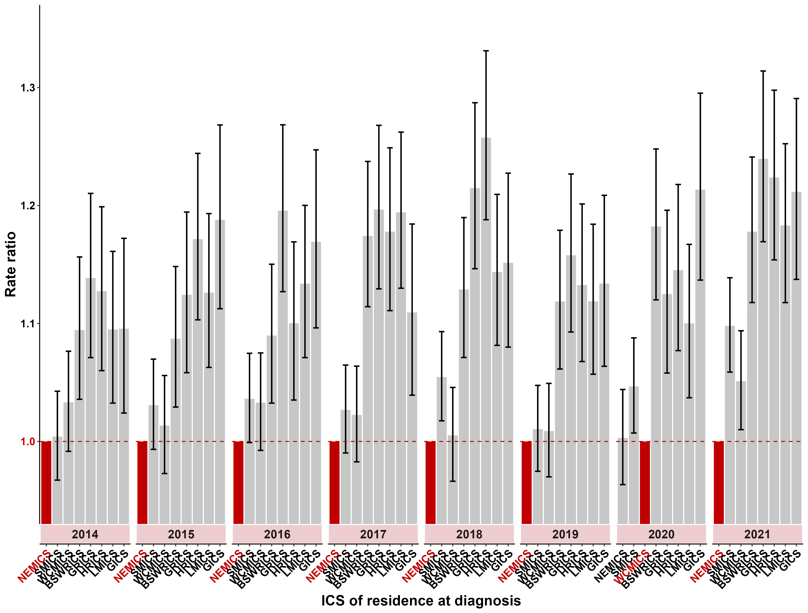
Notes:
Estimated and projected resident population files sourced from the ABS. Note that at the time of preparing results, the ABS had not yet finalised the 2021 ERP.
The baseline ICS for calculating the rate of ratios for each year is the ICS with the lowest adjusted incidence rate for the year of interest and is highlighted in red. A rate ratio greater than 1 indicates a higher incidence rate than the baseline ICS.
Table 4.1: Rate ratio of preventable cancer incidence in ICS of residence compared with the ICS of residence with the lowest adjusted incidence rate, grouped by year of diagnosis from 2014 to 2021
ICS | 2014  (95% CI) | 2015  (95% CI) | 2016  (95% CI) | 2017  (95% CI) | 2018  (95% CI) | 2019  (95% CI) | 2020  (95% CI) | 2021  (95% CI)
NEMICS | Ref point | Ref point | Ref point | Ref point | Ref point | Ref point | 1.0 | Ref point
SMICS | 1.0  (0.9–1.1) | 1.0  (0.9–1.1) | 1.0  (0.9–1.1) | 1.0  (0.9–1.1) | 1.1  (1.0–1.2) | 1.0  (0.9–1.1) | 1.0  (0.9–1.1) | 1.1  (1.0–1.2)
WCMICS | 1.0  (0.9–1.1) | 1.0  (0.9–1.1) | 1.0  (0.9–1.1) | 1.0  (0.9–1.1) | 1.0  (0.9–1.1) | 1.00  (0.9–1.1) | Ref point | 1.1  (1.0–1.2)
BSWRICS | 1.1  (1.0–1.2) | 1.1  (1.0–1.2) | 1.1  (1.0–1.2) | 1.2  (1.1–1.3) | 1.1  (0.9–1.2) | 1.1  (1.0–1.2) | 1.1  (1.0–1.3) | 1.2  (1.1–1.3)
GRICS | 1.1  (1.0–1.2) | 1.1  (1.0–1.2) | 1.1  (1.0–1.2) | 1.2  (1.1–1.3) | 1.2  (1.1–1.3) | 1.2  (1.1–1.3) | 1.0  (0.9–1.1) | 1.2  (1.1–1.3)
HRICS | 1.1  (1.0–1.2) | 1.2  (1.1–1.3) | 1.1  (1.0–1.2) | 1.2  (1.1–1.3) | 1.3  (1.1–1.4) | 1.1  (1.0–1.2) | 1.1  (1.0–1.2) | 1.2  (1.1–1.3)
LMICS | 1.1  (1.0–1.2) | 1.1  (1.0–1.2) | 1.1  (1.0–1.2) | 1.2  (1.1–1.3) | 1.1  (1.0–1.2) | 1.1  (1.0–1.2) | 1.0  (0.9–1.1) | 1.2  (1.1–1.3)
GICS | 1.1  (1.0–1.2) | 1.2  (1.1–1.3) | 1.2  (1.1–1.3) | 1.1  (1.0–1.2) | 1.2  (1.0–1.2) | 1.1  (1.0–1.2) | 1.2  (1.1–1.3) | 1.2  (1.1–1.3)

Measure assessment
Traffic light rating: Amber (desired result not yet evident)
Overall trend: Static or unchanging
Commentary: Figure 4.1 and Table 4.1 show there are disparities in cancer outcomes between people living in metropolitan versus non-metropolitan regions, with the rate of preventable cancer incidence between ICS from 2014 to 2021 generally lower in ICSs covering large metropolitan areas such as Melbourne compared with those who service regional patients. While no target has been set for this measure, the Department of Health recognises and is continuing to address the need to improve access to cancer treatment within non-metropolitan regions.

Measure 4.2 – Rate ratio of preventable cancer incidence between socioeconomic quintiles
Figure 4.2: Rate ratio of preventable cancer incidence (with confidence intervals) for Victoria in SES quintiles 1–4 (where SES 1 is most disadvantaged) compared with the least disadvantaged quintile (SES 5), grouped by year of diagnosis, 2014–2021
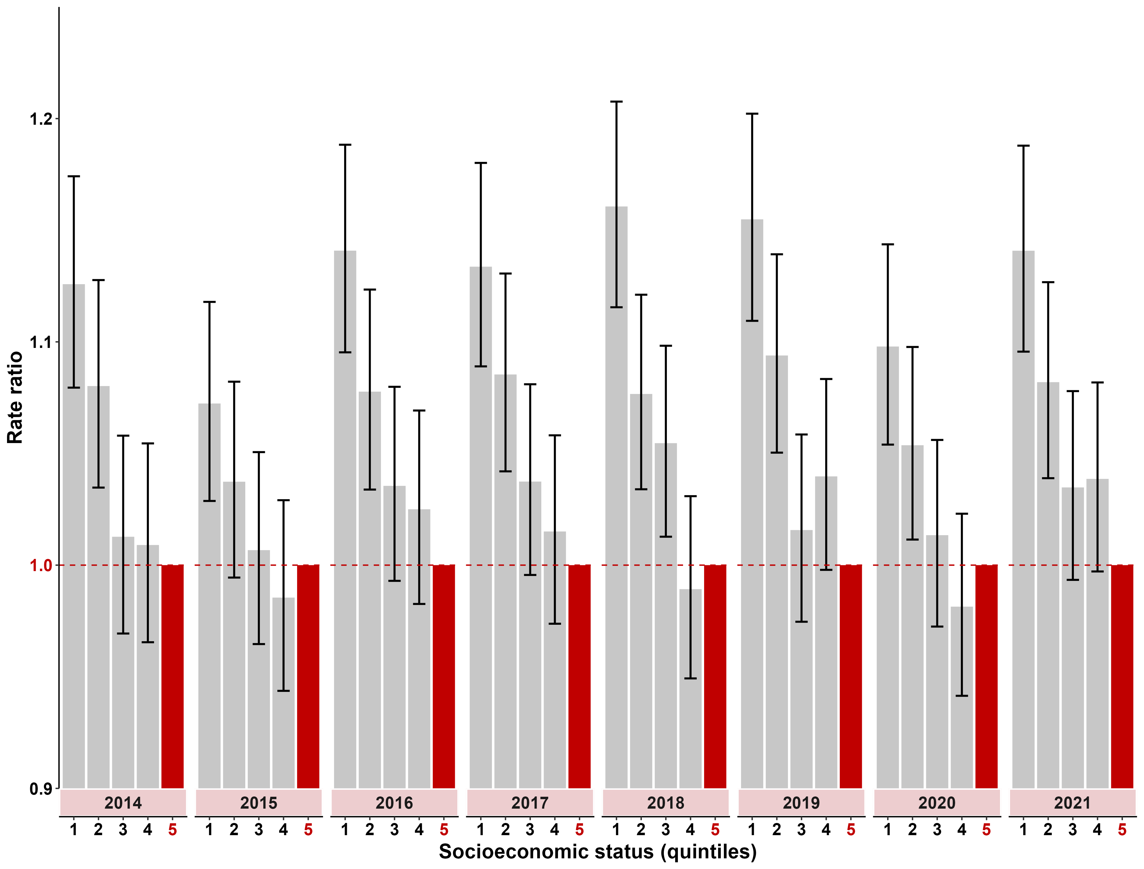
Notes:
Estimated and projected resident population files sourced from the ABS. Note that at the time of preparing results, the ABS had not yet finalised the 2021 ERP.
The baseline SES quintile used for calculating the rate of ratios for each year is quintile 5 (least disadvantaged) and is highlighted in red. A rate ratio greater than 1 indicates a higher incidence rate than the baseline ICS.
Table 4.2: Rate ratio of preventable cancer incidence (with confidence intervals) for Victoria in SES quintiles 1–4 (where SES 1 is most disadvantaged) compared with the least disadvantaged quintile, grouped by year of diagnosis, 2014–2021
SES | 2014  (95% CI) | 2015  (95% CI) | 2016  (95% CI) | 2017  (95% CI) | 2018  (95% CI) | 2019  (95% CI) |  | 2020  (95% CI) | 2021  (95% CI)
Quintile 1 (most disadvantaged) | 1.1  (1.0–1.2) | 1.1  (1.0–1.2) | 1.1  (1.0–1.2) | 1.1  (1.0–1.2) | 1.1  (1.0–1.2) | 1.1  (1.0–1.2) | 1.1  (1.0–1.2) |  | 1.1  (1.0–1.2)
Quintile 2 | 1.1  (1.0–1.2) | 1.0  (0.9–1.1) | 1.1  (1.0–1.2) | 1.1  (1.0–1.2) | 1.1  (1.0–1.2) | 1.1  (1.0–1.2) | 1.1  (1.0–1.2) |  | 1.1  (1.0–1.2)
Quintile 3 | 1.0  (0.9–1.1) | 1.0  (0.9–1.1) | 1.0  (0.9–1.1) | 1.0  (0.9–1.1) | 1.0  (0.9–1.1) | 1.0  (0.9–1.1) | 1.0  (0.9–1.1) |  | 1.1  (1.0–1.2)
Quintile 4 | 1.0  (0.9–1.1) | 1.0  (0.9–1.1) | 1.0  (0.9–1.1) | 1.0  (0.9–1.1) | 0.9  (0.8–1.0) | 1.0  (0.9–1.1) | 0.9  (0.8–1.0) |  | 1.1  (1.0–1.2)
Quintile 5 – (least disadvantaged) | Ref point | Ref point | Ref point | Ref point | Ref point | Ref point | Ref point |  | Ref point
(refer to note below Figure 4.2.1)

Measure assessment
Traffic light rating: Amber (desired result not yet evident)
Overall trend: Static or unchanging
Commentary: Socioeconomic disparities in incidence have been described for a range of cancers globally across various measures of socioeconomic circumstances. Figure 4.2.1 and Table 4.2 show that the rate of preventable cancer incidence increases as SES decreases. For example, in the period from 2014 to 2021, Victorians who were in the most disadvantaged quintile (first quintile) had a potentially preventable cancer incidence rate that was 1.1 times higher than the potentially preventable cancer incidence for Victorians in the least disadvantaged quintile. While a target has not been set for this measure, studying the relationship between socioeconomic circumstances and cancer incidence in Victoria may identify opportunities to improve the reach and effectiveness of cancer-related improvement activities.

Measure 4.3 – Rate ratio of preventable cancer incidence between Aboriginal and non-Aboriginal Victorians
Figure 4.3: Rate ratio of preventable cancer incidence (with confidence intervals) for Aboriginal Victorians relative to non-Aboriginal Victorians, by year of diagnosis, 2014–2021
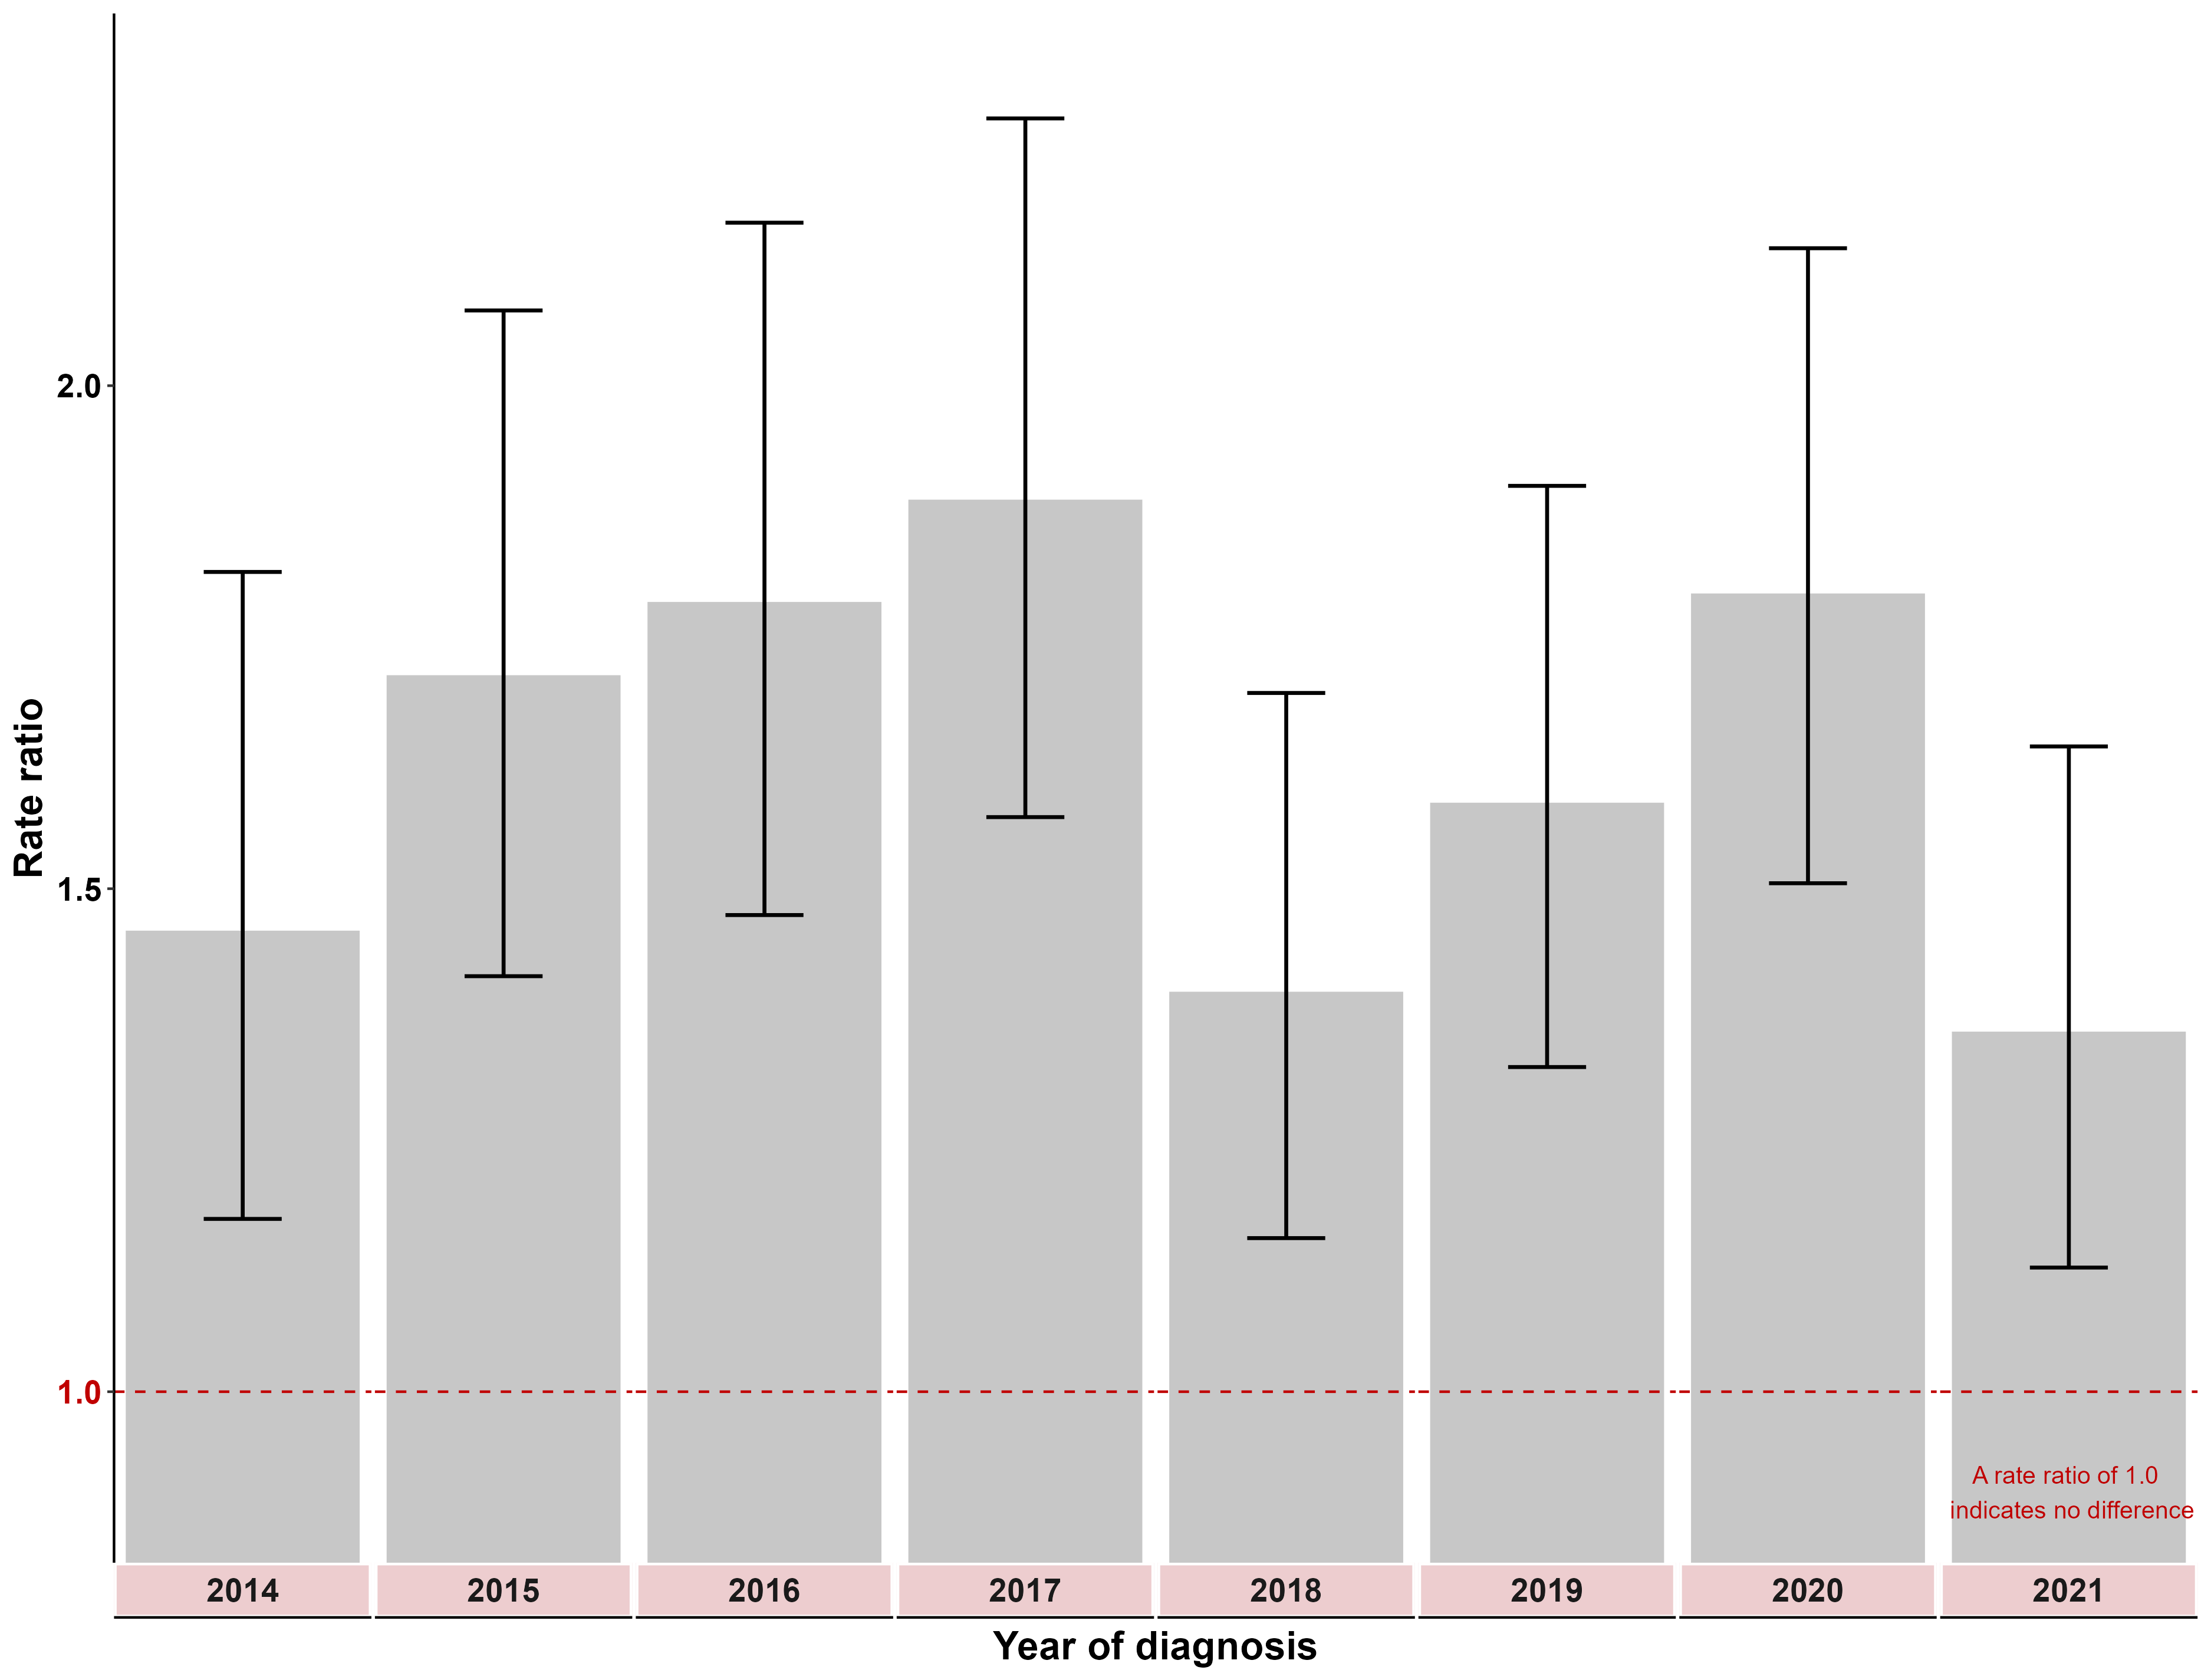
Notes:
These rate ratios are calculated as the Aboriginal and Torres Strait Islander adjusted incidence rate compared with non-Aboriginal and Torres Strait Islander rates for each year. A rate ratio greater than 1 indicates a higher incidence rate for Aboriginal and Torres Strait Islander individuals than non-Aboriginal people.
ERP files were sourced from the ABS. Note that at the time of preparing this report, the ABS had not yet finalised 2021 ERP. The ERP for the non-Aboriginal population in Victoria was calculated by subtracting the Aboriginal and Torres Strait Islander projected population from the total ERP.
Table 4.3: Rate ratio of preventable cancer incidence (with confidence intervals) between Aboriginal and non-Aboriginal Victorians, by year of diagnosis, 2014–2021
Year | 2014 | 2015 | 2016 | 2017 | 2018 | 2019 | 2020 | 2021
Result | 1.4 | 1.7 | 1.6 | 1.8 | 1.4 | 1.6 | 1.7 | 1.4
(95% CI) | (1.2–1.8) | (1.4–2.1) | (1.9–2.1) | (1.5–2.2) | (1.2–1.7) | (1.3–1.9) | (1.4–2.0) | (1.1–1.6)

Measure assessment
Traffic light rating: Red (result is of concern)
Overall trend: Static or unchanging
Commentary: Reducing the impact of preventable cancers among Aboriginal and Torres Strait Islander people is a crucial aspect in ‘closing the gap’ in health outcomes. Although Aboriginal and Torres Strait Islander people are less likely to have some types of cancer, they are significantly more likely to have cancers that have a poor prognosis, but that are largely preventable, such as lung and liver cancer. In the literature, risk factors for higher incidence of preventable cancers remain prevalent in Aboriginal and Torres Strait Islander people. These include smoking, drinking at high-risk levels and poor diet. Figure 4.3 and Table 4.3 show that between 2014 and 2021 Aboriginal Victorians were between one and a half to over two times more likely to have a high incidence rate of preventable cancer than non-Aboriginal Victorians. While a target has not been set for this measure, it is recognised that to address this disparity, programs (including screening programs) designed to improve equity in cancer outcomes for all Victorians are warranted.

Key result: Equitably reduce cancer deaths

Measure 5.1 – Rate ratio of premature death rate due to cancer between Integrated Cancer Services
Figure 5.1: Rate ratio of premature death (with confidence intervals) due to cancer in ICS of residence compared with the ICS of residence with the lowest premature death rate, grouped by year of diagnosis, 2014–2021
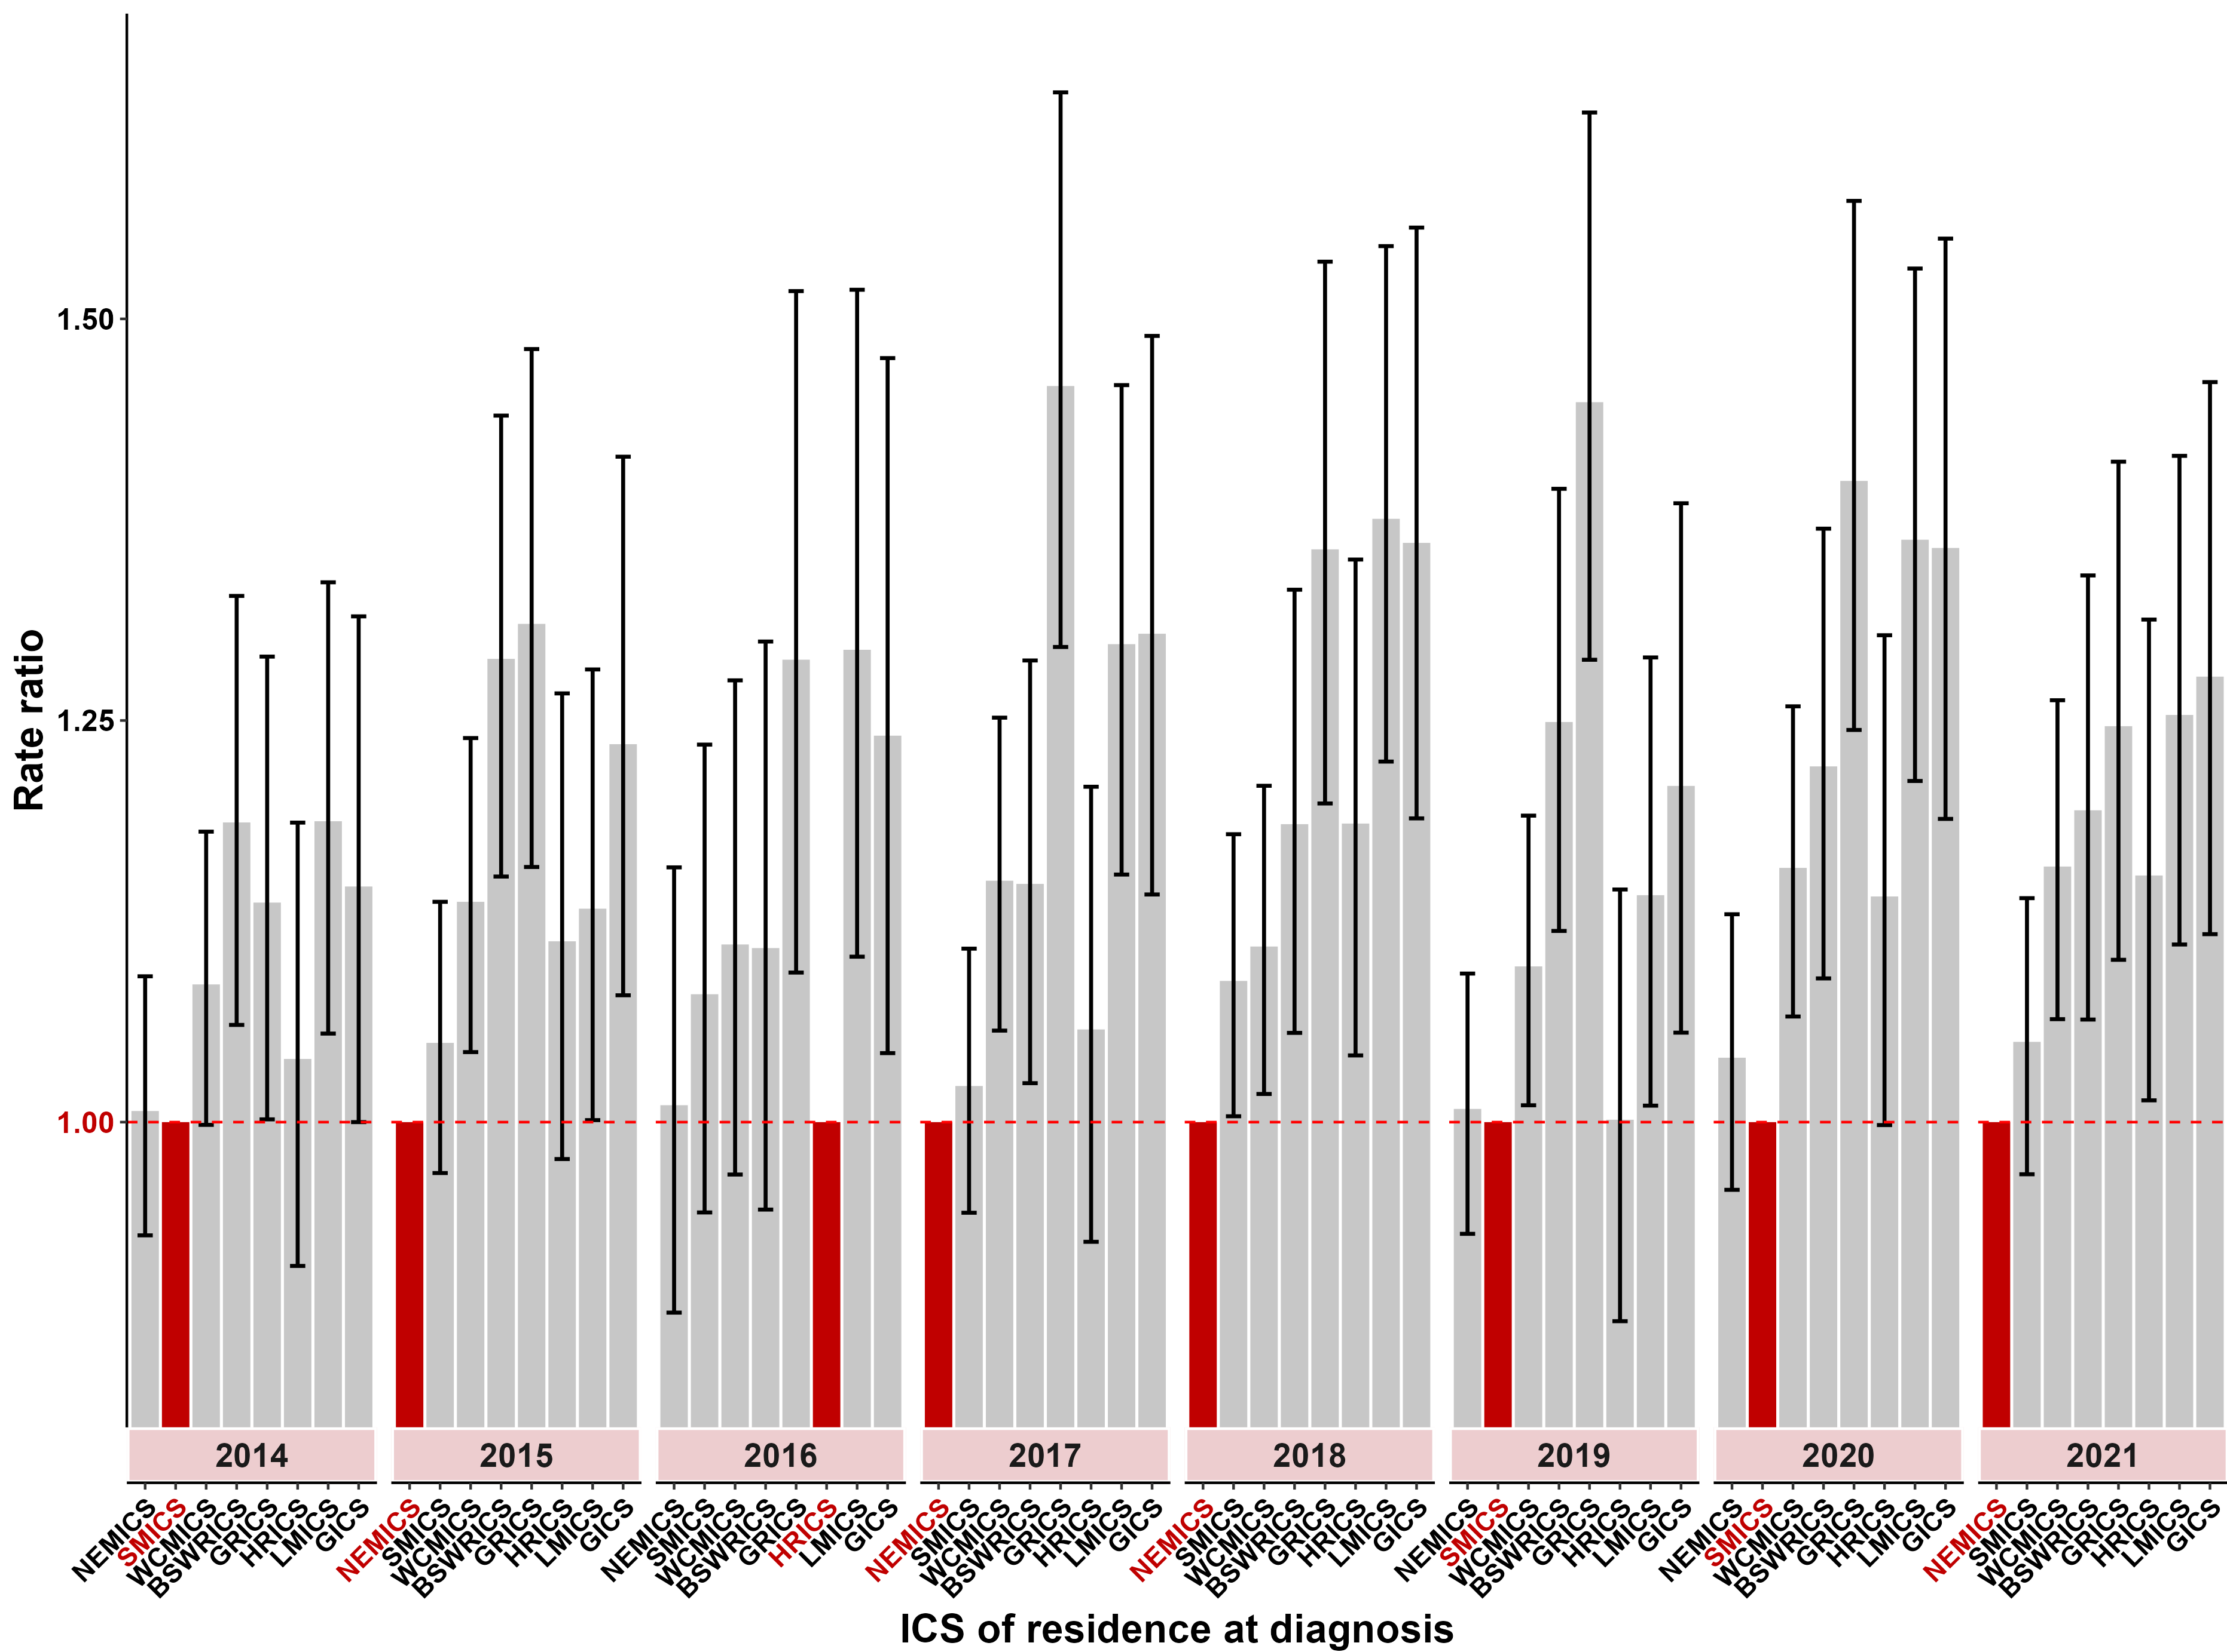
Note: ERP files were sourced from the ABS. Note that at the time of preparing this report, the ABS had not yet finalised the 2021 ERP.
The baseline ICS for calculating the rate ratios for each year is the ICS with the lowest adjusted incidence rate for the year of interest and is highlighted in red. A rate ratio greater than 1 indicates a higher incidence rate than the baseline ICS.
Table 5.1: Rate ratio of premature death (with confidence intervals) due to cancer in ICS of residence compared with the ICS of residence with the lowest premature death rate, grouped by year of diagnosis, 2014–2021
ICS | 2014  (95% CI) | 2015  (95% CI) | 2016  (95% CI) | 2017  (95% CI) | 2018  (95% CI) | 2019  (95% CI) | 2020  (95% CI) | 2021  (95% CI)
NEMICS | 1.0  (0.9–1.1) | Ref point | 1.0  (0.8–1.2) | Ref point | Ref point | 1.0  (0.9–1.1) | 1.0  (0.9–1.1) | Ref point
SMICS | Ref point | 1.0  (0.9–1.1) | 1.1  (0.9–1.2) | 1.0  (0.9–1.1) | 1.1  (1.0–1.2) | Ref point | Ref point | 1.0  (0.9–1.1)
WCMICS | 1.1  (1.0–1.2) | 1.1  (1.0–1.2) | 1.1  (1.0–1.3) | 1.2  (1.1–1.3) | 1.1  (1.0–1.2) | 1.1  (1.0–1.2) | 1.2  (1.1–1.3) | 1.2  (1.1–1.3)
BSWRICS | 1.2  (1.1–1.3) | 1.3  (1.2–1.4) | 1.1  (1.0–1.3) | 1.1  (1.0–1.2) | 1.2  (1.1–1.3) | 1.2  (1.1–1.4) | 1.2  (1.1–1.4) | 1.2  (1.1–1.3)
GRICS | 1.1  (1.0–1.3) | 1.3  (1.2–1.5) | 1.3  (1.1–1.5) | 1.5  (1.3–1.6) | 1.4  (1.2–1.5) | 1.4  (1.3–1.6) | 1.4  (1.2–1.6) | 1.2  (1.1–1.4)
HRICS | 1.0  (0.9–1.2) | 1.1  (1.0–1.3) | Ref point | 1.1  (0.9–1.2) | 1.2  (1.0–1.4) | 1.0  (0.9–1.1) | 1.1  (1.0–1.3) | 1.2  (1.1–1.4)
LMICS | 1.2  (1.1–1.3) | 1.1  (1.0–1.3) | 1.3  (1.1–1.5) | 1.3  (1.2–1.5) | 1.4  (1.2–1.5) | 1.1  (1.0–1.3) | 1.4  (1.2–1.5) | 1.3  (1.1–1.5)
GICS | 1.1  (1.0–1.3) | 1.2  (1.1–1.4) | 1.3  (1.2–1.5) | 1.3  (1.1–1.5) | 1.3  (1.2–1.6) | 1.2  (1.1–1.4) | 1.4  (1.2–1.6) | 1.3  (1.1–1.5)
Note: Ref point = the reference point – that is, the ICS residents with the lowest premature death rate for that particular year.

Measure assessment
Traffic light rating: Amber (desired result not yet evident)
Overall trend: Static or unchanging
Commentary: Figure 5.1 and Table 5.1 show that between 2014 and 2021, regional ICSs had populations that were experiencing a greater burden of disease due to cancer, in particular GRICS, LMICS and GICS, which on average had a higher rate of premature death. No target has been set for this measure; however, what these results show is that initiatives designed to address this disparity faced by Victorians in rural and remote regions who are diagnosed with cancer are still warranted.

Measure 5.2 – Rate ratio of premature death rate due to cancer between socioeconomic quintiles
Figure 5.2: Rate ratio of premature death (with confidence intervals) due to cancer in SES quintiles 1–4 (where SES 1 is most disadvantaged) compared with the least disadvantaged quintile, grouped by year of diagnosis, 2014–2021
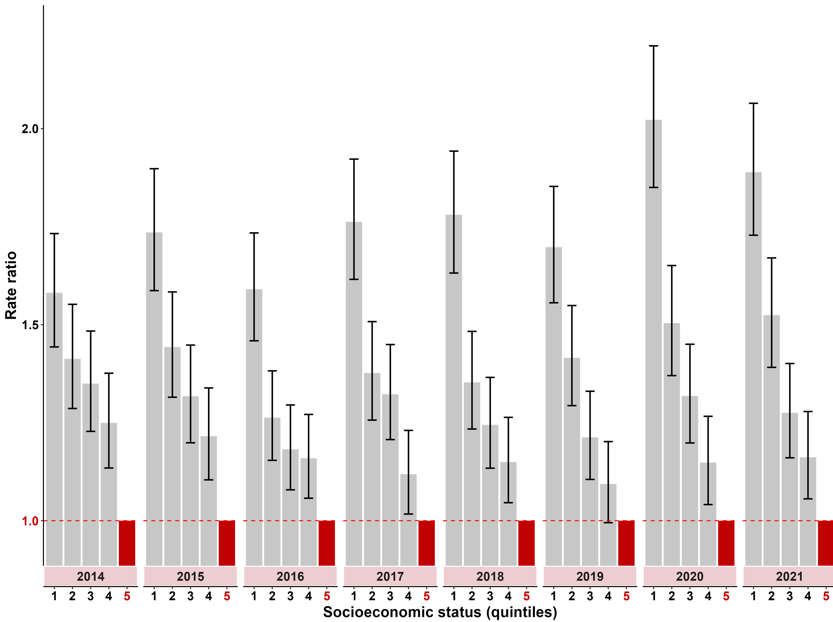
Note: ERP files were sourced from the ABS. Note that at the time of preparing this report, the ABS had not yet finalised the 2021 ERP.
The baseline SES quintile used for calculating the rate ratios for each year is SES quintile 5 (least disadvantaged) and is highlighted in red. A rate ratio greater than 1 indicates a higher incidence rate than the baseline SES quintile.
Table 5.2: Rate ratio of premature death incidence (with confidence intervals) for Victoria in SES quintiles 1–4 (where SES 1 is most disadvantaged) compared with the least disadvantaged quintile, grouped by year of diagnosis, 2014–2021
SES | 2014  (95% CI) | 2015  (95% CI) | 2016  (95% CI) | 2017  (95% CI) | 2018  (95% CI) | 2019  (95% CI) | 2020  (95% CI) | 2021  (95% CI)
Quintile 1 (most disadvantaged) | 1.5  (1.4–1.7) | 1.7  (1.6–1.9) | 1.6  (1.5–1.7) | 1.8  (1.6–1.9) | 1.8  (1.6–1.9) | 1.7  (1.6–1.9) | 2.0  (1.9–2.2) | 1.9  (1.7–2.1)
Quintile 2 | 1.4  (1.3–1.6) | 1.4  (1.3–1.6) | 1.3  (1.2–1.4) | 1.4  (1.3–1.5) | 1.4  (1.2–1.5) | 1.4  (1.3–1.5) | 1.5  (1.4–1.7) | 1.5  (1.4–1.7)
Quintile 3 | 1.3  (1.2–1.5) | 1.3  (1.2–1.4) | 1.2  (1.1–1.3) | 1.3  (1.2–1.4) | 1.2  (1.1–1.4) | 1.2  (1.1–1.3) | 1.3  (1.2–1.5) | 1.3  (1.2–1.4)
Quintile 4 | 1.2  (1.1–1.4) | 1.2  (1.1–1.3) | 1.2  (1.1–1.3) | 1.1  (1.0–1.2) | 1.1  (1.0–1.3) | 1.1  (1.0–1.2) | 1.1  (1.0–1.3) | 1.2  (1.1–1.3)
Quintile 5 – refer to note below Figure 5.2 | Ref point | Ref point | Ref point | Ref point | Ref point | Ref point | Ref point | Ref point
Note: Ref point = the reference point – that is, the SES residents with the lowest premature death rate for that particular year.

Measure assessment
Traffic light rating: Red (result is of concern)
Overall trend: Static or unchanging
Commentary: Figure 5.2 shows that the rate of premature death increases as SES declines. For example, in the period 2014–2021, Victorians who were in the most disadvantaged quintile (first quintile) had a premature death rate that was significantly higher than the other quintiles for all the years reported (Figure 5.2). In 2021 the premature death rate for Victorians living in the lowest socioeconomic quintile (SES 1) was 1.9 times higher compared with the premature death rate for those living in the highest socioeconomic areas (SES 5) (Table 5.2). While a target has not been set for this measure, the mix of cancers needs to be carefully considered in the context of ‘all cancers’. This is because the disparities that exist in cancer survival and death (including premature death) rates between SES groups reflects the mix of cancers prevalent in each group, with very different mortality/survival patterns. For example, lower SES quintiles have higher rates of smoking and lung cancer with higher mortality rates. This is contrary to higher SES quintiles, which have higher rates of prostate cancer with higher survival rates. Nevertheless, studying the relationship between socioeconomic circumstances and premature cancer death rates across Victoria may identify opportunities to improve the reach and effectiveness of health improvement activities.

Measure 5.3 – Rate ratio of premature death between Aboriginal and non-Aboriginal Victorians
Figure 5.3: Rate ratio of premature death (with confidence intervals) between Aboriginal and non-Aboriginal Victorians, by year, 2014–2021
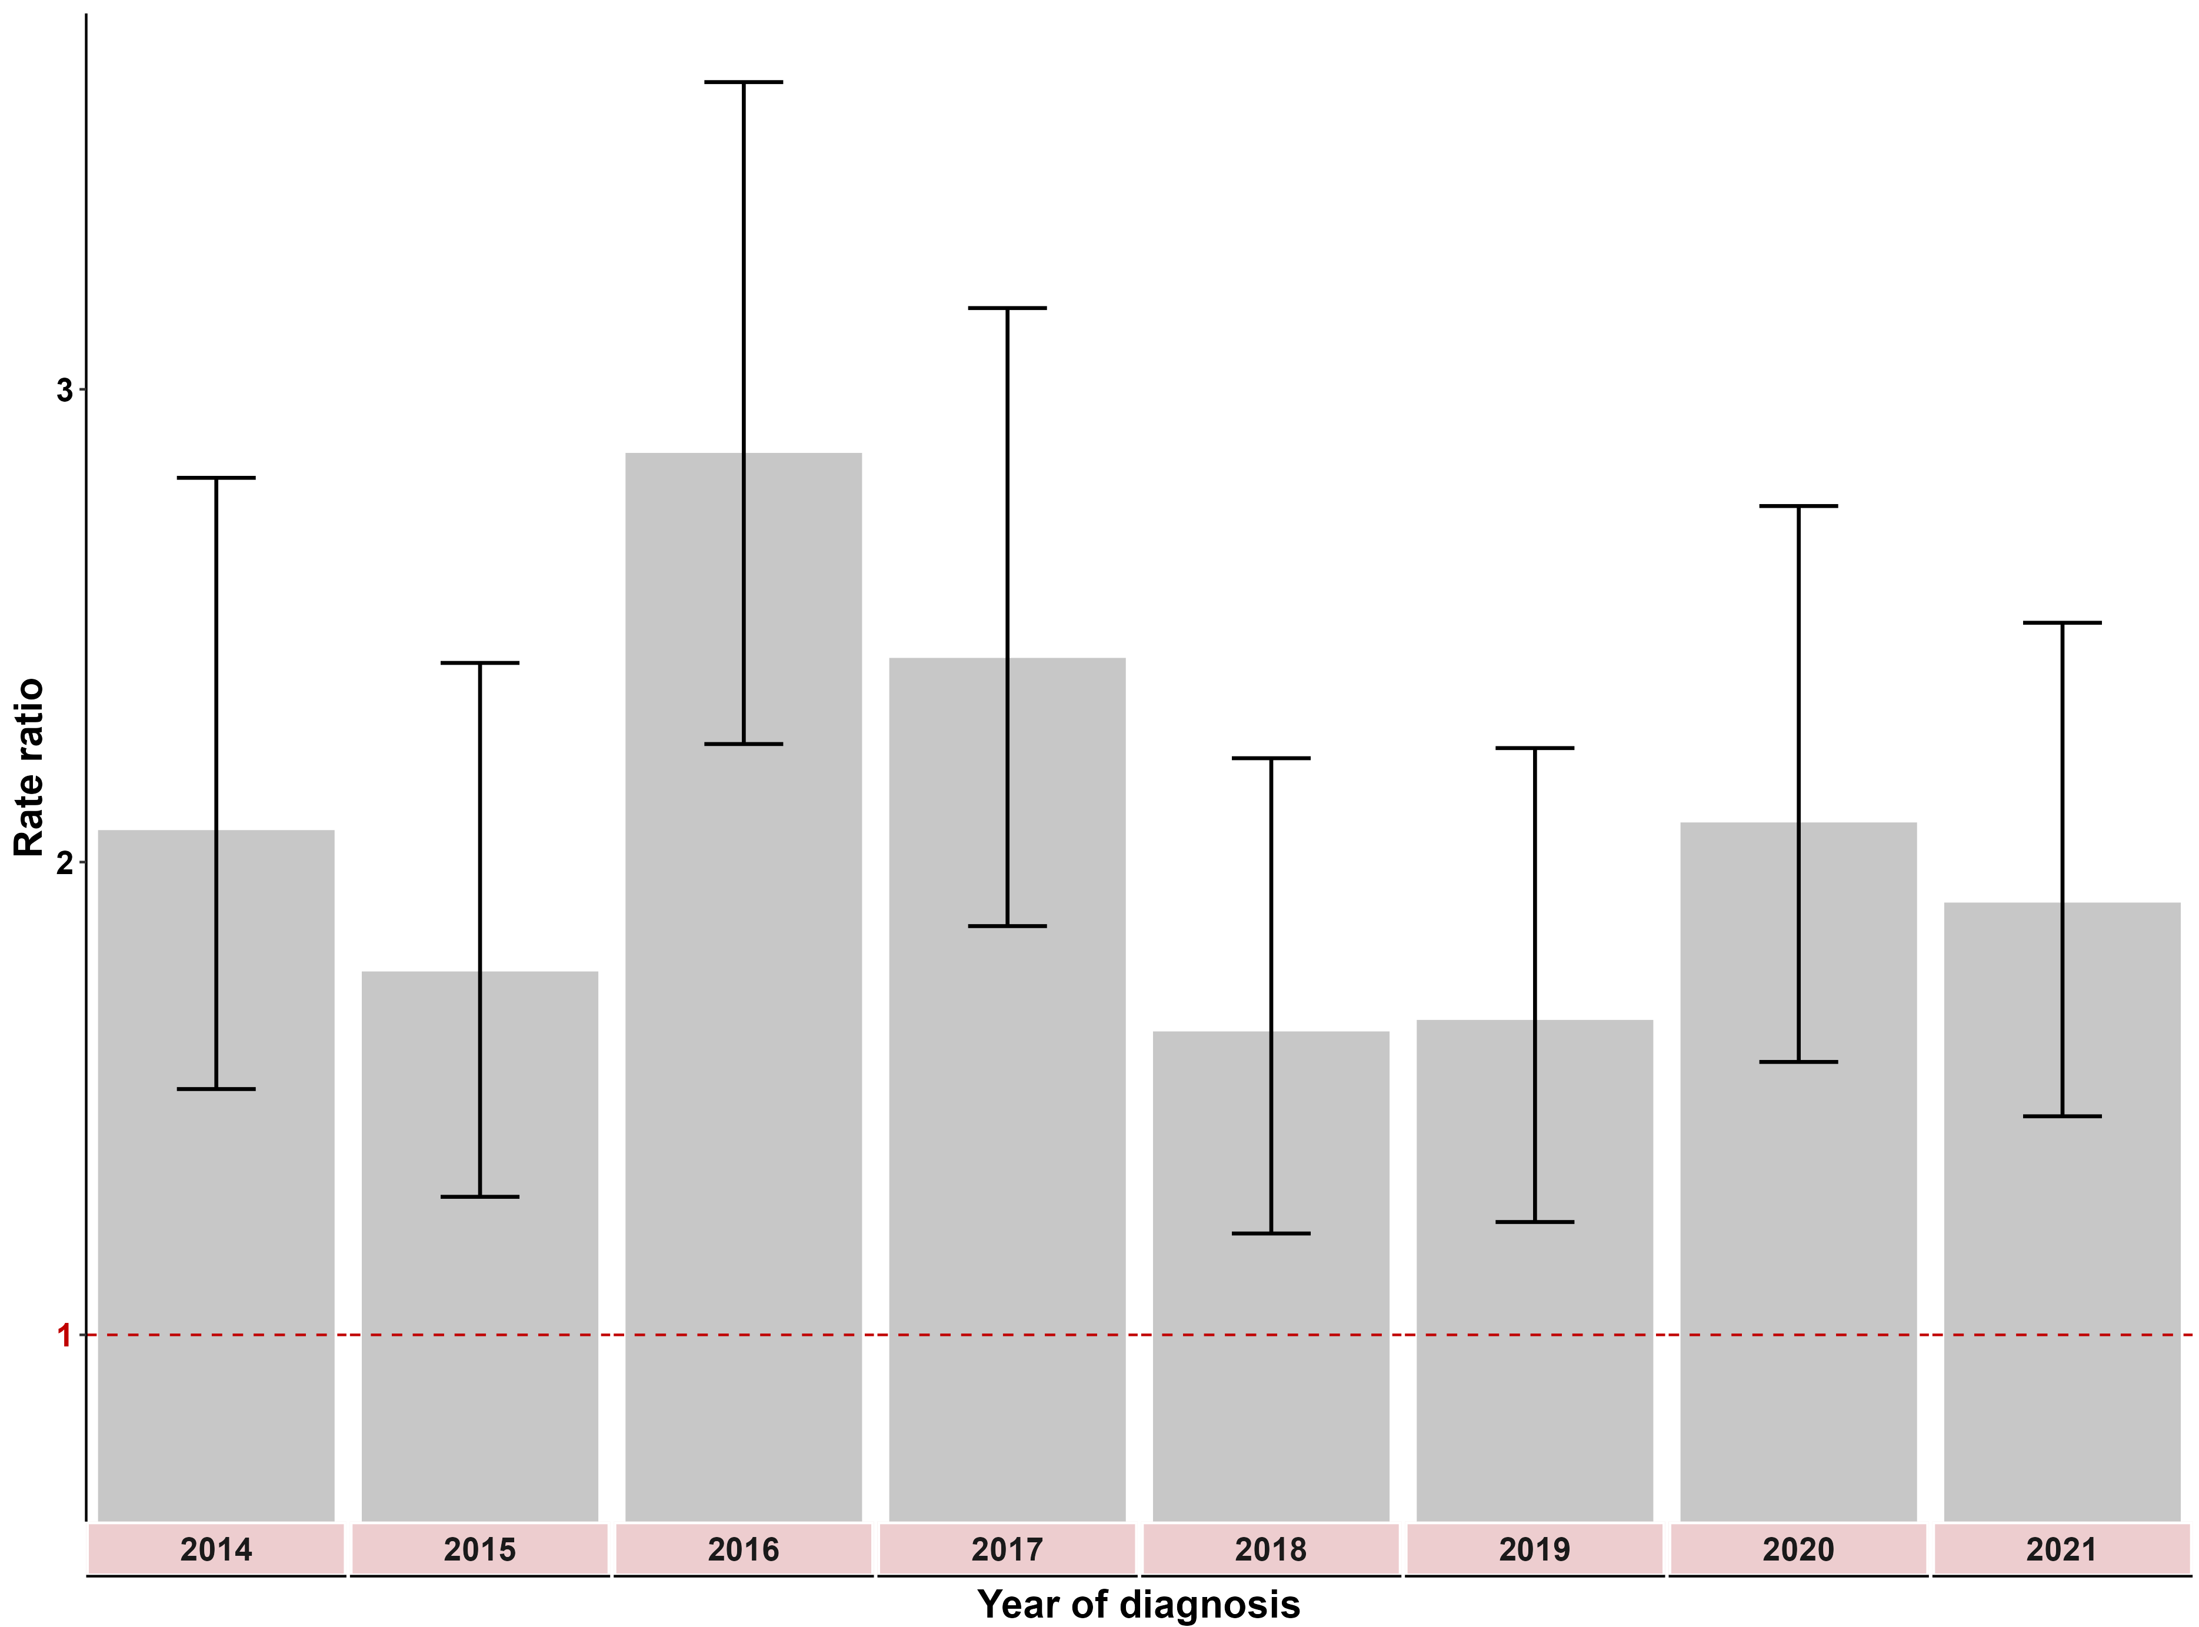
Note: ERP files were sourced from the ABS. Note that at the time of preparing this report, the ABS had not yet finalised the 2021 ERP. The ERP for the non-Aboriginal Victorian population was calculated by subtracting the Aboriginal and Torres Strait Islander projected population from the total ERP.
These rate ratios are calculated as the Aboriginal and Torres Strait Islander adjusted incidence rate compared with the non-Aboriginal and Torres Strait Islander adjusted rate for each year. A rate ratio greater than 1 indicates a higher incidence rate for Aboriginal and Torres Strait Islander individuals than non-Aboriginal people. A rate of 1.0 indicates no difference.
Table 5.3: Rate ratio of premature death (with confidence intervals) between Aboriginal and non-Aboriginal Victorians, by year, 2014–2021
Year | 2014 | 2015 | 2016 | 2017 | 2018 | 2019 | 2020 | 2021
Result | 2.1 | 1.8 | 2.9 | 2.4 | 1.6 | 1.7 | 2.1 | 1.9
(95% CI) | (1.5–2.8) | (1.3–2.4) | (2.2–3.6) | (1.9–3.2) | (1.2–2.2) | (1.2–2.2) | (1.6–2.8) | (1.5–2.5)

Measure assessment
Traffic light rating: Red (result is of concern)
Overall trend: Static or unchanging
Commentary: Between 2014 and 2021 Aboriginal Victorians had a premature death rate that was almost or more than two times higher than non-Aboriginal Victorians (Figure 5.3 and Table 5.3). This trend is consistent with national reporting, which has shown that Aboriginal and Torres Strait Islander Australians have a higher premature cancer death rate attributable to screen-detectable and preventable cancers and cancers that are diagnosed at more advanced stages, and often with more complex comorbidities. Compared with non-Aboriginal Australians diagnosed with the same cancer, Aboriginal Australians are more likely to be doubly disadvantaged and therefore result in poorer health outcomes such as a higher premature death rate because they are usually diagnosed later with more advanced disease, are less likely to have treatment, and often wait longer for surgery than non-Aboriginal patients. There is growing evidence that these disparities may be partially due to reduced access and engagement with cancer services.
Outcome: Prevent cancers

Key result: Decrease smoking and harmful alcohol consumption

Measure 6.1 – Proportion of adults who smoke daily
Figure 6.1: OECD adult population smoking daily, by gender, 2019 (or nearest year)
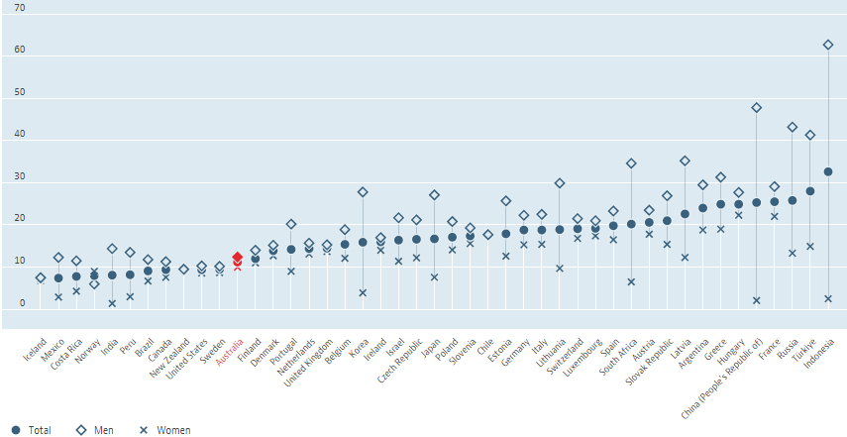
% of population aged 15 years or older

Source: OECD (2022), Daily smokers (indicator). doi: 10.1787/1ff488c2-en (Accessed on 2 August 2022); Australia is highlighted in red.
Note that daily smokers are defined as the population aged 15 years or older who are reporting to smoke every day. The proportion of daily smokers is defined as the percentage of the population aged 15 years or older who self-report tobacco smoking daily.
Figure 6.1.1: Proportion of Australian adults (aged 18 years or older) who smoke daily, by state/territory, 2014–15 and 2017–18
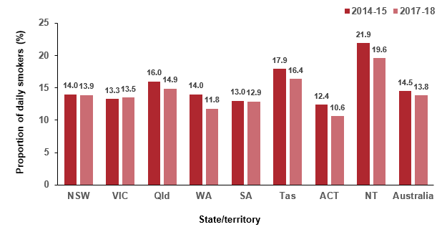

Source: ABS Australian Health Survey 2014–15 (4364.0) and 2017–18 (4364.0.55.001.DO002)
Figure 6.1.2: Proportion of Victorian adults (aged 18 years or older) who smoke daily, by year, 2015–2020 and 2022
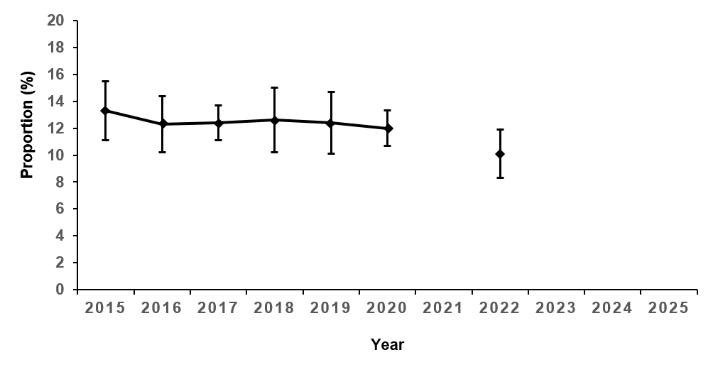
Table 6.1: Proportion of Victorian adults (aged 18 years or older) who smoke daily, by year, 2015–2020
Year | 2015 | 2016 | 2017 | 2018 | 2019 | 2020 | 2022
Per cent (%) | 13.3 | 12.3 | 12.4 | 12.6 | 12.4 | 12.0 | 10.1
95% CI | (12.2–14.4) | (11.3–13.4) | (11.8–13.1) | (11.4–13.8) | (11.8–13.1) | (11.4–12.7) | (9.2–11.0)
Sources: Victorian Population Health Surveys 2015–2020 and 2022
Note that the Victorian Population Health Survey was cancelled in 2021 due to the COVID-19 pandemic.

Measure assessment
Traffic light rating: Green (satisfactory result)
Overall trend: Moving in the right direction
Commentary: Tobacco smoking is the single largest cause of cancer globally and the predominant cause of lung cancer. The risk of developing lung cancer due to tobacco smoking increases with the duration of smoking and the number of cigarettes smoked per day.
Figure 6.1 shows that in 2019 Australia had the 12th lowest proportion of daily smokers in the OECD among people aged 15 or older (11.2%), with Indonesia ranking highest at 32.6%. It is important to note that while the data shown in Figure 6.1 is intended to provide a general global overview, it is not directly comparable because adult daily smokers are defined as the population aged 15 years or older. The data presented for Australian adults shows that while there has been a decrease over the past two decades from 22.4% in 2001 to 14.5% in 2014–15 (equated to approximately 2.6 million adults), the daily smoking rate has remained relatively similar (13.8% in 2017–18) over recent years (Figure 6.1.1).
The Northern Territory had the highest rate of daily smokers (21.9%) in 2014–15 and
2017–18 (19.6%), followed by Tasmania (17.9%, 2014–15 and 16.4%,
2017–18). The Australian Capital Territory had the lowest rate of daily smokers in 2014–15 (12.4%) and 2017–18 (10.6%). Figure 6.1.2 and Table 6.1 show that despite the proportion of Victorian adults who smoke daily decreasing from 13.3% in 2015 to 10.1% in 2022, overall, the proportion remains relatively the same. Nevertheless, any reductions show that Victoria’s tobacco laws are helping to decrease the rate of tobacco smoking. More work is still needed to help people quit smoking including the use of alternatives to tobacco smoking such as e-cigarettes and vaping. This is consistent with priority areas outlined in the National Tobacco Strategy 2023-2030.
Measure 6.2 – Proportion of adolescents 12–17 years who currently smoke
Table 6.2: Proportion of Australian adolescents aged 12–17 years (boys and girls) who currently smoke, by age and sex, 2014 and 2017
Current smokers (Australia) | 2014  12 yrs | 2017  12 yrs | 2014  13 yrs | 2017  13 yrs | 2014  14 yrs | 2017  14 yrs | 2014  15 yrs | 2017  15 yrs | 2014  16 yrs | 2017  16 yrs | 2014  17 yrs | 2017  12 yrs | 2014  12–17 yrs | 2017  12–17 yrs
Males (%) | 1.2 | 2 | 1.8 | 2 | 3.1 | 4 | 5.1 | 6 | 10.3 | 9 | 13.4 | 12 | 5.4 | 5
Females (%) | 0.9 | 1 | 1.8 | 1 | 4 | 3 | 5.9 | 5 | 7.3 | 8 | 10.9 | 9 | 4.9 | 4
Total (%) | 1.1 | 2 | 1.8 | 1 | 3.5 | 4 | 5.5 | 5 | 8.8 | 8 | 12.1 | 11 | 5.1 | 5
Table 6.2.1: Proportion of Victorian adolescents aged 12–17 years (boys and girls) who currently smoke, by age and sex, 2014 and 2017
Current smokers (Victoria) | 2014  12 yrs | 2017  12 yrs | 2014  13 yrs | 2017  13 yrs | 2014  14 yrs | 2017  14 yrs | 2014  15 yrs | 2017  15 yrs | 2014  16 yrs | 2017  16 yrs | 2014  17 yrs | 2017  12 yrs | 2014  12–17 yrs | 2017  12–17 yrs
Males (%) | 1 | 1 | 2 | 1 | 3 | 3 | 5 | 6 | 10 | 8 | 13 | 9 | 6 | 4
Females (%) | 1 | 1 | 2 | 1 | 4 | 4 | 6 | 5 | 7 | 7 | 11 | 9 | 6 | 4
Sources:
Guerin N, White V, Gascoyne C 2020, ASSAD 2017 Victorian statistics & trends: Victorian secondary students’ use of tobacco, alcohol, over-the-counter drugs, and other substances, Second Edition. Cancer Council Victoria.
White V, Williams T 2015, Australian secondary school students’ use of tobacco in 2014, Centre for Behavioural Research in Cancer, Cancer Council Victoria.
Victorian Department of Health and Human Services 2016, Tobacco, alcohol, over-the-counter and illicit substance use among Victorian secondary school students 2014.

Measure assessment
Traffic light rating: Amber (desired result not yet evident)
Overall trend: Moving in the right direction although because of the age of the data it is difficult to interpret whether the trend over time represents improved outcomes.
Commentary: Most adults who currently smoke will have started smoking when they were adolescents, therefore preventing tobacco use among young people is an integral part of ending the tobacco epidemic. Tables 6.2 and 6.2.1 show the proportion of males and females smoking cigarettes in different time periods at each age for Australia and Victoria in 2014 and 2017.,
Involvement with smoking appears more common as adolescents progress through secondary school both nationally and in Victoria. In Victoria the proportion of adolescents who were current smokers increased from 1.1% of 12-year-olds (males and females) in 2014 and 2017 to 11% of 17-year-old (males and females) (Table 6.2.1).
Overall, 6% of all Victorian adolescents 12–17 years were identified as current smokers, which was higher than the population of 12- to 17-year-old secondary school students throughout Australia (5.1%). However, this decreased to 4% in 2017, which was lower than the population of 12- to 17-year-old secondary school students throughout Australia (5%) for the same year (Table 6.2).
International comparisons of adolescent smoking prevalence show similar figures to Victoria. For example, the Canadian Student Tobacco, Alcohol and Drugs Survey found that, in 2014–15, 3% of students aged 12–17 were current smokers, which remained unchanged from 2016–17. Ireland’s Health Behaviour in School-aged Children Survey 2014 reported that 8% of 10‒17-year-olds were current smokers, decreasing to 5% in 2018, although it should be noted that the latter cannot be directly comparable with national and Victorian data because the Irish study includes 10- and 11-year-olds.
Overall, the target of a 30% decrease in smoking among adolescents by 2025 (4.2%) from the 2014 baseline (6%) has been met. Nevertheless because of the age of the data there is still the need for sustained attention at the population level, particularly as previous research has shown that smoking rates among adolescents increase when there is a reduction in tobacco control activity, including tobacco control advertising campaigns. To ensure that the gains made in reducing smoking prevalence among Australian adolescents from the 2014 baseline are sustained, interventions known to reduce adolescents’ involvement with smoking will need to continue. This will be important in ensuring the target continues to be met and or even reduced further until 2025.
Measure 6.3 – Proportion of adults who consume alcohol at lifetime risk of harm
Figure 6.3: Proportion of Victorian adults (aged 18 years or older) who consume alcohol at lifetime risk of harm, by year, 2015–2019
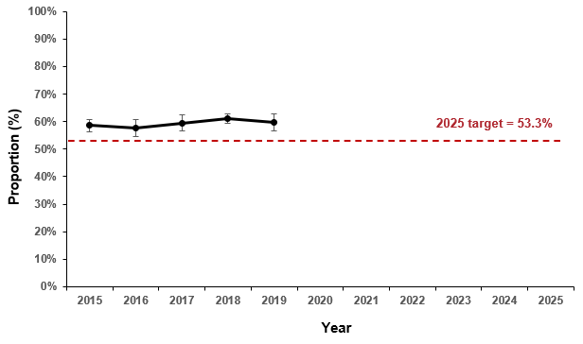
Table 6.3: Proportion of Victorian adults (aged 18 years or older) who consume alcohol at lifetime risk of harm, by year, 2015–2019
Year | 2015 | 2016 | 2017 | 2018 | 2019
Per cent (%) | 58.6 | 57.7 | 59.5 | 61.1 | 59.6
95% CI | (57.0–60.2) | (56.3–59.2) | (58.6–60.4) | (59.6–62.7) | (58–61.1)
Sources: Victorian Population Health Surveys 2015–2019 (age-standardised to 2011 Victorian population)
Notes:
Data prior to 2015 cannot be directly compared with data from 2015 onwards because there was a significant change in the sampling frame. Prior to 2015 the Victorian Agency for Health Information (VAHI) used landline telephone numbers only as their sampling frame, but from 2015 onwards VAHI used a dual overlapping sampling frame (with both landline and mobile telephone numbers).
Data specific to this measure was not collected in the Victorian Population Health Survey 2020 because it was modified to assess the impact of COVID-19 on population health.
The Victorian Population Health Survey was cancelled in 2021 due to the COVID-19 pandemic.

Measure assessment
Traffic light rating: Red (result is of concern)
Overall trend: Not moving in the right direction
Commentary: Lifetime risk of alcohol-related harm attempts to measure the risk associated with developing an illness that may include various cancers, namely cancers of the upper aerodigestive tract, liver, bowel and female breast. For the purposes of this measure, lifetime risky alcohol consumption was determined if alcohol consumption exceeded the 2009 National Health and Medical Research Council guidelines for reducing health risks associated with alcohol consumption. These guidelines state that, for healthy men and women, ‘drinking no more than two standard drinks on any day reduces the lifetime risk of harm from alcohol-related disease or injury’.
The Victorian public health and wellbeing outcomes framework has a target of a 10% decrease in the number of adults who consume excess alcohol by 2025, from the 2014 baseline of 59.2% (Figure and Table 6.3).
Currently Victoria is not on track to meet the 2025 target of 53.3%, with 59.6% of adults reported in 2019 as being at an increased lifetime risk of alcohol-related harm based on the National Health and Medical Research Council's 2009 guidelines.
Measure 6.4 – Proportion of adolescents 12–17 years who consume alcohol at least monthly
Figure 6.4: Proportion of Victorian adolescents aged 12–17 years (boys and girls) who consume alcohol at least monthly, by year, 2014, 2016 and 2018
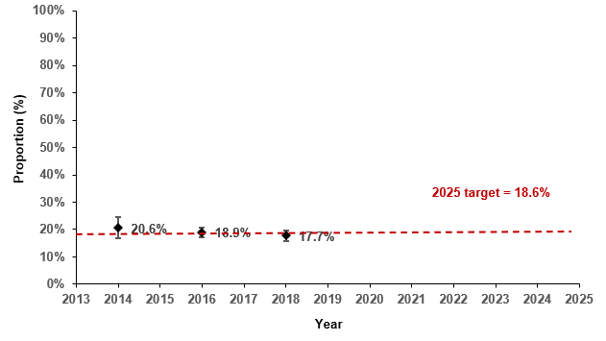
Table 6.4: Proportion of Victorian adolescents aged 12–17 years (boys and girls) who consume alcohol at least monthly, by year, 2014, 2016 and 2018
Year | 2014 | 2016 | 2018
Per cent (%) | 20.6 | 18.9 | 17.7
95% CI | (18.7–22.6) | (18–19.8) | (16.8–18.7)
Sources: Victorian Student Health and Wellbeing Surveys, Department of Education and Training, 2014, 2016 and 2018

Measure assessment
Traffic light rating: Green (satisfactory result)
Overall trend: Moving in the right direction
Commentary: The Victorian public health and wellbeing outcomes framework has a target of a 10% decrease in adolescents excessively consuming alcohol by 2025 from a baseline year of 2014. Figure 6.4 shows that adolescents who consume alcohol at least every month is decreasing, from 20.6% in 2014 to 17.7% in 2018. This means that Victoria is moving in the right direction having met the 2025 target of 18.6%.
Key result: Fruit and vegetable consumption of adults, adolescents and children

Measure 7.1 – Mean daily serves of fruit in adults
Figure 7.1: Daily fruit consumption among OECD adults, 2017 (or nearest year)
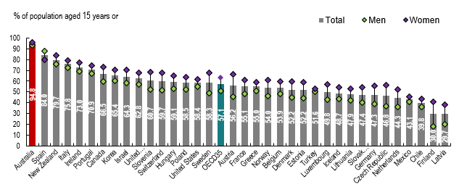

Source: OECD Health Statistics 2019
Note: Data for Australia, Korea and New Zealand are derived from quantity-type questions; OCED 34 = the average of 35 OECD countries; Australia is highlighted in red.
Figure 7.1.1: Australian average daily fruit intake for adults aged 18 years or older, 2014–15 and 2017–18
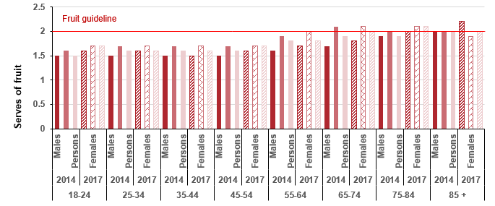
Sources: ABS 2015, 4364.0.55.001 National Health Survey: First results 2014–15, Australia, Australian Government, Canberra; ABS 2018, 4364.0.55.001 National Health Survey: First results 2017–18, Australia, Australian Government, Canberra
Note: Data not age-standardised.
Figure 7.1.2: Mean daily serves of fruit in Victorian adults (aged 18 years or older), by year, 2011–2019
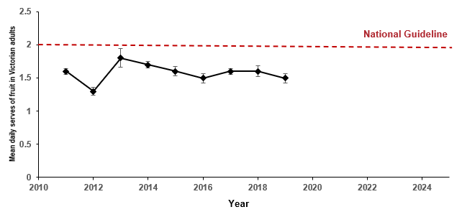
Table 7.1: Mean daily serves of fruit in Victorian adults (aged 18 years or older), by year, 2011–2019
Year | 2011 | 2012 | 2013* | 2014 |  | 2015 |  | 2016 |  | 2017 |  | 2018 |  | 2019
Mean | 1.6 | 1.3 | 1.8 |  | 1.7 |  | 1.6 |  | 1.5 |  | 1.6 |  | 1.6 |  | 1.5
(95% CI) | (1.61–1.65) | (1.27–1.33) | (1.68–1.82) |  | (1.66–1.71) |  | (1.55–1.62) |  | (1.48–1.55) |  | (1.58–1.62) |  | (1.52–1.60) |  | (1.47–1.54)
Sources: Victorian Population Health Surveys 2011–2019. There were changes to the 2020 Victorian Population Health Survey to allow for pandemic-relevant questions. As a result questions specific to fruit consumption in adults were removed. The 2021 survey was cancelled due to the COVID-19 pandemic. Data on fruit consumption specific to adults was not collected in the 2022 survey.
*Note that the new Australian dietary guidelines introduced in 2013 altered some of the serving sizes and recommendations for fruit consumption based on age and sex.

Measure assessment
Traffic light rating: Red (result is of concern)
Overall trend: Not moving in the right direction
Commentary: Fruit is high in nutrients that potentially protect against chronic disease such as cancer. Fruit consumption plays a key role in helping to maintain a healthy bodyweight. Unhealthy bodyweight (obesity) is a risk factor for cancer of the bowel, kidney, pancreas, oesophagus, endometrium and breast (in post-menopausal women). An Australian study suggests that 2% of cancers are attributable to low consumption of fruit and vegetables.
Comparable international data is unavailable on the level of daily fruit intake. However, a 2017 OECD report (Figure 7.1) shows that Australian males and females aged 15 years had the highest proportions reporting daily fruit consumption among the 35 countries of the OECD. Caution is advised when interpreting these findings due to differences in survey methodologies and variation in population ages reported as well as the potential impact of the COVID pandemic on this measure.
Consuming at least two serves of fruit per day is recommended for all Australian adults and forms the basis for this measure. In 2014–15 almost half (49.8%) or 8.8 million Australians aged 18 years or older reported consuming two or more serves of fruit per day (the recommended daily intake). The proportion of females meeting the national guideline (55.4%) was higher than the proportion for males (44%). In 2017–18 just over half (51.3%) of Australians aged 18 years or older met the guidelines for the recommended daily serves of fruit (two or more serves).
Overall, the average daily fruit intake among adult Australians aged 18 years or older was 1.7 serves for both 2014 and 2017, which is slightly higher among females compared with males. Figure 7.1.1 shows that the average daily fruit intake was similar for the age groups 18–24, 25–34, 35–44 and 45–54 years but increased for the age groups 55–64 and 65–74 years, especially in females.
In Victoria the significant increase between 2012 and 2013 is most likely in response to new Australian dietary guidelines introduced in 2013 that altered some of the serving sizes and recommendations for fruit consumption based on age and sex (Figure 7.1.1). Nevertheless, while no target has been set for this measure, Figure 7.1.2 and Table 7.1 show that even after 2013 the daily fruit consumption for all Victorian adults continues to not meet the recommended national guideline.

Measure 7.2 – Proportion of adolescents 10–17 years who eat the daily recommended serves of fruit
Figure 7.2: Proportion of Victorian adolescents aged 10–17 years (boys and girls) who eat the daily recommended serves of fruit, by year, 2014, 2016 and 2018
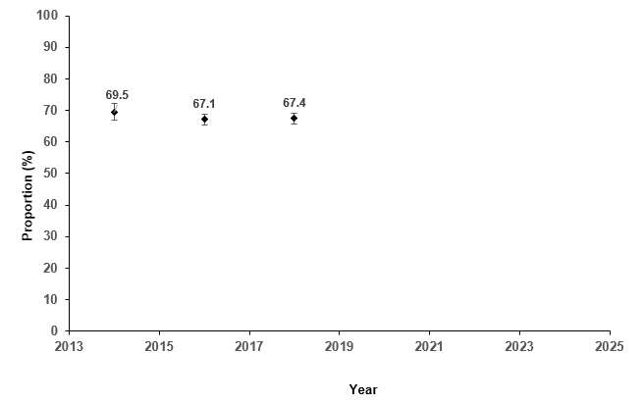

Table 7.2: Proportion of Victorian adolescents aged 10–17 years (boys and girls) who eat the daily recommended serves of fruit, by year, 2014, 2016 and 2018
Year | 2014 |  | 2016 | 2018
Per cent (%) | 69.5 |  | 67.1 | 67.4
95% CI | (68.1–70.8) |  | (66.3–68.0) | (66.5–68.3)
Sources: Victorian Student Health and Wellbeing Surveys 2014, 2016 and 2018
Figure 7.2.1: Proportion of Victorian adolescents aged 10–17 years (boys and girls) who eat the daily recommended serves of fruit, by remoteness area and gender, 2014, 2016 and 2018
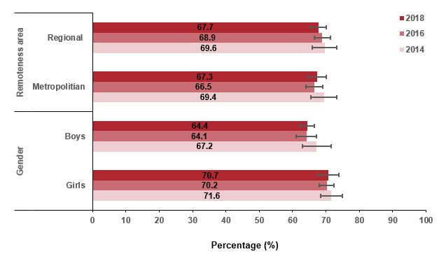

Sources: Victorian Student Health and Wellbeing Surveys 2014, 2016 and 2018

Measure assessment
Traffic light rating: Red (result is of concern)
Overall trend: Not moving in the right direction
Commentary: High consumption of fruit has been associated with reduced risk of chronic diseases such as cancer. A longitudinal study has suggested that high fruit consumption in adolescence has a beneficial influence on self-rated health in early adulthood. Consuming a minimum of two serves of fruit per day is recommended for all adolescents. While no target has been set, Figure 7.2 and Table 7.2 show that overall the proportion of adolescents aged 10–17 years in Victoria consuming fruit (excluding fruit juice) decreased between 2014 and 2016 among all children and for boys and girls but increased slightly in 2018. Both boys and girls reported decreased amounts of fruit consumed (across the two surveys) as recommended in the 2013 Australian dietary guidelines. The proportion of all adolescents living in metropolitan areas consuming fruit also decreased between 2014 and 2016 but slightly increased in 2018, while the proportion for all adolescents living in Victorian regional areas decreased also (Figure 7.2.1). Caution is advised when interpreting these findings due to the age of the data as well as the potential impact of the COVID pandemic on this measure.

Measure 7.3 – Proportion of children 4–12 years who eat the daily recommended serves of fruit
Figure 7.3: Proportion of children aged 4–12 years who eat the daily recommended serves of fruit, by year, 2013, 2017, 2019 and 2021
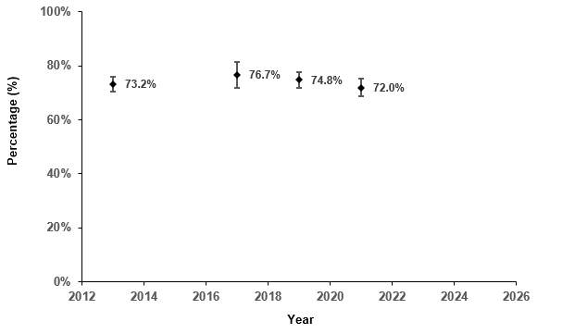

Table 7.3: Proportion of children aged 4–12 years who eat the daily recommended serves of fruit, by year, 2013, 2017, 2019 and 2021
Year | 2013 | 2017 | 2019 | 2021
Per cent (%) | 73.2 | 76.7 | 74.8 | 72.0
95% CI | (71.7–74.5) | (74.2–79.0) | (73.2–76.4) | (70.3–73.6)
Sources: Victorian Child Health and Wellbeing Surveys 2013, 2017, 2019 and 2021
Note: The minimum recommended serves of fruit daily is: 2–3 years: 1 serve; 4–8 years: 1½ serves; 9–11 years 2 serves; 12–13 years: 2 serves.
Figure 7.3.1: Proportion of children aged 4–12 years who eat the daily recommended serves of fruit, by gender, age, remoteness areas and SES, 2013, 2017, 2019 and 2021
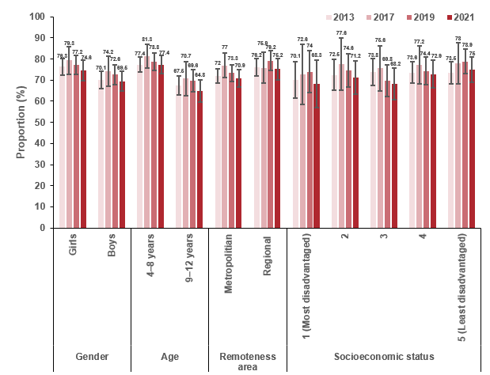
Sources: Victorian Child Health and Wellbeing Surveys 2013, 2017, 2019 and 2021

Measure assessment
Traffic light rating: Green (satisfactory result)
Overall trend: Moving in the right direction
Commentary: Data from the 2013, 2017, 2019 and 2021 Victorian Child Health and Wellbeing Surveys show that, among Victorian children aged between four and 12 years, more than 70% (Figure 7.3 and Table 7.3) met the recommended daily intake for servings of fruit in line with the 2013 Australian dietary guidelines. Each survey showed a marked difference in consumption by age, notably in 2021 only 64.8% of 9–12-year-olds meeting this target compared with 77.4% in the younger age cohort (aged 4–8 years) (Figure 7.3.1). Figure 7.3.1 also shows there was little variation between the proportion of children aged four to 12 years living in regional areas compared with metropolitan areas who were consuming the daily recommended serves of fruit. However, there was an increasing gradient between SES and daily recommended serves of fruit between 2013 and 2021, with children aged four to 12 years in 2019 living in least disadvantaged quintiles (SES 5) more recently (2021) consuming a higher proportion of fruit (75% compared with 68.3% (SES 1)).
From the available trend data for this age group, it is encouraging that in 2021 more than 70% of Victorian children aged between four and 12 years met the national dietary guideline for daily fruit intake. Caution is advised when interpreting these findings as it relates to this measure as consumption trends may have altered due to the restrictive measures imposed to reduce the impact of COVID-19.

Measure 7.4 – Mean daily serves of vegetables in adults
Figure 7.4: Daily vegetable consumption among OECD adults, 2017 (or nearest year)
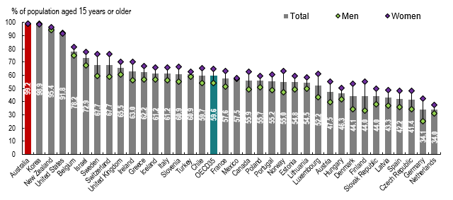
Source: OECD Health Statistics 2019
Note: Data for Australia, Korea and New Zealand are derived from quantity-type questions: OCED 34 = the average of 34 OECD countries; Australia is highlighted in red.
Figure 7.4.1: Average daily vegetable intake for adults aged 18 years or older, 2014–15 and 2017–18
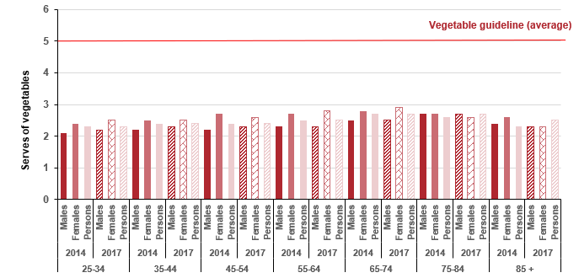

Sources: ABS 2015, 4364.0.55.001 National Health Survey: First results 2014–15, Australia, Australian Government, Canberra; ABS 2018, 4364.0.55.001 National Health Survey: First results 2017–18, Australia, Australian Government, Canberra
Note: Data not age-standardised.
Figure 7.4.2: Mean daily serves of vegetables in Victorian adults (aged 18 years or older), by year, 2011–2019
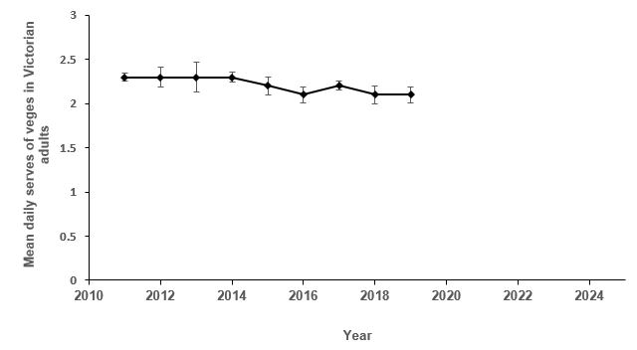
Table 7.4: Mean daily serves of vegetables in Victorian adults, by year, 2011–2019
Year | 2011 | 2012 | 2013 | 2014 | 2015 | 2016 | 2017 | 2018 | 2019
Mean | 2.3 | 2.3 | 2.3 | 2.3 | 2.2 | 2.1 | 2.2 | 2.1 | 2.1
95 % CI | 2.24–2.29 | 2.24–2.35 | 2.19–2.36 | 2.28–2.34 | 2.17–2.27 | 2.07–2.16 | (2.13–2.18) | (2.08–2.18) | (2.07–2.16)
Sources: Victorian Population Health Surveys 2011–2019. There were changes to the 2020 Victorian Population Health Survey to allow for pandemic-relevant questions. As a result questions specific to vegetable consumption in adults were removed. The 2021 survey was cancelled due to the COVID-19 pandemic. Data on vegetable consumption specific to adults was not collected in the 2022 survey.

Measure assessment
Traffic light rating: Red (result is of concern)
Overall trend: Not moving in the right direction
Commentary: Fruit and vegetable consumption is internationally accepted as an indicator of a healthy diet. A healthy diet that includes vegetable (and fruit) consumption also helps prevent chronic diseases such as cancer as well as their associated risk factors including overweight and obesity.
Comparable international data is not available on the level of daily vegetable intake. However, although the OECD reported in 2017 (Figure 7.4) that Australian males and females aged 15 years or older had the highest proportions reporting daily vegetable consumption among 35 countries of the OECD, caution is advised when interpreting these findings due to differences in survey methodologies and variation in population ages reported. For example, in Australia at the national level, data specific to adults is reported for the population aged 18 years or older.
In 2014–15, 7% (less than one in 10) of Australians aged 18 years or older met the national guidelines for serves of vegetables (six or more serves for men depending on age, and five [375 grams per day] or more for women). The proportion of females meeting this guideline (10.2%) was higher than for males (3.8%). However, in 2017–18 one in 13 (7.5%) adults met the guidelines for serves of vegetables (5–6 or more serves for men depending on age, and 5 or more for women).
Overall, the average daily vegetable intake of adult Australians aged 18 years or older was 2.4 serves in 2014 and remained the same for 2017. Average daily vegetable intake was slightly higher among females (2.5 serves) than among males (2.3 serves) and increased with age (Figure 7.4.1). While no target has been set for this measure, Figure 7.4.2 shows that the vegetable consumption across all Victorian adults is decreasing. Caution is advised when interpreting these findings as it relates to this measure as consumption trends may have altered due to the restrictive measures imposed to reduce the impact of COVID-19.

Measure 7.5 – Proportion of adolescents 10–17 years who eat the minimum daily recommended serves of vegetables
Figure 7.5: Proportion of adolescents aged 10–17 years who eat the daily recommended serves of vegetables, 2014, 2016 and 2018
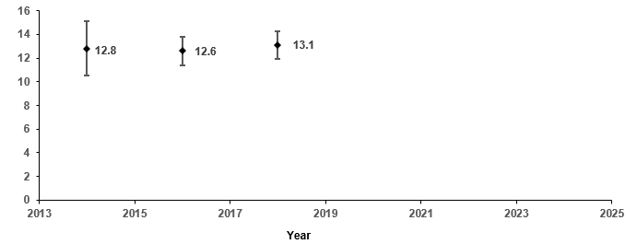
Source: Victorian Child and Adolescent Monitoring System – Department of Education and Training - https://www.education.vic.gov.au/about/research/Pages/vcamsindicator.aspx
Table 7.5: Proportion of adolescents aged 10–17 years who eat the daily recommended serves of vegetables, 2014, 2016 and 2018
Year | 2014 | 2016 | 2018
Per cent (%) | 12.8 | 12.6 | 13.1
95% CI | (11.8–13.7) | (12.0–13.2) | (12.5–13.7)
Figure 7.5.1: Proportion of adolescents aged 10–17 years who eat the daily recommended serves of vegetables, by remoteness area and gender, 2014, 2016 and 2018
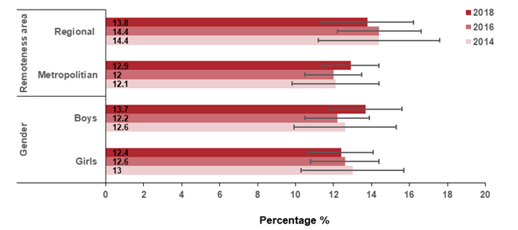
Sources: Victorian Child Health and Wellbeing Surveys 2014, 2016 and 2018.

Measure assessment
Traffic light rating: Amber (desired result not yet evident)
Overall trend: Static or unchanging
Commentary: Consuming vegetables (and fruit) that are high in nutrients potentially protects against cancers. A longitudinal study has suggested that high vegetable consumption in adolescence has a beneficial influence on self-rated health in early adulthood. Consuming a minimum of five serves of vegetables per day is recommended for all adolescents. Figure 7.5 and Table 7.5 show that the proportion of adolescents aged 10–17 years in Victoria consuming vegetables decreased slightly between 2014 and 2016 but then increased slightly in 2018 among all children and for boys and girls. The proportion of all adolescents living in metropolitan and regional areas consuming vegetables remained static between 2014 and 2018 (Figure 7.5.1).
While no target has been set, this measure shows that, overall, the proportion of daily vegetable consumption for adolescents aged 10–17 years who met the dietary guideline for daily vegetable intake is not significantly increasing. Furthermore, this observed trend is low, making the promotion of consumption an important health promotion challenge. Caution is advised when interpreting these findings as it relates to this measure as consumption trends may have altered due to the restrictive measures imposed to reduce the impact of COVID-19.

Measure 7.6 – Proportion of children 4–12 years who eat the daily recommended serves of vegetables
Figure 7.6: Proportion of children aged 4–12 years who eat the daily recommended serves of vegetables, by year, 2013, 2017, 2019 and 2021
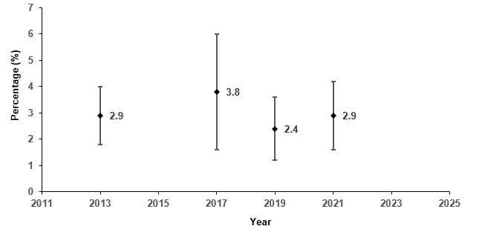
Source: Victorian Child and Adolescent Monitoring System – Department of Education and Training https://www.education.vic.gov.au/about/research/Pages/vcamsindicator.aspx
Note: The minimum recommended serves of vegetables daily is: 2–3 years: 2½ serves; 4–8 years: 4½ serves; 9–11 years 5 serves; 12–13 years: 5–5½ serves.
Table 7.6: Proportion of children aged 4–12 years who eat the daily recommended serves of vegetables, by year, 2013, 2017, 2019 and 2021
Year |  | 2013 |  | 2017 | 2019 | 2021
Per cent (%) |  | 2.9 |  | 3.8 | 2.4 | 2.9
95% CI |  | (2.4–3.5) |  | (2.8–5.0) | (1.9–3.1) | (2.3–3.6)
Figure 7.6.1: Proportion of children aged 4–12 years who eat the daily recommended serves of vegetables, by gender, age, remoteness area, SES and year, 2013, 2017, 2019 and 2021
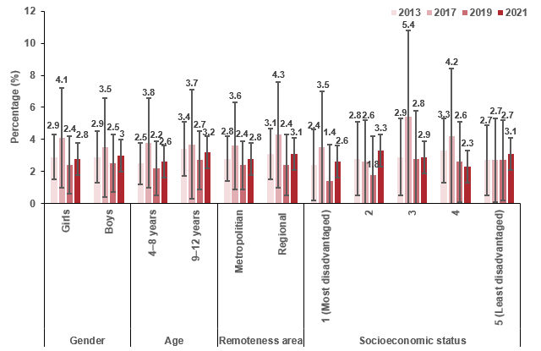

Sources: Victorian Child Health and Wellbeing Surveys 2013, 2017, 2019 and 2021

Measure assessment
Traffic light rating: Red (result is of concern)
Overall trend: Not moving in the right direction
Commentary: Data from the 2013, 2017, 2019 and 2021 Victorian Child Health and Wellbeing Surveys showed a fluctuation in the proportion of Victorian children aged between four and 12 years who met the recommended amount as set out in the 2013 Australian dietary guidelines (Figure 7.6). There was a marked difference in consumption by age, with children aged four to eight years less likely to meet this target compared with 3.2% in the older age cohort (aged 9–12 years) in 2021 (Figure 7.6.1). The proportion of children aged four to 12 years consuming the recommended serves of vegetables and living in regional areas was generally higher than those living in metropolitan areas in 2013, 2017 and 2021, with the exception of 2019 where it decreased to 2.4%, which was equal to children living in metropolitan areas (Figure 7.6.1). There was a fluctuating gradient in the proportion of children aged four to 12 years who eat the daily recommended serves of vegetables by SES across each of the surveys. However, caution should be taken when interpreting this result because of the wide confidence intervals (Figure 7.6.1).
Although no trend is available for this age group, the observed very low level of compliance with vegetable intake recommendations in 2013, 2017, 2019 and 2021 suggest that addressing deficiencies in vegetable consumption should continue to be a primary focus of future nutrition interventions. Caution is advised when interpreting these findings as it relates to this measure as consumption trends may have altered due to the restrictive measures imposed to reduce the impact of COVID-19.

Measure 7.7 – Red meat consumption
This measure will be reported in a future report. Refer to Appendix 1.

Measure 7.8 – Processed meat consumption
This measure will be reported in a future report. Refer to Appendix 1.

Measure 7.9 – Proportion of adults who are sufficiently physically active
Figure 7.9: Proportion of adults (18 years or older) who are sufficiently physically active, by year, 2015–2019
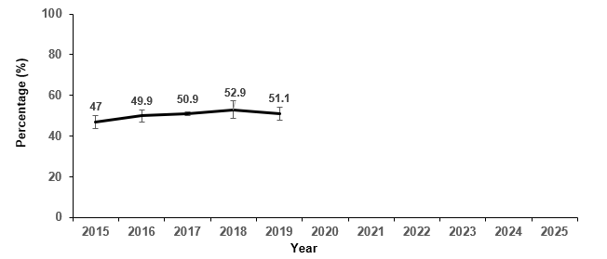
Year
Table 7.9: Proportion of adults who are sufficiently active, by year, 2015–2019
Year | 2015 | 2016 | 2017 | 2018 | 2019
Per cent | 47.0 | 49.9 | 50.9 | 52.9 | 51.1
(95% CI) | (45.5–48.6) | (48.4–51.4) | (50.0–51.8) | (49.9–54.3) | (49.5–52.7)
Sources: Victorian Population Health Surveys 2015–2019
There were changes to the 2020 Victorian Population Health Survey to allow for pandemic-relevant questions. As a result questions specific to physical activity in adults were removed. The 2021 survey was cancelled due to the COVID-19 pandemic. Data on physical activity specific to adults was not collected in the 2022 survey.

Measure assessment
Traffic light rating: Green (satisfactory result)
Overall trend: Moving in the right direction
Commentary: Physical activity helps adults to live longer and protects against some cancers. Current levels of physical inactivity have been attributed to increasing sedentariness of domestic and occupational activities, insufficient physical activity during leisure time, increasing use of passive modes of transport and increased urbanisation.
Approximately half of Victorian adults (18 years or older) are insufficiently physically active. Figure 7.9 and Table 7.9 show that in 2019, 51.1% of Victorian adults undertook sufficient physical activity (measured in both sufficient time and sessions) to meet the 2014 national physical activity guidelines compared with 47% in 2015.

Measure 7.10 – Proportion of adolescents 10–17 years who are sufficiently physically active
Figure 7.10: Proportion of Victorian adolescents aged 10–17 who are sufficiently physically active, 2014, 2016 and 2018
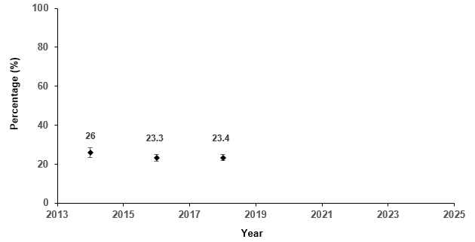

Sources: Victorian Student Health and Wellbeing Surveys 2014, 2016 and 2018
Note: In 2014 the definition of sufficient physical activity changed.
Table 7.10: Proportion of Victorian adolescents aged 10–17 who are sufficiently physically active, 2014, 2016 and 2018
Year | 2014 |  |  | 2016 | 2018
Per cent (%) | 26.0 |  |  | 23.3 | 23.4
95% CI | (24.8–27.3) |  |  | (22.5–24.1) | 22.6–24.2)

Measure assessment
Traffic light rating: Red (result is of concern)
Overall trend: Not moving in the right direction
Commentary: Physical activity provides important benefits throughout life. Establishing an active lifestyle such as participating in active recreation and sport during childhood and early adulthood can lay the foundation for lifelong participation in sport and wider physical activity. Children and adolescents who are physically active have better mental, cardio-metabolic and musculoskeletal health and are less likely to gain weight. Childhood obesity is a risk factor for chronic disease, such as some cancers, in adulthood. For example, a meta-analysis published in 2016 reported a statistically significant association between obesity in children aged 12–18 years and an increased incidence of some cancers, such as liver, colorectal and urothelial cancer, in adulthood.
The Victorian public health and wellbeing outcomes framework has a target of a 20% increase by 2025 in adolescents achieving sufficient physical activity based on the 26% 2014 baseline (Figure 7.10 and Table 7.10) and is not on track to be met. In 2018, only 23.4% of Victorian students (Figure 7.10) undertook sufficient physical activity that met the national physical activity guidelines. This observation aligns with new data from Cancer Council Australia that shows Australian students are almost a third less likely to walk or cycle to school than they were 10 years ago.

Measure 7.11 – Proportion of children 5–12 years who are sufficiently physically active
Figure 7.11: Proportion of children aged 5–12 years who are sufficiently physically active, 2013, 2017, 2019 and 2021
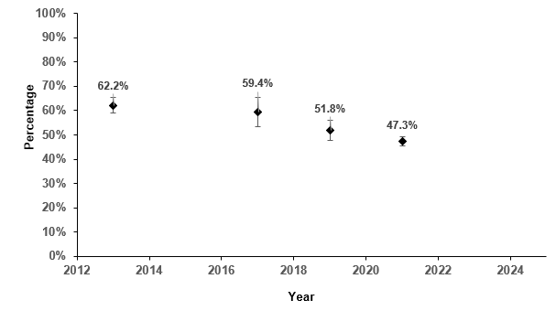
Sources: Victorian Child Health and Wellbeing Surveys 2013, 2017, 2019 and 2021 http://www.education.vic.gov.au/about/research/Pages/vcamsindicator.aspx
Note: In 2014 the definition of sufficient physical activity changed.
Table 7.11: Proportion of children aged 5–12 years who are sufficiently physically active, 2013, 2017, 2019 and 2021
Year | 2013 |  | 2017 | 2019 | 2021
Per cent (%) | 62.2 |  | 59.4 | 51.8 | 47.3
95% CI | (60.6–63.8) |  | (56.4–62.3) | (49.7–53.8) | (45.3–49.1)

Measure assessment
Traffic light rating: Red (result is of concern)
Overall trend: Not moving in the right direction
Commentary: As noted under Measure 7.10, children and adolescents who are physically active have better mental, cardio-metabolic and musculoskeletal health and are less likely to gain weight, the latter being a risk factor for developing cancer later in life.
A target has not been set for this measure; however, more than 50% of children are insufficiently physically active according to the most recent data (2021) (Figure 7.11 and Table 7.11).
Key result: Decrease obesity

Measure 8.1 – Proportion of adults who are overweight or obese (measured)
Figure 8.1: Proportion of overweight or obese among OECD adults (aged 15 or older), 2017 (or nearest year)
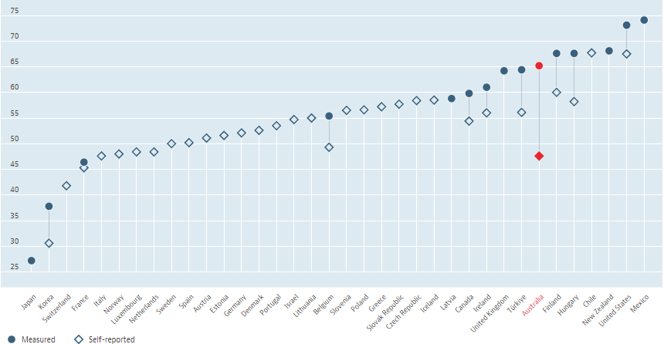
% of population aged 15 years or older
Source: OECD (2022), Overweight or obese population (indicator)
Notes:
It is important to note that international trends cannot be compared with Australian national data because Australian adults are defined as aged 18 years or older, affecting the comparability of data.
In the graph, Australia is highlighted in red.
Figure 8.1.1: Proportion of overweight/obesity (measured) in Australian adults, by state and territory, 2011–12, 2014–15 and 2017–18
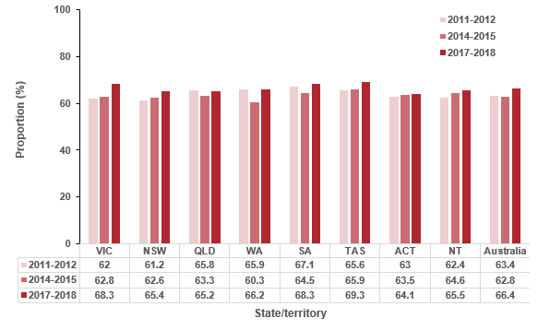
Sources: ABS Australian Health Surveys 2011–12 (4364.0.55.001); 2014–15 (4364.0.55.001) and
2017–18 (4364.0.55.001.DO002)
Note: Proportions have been age-standardised to the 2001 Australian population to account for differences in the age structure of the population over time.
Figure 8.1.2: Proportion of overweight including obesity (measured) among Victorian adults (aged 18 or older), by year, 2011–12, 2014–15 and 2017–18
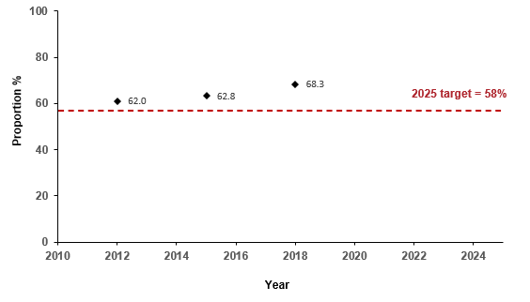
Sources: ABS Australian Health Surveys 2011–12 (4364.0.55.001); 2014–15 (4364.0.55.001) and 2017–18 (4364.0.55.001.DO002)

Measure assessment
Traffic light rating: Red (result is of concern)
Overall trend: Not moving in the right direction
Commentary: Overweight and obesity are major risk factors for many chronic diseases including cancer. For the purposes of this measure, overweight and obesity was calculated using the body mass index (BMI), a scale based on height and weight commonly used to define if a person is underweight, normal weight, overweight or obese. In Australia, of the cancers related to body fatness (n = 9,258), 13% (95% CI, 11–16%) could be avoided if those currently overweight or obese had a BMI of 18.5–24.9 kg/m² (normal range). Of note is that obesity is associated with a 20% excess risk of early-onset CRC and prevalence has risen most rapidly in young adults.
Figure 8.1 shows that the growing prevalence of overweight and obesity is a major public health concern globally. The results show that more than half of adults aged 15 years or older in OECD countries are overweight or obese (54%). In 2017 most Australian adults (65.2% of the population aged 15 or older) were overweight or obese (measured), the sixth highest proportion in the OECD behind Mexico, the United States, New Zealand, Hungary and Finland (Figure 8.1).
In Australia the proportion of men and women aged 18 years or older who are overweight or obese generally remained static between 2011 and 2015 across all states except Western Australia, which dropped by 5.6% (Figure 8.1.1), possibly in response to the state’s LiveLighter campaign (2011–2018). More recently there has been an increase across all states since 2015, with Victoria, South Australia and Tasmania above the national rate. In Victoria, Figure 8.1.2 shows that the proportions of overweight or obese adults between 2011–12 and 2014–15 were similar but increased from 2015.
The Victorian public health and wellbeing outcomes framework has a target of a 5% decrease in prevalence of overweight or obese adults aged 18 years or older by 2025, from the 2011–12 baseline of 61%. Currently, Victoria is not on track to meet the 2025 target of 58%, with 68.3% of adults overweight or obese in 2017–18 (Figure 8.1.2). Future research into etiological risk factors in diverse populations, alongside the implementation of effective primary prevention strategies, is needed to reduce the future impact of preventable cancers such as CRC.

Measure 8.2 – Proportion of adults who are overweight or obese (self-report)
Figure 8.2: Proportion of Victorian adults (aged 18 years or older) who are overweight or obese (self-report), by year, 2015–2020 and 2022
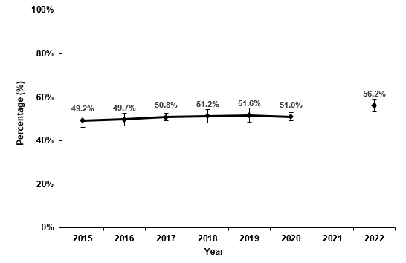
Table 8.2: Proportion of Victorian adults (aged 18 years or older) who are overweight or obese (self-report), by year, 2015–2020 and 2022
Year | 2015 | 2016 | 2017 | 2018 | 2019 | 2020 | 2022
Per cent | 49.2 | 49.7 | 50.8 | 51.2 | 51.6 | 51.0 | 56.2
(95% CI) | (47.7–50.8) | (48.2–51.2) | (49.9–51.7) | (49.6–52.8) | (50.0–53.2) | (50.0–52.0) | (54.8–57.6)
Sources: Victorian Population Health Surveys 2015–2020 and 2022
Note that the Victorian Population Health Survey was cancelled in 2021 due to the COVID-19 pandemic.

Measure assessment
Traffic light rating: Red (result is of concern)
Overall trend: Not moving in the right direction
Commentary: A target has not been set for this measure; however, the lack of reduction in the proportion of adults who self-report being overweight or obese is of major concern given the significant risks that this poses to individual health and the burden across the health and social care systems. Figure 8.2 and Table 8.2 show the proportion of Victorian adults who were overweight or obese was 49.2.8% in 2015, which increased to 56.2% in 2022. To add further cause for concern, it is known that self-reported measures significantly underestimate the prevalence of obesity (refer to the data reported under Measure 8.1).

Measure 8.3 – Proportion of children 5–17 years who are overweight or obese (measured)
Figure 8.3: Proportion of Australian children aged 5–17 years who are overweight or obese (measured), by year, 1995 to 2017–18
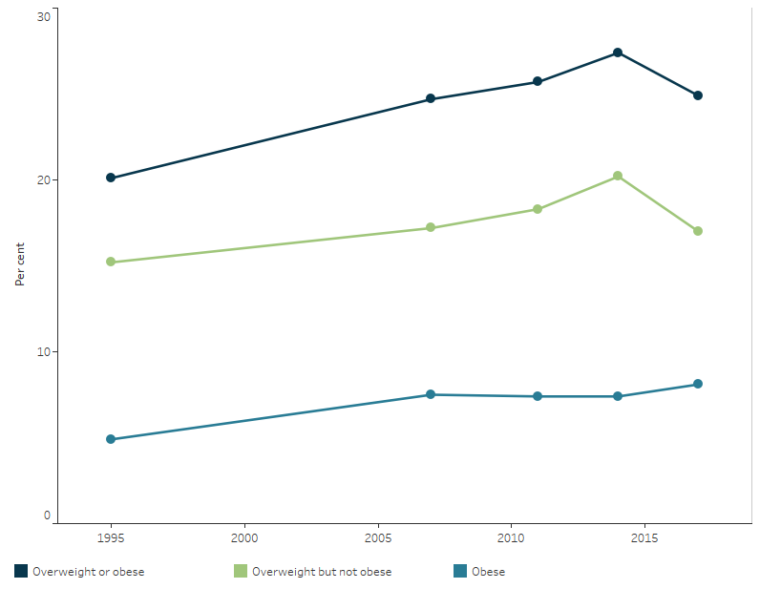

Source: Australian Institute of Health and Welfare
Figure 8.3.1: Proportion of Victorian children aged 5–17 years who are overweight or obese (measured), by year, 2011–12, 2014–15 and 2017–18
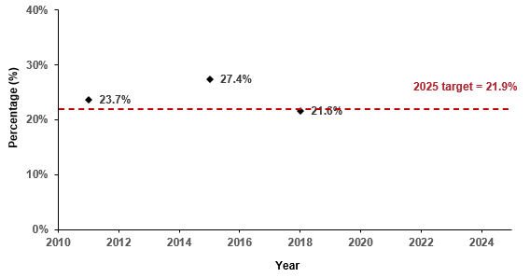
Sources: ABS Australian Health Surveys 2011–12 (4364.0.55.001), 2014–15 (4364.0) and 2017–18
Note: BMI data between the three survey years is comparable.

Measure assessment
Traffic light rating: Green (satisfactory result)
Overall trend: Moving in the right direction
Commentary: The rate of overweight and obesity in children is of significant concern now and for the future, given the lifelong implications including increased risk of obesity-related cancers. At the national level, information dating back to 1995 (Figure 8.3) shows the prevalence of overweight and obesity rose from 21% in 1995 to 25% in 2007, then remained relatively stable to 2017–18.
Figure 8.3.1 shows that the childhood rates of overweight and obesity in Victoria jumped from 23.1% in 2012 to 27.4% in 2015 but decreased to 21.6% in 2018, which is below the current 2018 national average of 24.9% published by the ABS. There is a target in the Victorian public health and wellbeing outcomes framework to reduce the prevalence of overweight and obesity in children and adults by 5% from the 2011–12 baseline year by 2025. Currently, Victoria is on track to meet the 2025 target of 21.9%.
Key result: Decrease UV exposure

Measure 9.1 – Proportion of Victorian adults aged 18 years and over who report getting sunburnt during the summer
Figure 9.1: Adjusted prevalence estimates for summer sunburn incidence among Victorian adults (aged 18 years and over) during the summer 2021–22
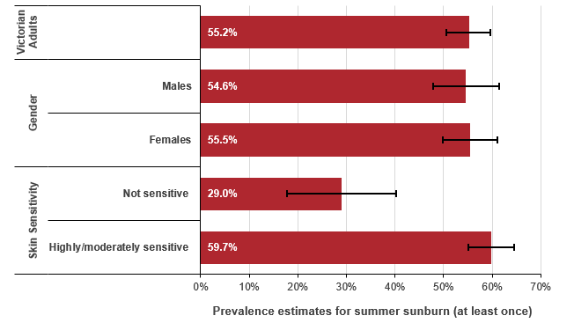
Note: These data were derived from the 2022 Summer Sun Protection Survey (collected via Life in AustraliaTM), including a representative sample of Australians aged 18 years and over. A mixed-mode methodology was adopted for the survey and included both online and telephone responses. Respondents completed the survey over two weeks between 17 and 31 January 2022. The data were weighted to be representative of Australians aged 18 years and over, using benchmarks from official Australian Bureau of Statistics sources including the 2016 Census. The Victorian sample consisted of 736 respondents (unweighted base).
Prevalence estimates for Victorian adults are unadjusted. Prevalence figures for sub-groups are estimated from multivariable models adjusting for age, gender and skin sensitivity.
Table 9.1 in Appendix 2 provides the unadjusted prevalence estimates for the proportion of Victorian adults (18 years or older) who reported getting sunburnt during the summer, 2021–22.

Measure assessment
Traffic light rating: Amber (desired result not yet evident)
Overall trend: Data from the National Sun Protection Survey (2013–14 and 2016–17) indicated this result was moving in the wrong direction. However, due to the National Sun Protection Survey terminating, assessment of future trends necessitates a new baseline. Data on sunburn is being collected as part of the 2022 Victorian Population Health Survey and the ABS’s 2023–24 Multipurpose Household Survey, with the view to establishing a new population monitoring series for skin cancer prevention. In the interim, data from the Cancer Council’s 2022 Summer Sun Protection Survey (collected via Life in AustraliaTM) is included to provide a point-in-time estimate.
Commentary: Sunburn is the skin’s reaction to UV radiation from the sun. The long-term effects of repeated bouts of sunburn include an increased risk of skin cancer, including melanoma (the most serious type of skin cancer). In Australia it is often called our ‘national cancer’ because Australia has one of the highest rates of skin cancer in the world, with approximately two in three Australians diagnosed with skin cancer during their lifetime. Figure 9.1 shows that 55% of Victorians adults aged 18 years and over reported being sunburnt at least once over summer. Those with highly/moderately sensitive skin were more likely to report being sunburnt at least once over the summer compared with those whose skin was not sensitive. There was no difference between males and females; this is in contrast to data from the National Sun Protection Survey (refer to the 2020 Victorian cancer plan monitoring and evaluation baseline report), which indicated males were more likely to report getting sunburnt on the weekend compared with females.

Measure 9.2 – Proportion of Victorian adults aged 18 years and over wearing a combination of broad-brimmed hats and/or sunscreen with one other key sun protective behaviour
Figure 9.2: Adjusted prevalence estimates of two or more sun protective behaviours among Victorian adults (aged 18 years and over) during the summer 2021–2022
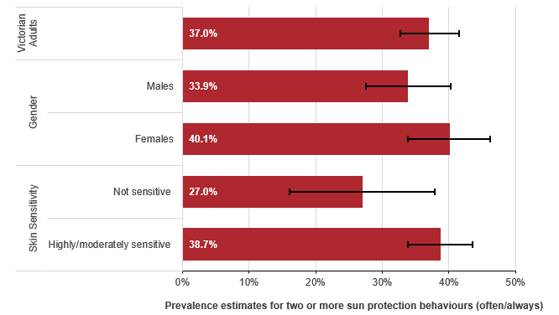

Note: These data were derived from the 2022 Summer Sun Protection Survey (collected via Life in AustraliaTM), including a representative sample of Australians aged 18 years and over. A mixed-mode methodology was adopted for the survey and included both online and telephone responses. Respondents completed the survey over two weeks between 17 and 31 January 2022. The data were weighted to be representative of Australians aged 18 years and over, using benchmarks from official Australian Bureau of Statistics sources including the 2016 Census. The Victorian sample consisted of 734 respondents (unweighted base).
Prevalence estimates for Victorian adults are unadjusted. Prevalence figures for sub-groups are estimated from multivariable models adjusting for age, sex and skin sensitivity.
Table 9.2 in Appendix 2 provides the unadjusted prevalence estimates of two or more sun protective behaviours among Victorian adults (aged 18 years and over) in the summer of 2021–22.

Measure assessment
Traffic light rating: Amber (desired result not yet evident)
Overall trend: Data from the National Sun Protection Survey (2013–14 and 2016–17) indicated this result was moving in the right direction (refer to the Cancer plan monitoring and evaluation framework baseline report, 2020). However, due to the National Sun Protection Survey terminating, assessment of future trends necessitates a new baseline. Data on sun protection behaviours is being collected as part of the 2022 Victorian Population Health Survey and the ABS’s 2023–24 Multipurpose Household Survey, with the view to establishing a new population monitoring series for skin cancer prevention. In the interim, data from Cancer Council’s 2022 Summer Sun Protection Survey (collected via Life in AustraliaTM) is included to provide a point-in-time estimate.
Commentary: Figure 9.2 shows that 37% of Victorian adults aged 18 years and over reported using of two or more sun protective behaviours always/often during the summer for sun protection. Females more commonly reported using two or more sun protective behaviours compared with males, as did respondents with highly/moderately sensitive skin compared with those whose skin is not sensitive. The increase in the use of multiple sun-protective behaviours indicated by the National Sun Protection Survey data to 2016–17 suggests that Victorian adults are generally adopting more sun protective measures (refer to the 2020 Cancer plan monitoring and evaluation framework baseline report). An increase in sun protection may indicate the benefits of implementing skin cancer prevention campaigns (such as the globally recognised SunSmart Program – one of Victoria’s longest running and most successful public health programs,), an approach supported in the National preventive health strategy 2021–2030.

Key result: Decrease HPV and viral hepatitis impact

Measure 10.1 – Proportion of adolescents 15 years of age fully vaccinated against HPV
Figure 10.1: HPV dose vaccination coverage for all females turning 15 years of age, by state/territory and year, 2013, 2017 and 2022
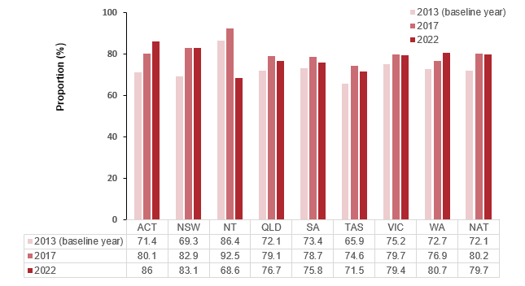
Figure 10.1.1: HPV dose vaccination coverage for all males turning 15 years of age, by state/territory and year, 2013, 2017 and 2022
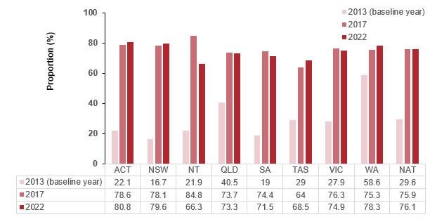
Source: Australian Immunisation Register, Commonwealth Department of Health and Aged Care
Note: From 31 December 2018, the National HPV Vaccination Program Register was decommissioned. Vaccination providers are now requested to submit HPV vaccination records to the Australian Immunisation Register (AIR), operated by Services Australia. Due to decommissioning of the HPV register, the business rules applied to the data may slightly differ in AIR as compared with the HPV register.
The National HPV Vaccination Program initially provided quadrivalent HPV vaccine for all females aged 12-26 years as at mid-2007 ( school program commenced April 2007 and GP/community program in July 2007) until end December 2009. From 2009 the Program offered HPV vaccination routinely to females in the first year of high school (usually at 12-13 years). From 2013, males were also offered HPV vaccination routinely in the first year of high school (age 12-13 years), with a catch-up program available for males aged 14-15 years in 2013 and 2014.
Appendix 2 provides the dataset for Figures 10.1 and 10.1.1.

Measure assessment
Traffic light rating: Green (satisfactory result)
Overall trend: Moving in the right direction
Commentary: Human papillomavirus (HPV) is highly contagious and most commonly transmitted through sexual contact. More than 150 types of the virus exist, and about four out of five people will have an HPV infection at some point in their lives. Chronic infection with some types of HPV is a primary cause of cervical cancer.
In Australia all girls aged 12–13 years have been routinely offered three doses of HPV vaccination since 2007, as have boys of the same age since 2013. For this reason, 2013 was set as the baseline year for this measure. In 2018 a new two-dose HPV (Gardasil 9) was introduced that provides protection against nine types of HPV and adds a further 10% protection against respective cancers, which in turn should result in an increase in fully vaccinated person coverage rates.
Nationally in 2022, 79.7% of girls aged 15 years were fully immunised against HPV, an increase from 80.2 in 2017 and 72.1 in 2013. In 2022 Victoria had the third highest coverage (79.4%) of girls aged 15 years fully immunised against HPV (two doses). However, this was not higher than the national average of 79.7% (Figure 10.1).
In boys aged 15 years, the national coverage with three HPV vaccine doses in 2017 was 75.9%, a significant increase from 29.6 reported in 2013. In 2022 Victoria had the fourth ranked proportion of boys aged 15 years fully immunised against HPV (two doses), which was below the national average of 76.1%. Of note is that all states reported a decrease in reported HPV vaccinations between 2021 and 2022. Nevertheless overall, the change in vaccination doses from 2018 to 2022 is likely to have resulted in an increase in fully vaccinated coverages for both girls and boys aged between nine and 14 years.

Measure 10.2 – Notification rate of unspecified hepatitis B
Figure 10.2: Notification rate per 100,000 population of unspecified HBV, by state/territory and year, 2014–2021
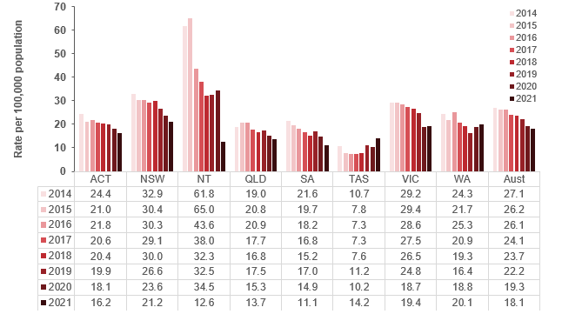

Source: National Notifiable Disease Surveillance System
Figure 10.2.1: Notification rate per 100,000 population of unspecified HBV, by sex and year, Victoria, 2014–2021
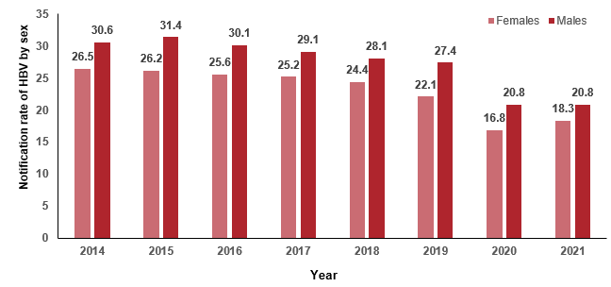
Year
Source: Public Health Event Surveillance System (PHESS), Department of Health
Figure 10.2.2: Notification rate per 100,000 population of unspecified HBV, by age group and year, Victoria, 2014–2021
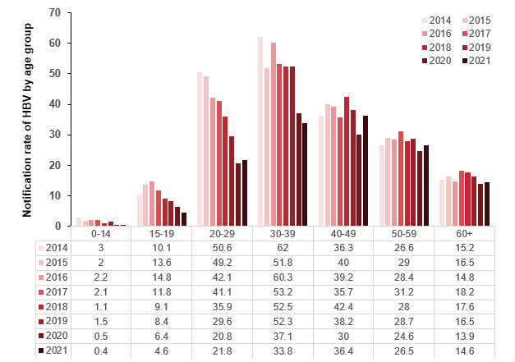

Source: Public Health Event Surveillance System (PHESS), Victorian Department of Health
Note: This data excludes cases where age is unknown or not reported.
Figure 10.2.3: Notification rate per 100,000 population of unspecified HBV, by ICS and year, Victoria, 2014–2021
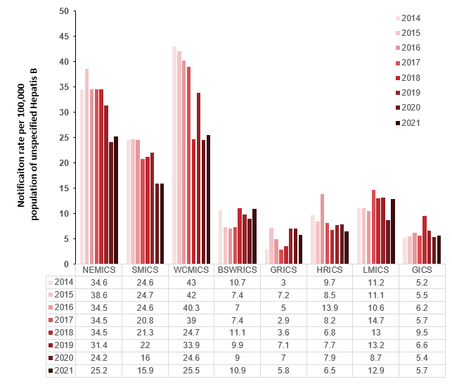

Source: Public Health Event Surveillance System (PHESS), Victorian Department of Health
Note: The decline in disease notifications seen in 2020 and 2021 should be interpreted with caution. They are likely to under-represent true disease incidence. Disease reductions are likely to be strongly influenced by the ongoing COVID-19 pandemic, resulting in changes in behavioural risk factors, access to healthcare services, health-seeking and testing practices and interstate and international travel restrictions.
Excludes cases where the postcode of residence was unknown or not reported.

Measure assessment
Traffic light rating: Green (satisfactory result)
Overall trend: Moving in the right direction
Commentary: In Victoria an estimated 63,000 people are living with hepatitis B (HBV), 37% of whom are undiagnosed. HBV is a viral infection that causes liver inflammation. Untreated chronic HBV is a leading cause of liver cancer, the fastest increasing cause of cancer deaths in Victorians.
In Victoria HBV is a notifiable disease under the Public Health and Wellbeing Regulations 2009. Figure 10.2 shows that the notification rate of unspecified HBV in Victoria has reduced by 9.8% from 29.2 cases per 100,000 population in 2014 to 19.4 cases per 100,000 population in 2021. During the same period (2014–2021), the rate of HBV notification in Victoria was higher than the national rate (Figure 10.2). However, the decline in disease notifications seen in 2020 and 2021 should be interpreted with caution. They are likely to under-represent true disease incidence. Disease reductions are likely to be strongly influenced by the impact of the COVID-19 pandemic, resulting in changes in behavioural risk factors, healthcare access, health-seeking and testing practices and interstate and international travel restrictions. For example, the decrease in testing rates from 2019 to 2020 in Western Australia may have resulted in an increase in notifications.
Rates have been consistently higher among males than females (Figure 10.2.1) but decreased from 30.6 per 100,000 population (2014) to 20.8 per 100,000 population (2021) for males and for females from 26.5 per 100,000 population (2014) to 18.3 per 100,000 population respectively. Notification rates were significantly higher for those aged 30–39 years compared with other age groups, although there was a marked decrease during 2020 and 2021 (Figure 10.2.2). In contrast, despite the much lower notification rates, rates for those aged 40–59 and 60+ years remained relatively stable between 2014 and 2021. Rates were consistently low among those aged 0–14 years during the reporting period (Figure 10.2.2).
Figure 10.2.3 shows the distribution of HBV notification rates by ICS across Victoria between 2014 and 2021. ICSs with the highest rates tended to be the metropolitan ICS such as NEMICS, WCMICS and SMICS, suggesting that the HBV burden is inequitably distributed across Victoria. Of note were the regional/rural ICSs, BSWRICS, LMICS and GICS, which all showed an increase between 2020 and 2021.
While no target has been set for this measure, the Victorian hepatitis B plan 2022–30 sets a vision to eliminate HBV as a public health concern by 2030.

Measure 10.3 – Notification rate of unspecified hepatitis C
Figure 10.3: Notification rate per 100,000 population of unspecified hepatitis C, by state/territory and year, 2014–2021
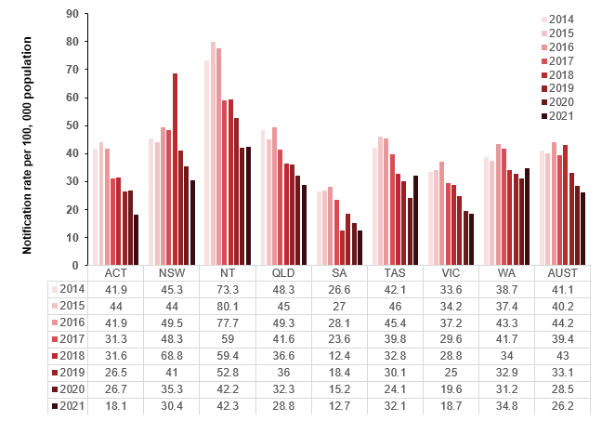
Source: National Notifiable Disease Surveillance System
Figure 10.3.1: Notification rate per 100,000 population of unspecified hepatitis C, by sex and year, Victoria, 2014–2021
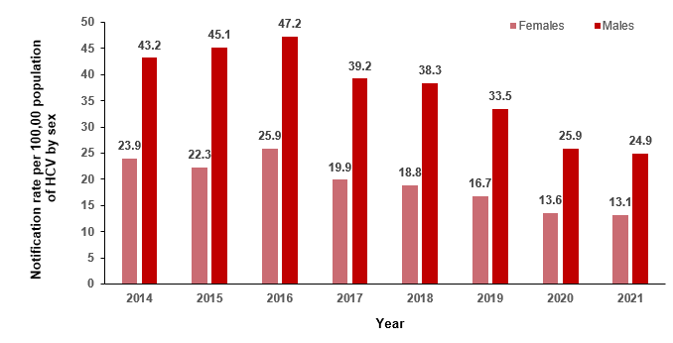Source: Public Health Event Surveillance System (PHESS), Department of Health
Figure 10.3.2: Notification rate per 100,000 population of unspecified hepatitis C, by age group and year, Victoria, 2014–2021
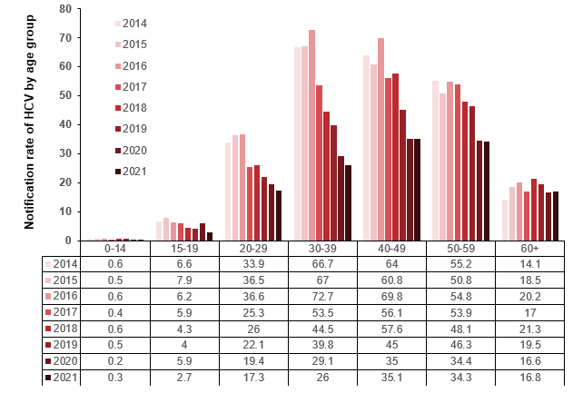

Source: Public Health Event Surveillance System (PHESS), Department of Health
Note: This data excludes cases where age is unknown or not reported.
Figure 10.3.3: Notification rate of unspecified hepatitis C, by ICS and year, Victoria, 2014–2021
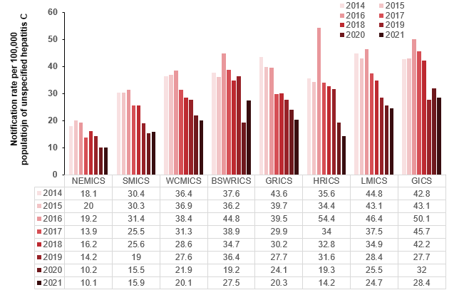
Source: Public Health Event Surveillance System (PHESS), Department of Health
Note: The decline in disease notifications seen in 2020 and 2021 should be interpreted with caution. They are likely to under-represent true disease incidence. Disease reductions are likely to be strongly influenced by the ongoing COVID-19 pandemic, resulting in changes in behavioural risk factors, access to healthcare services, health-seeking and testing practices and interstate and international travel restrictions.
Excludes cases where the postcode of residence was unknown or not reported.

Measure assessment
Traffic light rating: Green (satisfactory result)
Overall trend: Moving in the right direction
Commentary: In Victoria an estimated 65,000 people are living with HCV. As with HBV, HCV is a virus that causes inflammation and damage to the liver and, if left untreated, chronic HCV can lead to liver cancer.
In Victoria HCV is a notifiable disease under the Public Health and Wellbeing Regulations 2009. Figure 10.3 shows that the notification rate of unspecified HCV in Victoria has reduced by nearly 15% from 33.6 cases per 100,000 in 2014 to 18.7 cases per 100,000 in 2021 and is lower than the overall notification rate for HCV in Australia. It is important to note that the increase in the Victorian notification rate in 2016 may reflect increased testing as a result of people accessing new direct-acting antiviral regimens subsidised by the Pharmaceutical Benefits Scheme from March 2016. However, the decline in disease notifications seen in 2020 and 2021 should be interpreted with caution. They are likely to under-represent true disease incidence. Disease reductions are likely to be strongly influenced by the ongoing COVID-19 pandemic, resulting in changes in behavioural risk factors, healthcare access, health-seeking and testing practices and interstate and international travel restrictions.
As with HBV, rates for HCV have been consistently higher among males than females but are decreasing from 39.1 cases per 100,000 (2014) to 29.9 cases per 100,000 (2021) for males and 23.9 cases per 100,000 population in 2014 to 13.1 cases per 100,000 (2021) for females (Figure 10.3.1). Because the primary route of HCV transmission is sharing injecting equipment (a practice that typically starts in late adolescence (15–19 years) or early adulthood), trends in the rate of notifications in those under 20 years who are injecting drug users can be a proxy for the notification of HCV infection in recent years. Among Victorian people aged under 20 years, there has been a decrease in the notification rate among the 15–19-year age group between 2014 and 2021 (with the exception of 2020) from 6.6 cases per 100,000 population in 2014 to 2.7 cases per 100,000 population in 2021 (Figure 10.3.2). The age group 30–39 years had the next highest rate of notification, although the rate of notification of HCV has declined from 66.7 cases per 100,000 population in 2014 to 26 cases per 100,000 population in 2021. Over the reporting period 2014–2021, a relatively steady pattern was observed among people aged 40 years or older, except for in 2020 and 2021, which showed a decrease in the 40–59 but not the 60+ year category.
Figure 10.3.3 shows the distribution of HCV notification rate by ICS within Victoria between 2014 and 2021. ICSs with the lower rates tended to be those that have large metropolitan areas such as Melbourne, suggesting that the HCV burden is inequitably distributed across Victoria. However, some ICSs that include outer regional areas, while having higher rates, show a declining gradient between 2014 and 2021 – for example, GRICS, HRICS (except for 2016) and LMICS.
While no target has been set for this measure, the Victorian hepatitis C plan 2022–30 includes a vision to eliminate HCV as a public health concern by 2030.

Measure 10.4 – Proportion of people with a hepatitis B diagnosis with liver cancer, whose hepatitis B was diagnosed late
At the time of writing refreshed data was unavailable for further analysis. For data on this measure for the years 2010-2013 and 2014 refer to the Victorian Cancer Plan Monitoring and Evaluation Framework: Baseline Report (2020).

Measure 10.5 – Proportion of people with a hepatitis C diagnosis with liver cancer, whose hepatitis C was diagnosed late
At the time of writing refreshed data was unavailable for further analysis. For data on this measure for the years 2010-2013 and 2014 refer to the Victorian Cancer Plan Monitoring and Evaluation Framework: Baseline Report (2020).

Outcome: Detect cancers early

Key result: Increase early-stage diagnosis

Measure 11.1 – Proportion of all cancers diagnosed at stages 1 or 2
The VCR does not currently capture all staging information. Refer to Appendix 1.

Measure 11.2 – Proportion of female breast cancers diagnosed at stages 1 or 2
Figure 11.2: Proportion of female breast cancers diagnosed at stages 1 and 2, by age, Indigenous status and language spoken at home, 2014, 2016 and 2021
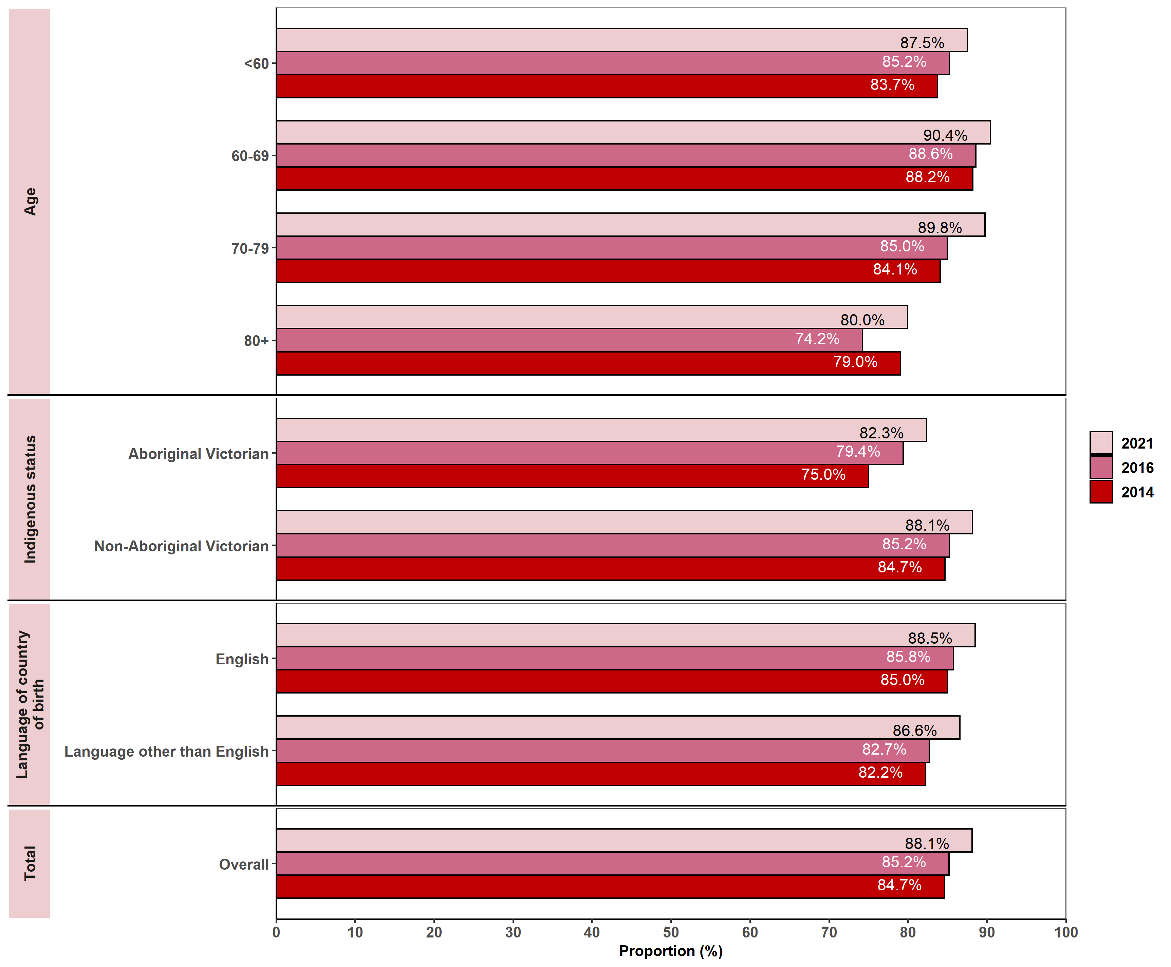
Note: The following was included:
- new diagnoses with stage recorded as 1–4 in the VCR, or with metastases recorded in the VCR (TNM = M1)
- patients diagnosed after neoadjuvant treatment
- for patients with multiple diagnoses within the year of interest, each diagnosis was included. Therefore, the number of new cancers does not necessarily equal the number of distinct patients.
The following was excluded: all cases of male breast cancer and all patients with unknown stage.
Appendix 2 provides the dataset.
Figure 11.2.1: Proportion of female breast cancers diagnosed at stages 1 and 2, by remoteness area, ICS and SES, 2014, 2016 and 2021
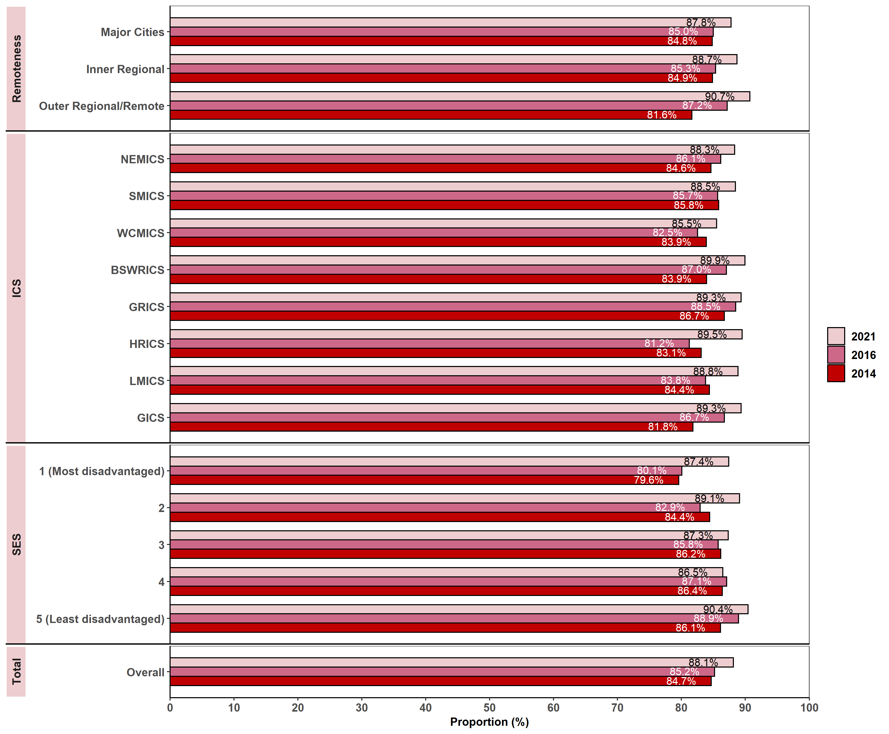
Note: Appendix 2 provides the dataset.

Measure assessment
Traffic light rating: Green (satisfactory result)
Overall trend: Moving in the right direction
Commentary: Cancers can be assigned a ‘stage’ that reflects how far the disease has spread. Stages range from 1 (best prognosis) to 4 (worst prognosis). At the international level it is important to note that due to differences in the scope of data collection, methodology and availability of information for staging, the distribution at a global level at diagnosis will vary considerably. This measure presents data for Victoria-specific stages 1 and 2 for female breast cancer, which is the second most common cancer in Victoria, accounting for 29% of all new cases diagnosed in females in 2021. Stages 1 and 2 diagnoses for female cancer indicates that the cancer is contained in the breast or that growth has only extended to the nearby lymph nodes. Overall from the baseline year more than 84% of cancers were diagnosed as early stage (stages 1 or 2) for breast (female) cancer and generally increased with age between 2014 (84.7%) and 2021 (88.1%) (Figure 11.2). The highest proportion of early-stage cancers were in females aged 60–69 years, increasing from 88.2% (2014) to 90.4% (2021). This trend may reflect an increase in the participation rate of breast cancer screening through BreastScreen Australia, which targets women aged 50–74 for two-yearly screening mammograms. New technologies such as magnetic resonance imaging (MRI) of the breast and increased breast cancer awareness may also have contributed to the increased diagnosis of breast cancer. The lower proportion of early-stage breast cancer detected in women 80 years of age or older may reflect lower rates of screening, high detection of cancers by mammography before 80 years of age and/or incomplete detection.
Due to the small number of incident cancer cases in a single year over the seven-year period (2014–2021), results of analysis by Aboriginal Victorian status should be interpreted with caution. Nevertheless, Figure 11.2 shows a slight increase in Aboriginal Victorian cases of female breast cancer being diagnosed at an earlier stage over the reporting period. It is recognised that groups in Victoria with the lowest participation rate in screening are mostly likely women from Aboriginal and Torres Strait Islander and culturally diverse backgrounds (where the language spoken at home may be a language other than English) (Figure 11.2). As a result, these women are more likely to have a later stage cancer diagnosis and therefore poorer outcomes. To reverse this trend the Department of Health, in collaboration with BreastScreen Victoria and cancer screening programs and key partners such as VACCHO (The Beautiful Shawl Project), continues to work in implementing a range of initiatives to reduce health disparities.
In the seven-year period (2014–2021) there were similar stage (1 and 2) distribution patterns for female (breast) cancer across remoteness area and SES (Figure 11.2.1). There were also no notable differences in the high proportion of female breast cancers diagnosed at stages 1 and 2 across each of the ICS. However, Figure 11.2.1 shows that despite the increase across all SES categories, disparities exist between those who are most compared with least disadvantaged. While no target has been set for this measure, early diagnosis and screening remain essential to enable the improvement in female breast cancer outcomes and survival.

Measure 11.3 – Proportion of colorectal cancers diagnosed at stage 1 or 2
Figure 11.3: Proportion of colorectal cancers diagnosed at stages 1 and 2, by age, sex, Indigenous status and language spoken at home, 2014, 2016 and 2021
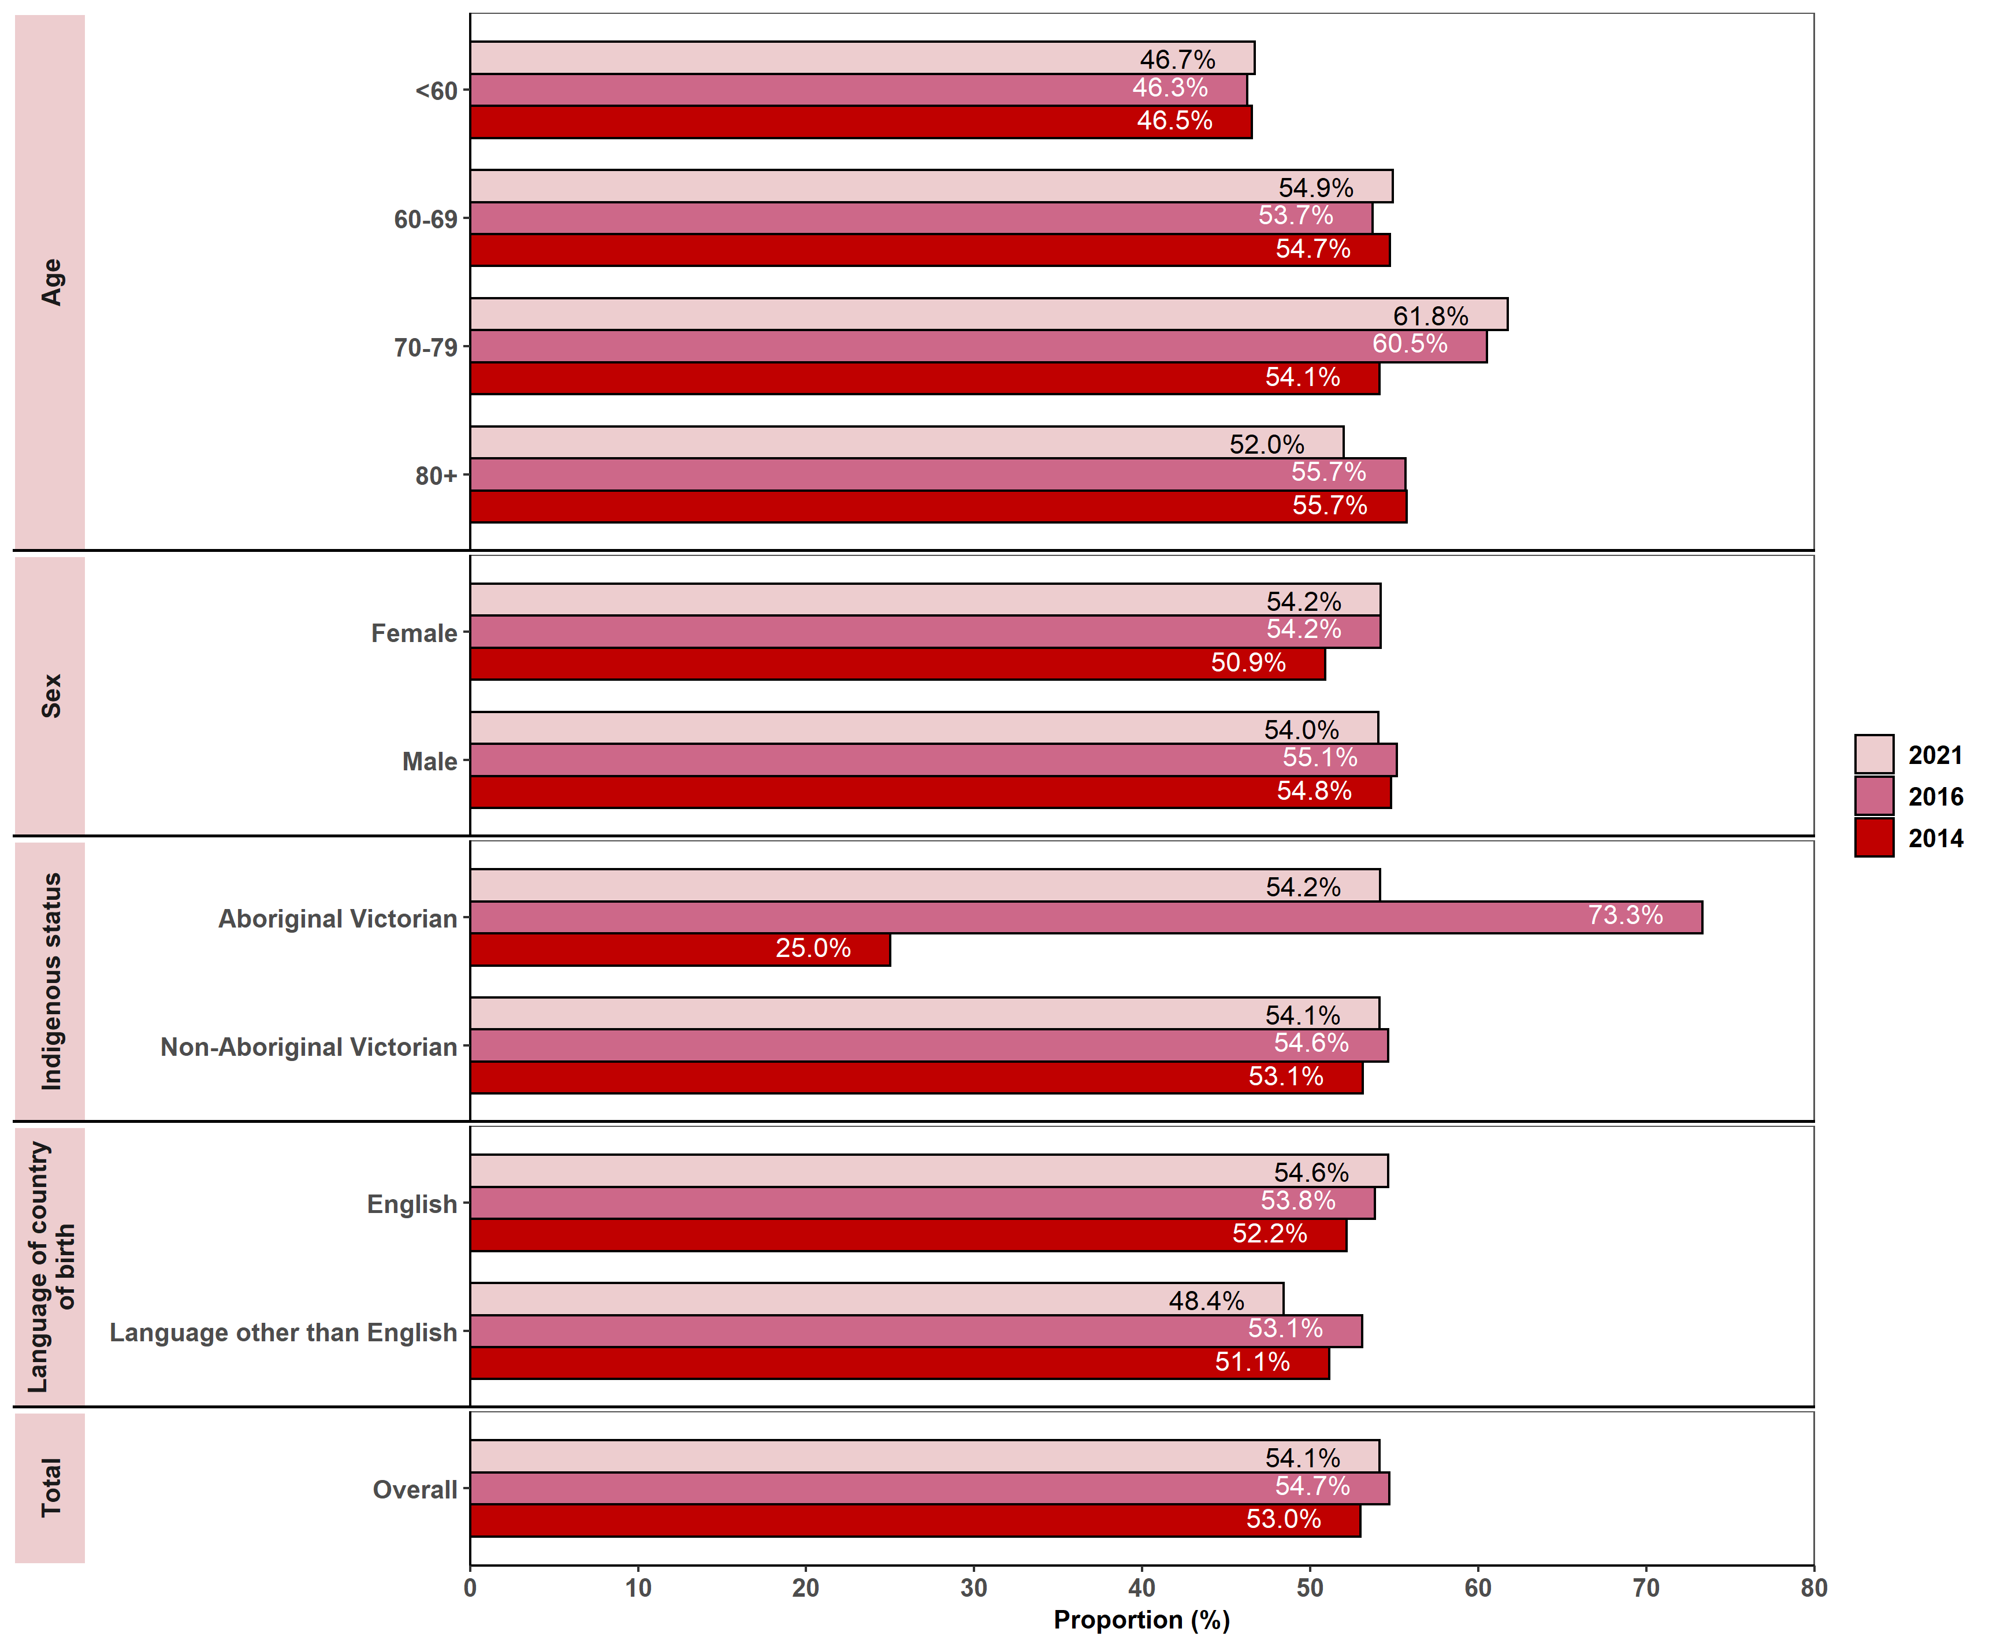
Note:
The following was included:
- new diagnoses with stage recorded as 1–4 in the VCR, or with metastases recorded in the VCR (TNM = M1)
- patients diagnosed after neoadjuvant treatment
- for patients with multiple diagnoses within the year of interest, each diagnosis was included. Therefore, the number of new cancers does not necessarily equal the number of distinct patients.
The following was excluded: all patients with unknown stage.
Appendix 2 provides the dataset.
Figure 11.3.1: Proportion of colorectal cancers diagnosed at stages 1 and 2, by remoteness area, ICS and SES, 2014, 2016 and 2021
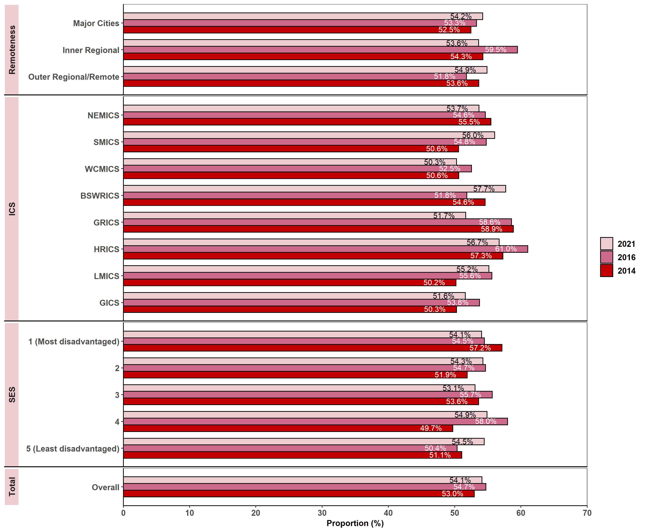
Note:
The following was included:
- new diagnoses with stage recorded as 1–4 in the VCR, or with metastases recorded in the VCR (TNM = M1)
- patients diagnosed after neoadjuvant treatment
- for patients with multiple diagnoses within the year of interest, each diagnosis was included. Therefore, the number of new cancers does not necessarily equal the number of distinct patients.
The following was excluded: all patients with unknown stage.
Appendix 2 provides the dataset.

Measure assessment
Traffic light rating: Green (satisfactory result)
Overall trend: Moving in the right direction
Commentary: The distribution of cancer stage at diagnosis provides an indication of whether a particular cancer type is diagnosed earlier or later. At the international level it is important to note that due to differences in the scope of data collection, methodology and availability of information for staging, the distribution at a global stage at diagnosis will vary considerably. This measure presents the distribution pattern of statewide stage (stages 1 and 2) at diagnosis data for colorectal cancer (CRC) or bowel cancer. Stage 1 disease indicates that the tumour is contained to the lining of the bowel. In 2021, 54.1% of CRC was diagnosed at stages 1 or 2 in Victoria.
Figure 11.3 shows that over half of all colorectal cases between 2014 (53.0%) and 2021 (54.1%) were diagnosed at an early stage (stages 1 or 2). Early-stage CRC (stages 1 and 2) accounted for between 80.6% in 2014 to 77.8% in 2021 of cancers for people aged 60 years or older. Slightly lower proportions of early-stage cancers were detected in people aged under 60 years (46.5% in 2014 rising slightly to 46.7% in 2021; refer to Table 11.3, Appendix 2). Between 2014 and 2021 there was a similar distribution of early stage (stages 1 and 2) at diagnoses for both males and females, although the latter showed a marked increase from 50.9% in 2014 to 54.2% in 2021.
Due to the small number of incident cancer cases among Aboriginal Victorians in a single year over the seven-year period (2014–2021), results of analysis by Indigenous status should be interpreted with caution. Figure 11.3 shows that Aboriginal Victorians has a lower proportion of CRCs diagnosed at stages 1 and 2 in 2014 than non-Aboriginal Victorians. However, in 2021 it was almost the same (54.2 percent for Aboriginal Victorians verses 54.1 percent for non-Aboriginal Victorians), but the number of Aboriginal patients is very low (Table 11.3, Appendix 2) – that is, approximately 71 Aboriginal patients between 2014 and 2021 compared with more than 10,000 non-Aboriginal patients over the same period. The difference in numbers may reflect a lower uptake in CRC screening among this population group.
People living in different SES groups had similar proportions of CRCs diagnosed at stages 1 and 2, which were generally over 50%. This was also reflected in the proportion of CRCs diagnosed at stages 1 and 2 across the different ICSs, language spoken at home and remote areas.
While no target has been set for this measure, CRC rates are anticipated to increase as a result of Victoria’s ageing population. Increasing (including targeted campaigns with under-screened communities) and maintaining high levels of participation in the National Bowel Cancer Screening Program will deliver benefits in terms of reducing illness and death from CRC, particularly in the target age group of people aged 50–74 years.

Measure 11.4 – Proportion of cervical cancers diagnosed at stages 1 or 2
The VCR does not currently capture this information. Refer to Appendix 1.

Measure 11.5 – Proportion of lung cancers diagnosed at stages 1 or 2
The VCR does not currently capture this information. Refer to Appendix 1.

Measure 11.6 – Proportion of all solid tumours diagnosed at metastatic stage
Figure 11.6: Proportion of all solid tumours diagnosed at the metastatic stage, by age, sex, Indigenous status and language spoken at home, 2014, 2016 and 2021
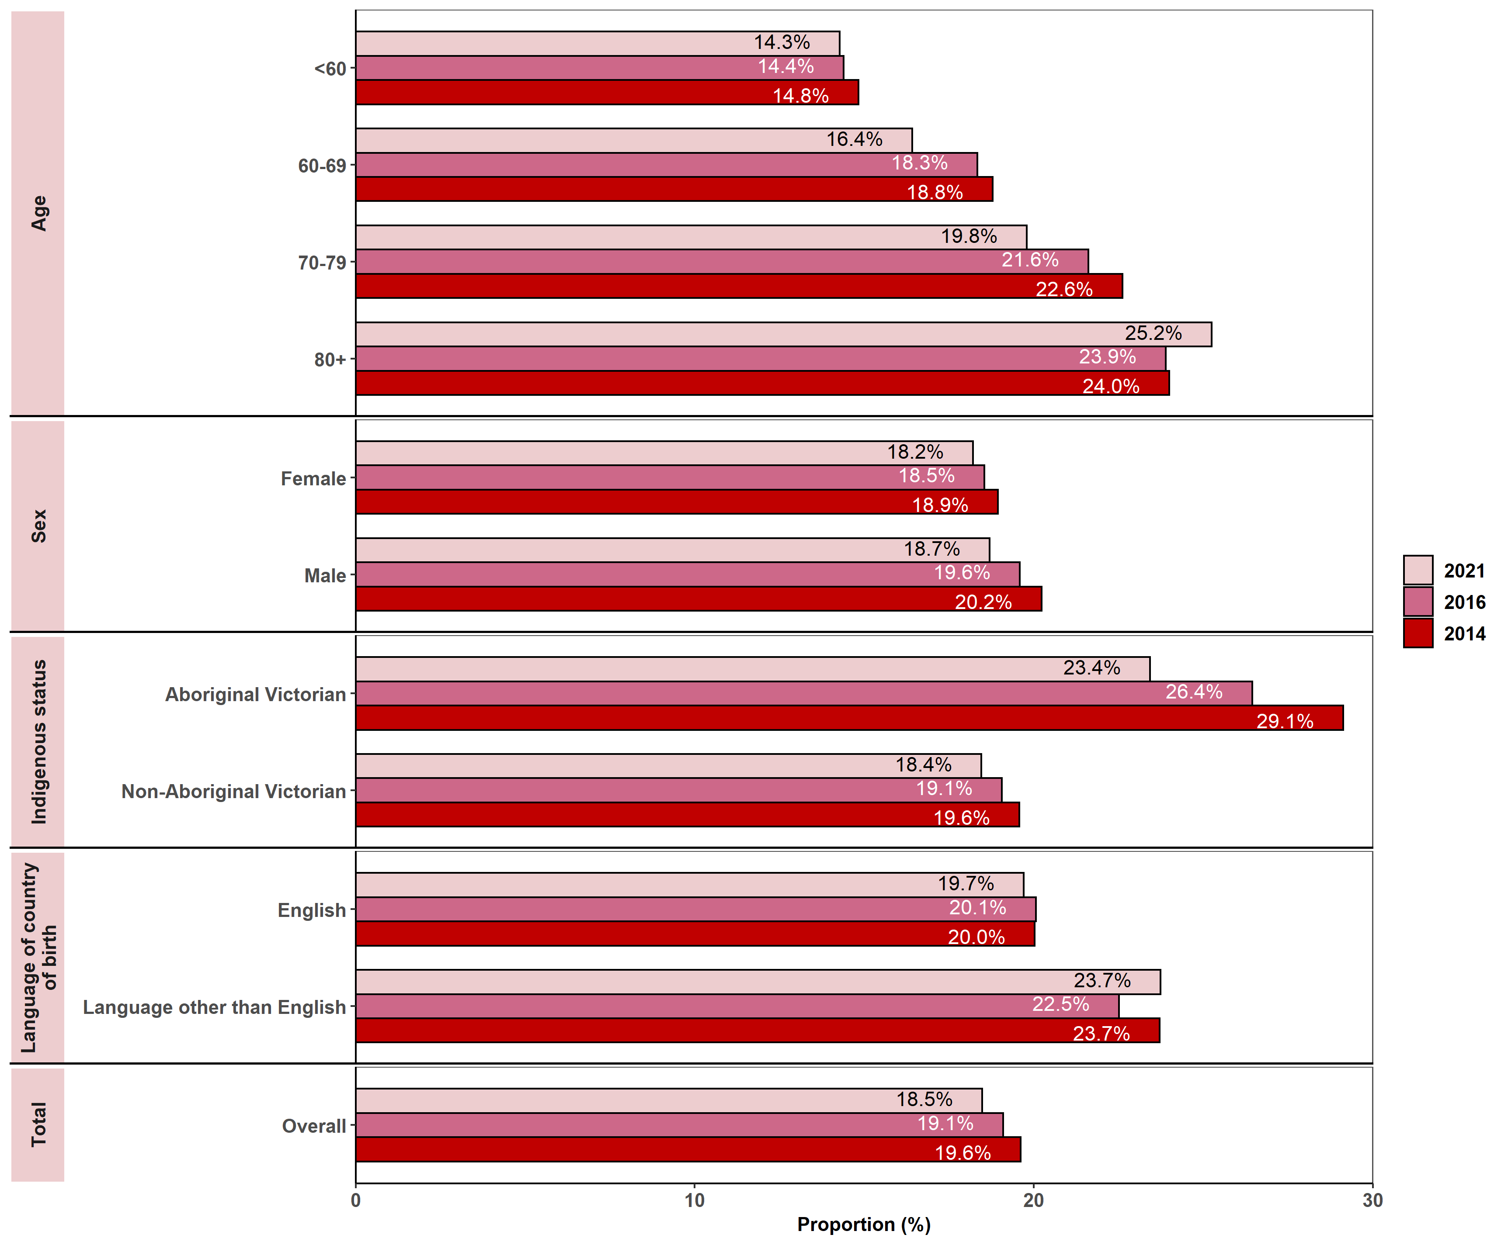
Notes:
- Metastatic disease at diagnosis was determined by:
  - VCR TNM-M (M1)
  - admitted episodes in the VAED, between 30 days prior and four months after diagnosis date, which contained metastatic cancer diagnosis codes.
- Patients who did not have an admitted episode in the VAED in the allocated timeframe could not be reclassified as metastatic at diagnosis, and so some cases of metastatic disease may not have been captured.
- New tumours with a VCR diagnosis of C00–C80 (solid tumour at diagnosis) were included, but codes C70–C72 (brain and CNS) were excluded in line with the Victorian cancer plan monitoring and evaluation framework – Data dictionary.
Appendix 2 provides the dataset.
Figure 11.6.1: Proportion of all solid tumours diagnosed at the metastatic stage, by remoteness area, ICS and SES, 2014, 2016 and 2021
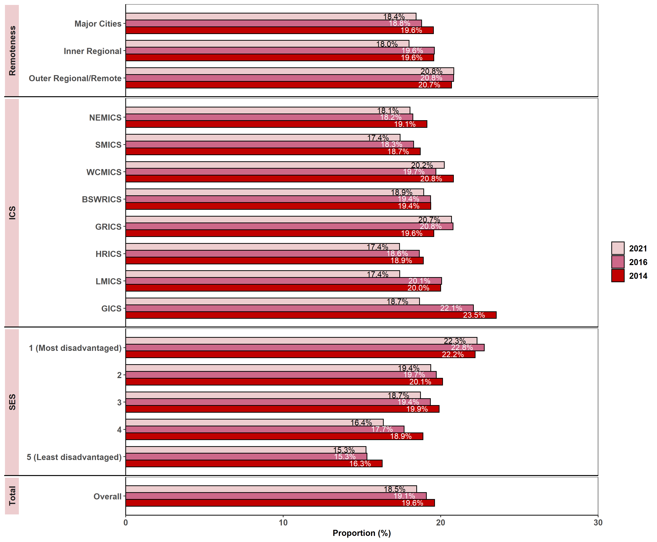
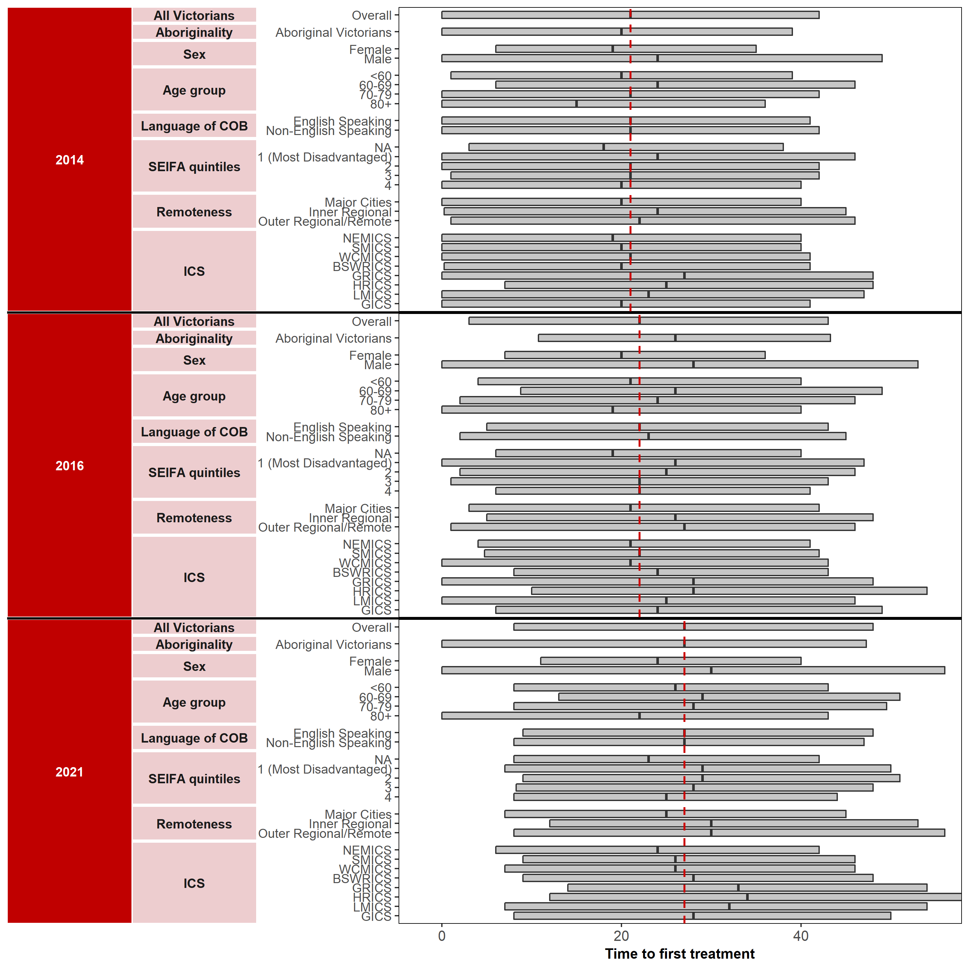Notes:
- Metastatic disease at diagnosis was determined by:
  - VCR TNM-M (M1)
  - admitted episodes in the VAED, between 30 days prior and four months after diagnosis date, which contained metastatic cancer diagnosis codes (neoplasm and morphology codes).
- Patients who did not have an admitted episode in the VAED in the allocated timeframe could not be reclassified as metastatic at diagnosis, and so some cases of metastatic disease may not have been captured.
- New tumours with a VCR diagnosis of C00–C80 (solid tumour at diagnosis) were included, but codes C70–C72 (brain and CNS) were excluded in line with the Victorian cancer plan monitoring and evaluation framework – Data dictionary.
Appendix 2 provides the dataset.

Measure assessment
Traffic light rating: Amber (desired result not yet evident)
Overall trend: Moving in the right direction
Commentary: The distribution of cancer stage at diagnosis provides an indication of whether a particular cancer type is diagnosed earlier (stage 1) or later (stage 4). The term ‘metastatic’ is used to describe cancers diagnosed at stage 4.
Figure 11.6 shows that the proportion of all solid tumours diagnosed at metastatic stage was consistent between 2014 (19.6%) and 2021 (18.5%). Figure 11.6 also shows a clear relationship between age and stage at diagnosis, with a greater proportion of patients over 80 years of age (24.0% in 2014; 24.3% in 2021) presenting with solid tumours compared with younger patients aged under 60 years (14.8% in 2014; remaining the same at 14.3% in 2021). However, there was a slight decrease for all age categories between 2014 and 2021, except for those patients aged 80 years or older. Males accounted for a slightly higher proportion of all solid tumours diagnosed at the metastatic stage than females between 2014 and 2016, possibly in part because males may be more likely to delay reporting symptoms and are less likely to participate in screening programs specific to bowel cancer, for example. Nevertheless this trend showed a slight decline for both sexes overall during the analysis period, equalising for both genders in 2021 (18.7% for males and 18.2% for females) (Figure 11.6).
For all three reporting years, Aboriginal Victorians had higher proportions of solid tumours diagnosed at the metastatic stage compared with non-Aboriginal Victorians. A similar pattern was observed for those whose language spoken at home was not English. This suggests that Aboriginal Victorians and culturally diverse communities may be under-served in early diagnosis, making them more vulnerable during the cancer treatment phase (Figure 2.3).
Figure 11.6.1 shows that overall, there was no clear association for all solid tumours diagnosed at the metastatic stage from 2014 to 2021. However, there was clear associations between SES and patients diagnosed with tumours at the metastatic stage, with those in the lowest quintile having the greatest burden of all tumours being diagnosed at an advanced stage compared with those in the highest quintile. This could be driven by individual cancer types such as lung cancer, which is more prevalent in low SES groups, of which 50% are metastatic at diagnosis. The distribution pattern by remoteness also showed some variability between 2014 to 2021, with those living in inner regional and outer regional/remote areas compared with major cites more likely to have patients with tumours diagnosed at the metastatic stage (Table 11.6.1, Appendix 2).
While no target has been set for this measure, knowing the distribution of all solid tumours diagnosed at the metastatic stage is crucial to understanding variations in survival and can help inform where targeted cancer control strategies such as screening and improved early detection/diagnosis of cancer can be applied to reduce the proportion of cancers diagnosed at an advanced stage (stage 4). As noted under Measure 1.3 at the time of writing, there is a proposal underway to implement a national lung cancer screening program targeted to people who are at high risk of developing lung cancer such as those in low SES groups. The screening component would be provided primarily through the Medicare Benefits Schedule.
Outcome: Optimal diagnostics and treatment

Key result: Increase adherence to Optimal Care Pathways

Measure 12.1 – Median days from diagnosis to start of primary curative treatment
Figure 12.1: Median days (and interquartile range) from diagnosis to start of primary curative treatment (overall), by year, 2014, 2016 and 2021
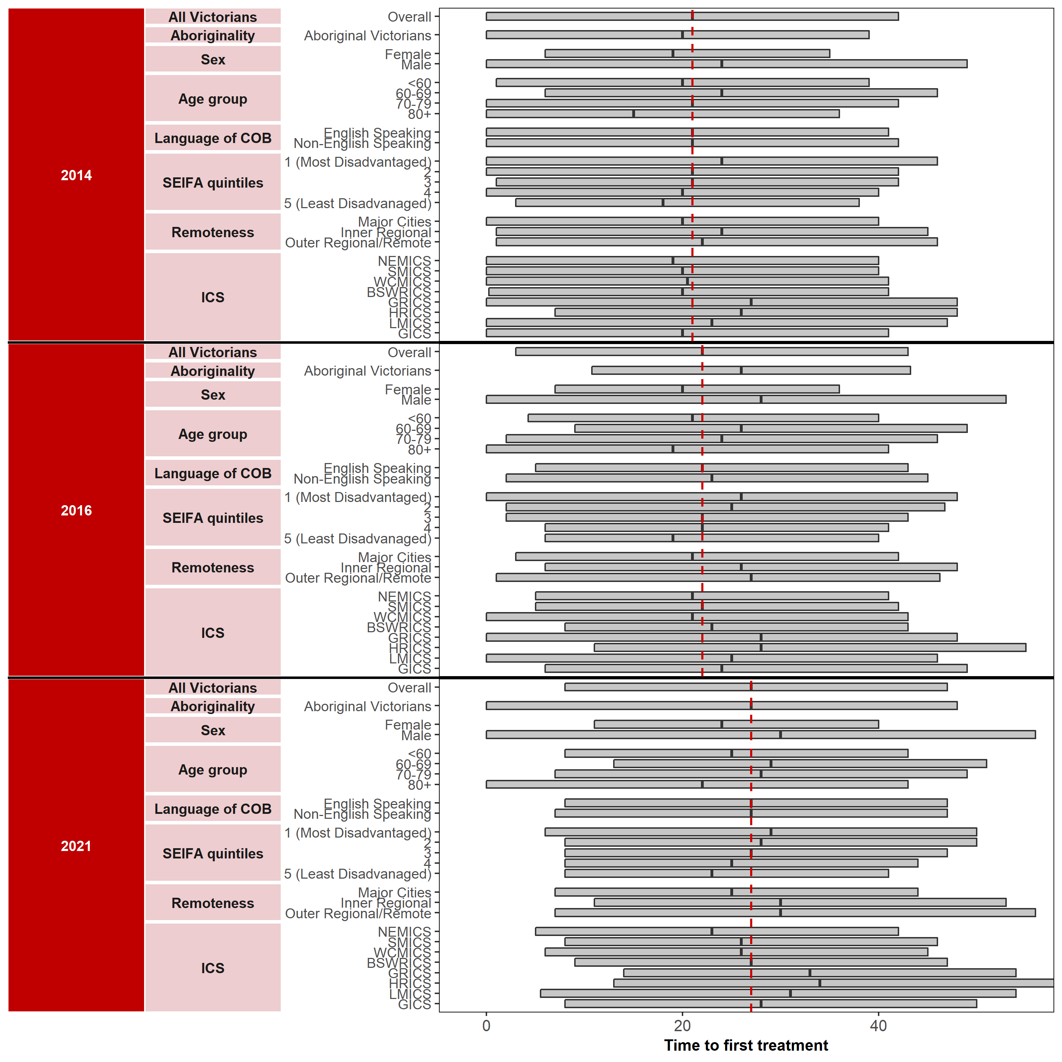

Notes:
- Patients who had a diagnosis that did not fall within one of the major tumour streams were grouped together in a new grouping called ‘Other’.
- If a patient had more than one diagnosis within the same tumour stream (excluding ‘Other’ tumour stream) within the year of consideration, only the earliest diagnosis was retained.
- For patients in the ‘Other’ tumour stream, if a patient had more than one diagnosis with the same three-digit ICD10 code, the earliest diagnosis was retained.
- For patients who had a diagnosis within one of the major tumour streams, they were:
  - flagged as having had surgery if they had an admitted episode in the VAED with a tumour stream–specific surgery code in one of the operation codes. Note that surgery activities at Albury-Wodonga Health were not captured in the VAED
  - flagged as having had chemotherapy if they had an admitted episode in the VAED with a chemotherapy code and a tumour stream–specific ICD10 code within the diagnosis codes
  - flagged as having had radiotherapy if they had radical radiotherapy with a primary site that matched any ICD10 codes within their tumour stream.
- For patients who had a diagnosis that did not fall within one of the major tumour streams (in the ‘Other’ grouping), they were:
- flagged as having had surgery if they had an admitted episode in the VAED with a surgery code related to any of the major tumour streams in the operation codes
- flagged as having had chemotherapy if they had an admitted episode in the VAED with a chemotherapy code
- flagged as having had radiotherapy if they had any radical radiotherapy.
- Metastatic disease at diagnosis was determined by:
- excluding patients with a metastatic diagnosis
- VCR TNM-M (M1)
- admitted episodes in the VAED, between 30 days prior and four months after diagnosis date, that contained metastatic cancer diagnosis codes (neoplasm and morphology codes).
Appendix 2 provides the dataset.
Figure 12.1.1: Median days from diagnosis to start of primary curative treatment (breast), by year, 2014, 2016 and 2021
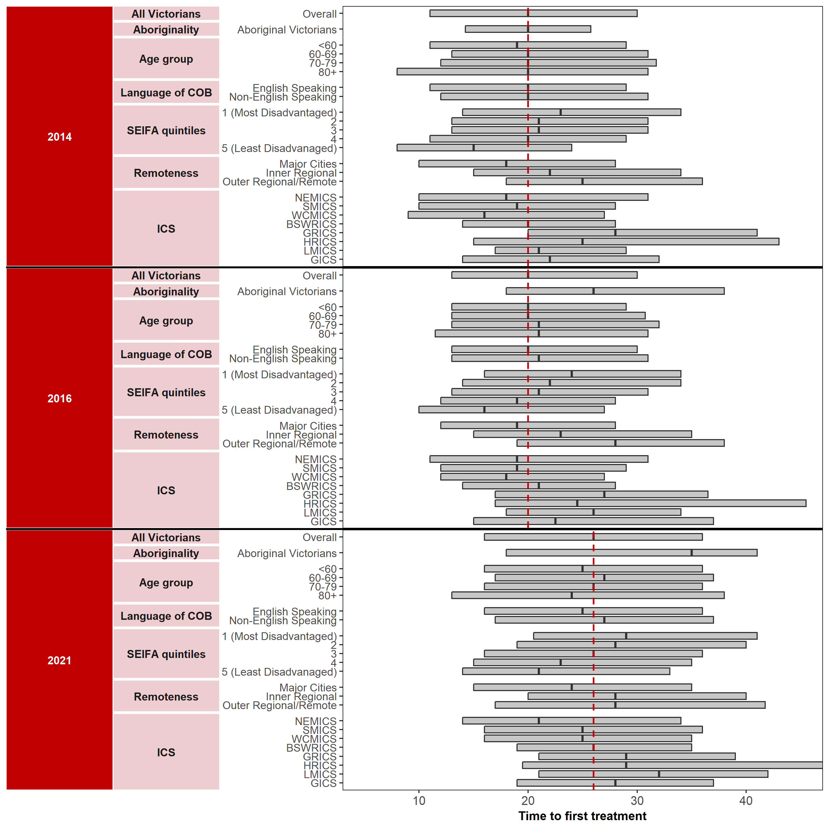

Appendix 2 provides the dataset.
Figure 12.1.2: Median days from diagnosis to start of primary curative treatment (colorectal), by year, 2014, 2016 and 2021
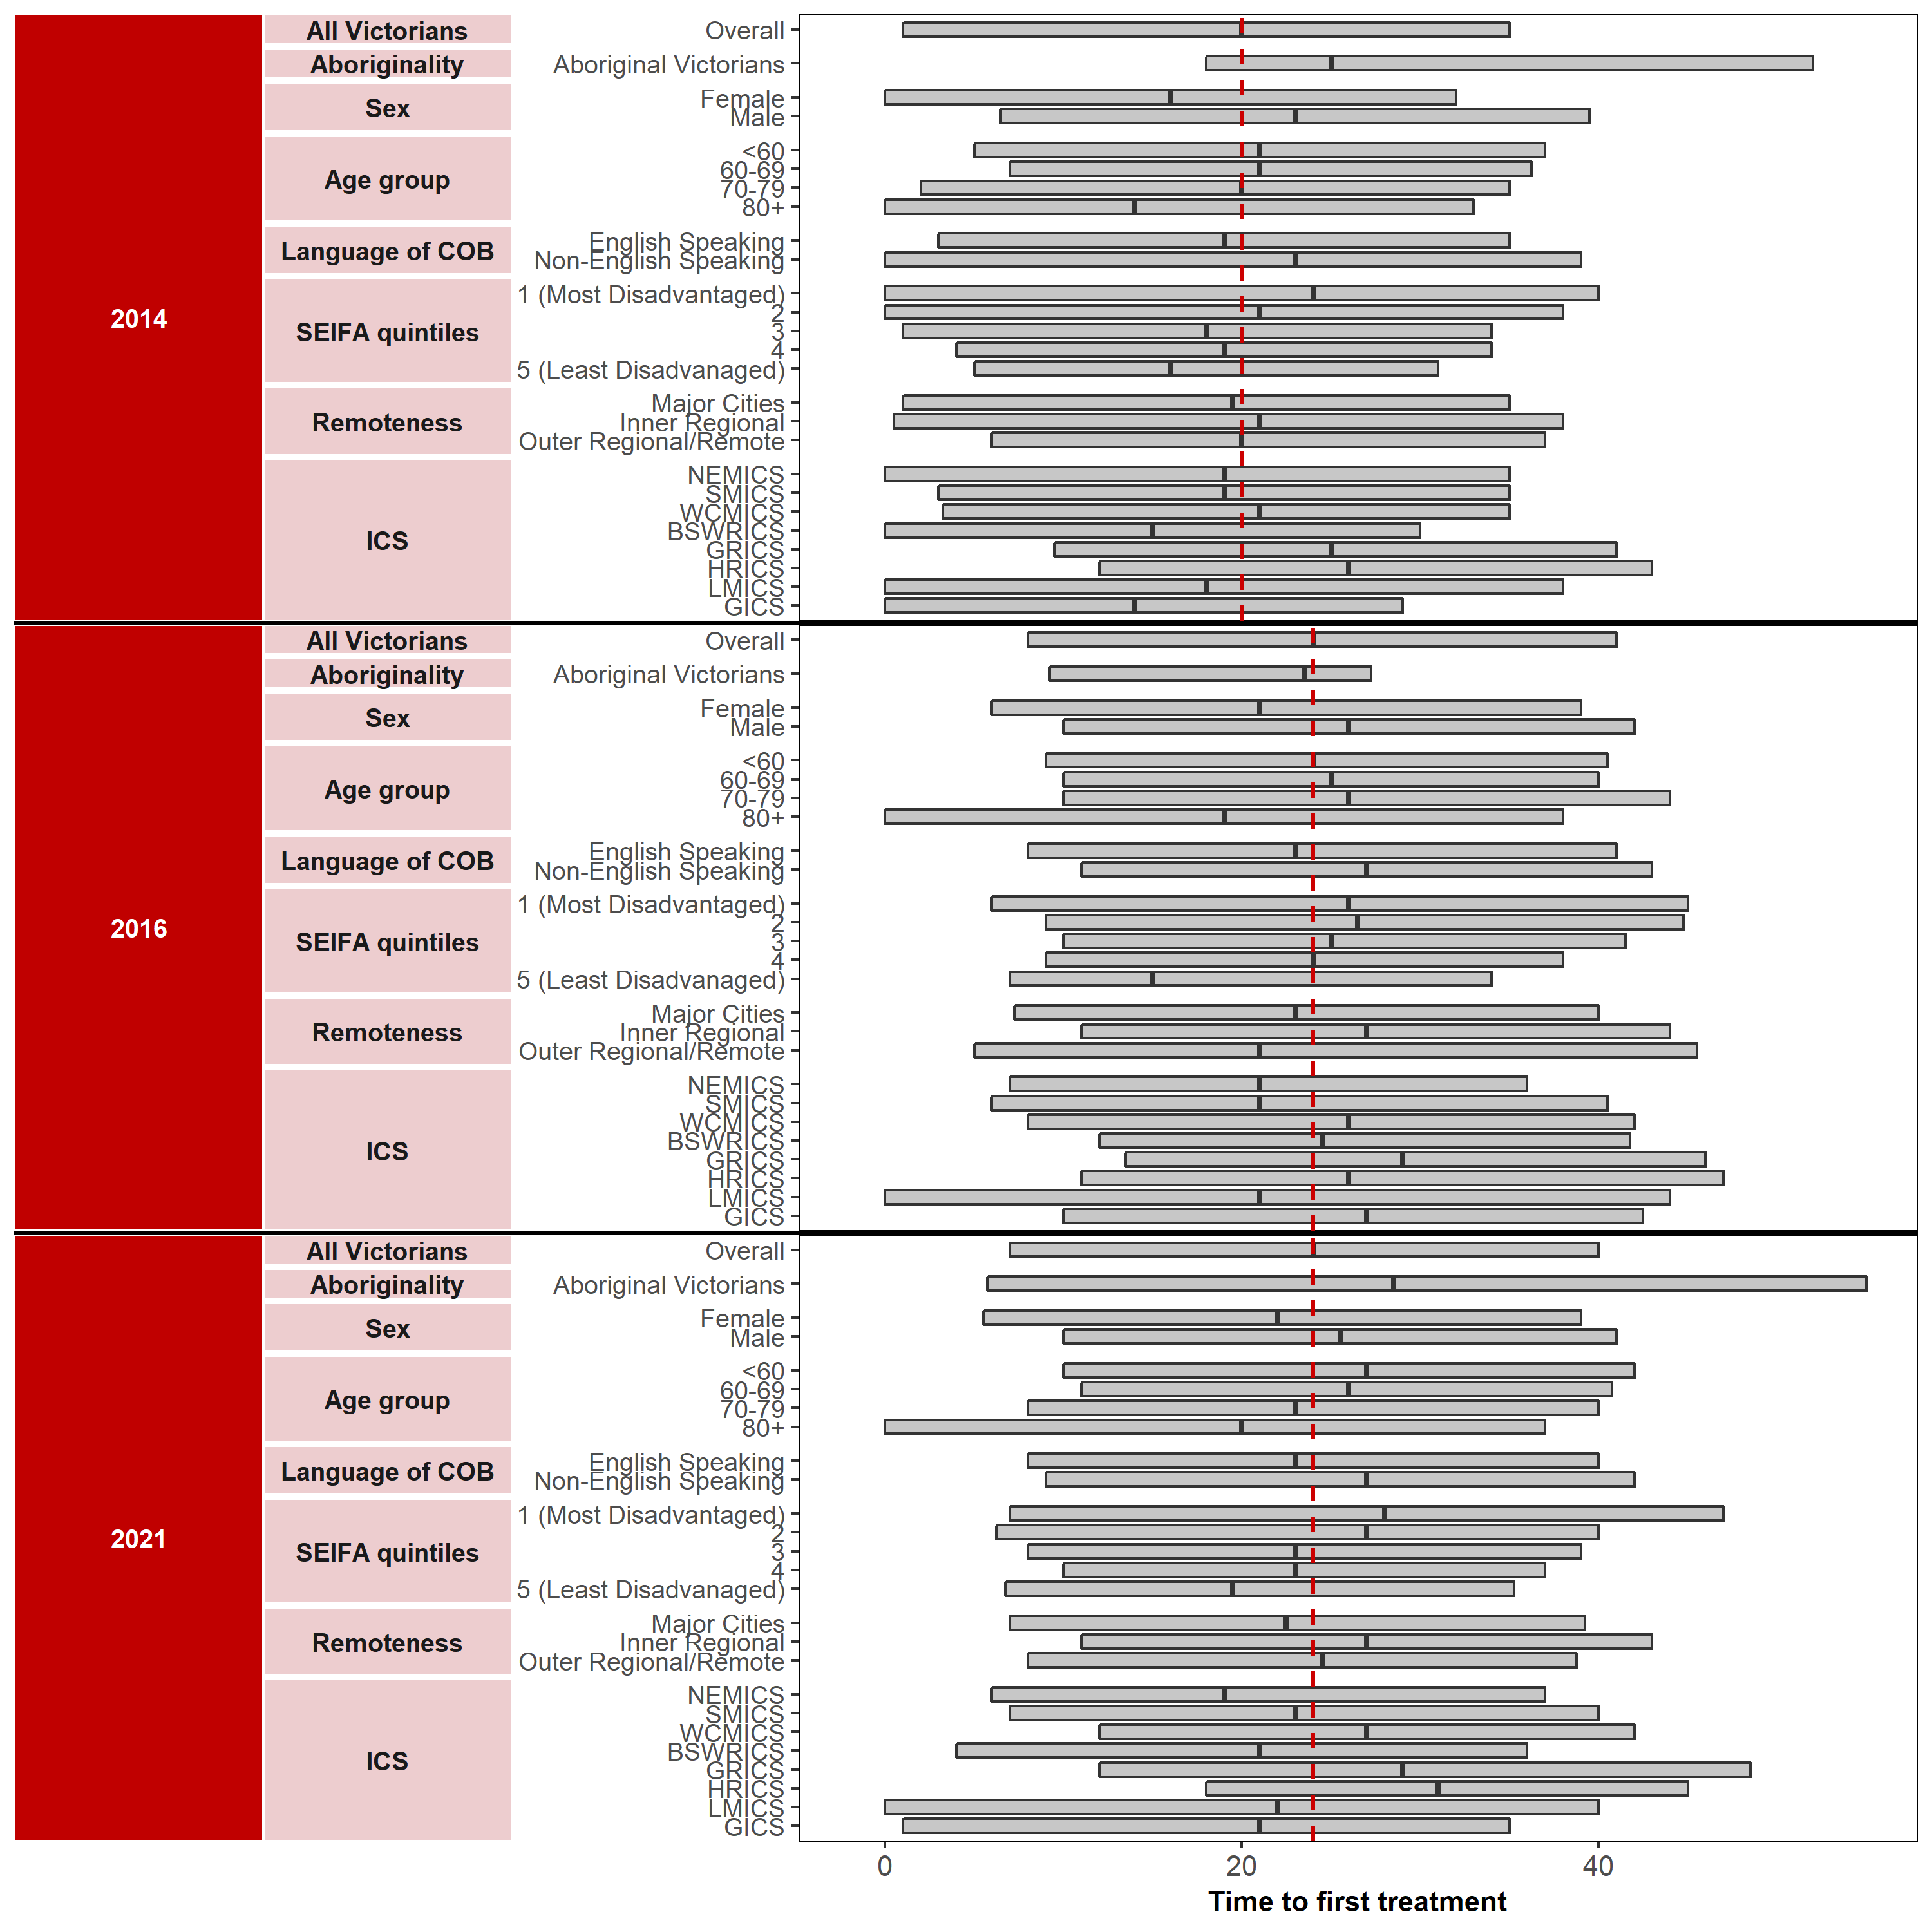

Appendix 2 provides the dataset.
Figure 12.1.3: Median days from diagnosis to start of primary curative treatment (genitourinary), by year, 2014, 2016 and 2021
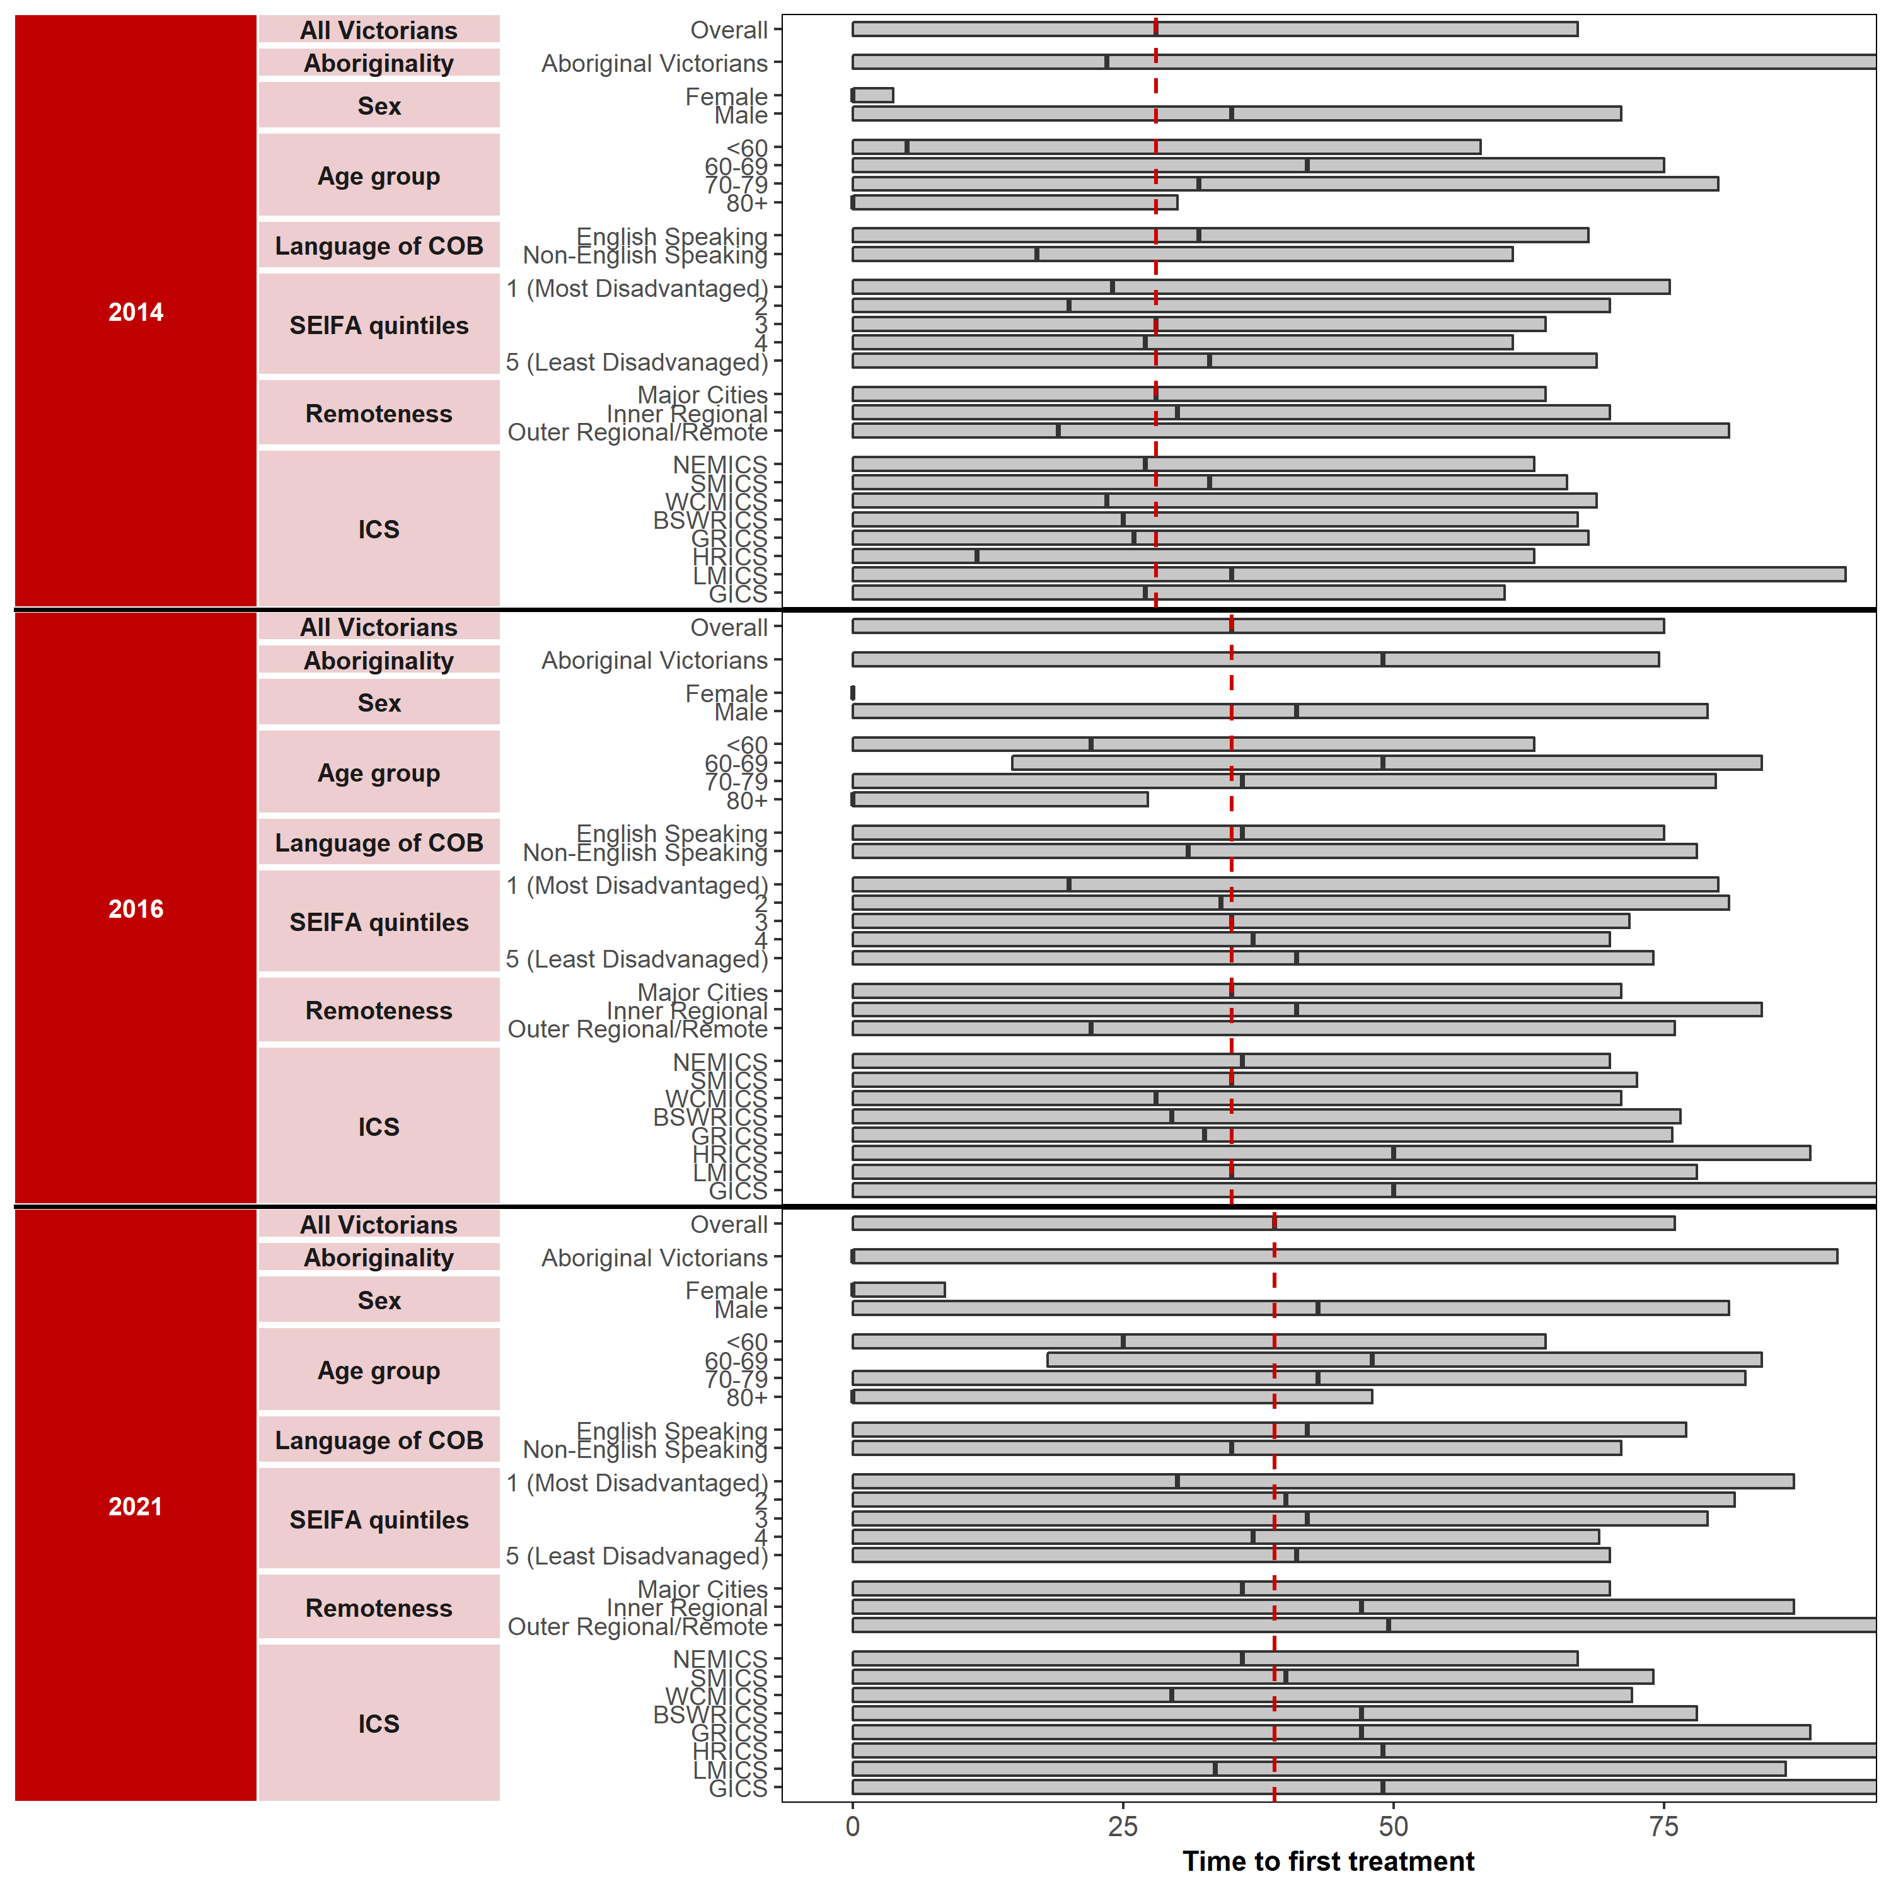

Appendix 2 provides the dataset.
Figure 12.1.4: Median days from diagnosis to start of primary curative treatment (haematological), by year, 2014, 2016 and 2021
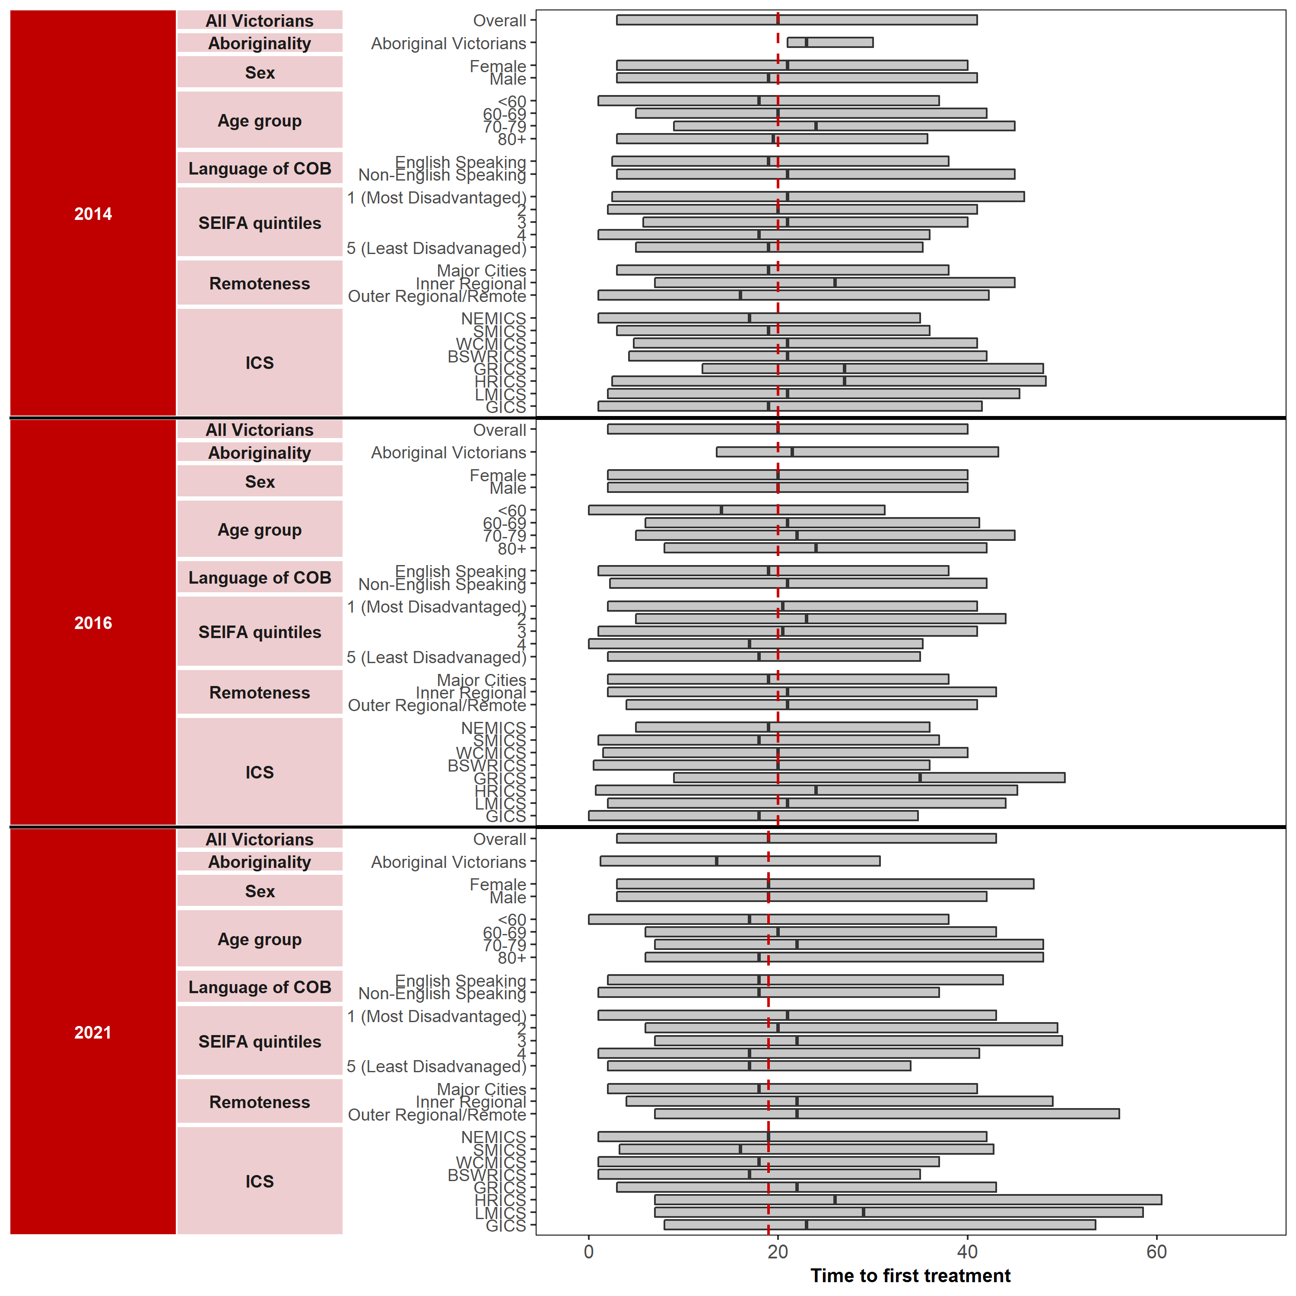

Appendix 2 provides the dataset.

Measure assessment
Traffic light rating: Red (result is of concern)
Overall trend: Not moving in the right direction but impacts of the COVID pandemic on median days from diagnosis is uncertain
Commentary: The time from a new diagnosis of cancer to starting treatment is a period of stress and anxiety for patients and their families. Delays in time to treatment worsen survival in some cancers, particularly early-stage cancers. Hence, it is important that people access timely treatment. For the purposes of this measure, primary curative treatment refers to surgery, radiotherapy or systemic anti-cancer therapy (SACT).
Figure 12.1 shows that the overall median time to treatment initiation from diagnosis increased from 21 days in 2014 to 27 days in 2021. Rural/regional Victorians experienced longer times from diagnosis to starting treatment (median time to treatment 22 days in 2014 increasing to 30 days in 2021), suggesting inequitable access to care for this group. Variation in the timeliness from diagnosis to the start of primary curative treatment between metropolitan and rural/remote ICS (for example, HRICS median days were 25 in 2014 rising to 34 in 2021) may indicate resource pressures in the public system or clinical variation by providers in ICSs in determining cancer treatment.
Figures 12.1.1 to 12.1.4 show the median time to treatment initiation from diagnosis for the top four tumour streams that recorded the highest number of cases varied from no change (median time 20 days) between 2014 and 2019 (Tables 12.1.4b and d, Appendix 2) decreasing slightly to a median time of 19 days in 2021 for haematological cancer (Figure 12.1.4) to more significant increases for genitourinary cancer (28 days in 2014 rising to 39 days in 2021) (Figure 12.1.3). The median time to treatment initiation from diagnosis for colorectal and breast cancer was 20 days (2014), rising to 24 days in 2021 and 20 days (2014) and 26 days in 2021, respectively.
No specific target has been set for this measure, rather the intent here is to align with the targeted approach set out in the Victorian optimal pathway for people with cancer; therefore, care should be taken when interpreting the results of this measure due to limitations outlined in the footnote below. Nevertheless greater efforts are needed to prevent treatment delays for patients with cancer, particularly because longer delays between diagnosis and initial treatment have been linked with worsened overall survival for stages 1 and 2 of some cancers including breast, lung, renal and pancreatic cancers, and stage 2 colorectal cancer.

Measure 12.2 – Proportion of patients receiving PET prior to primary treatment where appropriate
This measure will be reported in a future report. Refer to Appendix 1.

Measure 12.3 – Proportion of patients receiving molecular diagnostics prior to primary treatment where appropriate
This measure will be reported in a future report. Refer to Appendix 1.

Measure 12.4 – Proportion of patients with non-metastatic lung, breast, rectal and oesophageal cancers receiving radical radiotherapy as part of their primary treatment
Figure 12.4: Proportion of patients with non-metastatic lung cancer receiving radical radiotherapy as part of their primary treatment, by age, sex, Indigenous status, language spoken at home, remoteness area, SES and ICS, 2014, 2016 and 2020
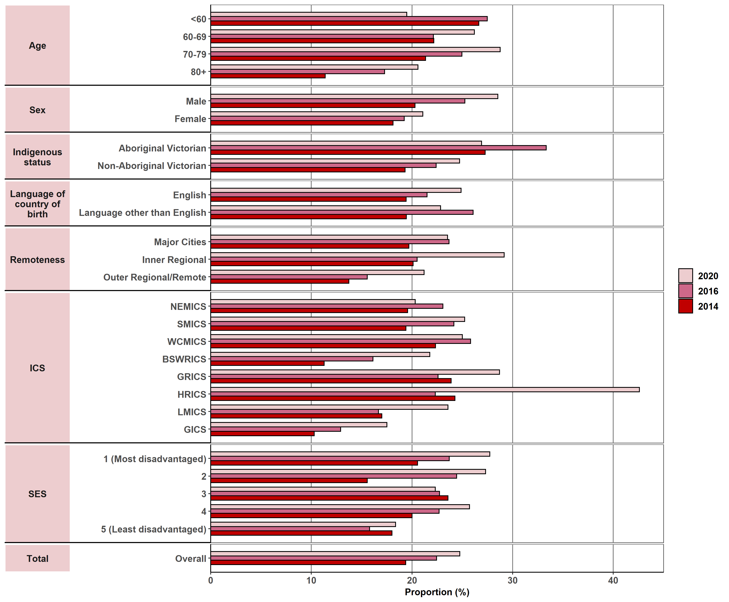
Appendix 2 provides the dataset.
Percentage (%)
Figure 12.4.1: Proportion of patients with non-metastatic breast cancer receiving radical radiotherapy as part of their primary treatment, by age, sex, Indigenous status, language spoken at home, remoteness area, SES and ICS, 2014, 2016 and 2020
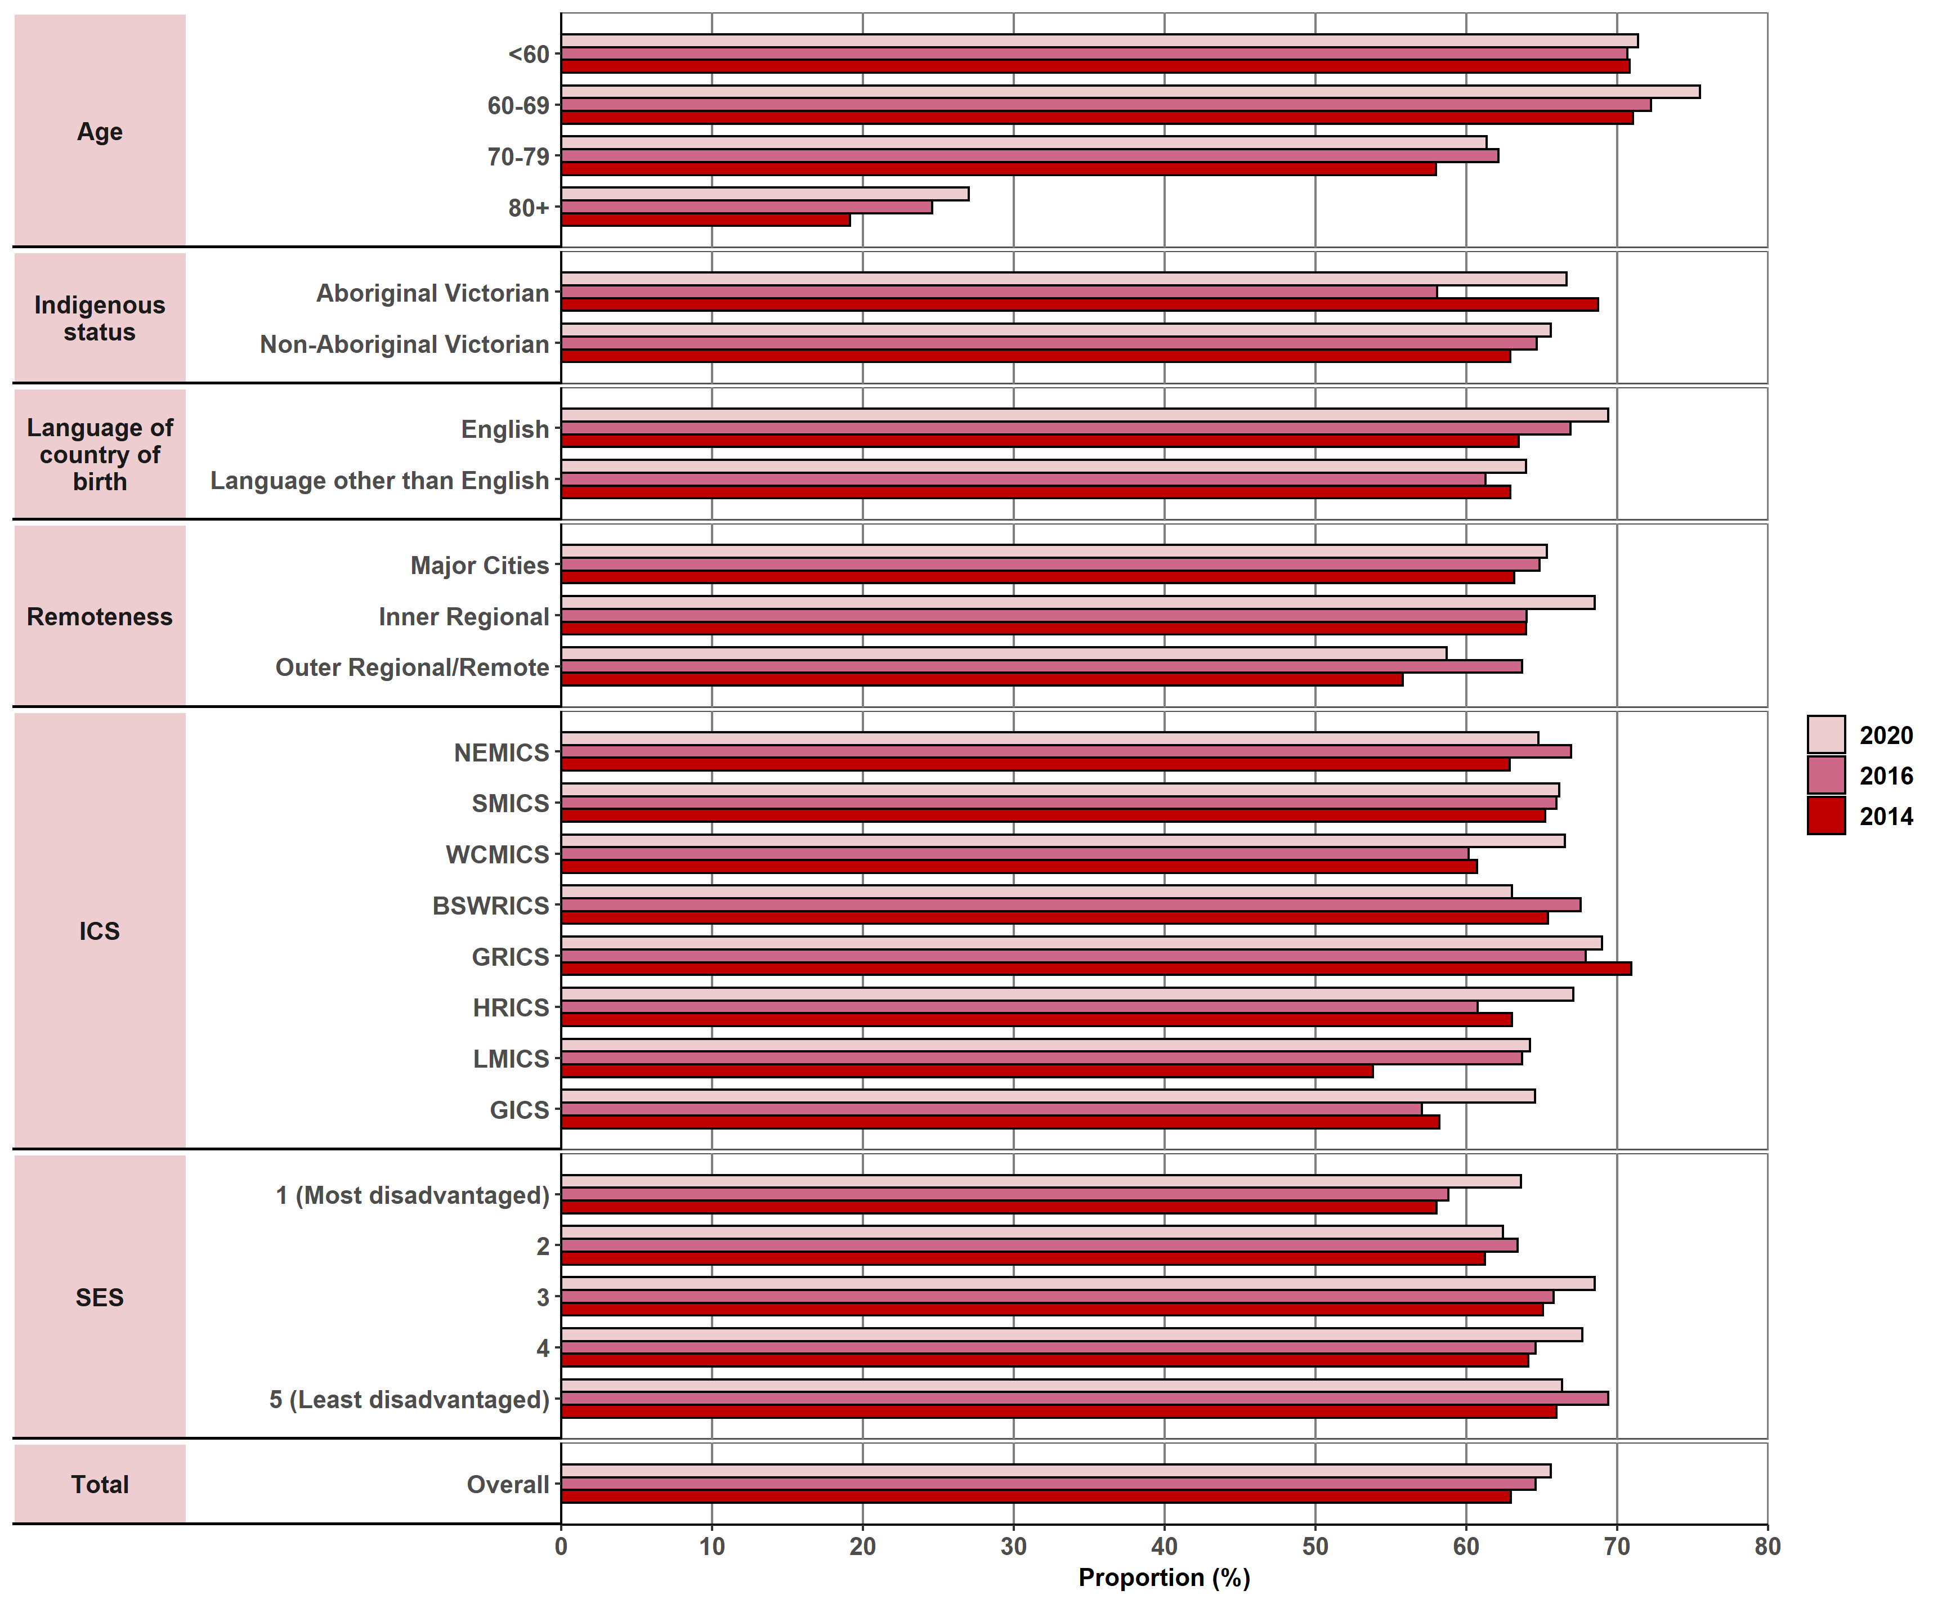
Appendix 2 provides the dataset.
Figure 12.4.2: Proportion of patients with non-metastatic colorectal cancer receiving radical radiotherapy as part of their primary treatment, by age, sex, Indigenous status, language spoken at home, remoteness area, SES and ICS, 2014, 2016 and 2020
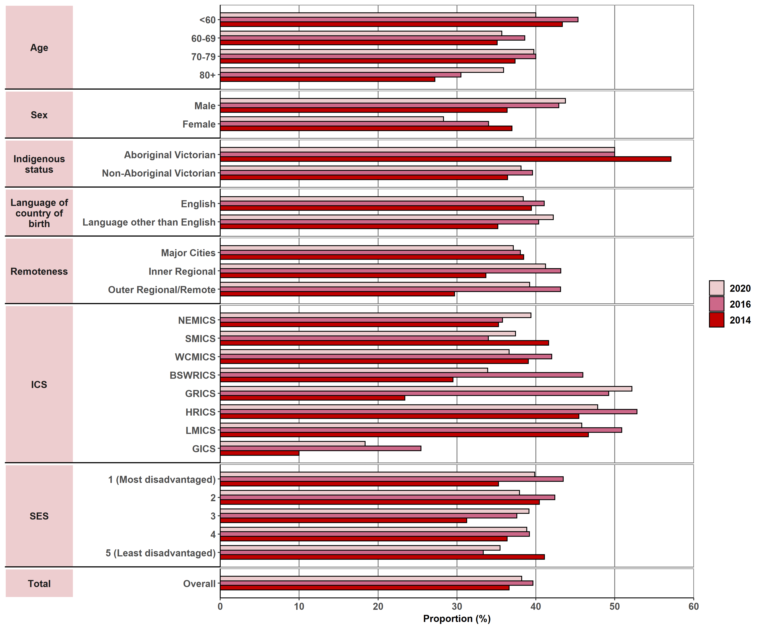
Appendix 2 provides the dataset.
Percentage (%)
Figure 12.4.3: Proportion of patients with non-metastatic oesophageal cancer receiving radical radiotherapy as part of their primary treatment, by age, sex, Indigenous status, language spoken at home, remoteness area, SES and ICS, 2014, 2016 and 2020
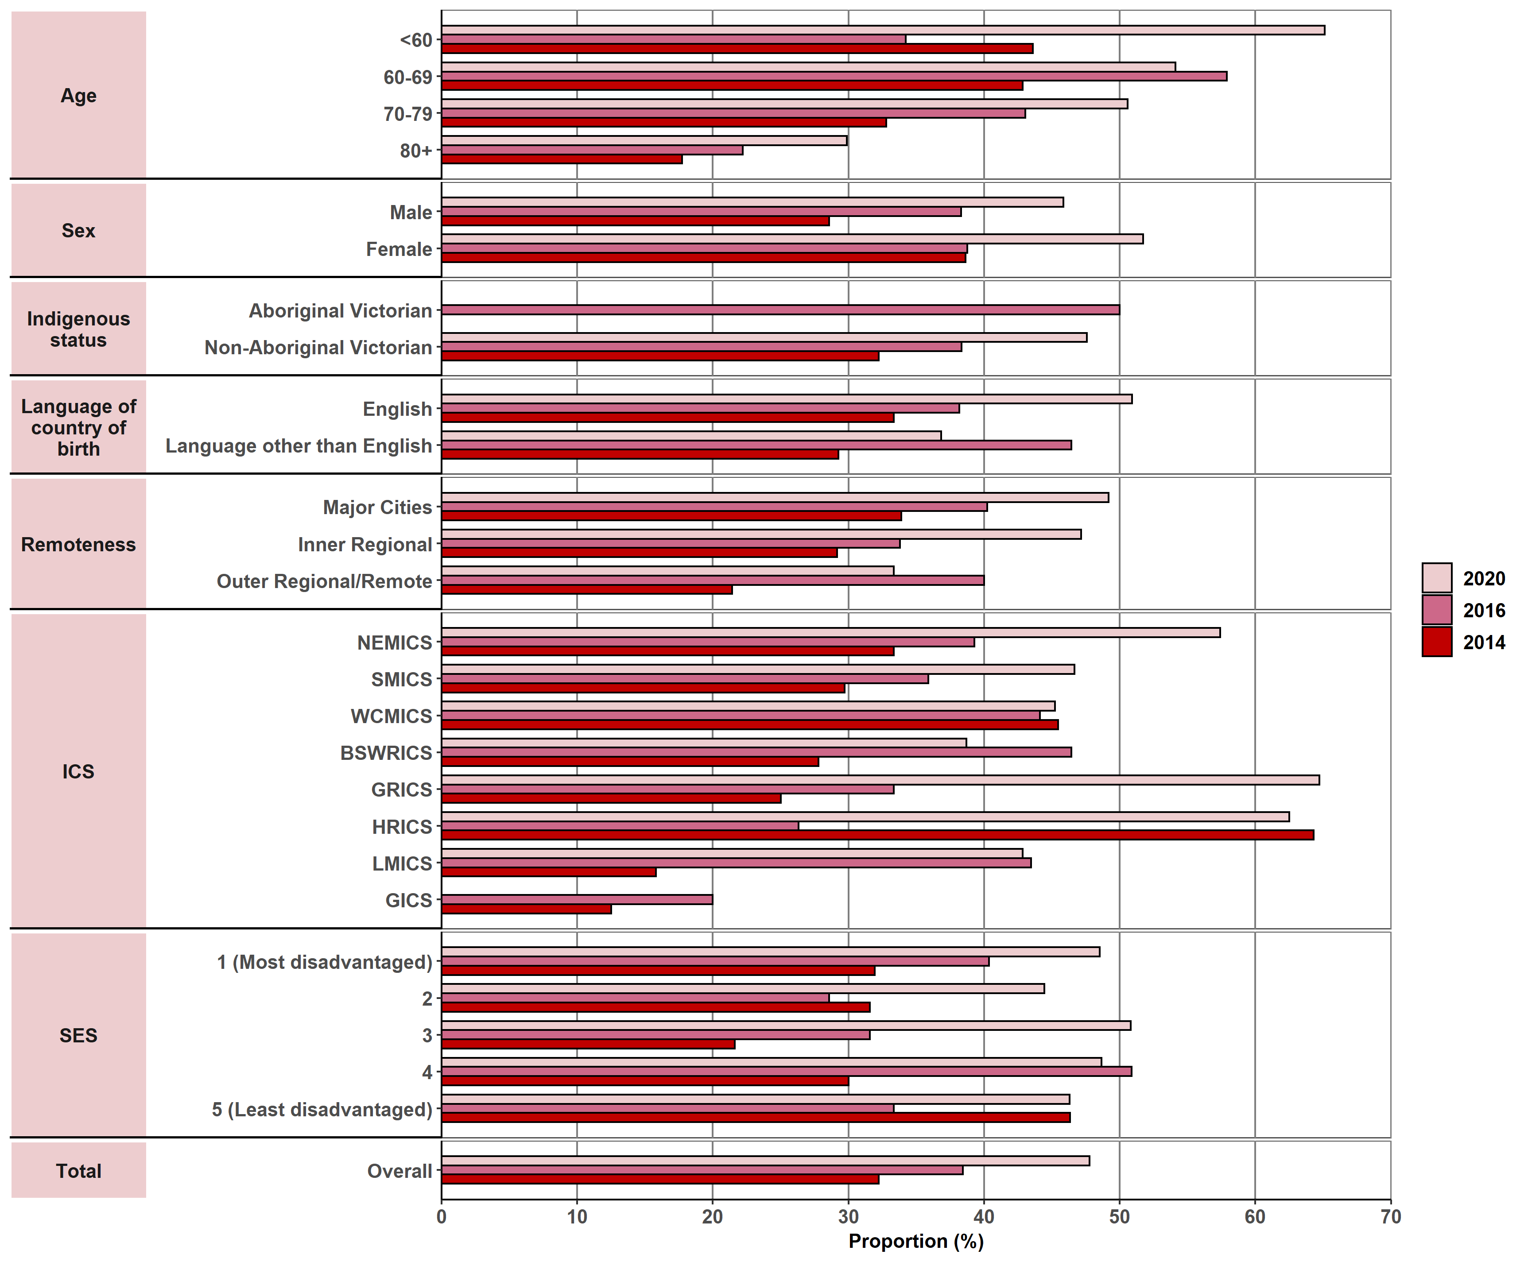
Appendix 2 provides the dataset.

Measure assessment
Traffic light rating: Green (satisfactory result)
Overall trend: Moving in the right direction
Commentary: Radical radiotherapy, also known as radiation therapy, is one of the main treatments for many cancers. It is also an area of health in which new technologies are emerging rapidly. This measure focuses on the proportion of patients with non-metastatic lung, breast, colorectal and/or oesophageal cancer who receive radiotherapy as part of their treatment. Of the four tumour streams, female breast cancer recorded the highest proportion of patients receiving radiotherapy at 62.9% in 2014 rising to 65.6% in 2020. By comparison oesophageal cancer recorded the next highest proportion of 32.2% in 2014 rising to 47.8% in 2020. This was followed by colorectal cancer (36.6% in 2014 and 38.2% in 2021) and lung cancer (19.4% in 2014 and 24.8 per and cent in 2020) (Figures 12.4, 12.4.1, 12.4.2 and 12.4.3).
No target has been set for this measure; however, as the population of Victoria ages, coupled with a projected increase in cancer incidence (including age and gender profiles) this will likely see an increase in treatment volume as it relates to radical radiotherapy. Figures 12.4, 12.4.1, 12.4.2 and 12.4.3 show that the proportion of patients receiving radical radiotherapy treatment varies across ICS. A higher proportion of patients receiving radical radiotherapy as part of their primary treatment were reported for urban patients. However, proportions for inner and outer regional/remote areas showed a steady increase between 2014 and 2020 over all four tumour streams – an indication that radiotherapy services (Albury Wodonga Regional Cancer Centre and South West Regional Cancer Centre) established in 2015 has improved access to this service for rural patients. Of note, too, Figures 12.4, 12.4.1, 12.4.2 and 12.4.3 show an increase in the proportion of culturally diverse cancer patients who do not speak English as a first language receiving radical radiotherapy as part of their primary treatment between 2014 and 2020. Data as it relates to Aboriginal Victorians should be interpreted with caution for all four tumour streams because of the very low numbers of cases reported (refer to Tables 12.4, 12.4.1, 12.4.2 and 12.4.3; Appendix 2).

Measure 12.5 – Proportion of patients receiving systemic anti-cancer therapy within recommended timelines
Figure 12.5: Proportion of patients (overall) receiving systemic anti-cancer therapy within recommended timelines, by age (A), sex (B), Indigenous status (C), language spoken at home (D), remoteness area (E), SES (F) and ICS (G), Victoria, 2014–2021
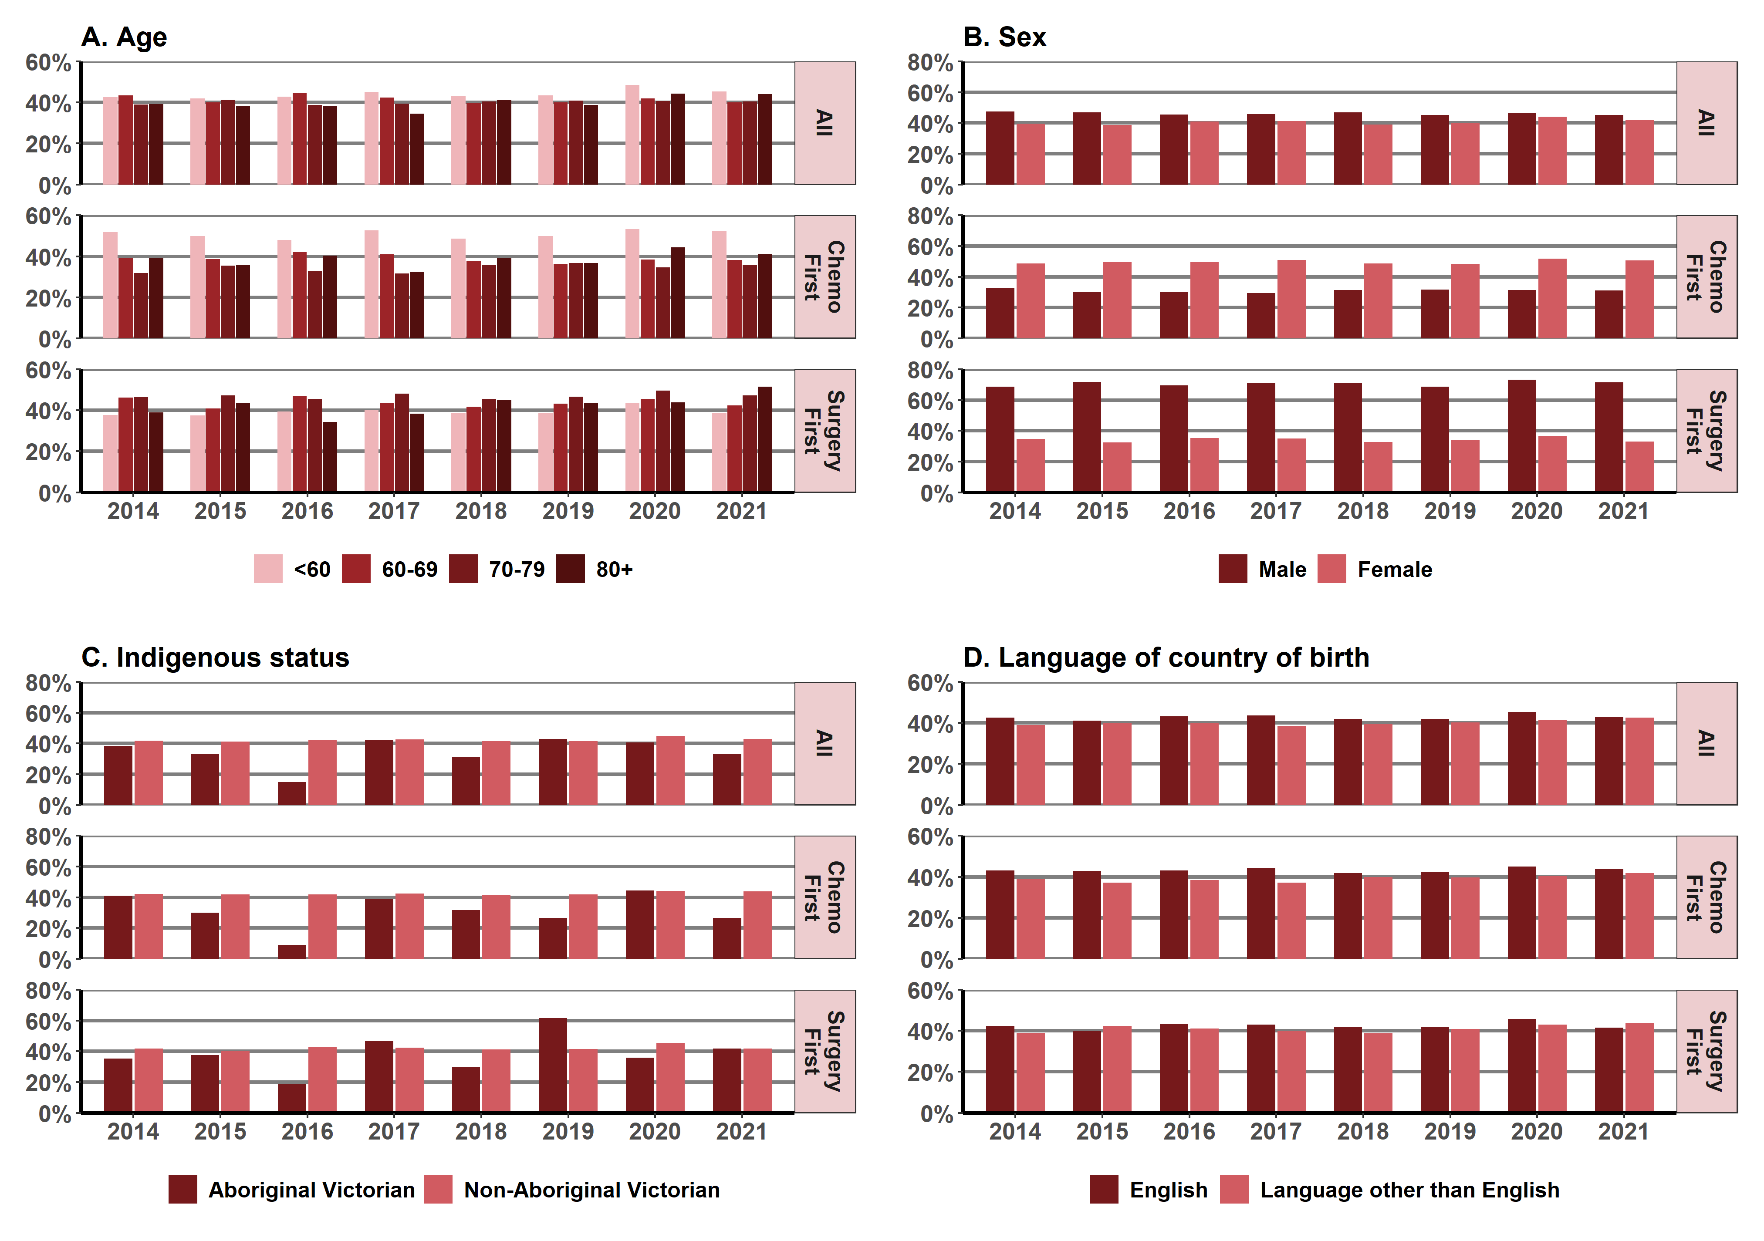
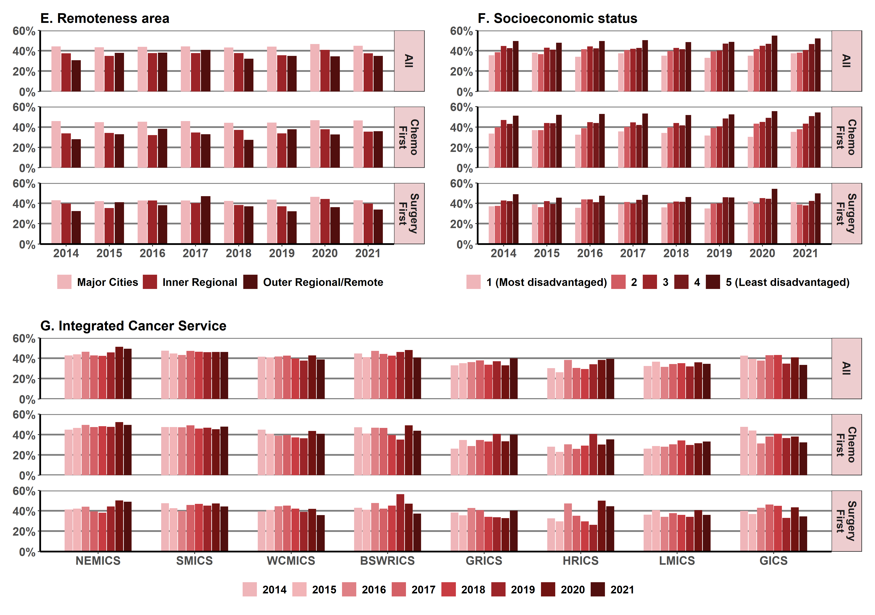

Notes:
The department’s Guidelines for timely initiation of chemotherapy: a proposed framework for access to medical oncology and haematology cancer clinics and chemotherapy services in Victoria (2015) describe the optimal timelines for treatment of colorectal, lung, breast and ovarian cancers in Victoria.
Victorians with cancer who live in HRICS may receive treatment in New South Wales (Albury) hospitals, which is not captured in the VAED. Therefore, variables in this report that are derived using the VAED (comorbidity count, distant metastases, surgery and chemotherapy) are likely to be underestimated for Victorians living in HRICS. Appendix 2 provides the dataset.
Figure 12.5.1: Proportion of lung cancer patients receiving systemic anti-cancer therapy within recommended timelines, by age (A), sex (B), Indigenous status (C), language spoken at home (D), remoteness area (E), SES (F) and ICS (G), Victoria, 2014–2021
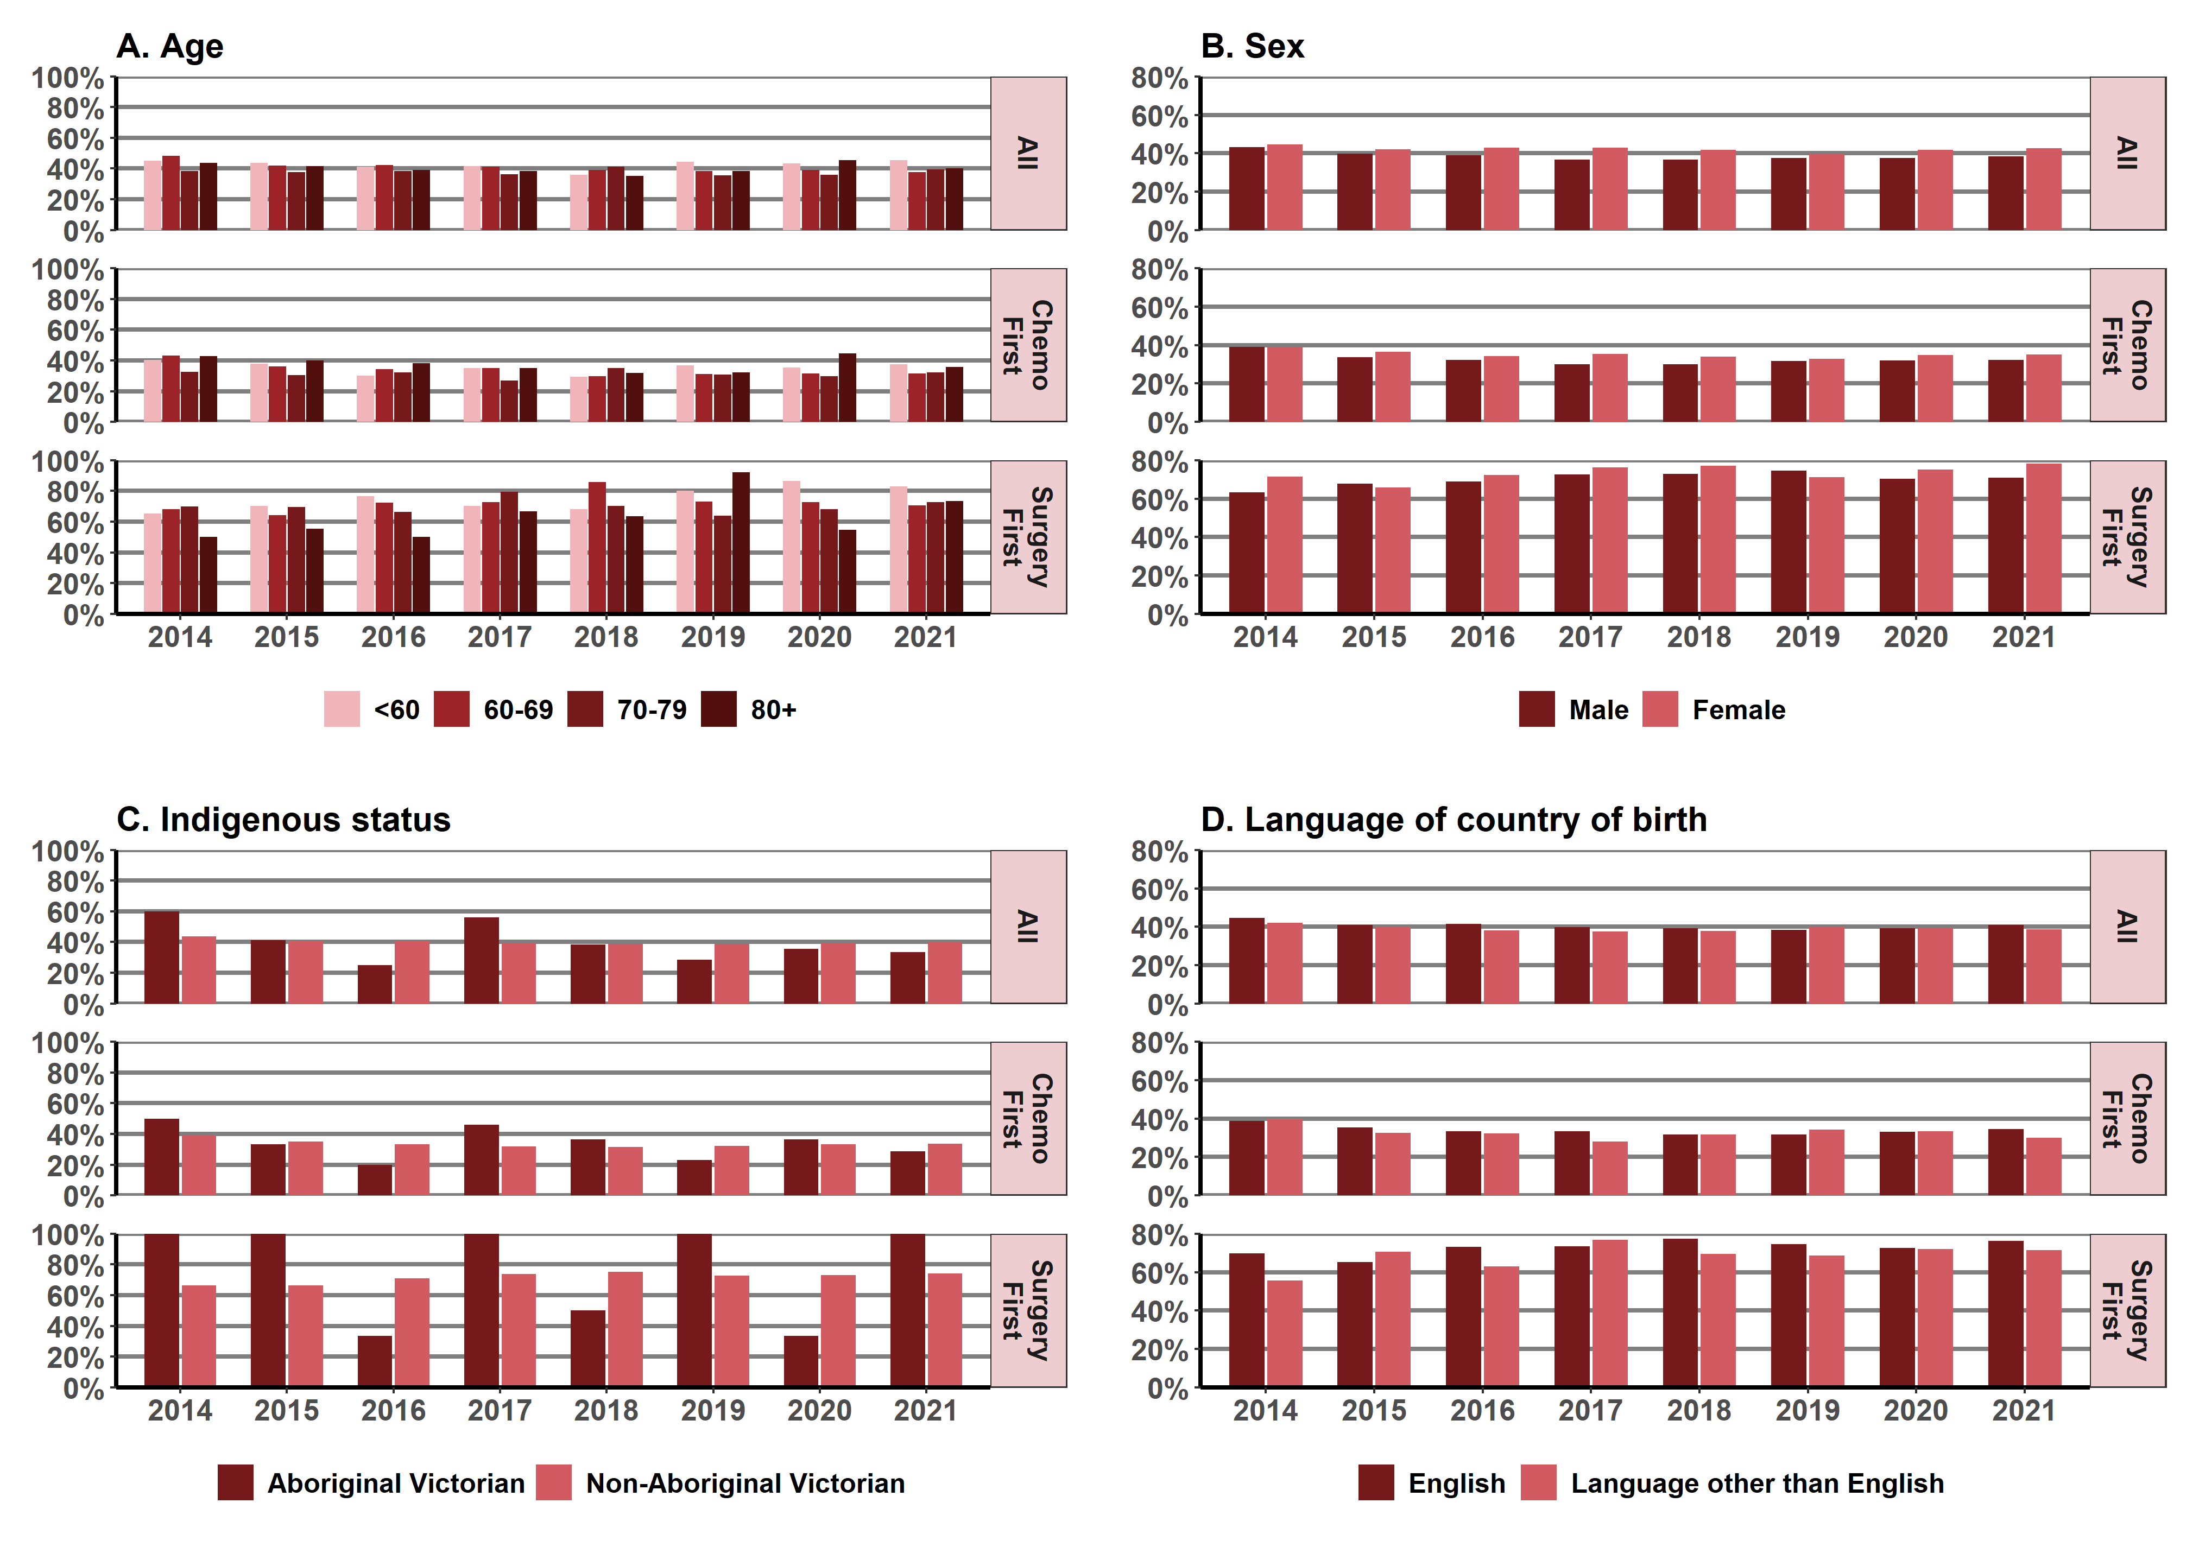
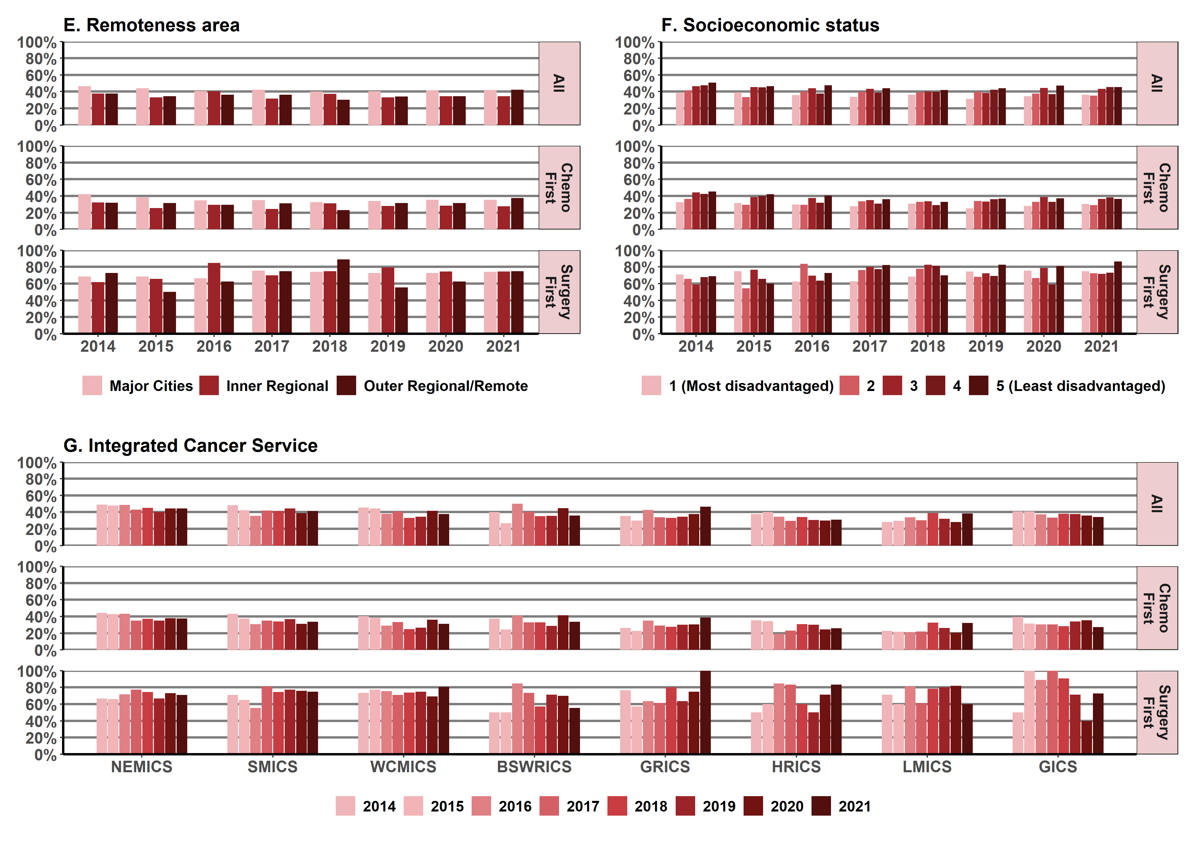

Note: Victorians with cancer who live in HRICS may receive treatment in New South Wales (Albury) hospitals, which is not captured in the VAED. Therefore, variables in this report that are derived using the VAED (comorbidity count, distant metastases, surgery and chemotherapy) are likely to be underestimated for Victorians living in HRICS.
Appendix 2 provides the dataset.
Figure 12.5.2: Proportion of breast cancer patients receiving systemic anti-cancer therapy within recommended timelines, by age (A), sex (B), Indigenous status (C), language spoken at home (D), remoteness area (E), SES (F) and ICS (G), Victoria, 2014–2021
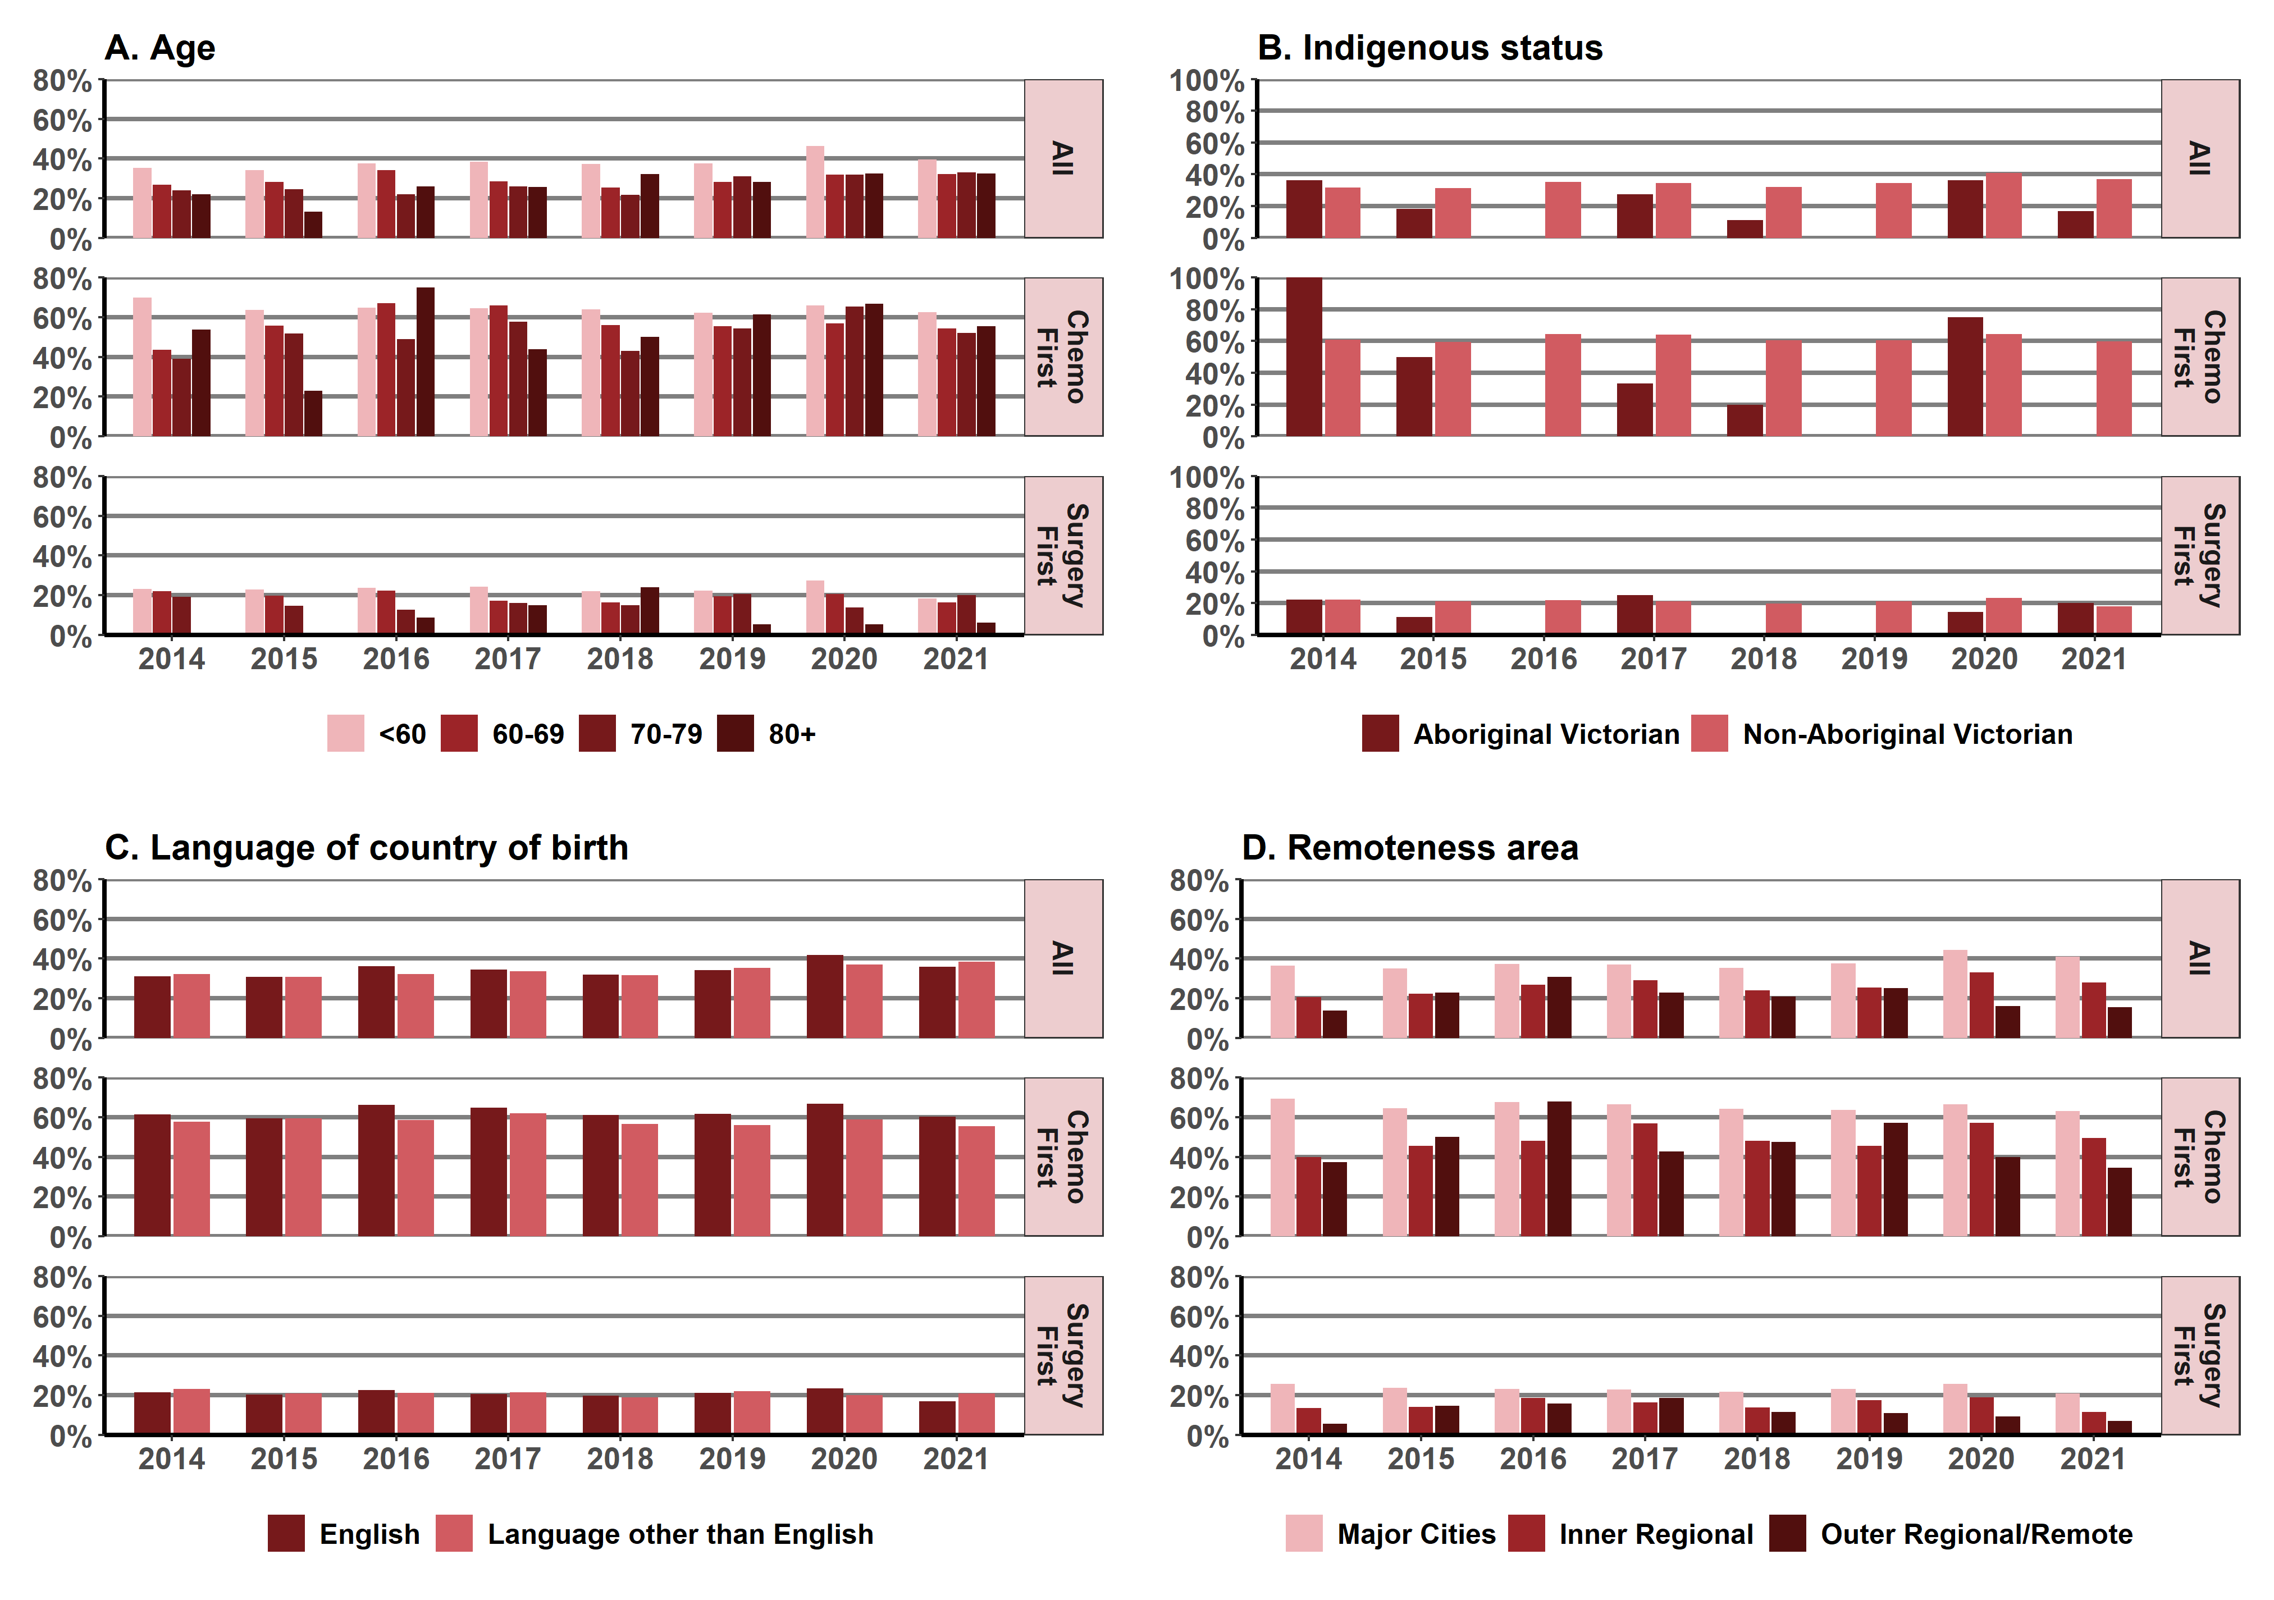
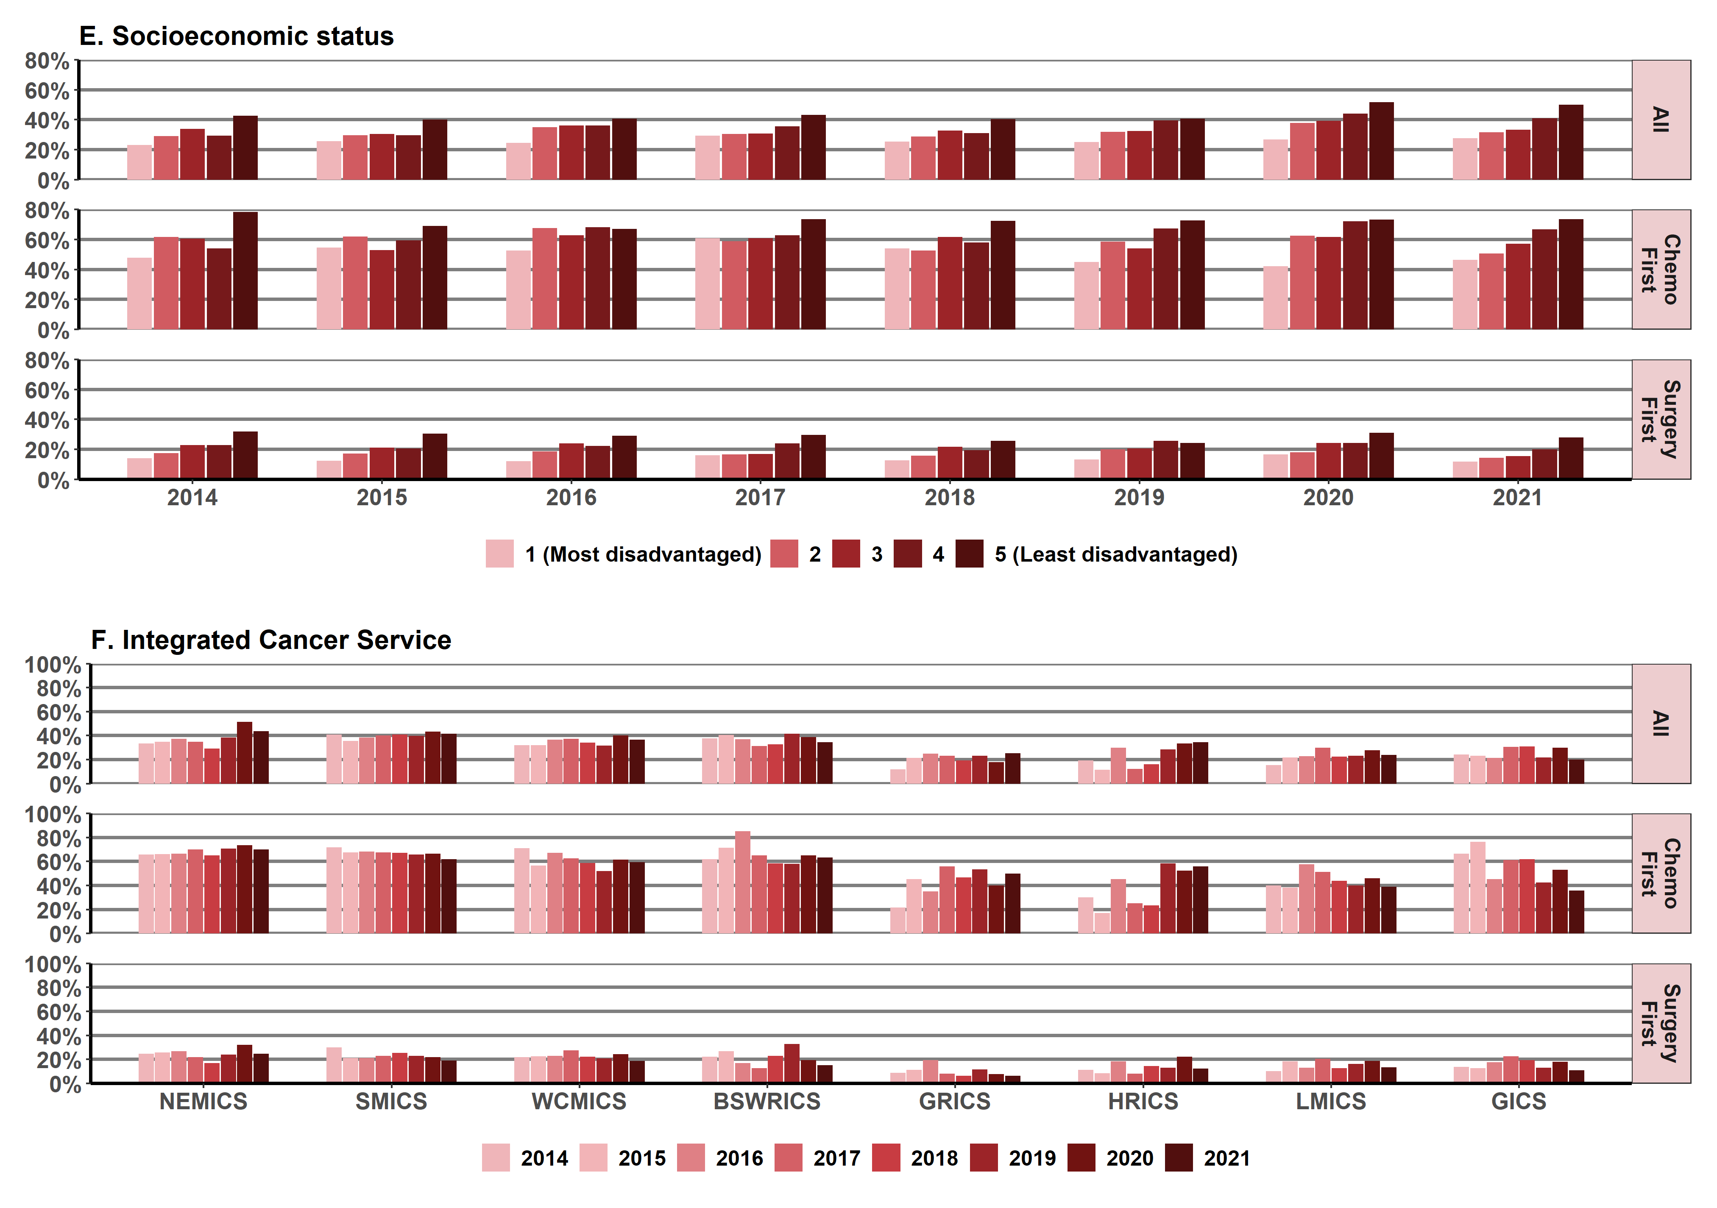

Note: Victorians with cancer who live in HRICS may receive treatment in New South Wales (Albury) hospitals, which is not captured in the VAED. Therefore, variables in this report that are derived using the VAED (comorbidity count, distant metastases, surgery and chemotherapy) are likely to be underestimated for Victorians living in HRICS.
Appendix 2 provides the dataset.
Figure 12.5.3: Proportion of colorectal cancer patients receiving systemic anti-cancer therapy within recommended timelines, by age (A), sex (B), Indigenous status (C), language spoken at home (D), remoteness area (E), SES (F) and ICS (G), Victoria, 2014–2021
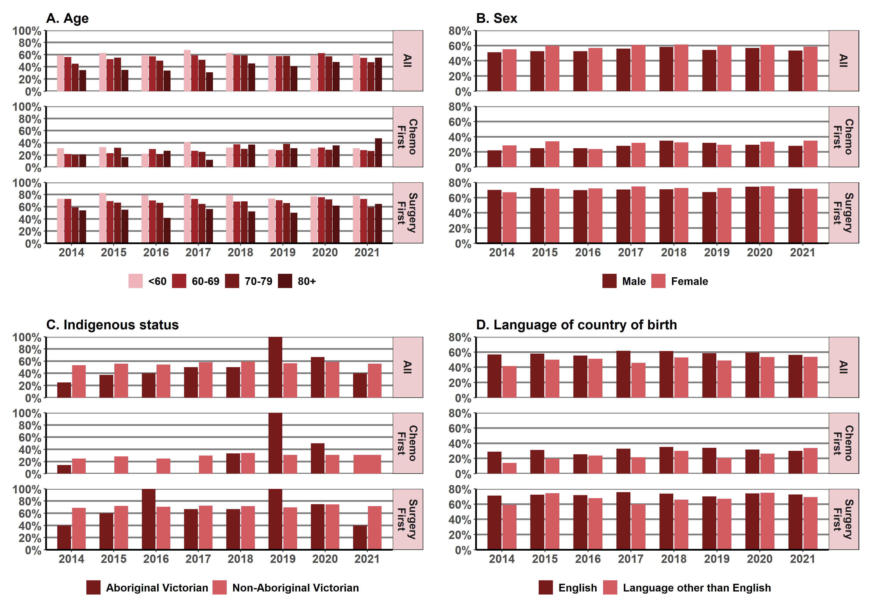
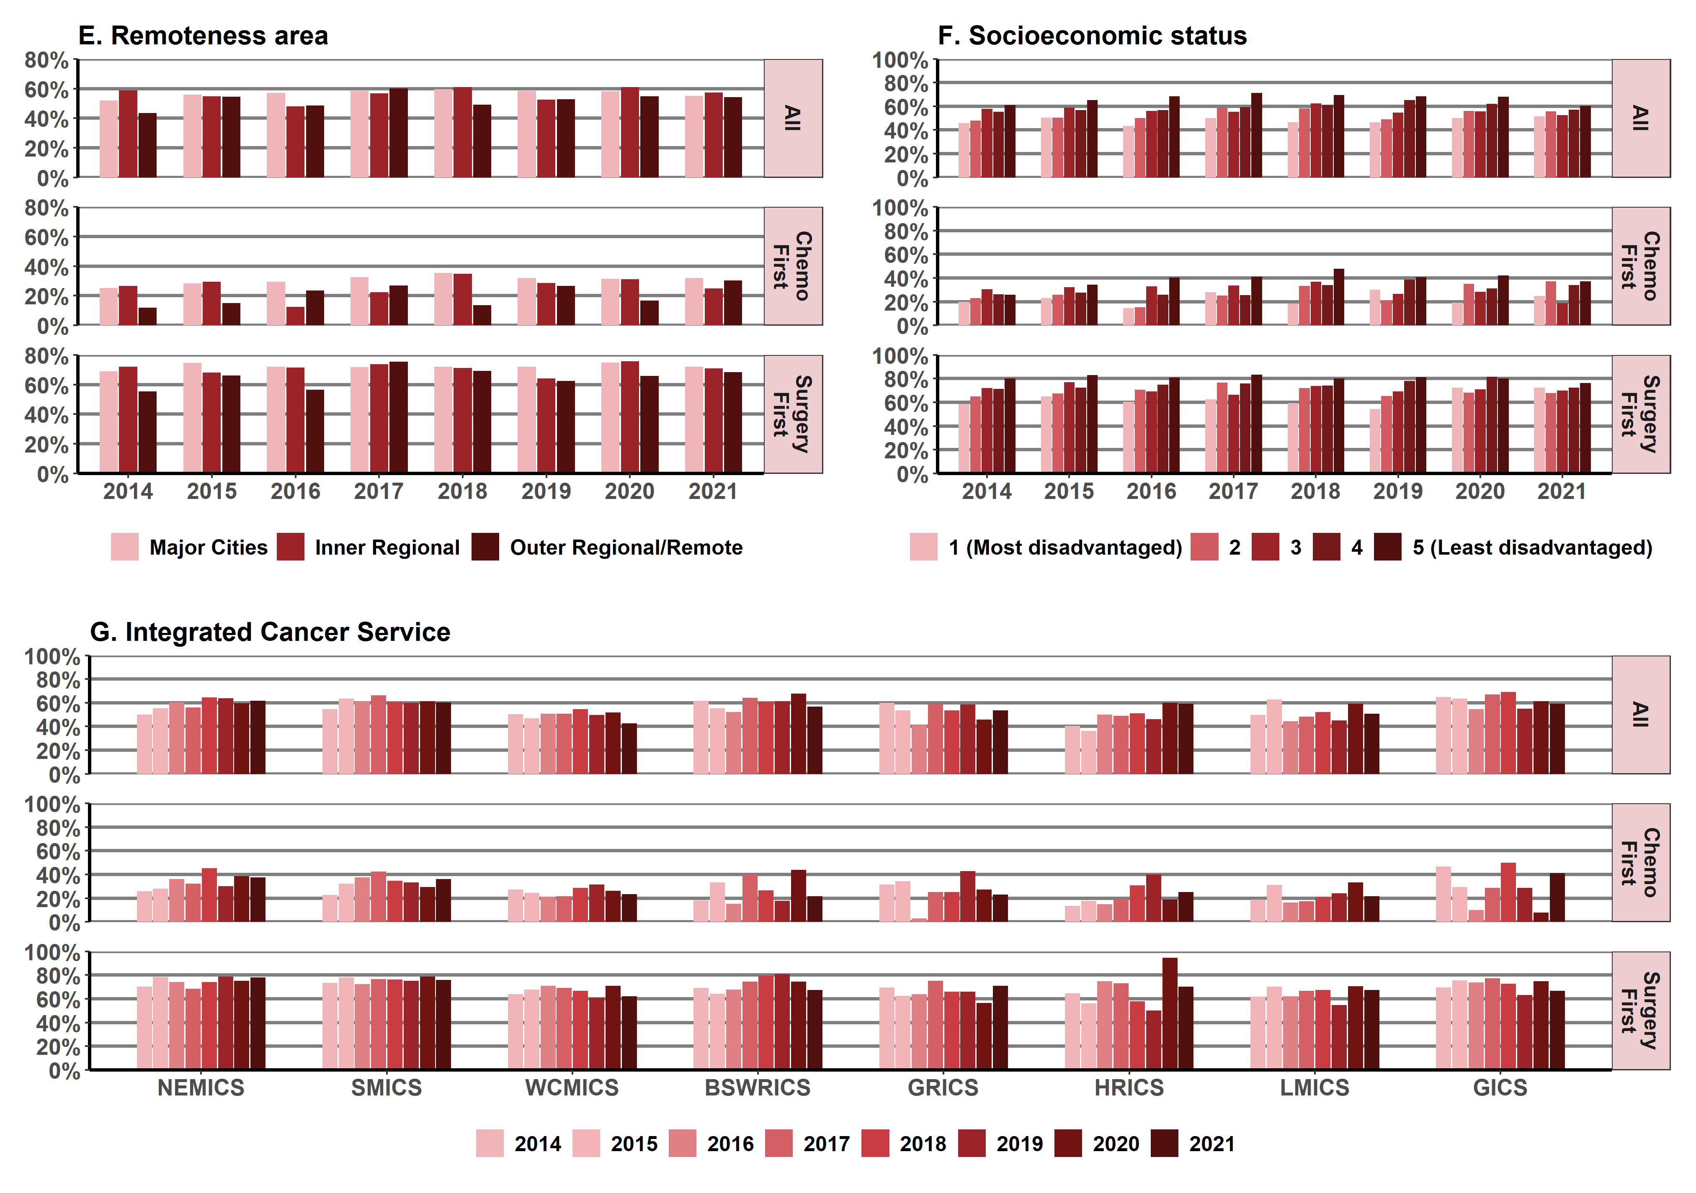
Note: Victorians with cancer who live in HRICS may receive treatment in New South Wales (Albury) hospitals, which is not captured in the VAED. Therefore, variables in this report that are derived using the VAED (comorbidity count, distant metastases, surgery and chemotherapy) are likely to be underestimated for Victorians living in HRICS.
Appendix 2 provides the dataset.
Figure 12.5.4: Proportion of ovarian cancer patients receiving systemic anti-cancer therapy within recommended timelines, by age (A), sex (B), Indigenous status (C), language spoken at home (D), remoteness area (E), SES (F) and ICS (G), Victoria, 2014–2021
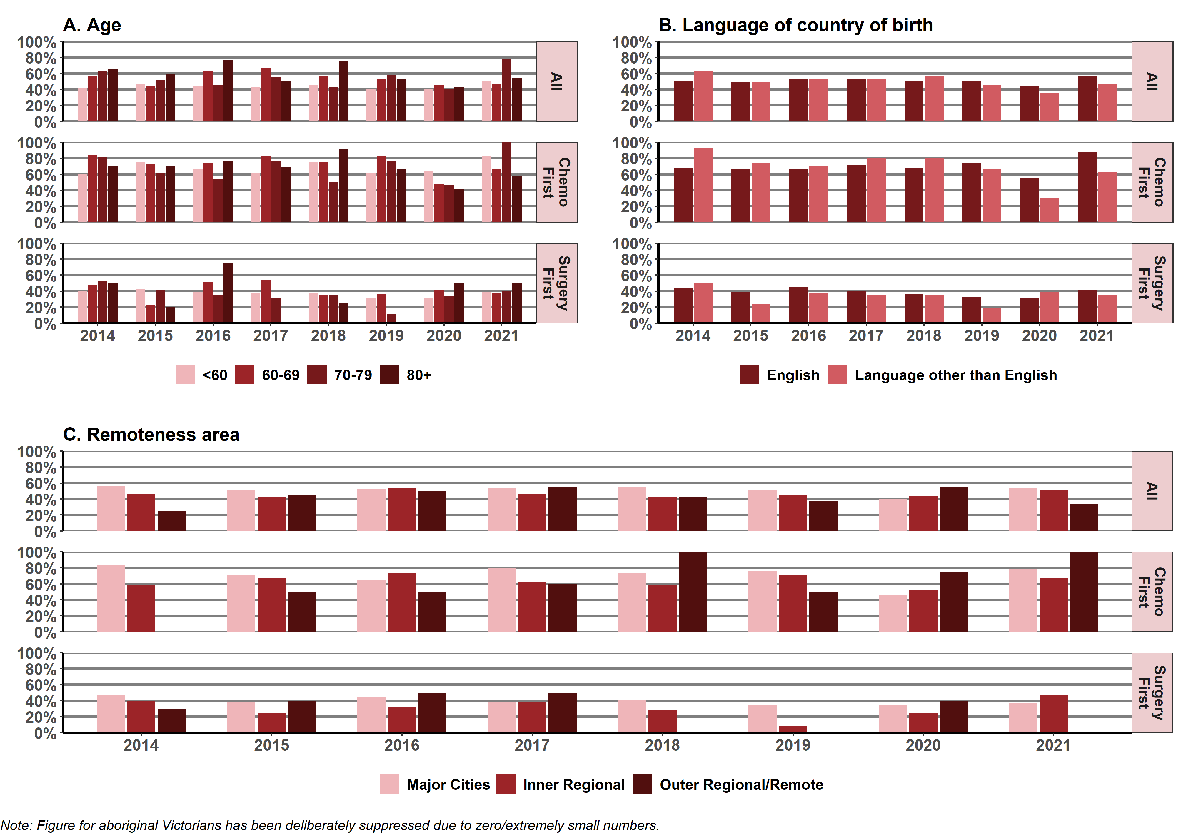
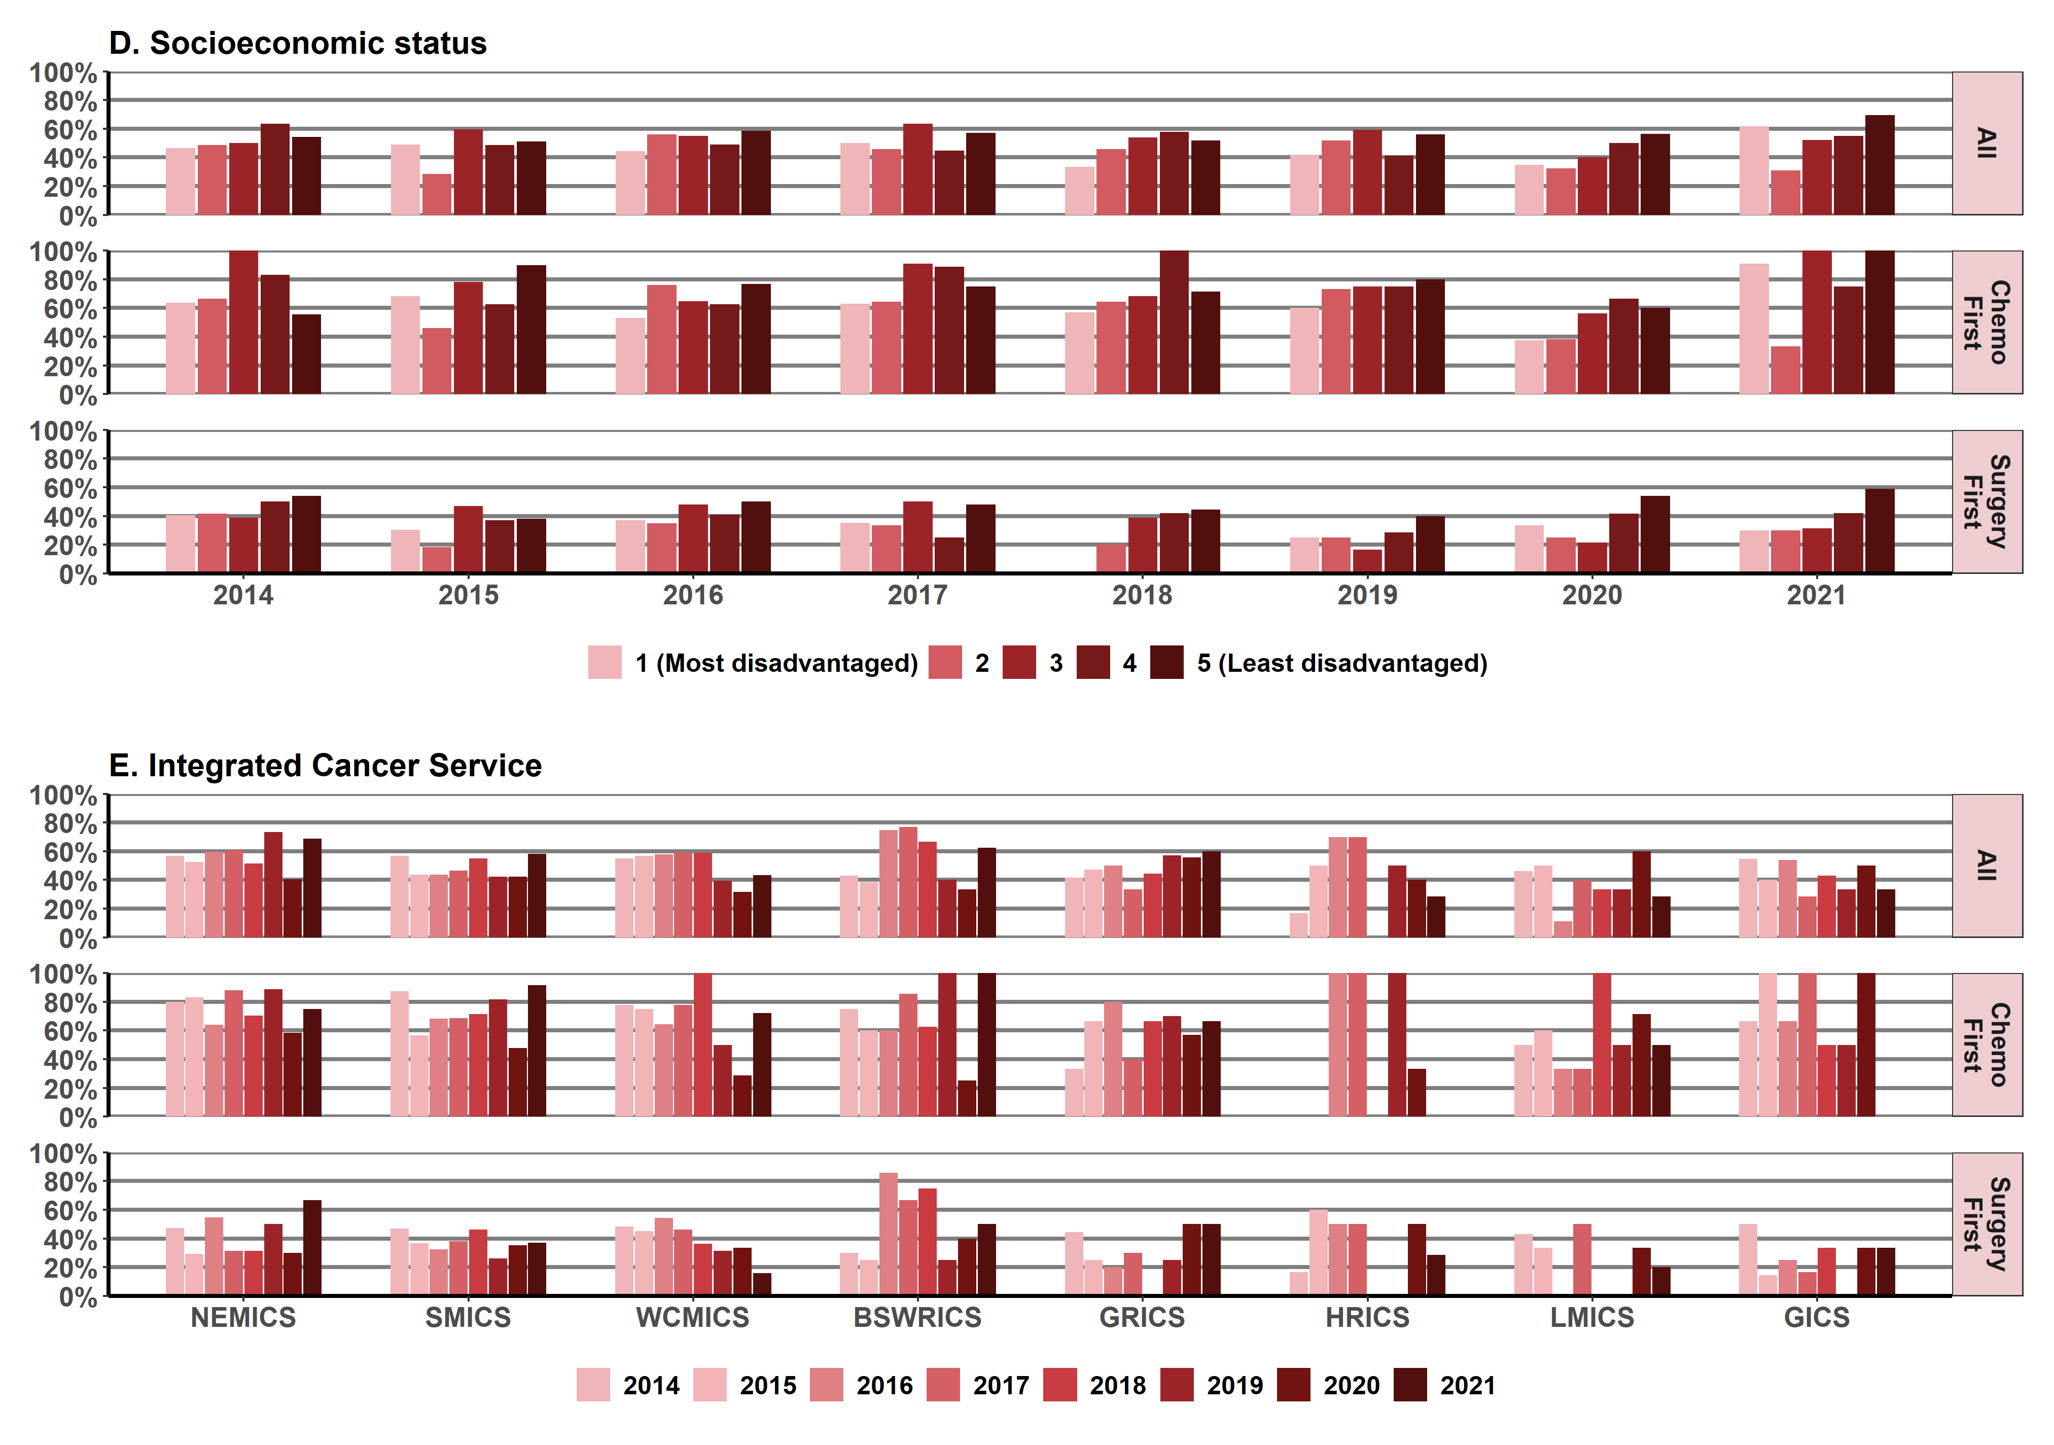
Note: Victorians with cancer who live in HRICS may receive treatment in New South Wales (Albury) hospitals, which is not captured in the VAED. Therefore, variables in this report that are derived using the VAED (comorbidity count, distant metastases, surgery and chemotherapy) are likely to be underestimated for Victorians living in HRICS.
Gaps in the data denote that no one was treated for ovarian cancer at that ICS for a particular year. For example, in 2018 (surgery first) LMICS and in 2014 (chemo first) HRICS.
Appendix 2 provides the dataset.

Measure assessment
Traffic light rating: Red (result is of concern)
Overall trend: Not moving in the right direction (static/unchanging) but impacts of the COVID pandemic on patients receiving systemic anti-cancer therapy within recommended timelines is uncertain
Commentary: For the purpose of this measure, SACTs include chemotherapy, targeted drugs and immunotherapy. The data presented here provides an overview of key systemic therapies (excluding oral therapies) for colorectal, lung, breast and ovarian cancers only because the evidence for timelines for delivering chemotherapy is stronger for these cancers.
In Victoria during the period 2014–2021 the proportion of people receiving SACTs within the recommended timeline overall increased slightly (41.8% in 2014; 43.3% in 2021; Tables 12.5a and b, Appendix 2) but was higher for those aged 69 years or younger and for males (Figures 12.5 (A) and (B)). This trend was reversed for those patients receiving surgery first, who were more likely to be 60 years or older. However, there was a much greater proportion of males compared with females who received surgery first, but this pattern changed for female patients for whom the proportion was higher than males who received chemotherapy first. Figure 12.5 (C) shows a disparity in timeliness across all three categories between those Aboriginal Victorians and non-Aboriginal Victorians, with the proportion decreasing significantly in 2016, although caution should be applied when interpreting these results due to the low numbers reported for Aboriginal Victorians (Tables 12.5a and b, Appendix 2). On the other hand, language spoken at home showed little variation between the three categories over the three reporting years (Figure 12.5 (D)).
Comparison of patterns of SACT use for all three categories across SES showed that patients living in the lowest quintile areas (SES 1) were less likely to receive SACT within the recommended timelines during the period 2014–2021 (Figure 12.5 (F)). A comparison by remoteness showed that most patients who received these therapies within the recommended timelines overall were living in major cities (Figure 12.5 (E)). The proportion of people living in these areas who used all these therapies each year increased slightly from 44.2% in 2014 to 46.1% in 2021. This trend was also reflected in regions of Victoria when compared between ICS. Metropolitan ICSs, namely NEMICS, SMICS and WCMICS, had a higher proportion of patients receiving SACTs across the three categories compared with regional/rural counterparts except for BSWRICS, which has seen an increase in its population in recent times resulting in more specialist services for major specialist service such as cancer. This may reflect the spatial distribution of SACTs, which are likely to be concentrated in urban areas, particularly where there are tertiary centres that specialise in all types of cancer treatments including SACTs (and offer clinical trials) compared with smaller centres that provide a narrower range of services to rural and remote communities.
Figures 12.5.1, 12.5.2, 12.5.3 and 12.5.4 show similarities with Figure 12.5 as they relate to the different variables.
No target has been set for this measure; however, it does continue to highlight the importance of cancer patients receiving SACT within recommended timelines to ensure improved overall survival in the metastatic setting.

Measure 12.6 – Proportion of cancer-related pancreatectomies and oesophagectomies taking place at appropriate volume facilities
Figure 12.6: Proportion and number of cancer-related oesophagectomies and pancreatectomies taking place at appropriate volume (facilities), by year, 2013–14 to 2021–22
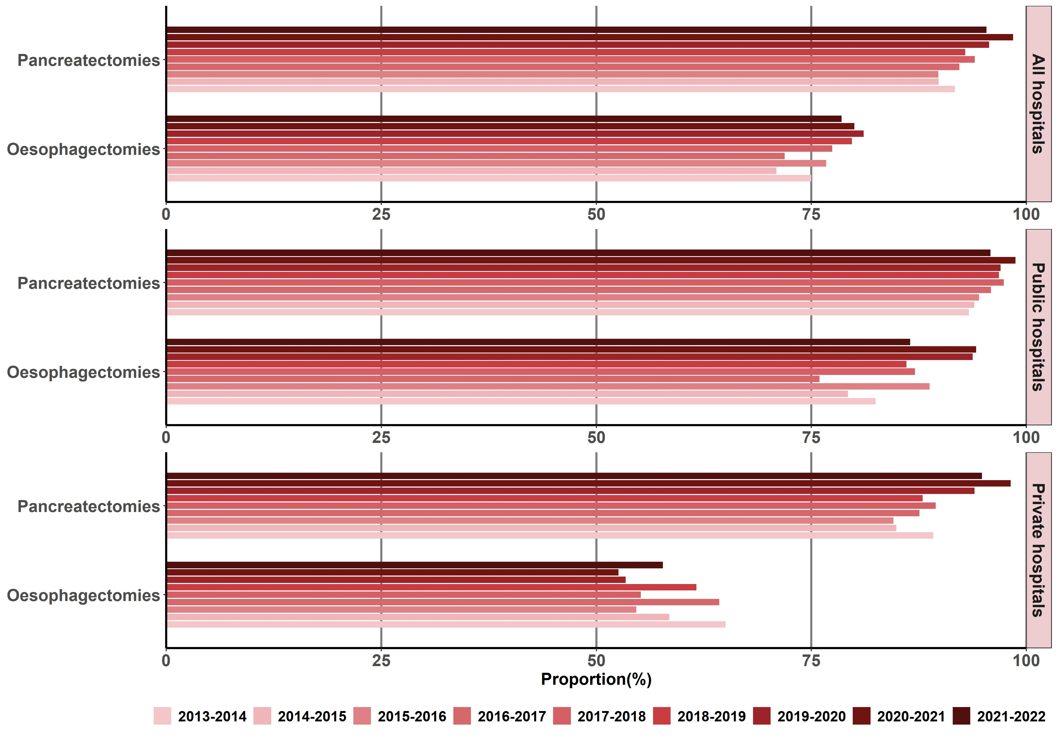

Table 12.6: Proportion and number of cancer-related oesophagectomies and pancreatectomies taking place at appropriate volume facilities, by year from 2013–14 to 2021–22
Number of surgeries [n] (%) | 2013–14 | 2014–15 | 2015–16 | 2016–17 | 2017–18 | 2018–19 | 2019–20 | 2020–21 | 2021–22
Pancreatic (all) | [253/276] (91.7) | [273/304] (89.8) | [281/313] (89.8) | [320/347] (92.2) | [376/400] (94.0) | [366/394] (92.9) | [397/415] (95.7) | [449/456] (98.5) | [391/410] (95.4)
Oesophageal (all) | [180/240] (75.0) | [188/265] (70.9) | [211/275] (76.7) | [202/281] (71.9) | [223/288] (77.4) | [224/281] (79.7) | [227/280] (81.1) | [228/285] (80.0) | [201/256] (78.5)
Pancreatic (public) | [154/165] (93.3) | [155/165] (93.9) | [155/164] (94.5) | [186/194] (95.9) | [223/229] (97.4) | [213/220] (96.8) | 226/233 (97.0) | 234/237 (98.7) | 207/216 (95.8)
Oesophageal (public) | [113/137] (82.5) | [126/159] (79.3) | [158/178] (88.8) | [139/183] (76.0) | [175/201] (87.1) | [179/208] (86.1) | [180/192] (93.8) | [177/188] (94.2) | [160/185] (86.5)
Pancreatic (private) | [99/111] (89.2) | [118/139] (84.9) | [126/149] (84.6) | [134/153] (87.6) | [153/171] (89.5) | [153/174] (87.9) | [171/182] (93.96) | [215/219] (98.2) | [184/194] (94.9)
Oesophageal (private) | [67/103] (65.1) | [62/106] (58.5) | [53/97] (54.6) | [63/98] (64.3) | [48/87] (55.2) | [45/73] (61.6) | [47/88] (53.4) | [51/97] (52.6) | [41/71] (57.8)
Number of hospitals [n] (%)
Pancreatic (all) | [16/33] (48) | [16/37] (43) | [17/36] (47) | [18/32] (56) | [19/31] (61) | [19/31] (61) | [19/31] (61) | [20/32] (62) | [20/34] (59)
Oesophageal (all) | [10/23] (43) | [10/23] (43) | [12/24] (50) | [10/26] (38) | [11/25] (44) | [11/23] (32) | [12/24] (50) | [12/24] (50) | [10/22] (45)
Pancreatic (public) | [9/19] (47) | [9/23] (39) | [9/22] (41) | [10/18] (56) | [11/17] (65) | [11/16] (69) | [11/17] (65) | [11/18] (61) | [11/20] (55)
Oesophageal (public) | [7/12] (58) | [7/12] (58) | [9/13] (69) | [6/14] (43) | [8/13] (62) | [8/13] (62) | [9/13] (69) | [9/12] (75) | [8/11] (73)
Pancreatic (private) | [7/14] (50) | [7/14] (50) | [8/14] (57) | [8/14] (57) | [8/14] (57) | [8/15] (53) | [8/14] (57) | [9/14] (64) | [9/14] (64)
Oesophageal (private) | [3/11] (27) | [3/11] (27) | [3/11] (27) | [4/12] (33) | [3/12] (25) | [3/10] (30) | [3/11] (27) | [3/12] (25) | [2/11] (18)
Source: Surgical data sourced from the Victorian Admitted Episodes Dataset (VAED)
Notes:
Hospital surgical volumes were calculated using admissions from the VAED; all oesophagostomies/ pancreatectomies for cancer and non-cancer patients were included. Admissions spanned a two-year interval (for example, if the year of interest is 2013, surgeries from across 2013–14 have been included).
The proportion for oesophagectomies was calculated by restricting the dataset to those admissions where both an oesophagectomy surgery code was present and an oesophagus/stomach cancer diagnosis code was present. Similarly, the proportion for pancreatectomies was calculated by restricting the dataset to those admissions where both a pancreatectomy surgery code was present, and a pancreatic cancer diagnosis code was present in one of the 40 VAED diagnosis codes (C25).

Measure assessment
Traffic light ratings: Green (satisfactory result) for pancreatectomies
Red (result is of concern) for oesophagostomies
Overall trend: Moving in the right direction for pancreatectomies; not moving in the right direction for oesophagostomies.
Commentary: Surgical procedures performed for pancreatic and oesophageal cancers are examples of complex surgery. Evidence shows that people who need complex surgery for these types of cancers are better to have this done at a hospital that performs these procedures often.,
It is recommended that hospitals treating people with these cancer types should perform a certain number of surgical resections each year. This is known as a ‘minimum suggested annual caseload’. For volume, this measure is based on the New South Wales performance indicator for cancer surgeries, which recommends the minimum suggested annual surgical caseload for a specialist centre as six procedures per year.
Figure 12.6 shows the proportion of resections for oesophageal and pancreatic cancers in Victorian hospitals (public and private) that performed these surgeries across the state above the minimum suggested annual caseloads. It also shows the number of hospitals that performed these surgeries between 2013–14 and 2021–22, with more pancreatic than oesophagectomy procedures reported (Table 12.6). Table 12.6 also shows that between 2013–14 and 2021–22 there was also a greater proportion of pancreatic and oesophagectomy procedures undertaken in public compared with private hospitals.
No target has been set for this measure; however, a 2016 review of Victoria’s hospital safety and quality assurance pointed to a need to consolidate hospital services, which implicitly included those that require specialist staff to perform complex surgery.

Measure 12.7 – Proportion of patients aged less than 40 years referred to fertility preservation treatment as part of their primary treatment
This measure will be reported in a future report. Refer to Appendix 1.

Measure 12.8 – Proportion of admitted cancer separations with a length of stay (LOS) > 1 day who have been coded as having malnutrition
Figure 12.8: Proportion of admitted cancer separations with a LOS > 1 day who have been coded as having malnutrition, by year, 2012–2022
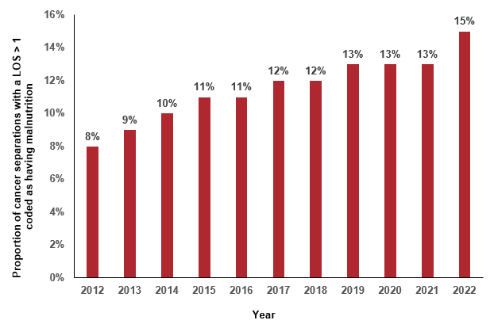
Notes:
The following ICD10 codes were used for flagging malnutrition: E43, E440, E441 and E46.
Separations were assigned to years based on VAED separation date and not admission date.

Measure assessment
Traffic light rating: Red (result is of concern)
Overall trend: Difficult to assess because the coding may have changed over the years, which may account for some of the increase in malnutrition separations and less underreporting in recent years.
Commentary: Malnutrition in cancer patients is associated with poorer outcomes such as reduced response to treatments and increased healthcare costs as a result of increased complications, longer LOS and hospital admissions. Preventing and managing malnutrition is increasingly being recognised as a significant element of cancer care, particularly because malnutrition can occur in all tumour types and in all settings. A multi-centre point prevalence study undertaken in 2012 and 2014 that investigated practices relating to malnutrition in Victorian cancer services researchers found that overall the prevalence of malnutrition was 26% (501/1,903) in 2014. This figure decreased to 23% in 2016 (308/1,340) and 15% in 2018 (219/1,462). More recently preliminary statewide findings from the 2022 Victorian Cancer Malnutrition Point Prevalence Study show overall malnutrition prevalence has increased to 32% (550/1,705).
Figure 12.8 shows that the proportion of cancer separations with an LOS greater than one day who have been coded as having malnutrition increased by 7% between 2012 and 2022. Care should be taken in interpreting this increase, which may be the result of malnutrition, although the VAED coding (which includes malnutrition) still has significant issues with data integrity, which means that malnutrition is likely being underreported in the coding.
Measure 12.9 – Proportion of patients who reported being involved in the decisions about their care and treatment as much as they wanted to
Figure 12.9: Proportion of cancer patients who reported being involved in decisions about their care and treatment as much as they wanted to, 2018 and 2022
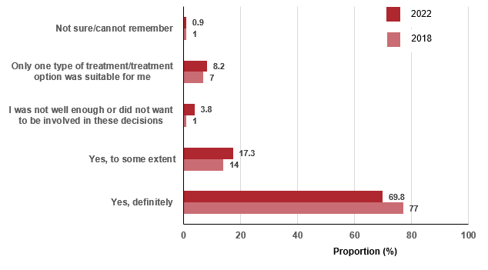
Note: These responses relate to the question, ‘Were you involved as much as you wanted to be in decisions about your care and treatment?’ in the Victorian Healthcare Experience Survey (Cancer).

Measure assessment
Traffic light rating: Red (result is of concern)
Overall trend: Not moving in the right direction
Commentary: Shared decision making is a key part of patient-centred care. Studies of shared decision making in cancer patients have found that most patients prefer to play a role in treatment decisions.
The Victorian Healthcare Experience Survey (VHES) is a state-wide survey of people's public healthcare experiences. The VHES cancer questionnaire looks to discover the experiences of patients who are receiving treatment for cancer. This includes patients who have undergone surgery, are receiving radiotherapy or chemotherapy treatment, have attended an emergency department because of their cancer or cancer treatment and/or are receiving follow-up care.
The proportion of patients who reported being involved in decisions about their cancer care and treatment in 2018 was 2,029 compared with 3,551 in 2022. A large percentage (77.4%) of patients reported they were definitely involved as much as they wanted to be in decisions about their care and treatment in 2018, but this decreased to 69.8% in 2022 (Figure 12.9).
While no target has been set for this measure, the fact that in 2018, and 2022, 77 and 69.8% of patients reported being definitely involved in decisions about their care highlights consistency in the result with other similar surveys. Nevertheless, the overall decrease between 2018 and 2022 in the proportion of patients who reported they were definitely involved as much as they wanted to be in decisions about their care and treatment is concerning.
Feedback from patients’ about their cancer experience provides valuable information about what they think of the healthcare services offered in terms of what is working well and areas that need further improvement in the way care is delivered resulting in more personalised care being provided.
Measure 12.10 – Proportion of newly diagnosed patients with evidence of multidisciplinary treatment plan in the patient records
Figure 12.10: Proportion of documented evidence of multidisciplinary team recommendations, 2014 to 2021
Source: Cancer Services Performance Indicators – audits from 2014 diagnoses
Note: There were no audits undertaken for 2016 and 2019 diagnoses.
Figure 12.10.1: Percentage of patients audited in 2014, 2017 and 2021 with documented evidence of multidisciplinary team recommendations presented by ICS (all tumours streams combined)
MDT 2017
Percentage (%)
Sources: Cancer Services Performance Indicators – 2014 (2015), 2017 (2018) and 2021 (2022) audits; audit target set at 80% prior to 2018.
Metropolitan ICSs
Figure 12.10.2: Number (and percentage) of audited patients who had documented evidence of multidisciplinary team recommendations presented by tumour stream (all ICSs combined) of Victorians diagnosed in 2014, 2017 and 2021
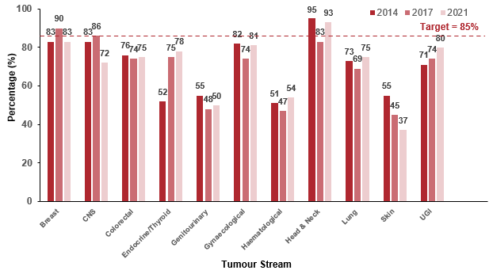
Sources: Cancer Services Performance Indicators – 2014 (2015), 2017 (2018) and 2021 (2022) audits
Audit target set at 80% prior to 2018.
Table 12.10.1: Number of documented evidence of multidisciplinary team recommendations by tumour stream (total audited), 2014, 2017 and 2021
Tumour stream | 2014 (%) | 2017 (%) | 2021 (%)
Breast | 537/647 (83) | 360/400 (90) | 344/414 (83)
CNS | 91/110 (83) | 149/173 (86) | 116/161 (72)
Colorectal | 447/588 (76) | 299/404 (74) | 312/416 (75)
Endocrine/thyroid | 55/106 (52) | 109/145 (75) | 93/119 (78)
Genitourinary | 291/529 (55) | 176/367 (48) | 213/426 (50)
Gynaecological | 175/213 (82) | 220/297 (74) | 193/238 (81)
Haematological | 193/379 (51) | 163/347 (47) | 181/335 (54)
Head & neck | 160/168 (95) | 186/224 (83) | 182/196 (93)
Lung | 256/351 (73) | 224/324 (69) | 266/355 (75)
Skin | 95/172 (55) | 132/288 (46) | 105/285 (37)
UGI | 211/297 (71) | 396/535 (74) | 245/306 (80)

Measure assessment
Traffic light rating: Red (result is of concern)
Overall trend: Not moving in the right direction
Commentary: International studies have shown that patients overseen by a multidisciplinary cancer care team experience better outcomes after cancer treatment. The role of a multidisciplinary cancer care team is to bring together healthcare professionals from different specialties to discuss a patient’s cancer diagnosis and staging, and their treatment options. Initiatives such as Aboriginal hospital liaison officers / cancer coordinators in the MDTs will enable the appropriate cultural factors and determinants to be considered to support improved outcomes.
Figure 12.10 provides a high-level summary of the state-wide results from 2014 to 2021. Note that there was no data available for 2016 and 2019. Although no target was set for this measure, the state-wide performance of patients having documented evidence of multidisciplinary team (MDT) recommendations fell below the target of 80% outlined in the Cancer Services Performance Indicators 2017 audit report, with 69% of patients having documented evidence. Figure 12.10 shows that 72% of patients had documented evidence of MDT recommendations, which was well below the target of 85% (target was set at 80% prior to 2018) articulated in the Cancer Services Performance Indicators 2021 audit report.
Figure 12.10.1 shows the percentage of patients audited between 2014 and 2021 by ICS. Documented evidence of MDT recommendations shows that metropolitan ICSs were the highest performing ICSs, with SMICS reporting 91% of audited patients having documented evidence of MDT recommendations. All regional/rural ICSs fell well below the target, with the highest performing regional/rural ICS overall from 2014, HRICS, having on average 57% of audited patients having documented evidence of MDT recommendations for 2014, 2017 and 2021.
Figure 12.10.2 shows the number (and percentage) of audited patients who had documented evidence of MDT recommendations and breaks down the results by tumour stream. The head & neck stream had the highest performance between 2014 and 2021 of audited patients having documented evidence of MDT recommendations. Only three tumour streams were not within 20% of the target – genitourinary, haematological and skin – between 2014 and 2021. Overall, despite some improvement over time at the state-wide level, across the board performance lags behind the targets. The department supports a strategy whereby sites that are exemplars share their insights on effective implementation strategies to improve achievements across all ICS.

Measure 12.11 – Proportion of patients with local recurrence of primary tumour within two years of surgical resection or curative radiotherapy of a primary tumour
This measure will be reported in a future report. Refer to Appendix 1.

Measure 12.12 – Proportion of patients receiving specialist palliative care within 12 months prior to death
Figure 12.12: Proportion of patients receiving specialist palliative care within 12 months prior to death, by ICS, 2014–2021
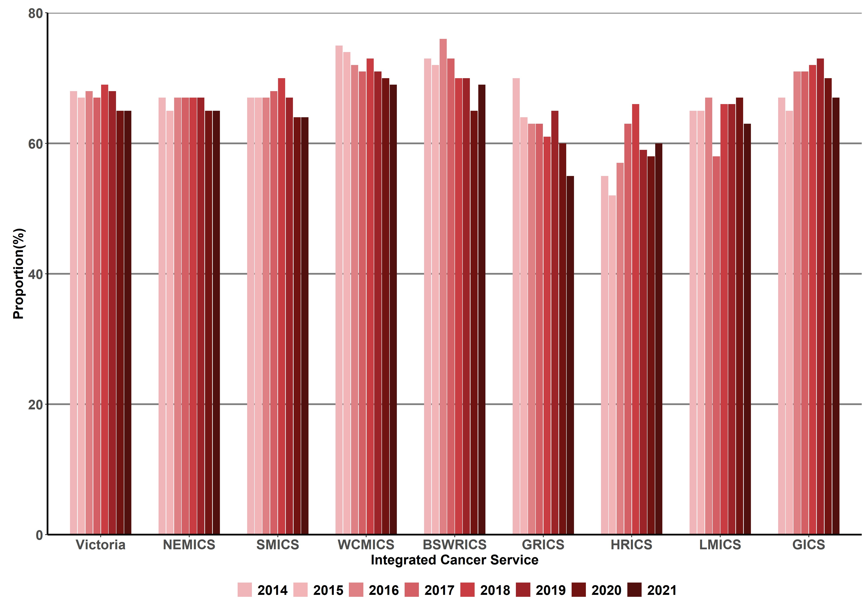
Table 12.12: Proportion and number of patients receiving specialist palliative care with 12 months prior to death, by ICS, 2014–2021
ICS | 2014 (year of death)  (%) [n/No.] | 2015 (year of death)  (%) [n/No.] | 2016 (year of death)  (%) [n/No.] | 2017 (year of death)  (%) [n/No.] | 2018 (year of death)  (%) [n/No.] | 2019 (year of death)  (%) [n/No.] | 2020 (year of death)  (%) [n/No.] | 2021 (year of death)  (%) [n/No.]
NEMICS | (67) [1,338/1,995] | (65) [1,357/2,080] | (67) [1,431/2,133] | (67) [1,440/2,140] | (67) [1,436/2,151] | (67) [1,538/2,292] | (65) [1,411/2,182] | (65) [1,456/2,232]
SMICS | (67) [1,572/2,344] | (67) [1,693/2,513] | (67) [1,713/2,544] | (68) [1,628/2,411] | (70) [1,791/2,572] | (67) [1,755/2,623] | (64) [1,591/2,499] | (64) [1,696/2,634]
WCMICS | (75) [1,228/1,644] | (74) [1,262/1,716] | (72) [1,288/1,787] | (71) [1,287/1,815] | (73) [1,286/1,757] | (71) [1,270/1,791] | (70) [1,294/1,850] | (69) [1,293/1,868]
BSWRICS | (73) [518/707] | (72) [584/811] | (76) [619/819] | (73) [559/762] | (70) [549/783] | (70) [597/854] | (65) [554/851] | (69) [581/844]
GRICS | (70) [385/553] | (64) [414/649] | (63) [416/664] | (63) [433/690] | (61) [431/709] | (65) [471/730] | (60) [447/749] | (65) [392/707]
HRICS | (55) [260/469] | (52) [297/567] | (57) [312/547] | (63) [337/533] | (66) [361/549] | (59) [319/541] | (58) [339/585] | (60) [356/594]
LMICS | (65) [408/632] | (65) [441/681] | (67) [488/723] | (58) [428/738] | (66) [500/761] | (66) [456/687] | (67) [493/740] | (63) [463/735]
GICS | (67) [301/449] | (65) [310/476] | (71) [352/493] | (71) [369/522] | (72) [378/523] | (73) [383/522] | (70) [395/566] | (67) [370/552]
Victoria | (68) [6,010/8,794] | (67) [6,358/9,493] | (68) [6,619/9,710] | (67) [6,482/9,612] | (69) [6,733/9,806] | (68) [6,792/10,045] | (65) [6,537/10,041] | (65) [6,617/10,184]
Notes:
Cases
- Those whose notification of cancer to the VCR was by death certificate only have been excluded (~5.5% of cancer deaths are death certificate only).
Palliative care (in the year prior to death)
- VAED – episodes with care type 8 or ‘Z515’ diagnosis code
- Victorian Integrated Non-Admitted Health dataset (VINAH) (public palliative care) – episodes in the community palliative care or hospital-based palliative care consultancy team streams. Note: All palliative care contacts are included, even if the care provided was indirect care, care provided to a carer/relative only or a scheduled appointment where the patient did not attend.

Measure assessment
Traffic light rating: Amber (desired result not yet evident)
Overall trend: Static or unchanging
Commentary: For the purposes of reporting against this measure the term ‘specialist palliative care’ refers to clinicians who have specialist qualifications in palliative care and the designated specialist palliative care sector funded to provide care for those with the most complex end-of-life and palliative care needs. In Victoria palliative care is delivered through community, inpatient and consultancy services administered by public, private and non-government providers.
While no target has been set, this outcome measure reports responsiveness of palliative care services to patient needs between 2014 and 2021. Overall, Figure 12.12 and Table 12.12 show that in Victoria there has been a slight decrease in the proportion and number of patients receiving specialist palliative care within 12 months prior to death (68% in 2014 compared with 65% in 2021). Figure 12.12 and Table 12.12 also show that over the eight-year period all the ICSs have focused on improving the effectiveness of services, with most reporting a slight variation, although there are exceptions with GRICS showing a decrease from 70% in 2014 to 55% in 2021. Despite this observation, the results associated with ICSs should be interpreted with caution noting that palliative care provided by private hospitals in a community setting is not captured in the linked dataset because VINAH is specific to public institutions only.

Measure 12.13 – Proportion of patients receiving aggressive interventions within 30 days prior to death
Figure 12.13: Proportion of patients receiving aggressive interventions (SACT, radical radiation, ICU) within 30 days prior to death, by year, 2014–2021
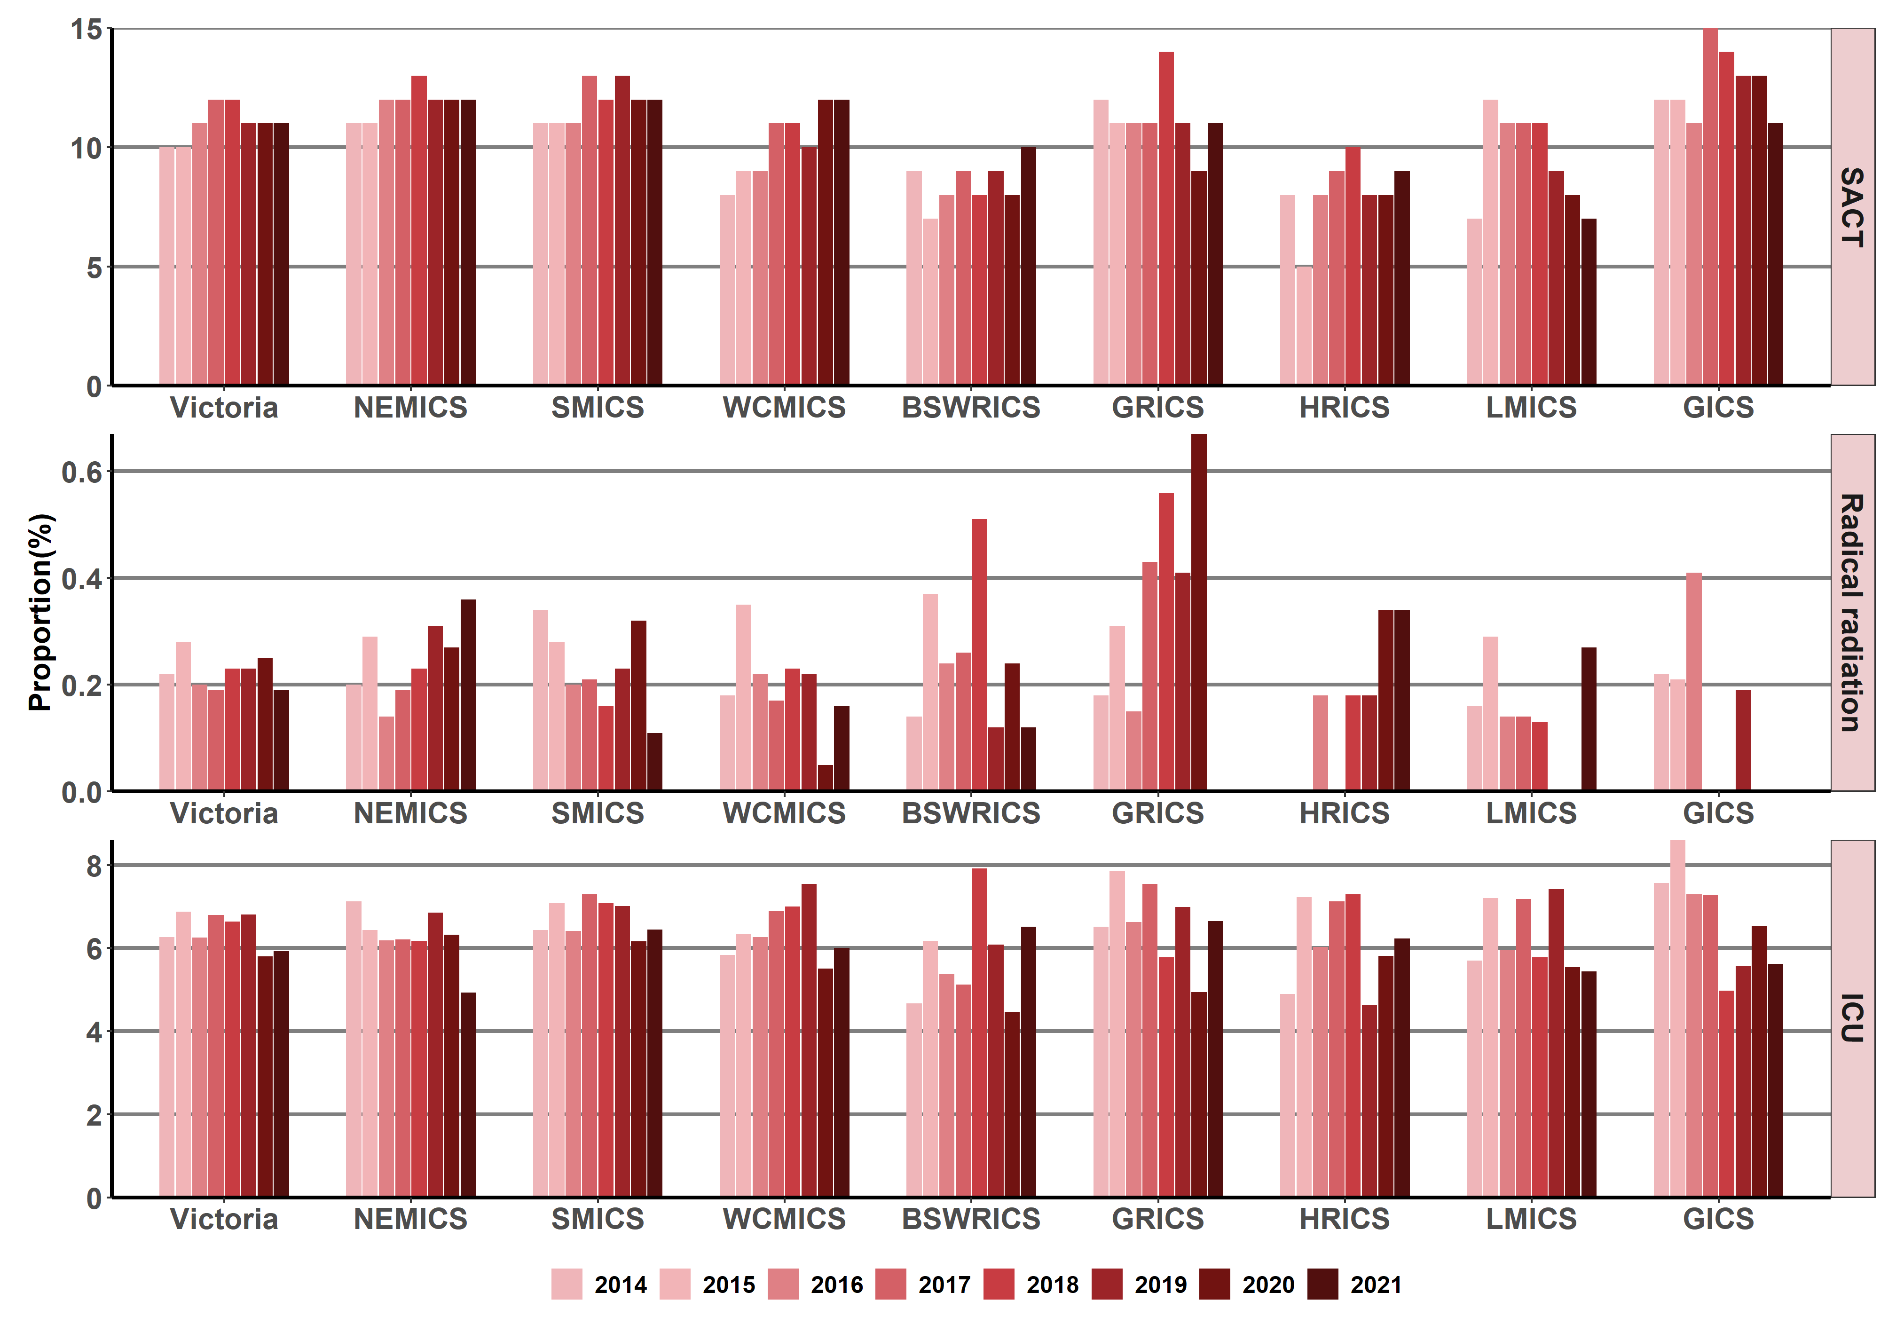

Note: Appendix 2 provides the dataset.
SACT = systemic anti-cancer therapy; ICU = intensive care unit

Measure assessment
Traffic light rating: Amber (desired result not yet evident)
Overall trend: Static or unchanging
Commentary: Aggressive care near death for patients with incurable cancers is an important end-of-life care quality indicator, because aggressive care has been linked with worse quality of life for the patient and worse bereavement adjustment for their caregivers. For the purpose of this measure key indicators of aggressive care (interventions) in the last 30 days of life that were examined by ICS were patients receiving SACT, radical radiotherapy (curative intent) and acute inpatient/ICU admissions. Figure 12.13 shows that the proportion of patients still receiving chemotherapy within the last 30 days of life was high across all the ICSs, ranging from 10 to 12% between 2014 and 2021. This is despite evidence that the use of chemotherapy near the end of life is not related to its likelihood of providing benefit. However, it cannot be excluded, since setting an a priori level of appropriate and inappropriate rate of chemotherapy near the end of life may hinder the aim of palliative care in oncology, which is to address the specific needs of each patient based not only on their illness trajectory or physical symptoms but also on their personal preferences and goals of care.
Radiotherapy is an indispensable modality for cancer treatment because it can be an effective tool for palliation of symptoms arising from cancer such as pain from bone metastases or neurological compromise from brain or spinal metastases. Figure 12.13 and Table 12.13.1 (Appendix 2) show that radiotherapy use remained low across all ICSs within the last month of life in this analysis ranging from zero to 0.7% between 2014 and 2021.
The proportion of patients admitted to intensive care within 30 days prior to death was similar across the ICSs (Figure 12.13 and Table 12.13.2 in Appendix 2) and was ranked the second highest in terms of key indicators of aggressive care reported via this measure (Figure 12.13).
While no target has been set for this measure, understanding this quality-of-care measure is a crucial step in identifying any shortcomings or variations of Victoria-wide current practice, which will then allow for opportunities for improvement in aggressive care delivery.

Measure 12.14 – Proportion of deaths due to cancer that occur in hospitals
Figure 12.14: Proportion of deaths due to cancer that occur in hospitals, by ICS and state, 2014–2021
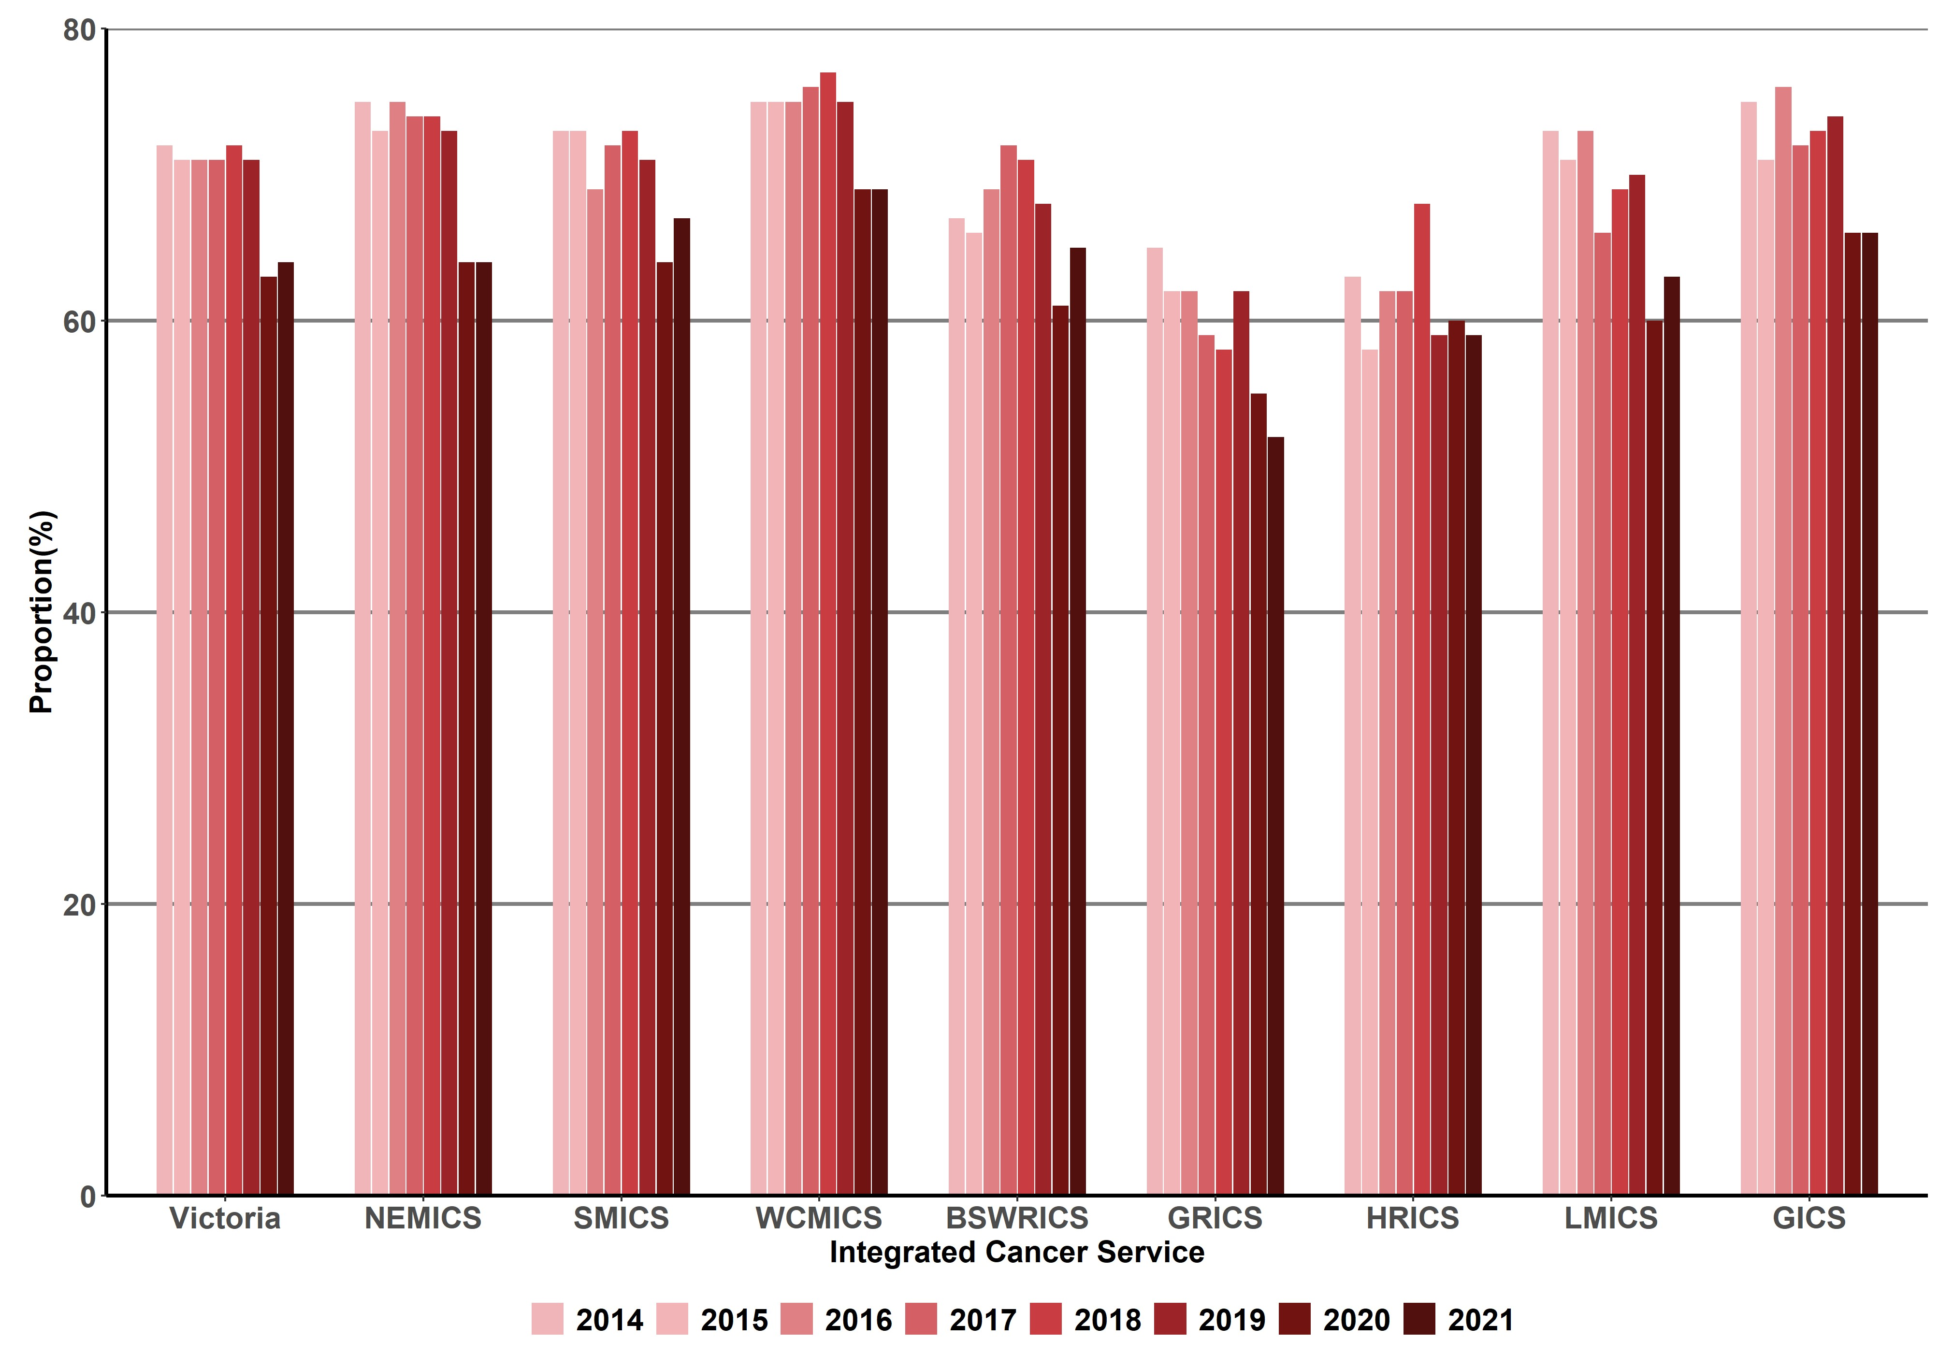

Table 12.14: Proportion/number of deaths due to cancer that occur in hospitals, by ICS, 2014–2021
ICS | 2014 (year of death) (%) [n/No.] | 2015 (year of death) (%) [n/No.] | 2016 (year of death) (%) [n/No.] | 2017 (year of death) (%) [n/No.] | 2018 (year of death) (%) [n/No.] | 2019 (year of death) (%) [n/No.] | 2020 (year of death) (%) [n/No.] | 2021 (year of death) (%) [n/No.]
NEMICS | (75) [1,489/1,995] | (73) [1,525/2,080] | (75) [1,591/2,133] | (74) [1,579/2,140] | (74) [1,599/2,151] | (73) [1,663/2,292] | (64) [1,394/2,182] | (64) [1,425/2,232]
SMICS | (73) [1,712/2,344] | (73) [1,836/2,513] | (69) [1,766/2,544] | (72) [1,743/2,411] | (73) [1,867/2,572] | (71) [1,869/2,623] | (64) [1,594/2,499] | (67) [1,753/2,634]
WCMICS | (75) [1,240/1,644] | (75) [1,289/1,716] | (75) [1,334/1,787] | (76) [1,379/1,815] | (77) [1,358/1,757] | (75) [1,347/1,791] | (69) [1,272/1,850] | (69) [1,283/1,868]
BSWRICS | (67) [477/707] | (66) [539/811] | (69) [564/819] | (72) [547/762] | (71) [555/783] | (68) [580/854] | (61) [522/851] | (65) [547/844]
GRICS | (65) [358/553] | (62) [400/649] | (62) [409/664] | (59) [406/690] | (58) [408/709] | (62) [453/730] | (55) [410/749] | (52) [369/707]
HRICS | (63) [297/469] | (58) [331/567] | (62) [337/547] | (62) [329/533] | (68) [372/549] | (59) [321/541] | (60) [349/585] | (59) [349/594]
LMICS | (73) [463/632] | (71) [484/681] | (73) [525/723] | (66) [488/738] | (69) [524/761] | (70) [479/687] | (60) [446/740] | (63) [465/735]
GICS | (75) [335/449] | (71) [339/476] | (76) [376/493] | (72) [376/522] | (73) [382/523] | (74) [387/522] | (66) [372/566] | (66) [362/552]
Victoria | (72) [6,371/8,794] | (71) [6,743/9,493] | (71) [6,902/9,710] | (71) [6,848/9,612] | (72) [7,066/9,806] | (71) [7,102/10,0045] | (63) [6,375/10,0041] | (64) [6,562/10,0184]

Measure assessment
Traffic light rating: Amber (desired result not yet evident)
Overall trend: Static or unchanging
Commentary: In 2016 the government released the Victoria’s end-of-life and palliative care framework, which aims to move towards delivering a more person-centred approach that respects people and their preferences, considering the whole person and what they value as important. This includes consultancy with people who require symptom and pain management or end-of-life care within hospitals alongside other care.
Monitoring where people die due to cancer is key to ensuring that end-of-life care and palliative care is provided in a responsive and integrated way. The need for such appropriate care is important given that Victoria’s population is both growing and ageing. Figure 12.14 shows that, although a hospital is still the most common place of death due to cancer, the percentage of cancer patients who died in hospital between 2014 and 2021 fluctuated during the study period but generally decreased from the baseline year between regions of Victoria when compared by ICS regions and for Victoria as a whole. For all of Victoria there was a noticeable decrease for reported deaths in hospitals from 72% in 2014 to 64% in 2021. This may relate to the impact of the COVID-19 pandemic and associated social restrictions which could have added complexity to the dying period. These differences in proportion of deaths due to cancer that occur in hospitals between ICSs may reflect variations in population composition and changes in palliative care that is meeting people’s wishes to die at home or in a more homelike environment rather than in a hospital. For Aboriginal Victorians in particular, the need to ‘return to country’ before the end of life, or at the end of life, can be both culturally and spiritually significant. Furthermore, it is also important to note that the lower percentage of deaths by HRICS region could be due to the unavailability of inpatient data for Albury (New South Wales) since it is not included in the VAED and thus could be underestimated.
Key result: Increase one- and five-year survival
Survival from cancer is a key measure of cancer prognosis, control and treatment. It refers to the probability of being alive for a given amount of time after diagnosis and reflects the severity of a cancer diagnosis.
Globally there are two commonly recognised measures of cancer survival: relative survival and observed survival. For the purposes of this report, relative survival is used, which adjusts for normal life expectancy by comparing survival among cancer patients with that of the general population, controlling for age, sex and year of diagnosis. Survival trends are presented for all cancers and other tumour streams by single years (2010–2021) (Measures 13.1–13.8) and a five-year period (2010–2014 and 2015–2019) (Measures 13.9–13.16). One-year survival is an important measure because it may more closely reflect timely access to care than five-year survival. It is also able to more quickly reflect changes in both access and quality of care, including new treatments.
This report does not focus on international trends as it relates to different cancer streams because survival differences may be attributable to differences in stage at diagnosis, reflecting delays in diagnosis or differences in staging procedures, or to differences in stage-specific survival, which could indicate differences in treatment, staging or comorbidity.

Measure 13.1 – One-year relative survival from all cancers
Figure 13.1: Trends in one-year relative survival from all cancers (combined) overall (A) and by sex (B), age (C), remoteness (D) and ICS (E), Victoria, by year, 2010–2021
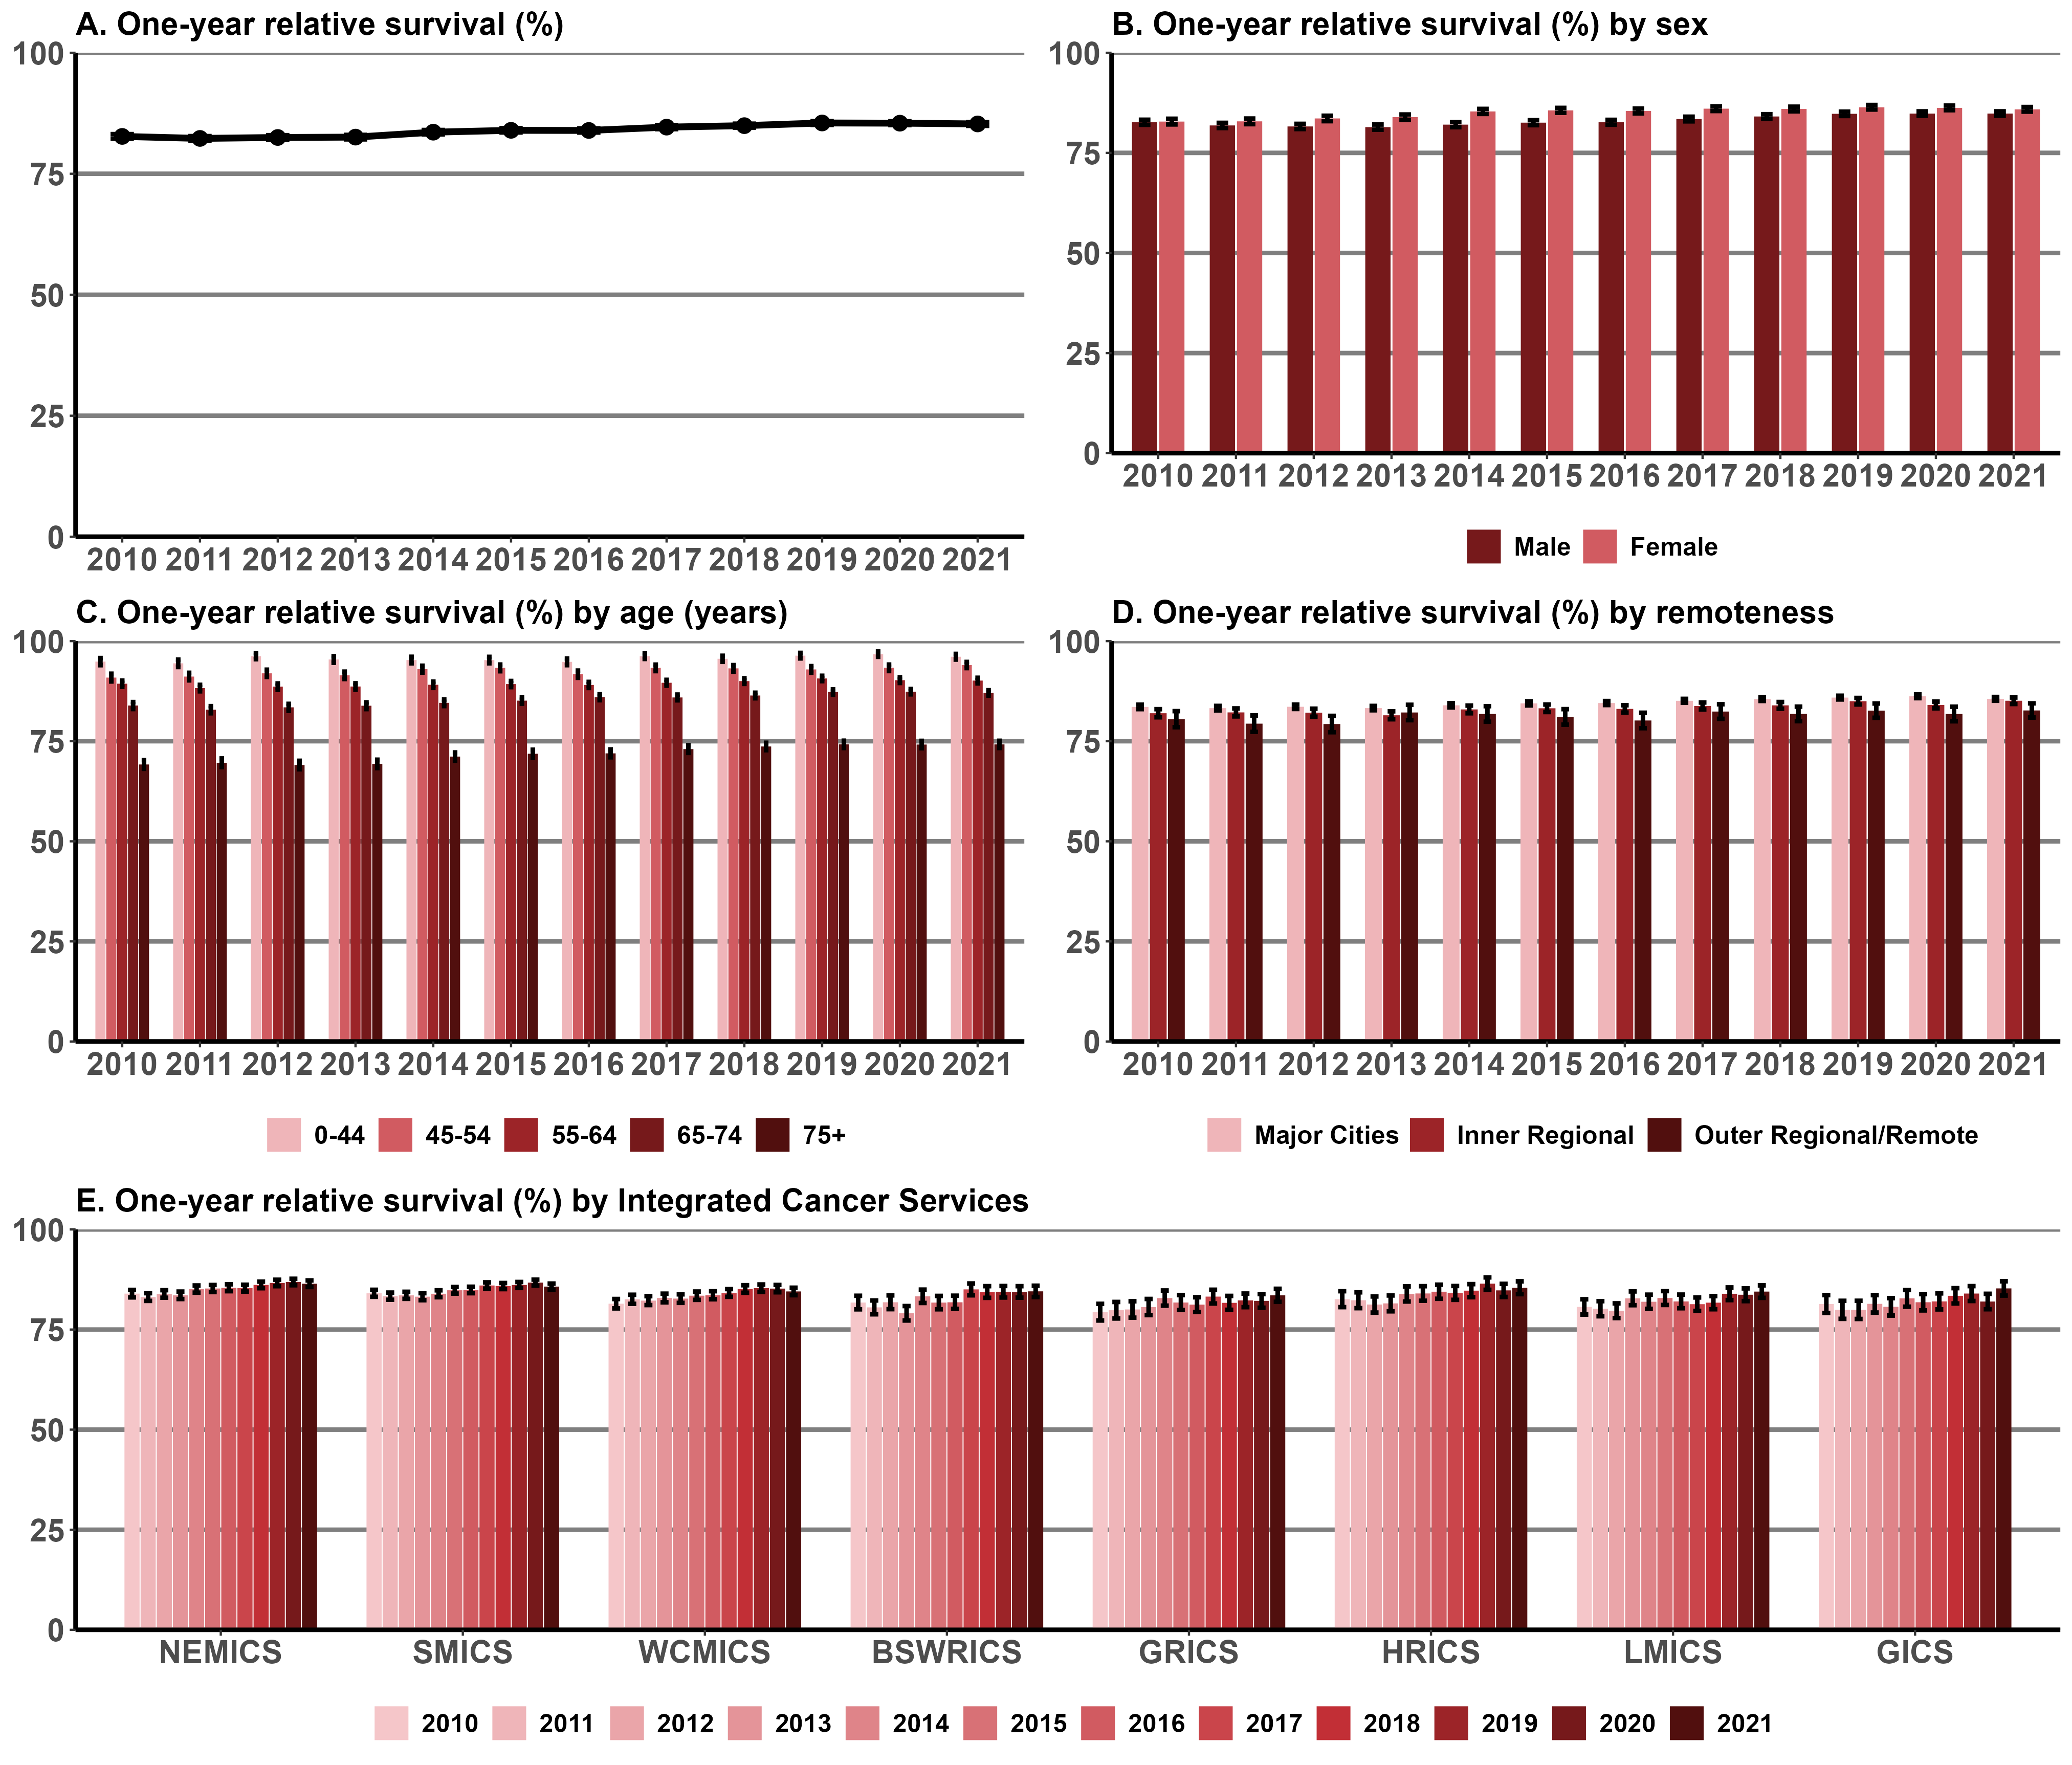

Note: Appendix 2 provides the dataset.

Measure assessment
Traffic light rating: Amber (desired result not yet evident)
Overall trend: Moving in the right direction but impacts of the COVID pandemic on one-year survival is uncertain
Commentary: Figure 13.1(A) shows that from 2010 to 2021, one-year relative survival for all cancers combined (C00–C97, D45–D46, D47.1, D47.3) increased slightly from 82.7% in 2010 to 85.3% in 2021. Females tended to have higher one-year relative survival rates than males overall, which is also widening (Figure 13.1 (B)). However, this varied with age. Figure 13.1 (C) shows that survival was highest for people under 44 years of age and decreased with age, so it was the lowest for those aged 75 years or older. This age-related pattern of survival is characteristic of most individual cancer streams presented in this baseline report. The reduction in survival with age was more pronounced in the second half of the life span – for almost all types of cancers, one-year survival was lowest in older people.
Figure 13.1 (D) shows that for each recorded year, one-year relative survival decreased with greater remoteness, although the differences were small, ranging from 83.6% (2010) and 85.6% (2021) in major cities compared with 80.5% (2010) and 82.7% (2021) in outer regional/remote Victorian areas. Similarly, there was a gradient of decreasing one-year relative survival rates by ICS region, with metropolitan ICSs such as NEMICS and SMICS reporting slightly higher survival rates compared with rural and regional ICS such as GRICS and LMICS, which generally reported the lowest survival rate for each recorded year (Figure 13.1 (E); refer to Tables 13.1a–c, Appendix 2).
The target for this measure set out in the data dictionary is to double the improvement in one-year survival by 2040 from the baseline (2010). The target of doubling the improvement in one-year survival will be met if the improvement in relative survival between the periods 2030–2034 and 2035–2039 is twice that of the improvement between the periods 2005–2009 and 2010–2014. It is important to note that while Figure 13.1 (A) shows Victoria is moving in the right direction it is anticipated that eventually a ceiling effect will be reached and each incremental increase in one-year survival will become more difficult to achieve.

Measure 13.2 – One-year relative survival from lung cancer
Figure 13.2: Trends in one-year relative survival from lung cancer overall (A) and by sex (B), age (C), remoteness (D) and ICS (E), Victoria, by year, 2010–2021
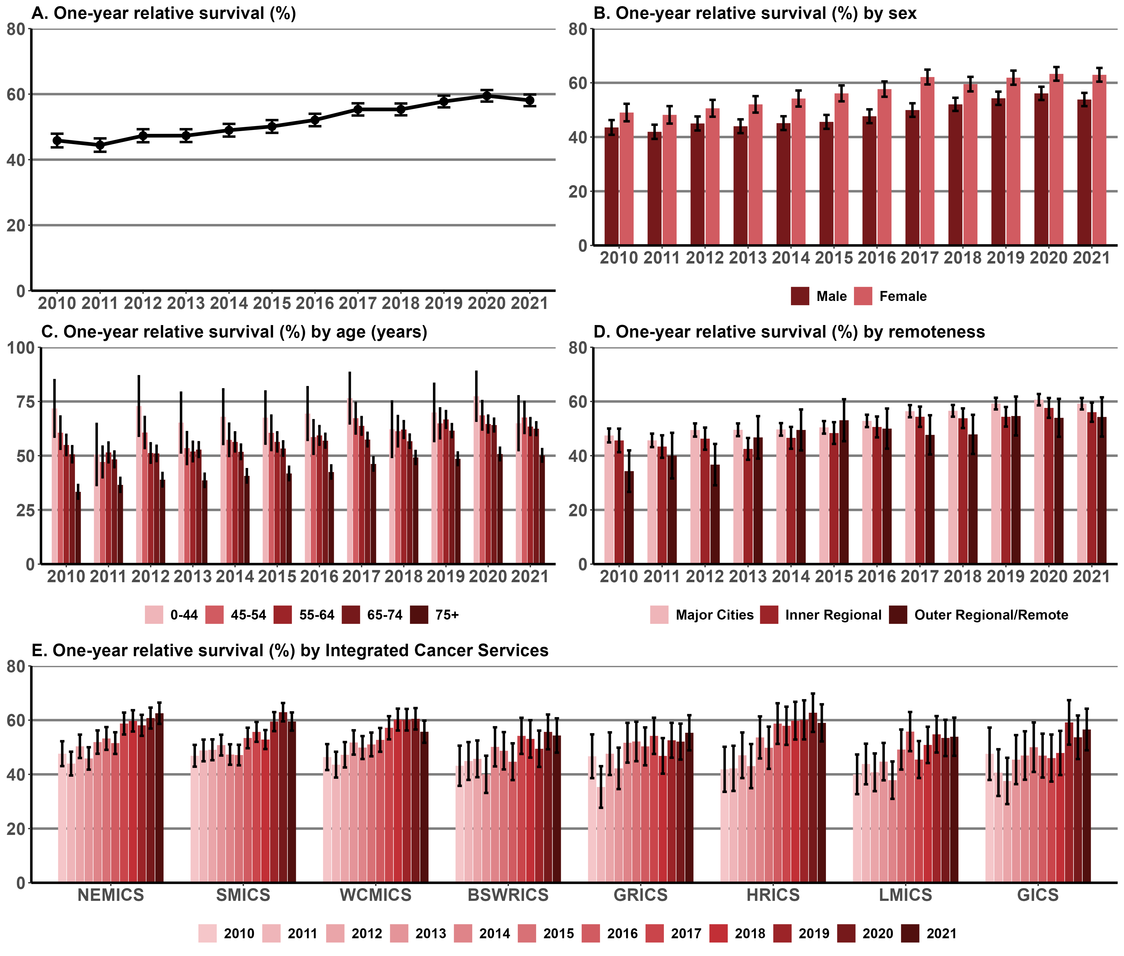

Note: Appendix 2 provides the dataset.

Measure assessment
Traffic light rating: Green (satisfactory result)
Overall trend: Moving in the right direction
Commentary: Relative to other tumour streams, lung cancer has a low survival rate nationally, with only 22% of those diagnosed with lung cancer surviving five years after diagnosis. This poor survival rate is due in part to the relatively high number of cases diagnosed at an advanced stage (with late-stage disease) and because it is associated with other smoking-related comorbidities.
In Victoria the one-year relative survival for lung cancer increased from 45.8% in 2010 to 58.1% in 2021 (Figure 13.2 (A)). Survival was higher for females than for males between 2010 and 2020, with the gender gap gradually widening (Figure 13.2 (B)). The one-year relative survival rate was significantly higher for those aged under 44 years compared with all older age groups (Figure 13.2 (C)). Survival fell sharply with age for those aged 75 years or older.
Survival varied by remoteness, with one-year survival generally higher in major cities for most years apart from 2015 where outer regional/remote areas had the highest survival rate by remoteness but complete overlap of confidence intervals. However, caution should be taken when interpreting this result because of the wide confidence intervals (Figure 13.3 (D); refer to Tables 13.2a–c in Appendix 2).
One-year survival rates did not vary between regions when compared by ICS between 2010 and 2021 and were generally higher in the metropolitan ICSs. Higher rates of survival observed for regional ICSs such as HRICS, particularly in 2020, should be interpreted with caution because of the wide confidence interval.
While no target has been set for this measure, the one-year survival rate for those patients diagnosed with lung cancer between 2010 and 2021 shows there has been a gradual improvement in the proportion of those surviving the one-year period.

Measure 13.3 – One-year relative survival from pancreatic cancer
Figure 13.3: Trends in one-year relative survival from pancreatic cancer overall (A) and by sex (B), age (C), remoteness (D) and ICS (E), Victoria, by year, 2010–2021
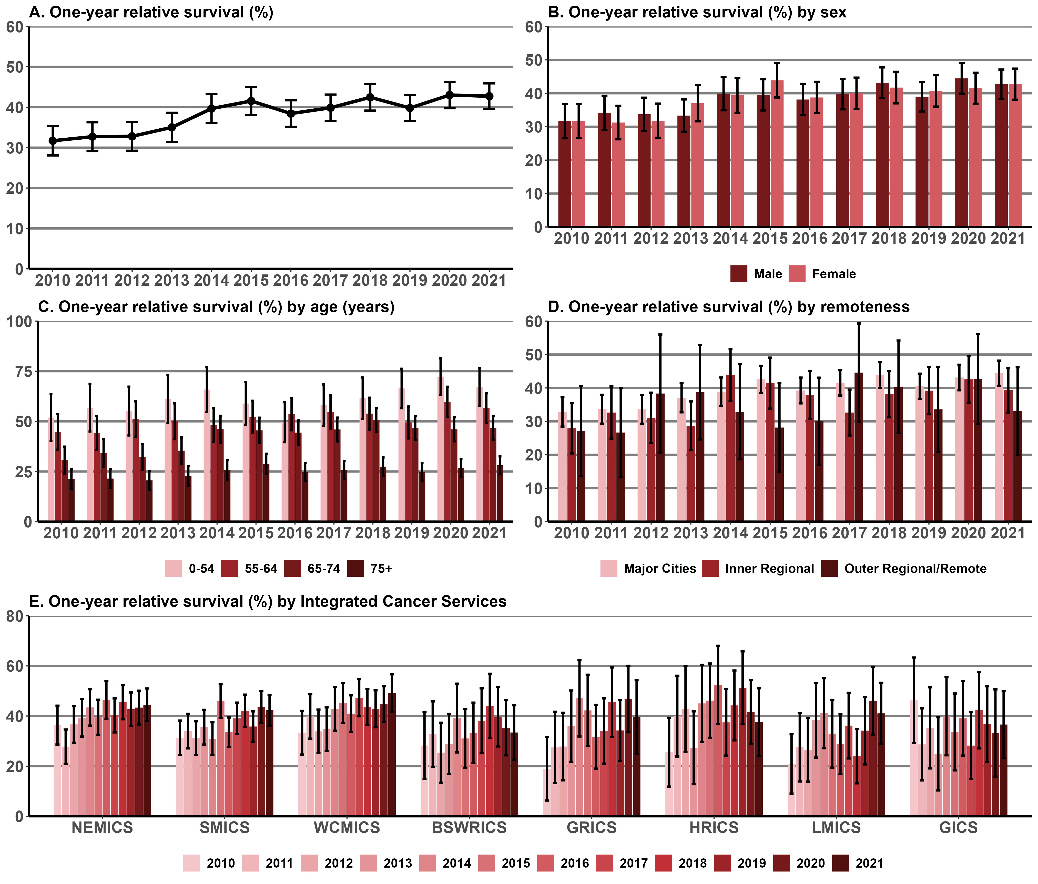
Note: Appendix 2 provides the dataset.

Measure assessment
Traffic light rating: Amber (desired result not yet evident)
Overall trend: Moving in the right direction but impacts of the COVID pandemic on one-year survival is uncertain
Commentary: While pancreatic cancer survival rates have been improving from decade to decade, the disease is still considered largely incurable globally. In Australia pancreatic cancer accounts for 2.5% of all new cancer diagnoses. The poor survival rates for this cancer have only marginally improved in Australia over a 40-year period. This poor prognosis is directly related to late diagnosis, when the disease is often locally advanced or metastatic.
In Victoria, for people diagnosed with pancreatic cancer between 2010 and 2021, the one-year relative survival ranged from 31.7% in 2010 to 42.7% in 2021 (Figure 13.3 (A)). Survival showed very little variation between the genders with males at a slightly higher risk than females overall except for some years such as 2015 (Figure 13.3 (B)). The one-year relative survival rate was higher for those aged under 54 years compared with all older age groups (Figure 13.3 (C)). Survival decreased markedly with age for those aged 75 years or older.
Survival varied by remoteness, with one-year survival generally higher in major cities for most years apart from 2012, 2013 and 2017 where outer regional/remote areas had the highest survival rate by remoteness. However, caution should be taken when interpreting this result due to the wide confidence intervals. The large 95% confidence intervals reflect the confidence around the estimated value. Nevertheless, it can still be representative to the population. The figure is large because there are few pancreatic patients living in Victorian outer regional/remote areas (Figure 13.2 (D)).
One-year survival rates varied between regions when compared by ICS between 2010 and 2021; they were generally higher in the metropolitan ICSs. Higher rates of survival observed for regional ICSs such as HRICS in 2016 and 2019 should be interpreted with caution because of the wide confidence intervals (Figure 13.3 (E)).
While no target has been set for this measure, the one-year survival rate for those patients diagnosed with pancreatic cancer remains low despite a gradual improvement in the proportion of those surviving the one-year period during the analysis period. However, due to small numbers, survival rates for pancreatic cancer are unstable and should be interpreted with caution.

Measure 13.4 – One-year relative survival from ovarian cancer (C56)
Figure 13.4: Trends in one-year relative survival from ovarian cancer overall (A) and by age (B), remoteness (C) and ICS (D), Victoria, by year, 2010–2021
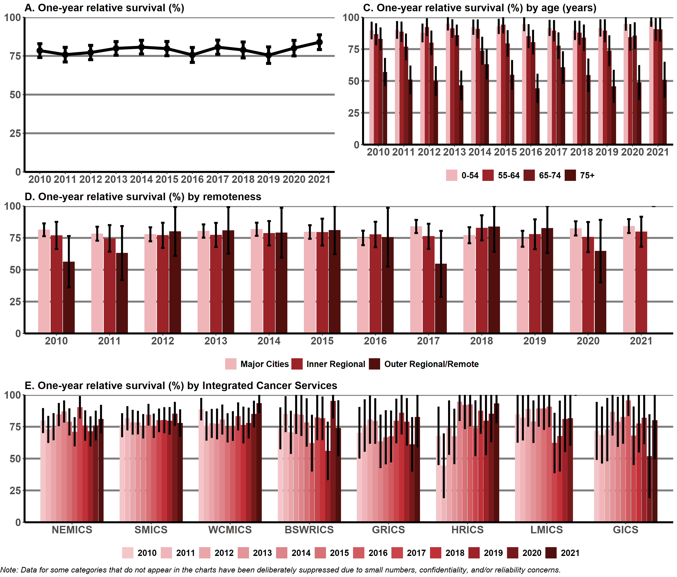
Note: Appendix 2 provides the dataset.

Measure assessment
Traffic light rating: Green (satisfactory result)
Overall trend: Moving in the right direction
Commentary: Ovarian cancer is a collective term for invasive cancers derived from different tissues. It is mainly a disease of postmenopausal women, the average age at diagnosis being 64 years. The risk of ovarian cancer increases with age. It is often diagnosed at a stage where the cancer has spread beyond the ovary, which in turn is associated with a poorer prognosis and treatment. In Australia ovarian cancer has the lowest survival rate of any women’s cancer.
In Victoria, for people diagnosed with ovarian cancer between 2010 and 2021, the one-year relative survival ranged from 78.4% in 2010 to 83.9% in 2021 (Figure 13.4 (A)). Figure 13.4 (B) shows that survival dropped with each older age group but decreased markedly for women aged 75 years or older.
There was no difference between survival and remoteness (Figure 13.4 (C)) and ICS (Figure 13.4 (D)), although caution should be taken when interpreting these results, particularly for outer regional/remote areas and regional ICSs, because the wide confidence intervals denote a small sample size that may not represent the population (refer to Tables 13.4a–c in Appendix 2).
While no target has been set for this measure, the one-year survival rate for those patients diagnosed with ovarian cancer between 2010 and 2021 increased.

Measure 13.5 – One-year relative survival from colorectal cancer
Figure 13.5: Trends in one-year relative survival from colorectal cancer overall (A) and by sex (B), age (C), remoteness (D) and ICS (E), Victoria, by year, 2010–2021
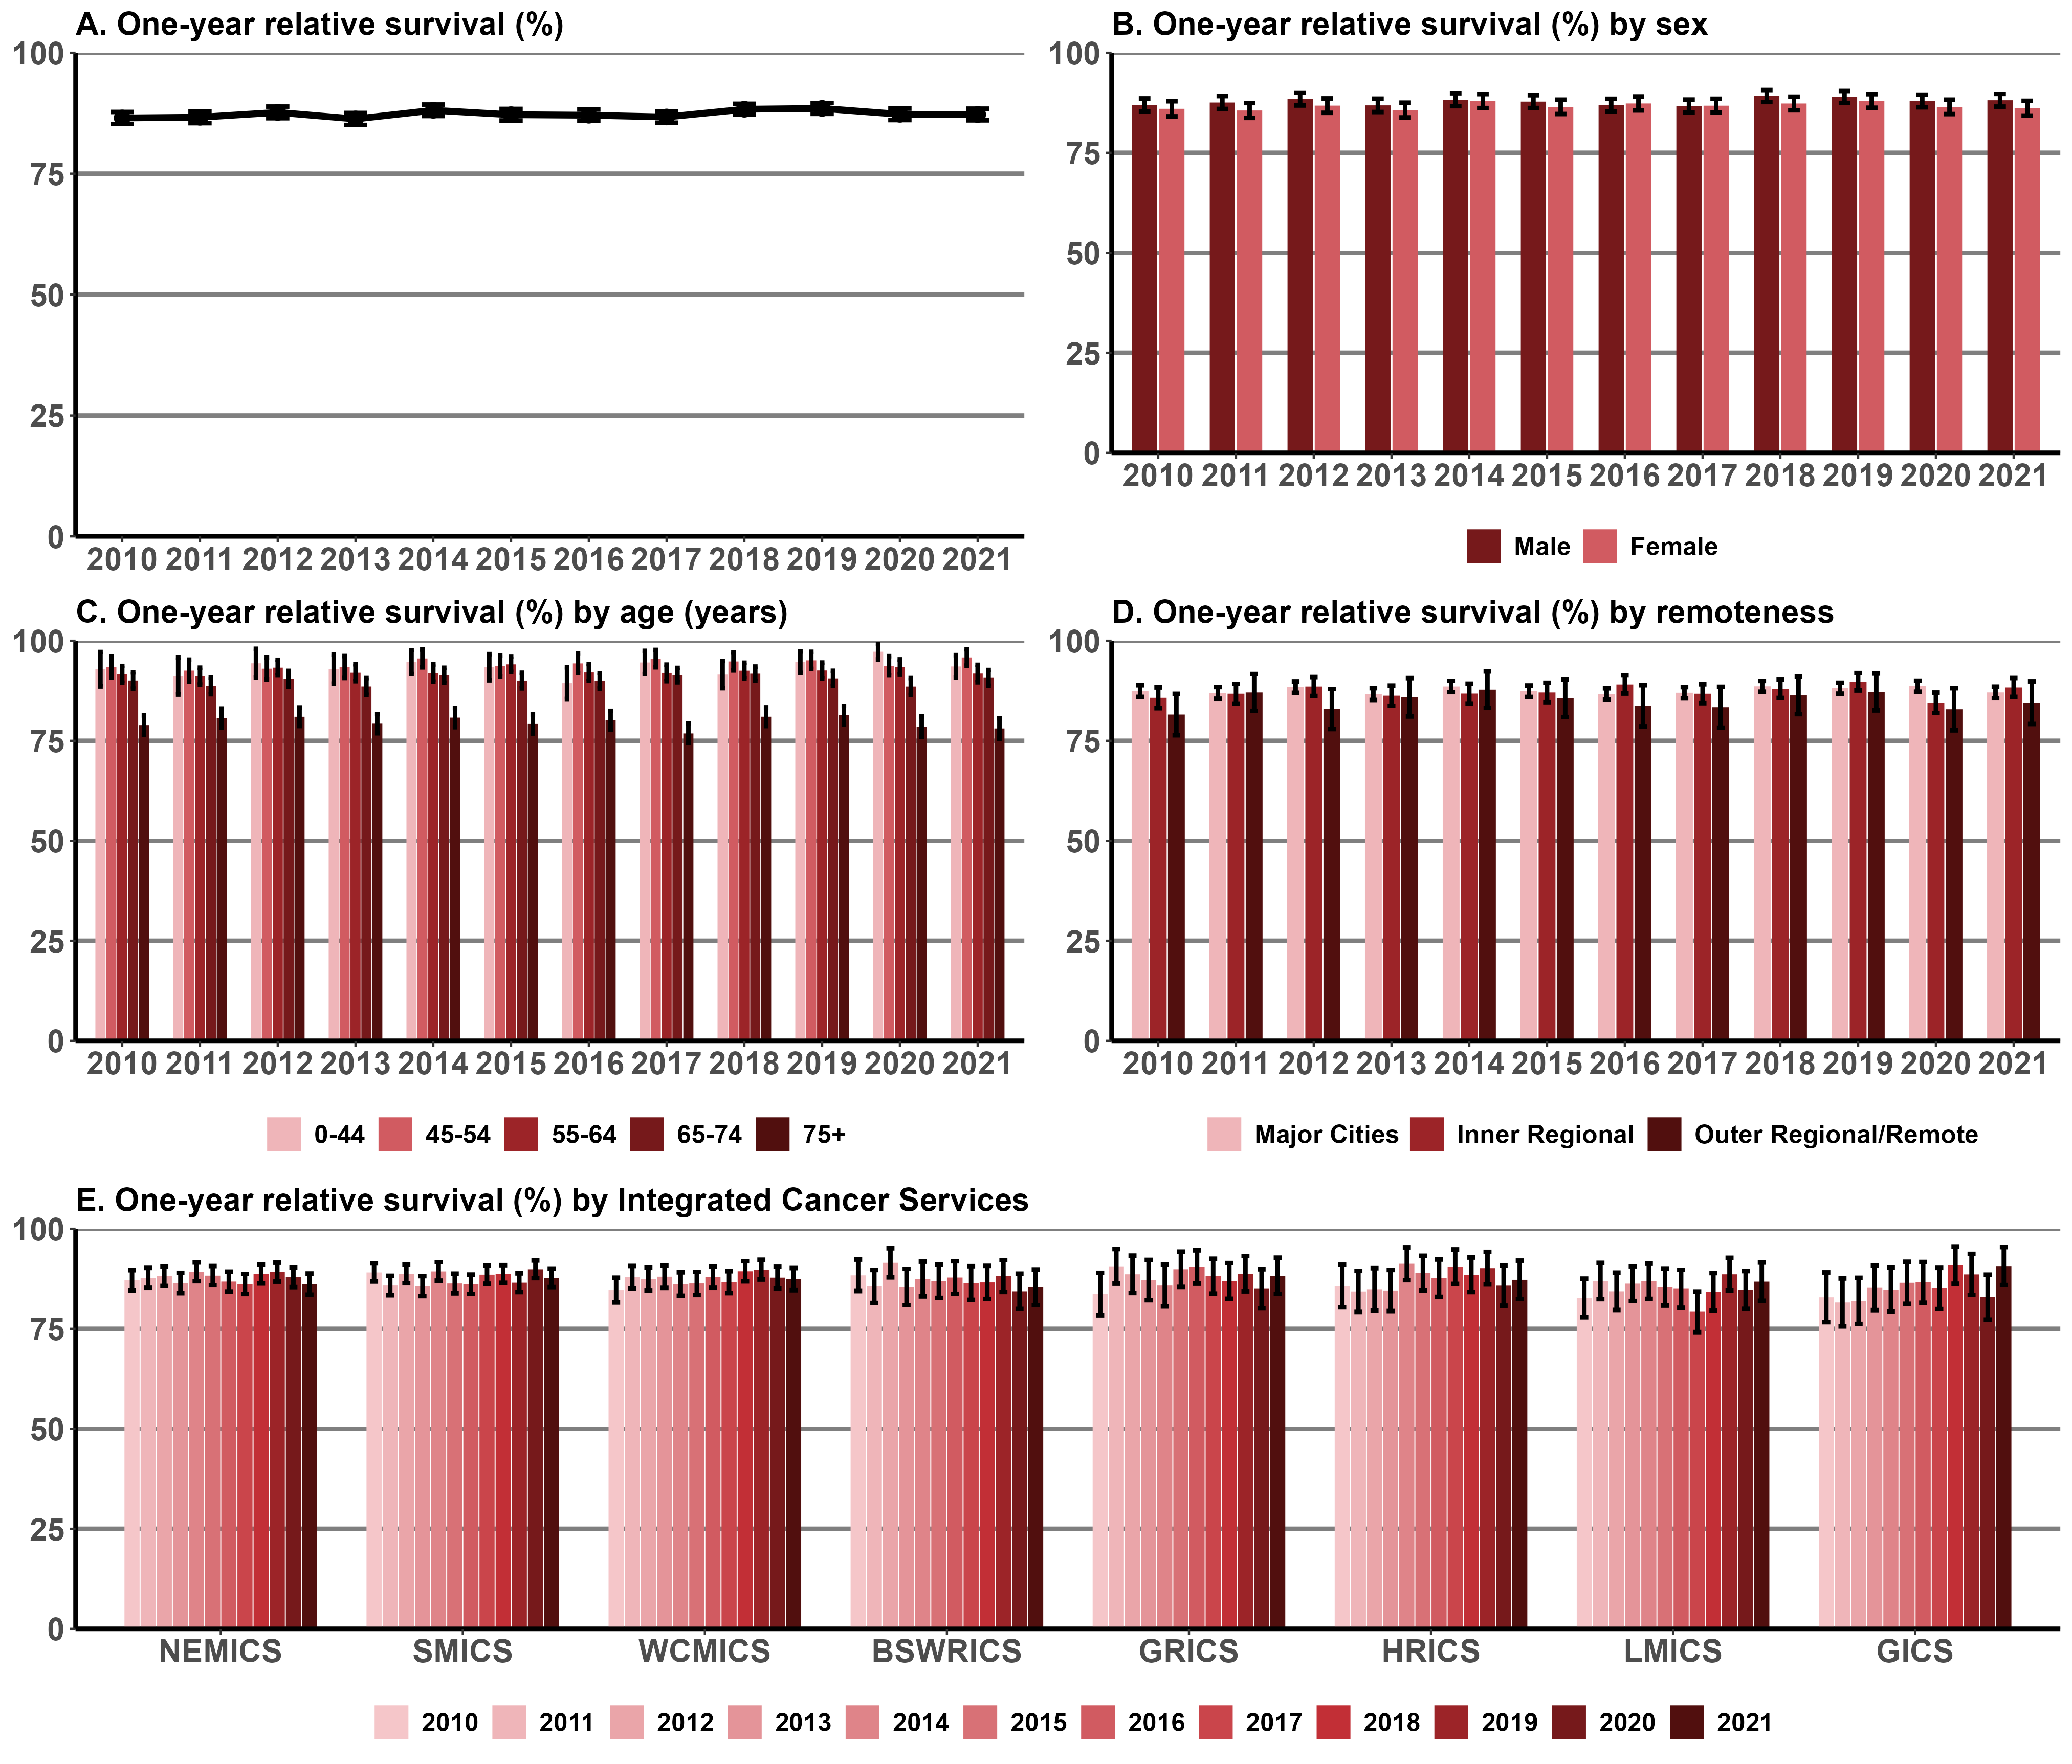
Note: Appendix 2 provides the dataset.

Measure assessment
Traffic light rating: Red (result is of concern)
Overall trend: Static or unchanging
Commentary: Colorectal cancer (CRC) is a disease characterised by abnormal cells that grow in the colon or rectum. Survival depends on the stage of the tumour at detection. However, because CRC often produces symptoms at an early enough stage that is treatable, survival rates are relatively high.
In Australia survival for people diagnosed with CRC in 2011 was 85.8% at one year from diagnosis. Figure 13.5 (A) shows that in Victoria the relative survival rate for CRC was similar to the national figure at one year following diagnosis ranging from 86.5% (2010) to 87.2% (2021). Table 13.5c in Appendix 2 shows that the one-year relative survival rate in 2020 (COVID-19 period) was not significantly different among Victorians diagnosed in 2019 (pre-COVID period). Relative one-year survival after a CRC cancer diagnosis in 2019 was 88.5 (87.4–89.6) and decreased slightly 87.2 (86.0–88.4) in 2021. This indicates that Victorians were not disadvantaged in terms of survival for CRC.
Survival did not vary between the genders, although in 2016 females had higher survival than males (Figure 13.5 (B)). In addition, survival did not vary much for those aged 74 years or younger but decreased for those aged 75 years or older.
There was no difference between survival and remoteness (Figure 13.5 (C)) and ICS (Figure 13.5 (D)). However, caution should be taken when interpreting these results because the wide confidence intervals denote a small sample size that may not represent the population (refer to Tables 13.5a–c, Appendix 2).
While no target has been set for this measure, the higher one-year survival rates for those patients diagnosed with CRC between 2010 and 2021 compared with other cancers only shows a slight improvement in the proportion of those surviving the one-year period over time.

Measure 13.6 – One-year relative survival from brain cancer (C70–C72)
Figure 13.6: Trends in one-year relative survival from brain cancer overall (A) and by sex (B), age (C), remoteness (D) and ICS (E), Victoria, by year, 2010–2021
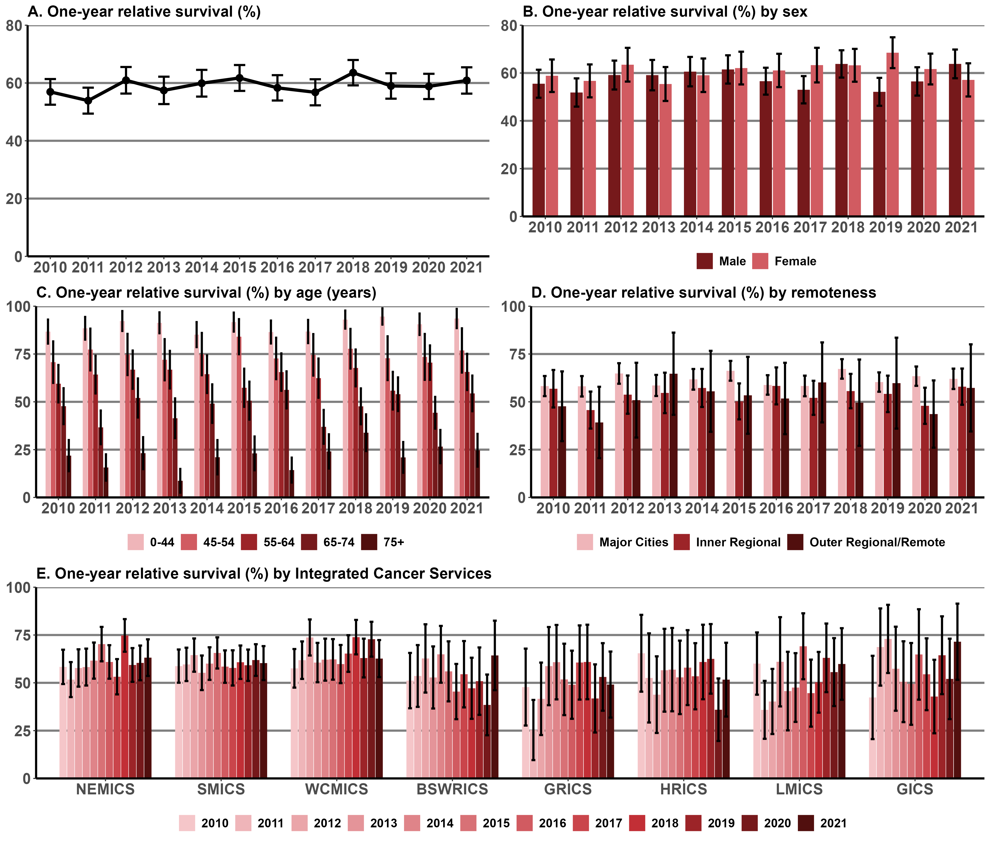
Note: Appendix 2 provides the dataset.

Measure assessment
Traffic light rating: Amber (desired result not yet evident)
Overall trend: Static or unchanging
Commentary: Brain cancers include primary brain tumours, which start in the brain and almost never spread to other parts of the body, and secondary tumours (or metastases), which are caused by cancers that have begun in another part of the body. In Australia brain cancer accounts for 1.4% of all cancers and is one of the most common cancers and leading causes of cancer death in young Australians. Brain cancer survival rates are low and have hardly changed for 30 years, despite significant increases in survival for Australians diagnosed with other types of cancer such as prostate and breast cancer. Treatment is challenging because it affects the most essential human organ – the brain.
In Victoria, for people diagnosed with brain cancer between 2010 and 2021, the one-year relative survival ranged from 56.9% in 2010 to 60.9% in 2021 (Figure 13.6 (A)). Survival was slightly higher for females than for males during the analysis period (Figure 13.6 (B)). Survival decreased markedly with all age categories (except in 2020) but was more pronounced for those aged 75 years or older (Figure 13.6 (C)).
Survival varied by remoteness, with one-year survival higher in major cities for most years except for 2013 when inner regional areas had a slightly higher survival rate. As with other measures, caution should be taken when interpreting this result because the wide confidence intervals shown for one-year survival rates, particularly as they relate to inner regional outer regional/remote areas, denotes a small sample size that may not represent the population (Figure 13.6 (D)).
One-year survival rates varied between regions when compared by ICS between 2010 and 2021. Fluctuating higher rates of survival seen in regional and rural ICSs such as LMICS and GICS should be interpreted with caution because of the wide confidence intervals due to small sample sizes (Figure 13.6 (E)). The full dataset is available in Appendix 2 – refer to Tables 13.6a–c.
While no target has been set for this measure, the one-year survival rate for those patients diagnosed with brain cancer between 2010 and 2021 shows a gradual improvement in the proportion of those surviving the one-year period over time.

Measure 13.7 – One-year relative survival from oesophageal cancer
Figure 13.7: Trends in one-year relative survival from oesophageal cancer overall (A) and by sex (B), age (C), remoteness (D) and ICS (E), Victoria, by year, 2010–2021
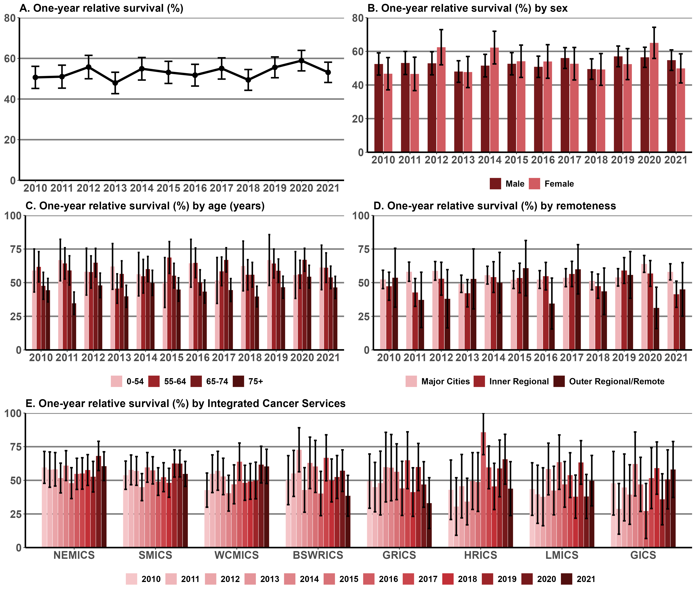
Note: Appendix 2 provides the dataset.

Measure assessment
Traffic light rating: Amber (desired result not yet evident)
Overall trend: Moving in the right direction but impacts of the COVID pandemic on one-year survival is uncertain
Commentary: Cancer of the oesophagus (stomach cancer) is a multifactorial disease and is relatively common in Australia. Nationally it is rare in people under 50 years of age and affects more men than women. The absence of specific symptoms or a marker for early detection often leads to diagnosis when the tumour is already locally advanced or met.
In Victoria, for people diagnosed with oesophageal cancer between 2010 and 2021, the one-year relative survival showed very little change, ranging from 50.7% in 2010 to 53.1% in 2021 (Figure 13.7 (A)). Survival fluctuated between genders, although it was slightly higher for females than for males in 2012, 2014, 2016 and 2020 during the analysis period (Figure 13.7 (B)). Survival was generally higher for those aged 74 years or under, although wide confidence intervals infer the likelihood of a small sample size that may not represent the respective age categories (0–54 and 55–64). However, survival decreased for those aged 75 years or older for each of the reporting years (Figure 13.7 (C)).
Survival varied by remoteness, with one-year survival generally higher in major cities for most years reported. However, as with other measures specific to one-year survival rates, caution should be taken when interpreting these results because the wide confidence intervals shown for one-year survival rates, particularly as they relate to outer regional/remote areas, denotes a small sample size that may not represent the population (Figure 13.7 (D)).
One-year survival rates varied between regions when compared by ICS between 2010 and 2021, with higher rates generally seen in metropolitan ICSs such as NEMICS and SMICS. Survival rates observed for regional and rural ICSs should be interpreted with caution because of the wide confidence intervals due to small sample sizes for these categories – for example, HRICS (2016) (Figure 13.7 (E)). The full dataset is available in Appendix 2 – refer to Tables 13.7a–c.
While no target has been set for this measure, the one-year survival rate for those patients diagnosed with oesophageal cancer between 2010 and 2021 shows an improvement in the proportion of those surviving the one-year period.

Measure 13.8 – One-year relative survival from acute myeloid leukaemia
Figure 13.8: Trends in one-year relative survival from acute myeloid leukaemia overall (A) and by sex (B), age (C), remoteness (D) and ICS (E), Victoria, by year, 2010–2021
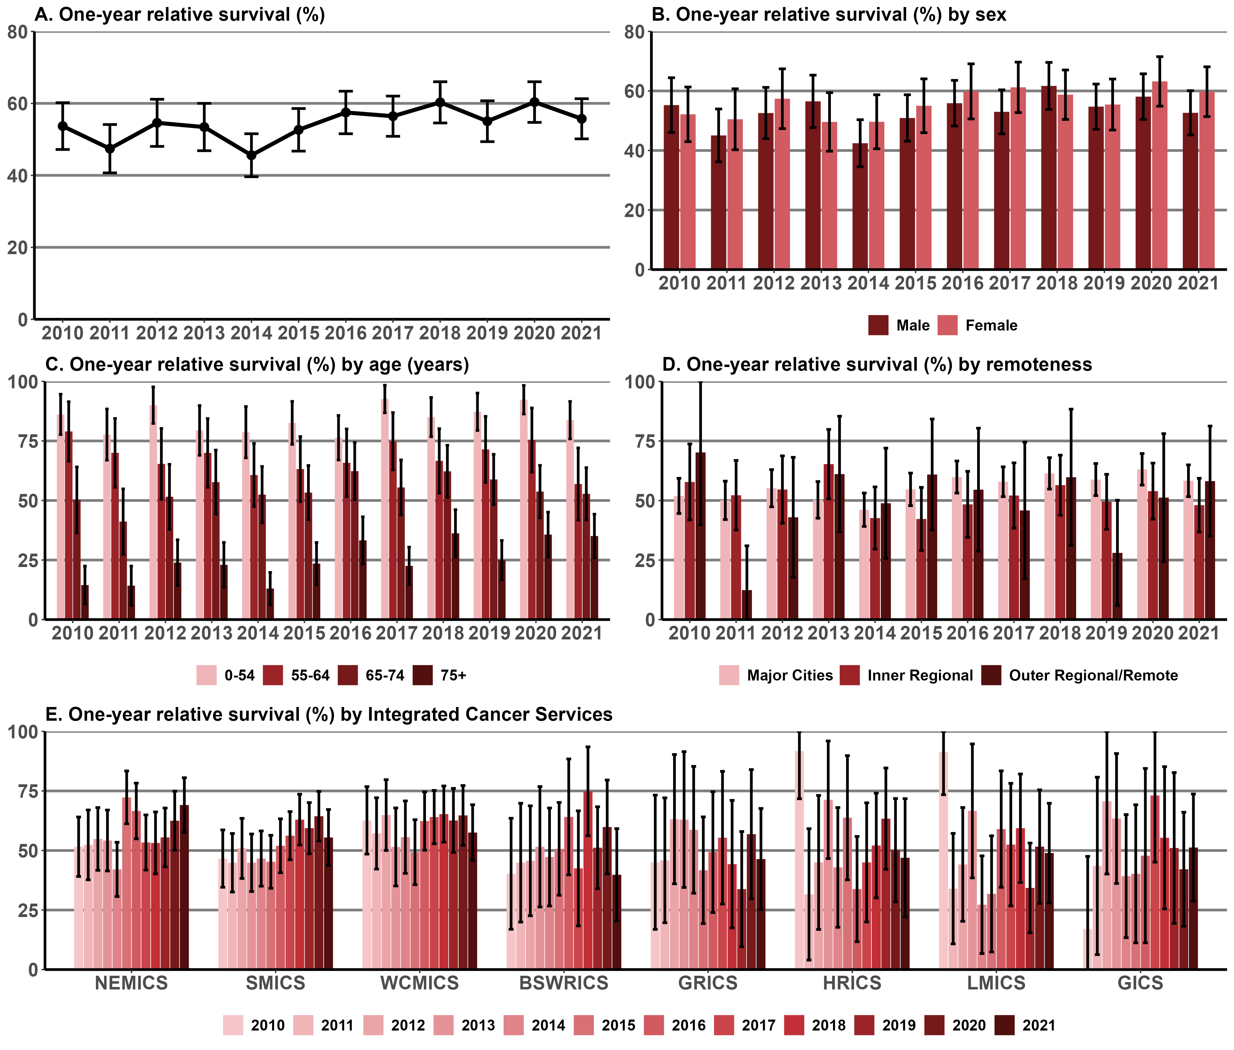
Note: Appendix 2 provides the dataset.

Measure assessment
Traffic light rating: Green (satisfactory result)
Overall trend: Moving in the right direction
Commentary: Acute myeloid leukemia (AML) is a type of cancer that affects the blood and bone marrow. It is a rare disease in Australia, accounting for 0.8% of all cancer diagnosed nationally. Because AML is a heterogeneous disease with different treatments, survival outcomes depend on the genetic makeup of leukaemic cells.
In Victoria, for people diagnosed with AML between 2010 and 2021, the one-year relative survival increased from 53.7% in 2010 to 55.7% in 2021 (Figure 13.8 (A)). Survival fluctuated between genders but from 2014 was higher for females than for males except for 2018 (Figure 13.8 (B)). Survival was higher for those aged under 54 years and decreased with age, although wide confidence intervals suggest the likelihood of a small sample size that may not represent the respective age categories (55–64 and 65–74 years). Figure 13.8 (C) shows that survival decreased significantly for those aged 75 years or older for each of the reporting years.
Survival varied by remoteness, with one-year survival generally higher in major cities for most years reported. However, as with other measures specific to one-year survival rates, caution should be taken when interpreting these results because the wide confidence intervals shown for these survival rates, particularly as they relate to outer regional/remote areas, denotes a small sample size that may not represent the population (Figure 13.8 (D)).
One-year survival rates varied between regions when compared by ICS between 2010 and 2021, with higher rates generally seen in metropolitan ICSs such as WCMICS. Survival rates observed for regional and rural ICSs should be interpreted with caution because of the wide confidence intervals due to small sample sizes for these categories (Figure 13.8 (E)). The full dataset is available in Appendix 2 – refer to Tables 13.8a–c.
While no target has been set for this measure, the one-year survival rate for those patients diagnosed with AML between 2010 and 2021 shows some improvement in the proportion of those surviving the one-year period.

Measure 13.9 – Five-year relative survival from all cancers
Figure 13.9: Five-year relative survival from all cancers combined, by age (A), remoteness (B), SES (C) and ICS (D), Victoria, 2010–2014 and 2015–2019
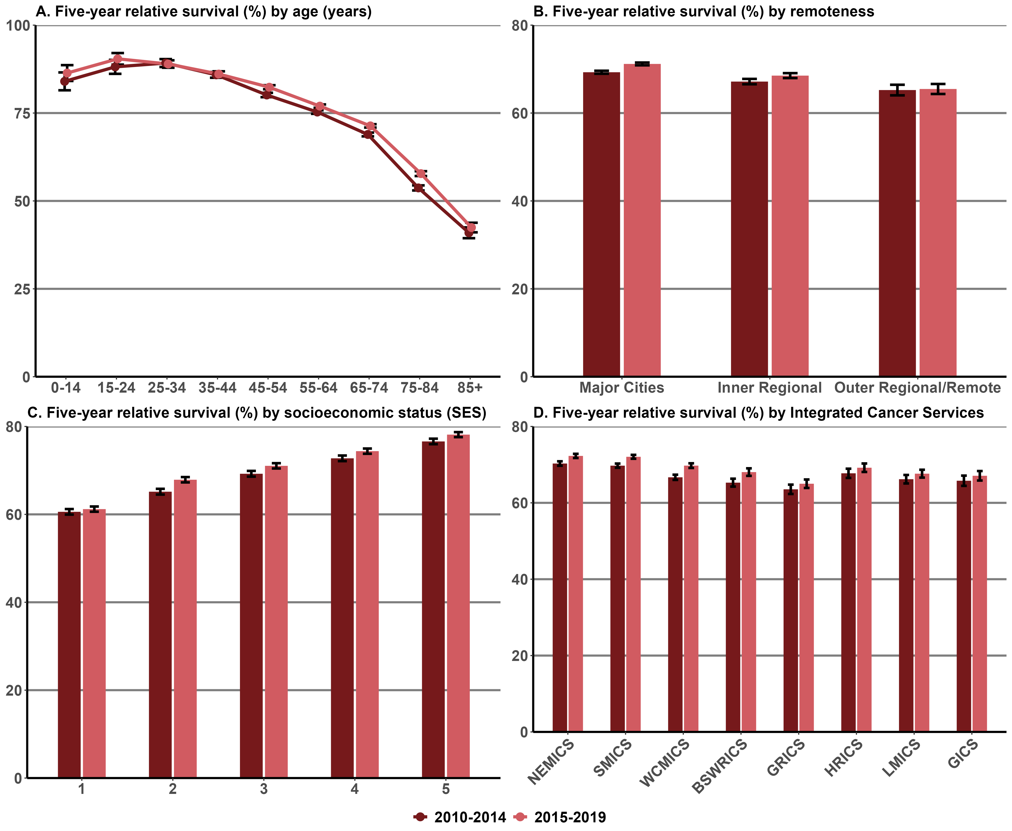
Notes:
Error bars indicate 95% confidence intervals.
Remoteness is classified according to the Australian Standard Geographical Classification (ASGC) Remoteness Areas.
SES is classified according to the ABS Socio-Economic Indexes for Areas (SEIFA) Index of Relative Socio-economic Disadvantage – 1= lowest and 5 = highest.
Appendix 2 provides the dataset.

Measure assessment
Traffic light rating: Amber (desired result not yet evident)
Overall trend: Appears to be moving in the right direction
Commentary: Survival from cancer can be influenced by a variety of different factors including demographic characteristics, tumour type, stage of the cancer at diagnosis, other prognostic indicators and the availability of treatment.
Information on survival from cancer provides an indication of a cancer prognosis and the effectiveness of treatment available. Relative survival of less than 100% means that people with cancer have a lower chance of surviving for at least five years after diagnosis than the general population. In Australia the national five-year relative survival was 69% in 2010–2014; that is, people diagnosed with cancer had a 69% chance of surviving for at least five years compared with their counterparts in the general population.
In 2010–2014, five-year relative survival in Victoria for all cancers combined mirrored the national trend (68.1%) and increased to 70.3% in 2015–2019. The increases in five-year survival occurred for both males and females, although females had a larger increase in survival over this period. Several factors may have contributed to this increase, including advances in diagnostic methods, earlier and increased detection through screening programs, and improvements in treatment.
Five-year survival varied with age: survival was highest for people aged 25–34 years (five-year survival of 89.2% for 2010–2014 increasing to 88.9% for 2015–2019) and lowest for those aged 85 years or older (40.9% for 2010–2014; increasing slightly 42.4% in 2015–2019; refer to Tables 13.9a and b, Appendix 2). This age-related pattern of survival is characteristic of most individual cancer types presented in this report. The reduction in survival with age was more pronounced in the second half of the life span – for almost all types of cancers, survival was lowest in older people (Figure 13.9 (A)).
Five-year survival decreased with greater remoteness, although the differences were small: five-year survival was 69.3% in 2010–2014 increasing to 71.2% in 2015–2019 for major cities, compared with 67.2% (2010–2014) and 68.5% (2015–2019) in inner regional areas and 65.2% (2010–2014) and 65.5% (2015–2019) in outer regional and remote areas (Figure 13.9 (B)). There was also a gradient of decreasing survival with greater socioeconomic disadvantage across the two five-year survival periods (Figure 13.9 (C)). Similarly, while there was an increase in five-year survival between the two periods, there was a gradient of decreasing survival with ICSs that did not contain a large metropolitan area such as Melbourne: five-year survival was seven percentage points higher for people in SMICS (69.7%, 2010–2014; 72.1%, 2015–2019) and NEMICS (70.3%, 2010–2014; 72.3%, 2015–2019) compared with those located in GRICS (63.5%, 2010–2014; 65.0%, 2015–2019) (Figure 13.9 (D)).

Measure 13.10 – Five-year relative survival from lung cancer (C33–34)
Figure 13.10: Five-year relative survival from lung cancer, by age (A), remoteness (B), SES (C) and ICS (D), Victoria, 2010–2014 and 2015–2019
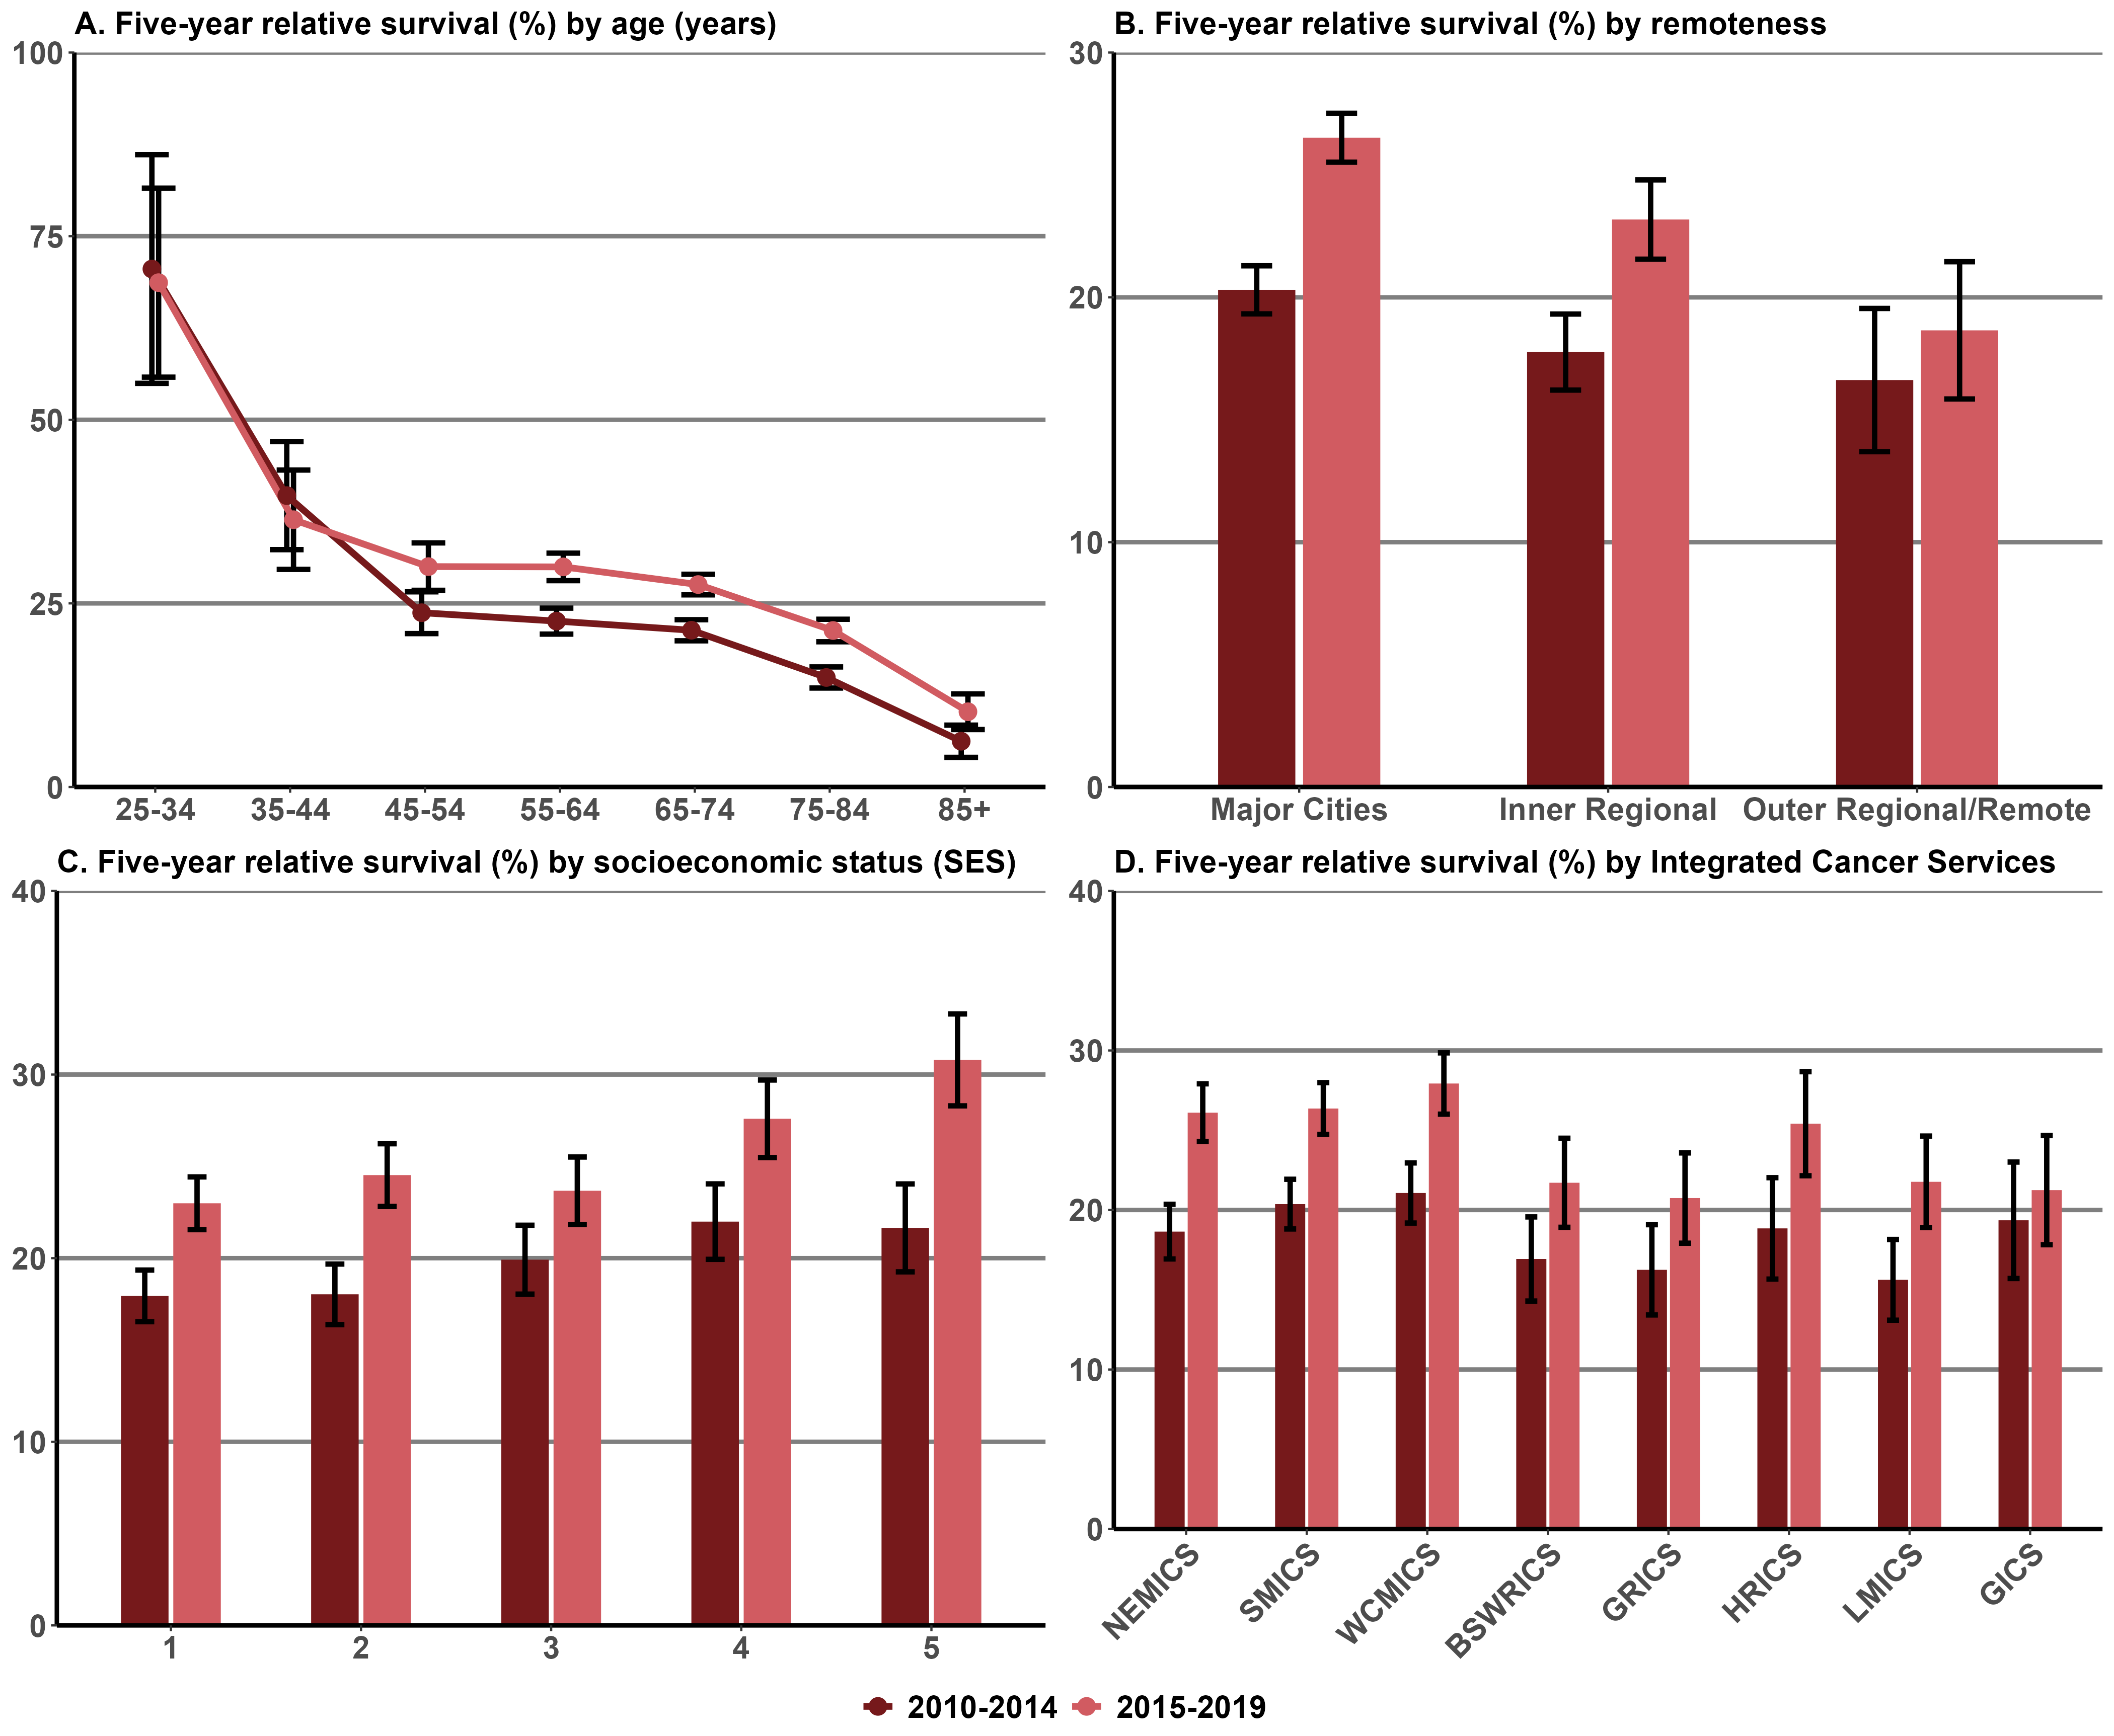
Notes:
Error bars indicate 95% confidence intervals.
Analysis for the age groups 0–14 years and 15–24 years were excluded because there were no deaths recorded.
Remoteness is classified according to the ASGC Remoteness Areas.
SES is classified according to the SEIFA Index of Relative Socio-economic Disadvantage – 1= lowest and 5 = highest.
Appendix 2 provides the dataset.

Measure assessment
Traffic light rating: Green (satisfactory result)
Overall trend: Moving in the right direction
Commentary: In 2010–2014, Australians diagnosed with lung cancer had a 17% chance (15% for males and 20% for females) of surviving for five years compared with their counterparts in the general Australian population. This pattern was similar in Victoria where people diagnosed with lung cancer during the same period had a 19.1% chance (17.5% for males and 21.3% for females) of surviving for five years compared with their counterparts in the general Victorian population. However, the five-year survival for Victorians diagnosed with lung cancer increased for the period 2015–2019 to 25.2% (21.7% for males and 29.7% for females; refer to Tables 13.10a and b, Appendix 2).
Five-year survival was significantly higher for those aged 25–34 (70.5%, 2010–2014; 68.7%, 2015–2019) compared with all older age groups. Survival decreased markedly with age, declining from 14.9% in 2010–2014 and 21.3% in 2015–2019 for those in the 75–84 age group to 6.2% in 2010–2014 and 10.2% in 2015–2019 for those aged 85 or older (Figure 13.10 (A)).
Survival varied by remoteness and SES. Five-year survival was higher in major cities (20.3%, 2010–2014; 26.5%, 2015–2019) compared with inner regional (17.8%, 2010–2014; 23.2%, 2015–2019) and outer regional/remote areas (16.6%, 2010–2014; 18.7%, 2015–2019) (Figure 13.10 (B)). However, survival was greatest in the higher socioeconomic quintile (SES 5) (Figure 13.10 (C)).
There was a gradient of decreasing survival with ICSs for both five-year survival time periods that did not contain a large metropolitan area such as Melbourne: five-year survival was four percentage points and above higher for people in SMICS (20.4%, 2010–2014; 26.4%, 2015–2019) and WCMICS (21.1%, 2010–2014; 27.9%, 2015–2019) compared with those located in LMICS (15.6%, 2010–2014; 21.8%, 2015–2019) (Figure 13.10 (D)).

Measure 13.11 – Five-year relative survival from pancreatic cancer (C25)
Figure 13.11: Five-year relative survival from pancreatic cancer, by age (A), remoteness (B), SES (C) and ICS (D), Victoria, 2010–2014 and 2015–2019
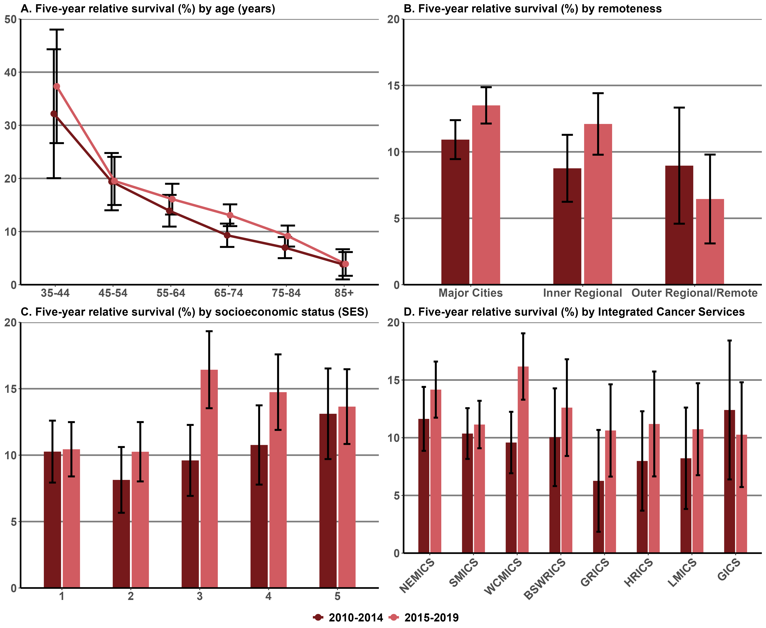
Notes:
Analysis for the age groups 0–14 years, 15–24 years, 25–34 years and 35–44 years were excluded because of low numbers.
Error bars indicate 95% confidence intervals.
Remoteness is classified according to the ASGC Remoteness Areas.
SES is classified according to the SEIFA Index of Relative Socio-economic Disadvantage – 1= lowest and 5 = highest.
Appendix 2 provides the dataset.

Measure assessment
Traffic light rating: Amber (desired result not yet evident)
Overall trend: Appears to be moving in the right direction
Commentary: The pancreatic cancer survival rate is one of the lowest of common cancers. In 2010–2014, Australians diagnosed with pancreatic cancer had an 8.7% chance of surviving for five years compared with their counterparts in the general population, which decreased with age. Victoria’s overall rate for the same period was more than the national trend – 10.1%. In Victoria the survival rate was similar for males (9.9%) and females (12.3%). However, the five-year survival for Victorians diagnosed with pancreatic cancer increased slightly for the period 2015–2019 to 12.8% (12.3% for males and 13.5% for females; refer to Tables 13.11a and b, Appendix 2).
Five-year survival was significantly higher for those aged 25–34 (29.3%, 2010–2014; 75.8%, 2015–2019) compared with all older age groups. Survival decreased markedly with age, dropping from 7.0% in 2010–2014 to 9.2% in 2015–2019 for those in the 75–84 age group to 3.8% in 2010–2014 and 3.9% in 2015–2019 for those aged 85 or older (Figure 13.11 (A)).
Five-year survival was higher for those diagnosed with pancreatic cancer living in major cities compared with inner regional and outer regional/remote areas across the two periods (Figure 13.11 (B)). The same pattern is observed for urban-centric ICSs compared with rural ICSs across the two periods with the exception of GICS, which reported a decrease in five-year survival: 12.4% in 2010–2014 and 10.3% in 2015–2019. However, these results should be interpreted with caution since wide confidence intervals denote small sample sizes (Figure 13.11 (D)).
Survival varied depending on socioeconomic disadvantage with socioeconomic quintile (SES 3) reporting the greatest variation across the two periods: 9.6% for 2010–2014 and 16.4% for 2015–2019 (Figure 13.11 (C)).

Measure 13.12 – Five-year relative survival from ovarian cancer (C56)
Figure 13.12: Five-year relative survival from ovarian cancer, by age (A), remoteness (B), SES (C) and ICS (D), Victoria, 2010–2014 and 2015–2019
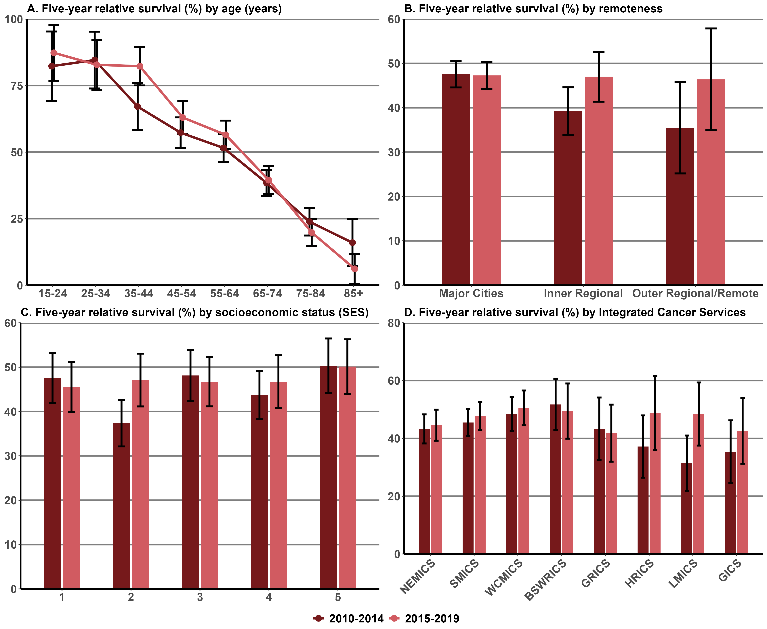
Notes:
Analysis for the age group 0–14 years was excluded because of low numbers.
Error bars indicate 95% confidence intervals.
Remoteness is classified according to the ASGC Remoteness Areas.
SES is classified according to the SEIFA Index of Relative Socio-economic Disadvantage – 1= lowest and 5 = highest.
Appendix 2 provides the dataset.

Measure assessment
Traffic light rating: Amber (desired result not yet evident)
Overall trend: Appears to be moving in the right direction
Commentary: In 2010–2014, Australian women diagnosed with ovarian cancer had a 44.8% chance of surviving for five years compared with 44.2% for Victorian women for the same period (refer to Tables 13.12a and b, Appendix 2).
In Victoria survival decreased markedly with age. Five-year survival was highest for women diagnosed in the 25–34 age range (84.6%, 2010–2014; 82.8%, 2015–2019) but decreased with each older age group. It was 16.0% in 2010–2014, decreasing to 6.1% in 2015–2019 for women aged 85 or older (Figure 13.12 (A)).
Five-year survival was generally higher in major cities between the two periods (47.5% in 2010–2014 decreasing to 47.3% in 2015–2019) compared with inner regional and outer regional/remote areas (Figure 13.12 (B)). The same pattern emerged for five-year survival within metropolitan ICSs across the two periods. For example, five-year survival for metropolitan ICSs such as SMICS and WCMICS were higher (45.5%, 2010–2014; 47.7%, 2015–2019 and 48.4%, 2010–2014; 50.6%, 2015–2019 respectively) compared with their rural counterparts such as GICS (35.4%, 2010–2014; 42.7%, 2015–2019) (Figure 13.12 (D)).
There was a fluctuating gradient of survival with greater socioeconomic disadvantage between the two periods that is for the highest socioeconomic quintile (SES 5) and the lowest (SES 1) socioeconomic quintile (Figure 13.12 (C)).

Measure 13.13 – Five-year relative survival from colorectal cancer (C18–20)
Figure 13.13: Five-year relative survival from colorectal cancer, by age (A), remoteness (B), SES (C) and ICS (D), Victoria, 2010–2014 and 2015–2019
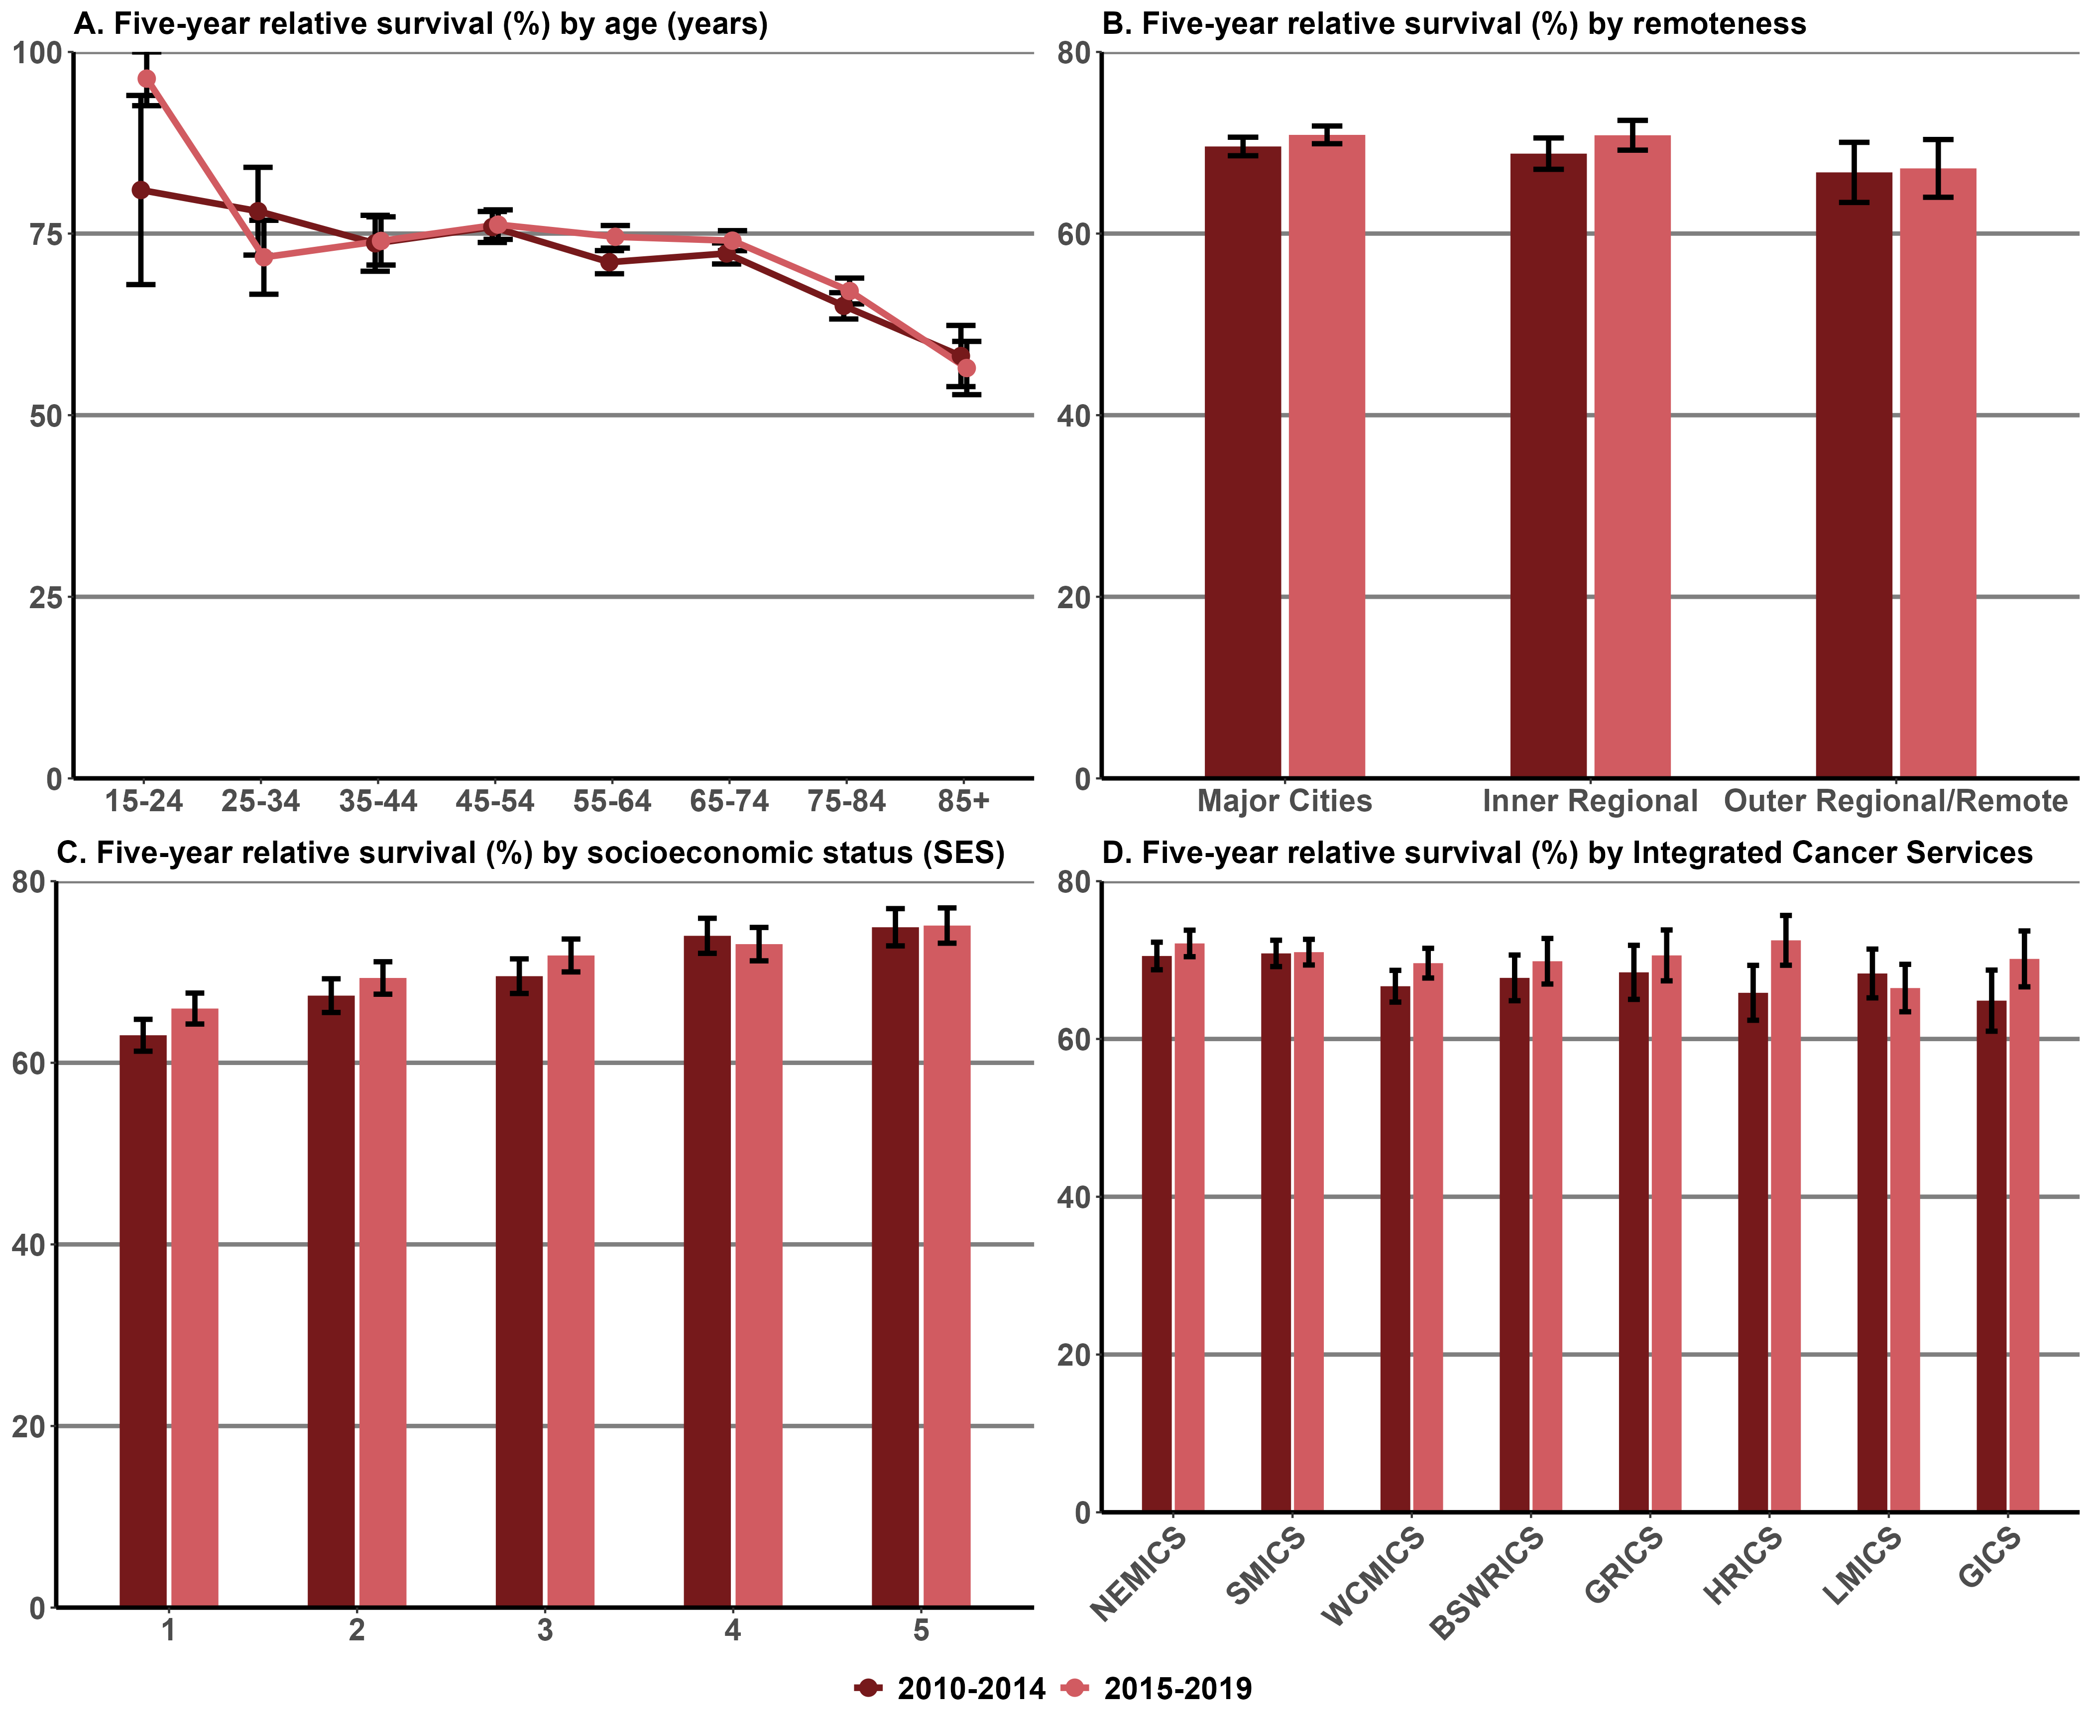
Notes:
Analysis for the age group 0–14 years was excluded because of low numbers.
Error bars indicate 95% confidence intervals.
Remoteness is classified according to the ASGC Remoteness Areas.
SES is classified according to the SEIFA Index of Relative Socio-economic Disadvantage – 1= lowest and 5 = highest.
Appendix 2 provides the dataset.

Measure assessment
Traffic light rating: Amber (desired result not yet evident)
Overall trend: Appears to be moving in the right direction
Commentary: In 2010–2014, Australians diagnosed with CRC had a 69% chance of surviving for five years compared with their counterparts in the general population. This was the highest five-year relative survival rate of all digestive-tract cancers and was similar to all cancers combined (68.1% – Measure 13.9). Males (67.4%) and females (69%) had similar five-year relative survival rates, which decreased with age.
Victorians diagnosed with CRC for the same period (2010–2014) had the same chance of surviving five years compared with the Australian average (68.9%). Five-year survival was 69.9% for females compared with 68.0% for males.
Five-year survival did not vary much under the age of 74 for the two periods but dropped from 65.1% in 2010–2014 and 67.1% in 2015–2019 for those in the 75–84 age group to 58.1% in 2010–2014 and 56.5% in 2015–2019 for those aged 85 or older (Figure 13.13 (A)).
Survival varied by remoteness area: five-year survival was slightly higher in major cities across the two periods compared with inner regional and outer regional/remote areas (Figure 13.13 (B)). This was contrary to the survival rates between the ICSs, which all reported an increase between the two periods except for LMICS (Figure 13.13 (D)).
Five-year survival decreased with greater socioeconomic disadvantage over the two periods; five-year survival was the highest socioeconomic quintile (SES 5) (74.9%, 2010–2014; 75.1%, 2015–2019) (Figure 13.13 (C)).

Measure 13.14 – Five-year relative survival from brain cancer (C71)
Figure 13.14: Five-year relative survival from brain cancer, by age (A), remoteness (B), SES (C) and ICS (D), Victoria, 2010–2014 and 2015–2019
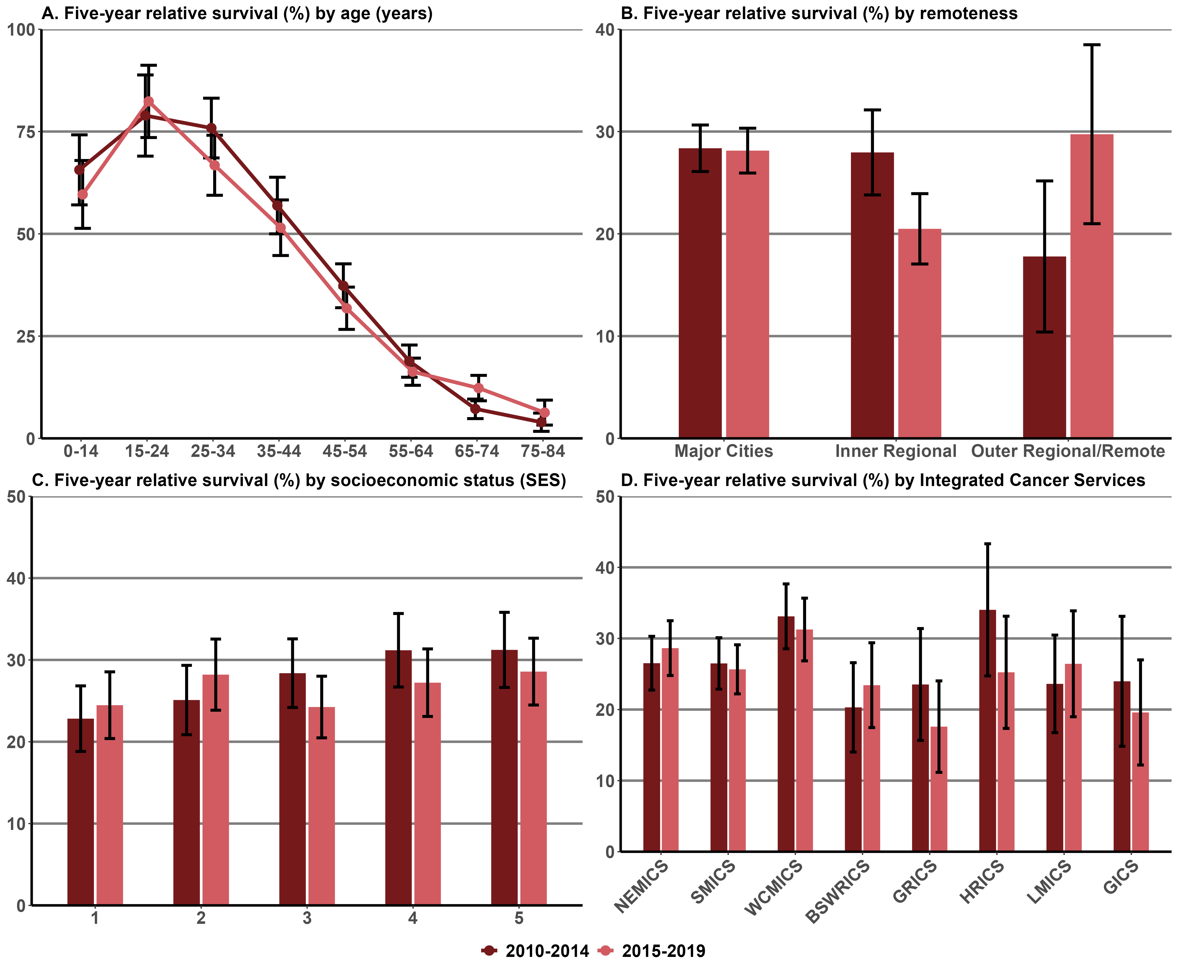
Notes:
Error bars indicate 95% confidence intervals.
Remoteness is classified according to the ASGC Remoteness Areas.
SES is classified according to the SEIFA Index of Relative Socio-economic Disadvantage – 1= lowest and 5 = highest.
Appendix 2 provides the dataset.

Measure assessment
Traffic light rating: Red (result is of concern)
Overall trend: Not moving in the right direction
Commentary: At the national level, in 2010–2014 people with brain cancer had a 21.9% chance of surviving for at least five years compared with the general population. Five-year survival was slightly higher for females (24%) than males (20%).
In Victoria people diagnosed with brain cancer had a higher chance (27.3%) than the Australian average of surviving for at least five years in 2010–2014. Five-year survival was higher for females (29.3%) than for males (25.7%).
Five-year survival was highest for those aged 15–24 (78.9%, 2010–2014; 82.4% 2015–2019) and dropped steeply with age thereafter (Figure 13.14 (A)).
Survival varied significantly by remoteness: five-year survival was higher and the same in major cities across both periods compared with the inner regional and outer regional/remote areas, which reported reversed survival between the two periods – that is, inner regional decreased, whereas outer regional/remote areas showed an increase in survival (Figure 13.14 (B)). This disparity was also reflected in survival broken down by ICS, with urban ICSs such as WCMICS having the highest recorded survival rate in 2010–2014 of 33.1%, decreasing to 31.3% in 2015–2019 compared with GRICS (predominantly rural), which had a rate of 23.5% in 2010–2014, which decreased to 17.6% in 2015–2019.
Five-year survival was generally higher for people in the highest socioeconomic quintile (SES 5) (31.2%, 2010–2014; 28.6%, 2015–2019) compared with those living in the lowest quintile (SES 1) (22.8%, 2010–2014; 24.5%, 2015–2019) (Figure 13.14 (C)).
Measure 13.15 – Five-year relative survival from oesophageal cancer (C15)
Figure 13.15: Five-year relative survival from oesophageal cancer, by age (A), remoteness (B), SES (C) and ICS (D), Victoria, 2010–2014 and 2015–2019
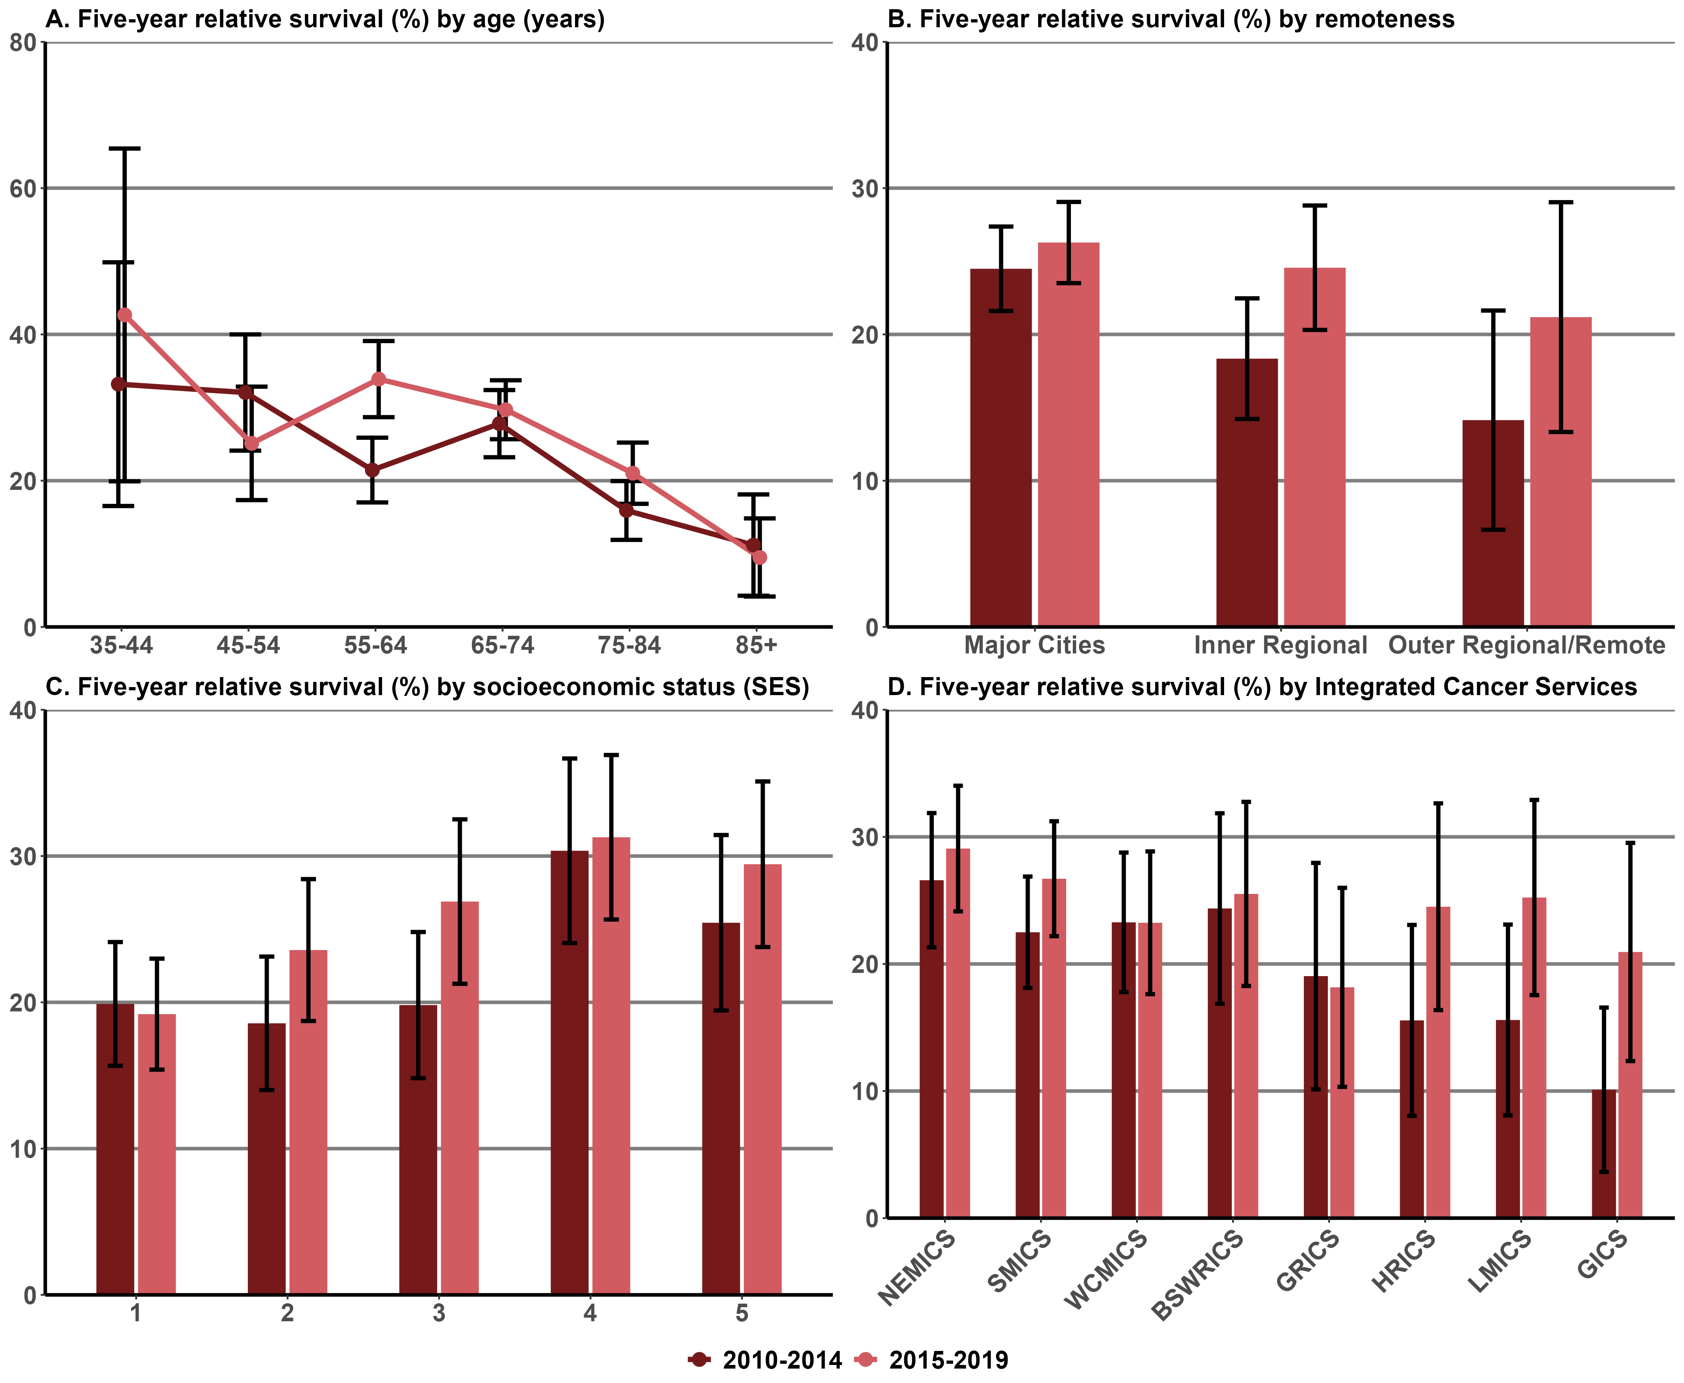
Notes:
Analysis for the age groups 0–14 years, 15–24 years and 25–34 years were excluded because of low numbers.
Error bars indicate 95% confidence intervals.
Remoteness is classified according to the ASGC Remoteness Areas.
SES is classified according to the SEIFA Index of Relative Socio-economic Disadvantage – 1= lowest and 5 = highest.
Appendix 2 provides the dataset.

Measure assessment
Traffic light rating: Green (satisfactory result)
Overall trend: Moving in the right direction
Commentary: Nationally, the five-year survival rate for oesophageal cancer in Australia in 2010–2014 was 23.5%. Victoria mirrored the national trend, with a five-year survival rate of 21.7% for the same period. However, the five-year survival rate for this cancer increased to 25.5% for the 2015–2019 period.
The increases in five-year survival occurred for both males and females, although females had a slightly larger increase in survival over the two periods (Tables 13.15a and c, Appendix 2). However, five-year survival showed contrasting trends for age groups 45–54 years and 55–64 years, with a marked decrease for those aged 85 years or older (Figure 13.15 (A)).
There was no consistent association between survival and SES. Overall five-year survival was the highest in the fourth highest quintile (SES 4) across both periods (30.4%, 2010–2014 and 31.3%, 2015–2019) (Figure 13.15(C).
Survival differed significantly by remoteness, with major cities having a higher five-year survival rate (24.5%; 2010–2014 and 26.3%, 2015–2019) than outer regional/remote areas (Figure 13.15 (B)).
This trend was also mirrored between ICSs where the five-year survival rate was highest in urban ICSs such as NEMICS compared with rural-centric ICSs, namely GRICS, which had significantly lower survival rates across the two periods (Figure 13.15 (D)). However, these results should be interpreted with caution because of the wide confidence intervals due to small sample sizes.

Measure 13.16 – Five-year relative survival from acute myeloid leukaemia
Figure 13.16: Five-year relative survival from acute myeloid leukaemia, by age (A), remoteness (B), SES (C) and ICS (D), Victoria, 2010–2014 and 2015–2019
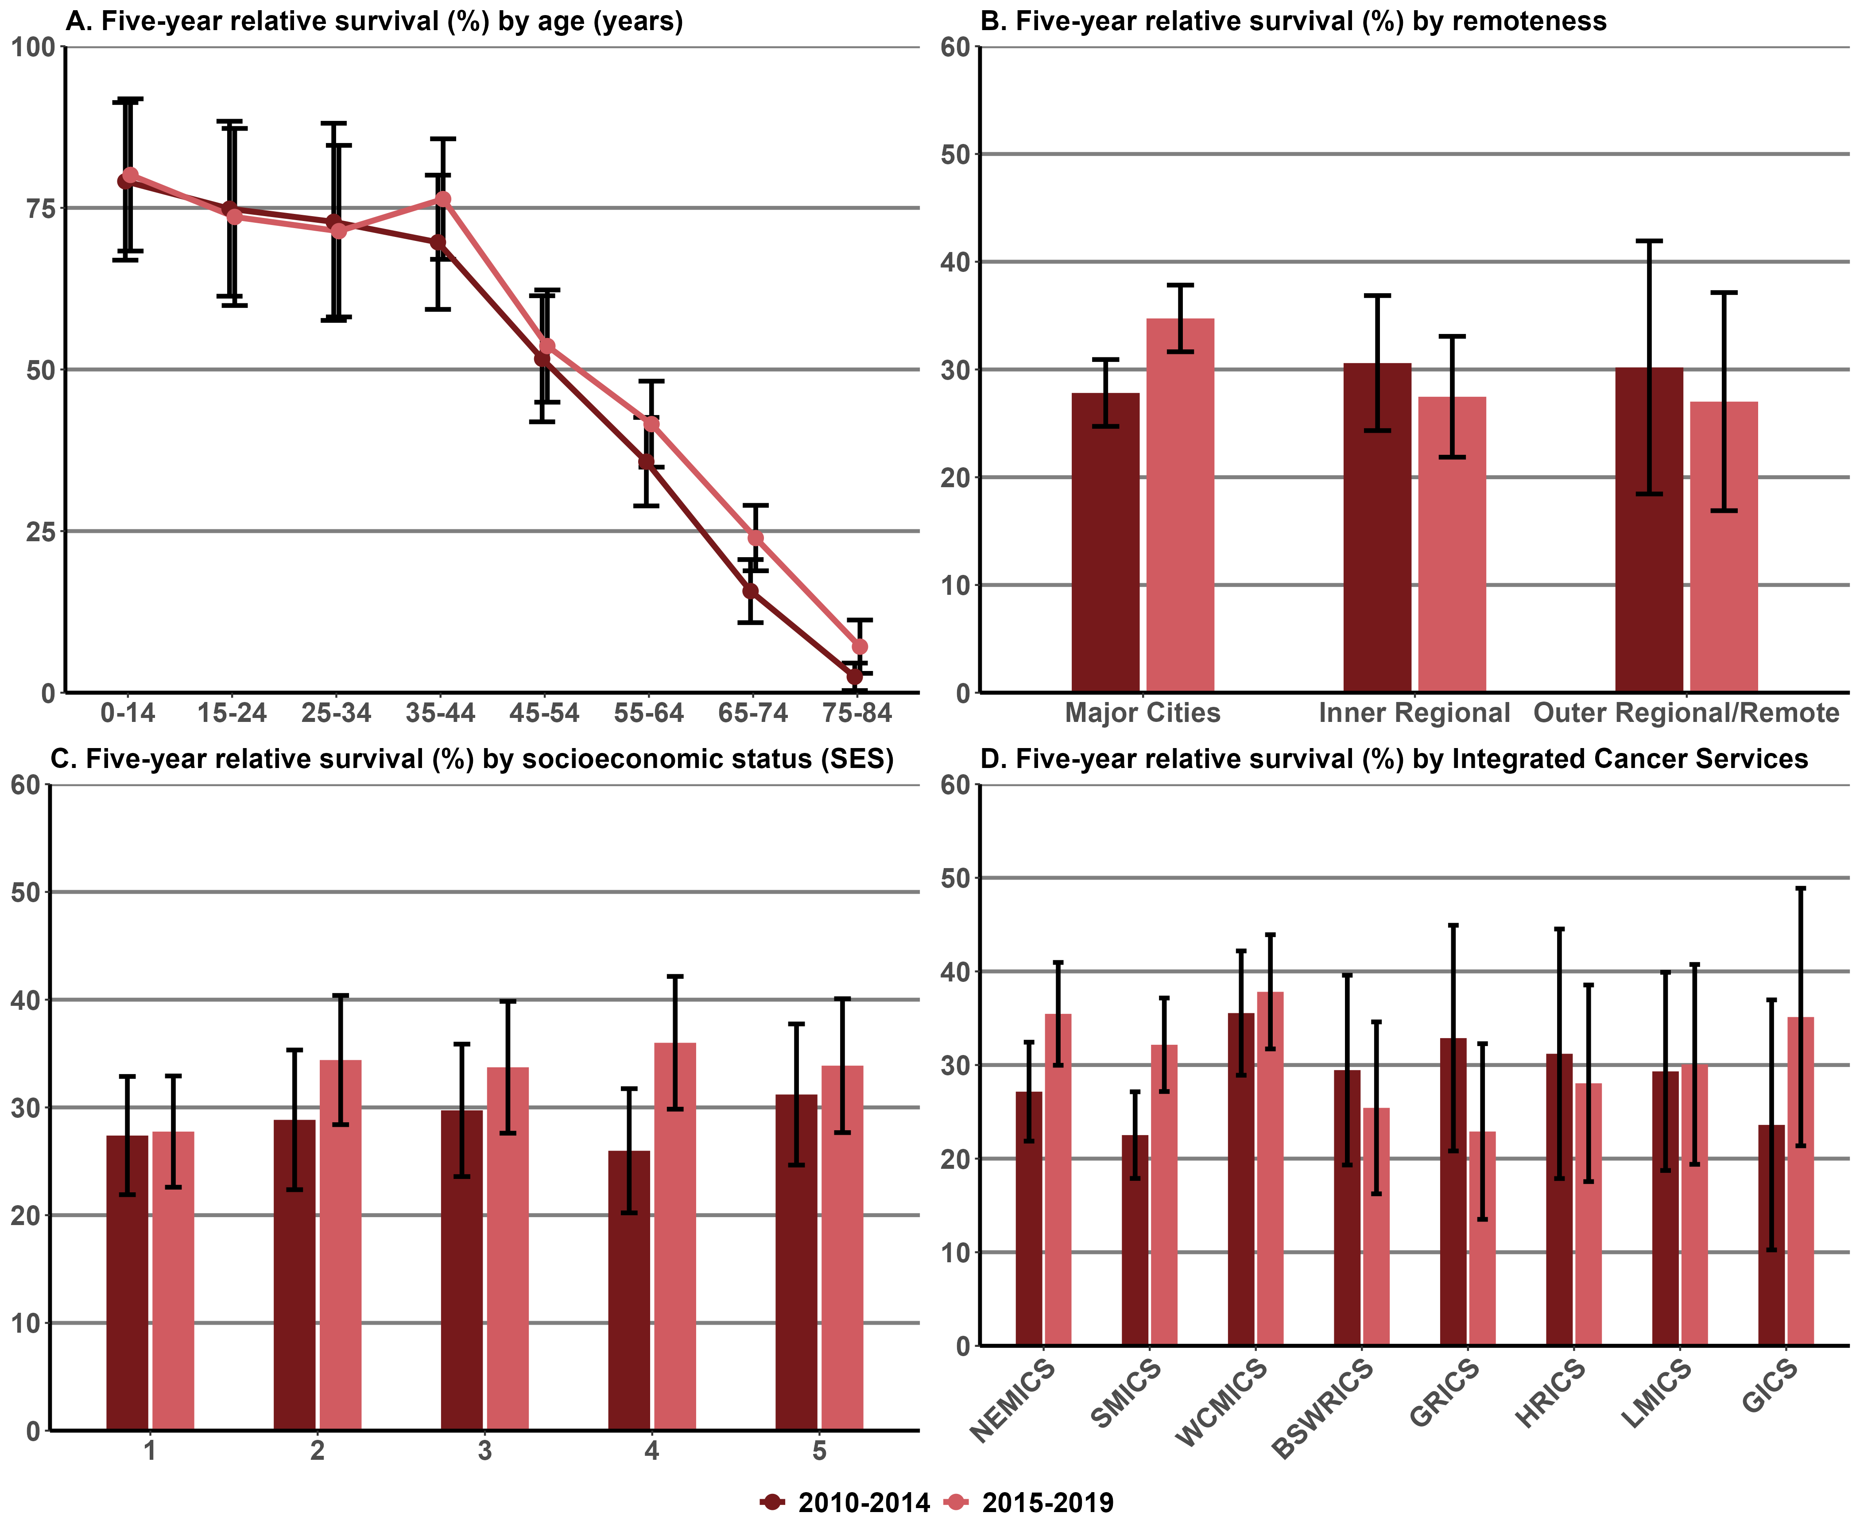
Notes:
Error bars indicate 95% confidence intervals.
Remoteness is classified according to the ASGC Remoteness Areas.
SES is classified according to the SEIFA Index of Relative Socio-economic Disadvantage – 1= lowest and 5 = highest.
Appendix 2 provides the dataset.

Measure assessment
Traffic light rating: Amber (desired result not yet evident)
Overall trend: Appears to be moving in the right direction
Commentary: In Victoria, at diagnosis, the probability of surviving from AML for at least five years was 28.1% in the period 2010–2014 but increased to 32.8% between 2015 and 2019. Survival rates between the two periods was higher for females compared with males. Figure 13.16A shows that older age at diagnosis was associated with lower survival, particularly from those aged 65 years or older (16.5%, 2010–2014; decreasing to 10.7% for the 2015–2019 period).
There were observed differences in survival by remoteness (Figure 13.16) between the two periods. Five-year survival was highest for people living in remote regional areas (2010–2014) compared with major cities and inner areas. However, Figure 13.16B shows an increase in five-year survival in major cities compared with inner and outer regional areas. Figure 13.6C shows that the five-year relative survival rate by SES were similar. Five-year survival increased more markedly for people in the second to fifth highest socioeconomic quintile between the two periods compared with socioeconomic quintile 1, which largely stayed the same (27.4%, 2010–2014 rising to 27.8%, 2015–2019).
The five-year survival rate varied across Victoria as it related to ICSs, with the urban ICSs showing an increase between the two periods compared with some of the regional ICSs, namely BSWRICS and GRICS, which showed a decrease in five-year survival between the two periods. Nevertheless, these results should be interpreted with caution because of the wide confidence intervals due to small sample sizes.

Measure 13.17 – Five-year relative survival from all cancers diagnosed at stages 1 and 2
Figure 13.17.1: Five-year relative survival from breast cancer diagnosed at stages 1 and 2, by age (A), remoteness (B), SES (C) and ICS (D), Victoria, 2010–2014 and 2015–2019
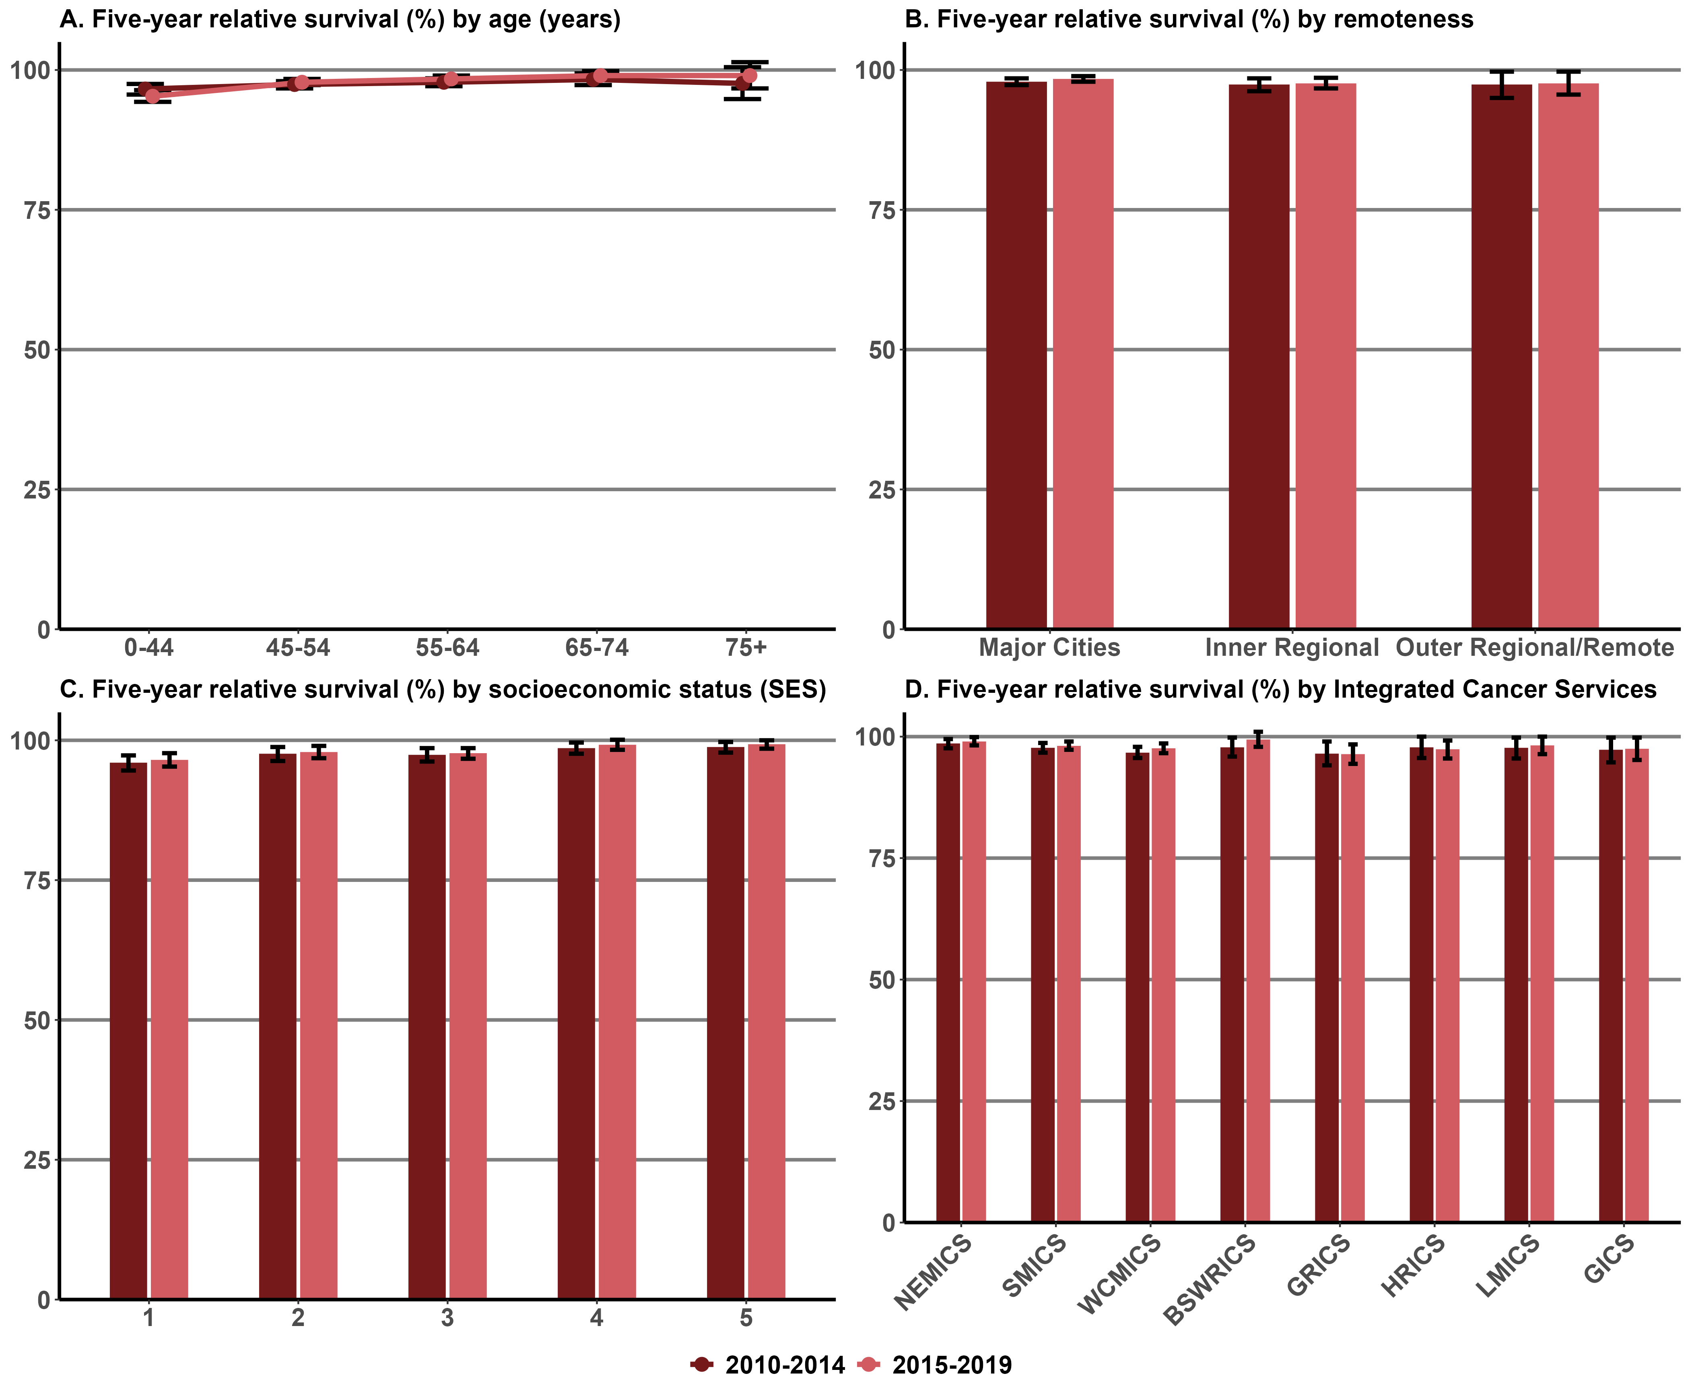

Figure 13.17.2: Five-year relative survival from colorectal cancer diagnosed at stages 1 and 2, by age (A), remoteness (B), SES (C) and ICS (D), Victoria, 2010–2014 and 2015–2019
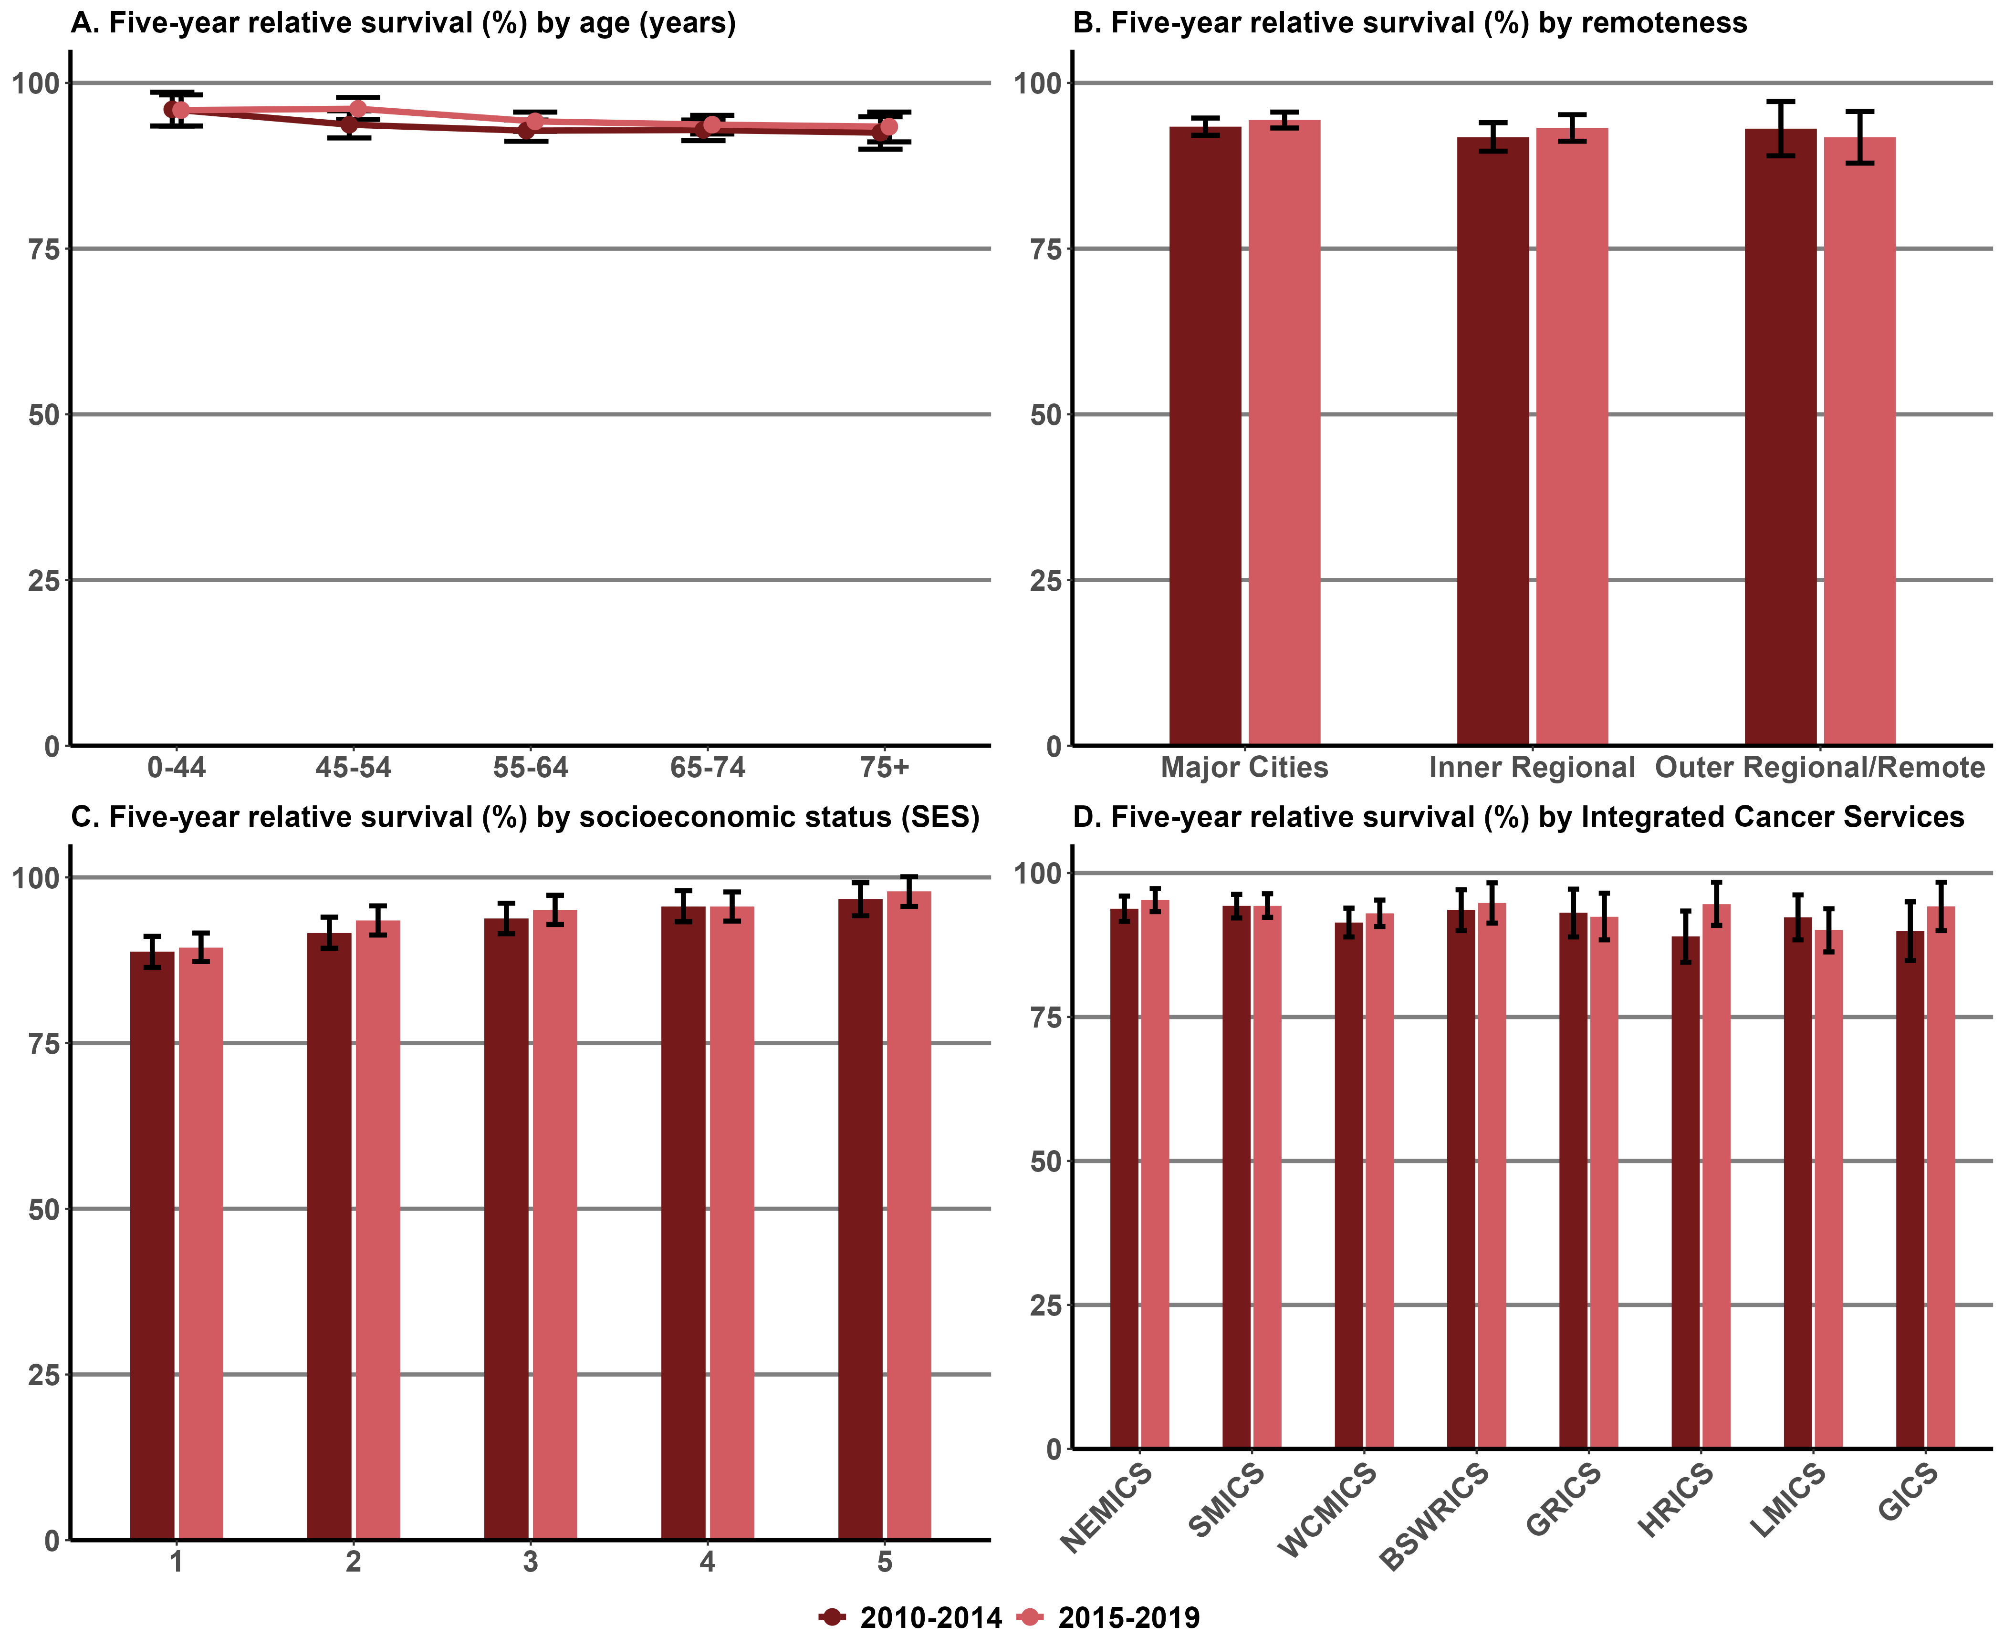

Figure 13.17.3: Five-year relative survival from prostate cancer diagnosed at stages 1 and 2, by age (A), remoteness (B), SES (C) and ICS (D), Victoria, 2010–2014 and 2015–2019
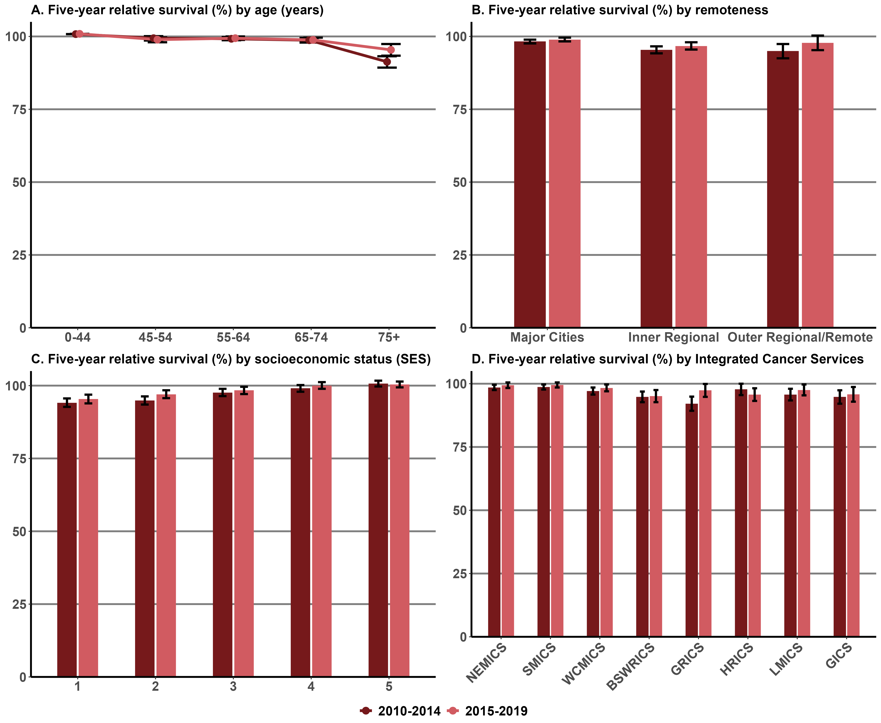
Notes for Figures 13.17.1, 13.17.2 and 13.17.3:
Data as it relates to registry-derived stage are currently only available for three cancer tumour streams, namely female breast, colorectal and prostate rather than ‘all’ cancers.
For melanoma and endometrial cancer, the staging at diagnosis for these two tumour streams were only available from 2018. To avoid biased results, these two cancers are not included in the analysis. It is expected that the registry-derived (RD) stage will be available for other cancers in the future so this measure, which specifies ‘all’ cancers at stages 1 and 2, can be reported on.
Error bars indicate 95% confidence intervals.
Remoteness is classified according to the ASGC Remoteness Areas.
SES is classified according to the SEIFA Index of Relative Socio-economic Disadvantage – 1= lowest and 5 = highest.
Appendix 2 provides the dataset.

Measure assessment
Traffic light rating: Amber (desired result for ‘all’ cancers not yet evident)
Overall trend: Appears to be moving in the right direction
Commentary: Knowing the distribution of stage at diagnosis is crucial to understanding variations in survival and can help inform where further research and targeted cancer control strategies can be applied to reduce the proportion of cancers diagnosed at an advanced stage. Stage at diagnosis is broadly categorised into four stages of increasing severity – stages 1, 2, 3 and 4.
In Victoria the distribution pattern of cancer diagnosed at stages 1 and 2 varied by cancer type. Specifically:
- For breast (female) cancer survival increased slightly between the two periods from 97.7% (2010–2014) to 98.2% (2015–2019). Figure 13.17.1 (A) shows that survival by age group was generally similar across age groups for early-stage cancers 1 and 2. Where differences by remote areas were observed, survival by stages 1 and 2 was slightly higher for people living in major cities compared with inner and outer regional areas or remote areas (Figure 13.17.1 (B)). Where differences by SES areas were observed, survival by stages 1 and 2 at diagnosis was higher for people living in the highest SES areas (SES 5) compared with lower SES areas (SES 1–3) (Figure 13.17.1 (C)). Observed survival by stages 1 and 2 at diagnosis by ICS showed a slight increase across all ICS between the two time periods 2010–2014 and 2015–2019 (Figure 13.17.1 (D)).
- For colorectal cancer survival increased slightly between the two periods from 92.9% (2010–2014) to 94.0% (2015–2019). Figure 13.17.2 (A) showed that early stage colorectal cancer (stage 1 and stage 2) generally decreased with age. Figure 13.17.2 (B) shows that survival by stages 1 and 2 was slightly higher for people living in major cities and decreased slightly between the two time periods for people living in outer regional areas. As with breast cancer survival (stages 1 and 2) differences by SES areas were observed, noting that survival by stages 1 and 2 at diagnosis was higher for people living in the highest SES areas (SES 5) compared with lower SES areas (SES 1–2) (Figure 13.17.2 (C)). An increase across all ICSs in survival by stages 1 and 2 for colorectal cancer was observed between the two time periods (Figure 13.17.2 (D)).
- As with breast and colorectal cancers, prostate cancer survival also increased slightly between the two periods from 97.3% (2010–2014) to 98.4% (2015–2019). Figure 13.17.3 (A) showed that early stage prostate cancer (stage 1 and stage 2) decreased markedly from 75 years onwards. Figure 13.17.3 (B) shows that survival by stages 1 and 2 was slightly higher for people living in major cities. However, survival increased between the two time periods for people living in major cities, inner regional and outer regional areas of Victoria. Differences by SES areas were observed; survival by stages 1 and 2 at diagnosis was higher for people living in the highest SES areas (SES 5) compared with lower SES areas (SES 1–2) (Figure 13.17.3 (C)). An increase across most ICSs in survival by stages 1 and 2 for prostate cancer was observed between the two time periods (Figure 13.17.3 (D)) with the exception of HRICS which observed a decrease.
In summary while no target has been set for this measure these results should be interpreted with caution because the data presented on cancer stages 1 and 2 at diagnosis under this measure is specific to three cancers – female breast, colorectal and prostate – rather than ‘all’ cancers.
Measure 13.18 – Five-year relative survival from all cancers diagnosed at stages 3 and 4
Figure 13.18.1: Five-year relative survival from breast cancer diagnosed at stages 3 and 4, by age (A), remoteness (B), SES (C) and ICS (D), Victoria, 2010–2014 and 2015–2019
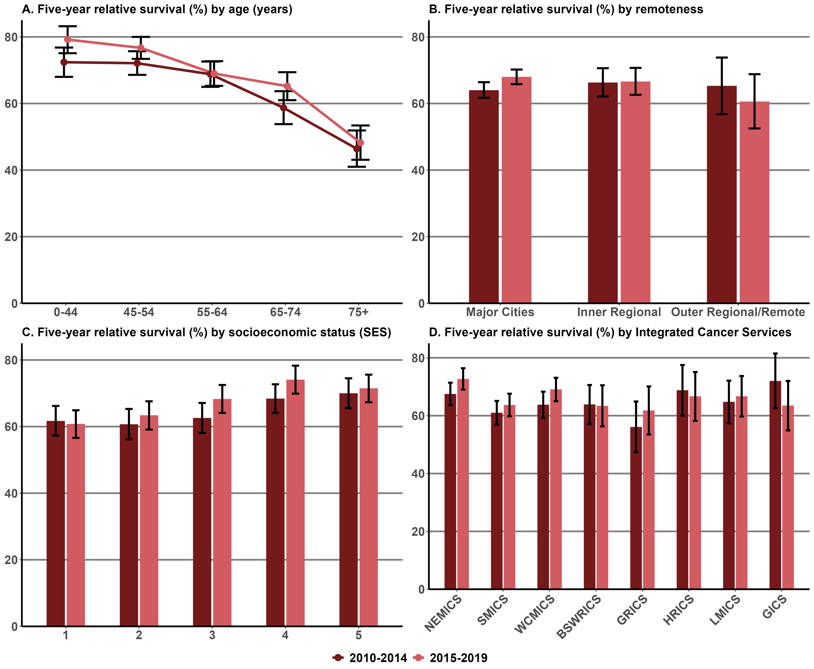

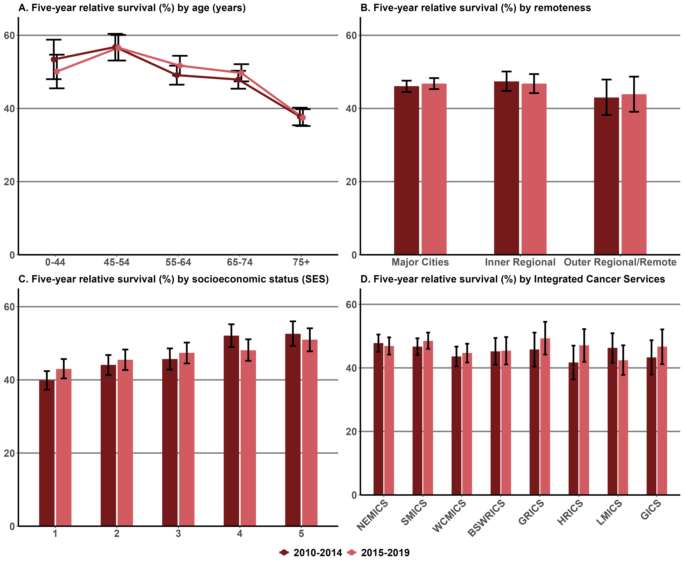
Figure 13.18.2: Five-year relative survival from colorectal cancer diagnosed at stages 3 and 4, by age (A), remoteness (B), SES (C) and ICS (D), Victoria, 2010–2014 and 2015–2019

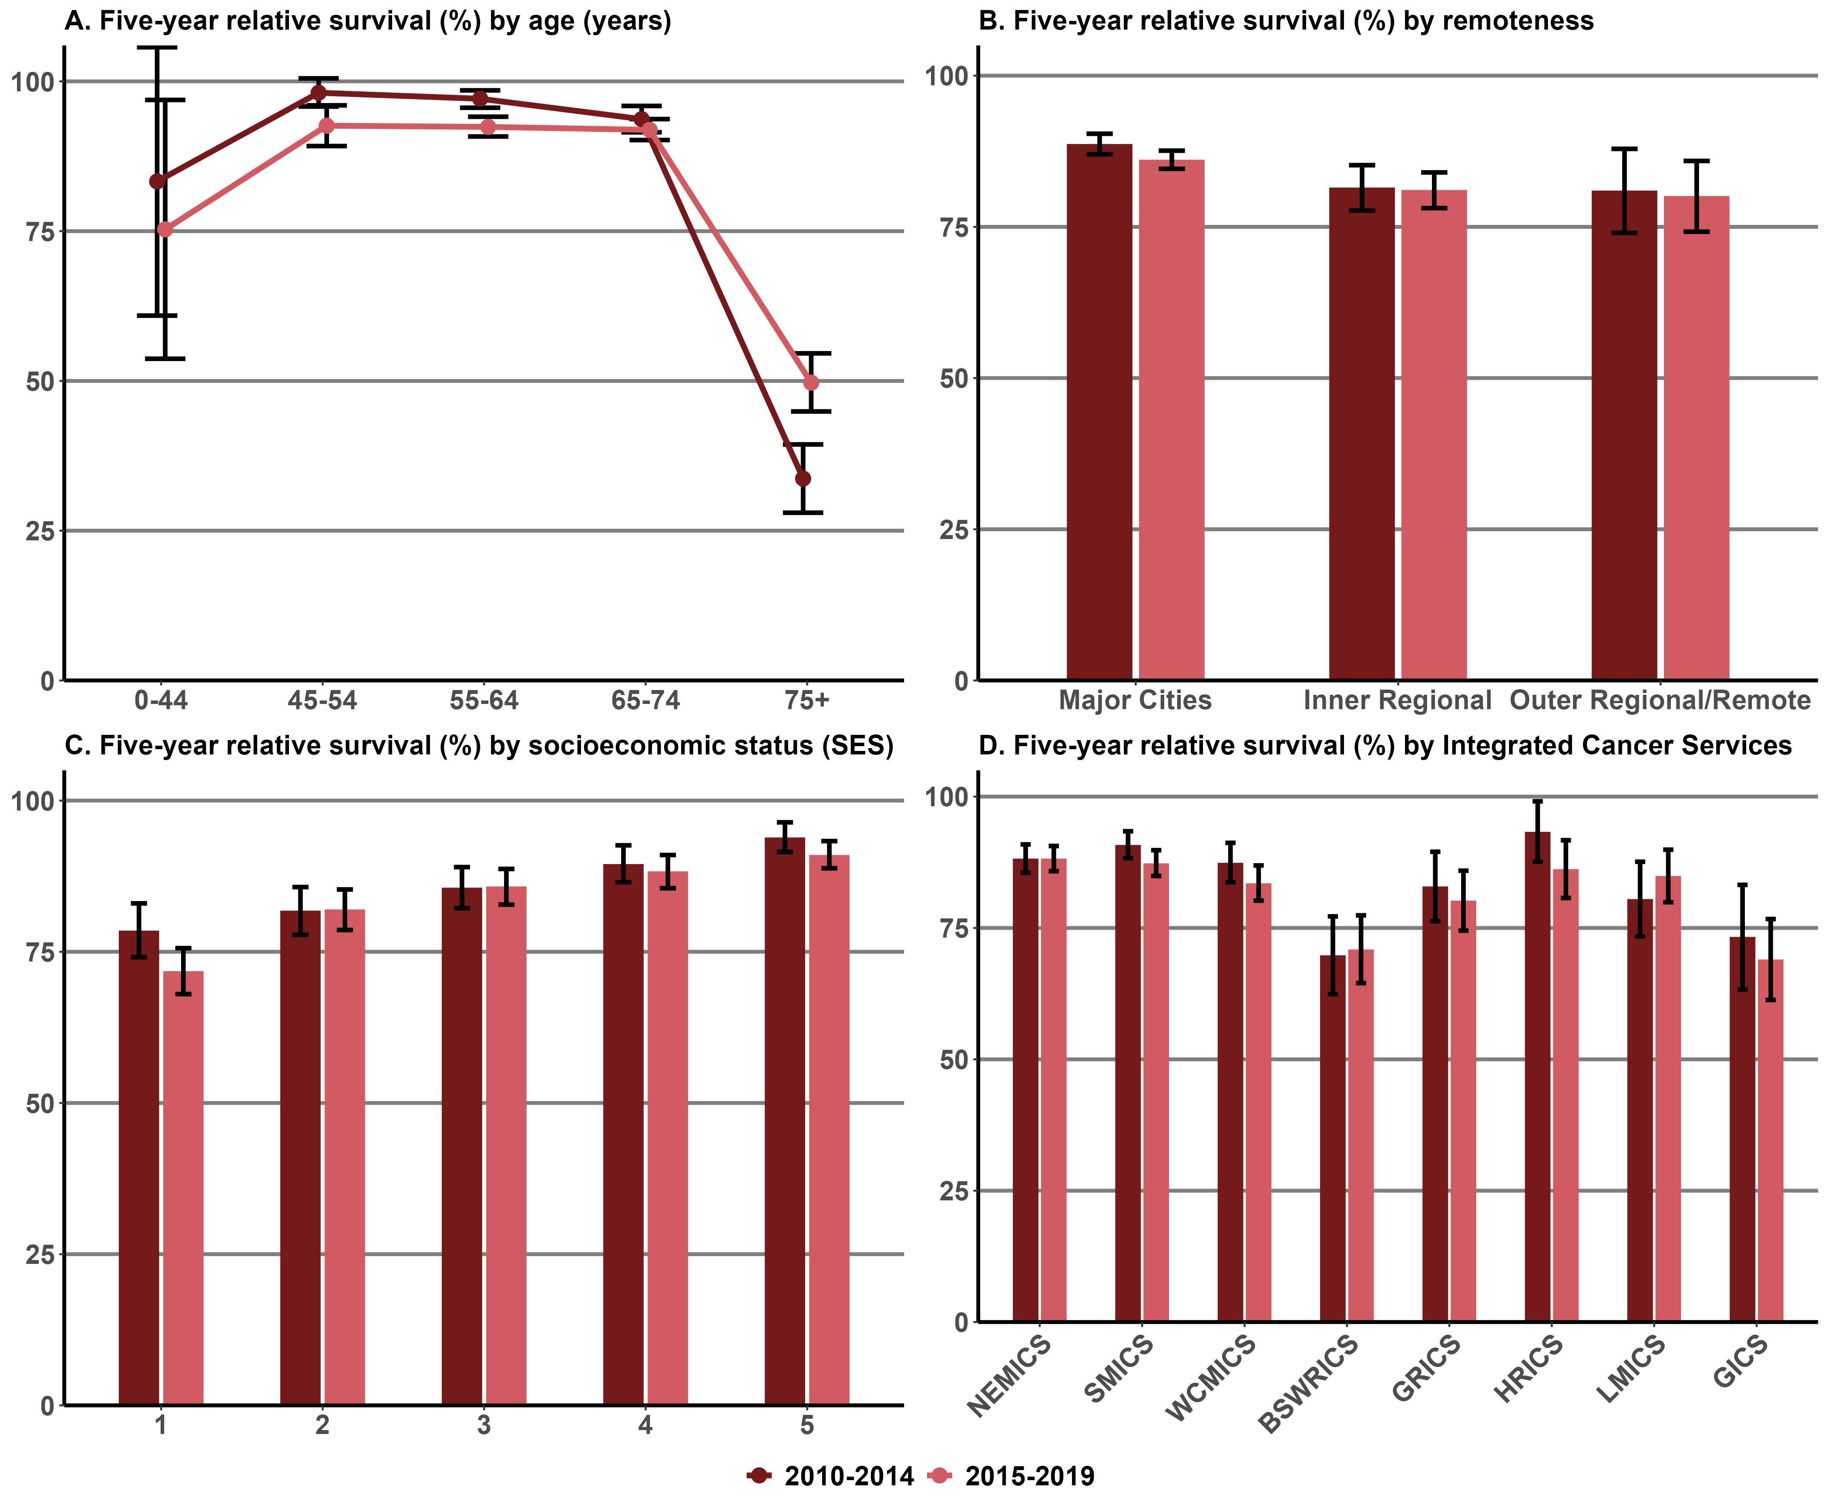
Figure 13.18.3: Five-year relative survival from prostate cancer diagnosed at stages 3 and 4, by age (A), remoteness (B), SES (C) and ICS (D), Victoria, 2010–2014 and 2015–2019

Notes for Figures 13.18.1, 13.18.2 and 13.18.3:
Data as it relates to registry-derived stage are currently only available for some cancer tumour streams, namely female breast, colorectal and prostate, rather than ‘all’ cancers.
The tumour streams included in the analysis are breast, colorectal and prostate.
For melanoma and endometrial cancer, the staging at diagnosis for these two tumour streams were only available from 2018. To avoid biased results, these two cancers are not included in the analysis. It is expected that the registry-derived (RD) stage will be available for other cancers in the future so this measure, which specifies ‘all’ cancers at stages 3 and 4, can be reported on.
Error bars indicate 95% confidence intervals.
Remoteness is classified according to the ASGC Remoteness Areas.
SES is classified according to the SEIFA Index of Relative Socio-economic Disadvantage – 1= lowest and 5 = highest.
Appendix 2 provides the dataset including where data was unknown.

Measure assessment
Traffic light rating: Amber (desired result for ‘all’ cancers not yet evident)
Overall trend: Appears to be moving in the right direction
Commentary: Knowing the distribution of stage at diagnosis is crucial to understanding variations in survival and can help inform where further research and targeted cancer control strategies can be applied to reduce the proportion of cancers diagnosed at an advanced stage. Stage at diagnosis is broadly categorised into four stages of increasing severity – stages 1, 2, 3 and 4.
In Victoria the distribution pattern of cancer diagnosed at stages 3 and 4 varied by cancer type. Specifically:
- For breast (female) cancer survival increased between the two periods from 64.3% (2010–2014) to 67.3% (2015–2019). Figure 13.18.1 (A) shows that survival by age group decreased from 45 years onwards for later-stage cancers 3 and 4. Where differences by remote areas were observed, survival by stages 3 and 4 decreased between the two time periods compared to major cities compared with inner regional areas, the latter showing no change between two time periods (Figure 13.18.1 (B)). Where differences by SES areas were observed, survival by stages 3 and 4 at diagnosis was higher for people living in the highest SES areas (SESs 4 and 5) compared with lower SES areas (SES 1–2) (Figure 13.18.1 (C)). Observed survival by stages 3 and 4 at diagnosis by ICS showed an increase across most ICS between the two time periods 2010–2014 and 2015–2019 with the exception of HRICS and GICS (Figure 13.18.1 (D)).
- For colorectal cancer survival increased slightly between the two periods from 45.7% (2010–2014) to 46.6% (2015–2019). Figure 13.18.2 (A) showed that later stage colorectal cancer (stage 3 and stage 4) decreased markedly from 75 years onwards. Figure 13.17.2 (B) shows that survival by stages 3 and 4 was slightly higher for people living in inner regional areas but decreased slightly between the two time periods in this area compared to people living in major cities or inner/outer regional areas. As with breast cancer survival (stages 3 and 4) differences by SES areas were observed, noting that survival by stages 3 and 4 at diagnosis was higher for people living in the highest SES areas (SES 5) compared with lower SES areas (SES 1) noting that there was a decrease between the two time periods for SESs 4 and 5 (Figure 13.18.2 (C)). An increase across most ICSs in survival by stages 3 and 4 for colorectal cancer was observed between the two time periods with the exception of NEMICS and LMICS which observed a decrease (Figure 13.18.2 (D)).
- Unlike breast and colorectal cancers, prostate cancer survival which showed a slight increase between the two periods, prostate cancer showed a slight decrease from 86.7% (2010–2014) to 84.6% (2015–2019). Figure 13.18.3 (A) showed that later stage prostate cancer (stage 3 and stage 4) decreased markedly from 75 years onwards. Figure 13.18.3 (B) shows that survival by stages 3 and 4 was slightly higher for people living in major cities. Differences by SES areas were observed; survival by stages 3 and 4 at diagnosis was higher for people living in the highest SES areas (SES 5) compared with lower SES areas (SES 1) (Figure 13.18.3 (C)). A decrease across most ICSs in survival by stages 3 and 4 for prostate cancer was observed between the two time periods (Figure 13.18.3 (D)) with the exception of BSWRICS and LMICS which observed an increase.

In summary while no target has been set for this measure these results should be interpreted with caution because the data presented on cancer stages 3 and 4 at diagnosis under this measure is specific to three cancers – female breast, colorectal and prostate – rather than ‘all’ cancers.

Key result: Improving quality of life

Measure 14.1 – Health-related quality of life following primary treatment
No data available. Refer to Appendix 1.

Outcome: Best possible experience of care systems

Key result: Improve patient experience of health care

Measure 15.1 – Proportion of adults admitted to public hospitals due to cancer who report a positive overall healthcare experience
Figure 15.1: Proportion of adults admitted to public hospitals due to cancer who reported being satisfied with the care received from all health professionals involved in their care in 2018, 2019 and 2022
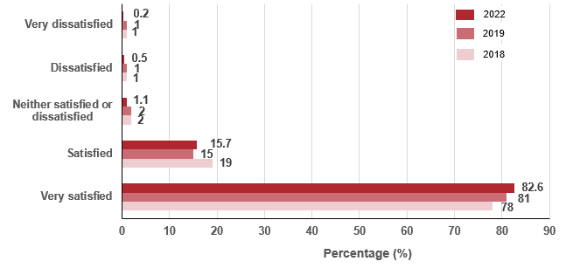
Notes:
Overall care question: How satisfied were you with the overall care you received from all health professionals involved in your treatment?
Total number of patients who answered the question = 3,673 (2018), 2,240 (2019), 3,227 (2022).
Experience of care occurs across the public and private health sector

Measure assessment
Traffic light rating: Green (satisfactory result)
Overall trend: Moving in the right direction
Commentary: Understanding a patient’s experience throughout each stage of their cancer journey can enable more personalised care and help improve the overall quality of the health system. The Victorian Cancer Patient Experiences of Care Survey asks adult inpatients how satisfied they were with the overall care they received from all health professionals involved in their treatment. This question highlights the importance of enabling people admitted to public hospitals due to cancer to give feedback about their experience, which in turn can lead to more personal care for others. This can help improve the safety and quality of care in health services and help to home in on aspects of concern to patients. Figure 15.1 shows that, in 2018, of the 3,673 patients who responded to the question, 97% were very satisfied or satisfied with the care they received from all health professionals involved in their care at each health service. In 2022, this increased to 98.3% of patients were very satisfied or satisfied with the care they received (Figure 15.1).

Measure 15.2 – Proportion of children and adolescents admitted to hospital due to cancer who report a positive healthcare experience
Figure 15.2: Proportion of children and adolescents admitted to hospital due to cancer who report a positive healthcare experience, 2021
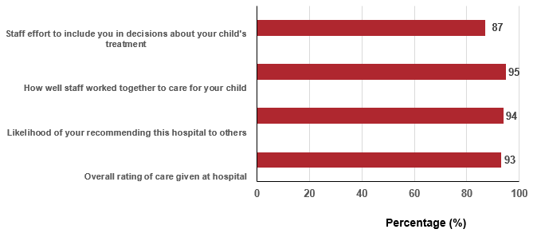

Measure assessment
Traffic light rating: Green (satisfactory result)
Overall trend: Unable to measure because this data relates to one year only and is not state-wide, but an otherwise satisfactory result
Commentary: Globally cancer is the leading cause of death for children and adolescents. The likelihood of surviving a diagnosis of childhood cancer depends on the country in which the child lives: in high-income countries such as Australia, the five-year survival rates is more likely to exceed 80% compared with many low- and middle-income countries where survival rates are less than 30%.
Although cancer in children and adolescents is rare, approximately 750 children aged 0 to 14 years are diagnosed with cancer each year in Australia. The most common types of cancers such as leukaemia that are diagnosed in children and adolescents are different from those seen in adults. Therefore, as with adults, treating most cancers will generally require admission to a hospital as part of the cancer journey for treatments such as chemotherapy. However, the cancer care pathways and care priorities for children and adolescents often differ from adults. Therefore, a more targeted approach is needed to understand their experiences of cancer care and treatment. This is important to ensure they and their carers receive more personalised care as well as helping to improve the overall quality of the health system.
In 2021 the Victorian Paediatric Integrated Cancer Service began a pilot survey appropriate for a younger patient population. This survey of families of paediatric patients who received treatment ran across three campuses that specialise in children’s cancer treatment: The Royal Children’s Hospital, Monash Children’s Hospital and Barwon Health, Geelong. Data was collected via email and SMS. Figure 15.2 shows that, in 2021, of the 211 patients who responded to the questions, the overall rating of care given at the hospital was 93%.

Measure 15.3 – Proportion of adults admitted to public hospitals due to cancer who report a positive transition-from-care index score
Resources to resolve this outstanding measure in the future are yet to be confirmed. The measure is yet to be determined – refer to Appendix 1.

Measure 15.4 – Proportion of adults attending emergency departments due to cancer who report a positive overall healthcare experience
Figure 15.4: Proportion of adults attending emergency departments due to cancer who report a positive healthcare experience, 2019 and 2022
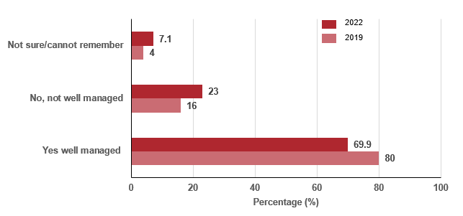

Notes:
Overall care question: Do you think that your condition was well managed while you were waiting to see an emergency department doctor?
Total number of patients who answered the question = 1,142 (2019) and 941 (2022)

Measure assessment
Traffic light rating: Red (result is of concern)
Overall trend: Not moving in the right direction
Commentary: Providing good-quality care that meets the needs of patients including cancer patients is a key objective of Victoria’s emergency departments (ED). The Department of Health has undertaken a series of initiatives to improve the ED patient experience including state-wide surveys of people’s healthcare experiences. The Victorian Healthcare Experience Survey allows a wide range of people to give feedback on their experiences and provides specialised questions for cancer patient ED attendees. This includes patients who have undergone surgery, are receiving radiotherapy or chemotherapy treatment, have attended the ED because of their cancer or cancer treatment, and/or are receiving follow-up care.
The Victorian Healthcare Experience Survey asks adult patients how well they think their condition was managed while they were waiting to see an ED doctor. Figure 15.4 shows that, in 2019, of the 1,142 patients who responded to the question, 83% of patients thought their condition was well managed while they were in the ED. However, this decreased to 69.9% in 2022.

Measure 15.5 – Proportion of people attending hospital outpatients due to cancer who report a positive healthcare experience
Resources to resolve this outstanding measure in the future are yet to be confirmed. The measure is yet to be determined – refer to Appendix 1.

Measure 15.6 – Proportion of people attending primary care due to cancer who report a positive healthcare experience
Resources to resolve this outstanding measure in the future are yet to be confirmed. The measure is yet to be determined – refer to Appendix 1.

Key result: Improve patient experience of screening

Measure 16.1 – Proportion of women who have a mammogram by BreastScreen Victoria who rate the service as highly satisfactory
Figure 16.1: Overall satisfaction with the breast screening process, 2014–2022
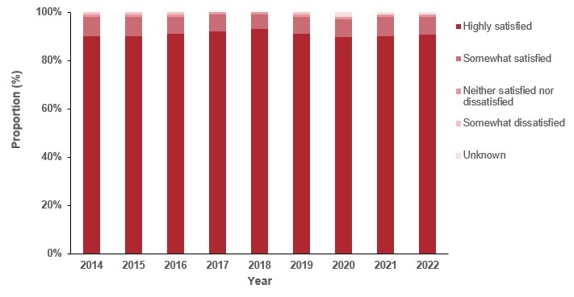

Notes:
Question 21: Overall, how satisfied were you with the entire breast screening process?
Total sample: 2014, n = 3,153; 2015, n = 3,976; 2016, n = 4,022; 2017, n = 6,447; 2018, n = 11,423; 2019, n =13,255; 2020, n = 44,551; 2021, n = 131,050; 2022, n = 115,468
Table 16.1: Proportion of women who have a mammogram by BreastScreen Victoria who rate the service from highly satisfactory to unsure, 2014–2022
Question 21 | 2014 | 2015 | 2016 | 2017 | 2018 | 2019 | 2020 | 2021 | 2022
Highly satisfied | 90% | 90% | 91% | 92% | 93% | 91% | 91% | 90% | 91%
Somewhat satisfied | 8% | 8% | 7% | 7% | 6% | 7% | 7% | 8% | 7%
Neither satisfied nor dissatisfied | 1% | 1% | 1% | 1% | 1% | 1% | 0 | 0 | 0
Somewhat dissatisfied | 1% | 1% | 1% | 0 | 0 | 1% | 0 | 0 | 0
Highly dissatisfied | 0 | 0 | 0 | 0 | 0 | 0 | 0 | 0 | 0
Unsure | 0 | 0 | 0 | 0 | 0 | 0 | 0 | 0 | 0
Unknown | 0 | 0 | 0 | 0 | 0 | 0 | 2% | 1% | 1%
Source: BreastScreen Victoria, 2023

Measure assessment
Traffic light rating: Green (satisfactory result)
Overall trend: Moving in the right direction
Commentary: BreastScreen Victoria is an accredited part of BreastScreen Australia, a national breast cancer screening program inviting women (including trans women, trans men and non-binary people who fit the eligibility criteria) aged 50–74 to have free breast screens every two years. The aim of this program is to reduce breast cancer deaths through early detection of the disease.
BreastScreen Victoria has a network of services around the state including 44 permanent screening clinics and eight assessment services that is continuing to expand to meet the needs of the growing eligible population. The Mobile Screening Service visits rural and regional locations throughout the state every two years. BreastScreen Victoria conducted client satisfaction survey each year between 2013 and 2019 and has run a real-time client satisfaction survey since 2020. This survey measures and monitors all aspects of service delivery received by women undergoing a breast screen including their intention to return for rescreening.
While no target has been set for this measure, overall satisfaction with the breast screening service continues to be very high. Since the baseline year of 2014, more than nine in 10 women are highly satisfied with their overall experience. Up until 2020 less than 2% of women reported being neutral or dissatisfied with their experience, reinforcing that nearly all are extremely satisfied overall, particularly given that the sample size has grown significantly over the past eight years (Figure 16.1 and Table 16.1).
Measure 16.2 – Proportion of women who are rescreened at BreastScreen Victoria within 27 months after the first screen
Figure 16.2: Age-adjusted proportion of women screened during 2014 and 2018 who rescreened within 27 months, first screening round, by state and territory, women aged 50–72 years
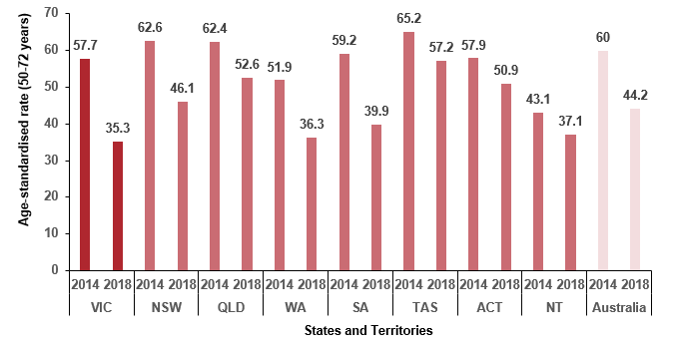
Sources: Australian Institute of Health and Welfare. BreastScreen Australia monitoring reports 2018 and 2022.
Notes:
The target age group used for rescreening (prior to 2014) was 50–67 rather than 50–69 because women aged 68–69 at that time of their screen would be outside the target age group of 50–69 when they would be due for their rescreen. The target age group for women screened from 2014 onwards has changed and is now 50–72.
‘Age-standardised rate’ is the number of women rescreened within 27 months as a percentage of women screened, age-standardised to the population of women attending a BreastScreen Australia service in 2008.
Table 16.2: Age-adjusted proportion of women screened during 2014 to 2018 who rescreened within 27 months, first screening round, by state and territory, women aged 50–72 years
 | VIC | NSW | QLD | WA | SA | TAS | ACT | NT | Australia
2014 | 57.7 | 62.6 | 62.4 | 51.9 | 59.2 | 65.2 | 57.9 | 43.1 | 60.0
2015 | 59.9 | 63.9 | 58.3 | 51.4 | 66.4 | 65.7 | 63.0 | 43.9 | 60.9
2016 | 60.0 | 62.8 | 60.0 | 49.5 | 61.3 | 70.7 | 57.2 | 47.1 | 60.6
2017 | 59.8 | 64.0 | 60.8 | 48.8 | 66.7 | 69.8 | 52.6 | 47.3 | 60.9
2018 | 35.3 | 46.1 | 52.6 | 36.3 | 39.9 | 57.2 | 50.9 | 37.1 | 44.2
Sources: Australian Institute of Health and Welfare. BreastScreen Australia monitoring reports 2018-2022.

Measure assessment
Traffic light rating: Red (result is of concern)
Overall trend: Not moving in the right direction
Commentary: Although the recommended screening interval is two years (24 months), 27 months is used to allow a reasonable timeframe for women to respond to invitations. The proportion of women who rescreened during 2014 (baseline year) and 2018 who rescreened within 27 months of their first screening around is shown in Figure 16.2. Figure 16.2 shows a significant decrease in the number of women in Victoria who rescreened within 27 months after the first screen from 57.7 in 2014 to 35.3 in 2018. Compared with other states such as Western Australia and the Northern Territory, the proportion of women who rescreened between 2014 to 2018 was higher but is still lower than the national rate (Table 16.2).
While there is no target for this measure, there is a clear relationship between women’s satisfaction of their breast screening experience and their intention to return. Women who are dissatisfied are less likely to intend to return for another breast screen in future. A high rescreen rate is important to both increase the likelihood of breast cancers being detected early and to maintain overall participation.
Measure 16.3 – Proportion of women who are rescreened for cervical cancer within three months of receiving a 27-month cervical screening register reminder letter
Table 16.3: Proportion of women sent a reminder letter to rescreen at 27 months after a negative Pap test and the number who re-screened, Victoria 2015–2017
Year | 2015 | 2016 | 2017
Percentage (%) of women who rescreened within 27 months following a negative test | 31.9 | 51.4 | 50.4
Source: Australian Centre for the Prevention of Cervical Cancer, Melbourne
Note: Data presented for 2017 is partially complete (only up to 30 November 2017) to account for a change in policy (new testing frequency).

Measure assessment
Traffic light rating: Amber (desired result not yet evident)
Overall trend: Moving in the right direction, but a new baseline measure will need to be established to account for policy changes that took effect on 1 December 2017.
Commentary: Table 16.3 shows that a cervical screening register letter reminding women to rescreen sent at 27 months after a previous negative Pap test prompts many women to rescreen. The proportion of woman who rescreened after receiving a reminder letter following a negative test increased from 31.7% in 2015 to 50.4% in 2017 (note: incomplete data).
It is important to note that this is the last report using the current measure. A new baseline will be established to reflect changes under the renewed national cervical screening program. From 1 December 2017, changes were made to program policy, the test type, the screening frequency/interval and the target age range.
As noted in the Cancer plan monitoring and evaluation framework baseline report (2020), this measure (and baseline year) has been amended to reflect the renewed National Cervical Screening Program (beginning 1 December 2017).

Measure 16.4 – Proportion of adults who are rescreened by the National Bowel Cancer Screening Program
Figure 16.4: Proportion of adults aged 50–74 who are rescreened (in subsequent rounds) by the National Bowel Cancer Screening Program, Victoria and Australia, 2014–2015 to 2020–2021
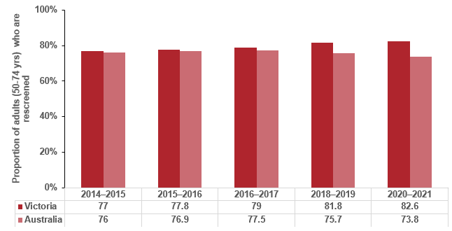
Source: AIHW National Bowel Cancer Screening Program monitoring reports
Note: Figure 16.4 includes all first-round invitations.
Participation data for 2014–2015 is based on the National Bowel Cancer Screening Program Register as at 31 December 2016, 30 June 2017, 30 June 2018 and 30 June 2021. From 2020 all Australians (including Victorians) aged between 50 and 74 years are now offered free screening every two years. The specific ages invited within the 50–74 age for the periods covered in this report are shown in Table 16.4.
Table 16.4: National Bowel Cancer Screening Program ages invited by year
Start date | End date | Ages invited
1 January 2015 | 31 December 2015 | 50, 55, 60, 65, 70 and 74
1 January 2016 | 31 December 2016 | 50, 55, 60, 64, 65, 70, 72 and 74
1 January 2017 | 31 December 2017 | 50, 54, 55, 58, 60, 64, 68, 70, 72 and 74
1 January 2018 | 31 December 2018 | 50, 54, 58, 60, 62, 64, 66, 68, 70, 72 and 74
1 January 2019 | ongoing | 50, 52, 54, 56, 58, 60, 62, 64, 66, 68, 70, 72 and 74

Measure assessment
Traffic light rating: Green (satisfactory result)
Overall trend: Moving in the right direction from baseline year
Commentary: While no target has been set for this measure, a high rescreen rate is important to increase the likelihood of CRCs being detected early and treated successfully. It also shows the acceptability of the faecal occult blood test and the National Bowel Cancer Screening Program more broadly by program participants. Figure 16.4 shows that since 2014–2015 the proportion of Victorian adults (50–74 years) who are rescreened via the National Bowel Cancer Screening Program is slowly increasing and is higher than the national rate. It is anticipated that this trend will continue to improve as the program expands.

Outcome: Integrated research systems

Key result: Innovations and improved evidence of best practice

Measure 17.1 – Number of new enrolments in cancer intervention clinical trials
Figure 17.1: Number of new enrolments in cancer intervention clinical trials in Victoria, by year, 2016–2021
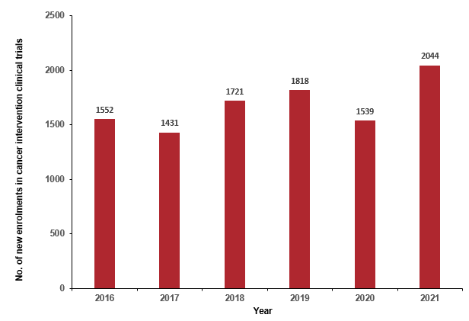

Source: Annual Cancer Trials Management Scheme data
Notes:
This analysis reports trials with a ‘treatment’ Common Scientific Outline, defined as a clinical trial according to World Health Organization criteria.
Interstate patients have been included in the number of new enrolments in cancer intervention clinical trials. Number of reporting sites = 37.
Figure 17.1.2: Proportion of new enrolments in cancer intervention clinical trials in Victoria stratified by tumour stream, by year, 2016–2021
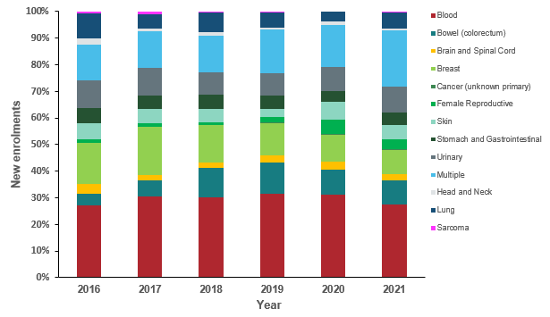
Note: Appendix 2 provides the dataset.

Measure assessment
Traffic light rating: Green (satisfactory result)
Overall trend: Moving in the right direction
Commentary: Clinical trials are an important part of translational cancer research and are essential for advancing cancer breakthroughs by testing the latest treatments, drugs and medical devices that can deliver better patient outcomes and save lives. Recruiting patients into cancer clinical trials is an important measurement to determine the proportion of patients being treated in clinical trials compared with those who are not. However, direct comparison of recruitment activity occurring in Victoria compared with the rest of Australia is currently not possible because very few other jurisdictions collect recruitment and trial activity data. For the jurisdictions that do collect these data, the definitions, systems and investments being used to measure clinical trial activity are different from Victoria.
Figure 17.1 shows that, overall, the number of new enrolments in cancer between 2014 and 2021 has fluctuated. The decline between 2019 and 2020 is most likely the result of clinical trials being impacted by the COVID-19 pandemic. This trend remains consistent, even when examined by metropolitan and rural populations (Table 17.1, Appendix 2). Despite this, the proportion of rural patients entering clinical trials, relative to metropolitan patients, has gradually increased over time, reaching 21.1% in 2021.
Overall, the number of patients enrolled in clinical trials at sites within metropolitan ICS was higher than the number of patients enrolled in rural and regional ICS (Table 17.1, Appendix 2). WCMICS reported the highest number of new enrolments, recording 4,161 between 2016 and 2021. LMICS had the lowest number of new enrolments (134) over the six-year period. On the other hand, GRICS reported no clinical trial activity during the analysis period.
Blood cancer trials consistently recruited the highest number of new enrolments in each reporting period, with 2,988. This was followed by multiple (1,607) and breast cancers (1,297). People with unknown primary cancers or uncommon cancers such as sarcoma were the least likely to enrol in a clinical trial for each reporting period. For example, in 2021, only 0.5% of patients enrolled in a clinical trial specific to sarcoma (Figure 17.1.2).
No target has been set for this measure, but research has shown that public education on the true value of clinical research and the reality of taking part in a clinical trial is needed. Involving trained patient advocates at each step of the clinical research process, even in preclinical phases, could offer significant benefit in helping to design informative trials, as well as in recruiting patients to participate.

Measure 17.2 – Number of recruiting cancer intervention clinical trials
Figure 17.2: Number of recruiting cancer intervention clinical trials in Victoria, by year,
2016–2021
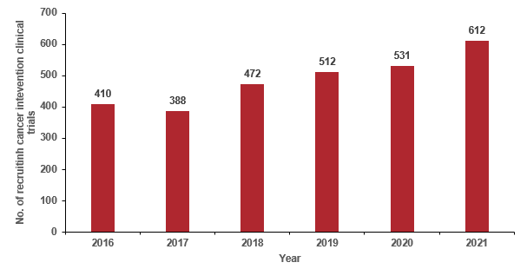
Source: Annual Cancer Trials Management Scheme data
Note: This analysis reports trials with a ‘treatment’ Common Scientific Outline, defined as a clinical trial according to World Health Organization criteria.
Figure 17.2.1: Proportion of recruiting cancer intervention clinical trials in Victoria, stratified by tumour stream, by year, 2016–2021
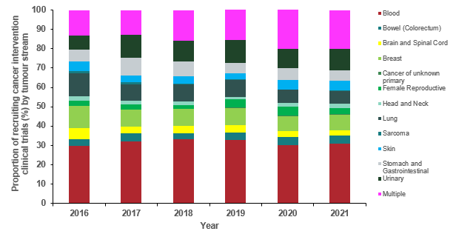
Note: This measure is limited to research specific to intervention clinical trials only. It does not include research relating to prevention, screening, supportive care or to basic science research not involving humans.
Appendix 2 provides the dataset

Measure assessment
Traffic light rating: Green (satisfactory result)
Overall trend: Moving in the right direction
Commentary: Clinical trials are studies that explore the impact of new or existing approaches to health care. Such trials are voluntary, are governed by strict rules and ethics, and are an important way to improve treatment for people with cancer. They are the only way to thoroughly evaluate the effects of a clinical intervention. Figure 17.2 shows that, overall, the number of recruiting cancer intervention trials between 2016 and 2021 showed an increase with time. This trend remained consistent when broken down by metropolitan and rural populations but, overall, the number of recruiting cancer intervention trials at sites with metropolitan ICS was much higher than the number of recruitments in rural and regional ICS (Table 17.2, Appendix 2). WCMICS recorded the highest number of new recruiting cancer intervention trials, reporting 1,049 trials between 2016 and 2021. LMICS had the lowest number of new recruiting cancer intervention trials (46) over the six-year period. On the other hand, as with Measure 17.1, GRICS also reported no clinical trial activity in the analysis period.
Like Measure 17.1, blood cancers had the highest proportion of recruiting cancer intervention trials in each reporting year (620 from 2016 to 2021) (Figure 17.2.1). This was followed by multiple cancers (333) and urinary (208) from 2016 to 2021. The tumour streams that attracted the fewest recruiting cancer intervention trials during the same period were cancer of unknown primary (3), sarcoma (11) and head and neck (21) cancers (Table 17.3, Appendix 2).
No target has been set for this measure; however, increasing the number of cancer intervention trials in Victoria will mean individual patients will continue to have more treatment choices in the future.

Measure 17.3 – Number of human research ethics committee approved cancer-related studies
Figure 17.3: Number of human research ethics committee approved cancer-related studies, by year, 2014–2022
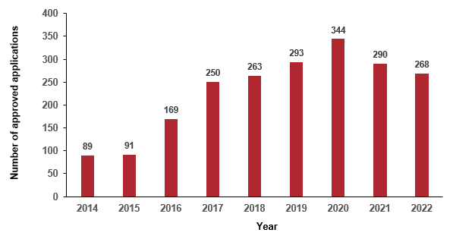

Source: Reform and Medical Research, Victorian Department of Health
Note: The data includes cancer-related clinical research (non-trials) and clinical trials.

Measure assessment
Traffic light rating: Green (satisfactory result)
Overall trend: Moving in the right direction
Commentary: High-quality cancer research drives clinical practice improvements and underpins the department’s efforts in prevention, detection, treatment and support for cancer. Victoria’s cancer research system is supported by world-renowned medical researchers, institutes, hospitals and universities, which have made great strides in improving cancer outcomes.
In 2015 the introduction of improved data capture and the start of a single ethics review of multi-centre health and medical research (non-trials) applications resulted in an increase in the number of studies now captured under this measure.
While no target has been set for this measure, Figure 17.3 shows that there has been an overall increase in cancer-related research since 2014, peaking in 2020, possibly in response to the COVID-19 pandemic, which fundamentally changed the cancer research experience in Victoria.

Measure 17.4 – Ratio of eligible patients who receive new SACT medications within 12 months of listing on the PBS relative to cancer incidence
Measure in development (refer to Appendix 1).

Measure 17.5 – Quit ratio^ of rate of sustained quitting to rate of people who had ever smoked
Figure 17.5: Quit ratio of people who have ever smoked, by year, 2015–2022
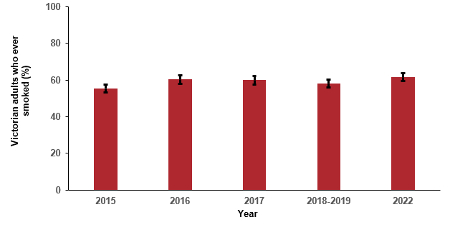

Table 17.5: Quit ratio of people who had ever smoked, by year, 2015–2022
Year | 2015 | 2016 | 2017 | 2018–19 | 2022
Per cent | 55.4 | 60.4 | 59.9 | 58.1 | 61.6
(95% CI) | (± 2.3) | (± 2.3) | (± 2.3) | (± 2.1) | (± 2.0)
Sources: Unpublished analysis of Victorian Smoking and Health Survey data and Cancer Council Victoria data from 2018–19 and 2022
Notes:
The calculation of the quit ratio excluded those who did not state how long ago they had quit.
Number of Victorians who had ever smoked = 1,693–1,798 (2015–2017). There were 3,589 people who had ever smoked who reported their smoking status and quitting history in 2018–19, and 5,010 in 2022 (weighted).
The samples from the Victorian Smoking and Health Surveys 2018 and 2019 were combined. This survey has transitioned to a four-yearly data collection cycle, meaning no information was collected during 2020 and 2021. As a result, the 2022 survey was collected with a much larger sample (n = 12,000) than in previous annual surveys (typically n = 4,000). The next survey will run in 2026.

Measure assessment
Traffic light rating: Green (satisfactory result)
Overall trend: Moving in the right direction
Commentary: The Victorian Smoking and Health Survey is a representative cross-sectional, telephone survey of English-speaking Victorian adults aged 18 years or older. The quit ratio is the proportion of people who had ever smoked (that is, people who currently smoke or previously smoked) who stated that they had not smoked for at least one year at the time of the survey.
Figure 17.5 and Table 17.5 show that the quit ratio among Victorians who had smoked increased between 2015 and 2022 (up from 55.4 to 61.6%). The result for 2022 means more than three in five adult Victorians who had ever smoked had quit for at least one year in 2022. The latest result shows the positive impact tobacco reforms are having in Victoria. At the time of writing, it is noted that e-cigarettes have gained in popularity in Australia (including Victoria) and worldwide over the past few years. A recent report showed almost double the number of Victorian adults reporting vaping in 2022 (estimated 308,827) compared with 2018–19 (estimated 154,895 users). This report also highlighted an alarming trend, namely that the proportion of Victorian adults who had never smoked who currently use e-cigarettes increased 4.5-fold from 0.6% in 2018–19 to 2.7% in 2022. This represents approximately 77,200 Victorian adults who never smoked who reported currently vaping, of which 44,534 (more than half; 57.7%) were 25 years of age or younger.
Some people argue that e-cigarettes can be used to help people stop smoking. From 1 October 2021 the Therapeutic Goods Administration (TGA) approved any e-cigarette products as a medicine to help people quit smoking. At the time of writing there were no nicotine vaping products approved by the TGA.

Progress towards achieving cancer plan 2020–2024 goals
The Victoria cancer plan 2020–2024 sets out several goals that are an extension from the Victorian cancer plan 2016–2020 including long-term goals to 2040. This report presents the most up-to-date information on trends in the state’s progress against the goals ranging from short-term (2024) to long-term (2040).

Short-term goals

Goal 1: At least 80% of hospital and health service retail outlets and vending machines meet recommended Victorian Government food and nutrition standards (2024)
The Victorian Government's Healthy Choices guidelines help make sure healthy foods and drinks are offered and promoted in places like sport and recreation centres, workplaces, universities and hospitals and health services. Healthy Choices uses a traffic light system to classify food and drinks as GREEN (best choices), AMBER (choose carefully) or RED (limit).
Health services have a key leadership role in providing healthier food and drink options to support the health and wellbeing of their staff and visitors. As such, in 2021, the Victorian Government introduced the ‘Healthy choices: policy directive for Victorian public health services’ (the Policy directive). It covers in-house retail food outlets, all vending machines, all staff/visitor catering and items purchased by staff and visitors from patient/resident menus.
To meet this policy directive drinks-only (phase 1) and drinks and food (phase 2) targets have been set. Phase 1 is specific to in-house retail outlets and all vending machines of health services and the target is to offer: (1) at least 50% GREEN drinks; and (2) no RED drinks in their retail/vending, the latter aligning with the Healthy Choices policy directive.
Health services reported on the drinks-only targets for their retail/vending machines from September to December 2022.
Health services, as well as other settings, have implemented Healthy Choices and, more recently, the policy directive, with the support of the Healthy Eating Advisory Service.
The timelines for health services meeting drinks-only targets for their retail/vending machines was September to December 2022. Health services meeting both food and drinks targets have until December 2023 to meet the target specific to this phase (phase 2).

Goal assessment
Traffic light rating: Green (satisfactory result)
Overall trend: Moving in the right direction
Commentary: As part of the department’s reporting requirements for the Healthy Choices policy directive, data has been gathered via a specifically designed monitoring system (the Progress Tracker).
As of December 2022, there were 74* services (91%, n = 81) that have met the drinks targets outlined above in their in-house retail outlets and vending machines.
As part of the policy directive, health services will be working on meeting the targets for food in 2023. Achieving phase 2 will help contribute to meeting this goal.
* Note: Services that do not have in-house retail outlets or vending machines are classified as having met the policy directive drinks target by default. (These services may provide healthy drinks/or restrict RED drinks via other means – by offering free drinking water or through staff catering, for example).

Goal 2: Encourage an additional 10,000 under-screened women to have a cervical screen through the self-collection pathway (2024)
Cervical cancer is recognised as one of the most preventable cancers – it can be treated if detected early. However, between 2018 and 2021 only about 62% of eligible Victorians took part in the National Cervical Screening Program. The rollout of self-collection screening for cervical cancer has provided women and people with a cervix a choice when it comes to managing their health. Importantly, research undertaken in Victoria has shown that self-collection is highly acceptable in a range of under-screened groups who otherwise choose not to screen.

Goal assessment
Traffic light rating: Green (satisfactory result)
Overall trend: This target has been met
Commentary: Until January 2018 when self-collection first became available for under-screened people, there was no self-collection. Therefore, the measure for this goal is the cumulative number of under-screened people who have had a self-collected sample since 1 January 2018.
There have been 15,859 self-collection tests taken in Victoria from 1 January 2018 to 31 December 2022. Of these tests, 7,959 have been in under-screened* women, 3,365 were in unscreened** women and 4,535 were in women who were on-time for screening.
There were 4,207 self-collection tests from 1 January 2018 to 31 December 2021. Of these tests, 2,822 were in under-screened women and 1,117 in unscreened women.
In the six months before expanding self-collection eligibility (1/1/2022–30/06/2022), there were 1,020 self-collection tests (747 in under-screened women, 231 in unscreened women and 42 in women on-time for screening).
In the six months following the expansion of self-collection eligibility (1/7/2022–31/12/2022), there were 10,632 self-collection tests (4,390 in under-screened women and 1,957 in unscreened women). As a result, Table G2 indicates that Victoria reached the target for 10,000 more self-collected tests among under-screened and never-screened people as soon as December 2022.
Table G2: Number of self-collection tests by screening history from 2018
 | Before self-collection policy change |  |  | After self-collection policy change
Screening history |  | 1/1/2018 – 31/12/2021 | 1/1/2022 – 30/06/2022 |  | 1/7/2022 – 31/12/2022 | Total self-collection tests
Under-screened* |  | 2,822 | 747 |  | 4,390 | 7,959
Unscreened** |  | 1,177 | 231 |  | 1,957 | 3,365
Total |  |  |  |  |  | 11,324
On-time |  | 208 | 42 |  | 4,285 | 4,535
Total self-collection tests |  | 4,207 | 1,020 |  | 10,632 | 15,859
Source: National Cancer Screening Register (NCSR) Mar Remote Data Entry (RDE) 2023
Notes:
Data presented in this table is restricted to women in the target age range of 25–74 years who had a Victorian address at the time of self-collection.
The dates 1/1/2018–30/6/2022 are before the self-collection policy change.
‘*Under-screened’ women are defined as those whose most recent test prior to self-collection was a pre-renewal test four or more years before the self-collection date, which corresponds to being at least two years overdue for screening. Women who had a renewal test prior to self-collection were classified as ‘on-time’ for screening, as no women in this category are two or more years overdue for screening due to the expanded five-year screening interval.
**’Unscreened’ women are defined as those who had no recorded tests prior to self-collection.

Goal 3: Increase access by 20% for symptom and urgent review clinics for chemotherapy patients to avoid emergency presentations for vulnerable patients (2024)

Goal assessment
Traffic light rating: Green (satisfactory result)
Overall trend: Moving in the right direction
Commentary: Symptom and Urgent Review Clinics (SURC) are an innovative approach that supports patients who are receiving systemic anti-cancer therapy (SACT) and experiencing treatment-related toxicities. The SURC model of care provides standardised patient education to patients referred for SACT in an outpatient setting. It offers a single point of contact for patients and carers to access support for toxicities experienced following chemotherapy through telephone or face-to-face contacts. In addition, patients were less likely to present to an ED and had a shorter stay in ED if attending ED within 28 days after the day oncology encounter. They were more likely to be readmitted to an inpatient unit after an ED presentation for further treatment or management of toxicity associated with SACT.
SURC clinics have been implemented across Victoria’s public and private hospitals in metropolitan and regional areas. An economic assessment of the SURC program in 2019 showed that the chance of presenting to an ED for SACT-related toxicity and other issues was significantly reduced from 8.5% to 7.2% (p = 0.01).
The Symptom and Urgent Review Clinic (SURC) model was first developed and piloted at Western Health in 2013. Subsequent to this the number of SURCs that have been established state-wide has increased to 20 in 2022. This means that this goal has been exceeded.

Goal 4: Increase by 50%, in people who have metastatic cancer, the proportion of people with an advance care directive (2024)
Table G4: Proportion of people with an advance care directive who have metastatic cancer, by Integrated Cancer Service of hospital (or hospital admission or treatment), by year, 2016–2022
Year | NEMICS | SMICS | WCMICS | BSWRICS | GRICS | HRICS | LMICS | GICS | Victoria
2016 | 186/3704  (5%) | 81/4045  (2%) | 177/4334 (4.1%) | 208/1266 (16.4%) | 35/790  (4.4%) | 27/757 (3.6%) | 60/962 (6.2%) | 33/842 (3.9%) | 807/16700 (4.8%)
2017 | 199/3555 (5.6%) | 160/4064 (3.9%) | 270/4516 (6%) | 247/1283 (19.3%) | 140/795 (17.6%) | 51/729  (7%) | 122/976 (12.5%) | 47/777 (6%) | 1236/16695 (7.4%)
2018 | 216/3804 (5.7%) | 187/4309 (4.3%) | 308/4601 (6.7%) | 259/1335 (19.4%) | 165/818 (20.2%) | 65/756 (8.6%) | 143/1012 (14.1%) | 38/828 (4.6%) | 1381/17463 (7.9%)
2019 | 272/3874  (7%) | 194/4523 (4.3%) | 403/4710 (8.6%) | 295/1374 (21.5%) | 239/802 (29.8%) | 50/739 (6.8%) | 133/993 (13.4%) | 37/838 (4.4%) | 1623/17853 (9.1%)
2020 | 262/3797 (6.9%) | 209/4473 (4.7%) | 371/4692 (7.9%) | 399/1405 (28.4%) | 295/855 (34.5%) | 55/832 (6.6%) | 139/1062 (13.1%) | 45/905 (5%) | 1775/18021 (9.8%)
2021 | 227/3812  (6%) | 257/4701 (5.5%) | 325/4885 (6.7%) | 426/1459 (29.2%) | 304/881 (34.5%) | 58/825  (7%) | 137/1048 (13.1%) | 47/864 (5.4%) | 1781/18475 (9.6%)
2022 | 177/3615 (4.9%) | 254/4425 (5.7%) | 563/4877 (11.5%) | 394/1480 (26.6%) | 279/880 (31.7%) | 63/769 (8.2%) | 142/1016 (14%) | 34/806 (4.2%) | 1906/17868 (10.7%)
Notes: Data was obtained via VAED for those who have a metastatic cancer diagnosis code in their hospital admission, and whether they also reported as having an advance care directive in that admission or following metastatic admissions. There are limitations with this method because only public hospitals record the advance care directive question and a person has to be admitted to hospital to be asked the question. Integrated Cancer Service was derived from the hospital admission of the metastatic cancer diagnosis.
The ‘advance care directive’ variable was recorded in the VAED from 2016 onwards.

Goal assessment
Traffic light rating: Green (satisfactory result)
Overall trend: Moving in the right direction
Commentary: Under the Medical Treatment Planning and Decisions Act 2016 Victorians can make advance care directives to give consent to or to refuse medical treatment in advance of losing capacity to make their own medical decisions. Advance care directives can include either a binding instructional directive, a values directive or both, and must be witnessed by a registered medical practitioner.
Table G4 shows that the proportion of patients with metastatic cancer (with an advanced cancer directive) increased from a baseline of 4.8% in 2016 to 10.7% in 2022. This means that Victoria is on track to meet this goal.

Goal 5: Increase the overall number of new clinical trial enrolments in rural and regional areas in Victoria by 30% (2024)
Figure G5: Number of new clinical trial enrolments in rural and regional/rural areas in Victoria, 2016–2021
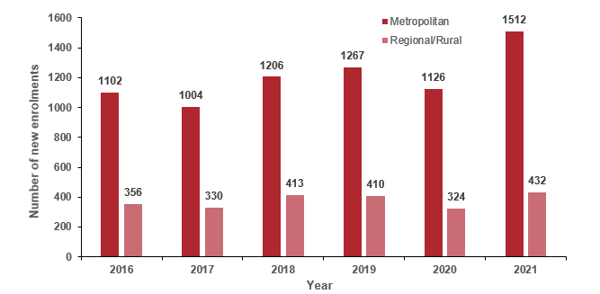

Goal assessment
Traffic light rating: Green (satisfactory result)
Overall trend: Moving at a pace to meet this goal by 2024
Commentary: People with cancer living in regional or rural Victoria experience several disadvantages compared with those living in Melbourne including geographical barriers to clinical trial access. A recent published study suggested that low trial participation rates may be a contributing factor to lower cancer five-year survival in regional Victoria compared with metropolitan Melbourne.
Figure G5 shows that the number of new enrolments in clinical trials is disproportionate with most clinical trials run in metropolitan health institutions. Nevertheless, Figure G5 shows that the number of new enrolments in rural areas increased between 2016 and 2021 by 21.5% and is on track to meet this goal by 2030. However, it is acknowledged that the pandemic had adversely affected the delivery of clinical trials in Victoria and likely progress against this goal as a consequence.
To achieve equal access to cancer care and clinical trials in regional Victoria, a new geographically based trials network has been established with the goal of increasing the number regional cancer patients recruited in clinical trials. Initially six regional services and Cancer Trials Australia collaborated to form Regional Trials Network Victoria (RTNV). Two more sites, Latrobe Regional Hospital and Mildura Public Hospital, were added to the RTNV trials network in 2021. This network represents a population of 1.9 million people and approximately 8,000 new cancer diagnoses each year.

Medium-term goals

Goal 6: Save 10,000 lives by 2025

Goal assessment
Traffic light rating: Green (satisfactory result)
Overall trend: This target has been met, with 10,529 lives saved between 2015 and 2021 (Measure 2.3).
Commentary: Data presented for Measure 2.3 shows that Victoria has met this medium-term goal. Increasing acceptability of screening improves outcomes (for example, better diagnoses) and saves lives. Early recognition of the disease has been achieved through targeted campaigns of screening and education for some types of cancer such as cervical, colorectal, skin and breast. For example, at the population level there is strong evidence to support the use of mass media public health campaigns to significantly increase bowel screening kit returns in Victoria. This is a key outcome, particularly once people have been screened for the first time, because they are nearly three times more likely to screen again compared with a first-time invitee. However, the question remains: How can we know whether screening saves lives? Funded research such as clinical trials are also helping to detect cancers earlier and diagnosing them more accurately, so people receive the right treatment at the earliest opportunity. This is boosting the likelihood of treatment success and better outcomes. Such trials are worth the expense compared with the continued cost of supporting widespread screening campaigns without knowing whether they truly benefit society.

Goal 7: 90% reduction in the number of new infections of hepatitis B and C (2030)
Figure G7: Number of newly acquired infections of hepatitis B and C in Victoria, by year, 2014–2022
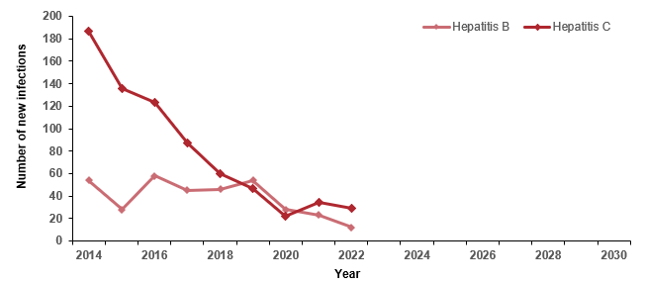

Source: Infectious diseases surveillance, Victoria; https://app.powerbi.com/view?r=eyJrIjoiMjQ0OWI3ZTAtNjMwOS00ODk4LTlmMjAtZDc5MjZiMzA2YWNiIiwidCI6ImMwZTA2MDFmLTBmYWMtNDQ5Yy05Yzg4LWExMDRjNGViOWYyOCJ9

Goal assessment
Traffic light rating: Green (satisfactory result)
Overall trend: Moving in the right direction
Commentary: Globally, viral hepatitis is responsible for more than 80% of liver cancers. Most primary liver cancers are from untreated chronic HBV or HCV infection. In Victoria all diagnoses of both HBV and HCV infection must be notified by medical practitioners and pathology services to the department in accordance with the Public Health and Wellbeing Regulations 2019. Identifying and characterising cases of newly acquired HBV and HCV infection enables public health officials to determine who is at risk and to assess and improve prevention efforts. Notifications are classified as newly acquired where there is laboratory or clinical evidence that infection has been acquired in the preceding two years or otherwise as unspecified (refer to Measures 10.2 and 10.3). The number of newly acquired cases categorised as unspecified overwhelmingly represent chronic cases of HBV and HCV.
Figure G7 shows that the number of newly acquired cases of HBV and HCV decreased between 2014 and 2022 by nearly 86% for HCV and 78% for HBV. Victoria is on target to meet the goal of a 90% reduction in the number of newly acquired infections by 2030.

Goal 8: Eliminate cervical cancer as a public health problem in Victoria (2030)
Australia could potentially become the first country globally to eliminate cervical cancer by 2030 if vaccination for HPV and cervical screening coverage are maintained at their current rates. The incidence of cervical cancer is predicted to decrease with:
- the introduction of the national HPV vaccination program in 2007
- the increased effectiveness of screening
- replacing the quadrivalent vaccine with the nonavalent vaccine in 2018 and from the beginning of 2023 change the routine dose from 2 to a single dose.

Goal assessment
Traffic light rating: Green (satisfactory result)
Overall trend: Moving in the right direction
Commentary: In 2020 the World Health Organization (WHO) published a global strategy to accelerate the elimination of cervical cancer as a public health problem. The definition of elimination of cervical cancer been initiated as a country reaching the threshold of less than 4 cases of cervical cancer incidence per 100 000 population per year.
Victoria’s relatively low incidence of approximately six new cases per 100,000 women of all ages between 2014 (6.4 per 100,000 population) and 2021 (6 per 100,000 population) (Measure 1.7) means the State is well positioned to meet the incidence threshold set down by WHO. Other WHO targets to be met by 2030 for countries such Australia to be on the path towards cervical cancer elimination include 90% of females fully vaccinated with HPV vaccine by age 15 years. Measure 10.1 shows that Victoria has HPV vaccination coverage for all males and females turning 15 years of age that was above the national average in 2021 (82.5% for females 15 years). Therefore Victoria is on the path to meet the vaccination WHO target in the elimination of cervical cancer. Of note is while the introduction of primary prevention in the form of HPV vaccination that complements the existing cervical screening program, cervical screening remains a key secondary prevention strategy for those who are HPV-vaccinated and those who are unvaccinated. This means there needs to be continued investment in education campaigns, particularly targeting at-risk communities, if Victoria is to eliminate cervical cancer as a public health problem by 2030. From 1 July 2022 the National Cervical Cancer Screening Program allowed all eligible women and people with a cervix aged 25–74 years to self-collect their cervical screening test. As a result, it is anticipated that screening participation rates, especially among Aboriginal Victorians, will improve and ultimately reduce the burden of cervical cancer among Aboriginal Victorians.

Goal 9: Increase the number of women who rescreen for breast cancer to more than 75% (2030)

Goal assessment
Traffic light rating: Red (result is of concern)
Overall trend: Not moving in the right direction to meet this goal by 2030
Commentary: Breast screening is the most effective measure in reducing breast cancer deaths and the impact of treatment among women in the 50–74 age group. Since the BreastScreen Australia program began in 1991, it has led to better health outcomes and a reduction of breast cancer in Victoria and across Australia. In 2015–16 the proportion of women who attended their second within 27 months of their first screening episode was 62.3%, which decreased to 37.9% in 2019–20.
This decrease is due to the impact of the COVID-19 pandemic, which resulted in BreastScreen Victoria pausing screening services and operating for an extended period with reduced screening due to COVID-19 safety measures. The number of women who rescreen within 27 months is predicted to increase following a recent announcement of $20 million in the 2022–23 State Budget. This will help BreastScreen Victoria to deliver breast screening services to an extra 36,000 people every year by 2026–27. Five new permanent breast screening services will be set up over the next three years in several LGAs across Victoria and three temporary sites will be converted into permanent sites with greater capacity. Services in Parkville (Melbourne) and Monash will be expanded.

Goal 10: 90% of cancer patients receiving specialist palliative care within 12 months prior to death (2030)

Goal assessment
Traffic light rating: Amber (desired result not yet evident)
Overall trend: Static or unchanging
Between 2015–16 and 2019–20, palliative care–related hospitalisations (all hospitals) in Victoria have increased slightly less than hospitalisations for all reasons, with a 0.7% increase (from 8,455 to 8,693) compared with a 1.5% increase (from 2.7 to 2.9 million), respectively. This was contrary to the national population rate between the same periods, which showed that palliative care–related hospitalisations (all hospitals) increased by 4.1%. This was more than hospitalisations for all reasons (1.4%). Nevertheless, Victoria’s population is continuing to grow and age, with predicted increases in the number of people who will be diagnosed with chronic illnesses such as cancer. Cancer is projected to increase the need and demand for palliative care (including specialist palliative care) across the state.
In Victoria, 25 public acute hospitals (15 in major cities and 10 in inner regional/outer regional areas) reported having a specialist palliative care inpatient unit (there were none reported for remote areas). Findings from Measure 12.12 (Proportion of patients receiving specialist palliative care within 12 months prior to death) showed very little variation during the reporting period (69% in 2014 and 68% in 2019). However, as reported under Measure 12.12, the results should be interpreted with caution, noting that palliative care provided by private hospitals in a community setting is not captured in the linked dataset used to inform reporting against Measure 12.12 because VINAH is specific to public institutions only.
In Victoria healthcare, human services and community workforce need to adapt with new skills to better support the development and strengthen the palliative care workforce (including specialist palliative care for example Aboriginal palliative care workforce) across the state to meet this goal.
Recent investments of $32.4 million in the 2022-23 State Budget will help to enable access to palliative care across Victoria in a range of community settings, including at home, as well as provide support through the Palliative Care Advice Service. Long-term goals

Goal 11: Halve the proportion of Victorians diagnosed with preventable cancers (2040)

Goal assessment
Amber (desired result not yet evident)
Overall trend: Moving in the right direction in some circumstances however there are several measures where health inequalities between population groups still exist
Commentary: Research has shown that up to 37,000 cancers could be prevented in Australia each year if the population avoided exposure to 13 common factors known or strongly suspected to cause cancer. Leading factors were tobacco smoke (population attributable fraction all cancers: 13.4%), solar radiation (6.2%), inadequate diet (6.1%) and overweight/obesity (3.4%).
Measure 1.1 of this report shows that the incidence rate of preventable cancers in Victoria has decreased from a baseline rate of 339 per 100,000 population in 2014 to 321 per 100,000 population in 2021. Despite this measure indicating that Victoria is moving in the right direction, other measures (Measure 6.1) that report on risk factors such as tobacco use (a leading preventable cause of cancer and cancer deaths) showed that the proportion of Victorian adults who smoke daily remained relatively the same between 2015 and 2020. Sustained and ongoing cancer prevention efforts that target risk factors including smoking, diet, alcohol and sun exposure remain essential to embed and reinforce health-promoting behaviours and to increase participation in cancer screening programs for early detection of cancer as advocated by the National Preventive Health Strategy 2021–2030.

Goal 12: Achieve equitable outcomes for all Victorians (2040)

Goal assessment
Traffic light rating: Amber (desired result not yet evident)
Overall trend: Moving in the right direction in some circumstances however there are several measures where health inequalities still exist
Commentary: The Department of Health plays a key role in reducing the impact of cancer on all Victorians. Despite Victoria having some of the best cancer survival outcomes globally, this progress report has identified some measures where there are still differences in cancer treatment, care and survival, meaning that the burden of cancer is unevenly spread. This report has identified several measures where health inequalities still exist for groups such as people experiencing socioeconomic disadvantage, culturally and linguistically diverse communities, people living in regional and rural communities, and Aboriginal and Torres Strait Islander people.
To address the disparity associated with Aboriginal communities/peoples, the Victorian Aboriginal Community Controlled Health Organisation (VACCHO), in partnership with community members with lived cancer experience and their families, the Aboriginal workforce and cancer organisations (Cancer Council Victoria, the Victorian Comprehensive Cancer Centre, health services and Regional Cancer Centres) has published a strategy designed to reduce cancer incidence and improve cancer survival among Aboriginal Victorians. The Victorian Aboriginal Cancer Journey Strategy (2023-2028) aims to advance self-determination by leading the development and delivery of high-quality care in a culturally appropriate way to Aboriginal Victorians. The goal of this strategy is to:
- complement the existing national Optimal Care Pathways for Aboriginal and Torres Strait Islander people with cancer, previous community consultations and work undertaken by VACCHO;
- embed Aboriginal ways and culture into the Cancer Journey in Victoria; and
close cancer equality of opportunity, access and outcome gaps across the state by imbedding culturally safe cancer support services to Aboriginal people in Victoria.

Goal 13: Ensure Victorians have the best possible experience of the cancer treatment and care system (2040)

Goal assessment
Traffic light rating: Green (satisfactory result)
Overall trend: Moving in the right direction
Commentary: The department continues to monitor changes to overall patient experience as well as across different types of cancers such as breast cancer via regular state-wide surveys. The Victorian Cancer Patient Experiences of Care Survey monitors state-wide progress on cancer care and helps focus on aspects of concern to patients to improve models of care such the Optimal Care Pathways. This integrated model of care pathways aims to improve patient outcomes by facilitating consistent cancer care based on a standardised pathway of care, irrespective of where people live or receive cancer treatment. The Victorian Tumour Summits program, an initiative of the ICSs delivered in collaboration with the department and Cancer Council Victoria, continues to support the broader program of work implementing the optimal care pathways.

Goal 14: Increase one- and five-year survival of Victorians with cancer (2040)

Goal assessment
Traffic light rating: Amber (desired result not yet evident)
Overall trend: Moving in the right direction but impacts of the COVID-19 pandemic on one- and five-year survival uncertain
Commentary: In Victoria more people are surviving cancer than ever before. This progress report shows that all cancer survival (one- and five-year survival, Measures 13.1 and 13.9) continues to improve across the state with uncertain impacts of the pandemic on one- and five-year survival likely to become clearer from data over the next few years. Nevertheless, the latest one- and five-year cancer survival is 85.3% (2021) and 70.3% (2015–2019), an increase from 83.6% (2014) and 68.1% (2010–2014). However, both one- and five-year survival rates vary significantly across cancer types and are also impacted by age, where people live and whether they identify as Aboriginal or Torres Strait Islander. Low survival cancers diagnosed include a wide range of common and less common cancers with challenges relating to prevention, early detection and treatment options. Cancers with five-year survival less than 30% still include those of the pancreas, lung, brain, oesophagus and acute myeloid leukaemia (Measures 13.10, 13.11, 13.14, 13.15 and 13.16).
Since 2011 the Victorian Cancer Survivorship Program has provided grant funding across acute, primary and community settings to pilot new and innovative models of cancer survivorship care across Victoria. More recently the department has supported a stepped-care approach to treat fear of cancer recurrence in cancer survivors (Fear-Less) originally targeting stage 4 melanoma survivors and more recently adapted for early-stage disease.

Appendix 1: Measures identified for future reporting
This table lists measures identified for future reporting with next steps and an indicative reporting schedule.
Key result area: Increase healthier eating and active living
Measure reference number | Name of measure | Required next steps | Indicative reporting schedule
7.7 | Mean number of times that adults eat red meat | The Intergenerational Health and Mental Health Study 2020–2024 funded by the Commonwealth Department of Health and conducted by the Australian Bureau of Statistics includes the National Nutrition and Physical Activity Survey). Red and processed meat consumption will be part of this survey. The department has recommended that it waits for this survey, which will inform the fourth state cancer plan.  For more information, refer to the ABS website <https://www.abs.gov.au/about/key-priorities/ihmhs>. | Future report
7.8 | Mean number of times that adults eat processed meat | Same as above for Measure 7.7 | Future report
Key result area: Increase early-stage diagnosis
Measure reference number | Name of measure | Required next steps | Indicative reporting schedule
11.1 | Proportion of all cancers diagnosed at stages 1 or 2 | Abrevio has been implemented. However, at the time of writing the VCR has not expanded its process for extracting staging. Unlikely to obtain a dataset to report against this measure (aspirational). | Obtaining staging data is a high priority for the VCR via several initiatives including obtaining MDM data and working with hospital health information managers to improve the reporting of staging data to the VCR.
11.4 | Proportion of cervical cancers diagnosed at stages 1 or 2 | Same as above for Measure 11.1. | Future report
11.5 | Proportion of lung cancers diagnosed at stages 1 or 2 | Same as above for Measure 11.1. | Future report
Key result area: Increase adherence to optimal care pathways
Measure reference number | Name of measure | Required next steps | Indicative reporting schedule
12.2 | Proportion of patients receiving PET prior to primary treatment where appropriate | There are currently no MBS data available for the cancer cohort, but it is expected this will be available in the future. | Future report
12.3 | Proportion of patients receiving molecular diagnostics prior to primary treatment where appropriate | The VCR has started work on biomarkers with external researchers – that is, validate with the golden standard (what the clinician extracts from the pathology reports). However, at the time of writing there was no suitable data available. | Future report
12.7 | Proportion of patients aged less than 40 years referred to fertility preservation treatment as part of their primary treatment | Currently no data source available. | Future report
12.11 | Proportion of patients with local recurrence or primary tumour within two years of surgical resection or curative radiotherapy of a primary tumour | Although date of recurrence is currently unavailable, it could probably be derived from the currently available linked data (VCR, VAED, VINAH). This requires an extensive validation process before it can be used to report against this measure. | Future report
Key result area: Improve quality of life
Measure reference number | Name of measure | Required next steps | Indicative reporting schedule
14.1 | Health-related quality of life following primary treatment | There is a population-wide dataset available based on supportive care screening (National Comprehensive Cancer Network distress monitor). This was undertaken in 2017. It is unclear what the local data may look like, which would necessitate the development of a state-wide specific patient-reported outcome measure (PROM). | To be determined
Key result area: Improve patient experience of health care
Measure reference number | Name of measure | Required next steps | Indicative reporting schedule
15.3 | Proportion of adults admitted to public hospitals due to cancer who report positive transition from care index score | Exploring whether the index score could be calculated using three questions. Reporting on this measure will depend on data linkage. | Future report
15.5 | Proportion of people attending hospital outpatients due to cancer who report a positive healthcare experience | The resources needed to resolve this measure in the future are yet to be confirmed. | To be determined
15.6 | Proportion of people attending primary care due to cancer who report a positive healthcare experience | Same as above for Measure 15.5. | To be determined

Key result area: Innovations and improved evidence of best practice
Measure reference number | Name of measure | Required next steps | Indicative reporting schedule
17.4 | Proportion of eligible patients who receive medication within 12 months of listing on the Pharmaceutical Benefits Scheme (PBS) | Substantial work is required to identify data criteria (the most appropriate medication) and obtain PBS data. | Future report

Abbreviations
ABS | Australian Bureau of Statistics
AIHW | Australian Institute of Health and Welfare
AML | acute myeloid leukemia
ASGC | Australian Standard Geographical Classification
BMI | body mass index
BSWRICS | Barwon South Western Integrated Cancer Service
CRC | colorectal cancer
CVDL | Centre for Victorian Data Linkage, Department of Health
ED | emergency department
ERP | Estimated Resident Population
GICS | Grampians Integrated Cancer Service
GRICS | Gippsland Regional Integrated Cancer Service
HBV | hepatitis B
HCV | hepatitis C
HPV | human papillomavirus
HRICS | Hume Regional Integrated Cancer Service
IARC | International Agency for Cancer Research
ICD | International Classification of Diseases
ICS | Integrated Cancer Service
LGA | local government area
LMICS | Loddon Mallee Integrated Cancer Service
LOS | length of stay
MDT | multidisciplinary team
NEMICS | North Eastern Melbourne Integrated Cancer Service
OECD | Organization for Economic Co-operation and Development
PHESS | Public Health Event Surveillance System
PBS | Pharmaceutical Benefits Scheme
PICS | Paediatric Integrated Cancer Service
RD stage | registry-derived stage
SACT | systemic anti-cancer therapy
SEIFA | Socio-Economic Indexes for Areas
SES | Socioeconomic status (quintiles); it is an area-based measure not an individual measure
SMICS | Southern Melbourne Integrated Cancer Service
UV | ultraviolet
VACCHO | Victorian Aboriginal Community Controlled Health Organisation
VAED | Victorian Admitted Episodes Dataset
VAHI | Victorian Agency for Health Information
VCR | Victorian Cancer Registry
VEMD | Victorian Emergency Minimum Dataset
VHES | Victorian Healthcare Experience Survey
VINAH | Victorian Integrated Non-Admitted Health dataset
WCMICS | Western and Central Melbourne Integrated Cancer Service

List of figures
Figure 1: Outcomes framework logic model 10
Figure 2: Simplified example of how relative survival is calculated 31
Figure 1.1: Incidence of preventable cancers in Victoria per 100,000 standardised to the 2001 Australian population, by year of diagnosis, 2014, 2017 and 2021 32
Figure 1.1.1: Incidence of preventable cancers in Victoria per 100,000 standardised to the 2001 Australian population, by ICS and year, 2014, 2017 and 2021 33
Figure 1.1.2: Incidence of preventable cancers in Victoria per 100,000 standardised to the 2001 Australian population, by Victorian LGA, 2014, 2017 and 2021 34
Figure 1.2: Lifetime risk of cancer before the age of 85 years by year, 2014, 2017 and 2021 35
Figure 1.2.1: Lifetime risk of developing cancer before the age of 85 years, by ICS and year, 2010–2021 36
Figure 1.3: Incidence of lung cancer in Victoria per 100,000 standardised to the 2001 Australian population, by year of diagnosis, 2014, 2017 and 2021 37
Figure 1.3.1: Incidence of lung cancer in Victoria per 100,000 standardised to the 2001 Australian population, by ICS and year, 2014, 2017 and 2021 38
Figure 1.3.2: Incidence of lung cancer in Victoria per 100,000 standardised to the 2001 Australian population, by Victorian LGA, 2014, 2017 and 2021 39
Figure 1.4: Incidence of colorectal cancer in Victoria per 100,000 standardised to the 2001 Australian population, by year of diagnosis, 2014, 2017 and 2021 41
Figure 1.4.1: Incidence of colorectal cancer in Victoria per 100,000 standardised to the 2001 Australian population, by ICS and year, 2014, 2017 and 2021 42
Figure 1.4.2: Incidence of colorectal cancer in Victoria per 100,000 standardised to the 2001 Australian population, by Victorian LGA, 2014, 2017 and 2021 43
Figure 1.5: Incidence of melanoma in Victoria per 100,000 standardised to the 2001 Australian population, by year of diagnosis, 2014, 2017 and 2021 45
Figure 1.5.1: Incidence of melanoma in Victoria per 100,000 standardised to the 2001 Australian population, by ICS and year, 2014, 2017 and 2021 46
Figure 1.5.2: Incidence of melanoma in Victoria per 100,000 standardised to the 2001 Australian population, by Victorian LGA, 2014, 2017 and 2021 47
Figure 1.6: Incidence of female breast cancer in Victoria per 100,000 standardised to the 2001 Australian population, by year of diagnosis, 2014, 2017 and 2021 48
Figure 1.6.1: Incidence of female breast cancer in Victoria per 100,000 standardised to the 2001 Australian population, by ICS and year, 2014, 2017 and 2021 49
Figure 1.6.2: Incidence of female breast cancer in Victoria per 100,000 standardised to the 2001 Australian population, by Victorian LGA, 2014, 2017 and 2021 50
Figure 1.7: Incidence of cancer of the cervix in Victoria per 100,000 standardised to the 2001 Australian population, by year of diagnosis, 2014, 2017 and 2021 51
Figure 1.7.1: Incidence of cancer of the cervix in Victoria per 100,000 standardised to the 2001 Australian population, by ICS and year, 2014, 2017 and 2021 52
Figure 1.7.2: Incidence of cancer of the cervix in Victoria per 100,000 standardised to the 2001 Australian population, by Victorian LGA, 2014, 2017 and 2021 53
Figure 1.8: Incidence of liver cancer (primary) in Victoria per 100,000 standardised to the 2001 Australian population, by year of diagnosis, 2014, 2017 and 2021 55
Figure 1.8.1: Incidence of liver cancer (primary) in Victoria per 100,000 standardised to the 2001 Australian population, by ICS and year, 2014, 2017 and 2021 56
Figure 1.8.2: Incidence of liver cancer (primary) in Victoria per 100,000 standardised to the 2001 Australian population, by Victorian LGA, 2014, 2017 and 2021 57
Figure 2.1: Global cancer death rate from all cancers combined per 100,000 population for both sexes, 2019 59
Figure 2.1.1: Victorian death rate for all cancers combined, by sex and year, 2010–2021 59
Figure 2.1.2: Forest plots comparing the age-adjusted mortality (death) rates (and 95% confidence intervals) for deaths by all cancers in the baseline year (2010) and the most recent year where mortality data is available (2021), standardised to the 2001 Australian population 60
Figure 2.1.3: Victorian death rate for all cancers combined, by LGA, 2010, 2017 and 2021 61
Figure 2.1.4: Victorian death rate for all cancers combined, by ICS by year, 2010–2021 62
Figure 2.2: Global map presenting national ranking of all cancers (combined) as a cause of premature death (below 70 years) in 2019 64
Figure 2.2.1: Victorian premature death rate for all cancers combined, by sex and year, 2010–2021 64
Figure 2.2.2: Forest plots comparing the age-adjusted mortality (death) rates (and 95% confidence intervals) for Victorian premature deaths by all cancers in the baseline year (2010) and the most recent year where mortality data is available (2021), in those younger than 75 years of age at death, standardised to the 2001 Australian population 65
Figure 2.2.3: Victorian premature death rate for all cancers combined, by LGA, 2010, 2017 and 2021 66
Figure 2.2.4: Victorian death rate for all cancers combined, by ICS by year, 2010–2021 67
Figure 2.3: Number of deaths averted in Victoria based on expected number of deaths, by year, 2015–2021 69
Figure 3.1: Proportion of adults who reported how they felt post active therapy, 2019 and 2022 70
Figure 4.1: Rate ratio of preventable cancer incidence in ICS of residence compared with the ICS of residence with the lowest adjusted incidence rate, grouped by year of diagnosis, 2014–2021 71
Figure 4.2: Rate ratio of preventable cancer incidence (with confidence intervals) for Victoria in SES quintiles 1–4 (where SES 1 is most disadvantaged) compared with the least disadvantaged quintile (SES 5), grouped by year of diagnosis, 2014–2021 73
Figure 4.3: Rate ratio of preventable cancer incidence (with confidence intervals) for Aboriginal Victorians relative to non-Aboriginal Victorians, by year of diagnosis, 2014–2021 75
Figure 5.1: Rate ratio of premature death (with confidence intervals) due to cancer in ICS of residence compared with the ICS of residence with the lowest premature death rate, grouped by year of diagnosis, 2014–2021 77
Figure 5.2: Rate ratio of premature death (with confidence intervals) due to cancer in SES quintiles 1–4 (where SES 1 is most disadvantaged) compared with the least disadvantaged quintile, grouped by year of diagnosis, 2014–2021 79
Figure 5.3: Rate ratio of premature death (with confidence intervals) between Aboriginal and non-Aboriginal Victorians, by year, 2014–2021 81
Figure 6.1: OECD adult population smoking daily, by gender, 2019 (or nearest year) 83
Figure 6.1.1: Proportion of Australian adults (aged 18 years or older) who smoke daily, by state/territory, 2014–15 and 2017–18 84
Figure 6.1.2: Proportion of Victorian adults (aged 18 years or older) who smoke daily, by year, 2015–2020 and 2022 84
Figure 6.3: Proportion of Victorian adults (aged 18 years or older) who consume alcohol at lifetime risk of harm, by year, 2015–2019 88
Figure 6.4: Proportion of Victorian adolescents aged 12–17 years (boys and girls) who consume alcohol at least monthly, by year, 2014, 2016 and 2018 90
Figure 7.1: Daily fruit consumption among OECD adults, 2017 (or nearest year) 91
Figure 7.1.1: Australian average daily fruit intake for adults aged 18 years or older, 2014–15 and 2017–18 91
Figure 7.1.2: Mean daily serves of fruit in Victorian adults (aged 18 years or older), by year, 2011–2019 92
Figure 7.2: Proportion of Victorian adolescents aged 10–17 years (boys and girls) who eat the daily recommended serves of fruit, by year, 2014, 2016 and 2018 94
Figure 7.2.1: Proportion of Victorian adolescents aged 10–17 years (boys and girls) who eat the daily recommended serves of fruit, by remoteness area and gender, 2014, 2016 and 2018 95
Figure 7.3: Proportion of children aged 4–12 years who eat the daily recommended serves of fruit, by year, 2013, 2017, 2019 and 2021 96
Figure 7.3.1: Proportion of children aged 4–12 years who eat the daily recommended serves of fruit, by gender, age, remoteness areas and SES, 2013, 2017, 2019 and 2021 97
Figure 7.4: Daily vegetable consumption among OECD adults, 2017 (or nearest year) 98
Figure 7.4.1: Average daily vegetable intake for adults aged 18 years or older, 2014–15 and 2017–18 98
Figure 7.4.2: Mean daily serves of vegetables in Victorian adults (aged 18 years or older), by year, 2011–2019 99
Figure 7.5: Proportion of adolescents aged 10–17 years who eat the daily recommended serves of vegetables, 2014, 2016 and 2018 101
Figure 7.5.1: Proportion of adolescents aged 10–17 years who eat the daily recommended serves of vegetables, by remoteness area and gender, 2014, 2016 and 2018 101
Figure 7.6: Proportion of children aged 4–12 years who eat the daily recommended serves of vegetables, by year, 2013, 2017, 2019 and 2021 103
Figure 7.6.1: Proportion of children aged 4–12 years who eat the daily recommended serves of vegetables, by gender, age, remoteness area, SES and year, 2013, 2017, 2019 and 2021 104
Figure 7.9: Proportion of adults (18 years or older) who are sufficiently physically active, by year, 2015–2019 106
Figure 7.10: Proportion of Victorian adolescents aged 10–17 who are sufficiently physically active, 2014, 2016 and 2018 107
Figure 7.11: Proportion of children aged 5–12 years who are sufficiently physically active, 2013, 2017, 2019 and 2021 109
Figure 8.1: Proportion of overweight or obese among OECD adults (aged 15 or older), 2017 (or nearest year) 110
Figure 8.1.1: Proportion of overweight/obesity (measured) in Australian adults, by state and territory, 2011–12, 2014–15 and 2017–18 111
Figure 8.1.2: Proportion of overweight including obesity (measured) among Victorian adults (aged 18 or older), by year, 2011–12, 2014–15 and 2017–18 111
Figure 8.2: Proportion of Victorian adults (aged 18 years or older) who are overweight or obese (self-report), by year, 2015–2020 and 2022 113
Figure 8.3: Proportion of Australian children aged 5–17 years who are overweight or obese (measured), by year, 1995 to 2017–18 114
Figure 8.3.1: Proportion of Victorian children aged 5–17 years who are overweight or obese (measured), by year, 2011–12, 2014–15 and 2017–18 115
Figure 9.1: Adjusted prevalence estimates for summer sunburn incidence among Victorian adults (aged 18 years and over) during the summer 2021–22 116
Figure 9.2: Adjusted prevalence estimates of two or more sun protective behaviours among Victorian adults (aged 18 years and over) during the summer 2021–2022 118
Figure 10.1: HPV dose vaccination coverage for all females turning 15 years of age, by state/territory and year, 2013, 2017 and 2022 120
Figure 10.1.1: HPV dose vaccination coverage for all males turning 15 years of age, by state/territory and year, 2013, 2017 and 2022 120
Figure 10.2: Notification rate per 100,000 population of unspecified HBV, by state/territory and year, 2014–2021 122
Figure 10.2.1: Notification rate per 100,000 population of unspecified HBV, by sex and year, Victoria, 2014–2021 122
Figure 10.2.2: Notification rate per 100,000 population of unspecified HBV, by age group and year, Victoria, 2014–2021 123
Figure 10.2.3: Notification rate per 100,000 population of unspecified HBV, by ICS and year, Victoria, 2014–2021 124
Figure 10.3: Notification rate per 100,000 population of unspecified hepatitis C, by state/territory and year, 2014–2021 126
Figure 10.3.1: Notification rate per 100,000 population of unspecified hepatitis C, by sex and year, Victoria, 2014–2021 127
Figure 10.3.2: Notification rate per 100,000 population of unspecified hepatitis C, by age group and year, Victoria, 2014–2021 127
Figure 10.3.3: Notification rate of unspecified hepatitis C, by ICS and year, Victoria, 2014–2021 128
Figure 11.2: Proportion of female breast cancers diagnosed at stages 1 and 2, by age, Indigenous status and language spoken at home, 2014, 2016 and 2021 132
Figure 11.2.1: Proportion of female breast cancers diagnosed at stages 1 and 2, by remoteness area, ICS and SES, 2014, 2016 and 2021 133
Figure 11.3: Proportion of colorectal cancers diagnosed at stages 1 and 2, by age, sex, Indigenous status and language spoken at home, 2014, 2016 and 2021 135
Figure 11.3.1: Proportion of colorectal cancers diagnosed at stages 1 and 2, by remoteness area, ICS and SES, 2014, 2016 and 2021 136
Figure 11.6: Proportion of all solid tumours diagnosed at the metastatic stage, by age, sex, Indigenous status and language spoken at home, 2014, 2016 and 2021 139
Figure 11.6.1: Proportion of all solid tumours diagnosed at the metastatic stage, by remoteness area, ICS and SES, 2014, 2016 and 2021 140
Figure 12.1: Median days (and interquartile range) from diagnosis to start of primary curative treatment (overall), by year, 2014, 2016 and 2021 143
Figure 12.1.1: Median days from diagnosis to start of primary curative treatment (breast), by year, 2014, 2016 and 2021 145
Figure 12.1.2: Median days from diagnosis to start of primary curative treatment (colorectal), by year, 2014, 2016 and 2021 146
Figure 12.1.3: Median days from diagnosis to start of primary curative treatment (genitourinary), by year, 2014, 2016 and 2021 147
Figure 12.1.4: Median days from diagnosis to start of primary curative treatment (haematological), by year, 2014, 2016 and 2021 148
Figure 12.4: Proportion of patients with non-metastatic lung cancer receiving radical radiotherapy as part of their primary treatment, by age, sex, Indigenous status, language spoken at home, remoteness area, SES and ICS, 2014, 2016 and 2020 151
Figure 12.4.1: Proportion of patients with non-metastatic breast cancer receiving radical radiotherapy as part of their primary treatment, by age, sex, Indigenous status, language spoken at home, remoteness area, SES and ICS, 2014, 2016 and 2020 152
Figure 12.4.2: Proportion of patients with non-metastatic colorectal cancer receiving radical radiotherapy as part of their primary treatment, by age, sex, Indigenous status, language spoken at home, remoteness area, SES and ICS, 2014, 2016 and 2020 153
Figure 12.4.3: Proportion of patients with non-metastatic oesophageal cancer receiving radical radiotherapy as part of their primary treatment, by age, sex, Indigenous status, language spoken at home, remoteness area, SES and ICS, 2014, 2016 and 2020 154
Figure 12.5: Proportion of patients (overall) receiving systemic anti-cancer therapy within recommended timelines, by age (A), sex (B), Indigenous status (C), language spoken at home (D), remoteness area (E), SES (F) and ICS (G), Victoria, 2014–2021 156
Figure 12.5.1: Proportion of lung cancer patients receiving systemic anti-cancer therapy within recommended timelines, by age (A), sex (B), Indigenous status (C), language spoken at home (D), remoteness area (E), SES (F) and ICS (G), Victoria, 2014–2021 158
Figure 12.5.2: Proportion of breast cancer patients receiving systemic anti-cancer therapy within recommended timelines, by age (A), sex (B), Indigenous status (C), language spoken at home (D), remoteness area (E), SES (F) and ICS (G), Victoria, 2014–2021 159
Figure 12.5.3: Proportion of colorectal cancer patients receiving systemic anti-cancer therapy within recommended timelines, by age (A), sex (B), Indigenous status (C), language spoken at home (D), remoteness area (E), SES (F) and ICS (G), Victoria, 2014–2021 161
Figure 12.5.4: Proportion of ovarian cancer patients receiving systemic anti-cancer therapy within recommended timelines, by age (A), sex (B), Indigenous status (C), language spoken at home (D), remoteness area (E), SES (F) and ICS (G), Victoria, 2014–2021 162
Figure 12.6: Proportion and number of cancer-related oesophagectomies and pancreatectomies taking place at appropriate volume (facilities), by year, 2013–14 to 2021–22 165
Figure 12.8: Proportion of admitted cancer separations with a LOS > 1 day who have been coded as having malnutrition, by year, 2012–2022 169
Figure 12.9: Proportion of cancer patients who reported being involved in decisions about their care and treatment as much as they wanted to, 2018 and 2022 171
Figure 12.10: Proportion of documented evidence of multidisciplinary team recommendations, 2014 to 2021 173
Figure 12.10.1: Percentage of patients audited in 2014, 2017 and 2021 with documented evidence of multidisciplinary team recommendations presented by ICS (all tumours streams combined) 173
Figure 12.10.2: Number (and percentage) of audited patients who had documented evidence of multidisciplinary team recommendations presented by tumour stream (all ICSs combined) of Victorians diagnosed in 2014, 2017 and 2021 174
Figure 12.12: Proportion of patients receiving specialist palliative care within 12 months prior to death, by ICS, 2014–2021 177
Figure 12.13: Proportion of patients receiving aggressive interventions (SACT, radical radiation, ICU) within 30 days prior to death, by year, 2014–2021 179
Figure 12.14: Proportion of deaths due to cancer that occur in hospitals, by ICS and state, 2014–2021 181
Figure 13.1: Trends in one-year relative survival from all cancers (combined) overall (A) and by sex (B), age (C), remoteness (D) and ICS (E), Victoria, by year, 2010–2021 184
Figure 13.2: Trends in one-year relative survival from lung cancer overall (A) and by sex (B), age (C), remoteness (D) and ICS (E), Victoria, by year, 2010–2021 186
Figure 13.3: Trends in one-year relative survival from pancreatic cancer overall (A) and by sex (B), age (C), remoteness (D) and ICS (E), Victoria, by year, 2010–2021 188
Figure 13.4: Trends in one-year relative survival from ovarian cancer overall (A) and by age (B), remoteness (C) and ICS (D), Victoria, by year, 2010–2021 190
Figure 13.5: Trends in one-year relative survival from colorectal cancer overall (A) and by sex (B), age (C), remoteness (D) and ICS (E), Victoria, by year, 2010–2021 192
Figure 13.6: Trends in one-year relative survival from brain cancer overall (A) and by sex (B), age (C), remoteness (D) and ICS (E), Victoria, by year, 2010–2021 194
Figure 13.7: Trends in one-year relative survival from oesophageal cancer overall (A) and by sex (B), age (C), remoteness (D) and ICS (E), Victoria, by year, 2010–2021 196
Figure 13.8: Trends in one-year relative survival from acute myeloid leukaemia overall (A) and by sex (B), age (C), remoteness (D) and ICS (E), Victoria, by year, 2010–2021 198
Figure 13.9: Five-year relative survival from all cancers combined, by age (A), remoteness (B), SES (C) and ICS (D), Victoria, 2010–2014 and 2015–2019 200
Figure 13.10: Five-year relative survival from lung cancer, by age (A), remoteness (B), SES (C) and ICS (D), Victoria, 2010–2014 and 2015–2019 202
Figure 13.11: Five-year relative survival from pancreatic cancer, by age (A), remoteness (B), SES (C) and ICS (D), Victoria, 2010–2014 and 2015–2019 204
Figure 13.12: Five-year relative survival from ovarian cancer, by age (A), remoteness (B), SES (C) and ICS (D), Victoria, 2010–2014 and 2015–2019 206
Figure 13.13: Five-year relative survival from colorectal cancer, by age (A), remoteness (B), SES (C) and ICS (D), Victoria, 2010–2014 and 2015–2019 208
Figure 13.14: Five-year relative survival from brain cancer, by age (A), remoteness (B), SES (C) and ICS (D), Victoria, 2010–2014 and 2015–2019 210
Figure 13.15: Five-year relative survival from oesophageal cancer, by age (A), remoteness (B), SES (C) and ICS (D), Victoria, 2010–2014 and 2015–2019 212
Figure 13.16: Five-year relative survival from acute myeloid leukaemia, by age (A), remoteness (B), SES (C) and ICS (D), Victoria, 2010–2014 and 2015–2019 214
Figure 13.17.1: Five-year relative survival from breast cancer diagnosed at stages 1 and 2, by age (A), remoteness (B), SES (C) and ICS (D), Victoria, 2010–2014 and 2015–2019 216
Figure 13.17.2: Five-year relative survival from colorectal cancer diagnosed at stages 1 and 2, by age (A), remoteness (B), SES (C) and ICS (D), Victoria, 2010–2014 and 2015–2019 217
Figure 13.17.3: Five-year relative survival from prostate cancer diagnosed at stages 1 and 2, by age (A), remoteness (B), SES (C) and ICS (D), Victoria, 2010–2014 and 2015–2019 218
Figure 13.18.1: Five-year relative survival from breast cancer diagnosed at stages 3 and 4, by age (A), remoteness (B), SES (C) and ICS (D), Victoria, 2010–2014 and 2015–2019 220
Figure 13.18.2: Five-year relative survival from colorectal cancer diagnosed at stages 3 and 4, by age (A), remoteness (B), SES (C) and ICS (D), Victoria, 2010–2014 and 2015–2019 221
Figure 13.18.3: Five-year relative survival from prostate cancer diagnosed at stages 3 and 4, by age (A), remoteness (B), SES (C) and ICS (D), Victoria, 2010–2014 and 2015–2019 222
Figure 15.1: Proportion of adults admitted to public hospitals due to cancer who reported being satisfied with the care received from all health professionals involved in their care in 2018, 2019 and 2022 226
Figure 15.2: Proportion of children and adolescents admitted to hospital due to cancer who report a positive healthcare experience, 2021 228
Figure 15.4: Proportion of adults attending emergency departments due to cancer who report a positive healthcare experience, 2019 and 2022 231
Figure 16.1: Overall satisfaction with the breast screening process, 2014–2022 233
Figure 16.2: Age-adjusted proportion of women screened during 2014 and 2018 who rescreened within 27 months, first screening round, by state and territory, women aged 50–72 years 235
Figure 16.4: Proportion of adults aged 50–74 who are rescreened (in subsequent rounds) by the National Bowel Cancer Screening Program, Victoria and Australia, 2014–2015 to 2020–2021 238
Figure 17.1: Number of new enrolments in cancer intervention clinical trials in Victoria, by year, 2016–2021 240
Figure 17.1.2: Proportion of new enrolments in cancer intervention clinical trials in Victoria stratified by tumour stream, by year, 2016–2021 241
Figure 17.2: Number of recruiting cancer intervention clinical trials in Victoria, by year, 2016–2021 243
Figure 17.2.1: Proportion of recruiting cancer intervention clinical trials in Victoria, stratified by tumour stream, by year, 2016–2021 243
Figure 17.3: Number of human research ethics committee approved cancer-related studies, by year, 2014–2022 245
Figure 17.5: Quit ratio of people who have ever smoked, by year, 2015–2022 247
Figure G5: Number of new clinical trial enrolments in rural and regional/rural areas in Victoria, 2016–2021 253
Figure G7: Number of newly acquired infections of hepatitis B and C in Victoria, by year, 2014–2022 255

List of tables
Table 2.1: Victorian death rate for all cancers combined, by sex and year, 2010–2021 60
Table 2.2: Victorian premature death rate for all cancers combined, by sex and year, 2010–2021 65
Table 4.1: Rate ratio of preventable cancer incidence in ICS of residence compared with the ICS of residence with the lowest adjusted incidence rate, grouped by year of diagnosis from 2014 to 2021 72
Table 4.2: Rate ratio of preventable cancer incidence (with confidence intervals) for Victoria in SES quintiles 1–4 (where SES 1 is most disadvantaged) compared with the least disadvantaged quintile, grouped by year of diagnosis, 2014–2021 74
Table 4.3: Rate ratio of preventable cancer incidence (with confidence intervals) between Aboriginal and non-Aboriginal Victorians, by year of diagnosis, 2014–2021 75
Table 5.1: Rate ratio of premature death (with confidence intervals) due to cancer in ICS of residence compared with the ICS of residence with the lowest premature death rate, grouped by year of diagnosis, 2014–2021 78
Table 5.2: Rate ratio of premature death incidence (with confidence intervals) for Victoria in SES quintiles 1–4 (where SES 1 is most disadvantaged) compared with the least disadvantaged quintile, grouped by year of diagnosis, 2014–2021 80
Table 5.3: Rate ratio of premature death (with confidence intervals) between Aboriginal and non-Aboriginal Victorians, by year, 2014–2021 81
Table 6.1: Proportion of Victorian adults (aged 18 years or older) who smoke daily, by year, 2015–2020 84
Table 6.2: Proportion of Australian adolescents aged 12–17 years (boys and girls) who currently smoke, by age and sex, 2014 and 2017 86
Table 6.2.1: Proportion of Victorian adolescents aged 12–17 years (boys and girls) who currently smoke, by age and sex, 2014 and 2017 86
Table 6.3: Proportion of Victorian adults (aged 18 years or older) who consume alcohol at lifetime risk of harm, by year, 2015–2019 88
Table 6.4: Proportion of Victorian adolescents aged 12–17 years (boys and girls) who consume alcohol at least monthly, by year, 2014, 2016 and 2018 90
Table 7.1: Mean daily serves of fruit in Victorian adults (aged 18 years or older), by year, 2011–2019 92
Table 7.2: Proportion of Victorian adolescents aged 10–17 years (boys and girls) who eat the daily recommended serves of fruit, by year, 2014, 2016 and 2018 94
Table 7.3: Proportion of children aged 4–12 years who eat the daily recommended serves of fruit, by year, 2013, 2017, 2019 and 2021 96
Table 7.4: Mean daily serves of vegetables in Victorian adults, by year, 2011–2019 99
Table 7.5: Proportion of adolescents aged 10–17 years who eat the daily recommended serves of vegetables, 2014, 2016 and 2018 101
Table 7.6: Proportion of children aged 4–12 years who eat the daily recommended serves of vegetables, by year, 2013, 2017, 2019 and 2021 103
Table 7.9: Proportion of adults who are sufficiently active, by year, 2015–2019 106
Table 7.10: Proportion of Victorian adolescents aged 10–17 who are sufficiently physically active, 2014, 2016 and 2018 107
Table 7.11: Proportion of children aged 5–12 years who are sufficiently physically active, 2013, 2017, 2019 and 2021 109
Table 8.2: Proportion of Victorian adults (aged 18 years or older) who are overweight or obese (self-report), by year, 2015–2020 and 2022 113
Table 12.6: Proportion and number of cancer-related oesophagectomies and pancreatectomies taking place at appropriate volume facilities, by year from 2013–14 to 2021–22 166
Table 12.10.1: Number of documented evidence of multidisciplinary team recommendations by tumour stream (total audited), 2014, 2017 and 2021 174
Table 12.12: Proportion and number of patients receiving specialist palliative care with 12 months prior to death, by ICS, 2014–2021 177
Table 12.14: Proportion/number of deaths due to cancer that occur in hospitals, by ICS, 2014–2021 181
Table 16.1: Proportion of women who have a mammogram by BreastScreen Victoria who rate the service from highly satisfactory to unsure, 2014–2022 233
Table 16.2: Age-adjusted proportion of women screened during 2014 to 2018 who rescreened within 27 months, first screening round, by state and territory, women aged 50–72 years 235
Table 16.3: Proportion of women sent a reminder letter to rescreen at 27 months after a negative Pap test and the number who re-screened, Victoria 2015–2017 237
Table 16.4: National Bowel Cancer Screening Program ages invited by year 238
Table 17.5: Quit ratio of people who had ever smoked, by year, 2015–2022 247
Table G2: Number of self-collection tests by screening history from 2018 251
Table G4: Proportion of people with an advance care directive who have metastatic cancer, by Integrated Cancer Service of hospital (or hospital admission or treatment), by year, 2016–2022 252
Key result area: Increase healthier eating and active living 261
Key result area: Increase early-stage diagnosis 261
Key result area: Increase adherence to optimal care pathways 262
Key result area: Improve quality of life 263
Key result area: Improve patient experience of health care 263
Key result area: Innovations and improved evidence of best practice 264

In this progress report, we have used the term ‘Aboriginal Victorians’ to include all people of Aboriginal and Torres Strait Islander descent living in Victoria. Indigenous is retained when it is part of the title of a report, program or quotation.
Victorian Cancer Registry 2022, Cancer in Victoria, 2021, Cancer Council Victoria, Melbourne.
Ibid.
Ibid.
Victorian Cancer Registry 2022, Cancer in Victoria, 2021, Cancer Council Victoria, Melbourne.
Ibid.
Marvelde L, Wolfe R, McArthur G, et al. 2021, ‘Decline in cancer pathology notifications during the 2020 COVID-19-related restrictions in Victoria’, Medical Journal of Australia, 214: 281–283.
Victorian Cancer Registry 2022, Cancer in Victoria, 2021, Cancer Council Victoria, Melbourne.
Australian Institute of Health and Welfare 2019, Cancer in Australia 2019, Cancer series no.119. Cat. no. CAN 123, AIHW, Canberra.
Whiteman DC, Webb PM, Green AC, et al. 2015, ‘Cancers in Australia in 2010 attributable to modifiable factors: summary and conclusions’, Australian and New Zealand Journal of Public Health, 39(5):477–484.
Department of Health and Human Services 2020, Victorian cancer plan 2020–2024, State Government of Victoria, Melbourne.
Australian Institute of Health and Welfare 2017, Cancer in Australia 2017, Cancer series no.101. Cat. no. CAN 100. AIHW, Canberra.
Australian Institute of Health and Welfare 2019, Cancer in Australia 2019, Cancer series no.119. Cat. no. CAN 123. AIHW, Canberra.
Hoy RF, Brims F 2017, ‘Occupational lung diseases in Australia’, Medical Journal of Australia, 207(10):443–448.
Cancer Australia 2022, Lung cancer in Australia Statistics. Available from: https://www.canceraustralia.gov.au/cancer-types/lung-cancer/statistics.
Victorian Cancer Registry 2022, Cancer in Victoria, 2021, Cancer Council Victoria, Melbourne.
Ibid.
Australian Institute of Health and Welfare & Cancer Australia 2011, Lung cancer in Australia: an overview, Cancer series no. 64. Cat. no. CAN 58. AIHW, Canberra.
Refer to the Medical Services Advisory Committee website <http://www.msac.gov.au/internet/msac/publishing.nsf/Content/1699-public>.
Morgan E, Arnold M, Gini A, et al. 2022, The global burden of colorectal cancer in 2020 and 2040: incidence and mortality estimates from GLOBOCAN Gut, Published online 8 September 2022. Available from: http://dx.doi.org/10.1136/gutjnl-2022-327736.
Ibid.
Cancer Australia. Bowel cancer (Colorectal cancer) in Australia statistics. Available from: https://www.canceraustralia.gov.au/cancer-types/bowel-cancer/statistics.
Victorian Cancer Registry 2022 Cancer in Victoria, 2021, Cancer Council Victoria, Melbourne.
Ibid.
Jideh B, Bourke MJ 2018, ‘Colorectal cancer screening reduces incidence, mortality and morbidity’, Medical Journal of Australia, 208(11):483–484.
Pignone MP, Flitcroft KL, Howard K, et al. 2011, ‘Costs and cost‐effectiveness of full implementation of a biennial faecal occult blood test screening program for bowel cancer in Australia’, Medical Journal of Australia, 194(4):180–185.
Refer to the Cancer Council website <https://www.cancer.org.au/about-cancer/types-of-cancer/skin-cancer/melanoma.html>.
World Health Organization 2017, Radiation: Ultraviolet (UV) radiation and skin cancer. Available from: https://www.who.int/news-room/questions-and-answers/item/radiation-ultraviolet-(uv)-radiation-and-skin-cancer#:~:text=The%20incidence%20of%20both%20non-melanoma%20and%20melanoma%20skin,132%2C000%20melanoma%20skin%20cancers%20occur%20globally%20each%20year.
Refer to the World Cancer Research Fund website <https://www.wcrf.org/cancer-trends/skin-cancer-statistics/>.
Karimkhani C, Green AC, Nijsten T, et al. 2017, ‘The global burden of melanoma: results from the Global Burden of Disease Study 2015’, British Journal of Dermatology, 177(1):134–140.
Refer to the Cancer Australia website <https://www.canceraustralia.gov.au/cancer-types/melanoma/statistics>.
Victorian Cancer Registry 2022, Cancer in Victoria, 2021, Cancer Council Victoria, Melbourne.
Ibid.
Refer to the World Health Organization website <https://www.who.int/news-room/questions-and-answers/item/radiation-ultraviolet-(uv)-radiation-and-skin-cancer#:~:text=The%20incidence%20of%20both%20non-melanoma%20and%20melanoma%20skin,132%2C000%20melanoma%20skin%20cancers%20occur%20globally%20each%20year>.
Victorian Cancer Registry 2021, Cancer in Victoria, 2020, Cancer Council Victoria, Melbourne.
Ghoncheh M, Pournamdar Z, Salehiniya H 2016, ‘Incidence and mortality and epidemiology of breast cancer in the world’, Asia-Pacific Journal of Cancer Prevention, 17(S3):43–46.
International Agency for Research on Cancer, GLOBOCAN 2020: New Global Cancer Data. World Health Organization. Available from: https://www.uicc.org/news/globocan-2020-new-global-cancer-data.
Cancer Australia. National Cancer Control Indicators – Cancer incidence. Available from: https://ncci.canceraustralia.gov.au/diagnosis/cancer-incidence/cancer-incidence.
Victorian Cancer Registry 2022, Cancer in Victoria, 2021, Cancer Council Victoria, Melbourne.
Ibid.
Sung H, Ferlay J, Siegel RL, et al. 2021, ‘Global cancer statistics 2020: GLOBOCAN estimates of incidence and mortality worldwide for 36 cancers in 185 countries’, CA: A Cancer Journal for Clinicians, 71(3):209–249.
IARC Working Group on the Evaluation of Carcinogenic Risks to Humans 2007, Human papillomaviruses, IARC Monographs on the Evaluation of Carcinogenic Risks to Humans. 90: 1-636.
Refer to the Cancer Australia website <https://cervical-cancer.canceraustralia.gov.au/statistics>.
Hall MT, Simms KT, Lew JB, et al. 2019, ‘The projected timeframe until cervical cancer elimination in Australia: a modelling study’, The Lancet Public Health, 4(1): PE19–E27.
Sung H, Ferlay J, Siegel RL, et al. 2021, ‘Global cancer statistics 2020: GLOBOCAN estimates of incidence and mortality worldwide for 36 cancers in 185 countries’, CA: A Cancer Journal for Clinicians, 71(3):209–249.
Refer to the Cancer Australia website <https://www.canceraustralia.gov.au/cancer-types/liver-cancer/statistics>.
Ibid.
Supramaniam R, O’Connell D, Robotin M, et al. 2008, ‘Future cancer trends to be influenced by past and future migration’, Australia and New Zealand Journal of Public Health, 32:90–92.
Refer to the Cancer Council website <https://www.cancervic.org.au/research/vcr/cancer-fact-sheets/liver-cancer.html>.
Institute for Health Metrics and Evaluation 2019, Global Burden of Disease. Available from: https://ourworldindata.org/cancer#deaths-from-cancer [Online Resource].
Victorian Cancer Registry 2021, Cancer in Victoria, 2020, Cancer Council Victoria, Melbourne.
Ibid.
Ibid.
Premature death refers to deaths that occur at an age earlier than a selected cut-off. For the purpose of this report deaths among people aged under 75 years are considered premature.
Sung H, Ferlay J, Siegel RL, et al. 2021, ‘Global cancer statistics 2020: GLOBOCAN estimates of incidence and mortality worldwide for 36 cancers in 185 countries’, CA: A Cancer Journal for Clinicians, 71(3):209–249.
Ibid.
Ibid.
Victorian Cancer Registry 2021, Cancer in Victoria, 2020, Cancer Council Victoria, Melbourne.
Kogevinas M, Pearce N, Susser M (eds) 1997, Social inequalities and cancer, International Agency for Research on Cancer, Lyon.
Cunningham J, Rumbold AR, Zhang X, et al. 2008, ‘Incidence, aetiology, and outcomes of cancer in Indigenous peoples in Australia’, The Lancet Oncology, 9(6):585–595.
Condon JR, Barnes A, Cunningham J 2003, ‘Cancer in Indigenous Australians: a review’, Cancer Causes & Control, 14(2):109–121.
Cunningham J, Rumbold AR, Zhang X, et al. 2008, ‘Incidence, aetiology, and outcomes of cancer in Indigenous peoples in Australia’, The Lancet Oncology, 9(6):585–595.
Valery PC, Coory M, Stirling J, et al. 2006 ‘Cancer diagnosis, treatment, and survival in Indigenous and non-Indigenous Australians: a matched cohort study’, Lancet, 367:1842–1848.
Anderson K, Diaz A, Parikh DR, et al. 2021, ‘Accessibility of cancer treatment services for Indigenous Australians in the Northern Territory: perspectives of patients and care providers’, BMC Health Services Research, 21, 95.
OECD 2021, Daily smokers indicator. In: Health at a Glance 2021: OECD Publishing, Paris.
International Agency for Research on Cancer 2012, Personal habits and indoor combustions, Volume 100E. IARC Monographs on the evaluation of carcinogenic risks to humans. IARC, Lyon.
Stewart BW, Wild CP (eds) 2014, World cancer report, International Agency for Research on Cancer, Lyon.
Retrieved from: Health and safety risks | Quit Vaping Facts; https://www.vapingfacts.org.au/
Retrieved from: National Tobacco Strategy 2023–2030 | Australian Government Department of Health and Aged Care.
Smoked in the past seven days.
US Department of Health and Human Services 1994, Preventing tobacco use among young people. A report of the Surgeon General, 1994. Atlanta, Georgia: Public Health Service, Centers for Disease Control and Prevention, Office on Smoking and Health. Available from: http://www.cdc.gov/tobacco/data_statistics/sgr/sgr_1994/index.htm.
Ibid.
Guerin N, White V 2020, ASSAD 2017 Statistics & trends: Australian secondary students’ use of tobacco, alcohol, over-the-counter drugs, and illicit substances. Second Edition. Cancer Council Victoria, Melbourne.
Guerin N, White V, Gascoyne C 2020, ASSAD 2017 Victorian statistics & trends: Victorian secondary students’ use of tobacco, alcohol, over-the-counter drugs, and other substances. Second Edition. Cancer Council Victoria, Melbourne.
Victorian Department of Health and Human Services 2016, Tobacco, alcohol, over-the-counter and illicit substance use among Victorian secondary school students 2014. Available from: https://www2.health.vic.gov.au/about/publications/researchandreports/australian-secondary-students-alcohol-and-drug-survey-victorian-report-2014.
Canadian Tobacco, Alcohol and Drugs Survey (CTADS) 2015, Statistics Canada. Available from: https://www.canada.ca/en/health-canada/services/canadian-student-tobacco-alcohol-drugs-survey/2014-2015-summary.html.
Ibid.
Keane E, Gavin A, Perry C, et al. 2017, Trends in health behaviours, health outcomes and contextual factors between 1998–2014: Findings from the Irish health behaviour in school-aged children study. National University of Ireland Galway: Health Promotion Research Centre, National University of Ireland. Available from: http://www.nuigalway.ie/media/healthpromotionresearchcentre/hbscdocs/nationalreports/HBSC-Trends-Report-2017-(web).pdf.
Költő A, Gavin A, Molcho M, et al. 2020, The Irish Health Behaviour in School-aged Children (HBSC) Study 2018. National University of Ireland Galway: Health Promotion Research Centre, National University of Ireland. Available from: https://www.gov.ie/en/publication/dc26c4-irish-health-behaviour-in-school-aged-children-study-2018/.
White VM, Hayman J, Hill DJ 2008, ‘Can population-based tobacco-control policies change smoking behaviours of adolescents from all socio-economic groups? Findings from Australia: 1987–2005’, Cancer Causes Control, 19(6): 631–640.
White V, Williams T 2015, Australian secondary school students’ use of tobacco in 2014, Centre for Behavioural Research in Cancer, Melbourne. Available from: http://www.nationaldrugstrategy.gov.au/internet/drugstrategy/Publishing.nsf/content/BCBF6B2C638E1202CA257ACD0020E35C/$File/Tobacco%20Report%202014.PDF.
WCRF/AICR 2007, Food, nutrition, physical activity and the prevention of cancer: a global perspective, AICR, Washington, DC.
National Health and Medical Research Council 2009, NHMRC Australian guidelines to reduce health risks from drinking alcohol, National Health and Medical Research Council, Canberra.
Ibid.
Department of Education and Training 2018, Victorian Student Health and Wellbeing Survey, State Government of Victoria, Melbourne.
OECD 2019, Health at a glance 2019: OECD indicators, OECD Publishing, Paris. Available from: https://doi.org/10.1787/4dd50c09-en.
Cancer Council Australia 2007, Position statement: Fruit, vegetables and cancer prevention, Cancer Council, Sydney.
Begg S, Vos T, Barker B, et al. 2007, The burden of disease and injury in Australia 2003, PHE 82. AIHW, Canberra.
OECD 2015, Health at a glance 2015: OECD indicators, OECD Publishing, Paris. Available from: http://dx.doi.org/10.1787/health_glance-2015-en
National Health and Medical Research Council 2013, Australian dietary guidelines, National Health and Medical Research Council, Canberra.
Australian Bureau of Statistics 2015, 4364.0.55.001 National Health Survey: First results 2014–15, Australia, Australian Government, Canberra.
Ibid.
Peto J 2001, ‘Cancer epidemiology in the last century and the next decade, Nature, 13:390–395.
Takaoka Y, Kawakami N 2013, ‘Fruit and vegetable consumption in adolescence and health in early adulthood: a longitudinal analysis of the statistics Canada’s National Population Health Survey’, BMC Public Health, 13(1):1206.
National Health and Medical Research Council 2013, Australian dietary guidelines, National Health and Medical Research Council, Canberra.
OECD 2019, Health at a glance 2019: OECD indicators, OECD Publishing, Paris. Available from: https://doi.org/10.1787/4dd50c09-en.
National Health and Medical Research Council 2013, Australian dietary guidelines, National Health and Medical Research Council, Canberra.
OECD 2019, Health at a glance 2019: OECD indicators, OECD Publishing, Paris. Available from: https://doi.org/10.1787/4dd50c09-en.
Australian Bureau of Statistics 2015, 4364.0.55.001 National Health Survey: first results 2014–15, Australia, Australian Government, Canberra.
Australian Bureau of Statistics 2018, 4364.0.55.001 National Health Survey: first results 2017–18, Australia, Australian Government, Canberra. Available from: https://www.abs.gov.au/statistics/health/health-conditions-and-risks/national-health-survey-first-results/latest-release#:~:text=Fruit%20and%20vegetable%20consumption%20In%202017-18%2C%20just%20over,on%20age%2C%20and%205%20or%20more%20for%20women%29.
Takaoka Y, Kawakami N 2013, ‘Fruit and vegetable consumption in adolescence and health in early adulthood: a longitudinal analysis of the statistics Canada’s National Population Health Survey’, BMC Public Health, 13(1):1206.
National Health and Medical Research Council 2013, Australian dietary guidelines, National Health and Medical Research Council, Canberra.
Department of Health 2014, Australia’s physical activity and sedentary behaviour guidelines, Australian Government, Canberra. Available from: http://www.health.gov.au/internet/main/publishing.nsf/Content/healthpubhlth-strateg-phys-act-guidelines.
Llewellyn A, Simmonds M, Owen CG, et al. 2016, ‘Childhood obesity as a predictor of morbidity in adulthood: a systematic review and meta-analysis’, Obesity Reviews,17:56–67.
Department of Education and Training 2015, Victorian Students Health and Wellbeing Survey 2014. Available from: https://www.education.vic.gov.au/about/research/Pages/studenthealthsurvey.aspx.
Department of Education and Training 2017, Victorian Students Health and Wellbeing Survey (2016). Available from: https://www.education.vic.gov.au/about/research/Pages/studenthealthsurvey.aspx.
Australia’s physical activity and sedentary behaviour guidelines changed in 2014.
https://www.mamamag.com.au/2022/11/22/research-reveals-fewer-aussie-teens-are-walking-or-cycling-to-school/
OECD 2021, Overweight or obese indicator 2017 (or nearest year). In: Health at a glance 2021: OECD Publishing, Paris.
Obese is defined as BMI ≥ 30 kg/m².
Arriaga ME, Vajdic CM, Canfell K, et al. 2017, ‘The burden of cancer attributable to modifiable risk factors: the Australian cancer-PAF cohort consortium’, BMJ Open, 7(6):e016178.
Afshin A, Forouzanfar MH, Reitsma MB, et al. 2017, ‘Health effects of overweight and obesity in 195 countries over 25 years’, New England Journal of Medicine, 377:13–27.
OECD 2021, Overweight or obese indicator 2017 (or nearest year). In: Health at a glance 2021: OECD Publishing, Paris.
The aim of this campaign was to address the burden of chronic disease caused by overweight and obesity, poor diet and physical inactivity via a variety of initiatives including mass media, social media, community engagement, tools/resources and public relations to inform, encourage and support Western Australians to adopt healthier lifestyle behaviours.
Drieskens S, Demarest S, Bel S, et al. 2018, ‘Correction of self-reported BMI based on objective measurements: a Belgian experience’, Archives of Public Health 76(1):10.
Refer to Australian Institute of Health and Welfare website <https://www.aihw.gov.au/reports/australias-health/overweight-and-obesity>.
Australian Bureau of Statistics 2018, National Health Survey: first results, 2017–18, ABS, Canberra. Available from: http://www.abs.gov.au/AUSSTATS/abs@.nsf/DetailsPage/4364.0.55.0012017-18?OpenDocument.
Department of Health 2020, Cancer plan monitoring and evaluation framework baseline report, State of Victoria, Melbourne.
The 2022 Summer Sun Protection Survey (Life in Australia™) was conducted by the Social Research Centre in the January 2022 wave of the probability-based online panel, Life in Australia™. The survey was funded by the Cancer Councils of Australia. In total, 3,194 respondents, representing Australian adults aged 18 years and over, completed the survey between 17 and 31 January 2022. Available from: https://www.cancer.org.au/media-releases/2022/australian-men-urged-to-reduce-their-risk-of-skin-cancer-with-new-research-showing-they-are-less-likely-than-women-to-use-sun-protection.
Lopes DM, McMahon SB 2016, ‘Ultraviolet radiation on the skin: a painful experience?’ CNS Neuroscience & Therapeutics 22:118–226.
Better Health Channel 2019, Sunburn. Available from: https://www.betterhealth.vic.gov.au/health/conditionsandtreatments/sunburn.
Refer to the Cancer Council website <https://www.cancer.org.au/media-releases/2022/australian-men-urged-to-reduce-their-risk-of-skin-cancer-with-new-research-showing-they-are-less-likely-than-women-to-use-sun-protection>.
Two or more sun protective behaviours were defined as used sunscreen or a broad-brimmed hat and at least one other sun protective behaviour (shade, arm cover or leg cover; excluding sunglasses) always/often during the summer.
Tabbakh T, Volkov A, Wakefield M, et al. 2019, ‘Implementation of the SunSmart program and population sun protection behaviour in Melbourne, Australia: Results from cross-sectional summer surveys from 1987 to 2017’, PLOS Medicine 16(10): e1002932.
SunSmart is the primary skin cancer prevention health promotion program in Victoria, delivering mass media–led public health campaigns and operating the popular SunSmart Schools Program, as well as other successful and valuable community, school, health professional and workplace programs.
Dobbinson SJ, Volkov A, Wakefield MA 2015, ‘Continued impact of SunSmart advertising on youth and adults’ behaviours’, American Journal of Preventive Medicine 49(1): 20-8.
PHAA Victoria Branch 2022, Public health in Victoria: ten successes to guide a healthier future, PHAA Victoria Branch, Melbourne.
As the age of students in the first year of high school varies between justifications, age 15 is used as the age for routine review of vaccination coverage that provides the best comparison to allow for those varying ages in administration, as per World Health Organization recommendations.
Unspecified hepatitis B notifications (cases that do not meet any of the criteria for a newly acquired case or acquired hepatitis B more than 24 months before diagnosis).
MacLachlan JH, Stewart S, Cowie BC 2020, Viral Hepatitis Mapping Project: national report 2020, Australasian Society for HIV, Viral Hepatitis, and Sexual Health Medicine (ASHM), Darlinghurst.
Department of Health 2022, Victorian hepatitis B plan 2022–30, State Government of Victoria, Melbourne.
Hepatitis B is classified into two categories: newly acquired and unspecified. Unspecified hepatitis B is defined as an infection acquired more than 24 months prior to diagnosis or unknown duration. Unspecified hepatitis B is generally considered a chronic infection.
Department of Health 2022, Victorian hepatitis B plan 2022–30, State Government of Victoria, Melbourne.
Unspecified hepatitis C (HCV) notifications (cases that do not meet any of the criteria for a newly acquired case or acquired HCV more than 24 months before diagnosis).
Department of Health 2022, Victorian hepatitis C plan 2022–30, State Government of Victoria, Melbourne.
HCV is classified into two categories: newly acquired and unspecified. For the purposes of this report unspecified HCV is defined as an infection acquired more than 24 months prior to diagnosis or unspecified period of time. Unspecified HCV generally considered a chronic infection.
This may include services to ensure HBV-related information on screening, vaccination and chronic disease management for migrations/refugees and people seeking asylum.
Iversen J, Maher L 2015, Australian NSP survey: prevalence of HIV, HCV and injecting and sexual behaviour among needle and syringe program attendees: 20-year national data report 1995–2014, Kirby Institute, UNSW, Sydney.
Department of Health 2022, Victorian hepatitis C plan 2022–30, State Government of Victoria, Melbourne.
It is recognised that both males and females can develop breast cancer. However, the proportion of females who develop breast cancer is much higher than the proportion of males who do so. To present the proportion across the entire population (males and females) would not accurately reflect the burden of breast cancer in females. Hence for this measure, all cases of male breast cancer were excluded.
Refer to Australia’s health 2018 <https://www.aihw.gov.au/getmedia/7c42913d-295f-4bc9-9c24-4e44eff4a04a/aihw-aus-221.pdf.aspx?inline=true>.
Victorian Cancer Registry 2022, Cancer in Victoria, 2021, Cancer Council Victoria, Melbourne.
Ibid.
Youlden DR, Cramb SM, Dunn NAM, et al. 2012, ‘The descriptive epidemiology of female breast cancer: an international comparison of screening, incidence, survival and mortality’, Cancer Epidemiology 36:237–248.
Women aged 40–49 and 75 or older are also eligible to participate in the national breast screening program but are not actively targeted.
Department of Health and Human Services 2020. Victorian cancer plan 2020-2024 – Improving cancer outcomes for all Victorians. State of Victoria, Department of Health and Human Services, Melbourne.
O'Hara J, McPhee, C, Dodson S, et al. 2018, ‘Barriers to breast cancer screening among diverse cultural groups in Melbourne, Australia’, International Journal of Environmental Research and Public Health, 15 (8):1677:1–13.
Victorian Cancer Registry 2022, Cancer in Victoria, 2021, Cancer Council Victoria, Melbourne.
Ibid.
Ibid.
Metastasis is a term used to describe the spread of cancer.
Australian Institute of Health and Welfare 2021, National Bowel Cancer Screening Program Monitoring Report. Available from: https://www.aihw.gov.au/reports/cancer‐screening/nbcsp‐monitoring‐report‐2021/summary.
Denton EJ, Hart D, Russell PA, et al. 2017, ‘Lung cancer and socio‐economic status: inextricably linked to place of residence’, Internal Medicine Journal 47(5):563–569.
Refer to the Medical Services Advisory Committee webpage <http://www.msac.gov.au/internet/msac/publishing.nsf/Content/C77B956C49CD6841CA25876D000392DF/$File/1699%20Final%20PSD_Jul2022.pdf>.
Hansen RP, Vedsted P, Sokolowski I, et al. 2011, ‘Time intervals from first symptom to treatment of cancer: a cohort study of 2,212 newly diagnosed cancer patients’, BMC Health Services Research, 11(1):284.
Optimal care pathways in practice refer to targets measured from the referral date, but the data is unavailable. Therefore, the diagnosis date as recorded in the VCR is used to report against Measure 12.1.
There are limitations to reporting against this measure, namely: - Patients who could not be assigned to a tumour stream may have inaccurate treatment information in these results. These patients were flagged for surgery if they had an operation code that matched any of the surgery codes for any of the tumour streams. Operations unrelated to their diagnosis may have been counted as a treatment for these patients. Also, without specific surgery codes related to their diagnoses, some treatments may have been missed because the surgery code was not in the currently available list of surgery codes. Chemotherapy and radiotherapy admissions were not matched by VAED diagnosis codes or Victorian Radiotherapy Minimum Data Set primary site, meaning that some treatments not specific to the diagnosis may have been included. However, if specific matching had been used, some treatments may have been missed for these individuals. Due to the small percentage of all non-metastatic patients that these individuals account for (approximately 3%%), this is unlikely to affect the overall results. - It is not possible to tell whether the intent of surgery or chemotherapy was curative or palliative, and so some patients who were receiving palliative treatment may have been included. - Patients who did not have an admitted episode in the VAED in the allocated timeframe could not be reclassified as metastatic at diagnosis. Some of these patients may have had metastatic disease and were then incorrectly included in the cohort.
Khorana AA, Tullio K, Elson P, et al. 2019, ‘Time to initial cancer treatment in the United States and association with survival over time: an observational study’, PloS One, 14(3):e0213209.
For example, for some cancers such as colorectal the risk of developing cancer in people under the age of 40 years is gradually increasing.
Chu QD, Hill HC, Douglass HO, et al. 2002, ‘Predictive factors associated with long-term survival in patients with neuroendocrine tumors of the pancreas’, Annals of Surgical Oncology, 9(9):855–862.
Anderson O, Ni Z, Møller H, et al. 2011, ‘Hospital volume and survival in oesophagectomy and gastrectomy for cancer’, European Journal of Cancer, 47(16):2408–2414.
Refer to the Cancer Institute NSW website < https://www.cancer.nsw.gov.au/what-we-do/supporting-cancer-care/specialist-cancer-centres/oesophageal-gastric-stomach-cancer-specialist-cent#:~:text=It%20is%20recommended%20that%20oesophagus%20and%20stomach%20cancer,the%20hospital-level%20distribution%20of%20oesophagectomies%20in%20NSW.%5B2%E2%80%93%207%5D >.
Duckett S, et al. 2016, Targeting zero Supporting the Victorian hospital system to eliminate avoidable harm and strengthen quality of care – Report of the Review of Hospital Safety and Quality Assurance in Victoria, Victorian Government, Melbourne.
Marshall K, Loeliger J 2012, Investigating practices relating to malnutrition in Victorian cancer services – summary report, Department of Health, State Government of Victoria, Melbourne.
Marshall KM, Loeliger J, Nolte L, et al. 2019, ‘Prevalence of malnutrition and impact on clinical outcomes in cancer services: a comparison of two time points’, Clinical Nutrition, 38(9):644–651.
Ibid.
Refer to the Peter MacCallum Cancer Centre website <https://www.petermac.org/services/treatment/allied-health/nutrition/VCMC/cancer-malnutrition-point-prevalence-study-pps>.
Steer B, Graham K, Picken S, Kiss N, Simkiss L, Quade K, Loeliger J 2022, Cancer Malnutrition Point Prevalence Study 2022 summary report, Victorian Cancer Malnutrition Collaborative (VCMC), Peter MacCallum Cancer Centre, Melbourne.
Schrager S, Phillips G, Burnside E 2017, ‘Shared decision making in cancer screening’, Family Practice Management, 24(3):5.
Kehl KL, Landrum MB, Arora NK, et al. 2015, ‘Shared decision making in cancer care: the association of actual and preferred decision roles with patient-reported quality’, JAMA Oncology, 1(1):50.
Prades J, Remue E, Elke van Hoof E, et al. 2015, ‘Is it worth reorganising cancer services on the basis of multidisciplinary teams (MDTs)? A systematic review of the objectives and organisation of MDTs and their impact on patient outcomes’, Health Policy, 119(4):464–474.
Department of Health and Human Services 2016, Victoria’s end-of-life and palliative care framework: a guide for high-quality end-of-life care for all Victorians, State Government of Victoria, Melbourne.
Earle CC, Park ER, Lai B, et al. 2003, ‘Identifying potential indicators of the quality of end-of-life cancer care from administrative data’, Journal of Clinical Oncology, 21(6):1133–1138.
Grunfeld E, Urquhart R, Mykhalovskiy E et al. 2008, ‘Toward population-based indicators of quality end-of-life care: testing stakeholder agreement’, Cancer 112(10):2301–2308.
Wright AA, Zhang B, Ray A, et al. 2008, ‘Associations between end-of-life discussions, patient mental health, medical care near death, and caregiver bereavement adjustment’, JAMA, 300(14):1665–1673.
Systemic anti-cancer treatment (SACT) is a broad term, including both conventional chemotherapy agents and biological agents such as immunotherapy.
Emanuel EJ, Young-Xu Y, Levinsky NG, et al. 2003, ‘Chemotherapy use among Medicare beneficiaries at the end of life’, Annals of Internal Medicine, 138:639–643.
Rochigneux P, Raoul JL, Beaussant Y, et al. 2016, ‘Use of chemotherapy near the end of life: what factors matter?’ Annals of Oncology, 28(4):809–817.
Guadagnolo BA, Liao KP, Elting L, et al. 2013, ‘Use of radiation therapy in the last 30 days of life among a large population-based cohort of elderly patients in the United States’, Journal of Clinical Oncology, 31(1):80.
Refer to the Cancer Australia website <https://www.canceraustralia.gov.au/cancer-types/lung-cancer/statistics#:~:text=Survival>.
Cancer Australia (Australian Government), National cancer stage at diagnosis data. Available from: https://ncci.canceraustralia.gov.au/cancer-types/lung-cancer.
Refer to the Australian Pancreatic Cancer Genome Initiative website <http://www.pancreaticcancer.net.au/patients-pancreatic-cancer/statistics/>.
Vaughan S, Coward JI, Bast Jr RC, et al. 2011, ‘Rethinking ovarian cancer: recommendations for improving outcomes’, Nature Reviews Cancer, 11(10):719.
Refer to the Ovarian Cancer Australia website <https://www.ovariancancer.net.au/page/67/about-ovarian-canceration>.
Refer to the Cancer Australia website <https://www.canceraustralia.gov.au/cancer-types/ovarian-cancer/statistics>.
World Cancer Research Fund / American Institute for Cancer Research 2011, Continuous update project report. food, nutrition, physical activity, and the prevention of colorectal cancer.
Refer to the Cancer Australia website <https://ncci.canceraustralia.gov.au/outcomes/relative-survival-rate/relative-survival-stage-diagnosis-colorectal-cancer>.
Refer to the Cancer Council website <https://www.cancer.org.au/about-cancer/types-of-cancer/brain-cancer.html>.
AIHW 2011, Cancer in adolescents and young adults in Australia, Cancer series no. 62. Cat. no. CAN 59. AIHW, Canberra.
Refer to the Cure Brain Cancer Foundation website <https://www.curebraincancer.org.au/page/8/facts-stats>.
The includes both lifestyle and environmental risk factors Helicobacter pylori infection, low SES, dietary factors, such as high intake of salty and smoked food and low consumption of fruits and vegetables, fibre intake, in addition to tobacco smoking, alcohol use, low physical activity, obesity, radiation, gastroesophageal reflux disease, positive family history and inherited predisposition. Refer to: Jayasekara H, MacInnis RJ, Lujan‐Barroso L, et al. 2021, ‘Lifetime alcohol intake, drinking patterns over time and risk of stomach cancer: a pooled analysis of data from two prospective cohort studies’, International Journal of Cancer,148(11):2759–2773.
Refer to the Cancer Australia website <https://www.canceraustralia.gov.au/cancer-types/stomach-cancer/statistics>.
Jayasekara H, MacInnis RJ, Lujan‐Barroso L, et al. 2021, ‘Lifetime alcohol intake, drinking patterns over time and risk of stomach cancer: A pooled analysis of data from two prospective cohort studies’, International Journal of Cancer, 148(11):2759–2773.
Refer to the Leukaemia Foundation website <https://www.leukaemia.org.au/blood-cancer-information/types-of-blood-cancer/leukaemia/acute-myeloid-leukemia/>.
Milligan DW 2008, ‘Survival from adult leukaemia in England and Wales up to 2001’, British Journal of Cancer, 99: S119–20.
Australian Institute of Health and Welfare 2017, Cancer in Australia 2017, Cancer series no.101.Cat. no. CAN 100. AIHW, Canberra.
Refer to the AIHW website <https://www.aihw.gov.au/getmedia/7c42913d-295f-4bc9-9c24-4e44eff4a04a/aihw-aus-221.pdf.aspx?inline=true>.
Refer to the Cancer Australia website <https://ncci.canceraustralia.gov.au/outcomes/relative-survival-rate/5-year-relative-survival-diagnosis>.
Australian Institute of Health and Welfare 2012, Cancer survival and prevalence in Australia: period estimates from 1982 to 2010. Cancer Series no. 69. Cat. no. CAN 65. AIHW, Canberra.
Cancer Australia, Lung cancer in Australia. Available from: https://lung-cancer.canceraustralia.gov.au/statistics.
Refer to the AIHW website <https://www.aihw.gov.au/reports/cancer/cancer-data-in-australia/contents/about>.
Ibid.
Ibid.
Australian Institute of Health and Welfare 2018, Colorectal and other digestive-tract cancers. Cancer series no. 114. Cat. no. CAN 117. AIHW, Canberra.
Refer to the AIHW website <https://www.aihw.gov.au/reports/cancer/cancer-data-in-australia/contents/about>.
Refer to the Cancer Australia website <https://ncci.canceraustralia.gov.au/outcomes/relative-survival-rate/5-year-relative-survival>.
Refer to the Cancer Australia website <https://ncci.canceraustralia.gov.au/features/national-cancer-stage-diagnosis-data>.
Refer to the Cancer Australia website <https://ncci.canceraustralia.gov.au/features/national-cancer-stage-diagnosis-data>.
Australian Commission on Safety and Quality in Health Care 2015, Vital signs 2015: The State of Safety and Quality in Australian Health Care, ACSQHC, Sydney.
Lam CG, Howard SC, Bouffet E, et al. 2019, ‘Science and health for all children with cancer’, Science, 363(6432):1182–1186.
Refer to the Cancer Council Victoria website <https://www.cancervic.org.au/cancer-information/children-teens-and-young-adults>.
Note that each dataset is reported two years later and relates to a two–calendar year period.
For example, it is anticipated that screening participation may increase due to invitations being issued to screen and the option for under-screened women to self-collect an HPV sample.
After a first cervical screening test, a negative result requires rescreening five years later. Pap tests were recommended every two years.
Target age range is now 25–74 years, changed from 18–69 years.
The National Bowel Cancer Screening Program offers screening via a faecal occult blood test sent in a kit to eligible age groups through the mail. Participants with a positive test result are advised to discuss the result with their general practitioner, who will generally refer them for a colonoscopy. The program is operated by the Australian Department of Health, which is responsible for contracting the pathology provider, contracting the Program Register and program policy, quality and evaluation. The Victorian Government undertakes several initiatives to support the program’s Victorian implementation, including funding to support timely access to colonoscopies in public health services, delivering the Victorian Participant Follow-Up Function, undertaking research, supporting education and training for health professionals, and initiatives to improve community awareness, primary care engagement and participation in bowel cancer screening.
It is important to note that this measure is limited to research specific to intervention clinical trials only. Hence, it does not include research relating to prevention, screening, supportive care or to basic science research not involving humans that is, it does not cover trials across the cancer continuum or trials in other settings.
Australian Commission on Safety and Quality in Health Care. The National Clinical Trials Governance Framework and user guide for health service organisations conducting clinical trials. Sydney: ACSQHC; 2022.
Bayly M, Mitsopoulos E, Durkin S, et al. 2022, E-cigarette use and purchasing behaviour among Victorian adults: Findings from the 2018–19 and 2022 Victorian Smoking and Health Surveys. Prepared for: Quit Victoria. Centre for Behavioural Research in Cancer, Cancer Council Victoria: Melbourne, Australia, October 2022. Available from: https://www.cancervic.org.au/downloads/cbrc/R22_MB_E-cigarette use and purchasing behaviour among Victorian adults.pdf.
Accessed from: Nicotine vaping product access | Therapeutic Goods Administration (TGA).
Victorian Cancer Registry 2022, Cancer in Victoria, 2021, Cancer Council Victoria, Melbourne.
Saville M, Hawkes D, McLachlan E, et al. 2018, ‘Self-collection for under-screened women in a National Cervical Screening Program: pilot study’, Current Oncology, 25(1):27–32.
Shih STF, Moodie M 2019, Implementation of a Symptom and Urgent Review Clinic (SURC) for cancer patients – an economic assessment. Deakin Health Economic, Institute of Health Transformation, Faculty of Health, Deakin University. Unpublished report, p. 33.
Refer to the Cancer Council Victoria website <https://www.cancervic.org.au/about/publications/newsletters/information-support-news-health-professionals/changes-to-advance-care-directives.html#:~:text=2016%20Victorians%20will%20be%20able%20to%20make%20advance,must%20be%20witnessed%20by%20a%20registered%20medical%20practitioner>.
Muthusamy A, Long D, Underhill CR 2021, ‘Improving recruitment to clinical trials for regional and rural cancer patients through a regionally based clinical trials network’, Medical Journal of Australia, 214(10): doi: 10.5694/mja2.51078.
Underhill C 2022, Achieving equitable access to cancer care and clinical trials in regional Australia: a networked approach to expand capacity and implement COSA teletrials models. Unpublished abstract presented at the Clinical Oncology Society of Australia Annual Scientific meeting 1–4 November 2022, Brisbane. Available from: http://cosa-2022.p.asnevents.com.au/days/2022-11-03/abstract/84032.
Lotfi-Jam KL, O’Reilly C, Feng C, et al. 2019, ‘Increasing bowel cancer screening participation: integrating population-wide, primary care and more targeted approaches’, Public Health Research and Practice, 29(2):2921916.
Australian Institute of Health and Welfare 2019, National Bowel Cancer Screening Program: monitoring report 2019, AIHW, Canberra. Available from: www.aihw.gov.au/getmedia/840c72ff-a0e6-40cb9b42-f68bfae112d2/aihw-can-125.pdf.aspx?inline=tru.
Prasad V 2013, ‘Powering cancer screening for overall mortality’, Ecancermedicalscience, 7:ed27.
Cancer Council Victoria, Hepatitis B & liver cancer. Available from: www.cancervic.org.au/for-health-professionals/community-health-professionals/hepatitis-b-and-liver-cancer.
MacLachlan JH, Romero N, Higgins N, et al. 2020, ‘Epidemiology of chronic hepatitis B and C in Victoria, Australia: insights and impacts from enhanced surveillance’, Australian and New Zealand Journal of Public Health, 44(1):59–64.
Hall MT, Simms KT, Lew JB, et al. 2019, ‘The projected timeframe until cervical cancer elimination in Australia: a modelling study’, The Lancet Public Health, 4(1):e19–27.
Access from https://www.who.int/publications/i/item/9789240014107.
Australian Institute of Health and Welfare 2022, National Cervical Screening Program monitoring report 2022, AIHW, Canberra.
Whop LJ, Butler TL, Lee N, et al. 2022, ‘Aboriginal and Torres Strait Islander women's views of cervical screening by self‐collection: a qualitative study’, Australian and New Zealand Journal of Public Health, 46(2):161–169.
Refer to the BreastScreen Victoria website <https://www.breastscreen.org.au/about-us/publications/annual-reports/2021-2022-annual-report/>.
The term ‘specialist palliative care’ refers to clinicians who have specialist qualifications in palliative care and the designated specialist palliative care sector funded to provide care for those with the most complex end-of-life and palliative care needs (Source: Department of Health and Human Services 2016, Victoria’s end-of-life and palliative care framework: a guide for high-quality end-of-life care for all Victorians, State Government of Victoria, Melbourne).
Australian Institute of Health and Welfare 2022, Palliative care services in Australia. Available from: https://www.aihw.gov.au/reports/palliative-care-services/palliative-care-services-in-australia/pdf-documents.
Whiteman DC, Webb PM, Green AC, et al. 2015, ‘Cancers in Australia in 2010 attributable to modifiable factors: summary and conclusions’, Australian and New Zealand Journal of Public Health, 39(5):477–484.
Department of Health 2021, National Preventive Health Strategy 2021–2030. Available from: https://www.health.gov.au/resources/publications/national-preventive-health-strategy-2021-2030?language=en.
Retrieved from https://www.vaccho.org.au/wp-content/uploads/2023/05/VACCHO_Victorian-Aboriginal-Cancer-Journey-Strategy-2023-2028_Web.pdf.
The Aboriginal Cancer Journey Strategy aligns with the Department’s Operational Plan 2022-2023 and the Aboriginal Health and Wellbeing Partnership Forum’s priority, “supporting cultural safety in the mainstream health service system”.

