

Blood Matters on the Bench and Beyond
Issue 17 – February 2024
OFFICIAL

Welcome to the Blood Matters newsletter for Scientists. It is distributed throughout the year to share information that may be helpful to you, and to let you know of upcoming activities which may be of interest.

Blood Matters online events 2024
Blood Matters online events have become a regular fixture in our education calendar, continuing to support scientists and our multidisciplinary network of transfusion professionals.

RhD Immunoglobulin (Ig) donor program

Tuesday 12 March 2024
1.00pm – 2.00pm (AEDT)
Virtual education session via Webex.


Registration prior to the event is required.
Click here or scan QR code to register.
Topic | Presenter
RhD Ig (Anti-D) donor program  - Haemolytic disease of the fetus and newborn (HDFN)  - pathogenesis  - prevention  - RhD Ig development  - RhD Ig guidelines  - RhD Ig donors  - selection  - recruitment  - collection of anti-D plasma  - RhD Ig program challenges and future actions | Dr Kobie von Wielligh  Transfusion Medicine Specialist – Clinical Lead (Vic/Tas/SA/WA region)  Pathology and Clinical Governance  Australian Red Cross Lifeblood  Dr Jackie Coughlin  Lead Medical Officer Rh (Anti-D) program  Pathology and Clinical Governance  Australian Red Cross Lifeblood  Jessie Wallis  Rh (Anti-D) Program Coordinator Lead  Donor Engagement and Experience  Australian Red Cross Lifeblood
Q&A  Discussion | Participants
This session would be of interest to all clinical and scientific staff.

Transfer of patients with blood components
There is ongoing work with Ambulance Victoria to minimise wastage and increase traceability of blood components which accompany patients on transfer between health services.
If blood is requested by a clinician within your health service for transfer with a patient, please ensure it is packed and labelled appropriately by the transfusion laboratory or other trained members of staff.
If blood is received at your health service with patient transfer, please do not open the shipper - contact your transfusion service for further instructions. If a shipper is opened at any stage prior to receipt into the transfusion laboratory, the blood will likely need to be discarded due to appropriate storage not being guaranteed.
Any queries regarding traceability (for example, a unit of blood missing from a shipper, but not signed off as having been transfused) can be forwarded to Ambulance Victoria at patientreview@ambulance.vic.gov.au. Please also copy rfrench@redcrossblood.org.au in the email and I can assist with follow-up if necessary.
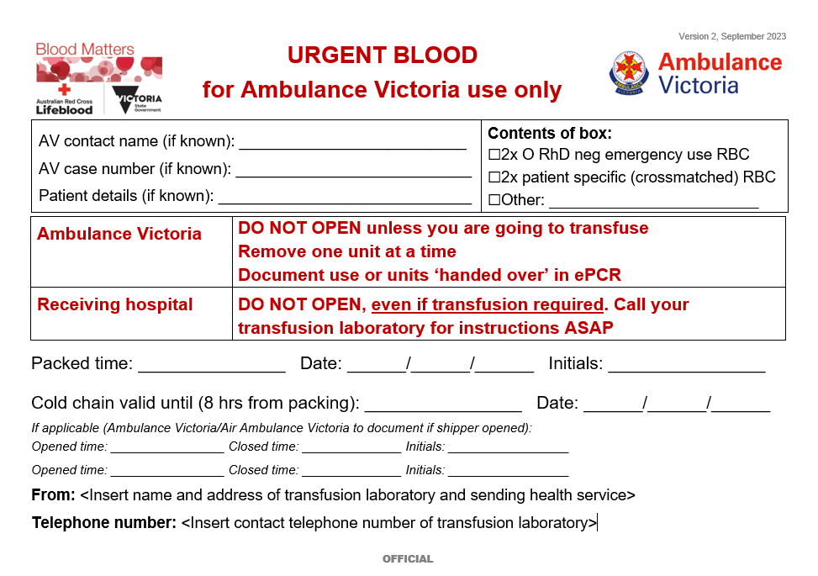
All blood components requested by Ambulance Victoria from regional health services should be packed with the Ambulance Victoria shipper label template to minimise wastage and increase traceability.
This label can be downloaded from the Blood Matters webpage.

BloodNet discard code
Comments entered into BloodNet discard episodes greatly assist understanding the events around discards.
If your laboratory receives blood with a patient transfer and this needs to be discarded, please use the discard location “Ambulance/Air Ambulance”, along with the corresponding discard code if that waste can be attributed to Ambulance Victoria or Air Ambulance Victoria.
Please consider that not all blood received with Ambulance Victoria patient transfer is attributable to them, for example:
    - Crossmatched RBC sent from transferring health service and not packed appropriately
    - Transport shipper received sealed and opened by staff within the receiving health service.
Either the receiving or transferring health service will need to enter the discard into BloodNet, the circumstances of the discard will help guide which health service will do so. All discard episodes must be captured in BloodNet.
Some waste is unavoidable in our duty of care to patients. While all waste should be minimised, waste may at times result from what was deemed to be appropriate actions to ensure patient safety during their care. The Victorian healthcare system works together to ensure best outcomes for patients.
Blood Matters monitor the frequency and volume of such waste and can provide a report for you (at your request) which lists those discards. Where issues arise, please don’t hesitate to contact Blood Matters as we may be able to assist reducing such incidents.

New resource available for download: 30-minute/4-hour rule poster
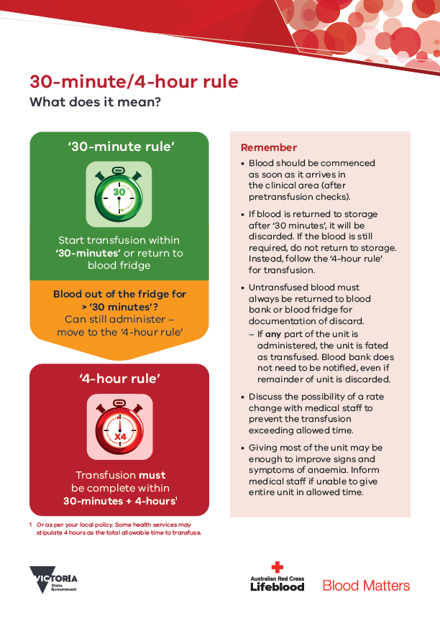
Blood Matters has developed a poster to help explain the ‘30-minute 4-hour rule’ with some simple visual cues.
Most of the monthly RBC wastage fluctuations occur due to RBC being outside controlled storage for >30-minutes. To minimise wastage, clinical staff should be encouraged to:
- Only collect blood from controlled storage when the transfusion is ready to commence.
- Return blood to controlled storage within 30-minutes if unforeseen circumstances mean the transfusion cannot commence as intended.
- Keep blood on the ward once this 30-minute period has passed if the transfusion is still required. The transfusion must then be completed within 30-minutes + 4-hours of removal from controlled storage.
The poster is attached to this email and will soon be available to download from the Blood Matters webpage.

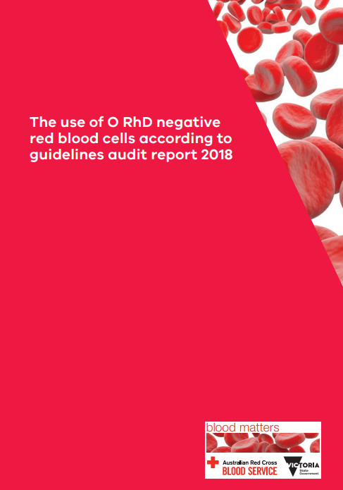
2024 Blood Matters audit
The 2024 Blood Matters audit will be ‘The use of group O RhD negative RBC according to guidelines.’
This audit will compare data collected in the Blood Matters 2017 audit (report published in 2018), for health services to assess compliance or gaps in practice and help identify any ongoing challenges.
The 2018 Blood Matters Use of Group O RhD negative RBC audit reported that 36 per cent of all O RhD negative RBCs were transfused to recipients outside the Guidelines for the use of group O RhD negative RBC (Blood Service and NBTC 2008). The most common reason (n=337, 17 per cent) for transfusing group O RhD negative RBCs to non-identical recipients was to prevent expiry.
Demand (15.5 per cent) for group O RhD negative red blood cells (RBC) continues to be greater than the proportion of the population who is O RhD neg (6.5 per cent (Hirani, 2022)).
Australian population demographics have changed, as have the distribution of blood groups. More Australians are RhD positive (85.9 per cent, up from previously quoted 81 per cent), and there has been a shift in proportion of the population group O to group B and AB (Hirani R 2022). Despite this changing demographic, in general inventory holdings are yet to reflect that of the population.
The National Statement for the Emergency Use of Group O Red Blood Cells (NBA, 2023) recommends O RhD positive RBCs to be given to women over 50 years and males over 18 years in an emergency setting, where patient blood group is unknown. This reduces the demand for O RhD negative RBCs to ensure ongoing supply for those recipients who have no alternative but to receive this group.
Health services/transfusion laboratories will be required to enter the fate of ALL O RhD negative RBC received into inventory during March 2024. The audit will be open for data entry from 1 May – 14 June 2024.
In early April, Blood Matters will provide all Victorian transfusion services/blood banks (AHPs) with a list of Group O RhD negative RBC which were received (issued by Lifeblood and transferred from other AHPs), discarded and recalled (by Lifeblood) during the audit month (March 2024).
Health services and their supplying transfusion service/s will then need to collaborate to ensure the fate of ALL these units received is entered into the audit tool.
Each health service/transfusion laboratory will have their own best method for completing the audit. Depending on the computer system interfaces, some health service staff will be able to complete most of the audit themselves, while others will rely heavily on collaboration with their supplying transfusion laboratory to obtain the necessary data.
It may be helpful during the month of March 2023 to use your laboratory information system comments/notes section (where available) to provide annotation on why O RhD negative RBC were selected to be transfused to non-group O RhD negative patients.
Further information will follow.

Lifeblood Transfusion Policy and Education (TPE) unit Webinar

Lifeblood TPE are hosting a webinar to introduce Lifeblood’s new microlearnings for new scientists and laboratory staff on Wednesday 21 February 2024.
A brief background of the microlearnings will be provided with an introduction of the first three modules:
- The Australian transfusion community
- Pretransfusion testing
- Pretransfusion specimen labelling requirements.
An outline of future topics being offered will also be included.
Register here for the webinar.

ANZSBT Guidelines update
The ANZSBT guidelines for the prevention of transfusion-associated graft-versus-host disease (TA-GVHD) 2nd edition, January 2024 and the Guidance for RHD non-invasive prenatal testing (RHD NIPT) for fetal RhD blood group prediction in pregnancy, November 2023 are both out now!
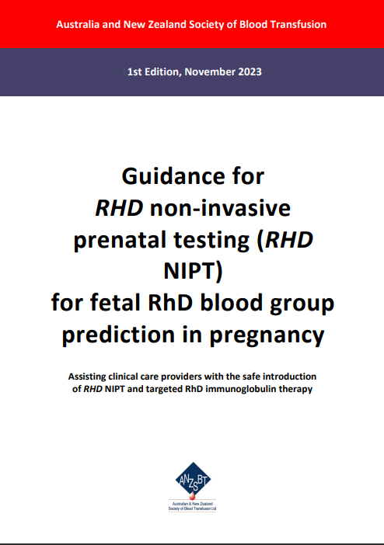
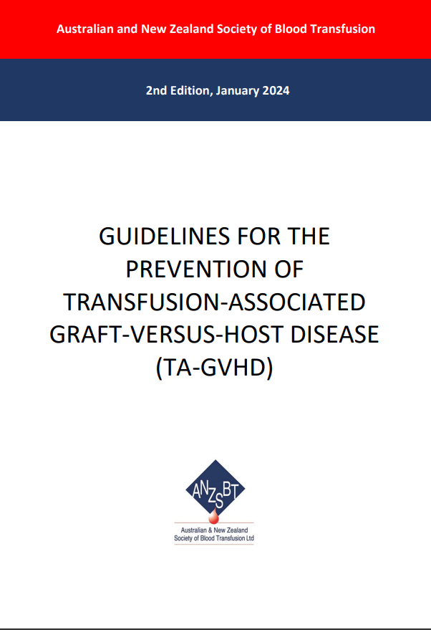
- The ANZSBT Clinical Practice Improvement Committee (CPIC) has undertaken an evidence-based review of the Guidelines for the prevention of TA-GVHD.
- Guidance for RHD non-invasive prenatal testing (NIPT) for fetal RhD blood group prediction in pregnancy was developed to support the advancement of the recommendation for the introduction of NIPT for fetal RHD in all RhD negative pregnant women, complementing the Guideline for the Prophylactic use of Rh D immunoglobulin in pregnancy care (NBA, 2021).
Both guidelines are now available at the ANZSBT website.


National certification of the medical scientist profession
The Australian Council for Certification of the Medical Laboratory Scientific Workforce (CMLS) was launched in 2020 as a voluntary national professional certification scheme for Medical Laboratory Scientists.
New applications for certification and renewals are processed by the professional bodies providing CPD. Please contact your relevant association for details. More information and links can be found at www.cmls.org.au.

Why become certified?
- Recognition of our professional standing as part of Australia’s health service workforce.
- Certification will be the best benchmark available to assure competent professional practice.
- With a certified workforce there will be more obligation on the employer to ensure staff have professional development opportunities afforded to them.
- As a nationally certified medical scientist you can demonstrate your ongoing commitment to professional development and self-improvement and be recognised as passionate, progressive and pro-active.
Click here to view a short video about the certification scheme (2021).
Blood Matters is committed to providing support and education to assist in certification of the medical scientific workforce.

How can Blood Matters help you?
The Blood Matters team are here to assist health services and laboratories through education and providing resources.
If you have suggestions for tools and resources that could assist in day to day activities and towards achieving accreditation please let Rae French or any of the Blood Matters team know by email rfrench@redcrossblood.org.au or bloodmatters@redcrossblood.org.au or phone 03 9694 3524.

To receive this document in another format, phone 03 9694 0102, using the National Relay Service 13 36 77 if required, or email Blood Matters <bloodmatters@redcrossblood.org.au>.
Authorised and published by the Victorian Government, 1 Treasury Place, Melbourne.
© State of Victoria, Australia, Department of Health, February 2024.
ISSN 2652-7278 – Online (pdf / word)
Available at Blood Matters <https://www.health.vic.gov.au/patient-care/transfusion-science-and-blood-stewardship>

Or as per your local policy. Some health services may stipulate 4 hours as the total allowable time to transfuse.
Proportion of O RhD negative RBC issued in Victoria FY2022-2023.

