
Step by step guide to assessing an AIR statement
A resource for early childhood education and care services in Victoria
OFFICIAL

How to assess an immunisation status

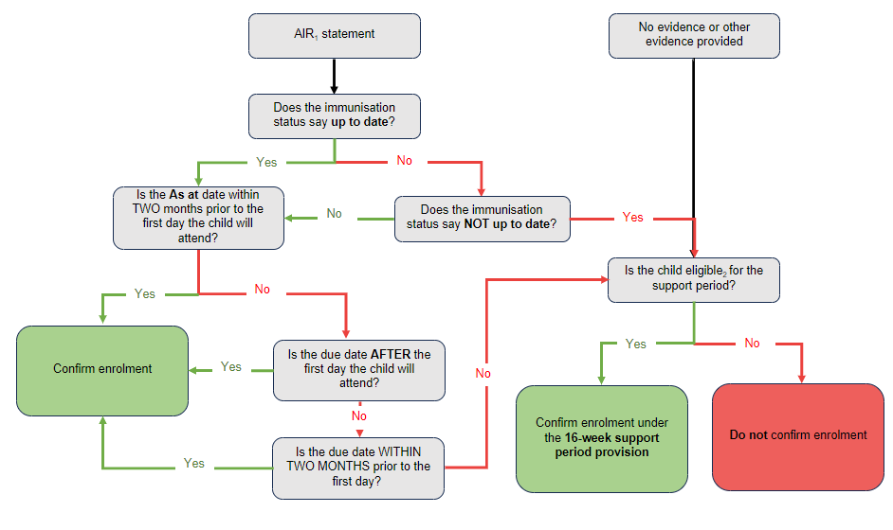
¹ Immunisation History Statement from the Australian Immunisation Register (AIR) issued by Medicare Australia.
² Use the Support period eligibility assessment form <https://www.health.vic.gov.au/publications/grace-period-eligibility-assessment-form>

Step-by-step process:

Step 1: Has the parent/carer provided an AIR statement?
If yes, go to step 2.
If no evidence or ‘other evidence’ has been provided, go to step 6.

Step 2: Look at the 'Immunisation status' at the top left of the statement.
If the immunisation status shows 'up to date', go to step 3.
If the immunisation status shows 'not up to date', do not confirm enrolment, go to step 6.

Step 3: Look at the 'As at' date at the top left of the statement.
If the 'As at' date is within two months of the first day the child will start attending your service, and the immunisation status is 'up to date', you can confirm enrolment.
If the 'As at' date shows the statement is older than 2 months, go to Step 4.

Step 4: Look at the 'Next due vaccine' date at the bottom of the statement.
If the date of the next due vaccine is after the first day the child will attend, you can confirm enrolment.
If the statement says, 'No vaccines due', you can confirm enrolment.
If the date of the next due vaccine is before the first day the child will attend, go to Step 5.

Step 5: Is the date of the 'Next due vaccine' within the two months prior to the child’s first day?
If yes, you can confirm enrolment.
- This two-month leeway allows services time to complete the enrolment process and allows parents/carers to organise vaccines for their child.
If the date of the next vaccine is due more than two months prior the child’s first day, go to step 6.

Step 6: Is the child eligible for the ‘support period’?
If yes, then enrolment and support can be confirmed for 16 weeks.
If no, then do not confirm enrolment.
Refer to Support period eligibility assessment form <https://www.health.vic.gov.au/publications/grace-period-eligibility-assessment-form> for assistance with enrolment.
See below for example statements

Example statements:

Components of the following statements
Note: The following examples of Immunisation History Statements are for illustrative purposes only and may not reflect the current immunisation schedule. The statements were issued by the AIR in 2019.
The statements are made up of the following components:
- Header: displays the Australian Government Department of Human Services – Medicare logo on the right.
- As at: shows the date the statement was issued by AIR
- For: this shows the name of the child
- Date of birth: the date of birth of the child
- Immunisation status: shows the immunisation status of the child at the date the statement was issued
- Immunisation history table: the table shows the details of scheduled immunisations the child has received, by type of immunisation, date given, brand name of the vaccine and provider type (for example Birth, Hepatitis B, Engerix-B, Hospital)
- Next immunisation/s due: shows the name of the next vaccine that the child is due to receive and the date when it is due.

Do enrol
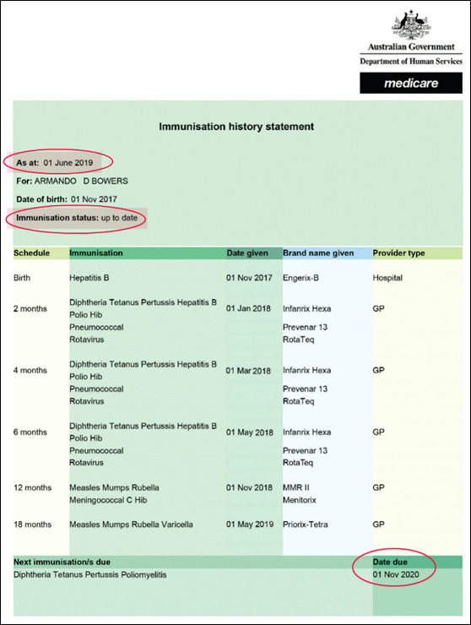

Should enrolment proceed?
Armando’s planned start date at the early childhood education and care service is 12 June 2019. In this example, the statement was issued on 1 June 2019.
- For enrolment to proceed, the date of his next immunisation should be on any date from two months before his start date onwards (after 12 April 2019).
- His next immunisation is due on 1 November 2020, so enrolment can proceed.

Do NOT enrol
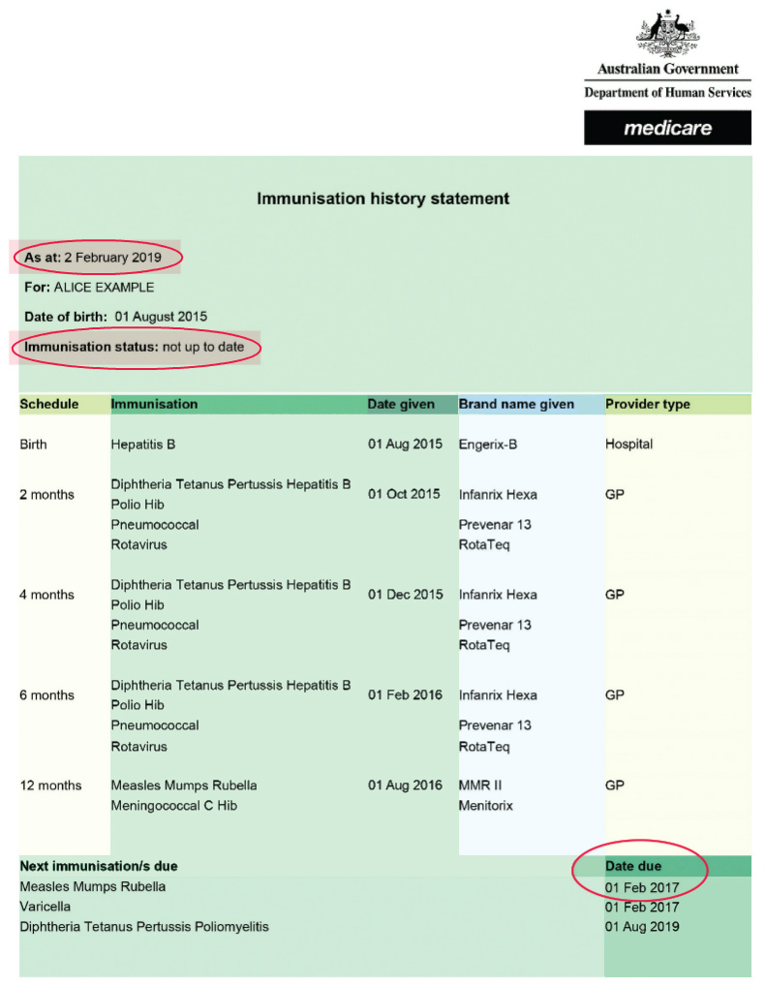

Should enrolment proceed?
Alice’s planned start date at the early childhood education and care service is 12 June 2019. In this example, the statement was issued on 2 February 2019.
- For enrolment to proceed, the date of her next immunisation should be on any date from two months before her start date onwards (after 12 April 2019).
- Her next immunisations due on:
    - 1 February 2017 (Measles Mumps Rubella and Varicella)
    - 1 August 2019 (Diphtheria Tetanus Pertussis Poliomyelitis).
- The due date of the next immunisations is not within the acceptable range, enrolment cannot proceed:
    - until the parent/carer supplies an AIR statement that shows Alice has received all immunisations due up to 12 April 2019 (that is, two months before her start date) or
    - unless Alice can enrol under the ‘support period’.

Medical exemption:
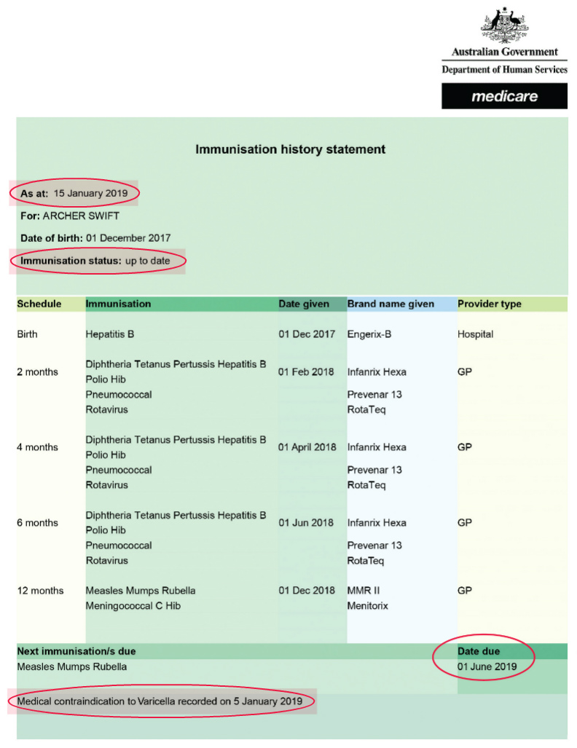

Should enrolment proceed?
Archer’s planned start date at the early childhood education and care service is 12 June 2019. In this example, the statement was issued on 15 January 2019.
- For enrolment to proceed, the date of his next immunisation should be on any date from two months before his start date onwards (after 12 April 2019).
- His next immunisation due is Measles Mumps Rubella on 1 June 2019.
- Because the due date of the next immunisations is within the acceptable range, enrolment can proceed.
- The statement also lists a medical contraindication to Varicella (chicken pox) recorded on 5 January 2019. This information would be important in the event of a chicken pox outbreak at the service.

To receive this publication in an accessible email the Immunisation Program, Community and Public Health Division, Department of Health <immunisation@health.vic.gov.au>.
Authorised and published by the Victorian Government, 1 Treasury Place, Melbourne.
© State of Victoria, Department of Health, July 2024.
ISBN 978-1-76131-615-9 (pdf/online/MS word)
Available from Step by step guide to assessing an AIR statement <https://www.health.vic.gov.au/publications/step-by-step-guide-to-assessing-an-air-statement>.

