
Victorian Perinatal Data Collection (VPDC) manual 2022-23
Section 5 Compilation and submission
Version 10.0
OFFICIAL

To receive this document in another format email HDSS Helpdesk <HDSS.Helpdesk@health.vic.gov.au>.
Authorised and published by the Victorian Government, 1 Treasury Place, Melbourne.
© State of Victoria, Australia, Department of Health, July 2022.
ISBN 978-1-76096-936-3 (pdf/online/MS word)
Available at the VPDC website <https://www.health.vic.gov.au/quality-safety-service/victorian-perinatal-data-collection>

Contents
Introduction 5
Data submission timelines 5
Reporting when data formats are updated 6
Test transmissions 7
Steps for submitting test transmissions 7
Test file and data formats 7
Health service responsibilities 8
Timing of testing 8
File naming convention 9
Updating or amending data submitted previously 9
Data delimiters 10
VPDC submission file structure 10
File structure specifications 11
Header record 11
Episode records 11
Table of Episode record data elements 12
Submitting data to the VPDC 19
The managed file transfer (MFT) portal 19
VPDC webform and the HealthCollect portal 19
General information about managed file transfer (MFT) portal 19
Requesting access to the MFT portal for VPDC reporting 19
Setting your Password 20
Password reset 21
Logging into the MFT Portal 22
Uploading a transmission file to the MFT portal 24
Processing the VPDC submission file 27
VPDC transmission reports 27
VPDC weekly status reports 27
Retention of reports in MFT pickup and backup folders 28
Accessing VPDC submission and status reports via the MFT portal 28
Reviewing transmission reports 30
Help with using the MFT portal 30
Common problems when uploading files through the MFT 31
MFT FAQs 31

Introduction
Each birth episode must be reported to the department via the Victorian Perinatal Data Collection (VPDC).
All births must be reported to the VPDC using electronic files. There is no reporting using paper forms.
For all birth episodes, the VPDC data elements applicable for the year of the baby’s birth must be reported as a single Episode record in the file structure defined in this document.
Appropriate software is used by health service personnel to compile one or more Episode records into a submission file, which is assigned a file name in the prescribed format. Submission files are lodged via one of two secure electronic file submission portals, depending on the software used to report the birth. The submission file is processed, and two reports are returned to the user via the same portal. These reports should be reviewed promptly and any errors identified should be corrected and the Episode record resubmitted.
This section provides the following information in relation to this version of the VPDC:
- timelines and frequency for VPDC data submissions
- the circumstances for submission of test files
- the format and sequence of data elements required for VPDC submission files, including file name conventions
- submitting VPDC files to the department via the managed file transfer (MFT) portal for health services that use software to capture and report birth information.
Health services and other health care providers that do not have software that captures and reports birth details can enter and submit birth information using the VPDC webform, accessible through the HealthCollect portal. Information on this, including a brief user guide for the webform, is provided in another section of this VPDC manual – Section 5a Webform.
Detailed specifications for data items referred to in this document are found in VPDC manual Section 3: Data definitions.

Data submission timelines
The Public Health and Wellbeing Regulations 2019 require VPDC data to be reported within 30 days of the birth. This includes correction of any rejections caused by non-compliance with business rules.
Where mother and/or baby remain in hospital at the submission deadline, report all data items known at the time of submission, and resubmit the Episode record when the episode ends, and data are complete.
Exceptions to reporting timelines are only permissible when negotiated on a case by case basis.
The minimum frequency for reporting is one submission file to report the births for an entire calendar month. Most health services report births for a shorter period, often weekly.
Births can be reported individually if that suits the health service.
More than one submission file can be lodged in a day.
Health services with high birth counts will benefit from more frequent submissions so the volume of data in each submission file, and the prompt correction of any rejections in that file, is more manageable.
Experience has shown that review, correction and resubmission of errors is easiest close to the clinical event.
The table below sets out the timeframes for reporting a single submission file for each calendar month, and represents the latest date for submission of data for that period:
Birth period (from) | Birth period (to) | Latest submission date
01/07/2022 | 31/07/2022 | 30/08/2022
01/08/2022 | 31/08/2022 | 30/09/2022
01/09/2022 | 30/09/2022 | 30/10/2022
01/10/2022 | 31/10/2022 | 30/11/2022
01/11/2022 | 30/11/2022 | 30/12/2022
01/12/2022 | 31/12/2022 | 30/01/2023
01/01/2023 | 31/01/2023 | 02/03/2023
01/02/2023 | 28/02/2023 | 30/03/2023
01/03/2023 | 31/03/2023 | 30/04/2023
01/04/2023 | 30/04/2023 | 30/05/2023
01/05/2023 | 31/05/2023 | 30/06/2023
01/06/2023 | 30/06/2023 | 30/07/2023

Reporting when data formats are updated
Episode records in any single VPDC submission file must report in the same VPDC format, which changes for births on and from 1 July each year.
For example, to submit records for births occurring between 1 June 2022 and 31 July 2022, at least two data submission files are required:
- At least one file must be created containing Episode records reporting births from 1 June 2022 to 30 June 2022 (inclusive) in accordance with the data specifications for 1 July 2021 to 30 June 2022 as set out in VPDC manual v9.0, with the Version identifier reported as ‘2021’ in the Header record, and in each Episode record in the file
- At least one file must be created containing Episode records reporting births from 1 July 2022 to 31 July 2022 (inclusive) in accordance with the data specifications for 2022-2023, as set out in this VPDC manual v10.0, with the Version identifier reported as ‘2022’ in the Header record and in each Episode record in the file.

Test transmissions
Test transmissions are strongly recommended when the health service:
- changes the software vendor or system used to capture and report VPDC data or
- makes changes within the existing VPDC reporting software that may alter the reporting process or
- updates the software to accommodate annual revisions to VPDC reporting specifications.

Steps for submitting test transmissions
- Contact the HDSS Helpdesk <hdss.helpdesk@health.vic.gov.au> before submitting any test file: this applies to health services and/or software vendors wishing to submit a test file
- Identify all test files by including ‘_TEST’ at the end of the submission file name, as follows: CCCC_NNNN_YYYYMMDDhhmm_TTTT_TEST.txt where
CCCC = Collection identifier (always VPDC)
NNNN = Hospital code (agency identifier)
YYYYMMDDhhmm = Data submission identifier
TTTT = Submission number
txt = Submission file extension (always .txt)
- Submit all test files via the non-production MFT of the health service submitting the test file: accessible at <https://prs2np-mft.prod.services/>.
Do not submit any test file via the production MFT portal. If a test file is inadvertently submitted via the prod MFT portal, notify the HDSS HelpDesk immediately.
- Reports generated by processing test files will be returned to the submitting health service’s non-prod MFT Pickup folder. Access reports to review results. Reports are downloaded in the same way reports are downloaded from the Pickup folder in the Production MFT.
- If the software vendor is supporting the testing process, a MFT login for the hospital campus can be arranged for the software vendor, with the written authorisation of the hospital, for the duration of the testing process or longer at the hospital’s discretion. Please contact the HDSS HelpDesk to arrange MFT logins.

Test file and data formats
- Test files do not need to include data for an entire month: the period of data tested is at the discretion of the health service and software vendor, but DH encourages submission of data for multiple births in any single test file.
- Test files must adhere to all submission file and Episode record specifications applicable for the births being reported in that submission file, as set out in the VPDC manual applicable for the year of the birth record(s) in the test file.
- Where a test file is submitted in the format applicable for the next financial year, the file format and all Episode records in the test file must conform to the specifications for the next financial year, as set out in the Specifications for revisions to the VPDC for the next financial year. That is, test files submitted via the non-prod MFT can include births dated later than the date the file is submitted. Such records will only be processed in the non-prod environment.
Where this option is chosen, a ‘Warning’ validation that identifies births dated ahead of the processing date will generate an error message: this can be ignored when testing submissions for a future format.

Health service responsibilities
- It is the responsibility of the health service to ensure data are reported in accordance with the VPDC specifications valid for the births reported, and that corrections can be made, and records resubmitted to the VPDC, in accordance with the reporting timeframe required under the Public Health and Wellbeing Regulations, that is, within 30 days of the birth.
- Health services are strongly encouraged to engage with their software vendor during the testing process, and to address data/software shortcomings, including submission file extract issues, before submitting data to the production environment.
- Health services should ensure test files assess the capacity of the software to create submission files.
- The department may request further test files be submitted to demonstrate compliance with reporting requirements before the health service commences/resumes reporting to the production environment.
- Staff at the department will endeavour to review test files and assist in identifying problems, where possible, to assist health services and software vendors.

Timing of testing
When planning software changes, health services are reminded to allow time to resolve reporting problems to ensure ongoing compliance with the reporting timeframes set out in the Public Health and Wellbeing Act 2008 and the Public Health and Wellbeing Regulations 2019, which require data for each birth to be reported within 30 days of the birth.
Where delays are anticipated, or encountered, health services must notify the HDSS HelpDesk indicating a timeframe for returning reporting to compliance with required reporting intervals.

File naming convention
Each VPDC submission file is uniquely identified by its file name, which must be in the following format:
CCCC_NNNN_YYYYMMDDhhmm_TTTT.txt
where:
CCCC = Collection identifier (always VPDC)
NNNN = Hospital code (agency identifier)
YYYYMMDDhhmm = Data submission identifier
TTTT = Submission number
txt = Submission file extension (always .txt)
Test files must include _TEST at the end of the submission file name as follows:
CCCC_NNNN_YYYYMMDDhhmm_TTTT_TEST.txt
For example, a health service with Hospital code (agency identifier) ‘1234’ creates a new submission file at 9.45 am on 13 July 2022, using that date and time as the Data submission identifier:
- Data submission identifier = 202207130945
- Submission number = 0001
The submission file name is then: VPDC_1234_202207130945_0001.txt
Detailed specifications for the components of the file name are provided in VPDC manual Section 3: Data definitions.

Updating or amending data submitted previously
Each Episode record is uniquely identified using a combination of the Hospital code (agency identifier) and the Episode identifier assigned by the reporting agency’s software to the birth reported in that Episode record.
Note that the Episode identifier is unique to the baby, not the mother, so a different Episode identifier must be assigned to each baby in a multiple birth.
Because an Episode identifier must never be changed or reassigned, an Episode record that is updated or amended and resubmitted will be matched to the original Episode record using this unique combination of identifiers.
To correct an error in an Episode record, correct the data in the hospital’s birthing software, and create a new extract, which must retain the original Episode identifier. The VPDC processor matches the newer submission with the prior one using the combination of Hospital code (agency identifier) and Episode identifier. The previous version of the Episode record is deactivated in the VPDC, leaving the most recent version as the active birth record.
To update or correct an Episode record, it is therefore not essential to resubmit it in a file with the same Data submission identifer as the file in which the Episode record was initially, or previously, submitted.
Any given Episode record can be submitted or resubmitted under any file name, provided the date of the birth being reported is not after the date in the Data submission identifier.
Corrections and updates to Episode records in one submission file can be included in a submission file for a subsequent period, rather than re-submitting the same period of data multiple times.
However, where data for a period is submitted multiple times, for example, to remedy issues identified in a previous submission, and the same Data submission identifier is included in the file name of successive submissions, the Submission number must increase by one for each successive file. If this is not done, any later file will be interpreted as a duplicate file, and will not be processed, so the data it contains, including any corrections to errors in the earlier file, will not be processed.

Data delimiters
All VPDC records are structured using the following delimiters:
- Record separator
  - value: carriage return
  - usage: records are separated by a carriage return (line feed permitted). ASCII character 13 (x0D) [10 (x0A)]
- Field separator
  - value: |
  - usage: data fields are separated by the pipe character. ASCII character 124 (x7C)
- Repetition separator
  - value: ^
  - usage: the caret character separates multiple occurrences of values within a field where allowed.
  - ASCII character 94 (x5E)

VPDC submission file structure
Every VPDC submission file must:
- report births in only one financial year
- be in the correct file structure for the financial year of the births being reported
- be named according to the file name convention
- have a Header record as the first record
- include at least one Episode record reporting the relevant birth details for the financial year of the birth indicated by the Version identifier
- be submitted within the required reporting timeline
- be submitted via the department’s managed file transfer (MFT) portal or as a VPDC webform via the HealthCollect portal.

The VPDC submission file structure specification to follow details the sequence, length, type and layout of data items to be included in the submission records.
File structure notes:
- Do not zero fill items unless specified
- Padding fields with space characters (either to the left or right) is not necessary and should be avoided
- Deleted fields retain their position number, but once notified as deleted, any data submitted in these fields will not be processed.

File structure specifications

Header record
The Header record must be the first record in any VPDC submission file.
The Header record is comprised of a number of components which must appear in the following format and sequence:
CCCC | VVVV | NNNN | YYYYMMDDhhmm | TTTT | NNNNN | AAA…AAA

where:
CCCC = Collection identifier (always VPDC)
VVVV = Version identifier
NNNN = Hospital code (agency identifier)
YYYYMMDDhhmm = Data submission identifier
TTTT = Submission number
NNNNN = Number of records following (the number of Episode records in this file)
AAA…AAA = Name of software
Details of the Header record components are set out in VPDC manual Section 3: Data definitions.

Episode records
Each Episode record reports data on an individual birth episode.
The VPDC data elements applicable for the current financial year of the baby’s birth must be reported as a single Episode record and in the structure defined in this document.
Full details of all data elements to be reported for the current financial year are provided in VPDC manual Section 3: Data definitions.
The sequence in which data elements are to be included in each Episode record reported to the VPDC for the current financial year is set out in the following table.

Table of Episode record data elements
Position number | Data item name | Data type | Format | Field size
1 | Collection identifier | String | AAAA | 4
2 | Version identifier | Number | NNNN | 4
3 | Transaction type flag | String | A | 1
4 | Hospital code (agency identifier) | Number | NNNN | 4
5 | Patient identifier – mother | String | A(10) | 10
6 | Patient identifier – baby | String | A(10) | 10
7 | Date of admission – mother | Date/time | DDMMCCYY | 8
8 | Surname / family name – mother | String | A(40) | 40
9 | First given name – mother | String | A(40) | 40
10 | Middle name – mother | String | A(40) | 40
11 | Residential locality | String | A(46) | 46
12 | Residential postcode | Number | NNNN | 4
13 | Residential road number – mother | String | A(12) | 12
14 | Residential road name – mother | String | A(45) | 45
15 | Residential road suffix code – mother | String | AA | 2
16 | Residential road type – mother | String | AAAA | 4
17 | Admitted patient election status – mother | Number | N | 1
18 | Country of birth | Number | NNNN | 4
19 | Indigenous status – mother | Number | N | 1
20 | Indigenous status – baby | Number | N | 1
21 | Marital status | Number | N | 1
22 | Date of birth – mother | Date/time | DDMMCCYY | 8
23 | Height – self-reported – mother | Number | NNN | 3
24 | Weight – self-reported – mother | Number | NN[N] | 3
25 | Setting of birth – intended | Number | NNNN | 4
26 | Setting of birth – intended – other specified description | String | A(20) | 20
27 | Setting of birth, actual | Number | NNNN | 4
28 | Setting of birth, actual – other specified description | String | A(20) | 20
29 | Setting of birth – change of intent | Number | N | 1
30 | Setting of birth – change of intent – reason | Number | N | 1
31 | Maternal smoking < 20 weeks | Number | N | 1
32 | Maternal smoking ≥ 20 weeks | Number | NN | 2
33 | Gravidity | Number | N[N] | 2
34 | Total number of previous live births | Number | NN | 2
35 | Parity | Number | NN | 2
36 | Total number of previous stillbirths (fetal deaths) | Number | NN | 2
37 | Total number of previous neonatal deaths | Number | NN | 2
38 | Total number of previous abortions – spontaneous | Number | NN | 2
39 | Total number of previous abortions – induced | Number | NN | 2
40 | Total number of previous ectopic pregnancies | Number | NN | 2
41 | Total number of previous unknown outcomes of pregnancy | Number | NN | 2
42 | Date of completion of last pregnancy | Date/time | {DD}MMCCYY | 6 (8)
43 | Outcome of last pregnancy | Number | N | 1
44 | Last birth – caesarean section indicator | Number | N | 1
45 | Total number of previous caesareans | Number | NN | 2
46 | Plan for VBAC | Number | N | 1
47 | Estimated date of confinement | Date/time | DDMMCCYY | 8
48 | Estimated gestational age | Number | NN | 2
49 | Maternal medical conditions – free text | String | A(300) | 300
50 | Maternal medical conditions – ICD-10-AM code | String | ANN[NN] | 5 (X12)
51 | Obstetric complications – free text | String | A(300) | 300
52 | Obstetric complications – ICD-10-AM code | String | ANN[NN] | 5 (x15)
53 | Gestational age at first antenatal visit | Number | N[N] | 2
54 | Discipline of antenatal care provider | Number | N | 1
55 | Procedure – free text | String | A(300) | 300
56 | Procedure – ACHI code | Number | NNNNNNN | 7 (x8)
57 | Deleted field
58 | Deleted field
59 | Deleted field
60 | Artificial reproductive technology – indicator | Number | N | 1
61 | Date of onset of labour | Date/time | DDMMCCYY | 8
62 | Time of onset of labour | Date/time | HHMM | 4
63 | Date of onset of second stage of labour | Date/time | DDMMCCYY | 8
64 | Time of onset of second stage of labour | Date/time | HHMM | 4
65 | Date of rupture of membranes | Date/time | DDMMCCYY | 8
66 | Time of rupture of membranes | Date/time | HHMM | 4
67 | Labour type | Number | N | 1 (x3)
68 | Labour induction/augmentation agent | Number | N | 1 (x4)
69 | Labour induction/augmentation agent – other specified description | String | A(20) | 20
70 | Indications for induction (other) – free text | String | A(50) | 50
71 | Indication for induction (main reason) – ICD-10-AM code | String | ANN[NN] | 5 (X1)
72 | Fetal monitoring in labour | String | NN | 2 (x7)
73 | Birth presentation | Number | N | 1
74 | Method of birth | Number | NN | 2
75 | Indications for operative delivery (other) – free text | String | A(300) | 300
76 | Indication for operative delivery (main reason) – ICD-10-AM code | String | ANN[NN] | 5 (x4)
77 | Analgesia for labour – indicator | Number | N | 1
78 | Analgesia for labour – type | Number | N | 1 (x4)
79 | Anaesthesia for operative delivery – indicator | Number | N | 1
80 | Anaesthesia for operative delivery – type | Number | N | 1 (x4)
81 | Events of labour and birth – free text | String | A(300) | 300
82 | Events of labour and birth – ICD-10-AM code | String | ANN[NN] | 5 (x9)
83 | Prophylactic oxytocin in third stage | Number | N | 1
84 | Manual removal of placenta | Number | N | 1
85 | Perineal laceration – indicator | Number | N | 1
86 | Perineal / genital laceration – degree/type | Number | N | 1 (x3)
87 | Perineal laceration – repair | Number | N | 1
88 | Episiotomy – indicator | Number | N | 1
89 | Blood loss (ml) | Number | N[NNNN] | 5
90 | Blood product transfusion – mother | Number | N | 1
91 | Postpartum complications – free text | String | A(300) | 300
92 | Postpartum complications – ICD-10-AM – code | String | ANN[NN] | 5 (x6)
93 | Discipline of lead intra-partum care provider | Number | N | 1
94 | Admission to high dependency unit (HDU) / intensive care unit (ICU) – mother | Number | N | 1
95 | Date of birth – baby | Date/time | DDMMCCYY | 8
96 | Time of birth | Date/time | HHMM | 4
97 | Sex – baby | Number | N | 1
98 | Birth plurality | Number | N | 1
99 | Birth order | Number | N | 1
100 | Birth status | Number | N | 1
101 | Birth weight | Number | NN[NN] | 4
102 | Apgar score at one minute | Number | N[N] | 2
103 | Apgar score at five minutes | Number | N[N] | 2
104 | Time to established respiration (TER) | Number | NN | 2
105 | Resuscitation method – mechanical | String | NN | 2 (x10)
106 | Resuscitation method – drugs | Number | N | 1 (x5)
107 | Congenital anomalies – indicator | Number | N | 1
108 | Deleted field
109 | Deleted field
110 | Deleted field
111 | Neonatal morbidity – free text | String | A(300) | 300
112 | Neonatal morbidity – ICD-10-AM code | String | ANN[NN] | 5 (x10)
113 | Admission to special care nursery (SCN) / neonatal intensive care unit (NICU) – baby | Number | N | 1
114 | Hepatitis B vaccine received | Number | N | 1
115 | Breastfeeding attempted | Number | N | 1
116 | Formula given in hospital | Number | N | 1
117 | Last feed before discharge taken exclusively from the breast | Number | N | 1
118 | Separation date – mother | Date/time | DDMMCCYY | 8
119 | Separation date – baby | Date/time | DDMMCCYY | 8
120 | Separation status – mother | Number | N | 1
121 | Separation status – baby | Number | N | 1
122 | Transfer destination – mother | Number | NNNN | 4
123 | Transfer destination – baby | Number | NNNN | 4
124 | Number of antenatal care visits | Number | NN | 2
125 | Influenza vaccination status | Number | N | 1
126 | Pertussis (whooping cough) vaccination status | Number | N | 1
127 | Spoken English Proficiency | Numeric | N | 1
128 | Year of arrival in Australia | Number | NNNN | 4
129 | Head circumference | Number | NN.N | 4
130 | Episode identifier | String | A (9) | 9
131 | Fetal monitoring prior to birth – not in labour | String | NN | 2 (x5)
132 | Reason for transfer out – baby | Number | N | 1
133 | Reason for transfer out – mother | Number | N | 1
134 | Congenital anomalies – ICD-10-AM code | String | ANN[NN] | 5 (x9)
135 | Maternal alcohol use at less than 20 weeks | Number | N | 1
136 | Maternal alcohol volume intake at less than 20 weeks | Number | N | 1
137 | Maternal alcohol use at 20 or more weeks | Number | N | 1
138 | Maternal alcohol volume intake at 20 or more weeks | Number | N | 1
139 | Antenatal corticosteroid exposure | Number | N | 1
140 | Chorionicity of multiples | Number | N | 1
141 | Cord complications | String | ANN[NN] | 5 (x3)
142 | Diabetes mellitus during pregnancy – type | Number | N | 1
143 | Diabetes mellitus – gestational – diagnosis timing | Number | NN | 2
144 | Diabetes mellitus – pre-existing – diagnosis timing | Number | NNNN | 4
145 | Diabetes mellitus therapy during pregnancy | String | N | 1 (x3)
146 | Main reason for excessive blood loss following childbirth | Number | N | 1
147 | Blood loss assessment - indicator | Number | N | 1
148 | Category of unplanned caesarean section urgency | Number | N | 1
149 | Date of decision for unplanned caesarean section | Date/time | DDMMCCYY | 8
150 | Time of decision for unplanned caesarean section | Date/time | HHMM | 4
151 | COVID19 vaccination status | Number | N | 1
152 | COVID19 vaccination during this pregnancy | Number | N | 1
153 | Gestation at first COVID19 vaccination during this pregnancy | Number | [N]N | 2
154 | Gestation at second COVID19 vaccination during this pregnancy | Number | [N]N | 2
155 | Gestation at third COVID19 vaccination during this pregnancy | Number | [N]N | 2
156 | Antenatal mental health risk screening status | Number | N | 1
157 | Edinburgh Postnatal Depression Scale score | Number | N[N] | 2
158 | Presence or history of mental health condition – indicator | Number | N | 1
159 | Family violence screening status | Number | N | 1
160 | Hepatitis B antenatal screening – mother | Number | N | 1
161 | HIV antenatal screening – mother | Number | N | 1
162 | Syphilis antenatal screening – mother | Number | N | 1
163 | Hypertensive disorder during pregnancy | Number | N | 1 (x3)
164 | Maternity model of care – antenatal | Number | NNNNNN | 6
165 | Maternity model of care – at onset of labour or non-labour caesarean section | Number | NNNNNN | 6

Submitting data to the VPDC

The managed file transfer (MFT) portal
Health services that use software systems to capture and report birth data to the VPDC must submit electronic files to the department using the managed file transfer (MFT) portal.
The MFT portal provides secure data transfer for data submission, and for return of reports generated following processing of submission files.
Cumulative status reports are also distributed to health services each week via the MFT portal. These reports list the births reported by month for the calendar year to date (‘Reported Births Summary’ report), and all rejection errors that remain unresolved at that date (‘Outstanding Rejections’ report).
Each person submitting VPDC data and/or retrieving reports via the MFT must have a user account, which can be obtained by emailing a request to the HDSS HelpDesk <hdss.helpdesk@health.vic.gov.au>.

VPDC webform and the HealthCollect portal
Health services that do not have an information system with the capacity to report birth data in accordance with the VPDC specifications must use the VPDC webform to enter and submit birth data via the HealthCollect portal. This includes homebirth midwives, and health services that do not regularly provide birthing services but where a birth has occurred.
Details of the VPDC webform and HealthCollect portal are provided in VPDC manual Section 5a: Webform and HealthCollect.

General information about managed file transfer (MFT) portal

Requesting access to the MFT portal for VPDC reporting
To request access to the MFT portal for VPDC reporting purposes:
- Email your request to the HDSS HelpDesk <hdss.helpdesk@health.vic.gov.au> providing your given name, surname, day and month of birth (not year), work email address and the health service campus for which you will be reporting VPDC data. Also provide your mobile phone number if you would like to receive the MFA authentication code by SMS text message.
- Each person submitting VPDC data for a health service must have their own Login identifier (Login ID) to submit VPDC data files and retrieve VPDC processing and weekly status reports.
- You will receive an email advising your MFT Login ID and the link to the MFT login page and the MFT password reset site.
- If you have not received an email in response to your request within 2 business days, please contact the HDSS HelpDesk by email for assistance.

Setting your Password
- Once you have your MFT Login ID you will need to create a password. Go to the self-service password reset site <https://ehvfimpwdreset.prod.services>, enter your Login ID in the space beneath the instruction ‘Please enter your username below’, and click on the ‘Next’ button.
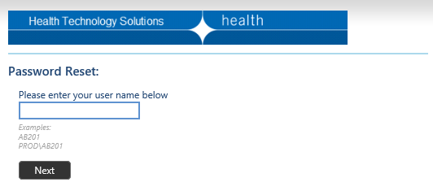
- A security code will be sent to the email address linked to your MFT account. Enter this security code and click ‘Next’.
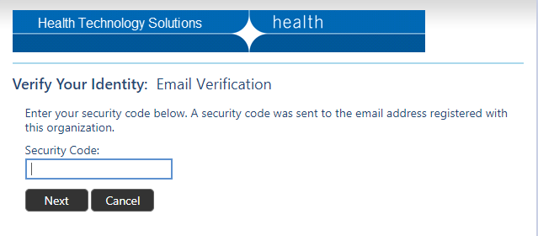
- In a few moments you will be taken to a new screen which displays your unique User ID (eg ZX987 below) into which you can enter, then repeat, a new password, then click on the ‘Next’ button:
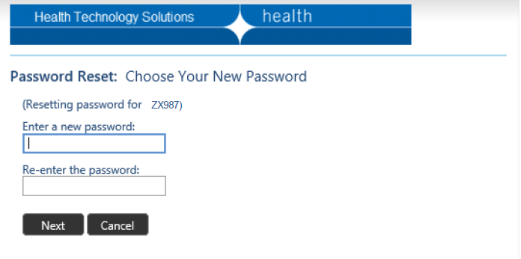
- If your proposed new password doesn’t meet the system requirements, you will be notified, and the restrictions on passwords will be displayed. Enter a new password that meets these requirements, then re-enter the same password, and click the ‘Next’ button:
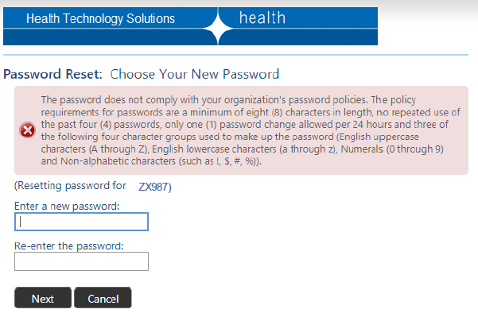
- When you have entered a password that meets system requirements, you will receive confirmation of acceptance:
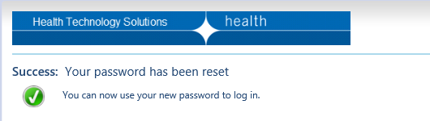

Password reset
- To reset your password for the MFT, go to the MFT portal and click on the ‘Forgot Password?’ link.
- You will be taken to the Password Reset: screen. This is the same process described under ‘Setting your password’ above. Follow the same steps to create a new password.

Logging into the MFT Portal
- Open an internet browser, and enter the MFT portal address <https://prs2-mft.prod.services>
- Bookmark this address to facilitate easy access in future.
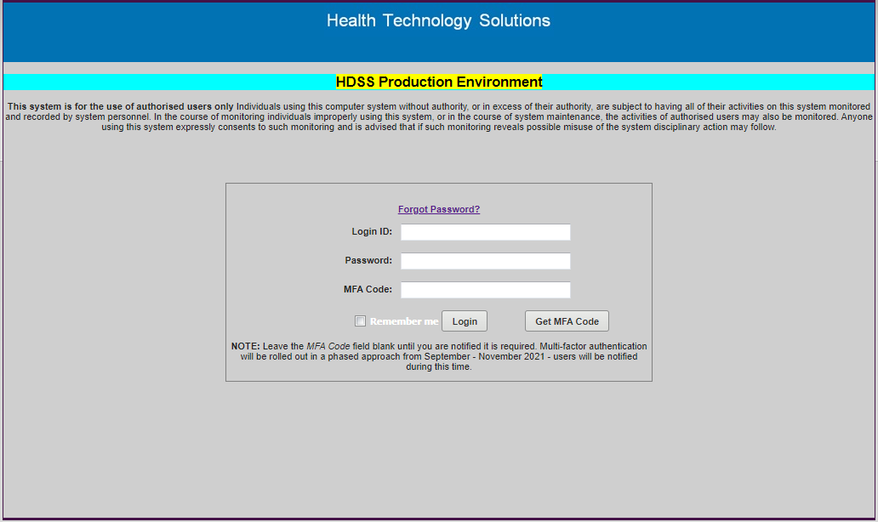
- Enter your MFT Login ID and select the ‘Get MFA Code’ button which will redirect you to the MFA Login page shown below:
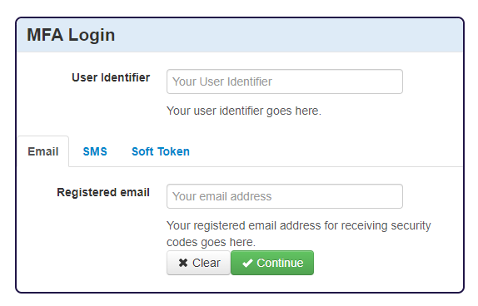
- Enter your MFT User Identifier (User ID) in the top box and the email address that is registered to your MFT User ID account in the bottom box and select ‘Continue’.
- If you have your mobile phone number linked to your MFT User ID, you can select ‘SMS’ in the window shown above. You can then enter your Registered mobile phone number in the lower box and select ‘Continue’. Enter either your registered email or mobile phone number, not both.
- You will then be redirected to the following window to confirm that you have requested a MFA security code. Select ‘Continue’.
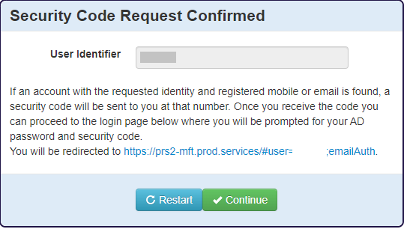
- In order to be able to have the unique MFA code sent via SMS, you must have your mobile phone number recorded against your MFT user ID account. Contact the HDSS HelpDesk to have your mobile number added to your MFT user ID account if this has not already been done.
- You should receive the unique MFA code via the method you selected – either email or SMS – within a few seconds. Enter the unique MFA code and your password (created previously) and click ‘Login’. Do not tick the ‘Remember me’ box as you will require a new unique MFA code each time you log into the MFT portal.
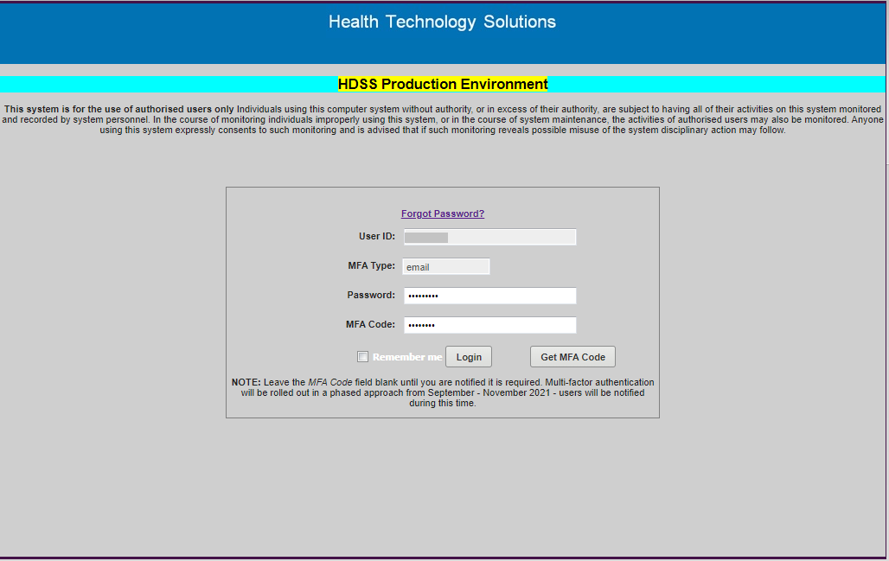

- Once you have entered your login ID, correct password and unique MFA code, you will be receive a notification that you are now entering the HDSS – Production MFT Environment. Select ‘OK’ if you wish to proceed or ‘Log out’ if you wish to log out.
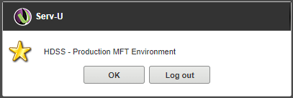

Uploading a transmission file to the MFT portal
- Login to the MFT portal. The ‘Serv-U’ confirmation window will appear, confirming you are logging in to the ‘HDSS – Production MFT Environment’: click the ‘OK’ button to proceed.
- You will be taken to the MFT Home page for the health service campus linked to your MFT login ID for VPDC reporting. Your name and Login ID will appear in the top right corner of the screen (grey bar). Check the VPDC identifier and campus code (VPDC_nnnn) in the MFT Home page:
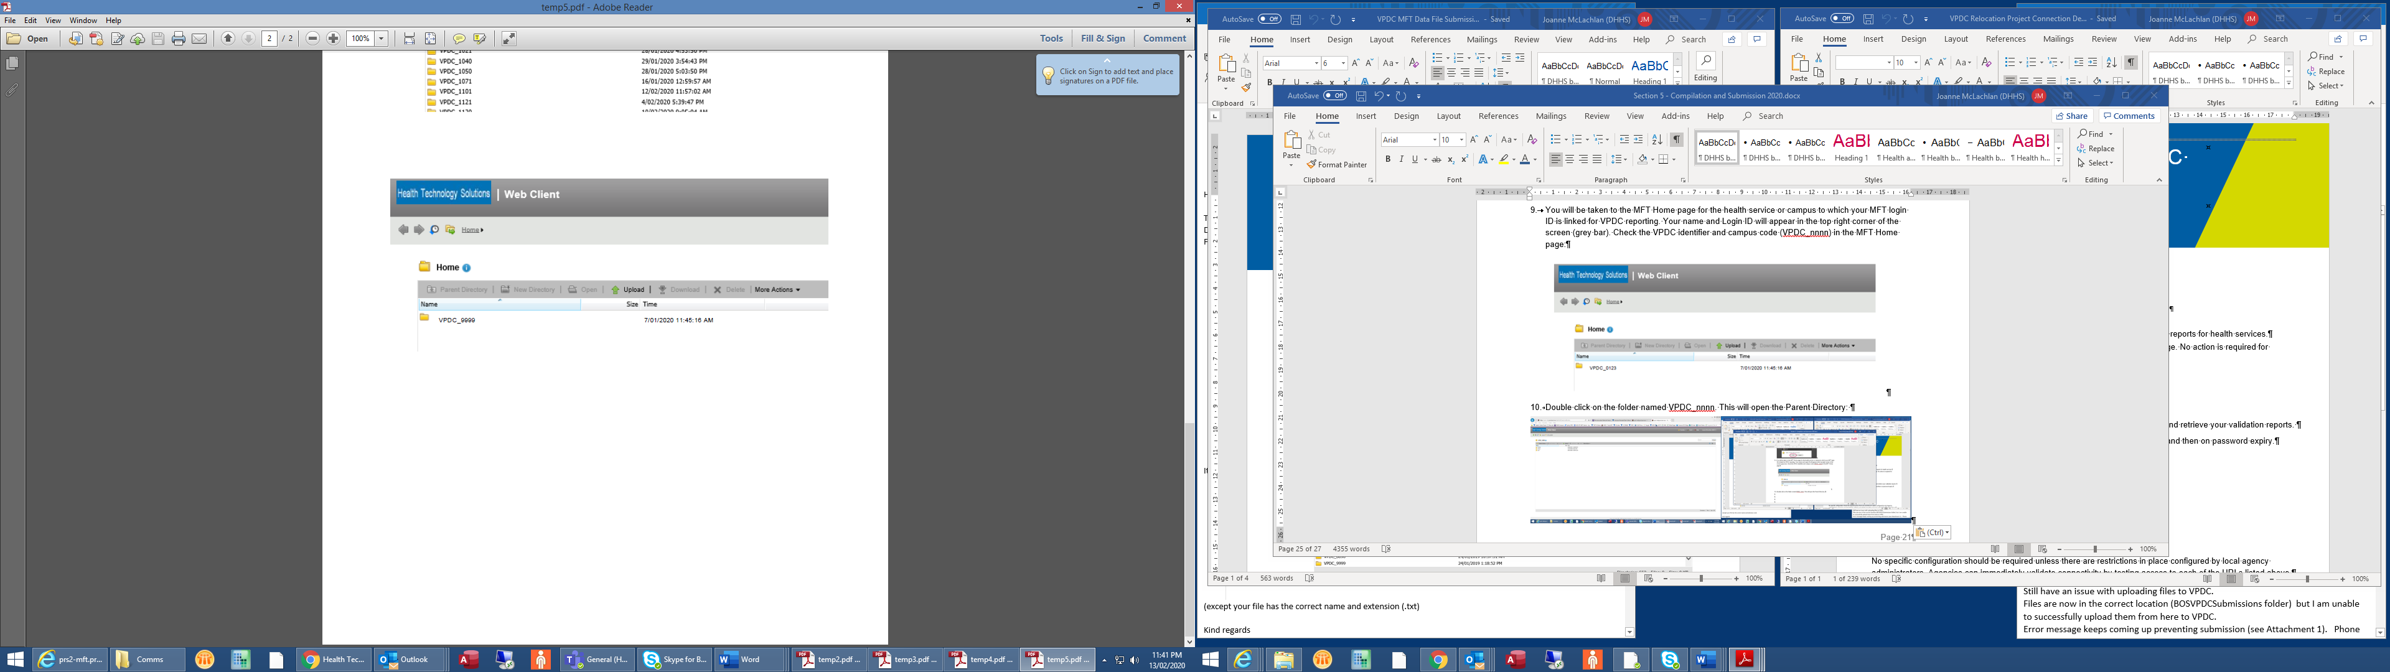
- Open the VPDC folder for this health service: double click on the folder name (VPDC_nnnn) where nnnn is the campus code for the site for which data is being reported.
- The Parent Directory will open, showing three folders – backup, pickup and sent – beneath the Parent Directory menu bar:
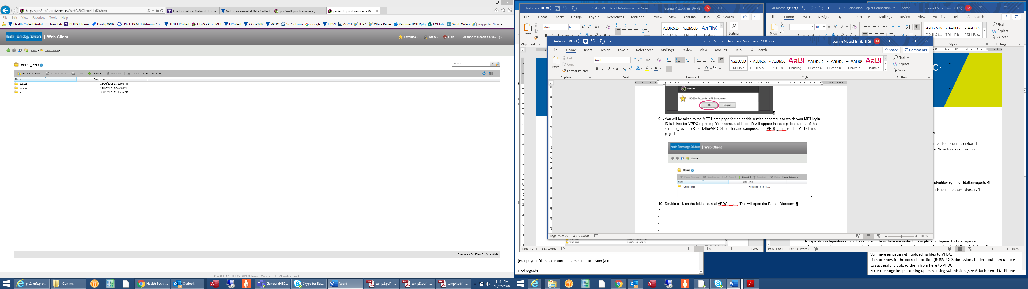
- These folders are used only to access reports for data that has already been submitted through the MFT portal: they are NOT used when uploading a transmission file. Submission files left within any of these folders will not be picked up by the MFT file transfer process.
- When the Parent Directory is open, and showing the three folders, you’re ready to submit a VPDC file. Click on the ‘Upload’ button:
- The Upload window will open. You should still be able to see the Parent Directory open and the three closed folders beneath it, slightly obscured behind the grey shading.
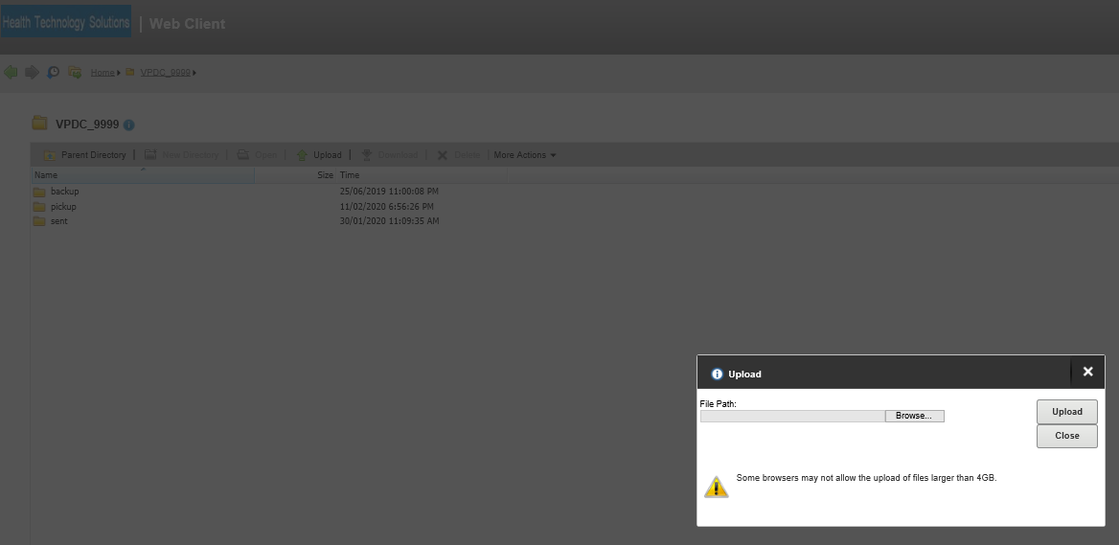
- In the Upload window, click the ‘Browse…’ button and navigate to the directory where your submission files are located.

- Select the submission file to be uploaded. The link to the file will display in the ‘File Path:’ box in the ‘Upload’ window. Check the correct file has been selected and is named in the correct format. If correct, click the ‘Upload’ button.
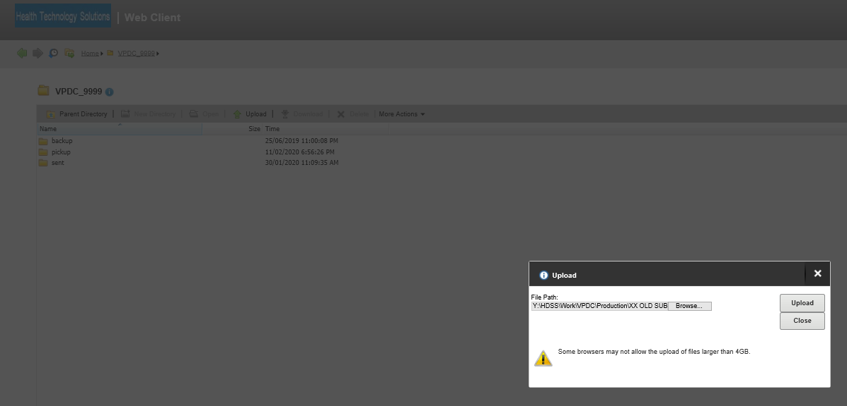
- The File Path box in the Upload window will clear, and you will be able to see the filename of the submission file beneath the three Parent Directory folders. When you can see the filename in this location, click the ‘Close’ button in the Upload window:
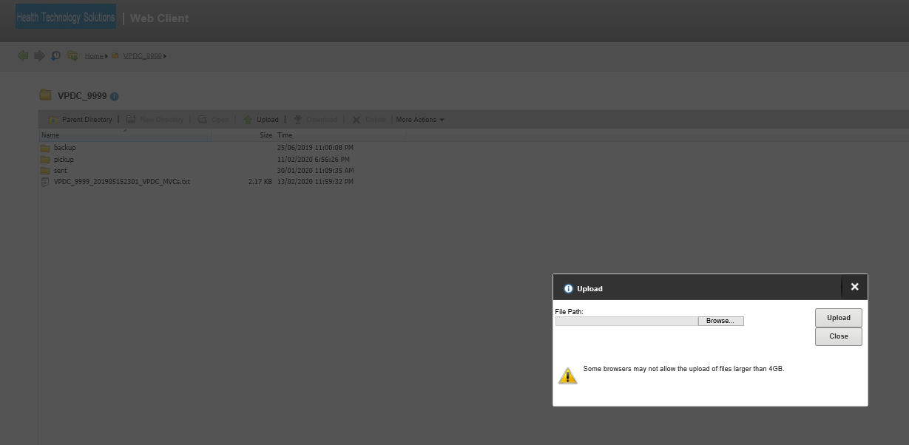
- When the Upload window closes the main screen will appear more clearly, showing the Parent Directory and three folders, as well as the submission file you’ve just loaded, beneath them.

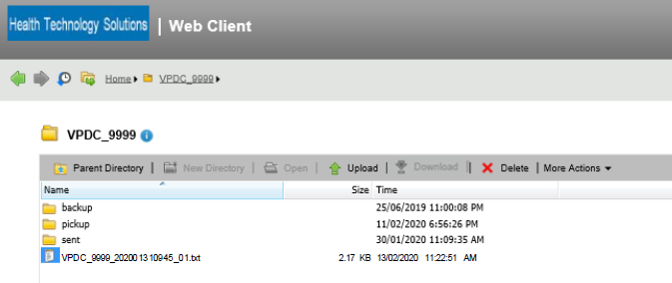
- It is important that the submission file is in this location so it can be detected by the MFT transfer process and forwarded for processing. This will not occur if the file is in a folder.
- When the submission file is uploaded and located correctly, you can log out of the MFT portal: click the ‘logout’ button in the top right corner (grey bar).

Processing the VPDC submission file
- When loaded to the correct location, as described above, the submission file will be detected by the MFT’s automated file transfer process and forwarded to the VPDC production environment where it will be processed against the validations and business rules.
  - Two transmission reports are generated from the processing of each submission file:
Clinician Report (.pdf)
Submitted Data Report (Excel)
The filename of each transmission report includes the filename of the submission file to which it relates.
- The two transmission reports are forwarded to the health service’s MFT portal ‘pickup’ folder, and a copy of the submission file is returned to the MFT portal ‘sent’ folder.
- Submission file processing should be completed, and reports returned, within an hour of submission. If the reports are not received in that time, please contact the HDSS HelpDesk.

VPDC transmission reports
- VPDC transmission report names have the same Submission number and Submission identifier as the submission file to which they relate. They also have the processing timestamp, and the report name, as described above.
- The ‘Clinician report’ shows the number of episodes reported in that submission file, the number of those in which errors (‘rejections’ or ‘warnings’) were identified in accordance with business rules and validations set out in the relevant VPDC manual, and lists all records that generated an error message, along with the error message which details the cause of the rejection.
- The ‘Submitted Data Report’ lists all values reported in each Episode record in the submission file, in Excel format: it can be sorted and filtered to perform data quality checks.

VPDC weekly status reports
- Early each Monday morning, the ‘pickup’ folder in each health service’s MFT portal receives two status reports listing the births reported to the VPDC, and any unresolved rejection errors.
- The ‘Reported Births Summary’ report provides two graphics showing the number of births reported for each date, and lists the births reported in date order by calendar month. This report helps health services identify any births that have not been reported to the VPDC.
- The ‘Outstanding Rejections’ lists the rejection errors that have not been corrected as at the date of the report. This report highlights errors that must still be corrected, and consolidates all outstanding errors across all data submission, which is useful when a site submits multiple files.
- The weekly status reports are accessed in the same way as transmission reports, as described below.

Retention of reports in MFT pickup and backup folders
- Reports in all MFT folders are archived after 35 days whether or not they have been downloaded.
- When reports are downloaded from the ‘Pickup’ folder, a copy is transferred to the ‘Backup’ folder, where it is held for 35 days before being archived.
- Submission files returned to the ‘Sent’ folder after processing are also archived after 35 days. A copy of any submission file should be held on the local server at your hospital.
- MFT archiving is automatic, so users must take care to download files within these timeframes.
- Contact the HDSS HelpDesk if seeking access to a report no longer present in an MFT folder.

Accessing VPDC submission and status reports via the MFT portal
- To access VPDC transmission reports, login to the MFT portal. When in the Home directory, open the Parent Directory for this health service by double clicking on the VPDC folder showing this health service’s campus code (eg VPDC_9999, below):
- After processing, the submission file is returned to the MFT ‘sent’ folder. To access this, after logging in to the Parent Directory, double-click on the ‘sent’ folder name. The filename retains the same Submission number and Submission identifier as the submission file, but when returned after processing, the filename now includes the processing timestamp as well:
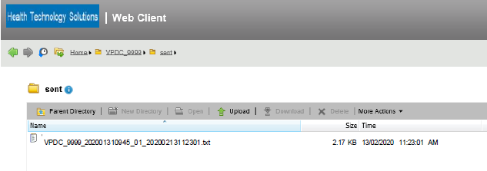
- To close the ‘sent’ folder, double click on the ‘Parent Directory’ folder.
- To access reports, open the ‘pickup’ folder. The two transmission reports are shown:
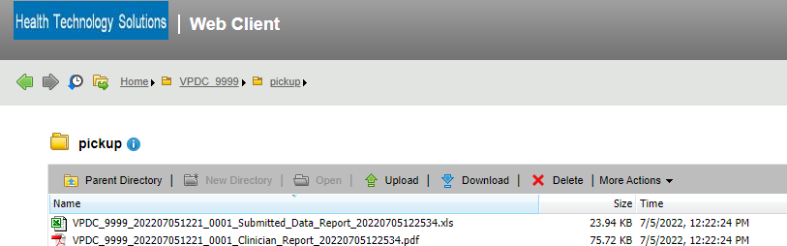
- To review transmission reports, they must be downloaded from the MFT. There are two ways to do this: you can select a single report by clicking on the report filename: this will highlight the report in blue. Then click the ‘Download’ button:
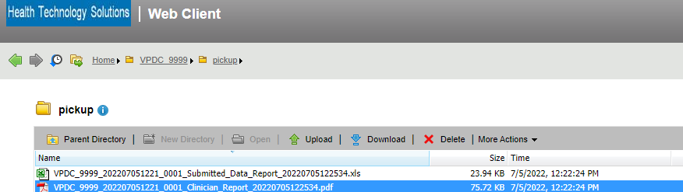
- Alternatively, select the report by right clicking on the report filename: this will highlight the report in blue, and open a drop down list, as below: select ‘Download’.
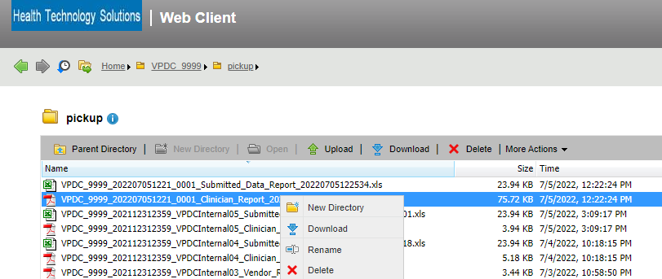

- Both methods of downloading result in a pop up window bar appearing at the base of the screen, as below: select ‘Save’. (If you select select ‘Open’ the report will no longer be accessible in the ‘Pickup’ folder. It will remain in the ‘Backup’ folder for 35 days until archived.)
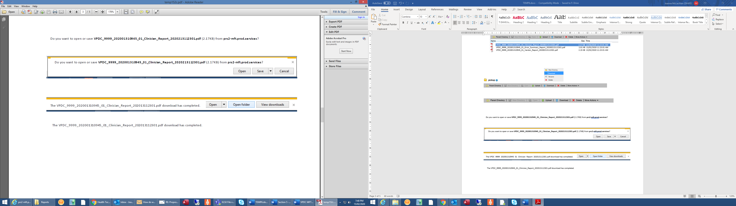
- Another pop up window bar will appear at the base of the screen, with options as below: select ‘Open folder’ to go to your local Downloads folder, where you can select the report file and save it to an appropriate directory with your other VPDC submission reports (not the C:\ drive as these reports contain confidential patient information). Once saved to a secure location, open the file and review the result of the submission’s processing.
- Repeat the steps above to download both transmission reports for each submission file.

Reviewing transmission reports
- The two transmission reports indicate how many birth records were processed in the transmission file, how many were rejected, and the reason/s for those rejection/s. This information helps the user go to the relevant birth record in the health service’s birth information system, correct the error, and resubmit that birth record.
- Check that the number of records submitted is consistent with the number you expected to be sent.
- Using the Clinician Report, check all error messages indicating a record was rejected. The reason/s for any rejections will be listed in detail. All rejections must be checked and the data corrected and then resubmitted.
- Review Section 3 Data definitions and Section 4 Business rules to clarify reporting rules or data code set restrictions.
- Also check any Warning errors: these suggest data submitted which may be inaccurate or where more detail could be available. Check the data items highlighted and if incorrect information has been reported, or more detail is now available, amend the record and resubmit.
- Contact the HDSS HelpDesk by email if unable to identify the cause of any rejection.

Help with using the MFT portal
- Email questions about using the MFT portal to submit VPDC data files, or to retrieve reports, to the HDSS HelpDesk <hdss.helpdesk@health.vic.gov.au>. We will respond in business hours.
- A short tutorial video <https://vimeo.com/629735934/8100600020> shows how to access the MFT portal using the unique MFA code.
- The VPDC Manual is accessible at the VPDC website <https://www.health.vic.gov.au/quality-safety-service/victorian-perinatal-data-collection>. Refer to the version of the manual for the year of the birth you are reporting, as different code sets may apply in different years.

Common problems when uploading files through the MFT
- Submission files uploaded into the wrong location or with an incorrect filename will not be detected or transferred by the MFT.
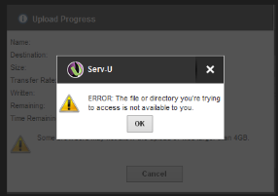
- The following error message is displayed if the user attempts to upload a submission file to the MFT portal when either:
(a) the Parent Directory has not been opened or
(b) one of the three folders in the Parent Directory is open when the file is being uploaded.
- If you encounter this error message, click ‘OK’ and return to the Parent Directory:
- if only the Home screen is displayed, (ie the Parent Directory is not open and the three folders are not visible) double click on the main folder (VPDC_nnnn) to display the Parent Directory and the three folders, then click on the ‘Upload’ button again;
- if any of the folders (Backup, Pickup or Sent) is open, close it by clicking on the Parent Directory, and ensure the Parent Directory and three folders are displayed before clicking on the ‘Upload’ button again.

MFT FAQs
Can I upload multiple files for the same site at the same time?
Yes – as long as each file name is unique. It is advisable to submit one file at a time for the same agency and await processing to determine if corrections need to be included in the subsequent file.
Can one person send a file and another person download the data validation report?
Yes. One user account can submit the data file and another user account can login and collect the validation report file – as long as all required user accounts have been nominated for this site.
How many times can I enter an incorrect MFT password?
You can enter an incorrect MFT password three times. After the third time, your account will be locked for 24 hours. It is not possible to unlock or reset your password if it has been locked.

