

Blood Matters on the Bench and Beyond
Issue 20 – November 2024
OFFICIAL

Welcome to the Blood Matters newsletter for Scientists.

Blood Matters online events 2025
Blood Matters online events are a regular fixture in our education calendar, continuing to support scientists and our multidisciplinary network of transfusion professionals.
There will be a slight reduction in the number of online education events due to a decrease in the program’s funded hours. Information will be sent as dates are finalised throughout the year.

‘STOP the waste’ festive campaign 2024-25
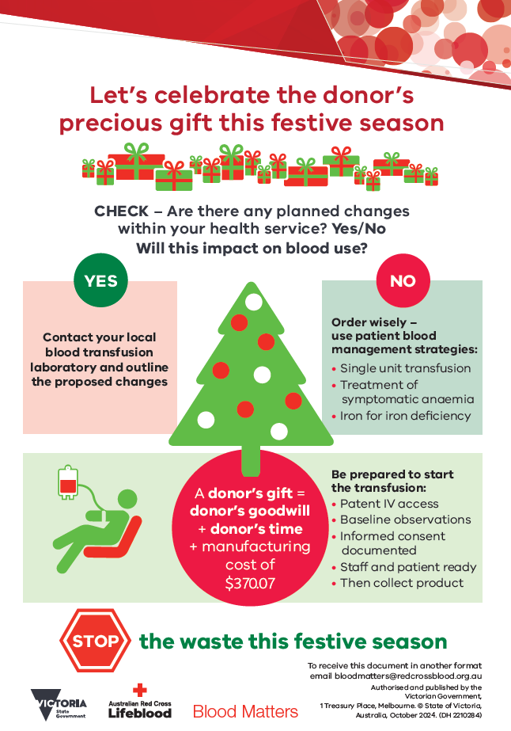
The festive season is fast approaching, and once again it is time for us to consider how we can keep blood wastage to a minimum over this period.
Donated blood is a gift, and we all need to do our part to protect and manage this valuable resource.
Let’s celebrate the donor’s precious gift this festive season.
Are there anticipated changes to activity over the festive season which will impact blood use at your health service?
Adjust inventory accordingly and inform Lifeblood of any anticipated changes to your blood inventory and usage, to assist them to adjust donor collections as required. This will help to ensure sufficiency of the blood supply over the festive season.
Checklists are attached to this email, and available for download from Blood Matters’ Blood component wastage webpage <https://www.health.vic.gov.au/patient-care/blood-component-wastage>
Your continued support of the ‘STOP the waste’ campaign is appreciated.

Changes to cryoprecipitate and cryodepleted plasma packing
Australian Red Cross Lifeblood will be transitioning to split apheresis cryoprecipitate and cryodepleted plasma components from 1 January 2025.
Due to the market withdrawal of a crucial consumable, and the lack of a compatible alternative, Lifeblood is unable to sustain the manufacture of the current large dose apheresis and cryodepleted plasma components.
While the large dose apheresis components will no longer be produced after 31 December 2025, the current large dose apheresis components will continue to be supplied until Lifeblood inventories are exhausted.
Plasma collected by apheresis will be split into three individual units during processing.

Cryoprecipitate dosing
For therapeutic treatment, whole blood derived and the new split apheresis cryoprecipitate (available in 2025) are considered equivalent and interchangeable.
1 split cryoprecipitate unit will be equivalent to 1 whole blood (WB) derived unit.
The recommended adult dose requires the same number of units of either presentation.
At the present time, the recommended adult dose is 10 units of either whole blood or split apheresis cryoprecipitate. The adult dose for the current large (unsplit) apheresis cryoprecipitate is 4 units.

Dual inventory management
Consideration will need to be given as to how dual inventory (large dose and split apheresis) of cryoprecipitate and cryodepleted plasma will be managed during the remaining 12-month shelf life of these products.

Action items
To prepare for the upcoming changes, transfusion laboratories will need to ensure that their laboratory information (LIS) is updated to accommodate the new product which will have new component names and component codes along with their associated ISBT128/CODABAR barcodes.
Please ensure all relevant stakeholders within your organisation are made aware of these upcoming changes.
More information available on Lifeblood Health professionals news webpage <https://www.lifeblood.com.au/news-and-stories/health-professionals-news/cryoprecipitate-and-cryodepleted-plasma-change-coming>.


Recently released Lifeblood courses
Lifeblood’s Clinical Education Team have released new courses to build your transfusion knowledge.
Each module is tailored to suit the needs of healthcare professionals in developing or improving knowledge in the transfusion setting.
More information at lifeblood.com.au/transfusion-courses <https://www.lifeblood.com.au/health-professionals/learn/transfusion-courses>.
Recently released modules are highlighted in italics in the table below.
Transfusion laboratory essentials | Transfusion practitioner microcredentials
Help new scientists and those returning to the workforce to feel safe and confident in their role in a transfusion laboratory.  Intended to complement your mandatory laboratory training programs. | Designed to build and support knowledge of safe transfusion practice and offer a certification of assessed learning.  These microcredentials are ideal if you’re new to transfusion and for existing health professionals who have identified gaps in their skills or knowledge.
Available now:  Module 1. The Australian transfusion community  Module 2. Pretransfusion testing  Module 3. Pretransfusion specimen labelling requirements  Module 4. Blood group systems (ABO, Rh and other) | Available now:  Module 1. Transfusion practitioner role  Module 2. Blood physiology  Module 3. Blood components  Module 4. Decision to transfuse and consent
Coming soon:  Module 5. An introduction to ABO and Rh discrepancies  Module 6. Antibody investigations  There will be 12 self-paced and interactive modules in total. | Coming soon:  Module 5. Blood administration  Module 6. Transfusion adverse events  Module 7. Extending the TP Role


National certification of the medical scientist profession
The Australian Council for Certification of the Medical Laboratory Scientific Workforce (CMLS) was launched in 2020 as a voluntary national professional certification scheme for Medical Laboratory Scientists.
New applications for certification and renewals are processed by the professional bodies providing CPD. Please contact your relevant association for details. More information and links can be found at www.cmls.org.au <https://www.cmls.org.au/>

Why become certified?
- Recognition of our professional standing as part of Australia’s health service workforce.
- Certification will be the best benchmark available to assure competent professional practice.
- With a certified workforce there will be more obligation on the employer to ensure staff have professional development opportunities afforded to them.
- As a nationally certified medical scientist you can demonstrate your ongoing commitment to professional development and self-improvement.
View a short video about the certification scheme (2021) < https://www.youtube.com/watch?v=6Zc4QQJEijs>
Blood Matters is committed to providing support and education to assist in certification of the medical scientific workforce.

How can Blood Matters help you?
The Blood Matters team are here to assist health services and laboratories through education and providing resources.
If you have suggestions for tools and resources that could assist in day to day activities and towards achieving accreditation please let Rae French or any of the Blood Matters team know by email rfrench@redcrossblood.org.au <rfrench@redcrossblood.org.au> or bloodmatters@redcrossblood.org.au <bloodmatters@redcrossblood.org.au> or phone 03 9694 3524.

To receive this document in another format, phone 03 9694 0102, using the National Relay Service 13 36 77 if required, or email Blood Matters <bloodmatters@redcrossblood.org.au>.
Authorised and published by the Victorian Government, 1 Treasury Place, Melbourne.
© State of Victoria, Australia, Department of Health, November 2024.
ISSN 2652-7278 – Online (pdf / word)
Available at Blood Matters <https://www.health.vic.gov.au/patient-care/transfusion-science-and-blood-stewardship>

