

Blood Matters on the Bench and Beyond
Issue 19 – September 2024
OFFICIAL

Welcome to the Blood Matters newsletter for Scientists.


Blood management summit for scientists

Wednesday 18 September 2024
Lifeblood, Melbourne Processing Centre. Level 1, Meeting rooms 5-8.
100-154 Batman Street, West Melbourne, VIC 3003

Registration prior to the event is required
Register quickly as there is limited space available for in-person attendance. In-person attendance is encouraged, it will provide a better participant experience and networking opportunities. Virtual attendance is also possible for those who cannot attend in person

Click here < https://www.trybooking.com/events/landing/1260172>
or scan QR code to register

A program is attached to this email.
Please note to allow the summit to go ahead with budget constraints, lunch is not provided.

Important upcoming BloodPortal security updates

On 15 September 2024, the National Blood Authority (NBA) will be enhancing the security of the Blood Sector Systems (BSS).
Multi Factor Authentication (MFA) will be implemented for all BloodPortal accounts to comply with the Australian Government security strategies and to mitigate cyber security incidents.
- MFA will mean an authentication code will need to be entered in addition to your Username and Password to log in to BloodPortal (BloodNet and BloodSTAR) accounts. More information on MFA can be found at the Australian Cyber Security Centre webpage <https://www.cyber.gov.au/protect-yourself/resources-protect-yourself/personal-security-guides/protect-yourself-multi-factor-authentication>.
- MFA can be sent to:
  - your registered mobile phone number (SMS, six-digit code)
  - your registered email address (six-digit code)
  - Okta Verify App (six-digit code)
  - Okta Verify App (push notification)
The mobile and email you use for authentication must be the same as your Blood Sector Systems account.

BloodPortal user account management
- BloodPortal accounts that have not been used or accessed for >45 days will become inactivated.
- BloodNet and BloodSTAR facility access which has not been used in >45 days will become inactivated.
- ‘Generic’ accounts which are not linked to any individual person but are being used by multiple users will become inactivated.
Inactivated accounts can be reactivated via a user-initiated password reset within 12 months of the last login. A notification will be sent to all users of the intent to inactivate a user account.
- Accounts that have not been used in 12 months will be archived.
The Terms and Conditions will be amended to reflect these changes and user support materials and resources will be updated, including BloodPortal training and the NBA website.

Action items
- Review and update your user details before changes are implemented (including security questions, phone number, mobile number, and email). This can be done through BloodPortal Account Management.
- Consideration of how the changes might impact the use of BloodNet, particularly where staff at your facility share accounts or use their access infrequently.
- Okta Verify App can be downloaded on your mobile device now, ahead of the upcoming changes. The app however will not be able to be linked to your Blood Sector Systems account until 15 September.
- Web-based email options may be available to access your one-time codes. Talk to your manager and/or IT department prior to 15 September.

Visual inspection of platelets prior to transfusion
Lifeblood has sent a reminder to transfusion laboratories and clinical staff of the importance of visual inspection of platelet components in avoiding transfusion-transmitted bacterial infections.
Bacterial contamination of platelets is an uncommon but potentially serious complication of transfusion. Visual inspection of platelets by hospital laboratory staff prior to issue to a patient, and clinical staff prior to transfusion, is an important step in preventing transfusion-transmitted bacterial contamination.
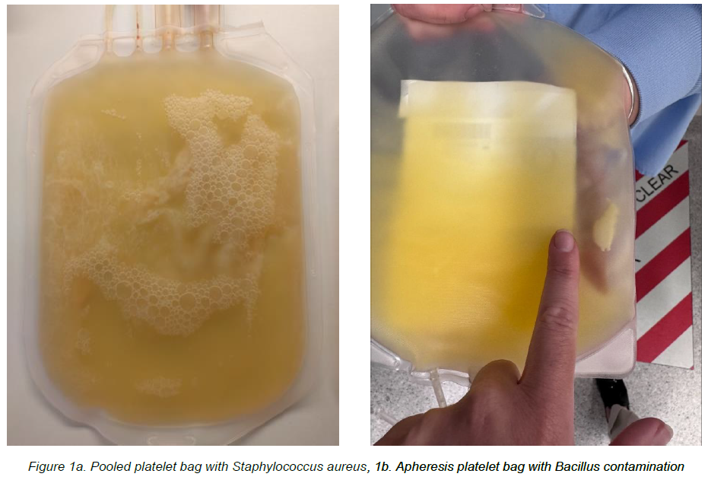
Changes that are associated with bacterial contamination include gas formation, clots or aggregates and unusual odour. These changes in appearance can start at any time during the valid shelf-life of the platelet component and can progress rapidly.
See attached letter from Lifeblood for more information.

Lifeblood Customer Letter – Visual Inspection of Platelets Prior to Transfusion (Aug 2024)

Lifeblood Blood Component Information (BCI) 2024 edition
The BCI is an important and informative guide that describes the blood components produced by Lifeblood and functions like a package insert that accompanies medications. This resource includes a description of:
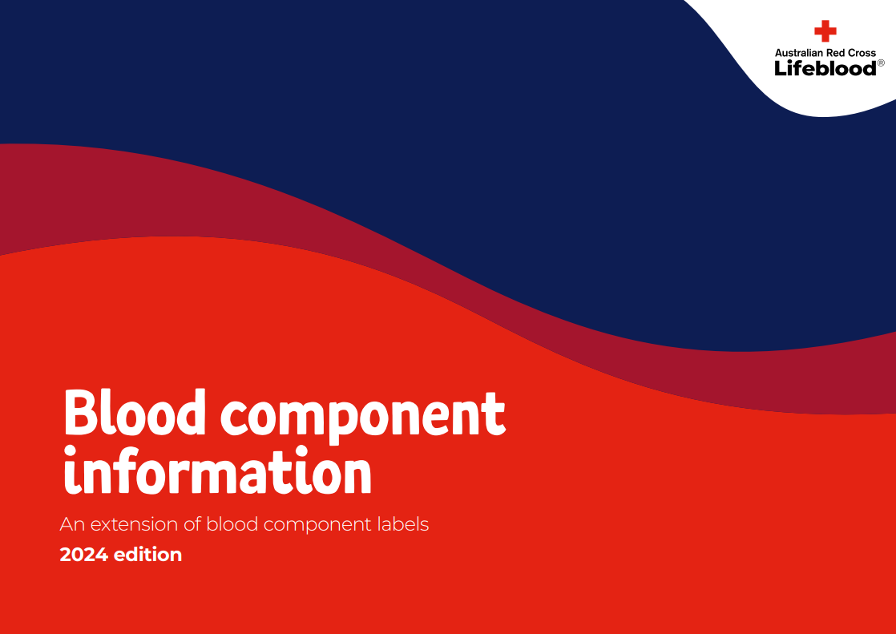
- the blood collection process
- critical manufacturing steps
- anticoagulants and additive solutions
- requirements for storage, transport, and handling
- component specifications and typical unit contents
- clinical indications for use
- potential adverse reactions and
- administration methods.

The BCI can be downloaded from Lifeblood <https://www.lifeblood.com.au/sites/default/files/resource-library/2024-08/Blood_Component_Information_2.0_0.pdf>.

Use of intravenous albumin guideline
The International Collaboration for Transfusion Medicine Guidelines (ICTMG) have recently published a guideline on the use of intravenous albumin.
The ICTMG, comprising a panel of neonatal, paediatric, and adult specialists with expertise in the use of albumin, developed these guidelines to provide clinicians with actionable evidence-based recommendations for the appropriate use of intravenous albumin.
Click here to download the guidelines <https://journal.chestnet.org/article/S0012-3692(24)00285-X/fulltext>.

Blood 2024

27-30 October 2024, Brisbane
Blood 2024 is the combined Annual Scientific Meeting of the:
- Haematology Society of Australia and New Zealand
- Australian and New Zealand Society of Blood Transfusion
- Thrombosis and Haemostasis society of Australia and New Zealand

Registrations are open
Register on the Blood 2024 webpage < https://www.blood2024.com/register-for-the-meeting>.


National certification of the medical scientist profession
The Australian Council for Certification of the Medical Laboratory Scientific Workforce (CMLS) was launched in 2020 as a voluntary national professional certification scheme for Medical Laboratory Scientists.
New applications for certification and renewals are processed by the professional bodies providing CPD. Please contact your relevant association for details. More information and links can be found at www.cmls.org.au. < https://www.cmls.org.au/>

Why become certified?
- Recognition of our professional standing as part of Australia’s health service workforce.
- Certification will be the best benchmark available to assure competent professional practice.
- With a certified workforce there will be more obligation on the employer to ensure staff have professional development opportunities afforded to them.
- As a nationally certified medical scientist you can demonstrate your ongoing commitment to professional development and self-improvement.
View a short video about the certification scheme (2021) < https://www.youtube.com/watch?v=6Zc4QQJEijs>
Blood Matters is committed to providing support and education to assist in certification of the medical scientific workforce.

How can Blood Matters help you?
The Blood Matters team are here to assist health services and laboratories through education and providing resources.
If you have suggestions for tools and resources that could assist in day to day activities and towards achieving accreditation please let Rae French or any of the Blood Matters team know by email rfrench@redcrossblood.org.au <rfrench@redcrossblood.org.au> or bloodmatters@redcrossblood.org.au <bloodmatters@redcrossblood.org.au> or phone 03 9694 3524.

To receive this document in another format, phone 03 9694 0102, using the National Relay Service 13 36 77 if required, or email Blood Matters <bloodmatters@redcrossblood.org.au>.
Authorised and published by the Victorian Government, 1 Treasury Place, Melbourne.
© State of Victoria, Australia, Department of Health, September 2024.
ISSN 2652-7278 – Online (pdf / word)
Available at Blood Matters <https://www.health.vic.gov.au/patient-care/transfusion-science-and-blood-stewardship>

