


Maternal and Child Health Service Guideline Update
Title: Practice Note - Creating and Deactivating CDIS Users
OFFICIAL
Description | To define the mandatory process for creating and deactivating CDIS users. CDIS users includes agency staff contracted to deliver Maternal and Child Health services in Victoria.
This practice note applies to: | All MCH Service Providers  All Aboriginal MCH Service Providers
Status | Mandatory
Authorisation | Department of Health
Implementation date | 16/10/2024

Contents

Aim 1
Implementation 1
Responsibilities 2
Relevant legislation and protocols 2
Process for Creating and Deactivating CDIS Accounts 3
CDIS New User Creation Checklist 4
CDIS New User Creation Summary Instructions 4
CDIS Deactivate (Close) Users Account Checklist 6
CDIS Deactivate User Summary Instructions 6
CDIS New User Request Form 8
CDIS Deactivate User Request Form 11
Example CDIS New User Request Form 12
Example CDIS Deactivate User Request Form 13
Appendix A. Detailed Instructions: Create new CDIS user 14
Appendix B. Detailed Instructions: Deactivate CDIS user 20
Appendix C. Adding or Removing Sites, Centres & Calendars 22
Adding Sites to User Accounts 22
Removing Sites from User Accounts 26

Aim
The purpose of this practice note is to define the mandatory processes that must be used by all MCH service providers when creating or closing a user account in the Child Development Information System (CDIS). The mandatory process exists to protect electronic client information and ensure data security when creating new CDIS user accounts for CDIS users. This includes employed or contracted users (e.g., via Agency) and de-activating or closing CDIS accounts when employment or contract engagement has ended.
CDIS is the approved client information management system for the Maternal and Child Health (MCH) Service. It is the health record of the child, parent and/or carer/s, and contains personal, sensitive health information. Access to and use of CDIS by all approved users must comply with relevant legislation, regulations, privacy principles and professional code of conduct as outlined in the Maternal and Child Health Service Guidelines (2019), Maternal and child health service practice guidelines | health.vic.gov.au <https://www.health.vic.gov.au/publications/maternal-and-child-health-service-practice-guidelines>.

Implementation
All Local Government Area (LGA) authorised Maternal and Child Heath (MCH) service providers and Aboriginal Maternal and Child Health service providers are responsible for maintaining the security of employee accounts. Security of accounts is achieved through education of users, following on appropriate creation and deactivation procedures, and advising the Department of Health (the department) of any issues they experience.
CDIS Support, contactable via cdis@support.vic.gov.au can provide support to all service providers who may require assistance fulfilling this direction if local resources are limited or unavailable.

Responsibilities
MCH service providers and Aboriginal MCH service providers are responsible for:
- Maintaining confidentiality of client health information, including passwords or information required to access the client health record.
- Taking appropriate and reasonable steps to protect the personal information it holds from misuse, loss, from unauthorised access, modification, and disclosure.
- Ensuring employee emails are unique and not shared.
- Ensure that when staff are provided an CDIS user account, it is created with an organisation email address provided by the MCH service. The use of a personal email address is not compliant with this directive. This includes Agency staff.
- Ensure CDIS accounts only ever contain email addresses licensed by the MCH Service Provider. If they are ever to be updated, or changed, this must only be with an organisation email address provided by the MCH service.
- Ensuring passwords are compliant, not shared with anyone.
- Do not save your username or password, when prompted, in any Internet browser.
- Ensuring when staff leave the organisation, their CDIS accounts are de-activated completely.
- Ensuring that staff who take long service leave, parental leave, extended sick or carers leave have their accounts temporarily deactivated. These accounts can be reactivated on return from leave if they return to their former role which includes the use of CDIS.
- Ensuring when staff have a change of name change (e.g. married, divorced, gender re-assignment that includes registering a new name), best practice is maintained. This means their current CDIS accounts are de-activated, and they are supplied a new CDIS account. This process is required, because any change of name will retrospectively update all client health records in CDIS, completed by that CDIS user and will note their new name. This will inaccurately reflect the service delivery performed at the time for that client.
- Ensuring when staff have a change of role (e.g. Clinician to Clinical Coordinator), best practice is maintained. This means their CDIS accounts are deactivated, and they are supplied a new CDIS account. This process is required, because any change of role will retrospectively update all client health records in CDIS, completed by that CDIS user and will note their new role. This will inaccurately reflect the service delivery performed at the time for that client.

Relevant legislation and protocols
The process outlined in this practice note is consistent with obligations and agreements set out in:
- Health Records Act 2001
- Privacy and Data Protection Act 2014
- Freedom of Information Act 1982
- Public Records Act 1973
Protocols
- MCH Service Guidelines 2019
- MCH Program Standards 2011
- MCH Documentation Standards 2015
- Child Development Information System (CDIS) Back-To-Back Agreements

Process for Creating and Deactivating CDIS Accounts
There are four situations that may trigger either creating a new user, re-activating a user on leave, or de-activating (closing) a CDIS account temporarily or permanently:
- Activate / create a new user account.
- De-activate / close an existing staff account (making it ‘inactive’), and creating a new account, for a staff member who has changed their name or role and creating a new account.
- De-activate / close a staff member’s account because of extended leave (e.g., parental leave, long-service service) – temporarily deactivating their account. In CDIS this is making their account “inactive”.
- De-activate / close staff permanently (e.g., employee departure, termination) – permanently de-activating their account. In CDIS this is making their account “inactive”.

CDIS New User Creation Checklist
Review your organisation’s ‘new user’ advice. The information on the CDIS New User Request Form will assist with collection of information for you to create CDIS accounts, and page 2 of this form may support you to assign the appropriate Discipline and Role and may be used to support local requirements, AHPRA Registrations etc. This form is required if you are submitting new user request to CDIS Support.
- Confirm that the person’s Organisation email address has been completed for the new user and is working.
- When the CDIS account is created, CDIS will generate and send an email with the username and password directly to mail account of the new user.
- CDIS user accounts cannot be created using personal email addresses, including agency staff. Personal or non-organisation email addresses are not secure and contradict legislation, agreements, and guidelines. All CDIS accounts must use email addresses licensed by the MCH Service Provider.
- Know your organisation’s naming conventions for the CDIS ‘User Name’ before commencing creation of the CDIS account. You cannot save the new user as a draft; you will need to cancel and start again.
- If you are creating an account for a staff member who changed their name or role, and they have not been issued a new email address, you will need to be sure their old CDIS account is properly de-activated. CDIS will not allow any single email address to be used for two active users.
- Check that all the mandatory information for CDIS is provided. Guidance of this advice is included in the CDIS New User Request Form. An example pre-populated form is available on Example CDIS New User Request Form.
- Follow the Summary Instructions below. For detailed guidance, you can refer to Appendix A. Detailed Instructions: Create new CDIS user.

CDIS New User Creation Summary Instructions
Pre-requisites: The following CDIS roles are authorised and have appropriate permission to create user accounts in CDIS. These roles may not exist in all organisations but are the CDIS roles with administrative access to perform these functions.
- System Administrator – Council
- Clinical Coordinator
- IT Support - Council

- Login to CDIS.
- From CDIS home screen, select menu option Administration > Employee Administration.
- Check if the new CDIS user has an active account.
- Check if the new CDIS user has an inactive account. You may re-activate this account if the staff member has the same Discipline and the same Name. If they have a different Discipline or a different Name, create a new CDIS user account.
- If user account does not exist, Click the Add New Employee button.
- Enter all the new staff details from the CDIS New User Request Form, referring to the Detailed Instructions outlined below.
- When all details are entered, click the Save button. Clicking ‘save’ will trigger the User Name and password to be automatically emailed to the new user’s email address.
- The system will return you to the Employee Administration Screen. For the newly created CDIS account, click the PLUS expansion button.
- Add the MCH Service, select all required Sites/Centres. Refer to the section Adding or Removing Sites, Centres & Calendars as needed.
- Re-open the new user account and ensure the ‘Current Site’ matches the one on the CDIS New User Request Form.
If there are no sites listed on the form, choose one, and save the record. This is required to maintain system functionality and can be updated by the user or their manager later. If you updated this, click save. If it was accurate and you did not change anything, click Cancel.

CDIS Deactivate (Close) Users Account Checklist
De-activate (close) checklist for staff on extended leave (e.g., parental leave, long-service service)
Use this checklist for staff that will be returning to work and using their same CDIS account.
- Review your organisation’s ‘leave advice’ or ‘termination process’. The information in the CDIS De-activate User Request Form may assist you to complete deactivating users. This form should be filled in before submitting a request to CDIS Support, if you require support with deactivating users.
- Record the staff member’s CDIS username somewhere, so it can be re-used when the staff member returns from leave. The information in the CDIS De-activate User Request Form may assist you to complete this task, or refer to Example CDIS De-activate User Request Form.
- To ensure the account is temporarily deactivated properly, use the Summary Instructions below. For detailed guidance, you can refer, you can refer to the Appendix B. Detailed Instructions: Deactivate CDIS user as required.

De-activate (close) checklist for staff departures (e.g., contract end, termination), or staff with change of name or change of CDIS Discipline.
Use this checklist for staff that will not be returning to work or staff requiring a new user account.
- Review your organisation’s staff departure/termination advice. The CDIS Deactivate User Request Form may assist you to complete this task and should be filled in if you’re submitting the deactivation request to CDIS Support.
- Record the staff member’s CDIS username somewhere, if it will be re-used in their new account. The information in the CDIS De-activate User Request Form may assist you to complete this task, or refer to Example CDIS De-activate User Request Form.
- Follow your organisation’s personnel departure instructions. Use the Summary Instructions below, to ensure complete and permanent deactivation (closure) of the CDIS account. For detailed guidance, you can refer to the Appendix B. Detailed Instructions: Deactivate CDIS user as required.

CDIS Deactivate User Summary Instructions
Pre-requisites: The following CDIS roles are authorised and have appropriate permission to close user accounts in CDIS. These roles may not exist in all organisations but are the CDIS roles with administrative access to perform these functions.
- System Administrator – Council
- Clinical Coordinator
- IT Support - Council
- Log in to CDIS with your authorise username and password
- From CDIS home screen, select menu option Administration > Employee Administration.
- Search for the CDIS user; they should have an active account.
NB: If they do not have an active account, they may have already been de-activated. Tick the show inactive employees checkbox. If they appear in this list, they have already been deactivated.
- Update all the staff details from your organisations forms or use the CDIS Deactivate User Request Form. refer to the Detailed Instructions if needed.
- When this is completed, click the Save button.
- You will be returned to the Employee Administration Screen.
- If you have followed all the steps completely, the user account will not be listed on the Employee Administration Screen amongst the active users listed. Tick the show inactive employees checkbox to confirm the account is inactive.
CDIS New User Request Form
NB: Use this form to assist with recording details for creating new users. If your service is unable to create CDIS accounts, this is the minimum information to collect before submitting requests to CDIS Support.
If you are not a Team Leader, MCH Coordinator or Manager, please ensure that the Approver is copied into any emailed request to CDIS Support.
- Items marked with the asterisk * are mandatory.
- All other items are not mandatory for CDIS but may be for your organisation.
- Link to an Example CDIS New User Request Form.
MCH Service/Council Name: _______________
MCH Coordinator/Team Leader/Manager approving this request: ___________________
CDIS Account Information
*First Name:
*Last Name*
Birth date
*E-mail:
Work Phone
*Mobile Phone:
Qualifications:
Position:
*MCH Service
*Sites/Calendars:
*Current Site:
*Discipline: See CDIS Disciplines
*Gender:
Manager:
AHPRA Nurse Registration Number (Division 1)
AHPRA Midwife Registration Number
APHRA Aboriginal Health Practitioner Number
*Clinician: (Yes or No)
*User Name:
*Start Date:
End Date:
*Role: See CDIS Roles
Completed By (Name / Title):
Date Completed:

CDIS Disciplines
NB: only one Discipline can and must be selected.
- MCH Nurse
- MCH Coordinator
- MCH Student Model Nurse
- Midwife
- Breastfeeding Support
- Enhanced maternal Child Health Nurse
- Enhanced maternal Child Health Worker
- Aboriginal Health Practitioner
- Aboriginal Support Worker
- Family Support Worker
- Parent Support worker
- Early Years Development Officer
- Program Support Office
- Lactation Consultant
- Educator
- Office Administrator
- Team Leader
- Manager
- System Administrator

CDIS Roles
NB: Only one Role can and must be, selected. Access should be granted relevant to the employee’s job description to support them in completing their duties.
- System Administrator – Council
- Clinical Coordinator
- Clinician
- Office Admin
- Executive
- IT Support – Council

Guidance – See Table 1
- Every active CDIS account incurs an annual license fee.
- Executive roles can run reports but to save license fees these reports could be run by an existing CDIS user. To meet the requirements of the Health Records Act deidentified data only can be used by an Executive.
- Many MCH Services mistakenly provide the MCH Clinical Coordinator with ‘System Administrator – Council’ access. There should only be one or two CDIS users with this role as needed by the organisation.
- Clinicians and Clinical Coordinator roles have access to personal information about clients.

 | Role | Clinician | Office Admin | Clinical Coordinator | Executive | System Administrator – Council | IT Support – Council
Discipline | Notes |  |  |  | For non-clinical MCH Managers |  | For IT Support Staff
MCH Nurse |  | ü |  |  |  | Yes - if a sole practitioner at the Service
MCH Coordinator |  |  |  | ü | Yes - For non-clinical MCH  Coordinators | Yes - if a sole practitioner at the Service
MCH Student Model Nurse |  | ü
Midwife |  | ü
Breastfeeding Support |  | ü
Enhanced maternal Child Health Nurse |  | ü
Enhanced maternal Child Health Worker |  | ü
Aboriginal Health Practitioner |  | ü
Aboriginal Support Worker |  | ü
Family Support Worker |  | ü
Parent Support worker |  | ü
Early Years Development Officer | If employed within MCH Team | ü
Program Support Office | If employed within MCH Team | ü
Lactation Consultant |  | ü
Educator |  | ü |  | Yes - if the Educator is in a Leadership role.
Office Administrator |  |  | ü
Team Leader |  | ü |  | Yes - if an MCH Clinician
Manager |  |  |  | Yes - if an MCH Clinician | Yes - if an MCH Clinician
Table 1 – Guidance for Disciplines with appropriate CDIS access (roles)

CDIS Deactivate User Request Form
NB: Use this form to assist you with recording details for deactivation users, or if your service is unable to make CDIS accounts inactive, this is the minimum information required before sending to CDIS Support.
If you are not a Team Leader, MCH Coordinator or Manager, please ensure that the Approver is copied into any emailed request to CDIS Support.
- Items marked with the asterisk * are mandatory.
- All other Items are not mandatory fields for CDIS but may be for your organisation.
- Link to an Example CDIS De-activate User Request Form.

MCH Service/Council Name: _______________
MCH Coordinator/Team Leader/Manager approving this request: ___________________
CDIS Account Information
*First Name:
*Last Name*
Birth date
*E-mail:
Work Phone
*Mobile Phone:
Qualifications:
Position:
*MCH Service
*Sites/Calendars:
*Current Site:
*Discipline: See CDIS Disciplines
*Gender:
Manager:
*Clinician: (Yes or No)
*User Name:
*Start Date:
* End Date:
*Role: See CDIS Roles
Completed By (Name / Title):
Date Completed:

Example CDIS New User Request Form
This form has been populated with Example information.
MCH Service/Council Name: West Melbourne Council
MCH Coordinator/Team Leader approving this request: Jane Black

CDIS Account Information | Example only
*First Name: | John
*Last Name* | Smith
*E-mail: | John.smith@MCHService.gov.au
*Mobile Phone: | 0414123456
Position: NB: This is not mandatory and is a job title. Can be the same as Discipline. | MCH Nurse
*MCH Service | MCH Name
Current Site: | Site A
NB: This may have to be updated following the completion of the user account. See detailed instructions for guidance.
*Discipline: | MCH Nurse
Gender: | Not stated
Manager: NB: Optional  Please choose an appropriate person if available in drop down list or leave blank | Mary Jane
AHPRA Nurse Registration Number (Division 1) | ABC0001006938  Can be entered if known or left for the employee to update in CDIS (Menu: User Settings > Update Details).
AHPRA Midwife Registration Number
APHRA Aboriginal Health Practitioner Number
*Clinician: (Yes or No) | Yes
*User Name: | John-S
End Date:  - Temporary/Agency staff use their contract end date. | 01/01/9999 (If no contract end date (i.e., Permanent departure), set this to 01/01/9999)
*Role: | Clinician
This section can be used for administration / internal governance, noting who is creating the account
Completed By (Name / Title): | John Blogs – Team Leader
Date Completed: | 20/07/2023

Example CDIS Deactivate User Request Form
This form has been populated with Example information.
MCH Service/Council Name: West Melbourne Council
MCH Coordinator/Team Leader approving this request: Jane Black

CDIS Account Information | Example
*First Name: | John
*Last Name* | Smith
*E-mail: | John.smith@MCHService.gov.au
*Mobile Phone: | 0414123456
Position: | MCH Nurse
*MCH Service | MCH Name
Current Site: NB: Optional. | Site A
NB: This may be useful if the CDIS user is returning after leave, or to perform another contract. However, if that is the case this should be updated in CDIS in accordance with their work, when the staff member returns.
*Discipline: | MCH Nurse
Manager:
*Clinician: (Yes or No) | Yes
*User Name: This must be noted, so that if the staff member returns, the same User Name can be used. This is also useful for staff changing names, or changing roles as their user name can be re-used on their new account. | John-S
End Date: Select the appropriate scenario (examples provided):  - Temporary/Agency staff use their contract end date.  - For staff on temporary leave, set this end date to the last day of their planned leave. When they return, clear the ‘end date’ in CDIS, and set to 01/01/9999 | - 21/12/23  - Planned leave end date
*Role: | Clinical Coordinator
This section can be used for administration, to record details to support you re-activating the account and internal governance.
*End Date Reason: To be provided by the person requesting the account be deactivated | Example reasons: temp / agency staff contract complete, parental leave, long service leave, extended sick leave, staff name change, staff role change.
*[Return] Start Date: If staff are due to return, schedule a reminder to check with the requestor prior to re-commencement to confirm the date, and update CDIS, closer to that time, clearing the end date
This section can be used for administration / internal governance, noting who is creating the account
Completed By (Name / Title): | John Blogs – Senior IT Support Officer
Date Completed: | 20/07/2023

Appendix A. Detailed Instructions: Create new CDIS user
- Log into CDIS with your authorised username and password
- From CDIS home screen, select menu option Administration > Employee Administration.
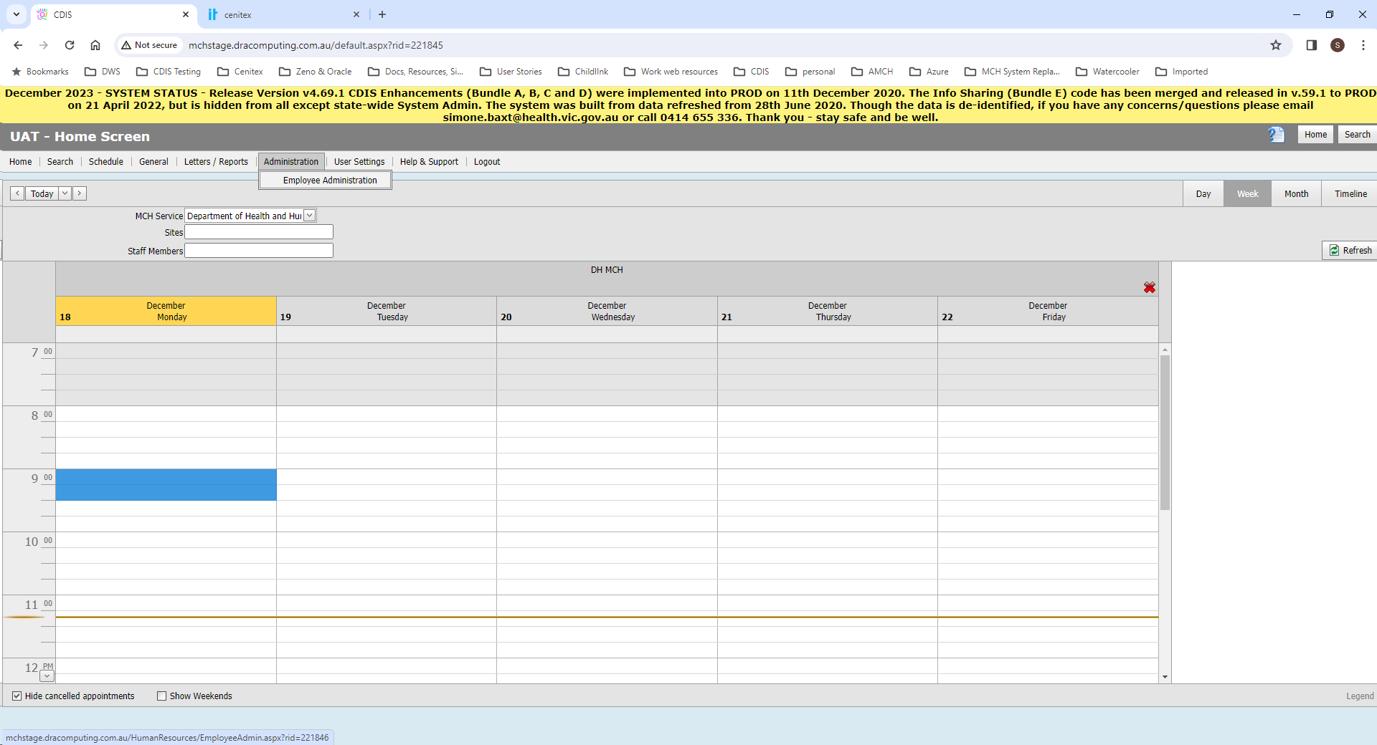
Image 1 – Accessing the CDSI Employee Administration Screen

- Check if the new CDIS user has an active account. Type the surname of the user in the search box. If nothing happens wait for the screen to refresh or click “Filter’. If no user exists, you will see the message “No data to display”. If a user with the same surname exists, cross check that they are not the new user you’re creating.
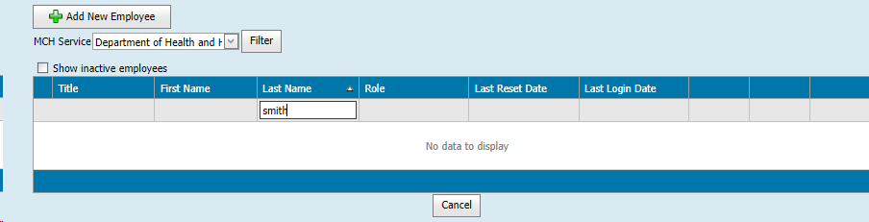
Image 2 – CDIS Employee Administration Screen: Searching Active Users

- Check to view if the new CDIS user has an inactive account. Tick the ‘Show inactive employees’ checkbox, with the surname still in the search field. If no user exists, you will see the message “No data to display”.
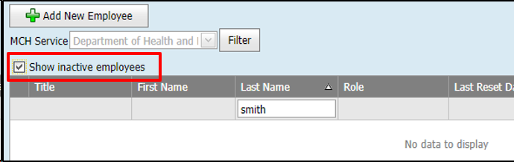
Image 3 – CDIS Employee Administration Screen: Searching Inactive Users

- If a user with the same surname exists, click Update to cross check that they are not the user you’re creating. Click Cancel to return to Employee Admin screen
NB: If the new CDIS user has an existing inactive account:
- If the staff member has a different Discipline, or different Name, you need to create a new CDIS user account.
- You may re-activate an inactive account if the staff member has the same Discipline. If the Discipline is the same, check all the information in the form is correct in the system, and proceed to step 7.
- You may be able to re-active this account if appropriate e.g., staff returning from long service leave, parental leave. If this is the case, check all the information in the form is correct in the system, and proceed to step 7.
- If no user account exists, Click the Add New Employee button.
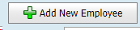
Image 4 - CDIS Add New Employee button

- Enter the staff details, from the CDIS New User Request Form, or using your internal form.
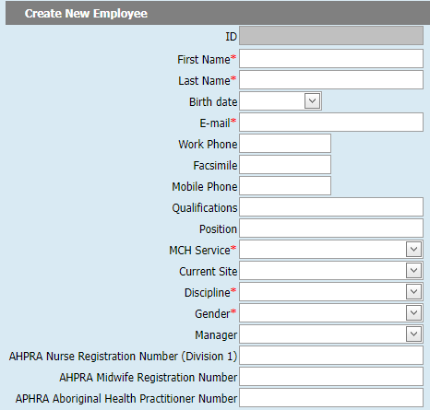
Image 5 - CDIS New Employee screen

- When you get to this section:
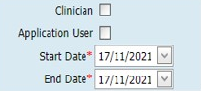
Image 6 - CDIS Clinician checkbox, Application User checkbox, start date and end date

- For Clinicians, tick both the ‘Clinician’ and ‘Application User’ checkboxes (see image 7).
- For users that are not Clinicians tick the ‘Application User’ checkbox only (see image 8).
- The start date should be the first date of employment in the role.
- The end date should be set as noted on the form; if no end date is noted, keep the default CDIS end date which is set to 01/01/9999.
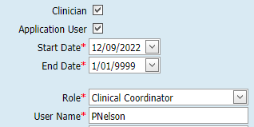
Image 7 – CDIS Clinical Coordinator (active user): Clinician checkbox and Application User checkbox are both ticked, start and end dates set appropriately
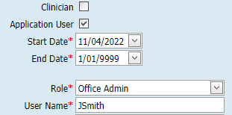
Image 8 – CDIS Admin user (active user): Clinician checkbox unticked and Application User checkbox is ticked, start and end dates set appropriately

- After ticking the ‘Application User’ checkbox, the following dialogue box will become available on the screen. Only fill out the Role and User Name fields, using the information from the CDIS New User Request Form, or your own internal form, and following your Organisations user naming conventions.
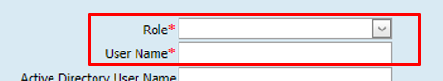
Image 9 – CDIS Role and User Name
- When complete, click the Save button. (The User Name and password will be automatically emailed to the email address entered).
- You will be returned to the Employee Administration Screen. Search for the newly created CDIS account by typing their surname in the search box. The screen will take a moment to search for the account. Once the account is listed, follow these next steps.
The next instructions are from the Appendix C Adding or Removing Sites, Centres & Calendars section of this document.
- Click the + Add MCH Service button, and an ‘MCH Service’ section will appear.
- Use the drop-down arrow to select your MCH service.
- Click the + Add Site button.
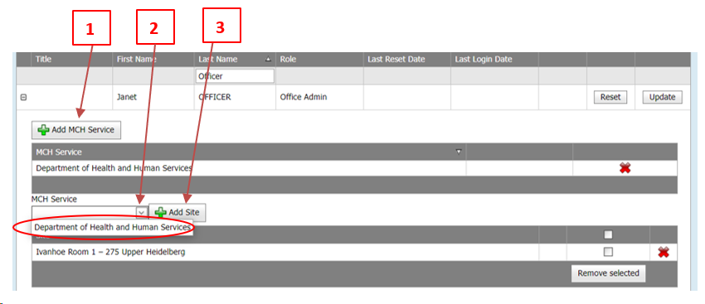
Image 10 – Managing sites for CDIS users, in the Employee Administration Screen

- Within the Site Section, click on the drop-down arrow, and a pop-up selection window, with all the sites in the MCH Service will appear. Select the site(s) listed in the new user request form, as this is required to complete the creation of the user account. This can also be updated later. NB: Under the pop-up box, all the sites the user currently has access to, if any, will be listed.
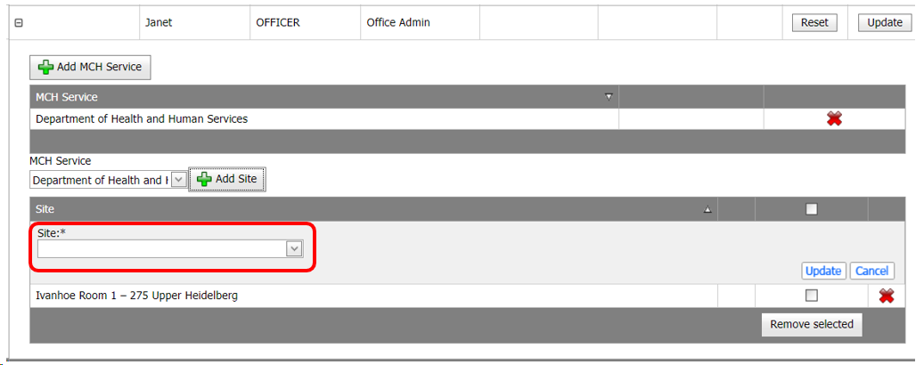 | 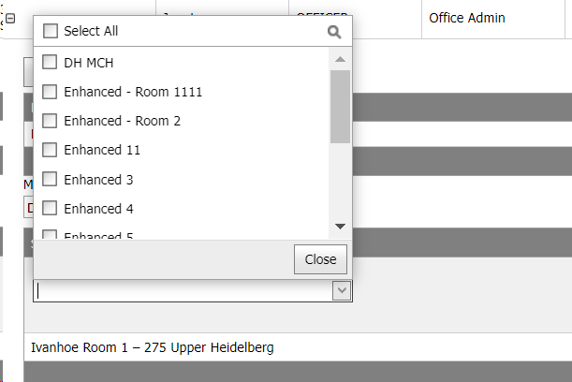
Image 11 – Site drop down list | Image 12 – Scroll through the site list

- Scroll through the list, using the toggle bar on the right, and tick the checkbox for each site the user should have access to. Alternatively, use the “Select All’ checkbox at the top if the user should have access to all sites. This is unusual in larger MCH Services but may be needed when setting up accounts for ‘Clinical Coordinator’, or ‘System Administrator - Council’ users.
- When you have finished, click the Close button, and all the sites you selected will be populated into the Sites Drop-down box.

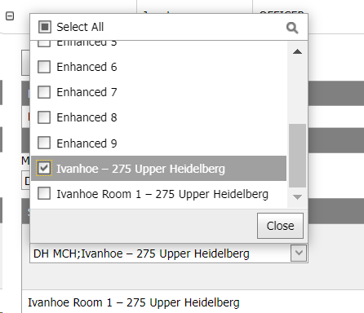 | 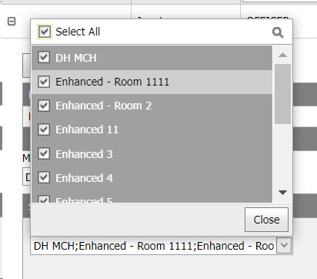
Image 13 – Select site(s) from the list | Image 14 – Once selected, click Close
- Finally, click ‘Update’ to complete the action of adding all the selected sites to the User Account.
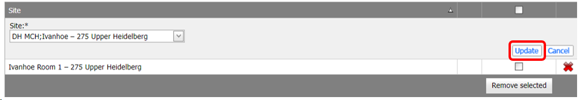
Image 15 – Click Update to complete the action of adding all the selected sites to the User Account

- When the update is complete, you will see all the sites listed for the user (under the user’s name) in this Employee Administration screen.
- Finally, to check the user has their Current Site set correctly within their account details, click the ‘Update’ button to open their account.
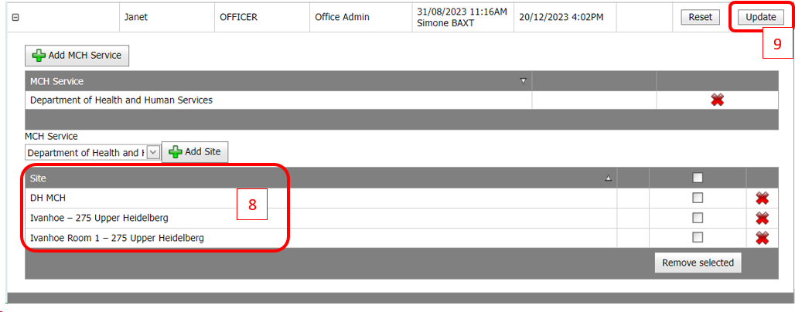
Image 16 – Sites listed that the CDIS user has access to use

- Check the user account’s Current Site and update as necessary. Use the drop-down arrow.
  - If it is correct, scroll down and click Cancel.
  - If it requires updating, choose the appropriate site from the drop-down list, scroll down, click Save.

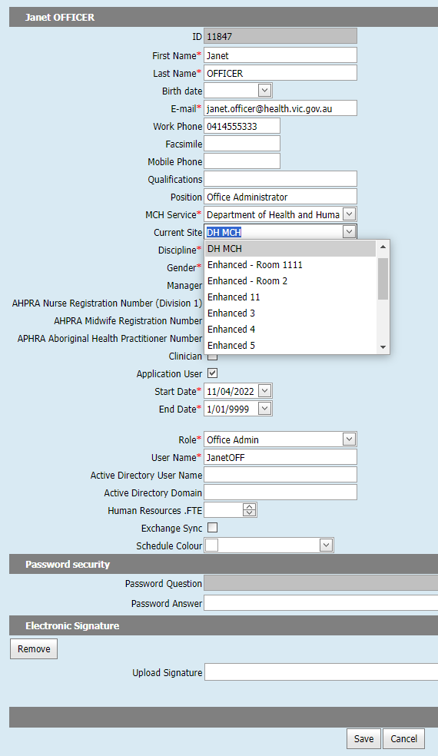
Image 17 – Updating the CDIS User’s Primary site in their account

- When the user logs in, they will see their site access list; their Current Site will be ticked, the ‘Home’ screen opening this Calendar by default.
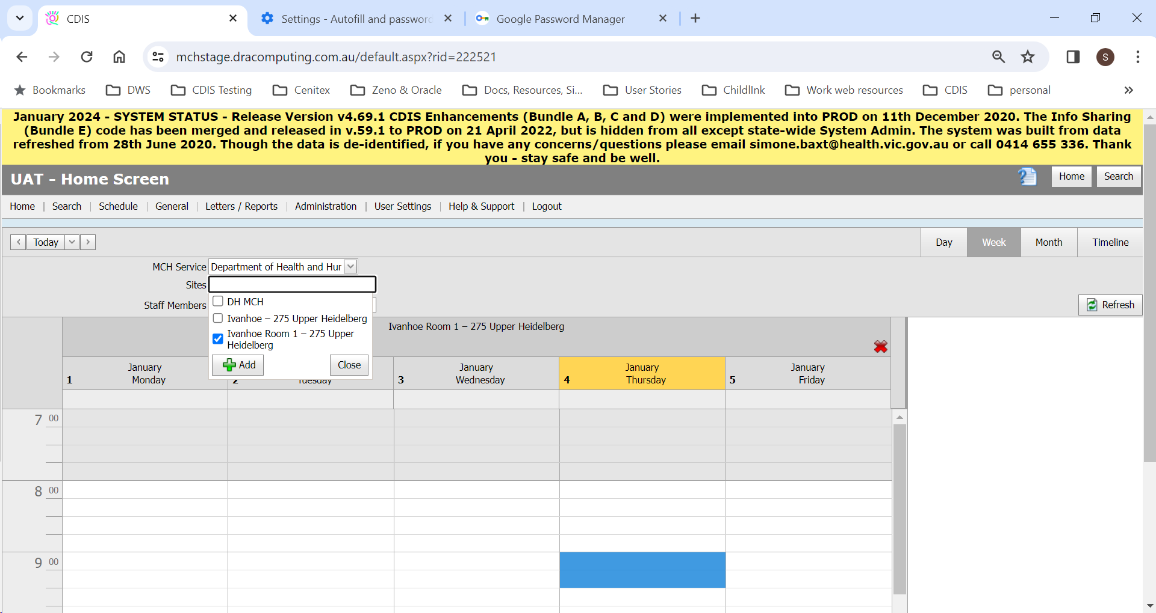
Image 18 – User’s Home Screen, with Default Calendar set by their Primary Site

It may take up to 24 hours for the Site list (and respective permissions) to update, either in the User’s Employee Screen within Employee Administration, and/or their own Sites list on the Calendar (Home Page).
For adding or removing any other sites, refer to Appendix C Adding or Removing Sites, Centres & Calendars.

Appendix B. Detailed Instructions: Deactivate CDIS user
- Log into CDIS with your authorised username and password
- From CDIS home screen, select menu option - Administration > Employee Administration.
Image 19 – Accessing the CDIS Employee Administration Screen

- Locate the CDIS user. Type the surname of the user in the search box. You can wait for the screen to refresh or click “Filter’ if nothing happens. If no user exists, you will see the message “No data to display”. If a user with the same surname exists, cross check that they are not the user you’re deactivating (see step 7).
Image 20 – CDIS Employee Administration Screen: Searching Active Users

- Check if the CDIS user account was made inactive. Tick the ‘Show inactive employees’ checkbox, with the surname still in the search field. If no user exists, you will see the message “No data to display”.
Image 21 – CDIS Employee Administration Screen: Searching Inactive Users

- If a user with the same surname exists, click Update to cross check that they are not the user you’re deactivating. Click Cancel to return to Employee Admin screen
- Once you have confirmed that you have found the correct CDIS account to deactivate, click the Update button to open the user account.
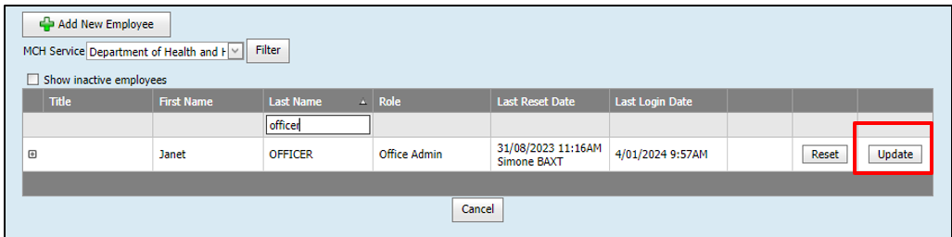
Image 22 – Click Update to open the User Account
- Do not update any personal information.
- Scroll down to the section with the clinician and application user checkboxes, dates, and User Name.
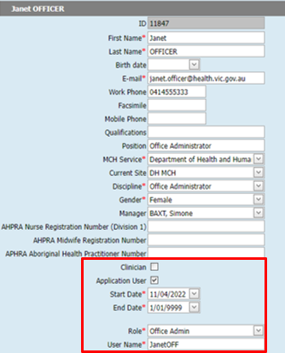
Image 23 - CDIS Employee screen

- When you scroll get to this section of the user account:
  - If you think you may need to re-activate this account in future (e.g. maternity leave), please copy and paste the “User Name” to another location and record this. This could be your own deactivation process managed by your service. This ensures if the user is created in CDIS again (e.g., staff on long service leave), they retain their CDIS User Name.
  - Clinician checkbox - If there is a tick, remove the tick.
  - Application User checkbox – If there is a tick, remove the tick. NB: This action will permanently remove the user’s role and User Name from the Employee Record in CDIS.
  - Update the End Date to the last known date the person worked, or a departure date if working from a termination or long service leave form. NB: This date will need to be in the past for the account to be successfully deactivated.
  - Click Save.
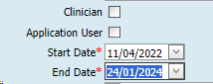
Image 24 - CDIS user (inactive user i.e., deactivated): Clinician checkbox and Application User checkbox are both un-ticked, and the end date is updated appropriately.

- You will be returned to the Employee Administration Screen. Search for the deactivated CDIS account, by clicking Show inactive employees.
- Click update to verify there are no ticked checkboxes, no role or User Name, and the end date is set as per the form. If you updated anything, click save. If the information was accurate and you didn’t make any changes, click Cancel.

Appendix C. Adding or Removing Sites, Centres & Calendars
Pre-requisites: Your role must be one of the following:
  - System Administrator – Council
  - Clinical Coordinator
  - IT Support - Council

In CDIS, the terms Sites, Centres and Calendars are synonymous. In this section, the word ‘Sites’ pertains to all of these.

Adding Sites to User Accounts
Navigate to Administration > Employee Administration.
Locate the user from the list, using the free text box to enter the surname of the user.
Expand the user’s Site access, using the + on the left of the user details.
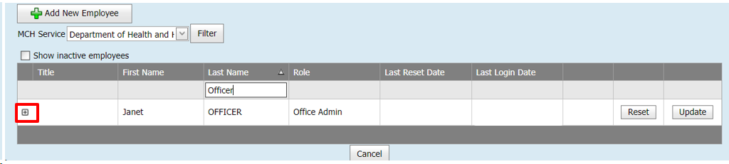
Image 25 – Click + on the left of the user details to Expand the user’s Site access

- Click the + Add MCH Service button, and an ‘MCH Service’ section will appear.
- Use the drop-down arrow to select your MCH service.
- Click the + Add Site button.
Image 26 – Managing sites for CDIS users, in the Employee Administration Screen
- Within the Site Section, click on the drop-down arrow, and a pop-up selection window, with all the sites in the MCH Service will appear. NB: Under the pop-up box, all the sites the user currently has access to, if any, will be listed.
Image 27 – Site drop down list | Image 28 – Scroll through the site list
- Scroll through the list using the toggle bar on the right and tick the checkbox for each site the user should have access to. Alternatively, use the “Select All’ checkbox at the top if the user should have access to all sites. This is unusual in larger MCH Services but could be required when setting up accounts for ‘Clinical Coordinators’, or ‘System Administrators’.
- When you have finished, click the Close button, and all the sites you selected will be populated into the Sites Drop-down box.
Image 29 – Select site(s) from the list | Image 30 – Once selected, click Close
- Finally, click ‘Update’ to complete the action of adding all the selected sites to the User Account.
Image 31 – click ‘Update’ to complete the action of adding all the selected sites to the User Account
- When the update is complete, you will see all the sites listed under the user’s account (see image 32).
- To check the user has their Current Site set correctly within their user account details, click the ‘Update’ button to open their account.
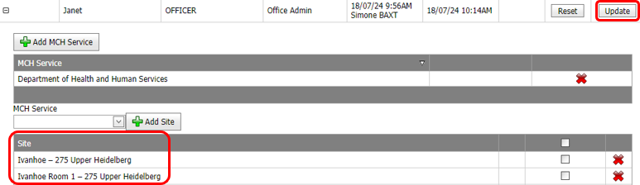
Image 32 – Click ‘Update’ to view or change sites listed that the CDIS user has access to use

- Check the user account’s Current Site (see image 33) and update as necessary. Use the drop-down arrow.
  - If it is correct, scroll down and click Cancel.
  - If it requires updating, choose the appropriate site from the drop-down list, scroll down, click Save.
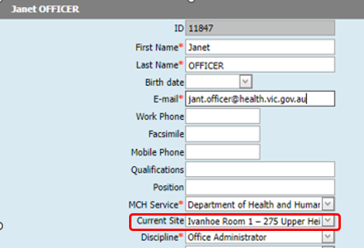
Image 33 – Check the user’s current site is set correctly

Image 35 – Updating the CDIS User’s Primary site in their account

- When the user logs in, they will see their site access list, and their Current Site ticked, as this is opened on their Home Screen (Calendar) by default.

It may take up to 24 hours for the Site list (and respective permissions) to update, either in the User’s Employee Screen within Employee Administration, and/or their own Sites list on the Calendar (Home Page).
Image 36 – User’s Home Screen, with Default Calendar set by their Primary Site

Removing Sites from User Accounts
- Navigate to Administration > Employee Administration.
- Locate the username from the list, using the free text box to enter the surname of the user.
- Expand the user Site access, using the + on the left of the user details.
Image 37 – Click + on the left of the user details to Expand the user’s Site access

- To remove a single site, or multiple sites, click in the respective site checkboxes.
  - (To remove most, or all sites, skip to step 10)
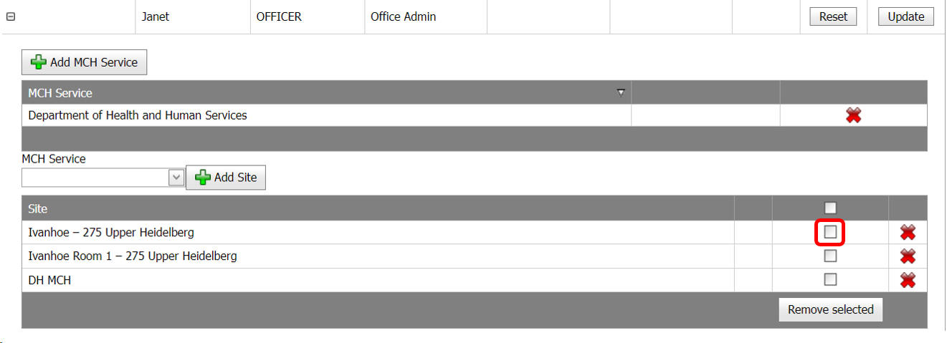
Image 38 – To remove a single site, or multiple sites, click in the respective checkboxes

- The site(s) selected will then be highlighted in grey. Click the ‘Remove selected’ button to complete this action and remove the sites.
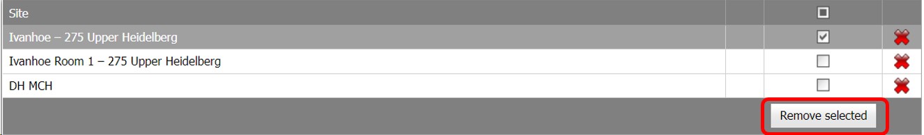
Image 39 – Click the ‘Remove selected’ button to complete this action and remove the sites

- At the top of the CDIS screen, a confirmation question/message will be displayed. Select ‘OK’ or ‘Cancel’ to return to the Site screen of the user.
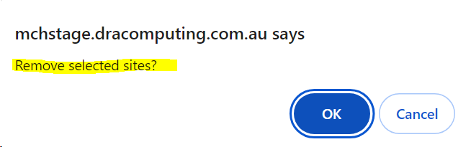
Image 40 – The confirmation question/message that will be displayed
- You will be returned to the screen with the User’s Site details. If ‘Cancel’ was selected, repeat steps 4-6 if appropriate.)
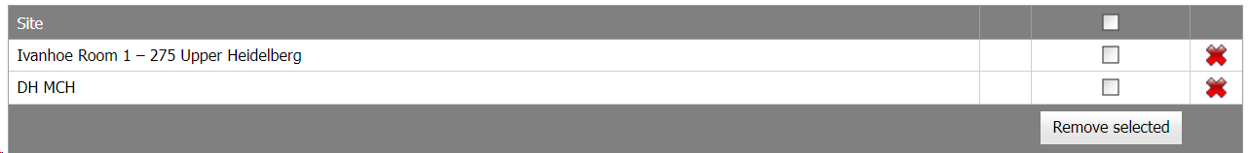
Image 41 – User’s Site details

- As you have made changes, check the user has their Current Site set correctly within their user account details; click the Update button to open their account.
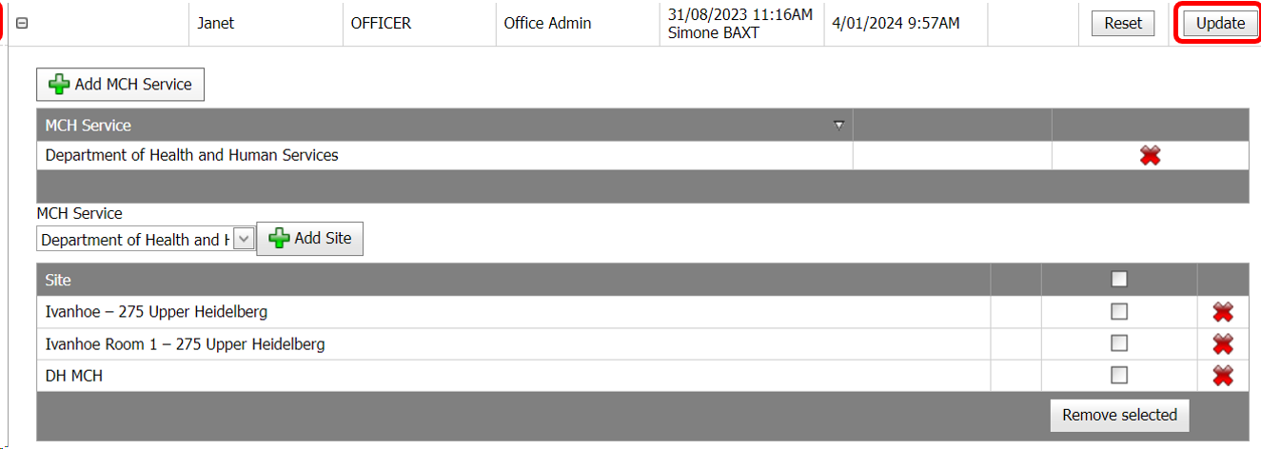
Image 42 – Click the Update button to open the user account

- Check the user account’s Current Site and update as necessary. Use the drop-down arrow.
  - If it is correct, scroll down and click Cancel.
  - If it requires updating, choose the appropriate site from the drop-down list, scroll down, click Save.
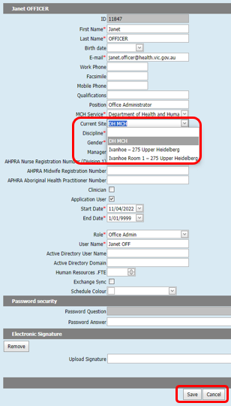
Image 43 – Updating the CDIS User’s Primary site in their account
- Tick the individual sites you wish to remove. If you want to remove most or all sites, tick the checkbox in the grey header of the Site list, to select all the sites.
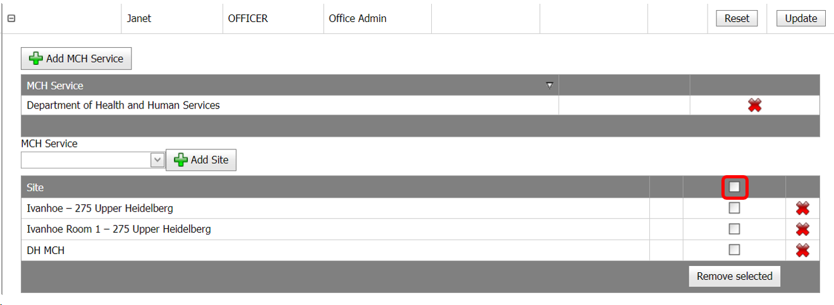
Image 44 - To remove most or all sites, tick the checkbox in the grey header of the Site list

- Scroll through to confirm you have ticked all the sites for which access is to be removed. If appropriate, untick Sites that are not being removed. Click the ‘Remove Selected’ button.
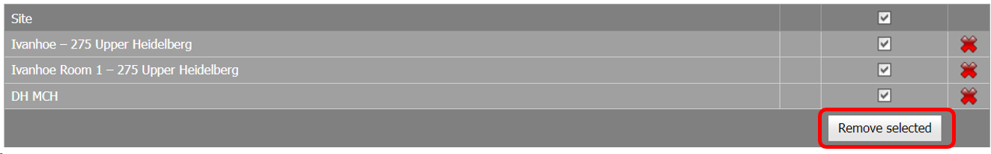
Image 45 – All sites are now selected, Click Remove selected

- At the top of the CDIS screen, a confirmation question/message will be displayed. Select ‘OK’ or ‘Cancel’ to return to the Site screen of the user.
Image 46 – The confirmation question/message that will be displayed

- You will be returned to the screen with the User’s Site details. (If ‘Cancel’ was selected, repeat steps 4-6 if appropriate.)
  - If you removed all sites, there will be no sites and a message “No data to display”.
  - To add sites again, go to the previous section Adding Sites to User Accounts.
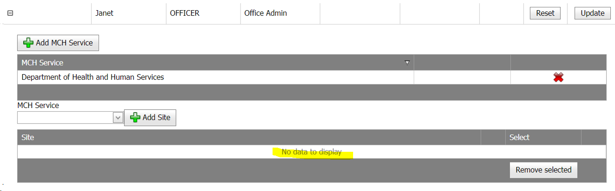
Image 47 – No data to display message means there are no sites the user has access to use
It may take up to 24 hours for the Site list (and respective permissions) to update, either in the User’s Employee Screen within Employee Administration, and/or their own Sites list on the Calendar (Home Page).

If you require assistance with CDIS regarding any of these items, please email CDIS Helpdesk or call 1300 856 183.

To receive this document in another format, phone 1300 650 172, using the National Relay Service 13 36 77 if required, or email Maternal and Child Health and Early Parenting Unit <mch@health.vic.gov.au>.
Authorised and published by the Victorian Government, 1 Treasury Place, Melbourne.
© State of Victoria, Australia, Department of Health, April 2024.
Except where otherwise indicated, the images in this document show models and illustrative settings only, and do not necessarily depict actual services, facilities or recipients of services. This document may contain images of deceased Aboriginal and Torres Strait Islander peoples. In this document, ‘Aboriginal’ refers to both Aboriginal and Torres Strait Islander people. ‘Indigenous’ or ‘Koori/Koorie’ is retained when part of the title of a report, program or quotation.
ISBN 978-1-76131-692-0 (pdf/online/MS word)
Available at Child Development Information System | health.vic.gov.au <https://www.health.vic.gov.au/maternal-child-health/child-development-information-system>

