

Blood administration competency template
OFFICIAL

How to use the template
This is an “example only” template to provide a structure for those assessing blood administration competency. It should be modified to suit the local health service policy.
For further information contact Blood Matters <bloodmatters@redcrossblood.org.au>

Background
In accordance with Australian and New Zealand Society of Blood Transfusion (ANZSBT) Guidelines for the administration of blood products, 3rd edition (2024) <https://anzsbt.org.au/wp-content/uploads/2024/02/Guidelines-for-the-Administration-of-Blood-Products-revised-Feb-2024.pdf> the pre-administration check of blood must be conducted independently by two authorised staff members, known as double independent checking, (and in accordance with local health service policy) at the patient’s side immediately prior to transfusion.
Double independent check is defined as:
- Two clinicians individually and without requiring direct involvement of each other, check the prescription, patient and blood component identification, and blood component characteristics (including expiry, compatibility, and special requirements, if any).
This process must ensure that each clinician is individually satisfied that, and responsible for, the correct component is transfused in the correct way to the correct patient. The clinicians must agree before the transfusion is commenced.
In a teaching environment the teacher may indicate what needs to be checked and where to find it, but the learner must still independently view each item and confirm the match to the patient (ANZSBT Guidelines for the administration of blood products, 3rd edition, 2024).
One of these two staff members must then commence the transfusion.
Authorised staff are as determined by health service policy.

Purpose
The purpose of this competency assessment template is to provide health services with a structure that can be adapted for local needs to assess a staff member’s competency to undertake the pretransfusion check and blood administration by demonstrating and articulating the key principles as outlined by the ANZSBT Guidelines for the Administration of Blood and Blood Products.

Demonstrates sound knowledge of blood product administration
Criteria / understands each element | Evidence / able to state: | Criteria met  Yes (Y)/ No (N)
Blood compatibility requirements | - The importance of ensuring ABO & Rh compatibility  - Compatibility testing requirements e.g. RBC crossmatch, patient blood group on record for platelets/FFP/cryoprecipitate
Storage and handling requirements for blood components | - Health service process for blood and blood product storage and handling  - The documentation required including the use of a blood fridge register and patient and product identifiers  - Requirements to collect blood / blood product from pathology or remote fridge  - Staff who can collect blood (as per local policy)
Blood product prescription requirements | - Use of health service approved form or EMR  - Prescription requirements:  - patient identification details (full name, gender, DOB and MRN)  - date, timing and urgency of transfusion  - blood/blood product required  - special blood product requirements  - route of administration  - dose (pack/unit)  - rate of administration  - legible name and signature of prescriber and contact number  - must be available to check at the patient’s side when the transfusion is administered  - must form part of the pretransfusion check
Importance of consent for blood and blood products prior to transfusion  Documentation required | - Use of health service approved form (e.g. generic or blood consent form) or in health care record  - Use of a health service approved interpreter where the patient has limited proficiency in English  - Documentation required if the patient refuses blood / blood product transfusion
The actions to take if blood and blood product consent has not been documented. | - Unless the transfusion is an emergency the transfusion cannot go ahead until consent is obtained  - Contact treating team to obtain consent
The pretransfusion checking process, its rationale, and impact on patient safety. | - Double independent check – two staff required to perform every part of the check independently  - Check performed at the patient side  - Verbal check with patient where possible  - No ID band = no transfusion  - Check of all forms (laboratory compatibility label or form, prescription, and product)  - Transfusion cannot be commenced if any discrepancies  - Cause and significance of possible errors – e.g. wrong blood given to patient from errors in patient ID, lab error
Action to take if the ABO or RhD group of the blood component is different to that of the patient. | - Able to state what is compatible or where to find this information, and what they would do if the ABO or RhD groups were different and they were unsure of the compatibility
The appropriate equipment for blood and blood product administration including giving set. | - Must use a giving set with 170–200-micron filter for all fresh components (both gravity and pump sets), filters clots and aggregates  - Pump, as per hospital policy  - Use of syringe drivers in small volume transfusions (babies)
Restrictions for co-administration of IV fluids and medications during transfusion. | - Incompatibility between fluids/meds and blood products  - Unable to assess cause should a reaction occur  - No meds/fluids other than normal saline  - How to administer a medication, if required, during a transfusion
Maximum infusion time for blood and blood products | - Fresh components must be completed within 4 hours  - Manufactured products as per local policy maximum 6 hours
The action required if a blood component cannot or is not commenced immediately or is no longer required | - Must be returned to controlled storage (e.g. Transfusion laboratory, blood fridge) within 30 minutes to ensure cold chain and ability for the component to be returned to inventory  - Component can be kept on the ward if it is still required but must be completed within 4 hours of removal from controlled storage or disconnected from the patient 4 hours from removal from cold storage and discarded  - Treating team to determine course of action, such as a faster rate or discard after 4 hours  - All blood and blood products to be returned to the transfusion laboratory if it is no longer required  - If any volume of the product is administered to the patient, it is considered transfused and any unused portion does not need to be returned to the laboratory.
Observation and vital signs required and why | - Pretransfusion assessment and observation helps determine if it's appropriate to start the transfusion and provides a baseline from which any deviation/s may be indicative of a reaction  - Patients receiving transfusions must be monitored for signs and symptoms of potential complications or adverse transfusion reaction, during and in the immediate post transfusion period.  - Vital signs must be taken at a minimum T, RR, HR, BP pretransfusion, 15 minutes after commencement and post transfusion and if a reaction is suspected. More frequently if stated in local policy.  - States need to remain with patient for first 15 minutes of transfusion
Signs and symptoms (S&S) of a transfusion reaction and immediate management | - Refer to Appendix A transfusion reaction signs and symptoms.  - Immediate action required if there is a suspected adverse reaction  - STOP the transfusion,  - Vital signs  - Assess and manage the patient / provide emergency care if required  - Clerical check, patient and product  - Maintain IV access, do not discard blood until review  - Report the suspected reaction to medical team for clinical review  - Report to transfusion laboratory, and document in medical record,  - Report to incident management system (e.g. VHIMS/Riskman) as per health service policy

Demonstrates safe practice in blood and blood product administration
Criteria | Evidence / Demonstrates | Criteria met  Yes (Y)/ No (N)
Educates patient prior to transfusion | - Provides relevant and appropriate education to patient:  - Possible S&S of a reaction  - Importance of reporting any discomfort or S&S immediately  - Checks patient understanding  - Ensures call bell is within reach
Vital signs, patient assessment, and preparation for transfusion | - Performs pre-transfusion vital sign observations within one hour of commencing the transfusion (or as per health service policy)  - Assessment of patient for pre-existing signs and symptoms that could be confused with a reaction  - Patient in an area that can be visualised regularly during the transfusion  - Staff and patient are ready to commence the transfusion
Double independent check and positive patient identification | - Two staff members at patient side to perform the double independent check  - Asks the patient to state and spell their full name  Compares to:  - the patient’s ID band  - the compatibility label attached to the blood component  - the prescription and administration chart, or  - the ID banner with the blood prescription/administration screen open if using an EMR
Patient’s medical record number (MRN)  All must match exactly | - On the patient’s ID band and compare to:  - the compatibility label attached to the blood component (& report if used)  - the prescription and administration chart, or  - the ID banner with the blood prescription/administration screen open if using an EMR
ABO & RhD group of the patient  MUST be compatible with the ABO & RhD group of the component | - On the compatibility label attached to the component (and report if used)  - May be present in the administration screen if using an EMR
ABO & RhD group of the component  MUST be compatible with the ABO & RhD group of the patient | - On the compatibility tag attached to the product  - On the Lifeblood label on the product  - May be present in the administration screen after scanning the component if using an EMR
Component type (e.g. RBC)  All must match exactly | - On the Lifeblood label on the component  - On the compatibility label on the component (& report if used)  - On the prescription and administration chart
Donation number  All must match exactly | - On the Lifeblood label on the component  - On the compatibility label on the component (& report if used)
Component expiry  Must be within date | - On the Lifeblood label on the component  - On the compatibility label on the component (& report if used)
Crossmatch expiry  Must be within date | On the compatibility label attached to the component (& report if used)
Pack integrity | - Pack must be intact – no leaks  - No discolouration, clots, or foreign bodies
Commences blood transfusion | - Spikes bag immediately following double independent check  - Transfusion commenced at the prescribed rate (rate check if using pump)  - Stays with the patient for the first 15 minutes
Completes all documentation | - Signs blood prescription, with date and time, and ensures second checker signs prescription.  - Signs compatibility report if used and ensures the second checker signs the report.  - Progress note if required
Assessment summary
Assessment details | Result / response
Candidate’s name:
Hospital / ward
Date and assessment attempt
Assessor’s name and designation:
Competency achieved (Yes / NYC) and feedback:

Appendix A: Transfusion reaction signs and symptoms
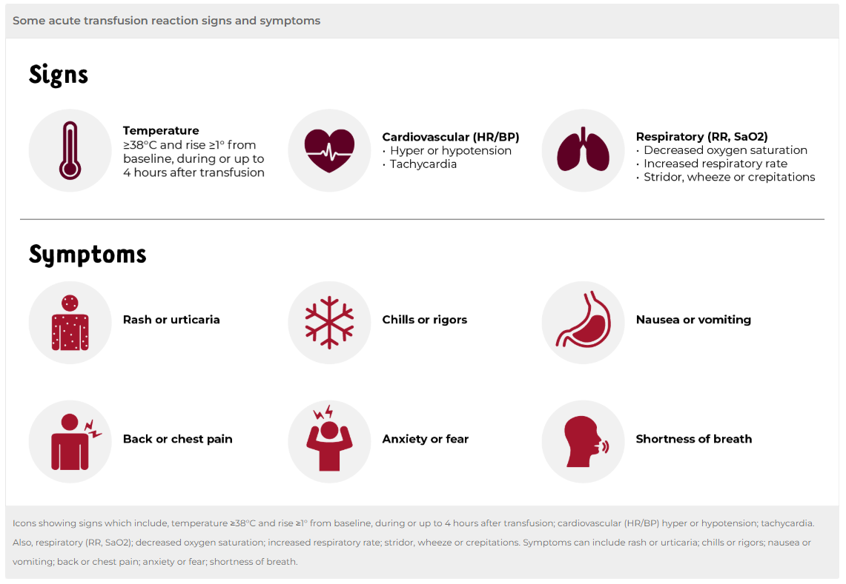
Reference: Lifeblood Transfusion Practitioner microcredentials module 5, Blood Administration, 2024

To receive this document in another format email Bloodmatters@redcrossblood.org.au <bloodmatters@redcrossblood.org.au>.
Authorised and published by the Victorian Government, 1 Treasury Place, Melbourne.
© State of Victoria, Australia, Department of Health, December 2024.
Except where otherwise indicated, the images in this document show models and illustrative settings only, and do not necessarily depict actual services, facilities or recipients of services.
ISBN 978-1-76131-716-3 (pdf/online/MS word)
Available at Blood Matters Program <https://www.health.vic.gov.au/patient-care/blood-matters-program>

