

Intravenous immunoglobulin (IVIg), subcutaneous immunoglobulin (SCIg) safety notice
Potential for error due to look-alike, sound-alike products
OFFICIAL

Background
Recent changes to IVIg and SCIg products available in Australia have led to products with similar names and packaging. This is particularly in relation to Privigen® and Privigen® AU, and Hizentra® and Hizentra® AU, where the AU denotes Australian product (domestic). Products without the AU are imported products.

Although these products have similar names, they are different products and NOT interchangeable.
The appropriate product provided under the National Blood Supply arrangements and authorised via BloodSTAR must be prescribed, dispensed and administered.
BloodSTAR and BloodNET are the sources of information for current patient product information.

Privigen® (imported) Privigen® AU (domestic)
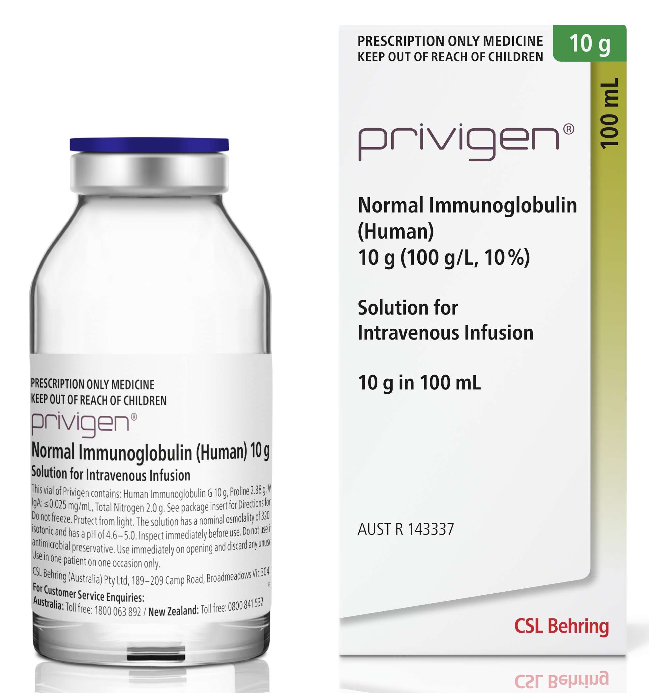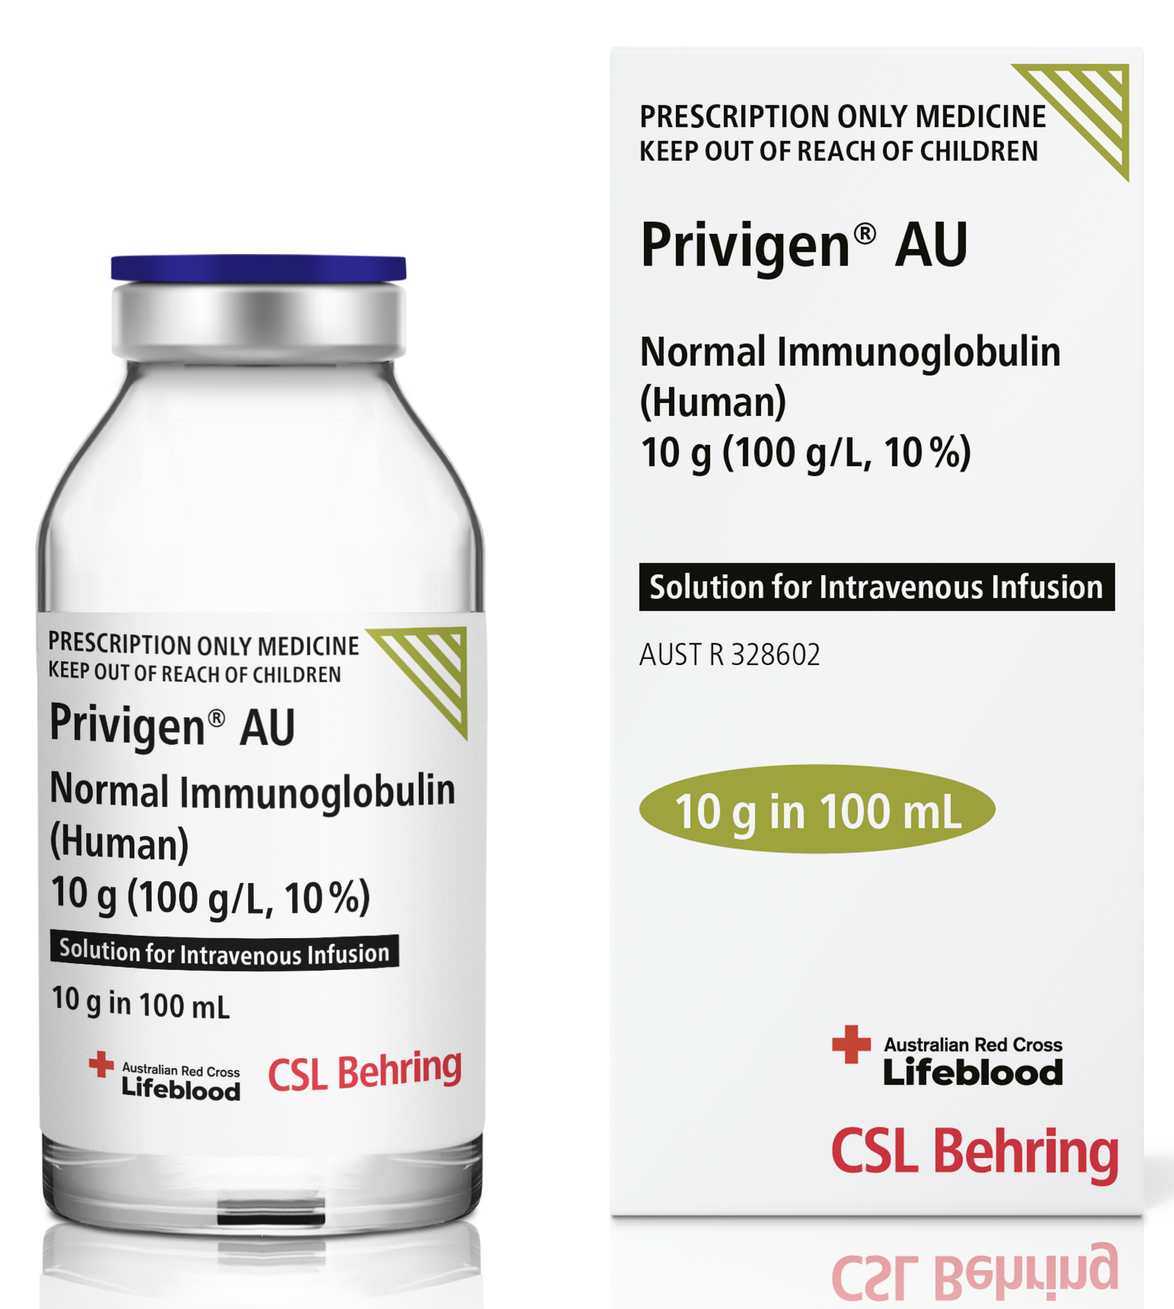
Similarities: | Differences:
- Same colour palette  - Same size packaging | - Privigen® AU includes Lifeblood logo on package and on the bottle label  - Privigen® AU has green triangle in upper corner of package and bottle label

Hizentra® (imported) Hizentra® AU (domestic)

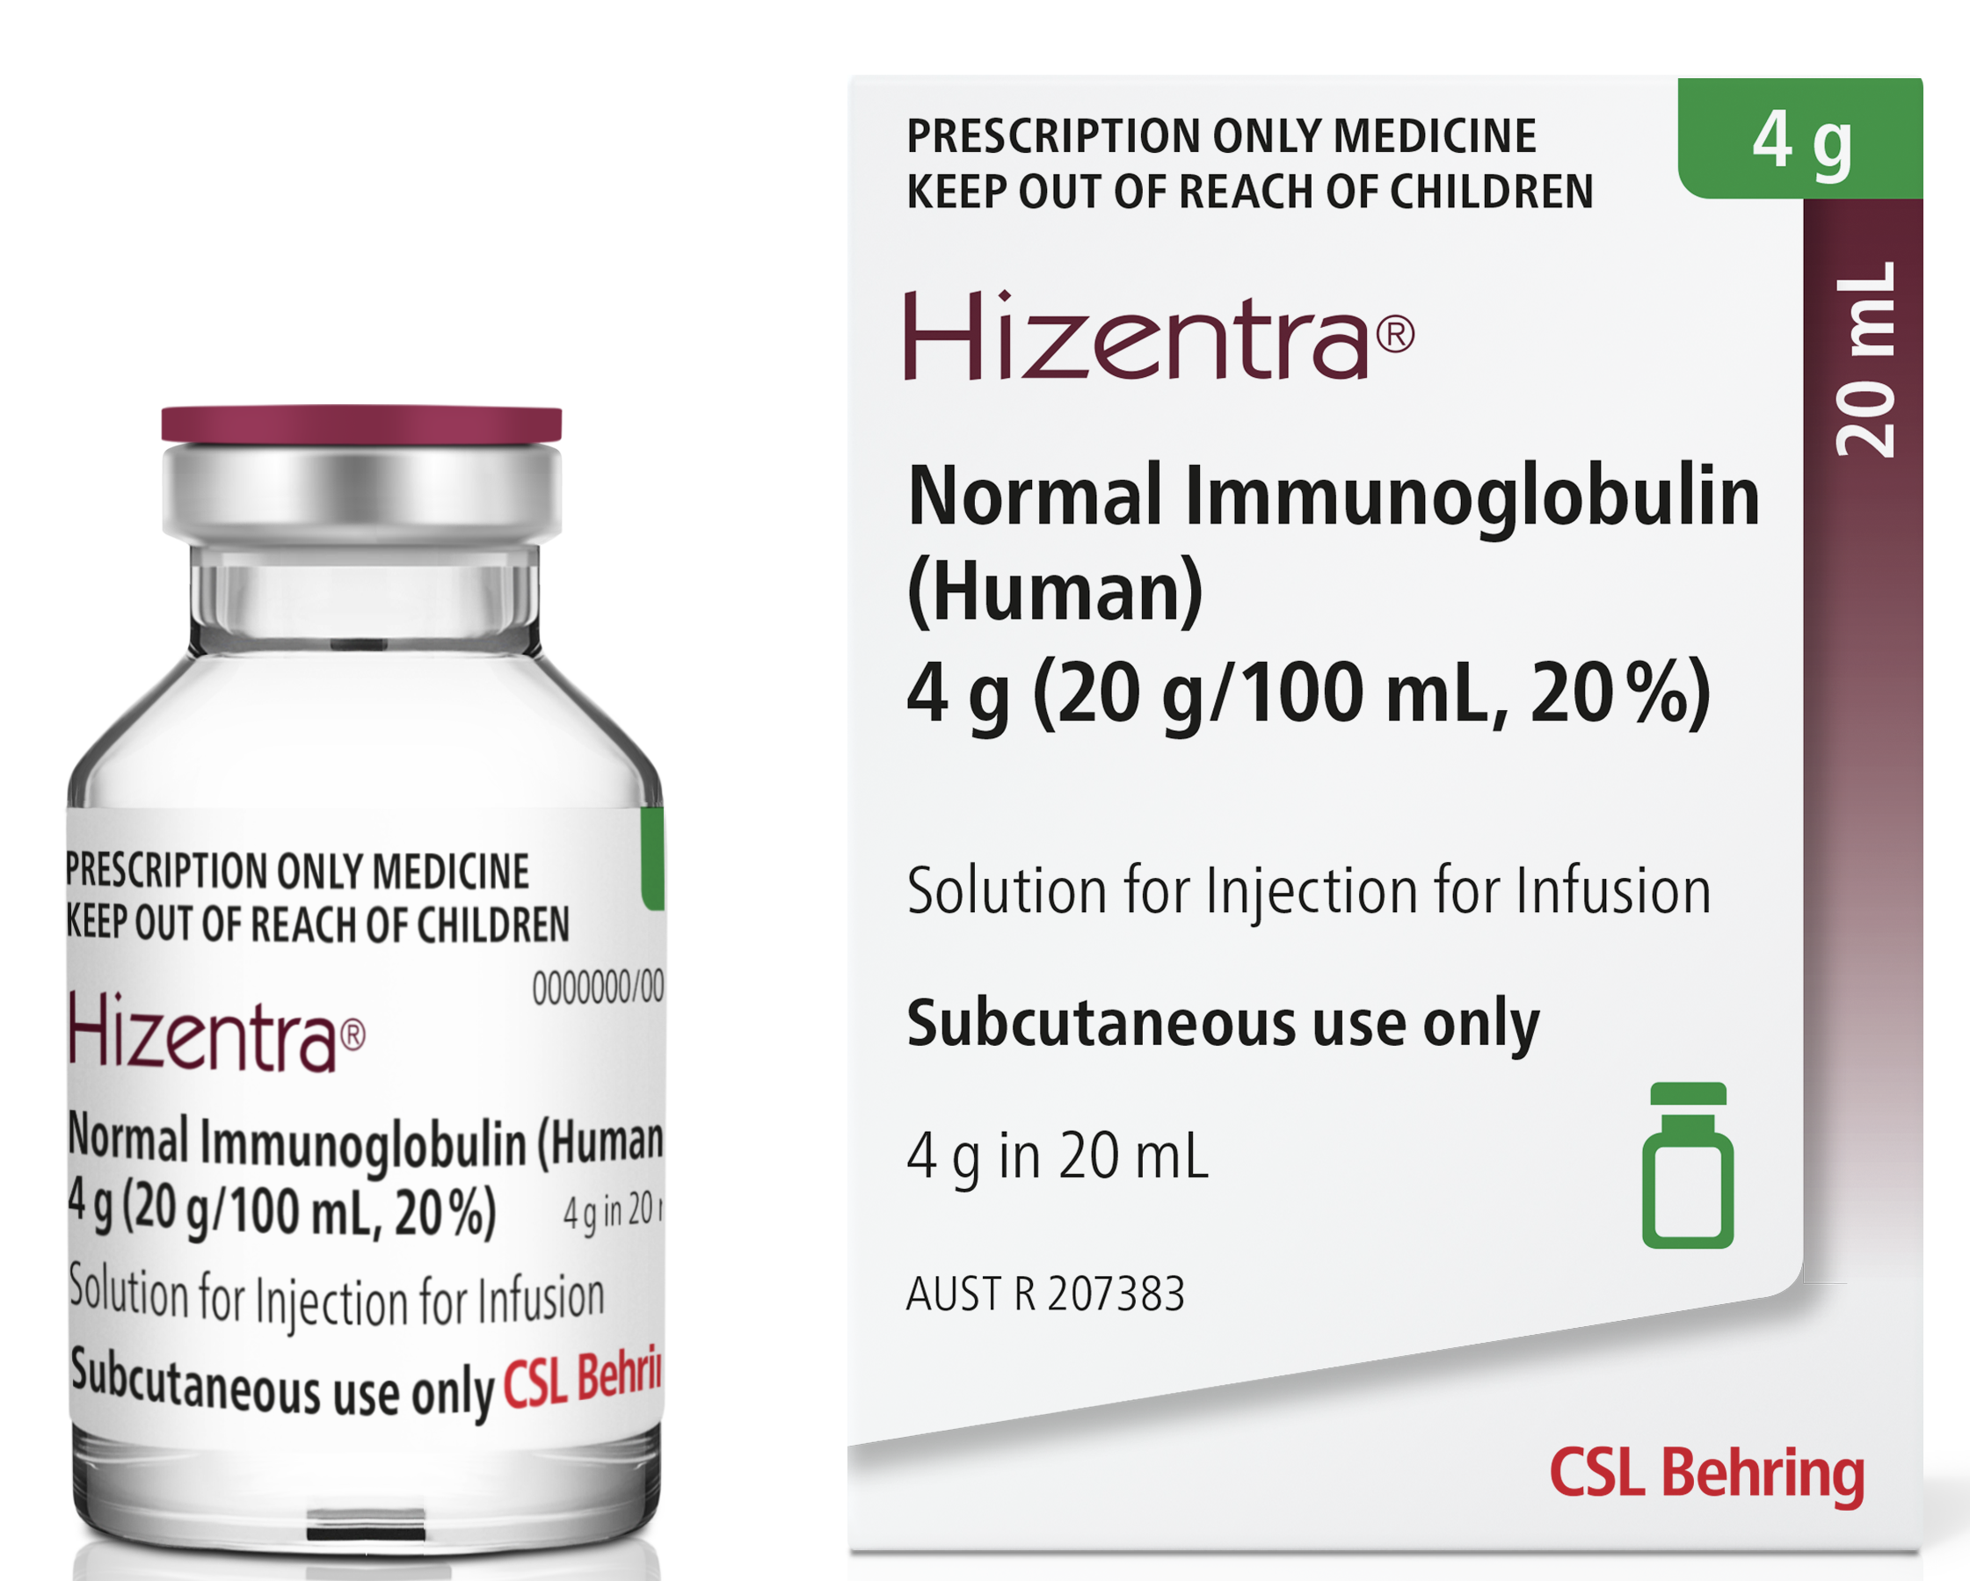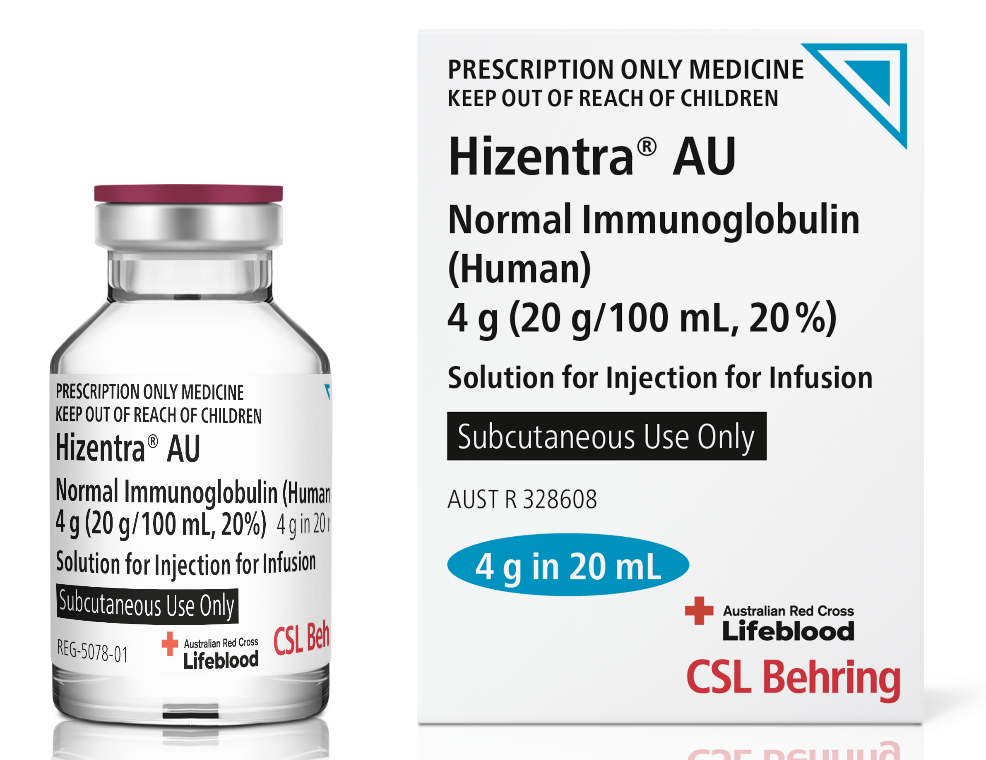
Similarities: | Differences:
- Similar colour palette  - Same size packaging | - Hizentra® AU has blue triangle in upper corner of package and bottle label  - Hizentra® AU includes Lifeblood logo on package and on the bottle label

Product images sourced with thanks from CSL Behring.
To receive this document in another format, phone 03 9694 0102, using the National Relay Service 13 36 77 if required, or email Blood Matters <bloodmatters@redcrossblood.org.au>.
Authorised and published by the Victorian Government, 1 Treasury Place, Melbourne.
© State of Victoria, Australia, Department of Health, August 2023.
ISBN 978-1-76131-376-9 (pdf/online/MS word)
Available at Immunoglobulin (Ig) replacement therapy (health.vic.gov.au)< https://www.health.vic.gov.au/patient-care/immunoglobulin-ig-replacement-therapy>

