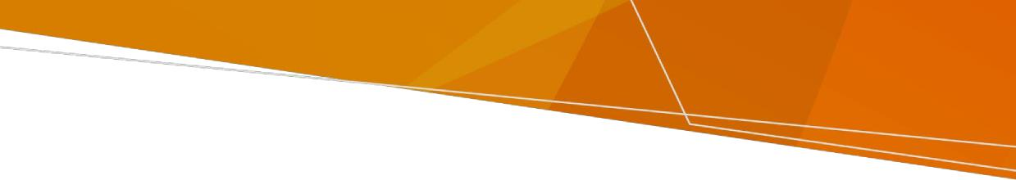
Refund policy

Refund Policy

Radiation Act 2005


OFFICIAL
How do I obtain a refund?
To obtain a refund, you must make an application to the Department. You can apply for a refund by completing an online refund form <https://forms.business.gov.au/smartforms/landing.htm?formCode=ehrc-refund>.
You are required to provide proof of any payment/s in support of your application.
A decision to issue a refund will be based on this policy.
Refused or withdrawn applications
The department will refund the licence fee for an application that is refused or withdrawn prior to the issue of the licence. The application fee will not be refunded.
Surrender of licence
Once a licence has been issued, no refunds will be granted regardless of whether the reason for the licence ceases during the term of the licence. Surrendering a licence to the department does not entitle the holder to a refund.
Over-payments
The department will refund in full any over-payment.
Minimum refund amount
The department is unable to process refunds amounting to less than $2.
Licence period
Once a licence has been issued, no refunds will be granted in the event of applicant or licence holder requests to change the licence duration.

Changes to licence scope
It is the responsibility of the licence holder to ensure that the licence reflects the actual radiation practice or use being conducted.
When a licence has been renewed which authorises, for example, the possession of three X-ray units but the licence holder realises that they no longer require two of those authorisations, no refund of part of the licence fee will be issued.
To whom will the refund be issued?
Where approved, refunds will be issued to the individual or company proven to have made the payment.
How will the refund be issued?
Where bank details are provided on the application form refunds will be issued via EFT.
How long will it take for a refund to be issued?
Refunds can take up to 60 days to be issued following receipt of a completed application.
How long do I have to make an application for a refund?
The department will accept applications for a refund up to 12 months after the date of payment.

To receive this document in another format email the Radiation Team <Radiation.safety@health.vic.gov.au>.

Authorised and published by the Victorian Government, 1 Treasury Place, Melbourne.
© State of Victoria, Australia, Department of Health, September 2022.
Available at Refund Policy Radiation Act 2005 < https://www.health.vic.gov.au/publications/fee-refund-policy-radiation-act-2005>.

