

Radiation safety requirements for CT based units for security or quality control purposes
Radiation Act 2005
OFFICIAL

Introduction
The Victorian Radiation Act 2005 (the Act) has the objective of protecting the health and safety of persons and the environment from the harmful effects of radiation. The Department of Health (the department) administers this legislation.
The Act seeks to fulfil this objective by establishing a licensing framework to regulate the conduct of radiation practices and the use of radiation sources.
Any person who conducts a radiation practice must hold a management licence (unless exempted from that requirement). The management licence holder must comply with every condition of their licence.

Scope
Management licences issued by the department that authorise radiation practices involving computed tomography (CT) based units for examination of articles for security or quality control purposes include a condition that requires a management licence holder to meet the requirements described in this document.
A typical arrangement for a CT based unit is shown in Figure 1.

Dose rate requirements
The management licence holder must ensure that CT based units satisfy the following dose rate requirements:
Table 1
Location | Situation | Dose rate*
Any position occupied by an operator’s body. |  | Less than 0.5 µSv/h
Any point 10 cm from the surface of the unit – including the entrance to any entry and exit ports | Flexible shielding (if fitted) is not displaced (for example, by the passage of articles). | Less than 1 µSv/h
Any point that can be accessed by the operator’s hands during operations | Flexible shielding (if fitted) is displaced by a continuous series of articles (in trays if applicable) passing through the system with separation or articles consistent with maximum operational throughput. | Less than 5 µSv in one hour
* Dose rate levels are inclusive of background.

4. Access points

4.1 Entry and exit ports
The management licence holder must ensure that:-
- the CT unit is designed to prevent operators and members of the public from inserting their hand or any other part of their body into an entry port or exit port during operation; and
- members of the public do not insert their hand or any other part of their body into a port at any time; and
- if access into a port is required by an operator to assist with the operation of the CT unit when the CT unit is capable of generating X-rays (e.g. to dislodge a bag which has become stuck), a long handled tool or a method that enables access into the port without the operator inserting a hand into the port must be used. If a hand of an operator is required to be inserted into a port to assist with the operation of the CT unit, the CT unit must be isolated such that it cannot generate X-rays.

4.2 Maintenance panels
The management licence holder must ensure that:
- maintenance panels are only opened by service technicians who have a current radiation use licence issued by the department; and
- maintenance panels are secured or locked in a manner that prevents removal by operators or members of the public. If the maintenance panel forms part of the radiation shielding, the panel must be interlocked so that X-rays cannot be produced when the panel is removed. If it is necessary to disable the interlock to perform maintenance, a Controlled Area must be established around the CT unit to the extent that operators and members of the public are not exposed to radiation levels above 0.5 µSv/h.

Controls

5.1 Operator requirements
The management licence holder must ensure that;
- at least one operator is present if the CT unit is capable of generating X-ray radiation; and
- at least one operator is present near each of the entry ports and exit ports to:
  - prevent a person entering or inserting any body part into the unit; and
  - press the emergency stop button when necessary to shut down the production of X-rays.

5.2 Emergency stop requirements
The management licence holder must ensure that emergency stop devices are installed:
- at the viewing console continually occupied by an operator, and
- in sufficient numbers at the entry/exit port and conveyer belt to ensure they can be pressed in the event of an emergency.

5.3 Power and X-ray requirements
The management licence holder must ensure that:
- the CT unit is designed and constructed such that it can only produce X-rays following manual activation of a dedicated switch. The X-ray activation switch must be fully independent of other controls including the CT unit “power on” switch. The X-ray activation switch must be secured by physical (e.g. key) or electronic (e.g. password) means to prevent persons other than the operator from activating the production of X-rays; and
- the production of X-rays only takes place when the CT unit is under the direct supervision of an operator.

6. Warning lights and warning signs

6.1 X-ray warning lights
The management licence holder must ensure that X-ray warning lights:
- are fully independent of any “power on” lights;
- are installed in sufficient numbers and locations to ensure that at least one warning light is clearly visible from any accessible position around the CT unit;
- are clearly labelled with “X-ray on”; and
- are designed as failsafe so that X-rays cannot be produced if the light is faulty.

6.2 X-ray Warning signs
The management licence holder must ensure that all entry/exit ports and maintenance panels display a non-removable, prominent X-ray warning sign.

7. Information, instruction and training

7.1 Instructions and radiation management plan
The management licence holder must ensure that;
- they are provided with adequate information and instruction by the manufacturer or supplier of a CT based unit, which covers the safe operation of the equipment; and
- a Radiation Management Plan is developed, documented, resourced, implemented and regularly reviewed. The Radiation Management Plan must include the following:
- roles and responsibilities;
- work practices;
- control and management of incidents; and
- any other requirement that may have a bearing on radiation safety.

7.2 Training
The management licence holder must ensure that:
- operators are provided with suitable training; and
- training records for the following are maintained:
- safe operation of the CT based unit with respect to the radiation hazards; and
- precautions necessary to minimise personal radiation exposures and avoid radiation incidents.

8. Radiation monitoring

8.1 Personal radiation monitoring
The management licence holder must ensure that:
- licensed service technicians responsible for maintenance and servicing of the CT based unit wear an approved personal radiation dosemeter; and
- operators wear an approved personal radiation dosemeter unless an exemption has been granted by the department.

8.2 Periodic radiation monitoring
The management licence holder must ensure that:
- periodic radiation monitoring, with objects passing through the CT unit in a manner typical of normal operating parameters, is carried out at the locations specified in column 1 of Table 1, at intervals not exceeding twelve months; and
- radiation monitoring is carried out at the locations specified in column 1 of Table 1 after the following:
- Maintenance, repair, removal, replacement of any component related to X-ray production or radiation safety (e.g. X-ray tube assembly, radiation shielding, interlocks and warning lights).
- Increasing the X-ray tube voltage.
- Relocation of the unit or part thereof.
- Damage to the unit that has potentially compromised radiation shielding or radiation safety controls.
- verification of the correct operation of all radiation safety features is carried out during commissioning and at intervals not exceeding twelve months.
- the radiation survey monitor used to conduct the radiation monitoring meets the following requirements:
- it can accurately measure a dose equivalent response across the range of primary and secondary X-ray radiation energies produced by the CT unit;
- it has sufficient sensitivity to accurately measure radiation levels below the dose rate requirements specified Section 3; and
- it has been calibrated within the last twelve months at a calibration facility with reference source(s) directly traceable to an international primary standard.

9. Glossary
Controlled area
A defined area in which specific protection measures and safety provisions are required for controlling exposures.

Emergency
A non-routine situation that necessitates prompt action to mitigate the serious consequences of a hazard resulting from that situation.

Emergency stop device
A device that immediately stops, or effectively isolates the production of X-rays and requires manual resetting. The device must be prominent, clearly and durably marked and immediately accessible to each operator. The button must be coloured red. An emergency stop button is not an operational stop control.

Entry and exit port
Entry and exit ports are the position at the outermost flexible shielding curtain installed in a tunnel or other opening, or – in the event that no flexible shielding is used – openings in the outside surface of the enclosure which are designed to remain open during operation, permitting items to pass through the CT unit for examination.

Interlock
An interlock is a feature which prevents an operation being undertaken if a feature is not in the desired state, for example it prevents X-rays being generated if a guard or shielding has been removed.

Maintenance panel
A panel or hatch which is locked or fastened in such a way that prevents deliberate or accidental access by operators or members of the public.

Operator
An operator is an individual who is present to undertake a role in support of the operation of the unit. This will include operation of controls, assisting members of the public or supervising the operations.

X-ray warning light
X-ray warning lights are illuminated signs warning of the production of X-rays from the CT unit.

X-ray warning sign
A sign that warns of the X-ray hazard and includes the following:
- ionising radiation warning symbol (trefoil) and the word “Caution” in black print with yellow background
- additional description of the nature of the ionising radiation hazard

An example of a suitable sign is shown below:

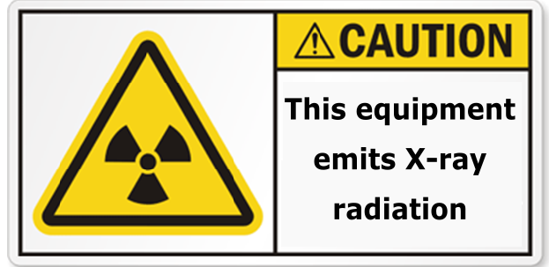

Figure 1

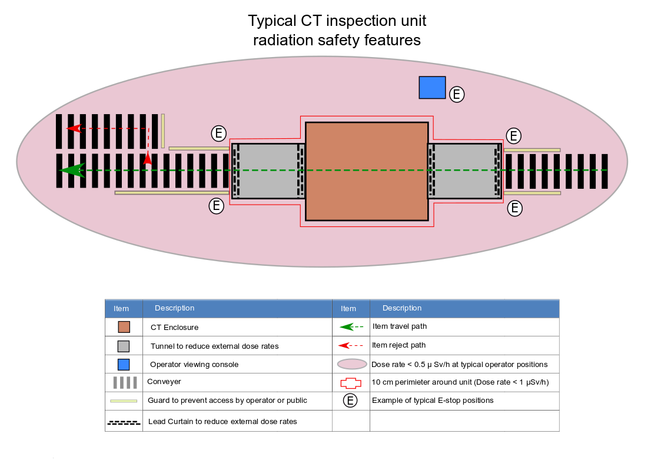

To receive this document in another format, email <Radiation.safety@health.vic.gov.au>.
Authorised and published by the Victorian Government, 1 Treasury Place, Melbourne.
© State of Victoria, Australia, Department of Health, December 2024.
Available at Radiation safety <https://www.health.vic.gov.au/publications/radiation-safety-requirements-for-ct-based-units-for-security-or-quality-control >

To apply for an exemption from the personal radiation monitoring requirements, the management licence holder must send an email with the subject “Application for exemption from personal monitoring requirements for CT based units” to radiation.safety@dhhs.vic.gov.au, providing the management licence number and a minimum of twelve months monitoring results.

