

Double independent pretransfusion check
OFFICIAL

I check and YOU check
Two authorised staff complete the following checks:
√ Independently
√ At the patient’s side
√ Immediately before the transfusion

Step 1  Patient Identification | - Ask the patient to state & spell their name and date of birth  - Check it matches the patient’s identification (ID) band  - Check the patient ID + medical record number (MRN) on the ID band matches the compatibility label on the component  - Check the patient ID + MRN on the ID band matches the prescription (paper / electronic) | 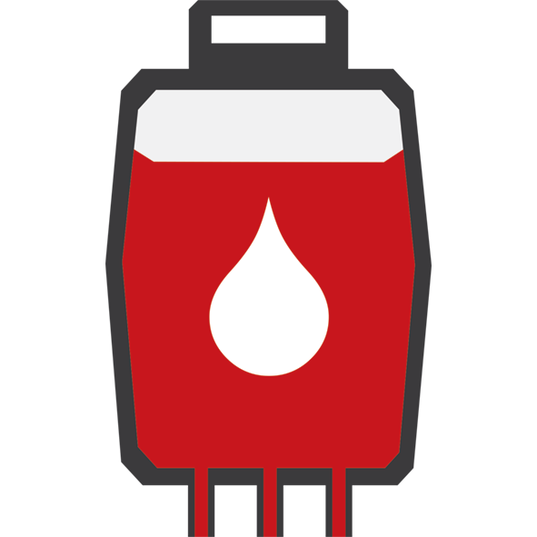
Step 2  Product and prescription details | - Check the patient blood group is compatible with component blood group  - Check the donation number on the Lifeblood label = donation number on compatibility label  - Check the component prescribed is the component received  - Check the component is within expiry date  - Check the crossmatch is within expiry date (RBC only)
Step 3  Pack check | - Check the pack is intact – no leaks  - Check there are no visible clots  - Check there is no discolouration

ANY discrepancy – clarify / rectify and then recheck
If both staff are independently satisfied that the correct component is being transfused to the correct patient in the correct way, the transfusion can commence
To receive this document in another format, email Blood Matters, <bloodmatters@redcrossblood.org.au>.
Authorised and published by the Victorian Government, 1 Treasury Place, Melbourne.
© State of Victoria, Australia, Department of Health, January 2025.
Except where otherwise indicated, the images in this document show models and illustrative settings only, and do not necessarily depict actual services, facilities or recipients of services.
ISBN 978-1-76131-733-0 (pdf/word/online)
Available at Resources and education – blood transfusion <https://www.health.vic.gov.au/patient-care/resources-and-education-blood-transfusion>

