

Blood Matters on the Bench and Beyond
Issue 21 – February 2025
OFFICIAL

Welcome to the Blood Matters newsletter for Scientists.

Blood Matters online events 2025
Blood Matters online events are a regular fixture in our education calendar, continuing to support scientists and our multidisciplinary network of transfusion professionals.
Information will be sent as dates are finalised throughout the year.

Optimising blood supply: Statewide contingency planning and strategies


Wednesday 19 March 2025
1.00pm – 2.00pm (AEDT)
Virtual education session via Microsoft Teams
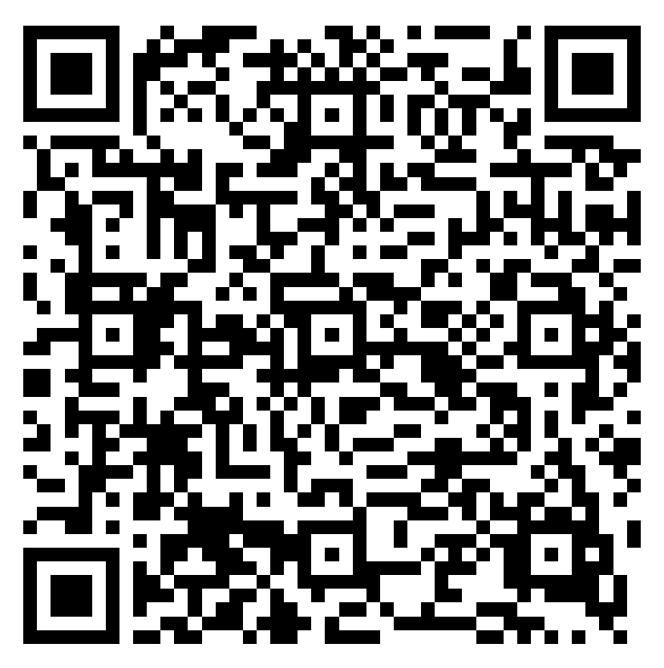

Registration prior to the event is required.
Click here or scan QR code to register.
<https://events.teams.microsoft.com/event/64479f41-9d1c-4436-8a53-cf8b91917cc5@957b3627-a629-4769-908d-ff92d7d3323d>
Topic | Presenter
Optimising blood supply: Statewide contingency planning and strategies  - Review and assessment of local Emergency Blood Management Plans (EBMP)  - Development of South Australian Blood Contingency Plan  - Discussion and functional exercises undertaken | Cathie Gore  Medical Scientist, BloodMove  Blood, Organ and Tissue Programs  Department for Health and Wellbeing  South Australia

Blood management summit for scientists – save the date
Wednesday 15 October 2025
10.00am – 3.30pm (time TBC)
Australian Red Cross Lifeblood, Melbourne Processing Centre, West Melbourne
Mark the date in your calendar, further details to follow later in the year.

‘STOP the waste’ festive campaign 2024-25
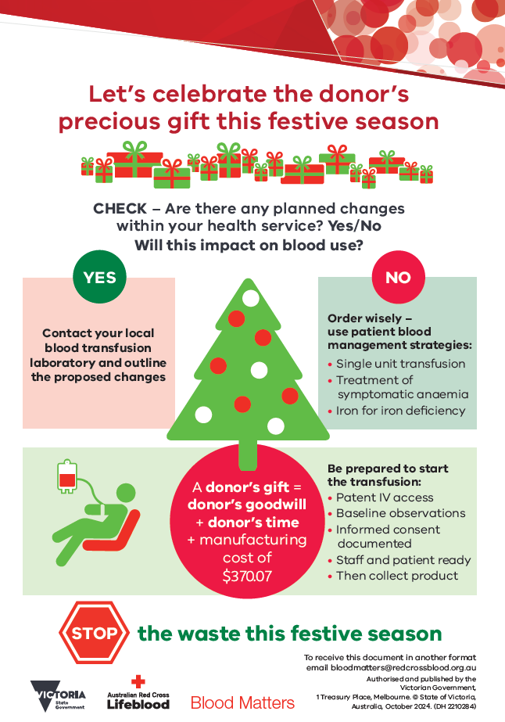
The 2024-25 ‘STOP the waste’ festive campaign is off to a great start, with RBC wastage rates for November and December 2024 well below average at 1.0%.

As the festive campaign continues through to February, your dedication to monitoring inventory and minimising RBC waste is much appreciated.

Your continued support of the ‘STOP the waste’ campaign is appreciated.
A summary of the 2024-25 festive campaign will be distributed at its conclusion.

Beriplex AU to replace Beriplex P/N from March 2025
Australian Red Cross Lifeblood has advised the second and final stage of Australia’s prothrombin complex concentrate (PCC) product transition from Prothrombinex-VF to Beriplex AU is commencing in March 2025.
Continue to order Beriplex P/N until Lifeblood notify that stock has been exhausted.
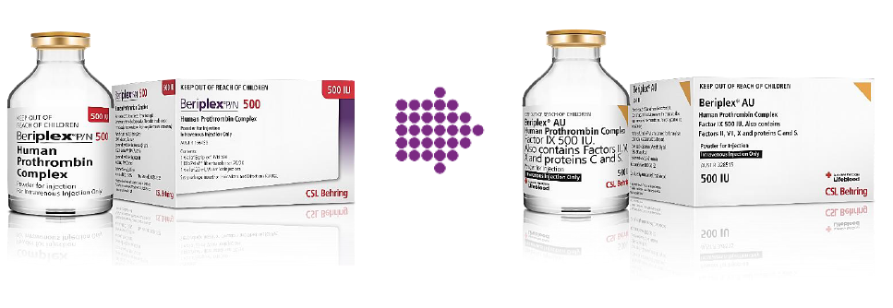

Lifeblood Customer Letter – Introduction of Beriplex AU 500IU (December 2024)

Differences between the products
Whilst Beriplex B/N and Beriplex AU are manufactured using the same process and have the same registered indication, they are made from different plasma sources and are separately registered on the Australian Register of Therapeutic Goods (ARTG). There is no data assessing their use together and they should not be used together as a single dose.
Any queries regarding the comparison of the products should be directed to CSL Behring: email medicalinformation@cslberhing.com.au <medicalinformation@cslberhing.com.au> phone 1800 642 865.

Action items
- Update your Laboratory Information Management System (LIMS)
- Note the Product Information and Consumer Medicine Information
- Update your laboratory and hospital policies and documents
Further Information, test barcodes and links to information are provided in Lifeblood communication and attachments dated 5 December 2024. These have been attached to this email for your convenience.

Warfarin reversal guidelines
The updated Thrombosis and Haemostasis Society of Australia and New Zealand (THANZ) Warfarin Reversal Guidelines can be found on the THANZ website <https://www.thanz.org.au/resources/thanz-guidelines>.

BloodNet data entry

Inventory on hand
To ensure Lifeblood and the National Blood Authority (NBA) have full visibility of inventory held across Australia, please enter ALL stock (including those reserved for emergency use) into BloodNet. Inventory levels are important in understanding demand for planning.
Inventory should be counted once unused reserved RBC (e.g. crossmatched RBC which have not been used after 24 hours) are returned to stock.
Consideration should also be given to RBC being transferred into your laboratory from another site. Implement robust systems for communicating transfers and adjust your Lifeblood order accordingly.

Discards
Choose the correct (or closest) discard code when entering into BloodNet. Additional comments are very useful inclusions (where appropriate) to assist in understanding wastage trends and corrective actions.
Discard reason ‘Other’ should only be used in exceptional circumstances – there is usually a more appropriate code. When using discard reason ‘Other’ please remember to enter comments.

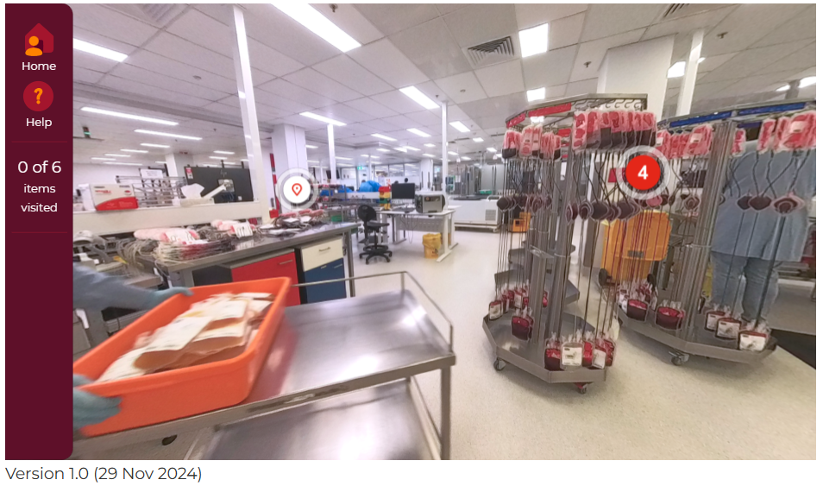
Virtual tour of Lifeblood’s Melbourne Processing Centre
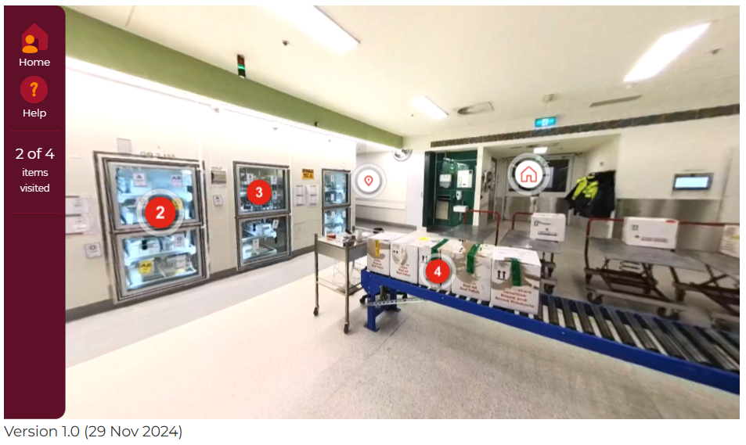

https://learn.transfusion.com.au/course/view.php?id=766

Experience an immersive virtual tour starting at a Lifeblood donor collection centre, where the blood donation journey begins. Be captivated as you move through processing and testing, with the tour featuring 3D photography, detailed text, and short gifs to guide you through essential processes and information. Dive into the 3D views to explore different areas, with numbered markers providing insights into the technical details.
Log-in to Lifeblood’s Transfusion Online Learning webpage <https://learn.transfusion.com.au/course/view.php?id=766> to have your tour!


National medical scientist certification
The Australian Council for Certification of the Medical Laboratory Scientific Workforce (CMLS) was launched in 2020 as a voluntary national professional certification scheme for Medical Laboratory Scientists.
New applications for certification and renewals are processed by the professional bodies providing CPD. More information and links can be found at www.cmls.org.au <https://www.cmls.org.au>.

Why become certified?
- Recognition of our professional standing as part of Australia’s health service workforce.
- Certification helps ensure competent professional practice.
- A certified workforce will promote professional development amongst the scientific community.
- As a nationally certified medical scientist you can demonstrate your ongoing commitment to professional development and self-improvement.
Blood Matters can provide support and education to assist in certification of the medical scientific workforce.

How can Blood Matters help you?
The Blood Matters team are here to assist health services and laboratories with education and provision of resources.
If you have suggestions for tools and resources please contact Rae French or the Blood Matters team via email rfrench@redcrossblood.org.au <rfrench@redcrossblood.org.au> or bloodmatters@redcrossblood.org.au <bloodmatters@redcrossblood.org.au> or phone 03 9694 3524.

To receive this document in another format, phone 03 9694 0102, using the National Relay Service 13 36 77 if required, or email Blood Matters <bloodmatters@redcrossblood.org.au>.
Authorised and published by the Victorian Government, 1 Treasury Place, Melbourne.
© State of Victoria, Australia, Department of Health, February 2025.
ISSN 2652-7278 – Online (pdf / word)
Available at Blood Matters <https://www.health.vic.gov.au/patient-care/transfusion-science-and-blood-stewardship>

