

Positive patient identification and pretransfusion checking procedure
Blood Matters Audit 2025
OFFICIAL
Contents
Background 1
Aims 2
Objectives 2
Method 2
Definitions 3
References 5

Background
The Blood Matters Program assists health services to ensure blood and blood products are administered to patients appropriately and safely in accordance with best practice guidelines.
The Serious Transfusion Incident Reporting (STIR) system has received an increase in notifications for wrong blood in tube (WBIT) and incorrect blood component transfused (IBCT) in FY 2024 (see table 1 below). Fortunately, ABO incompatible transfusions, a form of IBCT with the potential for significant morbidity and mortality, are reported infrequently; however, STIR continues to receive reports of components administered to a patient other than the intended patient. This indicates there is improvement to be made in the areas of patient identification and the pretransfusion check.
Table 1 WBIT and IBCT events for the financial years 2022 to 2024
Year | WBIT | IBCT
2023-2024 | 36 | 15
2022-2023 | 27 | 10
2021-2022 | 22 | 15

Patient identification and the matching of a patient to an intended treatment is performed routinely in all care settings. The development of safety routines for this common but critical task, help prevent mistakes that can cause harm or death (National Safety and Quality Health Service Standards, 2021) <https://www.safetyandquality.gov.au/our-work/communicating-safety/patient-identification>.
The pretransfusion checking procedure, which includes positive patient identification and blood component matching, is the last chance to ensure the right blood component is transfused to the right patient at the right time.
Commonly staff have undertaken a shared pretransfusion checking procedure where one person reads information aloud from one source and another checks that information against another source, which is not aligned with current guidelines and best practice.
The ANZSBT Guidelines for the Administration of Blood Products 3rd edition (2024) <https://anzsbt.org.au/wp-content/uploads/2024/02/Guidelines-for-the-Administration-of-Blood-Products-revised-Feb-2024.pdf> outline the requirements for positive patient identification, double independent checking and the pretransfusion checking procedure. Double independent checking was first included in these guidelines in 2018 to minimise the risk of error at the final check before transfusion.
Double independent checking: Clinicians individually and without requiring direct involvement of each other, check the prescription, patient and blood and blood product identification, and blood and blood product characteristics (including expiry, compatibility and special requirements (if any)). This process must ensure that each clinician is individually satisfied that, and responsible for, the correct product/ component is transfused in the correct way to the correct patient. The clinicians must agree before the transfusion is commenced.
Health services should have policies and procedures for blood administration that are aligned with national guidelines.

Aims
To identify if health service blood administration policies and practices are consistent with the Australian and New Zealand Society of Blood Transfusion (ANZSBT) Guidelines for the administration of blood products 3rd edition (2024).

Objectives
    - To determine if health services have pretransfusion checking procedures and protocols, incorporating positive patient identification and double independent checking and alignment with the ANZSBT Guidelines for the administration of blood products (2024)
    - To observe clinical staff performing pretransfusion checks to determine if double independent checking and positive patient identification as defined by ANZSBT guidelines is undertaken prior to blood component administration.

Method
The audit comprises two parts:
Part A – Audit of health service blood administration policy, specifically pretransfusion checking procedure, to determine if it is aligned with the ANZSBT Guidelines for the administration of blood products (2024). Part A is to be completed once for each health service.
Part B – Observation of the pretransfusion patient identification and component check prior to blood administration. Part B is to be completed for up to 20 individual, randomly selected patients who receive a transfusion between 1 March 2025 to 30 April 2025.
Inclusions: all patients receiving a transfusion that do not have an active massive haemorrhage protocol (MHP) or critical bleeding event.
Exclude: Patients with activated MHP or critical bleeding event.
Data entry is open and available to be completed from 1 March to 12 May 2025.
Data entry is electronic using REDcap.
Part A < https://redcap.lifeblood.com.au/surveys/?s=YP98FY4PPXPAYDDM>
Part B < https://redcap.lifeblood.com.au/surveys/?s=FCMXAYTHMXYC3JAC>
A data collection tool has been provided to assist in the collection of data prior to entry.
When entering data for part B, it is not necessary to input all records at once. However, it is necessary to complete all questions for an individual patient.
If experiencing problems entering data or if you have questions, please contact Blood Matters on 03 9694 0102 or email bloodmatters@redcrossblood.org.au
Victorian health services are expected (as outlined in the Victorian Department of Health Policy and Funding agreement) to complete both part A & B.

Definitions
Element | How it is defined
Blood components | Refers to fresh blood components - red blood cells, platelets, fresh frozen plasma, cryoprecipitate.
Blood products | Refers to fractionated plasma products such as immunoglobulins, albumin, clotting factors.  *Please note the ANZSBT guidelines use the term blood product as an all-encompassing term for both blood components and fractionated products.
Positive patient identification | ‘Positive patient identification’ is correctly identifying a patient to ensure that the right person receives their intended care. This involves the following:  - Ask the patient (if conscious and competent) to state and spell their family name and given name in full, and their date of birth (DOB).  - ensure that the stated family name and given names and DOB are identical to those on the identification band.  - If the patient is unable to state and spell their name, ask a parent, guardian or carer (if present and able to do so) to verify the patient’s identity; ensure that the stated family name and given name and DOB are identical to those on the identification band.
Double independent checking | A defined process where two clinicians individually and without requiring direct involvement of each other, check the prescription, patient and blood component identification, and blood component characteristics (including expiry, compatibility and special requirements, if any).  This process must ensure that each clinician is individually satisfied that, and responsible for, the correct component is transfused in the correct way to the correct patient.  The clinicians must agree before the transfusion is commenced. (ANZSBT Guidelines for the administration of blood products 3rd edition,2024)
DOB | Date of birth
MRN | Medical record number
EMR | Electronic medical record
ID | Identification
Shared checking | This occurs when one staff member reads information from one source e.g. the patient ID band while the other staff member reads the same information from another source e.g. the prescription.  In this case each person has not independently fulfilled the requirements for patient identification. This is not recommended as safe pretransfusion checking.
Family name | Surname or last name
Given names | First name and/or middle name

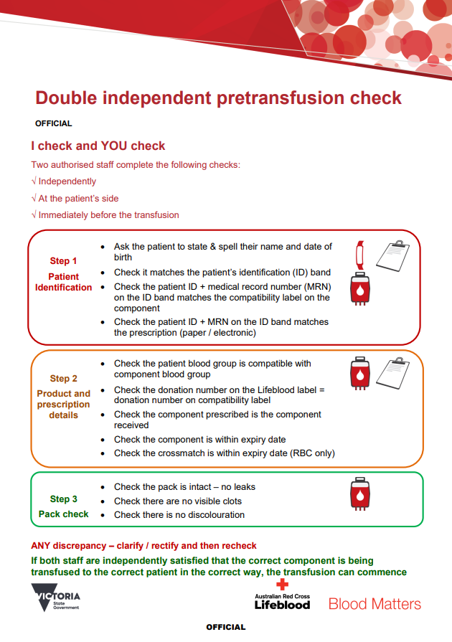https://www.health.vic.gov.au/patient-care/resources-and-education-blood-transfusion

References
Australian Commission on Safety and Quality in Health Care. National Safety and Quality Health Service Standards. 2nd ed. – version 2. Sydney: ACSQHC; 2021. Accessed Nov. 12, 2024. [Online] Available: https://www.safetyandquality.gov.au/sites/default/files/2021-05/national_safety_and_quality_health_service_nsqhs_standards_second_edition_-_updated_may_2021.pdf
Australian commission on safety and quality in health care. National Safety and Quality Health Services Standards. Blood Management Standard. Accessed Sep. 25, 2024. [Online]. Available: https://www.safetyandquality.gov.au/standards/nsqhs-standards/blood-management-standard
Australian commission on safety and quality in health care. National Safety and Quality Health Services Standards. Communicating for Safety Standard Accessed Sep. 25, 2024. [Online]. Available: https://www.safetyandquality.gov.au/standards/nsqhs-standards/communicating-safety-standard
Australian and New Zealand Society of Blood Transfusion. Guidelines for the administration of blood products. 3rd Ed. (2024) [Online]. Accessed Sep. 25, 2024. \Available: https://anzsbt.org.au/wp-content/uploads/2024/02/Guidelines-for-the-Administration-of-Blood-Products-revised-Feb-2024.pdf
BloodSafe SA EMR Double independent check video <https://vimeo.com/599951929/ee654d8e61>
Double Independent Checking: Transfusion - Clinical Excellence Commission New South Wales information sheet https://www.cec.health.nsw.gov.au/__data/assets/pdf_file/0006/476520/Information-for-Clinicians-Double-Independent-Checking-BW.pdf
Patient identification and pretransfusion checking video <https://vimeo.com/303045235>
Pre-transfusion check (non EMR) poster <https://www.sahealth.sa.gov.au/wps/wcm/connect/39312629-55c8-4e8b-aebe-3b86a4a21945/Pre-Transfusion+Check+non+EMR.pdf?MOD=AJPERES&amp;CACHEID=ROOTWORKSPACE-39312629-55c8-4e8b-aebe-3b86a4a21945-p7.2NBt>

To receive this document in another format, phone 03 9694 0102, using the National Relay Service 13 36 77 if required, or email Blood Matters, <bloodmatters@redcrossblood.org.au>.
Authorised and published by the Victorian Government, 1 Treasury Place, Melbourne.
© State of Victoria, Australia, Department of Health, January 2025.
Except where otherwise indicated, the images in this document show models and illustrative settings only, and do not necessarily depict actual services, facilities or recipients of services.
ISBN 978-1-76131-721-7 (pdf/online/MS word)
Available at Blood Matters Program <https://www.health.vic.gov.au/patient-care/blood-matters-program>

