

Mental Health Bulletin 88
Service Recipient Codes – CMI/ODS
OFFICIAL

Purpose and Scope
To provide an update on the Service Recipient category codes in CMI/ODS as a new group code has been added

Overview
Service Recipient codes in CMI/ODS are used in the contact data entry screen to provide detail on the person or persons receiving the contact.

Activity Data Reporting
There are a number of service recipient codes currently in CMI/ODS, however, to ensure accurate reporting of group activity the following service recipient codes are counted as group contacts:
- 2 - Client group
- 9 - Parent/Family/Carer group
- 40 - Client & Family group (new)

The new code to identify Client & Family groups was added to CMI/ODS in March 2025 with a commencement date of 1st January 2025. This code is available to all AMHS to use to accurately record client & family group activity.

Contact Data Entry
Below is a screen shot of the individual contact data that is entered into CMI/ODS:
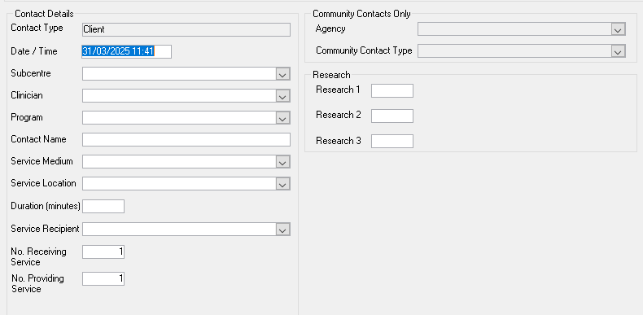

For More Information

Further information about the correct use of CMI/ODS , see the sections on; Registration of Clients, CMI/ODS Service Contacts and Subcentre/Program Maintenance. <https://www.health.vic.gov.au/research-and-reporting/bulletins-and-program-management-circulars-pmc>

For any queries relating to data reporting or program setup please email: MHDReporting@health.vic.gov.au
To receive this publication in an accessible format please email MHD Reporting <MHDReporting@health.vic.gov.au>
Authorised and published by the Victorian Government, 1 Treasury Place, Melbourne.
Available at Bulletins and Program Management Circulars (PMC) - https://www.health.vic.gov.au/research-and-reporting/bulletins-and-program-management-circulars-pmc>
© State of Victoria, Department of Health and Human Services, March 2025

