

Respiratory Syncytial Virus Mother and Infant Protection Program (RSV-MIPP)
Abrysvo® RSV vaccine preparation
OFFICIAL
This fact sheet provides guidance on the Abrysvo® respiratory syncytial virus (RSV) vaccine to support immunisation providers delivering the Respiratory Syncytial Virus Mother and Infant Protection Program (RSV-MIPP).
For more information about the RSV-MIPP, refer to the Department of Health Respiratory Syncytial Virus immunisation <https://www.health.vic.gov.au/immunisation/respiratory-syncytial-virus-immunisation>.

Abrysvo® immunisation during pregnancy
- A single dose of Abrysvo® RSV vaccine is recommended for pregnant women at 28-36 weeks pregnancy to protect the infant. All women who are already >28 weeks pregnant at the time of program commencement, should be offered immunisation as soon as possible.
- Abrysvo® RSV vaccine can be co-administered with other ante-natal vaccinations including the pertussis, influenza and COVID-19 vaccines.
- For more information of Abrysvo® RSV vaccine, refer to the Australian Immunisation Handbook <https://immunisationhandbook.health.gov.au/contents/vaccine-preventable-diseases/respiratory-syncytial-virus-rsv>.

Abrysvo® RSV vaccine information
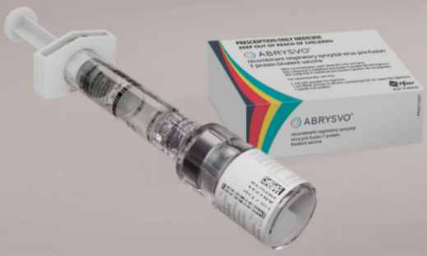
- Abrysvo® RSV vaccine: 0.5 ml vial
Figure 1. Abrysvo® RSV vaccine
- Presentation: powder and diluent for solution for injection
  - the powder or cake is white.
  - the diluent is a clear, colourless liquid
- Route & dosage:
  - intramuscular (IM) injection into the deltoid muscle
  - 0.5ml (1 dose per vial)

Storage
Abrysvo® RSV vaccine must be stored in a vaccine refrigerator, between +2ºC to +8ºC.
Use immediately after reconstitution. Do not return to the vaccine refrigerator.

Packet contents
Note: No needles are included in the packs.
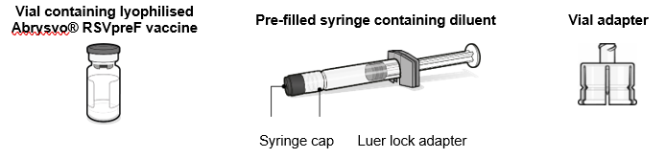
Figure 2: packet contents for Abrysvo RSVpreF vaccine
Preparation for administration

The lyophilised vaccine (powder) must be reconstituted only with the diluent provided using the vial adapter to form Abrysvo®. Three steps for administration are below.
Step 1. Attach vial adapter
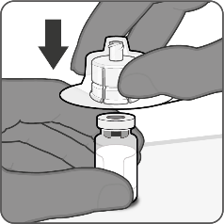
- Peel off the top cover from the vial adapter packaging and remove the flip-off cap from the vial.
- While keeping the vial adapter in its packaging, centre over the vial’s stopper and connect with a straight downward push. Do not push the vial adapter in at an angle as it may result in leaking. Remove the packaging.
Figure 3: Step 1. Attach vial adapter

Step 2. Reconstitute lyophilised vaccine component to form Abrysvo®
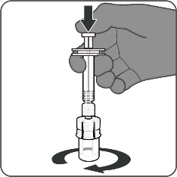
- For all syringe assembly steps, hold the syringe only by the Luer lock adapter. This will prevent the Luer lock adapter detaching during use.
- Twist to remove the syringe cap, then twist to connect the syringe to the vial adapter. Stop turning when you feel resistance.
- Inject the entire contents of the syringe into the vial. Hold the plunder rod down and gently swirl the vial until the powder is completely dissolved (less than 1 minute). Do not shake.
Figure 4: Step 2. Reconstitute lyophilised vaccine component to form Abrysvo®

Step 3. Withdraw reconstituted vaccine
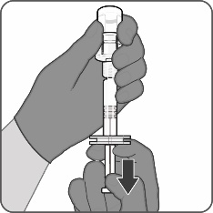
- Insert the vial completed and slowly withdraw the entire contents into the syringe to ensure a 0.5mL dose of Abrysvo® RSV vaccine.
- Twist to disconnect the syringe from the vial adapter.
- Attach a sterile needle suitable for intramuscular injection.
Figure 5: Step 3. Withdraw reconstituted vaccine

To receive this document in another format or email the Immunisation Program <immunisation@health.vic.gov.au>.
Authorised and published by the Victorian Government, 1 Treasury Place, Melbourne.
ISBN 978-1-76131-797-2 (pdf/online/MS word)
© State of Victoria, Australia, Department of Health, January 2025.

