
Cemetery sector newsletter
Edition 2, 2025
OFFICIAL

In this issue
Contact us 1
Welcome 1
New Cemeteries and Crematoria Regulations 1
New department contact for statutory approvals 2
Length of Class B cemetery trust member terms 2
Kerang Cemetery Trust grant project 2
Depth for interring cremated remains 2
Assistance program for low-activity cemeteries 3
Did you know? 3
Abstract of accounts due 1 September 3
Should cemetery trusts bundle fees? 3
When a trust’s primary contact is unavailable 3
Electronic banking and the removal of cheques 4
Native vegetation 4
Application to establish or alter a memorial 4
Free information sessions by the VPSC 5
Free governance training 5

Contact us
 | Email <cemeteries@health.vic.gov.au>
 | Phone 1800 034 280
 | Cemeteries and Crematoria website <https://www.health.vic.gov.au/public-health/cemeteries-and-crematoria>
 | Cemeteries and Crematoria  Department of Health  PO Box 4057  MELBOURNE VIC 3001

Welcome
Welcome to the Department of Health’s cemetery sector newsletter.

New Cemeteries and Crematoria Regulations
The new Cemeteries and Crematoria Regulations 2025 prescribe matters for the care, protection and management of public cemeteries and crematoria by cemetery trusts.
The Regulations include forms for applications relating to interments, cremations and exhumations. They set out Model Rules to control behaviours and activities within public cemeteries. The Regulations are available on the Legislation Victoria website <https://www.legislation.vic.gov.au/in-force/statutory-rules/cemeteries-and-crematoria-regulations-2025>.
The department has developed a summary of the changes in the new Regulations that are relevant to Class B cemetery trusts (attached).
For more detailed information, refer to the Cemeteries and Crematoria Regulations 2025 webpage <https://www.health.vic.gov.au/cemeteries-and-crematoria/cemeteries-and-crematoria-regulations-2025>.
The following resources published by the department have been updated:
- Manual for Victorian cemetery trusts <https://www.health.vic.gov.au/cemeteries-and-crematoria/class-b-cemetery-trust-governance>
- Records management handbook <https://www.health.vic.gov.au/cemeteries-and-crematoria/cemetery-trust-records-management>
- Secretary’s handbook <https://www.health.vic.gov.au/cemeteries-and-crematoria/class-b-cemetery-trust-governance#roles-and-responsibilities>

New department contact for statutory approvals
The following statutory approvals under the Cemeteries and Crematoria Act 2003 (the Act) are now assessed by the department’s Permits and Licensing Unit:
- Repatriation certificates
- Exhumation licences
- Approvals for interment other than in a public cemetery
- Cremation authorisations that cannot be granted by a cemetery trust
- Permission to remove and dispose of unsafe memorials
For enquiries about these applications, email the Permits and Licensing Unit <statutoryapprovals.cemeteries@health.vic.gov.au>.

Length of Class B cemetery trust member terms
We have recently had enquiries about why some member terms of office are shorter than a full 5-year period.
Under Schedule 1(1) of the Act, a Class B cemetery trust member holds office for a period not exceeding 5 years. This allows for differing terms of appointment to be made.
From time to time the appointment periods of some members may vary to:
- ensure not all members’ terms of appointment expire at the same time
- ensure continuity within the trust
- ensure a quorum for trust meetings can be met
- streamline administrative processes.
A full 5-year term of office is always considered first. When it is necessary to shorten a member’s term of office, we aim for a term as close to 5 years as possible.

Kerang Cemetery Trust grant project
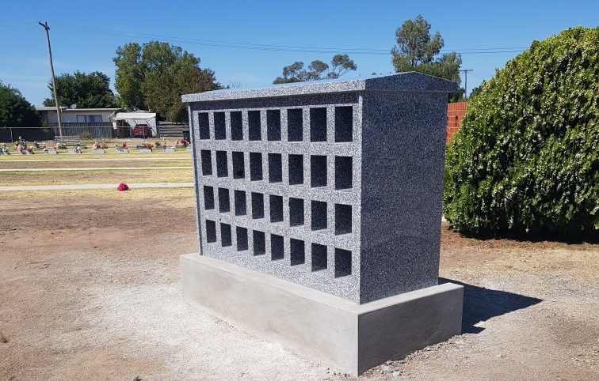
Kerang Cemetery Trust received a grant of $22,220 for a new niche wall for cremated remains in 2024 through the department’s Cemetery Grants Program.
The wall is made of polished grey granite and sits on a concrete base. It is double-sided and has 64 niches. Congratulations to the trust for this great addition to the cemetery.

Depth for interring cremated remains
Cemetery trusts often permit the interment of cremated remains in dedicated burial areas or existing graves.
There is no legal minimum burial depth for interring cremated remains in a grave, but the industry standard is for no less than 350 mm of ground cover.
The department recommends a burial depth of at least 450 mm for interring cremated remains. This helps prevent accidental exposure of the container – for example, through animals digging, grounds maintenance or earth works.
Please note that burial depth for cremated remains may vary depending on the size and shape of the container.

Assistance program for low activity cemeteries
The Assistance Payment Program for Low Activity Cemeteries (previously known as the Small Cemetery Operations Grants Program) assists Victoria’s smallest cemetery trusts with the cost of cemetery maintenance and operations.
The program offers fixed grants of $500 to Class B cemetery trusts that meet certain criteria.
Cemetery trusts that reported no more than $5,000 in financial assets and no more than 5 interments in their abstract of accounts for the previous financial year are eligible to apply.
A full list of eligibility criteria and examples of suitable grant requests is available in the program guidelines. Trusts should submit an application form by 31 October 2025. The form is shorter than the regular grants program application form and does not require quotes.
The guidelines and form are available to download from the Assistance Payment Program webpage <https://www.health.vic.gov.au/cemeteries-and-crematoria/assistance-payment-program-low-activity-cemeteries>.


Did you know?
The first cremation of a European in Victoria was conducted on the foreshore of Half Moon Bay in Black Rock in April 1895.
Cremation in Victoria was legalised in 1903, and the first legal cremation took place at The Necropolis (now called Springvale Botanical Cemetery) in 1905 using wood and kerosene.
Historical legislation enacted by the Victorian Parliament between 1851 and 1995 is available on the Australasian Legal Information Institute website <https://www.austlii.edu.au/au/vic/>.

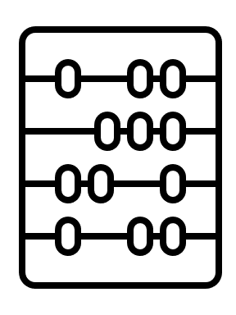
Abstract of accounts due 1 September
All Class B cemetery trusts must submit a financial report known as the abstract of accounts to the department each year.
A copy of the 2024–25 abstract of accounts was sent to each trust in June and is due to the department on 1 September 2025.
Copies can also be downloaded from the Class B cemetery trust financial reporting webpage <https://www.health.vic.gov.au/cemeteries-and-crematoria/class-b-cemetery-trust-financial-reporting-and-procedures>.

Should cemetery trusts bundle fees?
Different products and services should have separate fees. For example, there should be distinct fees for Rights of interment, Interment services and Memorialisation.
Cemetery trusts should be transparent in their billing, making it easy for families to understand what they have paid for. When raising an invoice, the trust should list out the gazetted fees that are being charged, rather than combine different fees into a single ‘bundled’ figure.
This will help the trust check the invoice against gazetted fees to ensure it is complete and accurate.

When a trust’s primary contact is unavailable
When the primary contact for a trust is unavailable due to illness or planned leave, the trust chairperson should arrange for a current trust member to take on the responsibilities of that role for the duration of the absence. This will ensure members of the public can contact the trust.
Trusts that haven’t already done so should consider setting up a trust email account so other trust members can access it when the primary contact is unavailable.

Electronic banking and the removal of cheques
All Victorian Government departments and agencies, including cemetery trusts, are required to work towards eliminating cheques as a payment method. The Commonwealth Government has confirmed that:
- issuing cheques will cease on 30 June 2028
- accepting cheques will cease on 30 September 2029.
The Victorian Government has set important milestones to prepare for the phase-out of cheques, ensuring all departments and agencies are ready before the Commonwealth’s deadlines.
Date | Action
30 Sep 2025 | All invoices and websites stop referring to cheque as a payment method.
31 Dec 2027 | Stop issuing cheques as a payment method.
30 Jun 2028 | Banks will not process cheques written after 30 June 2028.  Only cheques dated prior to 30 June 2028 can continue to be accepted.
30 Jun 2029 | Stop accepting cheques as a payment method.  (Note: cheques won’t be valid for payment if dated after 30 June 2028).
30 Sep 2029 | Financial institutions will no longer accept cheques for payments.  Cheque system is formally closed.
Cemetery trusts that do not already use electronic banking should arrange to do so. Please contact your bank’s relationship or account manager to discuss.
Please stop referring to cheques as a payment method on invoices, website and other trust documents.
More information about Australia’s cheque transition plan <https://treasury.gov.au/publication/p2024-555854> is on the Commonwealth Treasury website.


Native vegetation
Native vegetation is defined as plants (including trees, shrubs, herbs and grasses) that are indigenous to Victoria. Native vegetation is important for the habitat it provides for wildlife.
In Victoria, a permit is usually required to remove, destroy or lop native vegetation.
Your local council can advise if an exemption applies to works proposed by the trust (for example, for bushfire protection or public safety).
If a trust believes there is a need to remove, destroy or lop native vegetation, contact your local council to determine what is required before starting any works.

Application to establish or alter a memorial
The Cemeteries and Crematoria Association of Victoria developed the Application to establish or alter a memorial or place of interment <https://ccav.org.au/news-and-resources/> to assist trusts with the memorialisation approval process.
The form includes useful information about the Australian Standard for headstones and cemetery monuments (AS 4204:2019).
Once the trust approves an application, it can issue a memorial permit to the applicant. Before starting construction, cemetery trusts should ask monumental masons to submit a work schedule outlining the planned works, including inspection times. Cemetery trusts should provide clear and accurate information about the interment location to ensure memorials are constructed at the correct location.
Cemetery trusts may need to remove a memorial if the terms and conditions of the application have not been followed, or if the memorial has been established or altered without the trust’s consent.
Templates for monumental mason and memorialisation policies are available on the Cemeteries and crematoria website <https://www.health.vic.gov.au/cemeteries-and-crematoria/policy-templates-class-b-cemetery-trusts>. These templates can be adapted to suit the needs of individual trusts.

Free information sessions by the Victorian Public Sector Commission
The Victorian Public Sector Commission has released its 2025 program of free information sessions to support and enhance the performance of Victorian public boards (including cemetery trusts).
Sessions are suitable for both new and experienced board members, secretaries and staff. The department encourages attendance at these events.
For more information and to register for an event, visit the Victorian Public Sector Commission’s website <https://www.boards.vic.gov.au/board-events>.

Free governance training

Free face-to-face governance training workshops for Class A and Class B cemetery trusts are held across Victoria. The workshops are delivered by ICDA, an enterprise of Our Community, on behalf of the department.
To register for an upcoming workshop in your area please visit the ICDA website <https://communitydirectors.com. au/training/victorian-cemetery-trusts-governance-and-operational-training>.
For help with registrations or to arrange a workshop in your area by request, please contact Our Community:
Phone: 1300 137 475
Email: <learn@ourcommunity.com.au>

Class B online training
The department has developed a free online training program called Cemetery Essentials for Class B Cemetery Trusts.
If you would like to take part, please email Our Community <learn@ourcommunity.com.au> to request an invitation.
Please note: To access the course, participants need to have an email address.

To receive this document in another format, phone 1800 034 280, using the National Relay Service 13 36 77 if required, or email the department <cemeteries@health.vic.gov.au>.
Authorised and published by the Victorian Government, 1 Treasury Place, Melbourne.
© State of Victoria, Australia, Department of Health, July 2025.
ISSN 2208-8830 (print) 2208-8849 (online/PDF/Word)
Available on the Cemeteries and Crematoria website <https://www.health.vic.gov.au/cemeteries-and-crematoria/cemetery-sector-newsletters>
Printed by Razer Graphix, Bayswater

