
Check you are using the correct varicella containing vaccines
National Immunisation Program vaccine recommendations
July 2025
Vaccine brand | Packaging
Varilrix®  Varicella -zoster (chickenpox)  NIP – age recommendation  Catch-up  - From 19 months  - From 14 years to < 20 years  - Refugees and asylum seekers from 12 months  Notes  - Syringe of diluent + vial with pellet  - 14 years and older - 2 dose course, a minimum of 4 weeks apart  - Live attenuated virus vaccine  - Contraindicated in immunocompromised individuals | 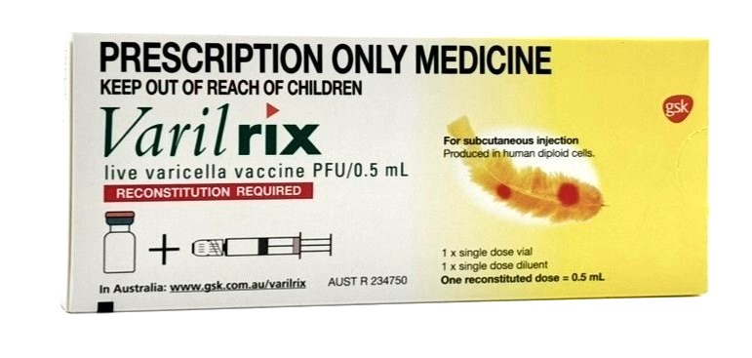
Shingrix®  Herpes-zoster(shingles)  Age recommendation  - People aged 65 years and older  - Aboriginal and Torres Strait Islander people aged 50 years and older  - Immunocompromised people aged 18 years or older with certain medical risk conditions.  Notes  - Syringe of diluent + vial with powder  - Two dose course:  - 2-6 months apart (immunocompetent person)  - 1-2 months apart (immunocompromised person) | 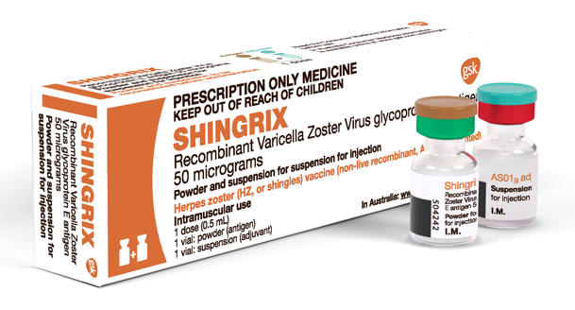
Vaccine brand | Packaging
Priorix-Tetra®  MMRV (measles-mumps-rubella-varicella)  Age recommendation  - 18 months  Catch-up  - 19 months to < 14 years - catch-up  Notes  - Syringe of diluent + vial with pellet  - Live attenuated virus vaccine  - Contraindicated in immunocompromised individuals  - Must be administered as the 2nd MMR dose for children <4 years of age due to the risk of febrile seizure if MMRV is given as a 1st dose | 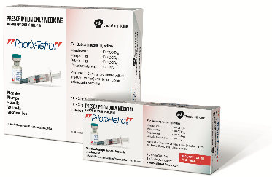
Images of packaging reproduced with permission.
Always check that vaccines are prepared and administered appropriately in accordance with product instructions and recommendations in the Australian Immunisation Handbook <https://immunisationhandbook.health.gov.au>.
Use this resource in conjunction with the Immunisation schedule Victoria and vaccine eligibility criteria <https://www.health.vic.gov.au/immunisation/immunisation-schedule-victoria-and-vaccine-eligibility-criteria>.
To receive this document in another format or email the Immunisation Program <immunisation@health.vic.gov.au>.
Authorised and published by the Victorian Government, 1 Treasury Place, Melbourne.
© State of Victoria, Australia, Department of Health, July 2025.
Available on Immunisation factsheets, consent templates and mature minor information
<https://www.health.vic.gov.au/immunisation/immunisation-fact-sheets-consent-templates-and-mature-minor-information>.

