

Check you are using the correct DTPa and dTpa containing vaccines

National Immunisation Program age recommendations
Use this resource in conjunction with the Immunisation schedule Victoria and vaccine eligibility criteria <https://www.health.vic.gov.au/immunisation/immunisation-schedule-victoria-and-vaccine-eligibility-criteria>.

DTPa containing vaccine - Childhood formulation – under 10 years of age
Infanrix hexa® or Vaxelis®  Diphtheria-tetanus-acellular pertussis-poliomyelitis-hepatitis B-Hib | 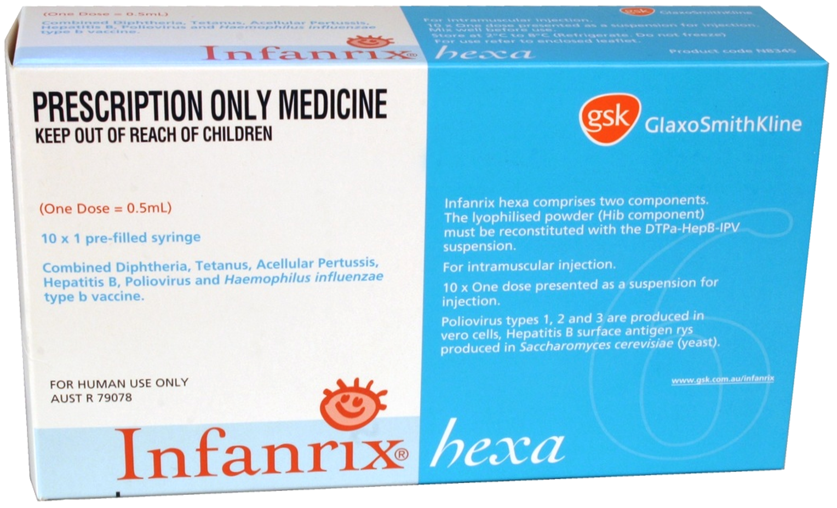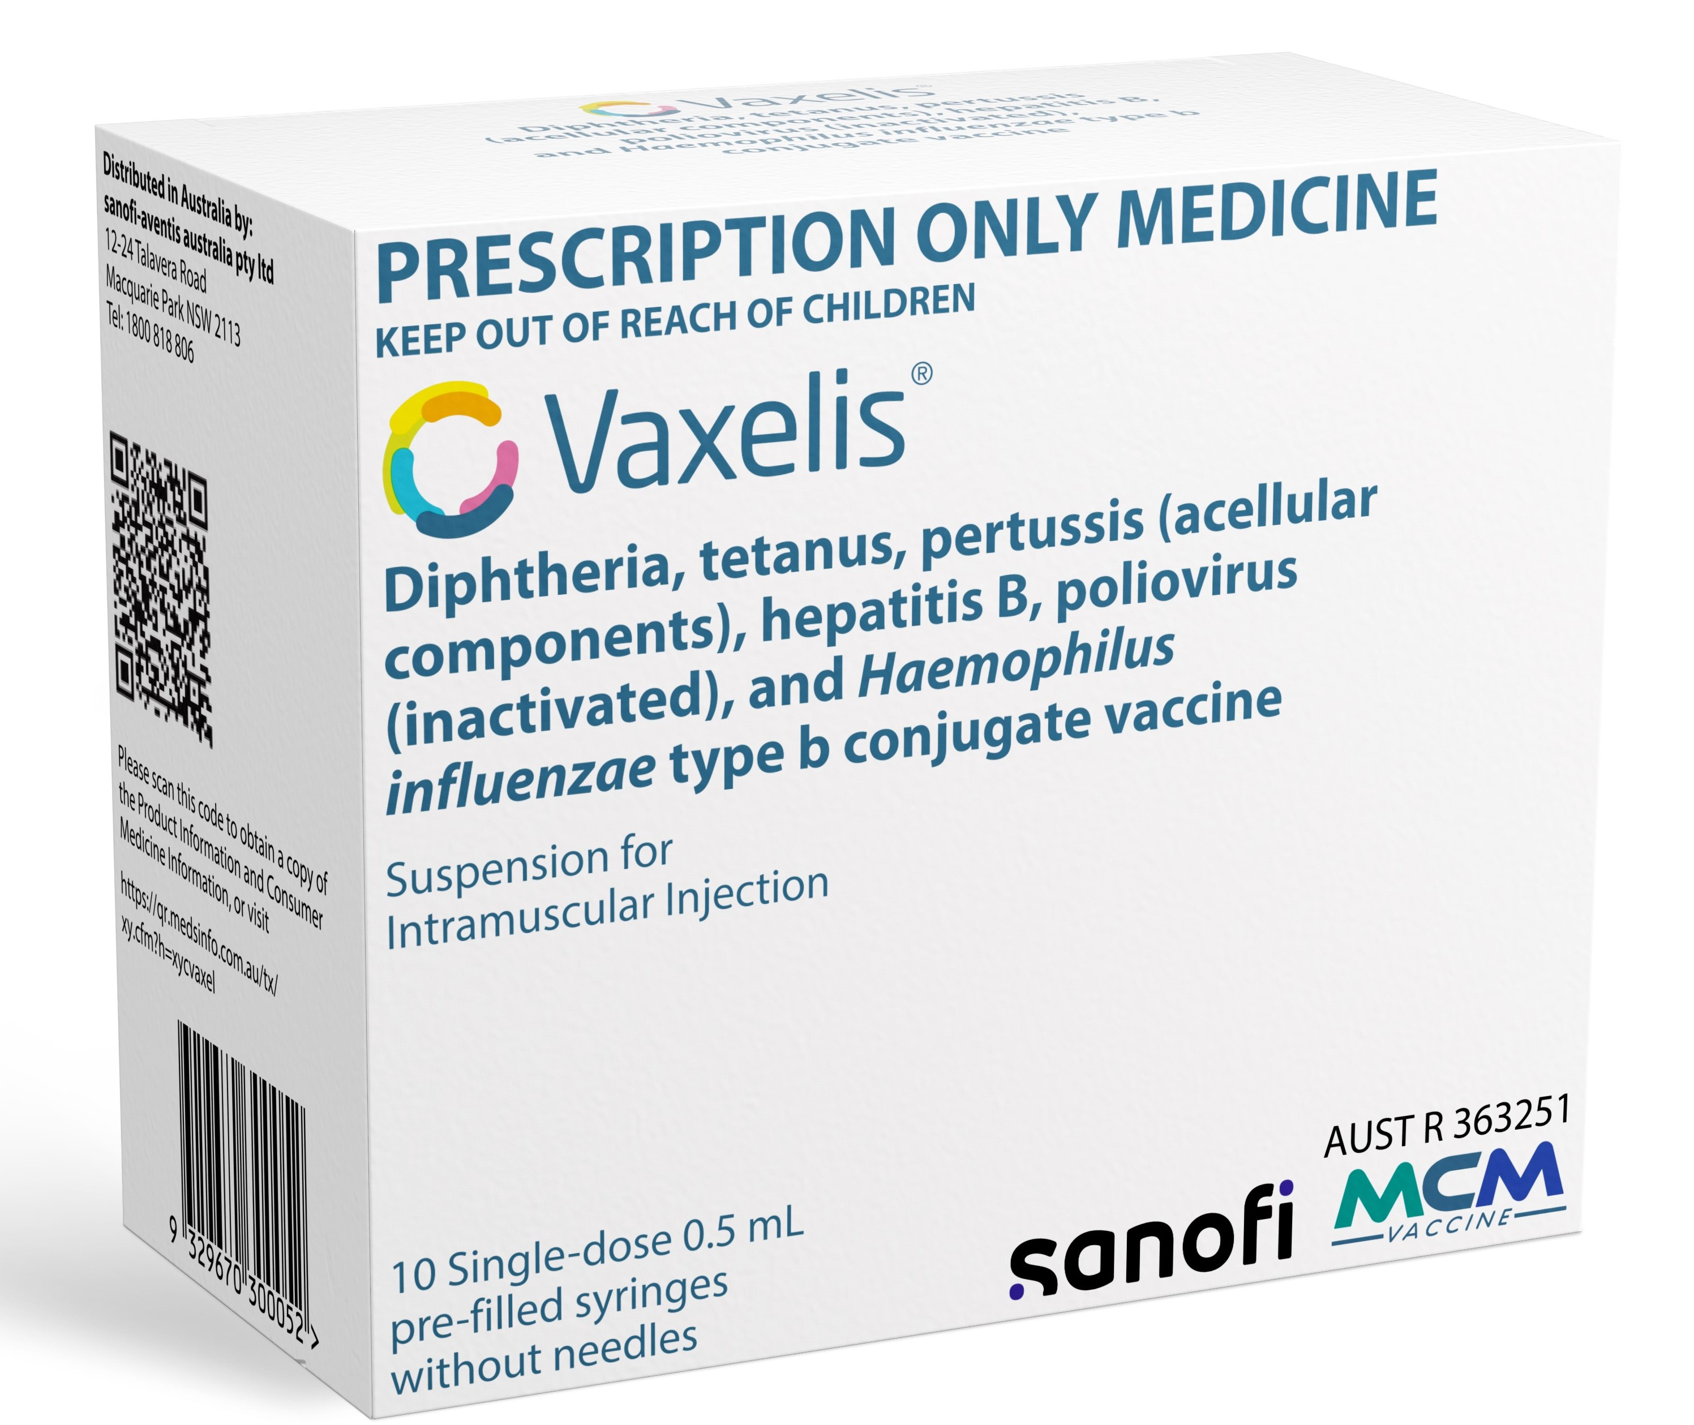
Age recommendation | Notes
- 2 months (from 6 weeks)  - 4 months  - 6 months  - Children <10 years for catch-up | - Infanrix hexa® - Prefilled syringe of diluent contains Diphtheria-tetanus-acellular pertussis-poliomyelitis-hepatitis B to be mixed with vial containing Haemophilus influenzae type b  - Vaxelis® - Prefilled syringe
Infanrix® or Tripacel®  Diphtheria-tetanus-acellular pertussis | 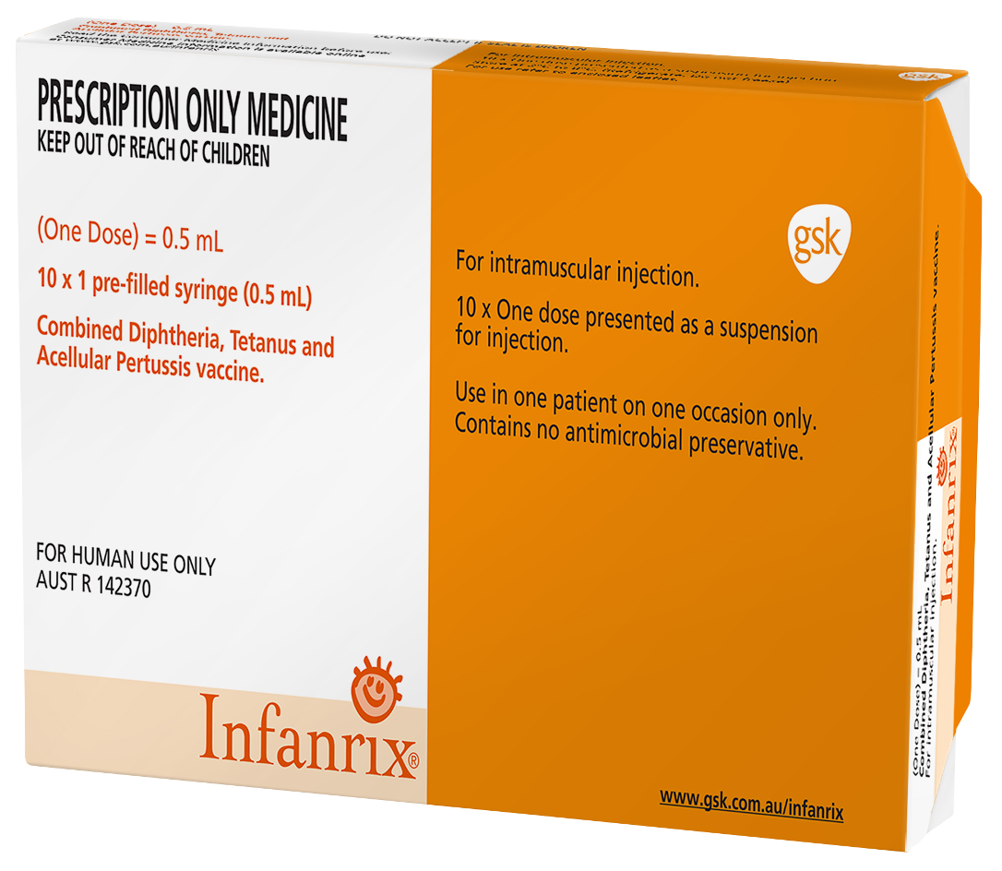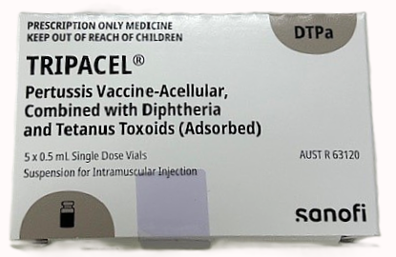
Age recommendation | Notes
- 18 months  - Children <10 years for catch-up | - Infanrix® – Prefilled syringe  - Tripacel® – Vial
Infanrix IPV® or Quadracel®  Diphtheria-tetanus-pertussis-poliomyelitis | 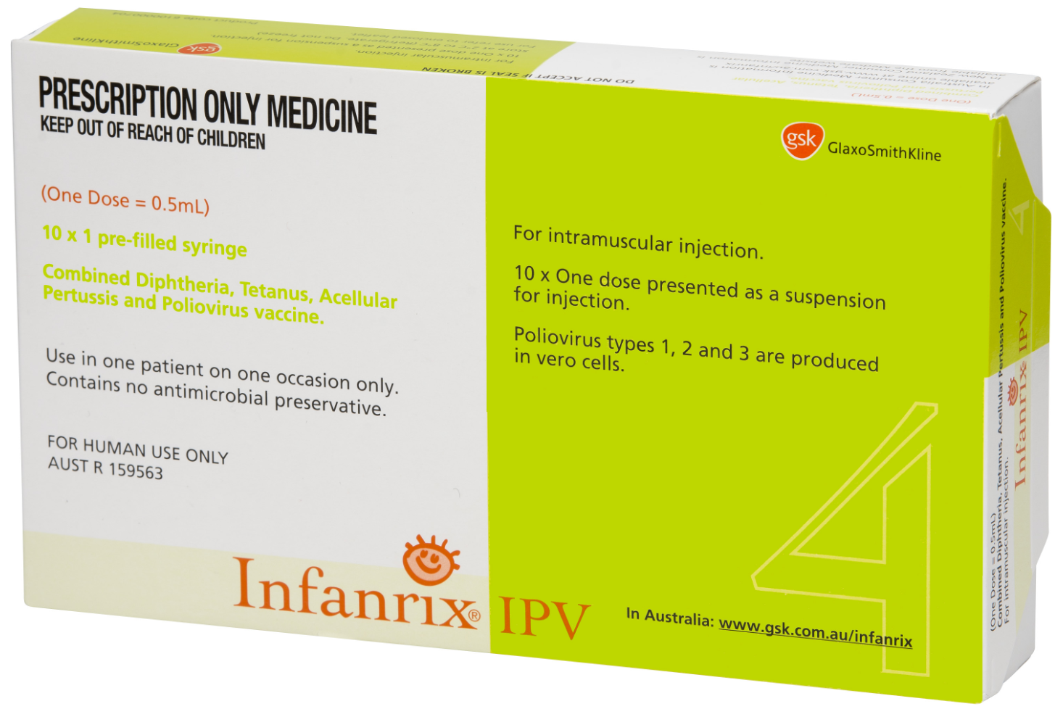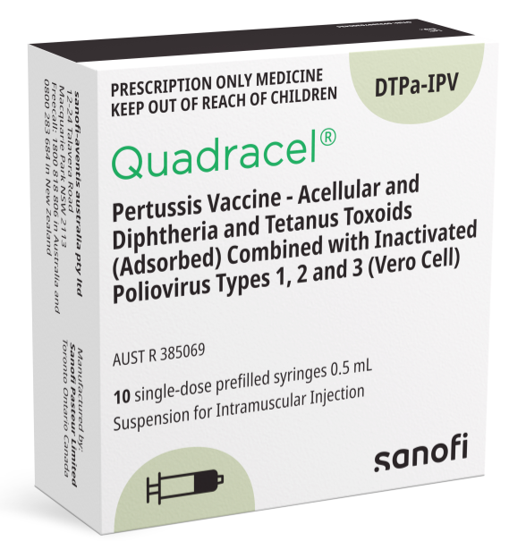
Age recommendation | Notes
- 4 years  - Children <10 years for catch-up | - Infanrix-IPV® - Prefilled syringe  - Quadracel® - Vial

dTpa containing vaccine - Adolescent/Adult formulation – 10 years of age and older
Adacel® or Boostrix®  Tetanus toxoid and reduced amount of diphtheria toxoid and acellular pertussis vaccine | 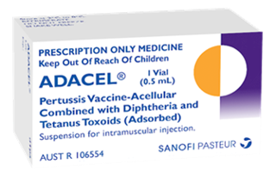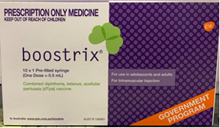
Age recommendation | Notes
- Year 7 of secondary school or 12 – 13 years  - 10 to <20 years for catch-up  - Pregnant woman from 20 weeks’ gestation  - Refugee / asylum seeker person ≥10 years  - Aboriginal and Torres Strait Islander person ≥10 years. | - Prefilled syringe  - Adults can receive 1 dose of dTpa vaccine at least 4 weeks after a dose of dT vaccine for pertussis protection. Studies show short intervals between doses are not associated with increased injection site reactions.

Reference – The Australian Immunisation Handbook, <https://immunisationhandbook.health.gov.au>.
Material adapted from the Australian Immunisation Handbook, Australian Government Department of Health.
Images of packaging reproduced with permission.

To receive this publication in an accessible format email <immunisation@health.vic.gov.au>.
Authorised and published by the Victorian Government, 1 Treasury Place, Melbourne.
© State of Victoria, Australia, Department of Health and Human Services, July 2025.
Available on Health.vic – Immunisation factsheets, consent templates and mature minor information
<https://www.health.vic.gov.au/immunisation/immunisation-fact-sheets-consent-templates-and-mature-minor-information>.

