

Check you are using the correct vaccine brand for age
National Immunisation Program childhood and adolescent schedule vaccine recommendations
September 2025
Always check that vaccines are prepared and administered appropriately in accordance with product instructions and recommendations in the Australian Immunisation Handbook <https://immunisationhandbook.health.gov.au/>.
Use this resource in conjunction with the Immunisation schedule Victoria and vaccine eligibility criteria <https://www.health.vic.gov.au/immunisation/immunisation-schedule-victoria-and-vaccine-eligibility-criteria>.

2 months (from 6 weeks) and 4 months of age
Vaccine brand | Packaging
Infanrix hexa® or Vaxelis®  Diphtheria-tetanus-acellular pertussis-hepatitis B-inactivated poliovirus-Haemophilus influenzae type b vaccine | 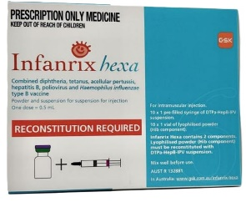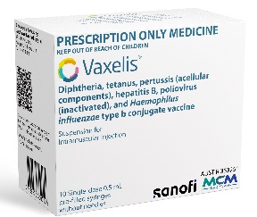
Prevenar 20®  20-valent pneumococcal conjugate vaccine | 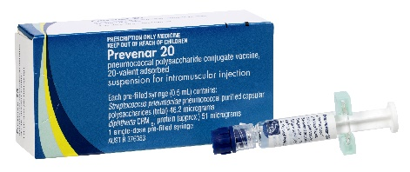
Rotarix®  Rotavirus vaccine | 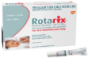
Aboriginal and Torres Strait Islander children only  Bexsero®  Meningococcal serogroup B vaccine | 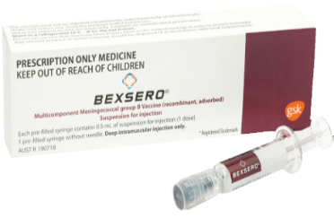

6 months of age
Vaccine brand | Packaging
Infanrix hexa® or Vaxelis®
Diphtheria-tetanus-acellular pertussis-hepatitis B-inactivated poliovirus-Haemophilus influenzae type b vaccine
Influenza vaccine  Annually for all children aged 6 months to <5 years | Vaccine brand supplied annually  - administer the age-appropriate NIP funded vaccine brand
Prevenar 20®  20-valent pneumococcal conjugate vaccine  - Aboriginal and Torres Strait Islander children  - Risk conditions for pneumococcal disease https://immunisationhandbook.health.gov.au/resources/handbook-tables/list-risk-conditions-for-pneumococcal-disease  - Babies born less than 28 weeks' gestation | 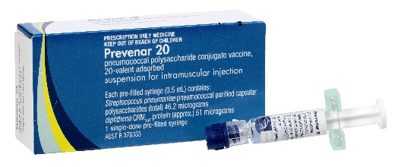

12 months of age
Vaccine brand | Packaging
Priorix®  Measles-mumps-rubella vaccine | 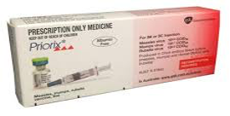
Prevenar 20®  20-valent pneumococcal conjugate vaccine | 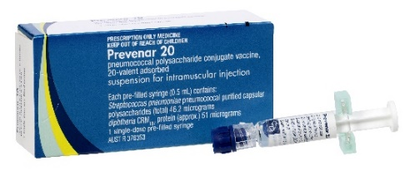
Nimenrix®  Meningococcal serogroups ACWY vaccine | 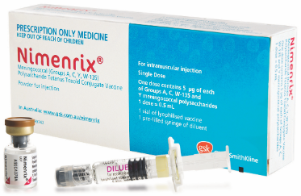
Aboriginal and Torres Strait Islander children only
Bexsero®
Meningococcal serogroup B vaccine

18 months of age
Vaccine brand | Packaging
Act-HiB®  Monovalent Haemophilus influenzae type b vaccine | 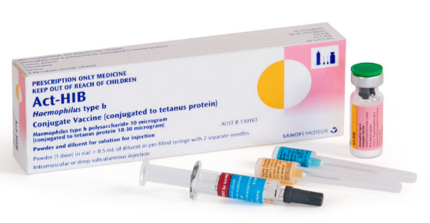
Priorix-Tetra®  Measles-mumps-rubella-varicella vaccine | 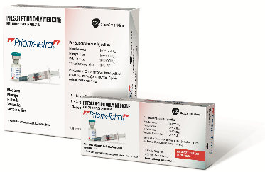
Infanrix® or Tripacel®  Diphtheria-tetanus-acellular pertussis vaccine | 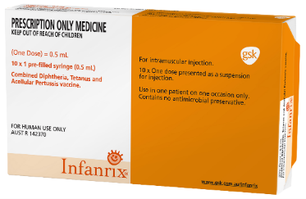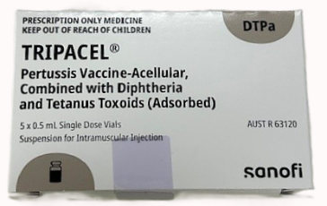

4 years of age
Vaccine brand | Packaging
Infanrix IPV® or Quadracel®  Diphtheria-tetanus-acellular pertussis-inactivated poliovirus vaccine | 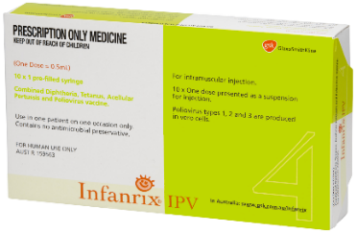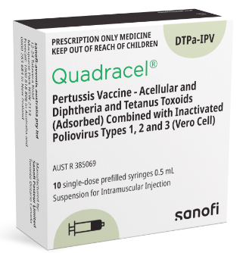

Year 7 of secondary school or 12 to 13 years of age
Vaccine brand | Packaging
Gardasil® 9  9-valent Human papillomavirus vaccine | 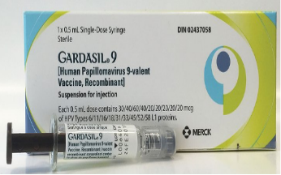
Adacel® or Boostrix®  Diphtheria-tetanus-acellular pertussis reduced antigen formulation vaccine | 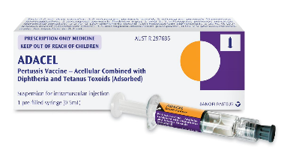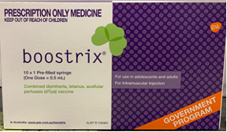

Year 10 of secondary school or 14 to 16 years of age
Vaccine brand | Packaging
MenQuadfi®  Meningococcal serogroups ACWY vaccine | 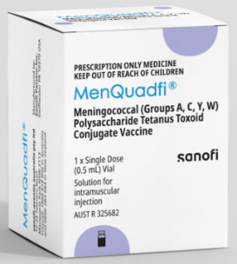

Newly diagnosed medical risk condition 12 months < 18 years
Vaccine brand | Packaging
Prevenar 20®  20-valent pneumococcal conjugate vaccine  Risk conditions for pneumococcal disease  https://immunisationhandbook.health.gov.au/resources/handbook-tables/list-risk-conditions-for-pneumococcal-disease | 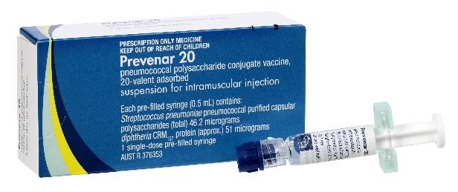

To receive this document in another format or email the Immunisation Program <immunisation@health.vic.gov.au>.
Authorised and published by the Victorian Government, 1 Treasury Place, Melbourne.
© State of Victoria, Australia, Department of Health, September 2025.
Available on Immunisation factsheets, consent templates and mature minor information
<https://www.health.vic.gov.au/immunisation/immunisation-fact-sheets-consent-templates-and-mature-minor-information>.

