

Blood Matters on the Bench and Beyond
Issue 23 – August 2025
OFFICIAL

Welcome to the Blood Matters newsletter for Scientists.

Blood Matters online events 2025
Blood Matters online events are a regular fixture in our education calendar, continuing to support scientists and our multidisciplinary network of transfusion professionals.
Information will be sent as dates are finalised throughout the year.

Blood management summit for scientists – save the date

Wednesday 15 October 2025
10.00am – 3.30pm (time TBC)
Australian Red Cross Lifeblood, Melbourne Processing Centre, West Melbourne
Mark the date in your calendar, further details to follow soon.

O RhD negative red blood cell (RBC) audit published
‘The indications for the use of O RhD negative RBC audit report 2024’ is now available on the Blood Matters webpage.
The audit was conducted in 2 parts:
- O RhD negative RBC policy and inventory
- A retrospective audit of the fate of all O RhD negative RBC issued during March 2024.
The audit aimed to assess the use of O RhD negative RBC against general principles and guidance in Australia and compare the results to the 2017 Blood Matters O RhD negative audit results.
The results of this audit will assist health services and transfusion laboratories to identify any gaps in policy and practice, understand the current pattern of use for O RhD negative RBC and prompt regular re-evaluation of their RBC inventory.
Audit results snapshot
Overall, health services and laboratories have policies in place that support and meet the guidelines and recommendations for the responsible use and stewardship of O RhD negative RBC. There are, however, opportunities for health services to improve in aligning practice with guidelines and local policy.
The data showed that there has been little change in practice from the 2017 audit and a large proportion (41 per cent) of O RhD negative RBC with a reported fate were not transfused according to current guidelines.
Twenty per cent of these were used to prevent expiry rather than for clinical need which is an increase from 17 per cent in 2017.
When comparing 2017 with 2024 audit data the proportion of sites holding only O RhD negative RBC increased (24 per cent in 2017 to 33 per cent in 2024) and sites holding all blood groups decreased (9 per cent in 2017 to 6 per cent in 2024).
There was a marked improvement in health service policy that outlined the requirement to rotate RBC to prevent time expiry, 74 per cent in 2017 to 90 per cent in 2024. RBC rotation occurred between 4-14 days prior to the date of expiry with 7 days being the most common time frame, a decrease from 14 days in the 2017 audit. To ensure RBC can be used appropriately, they must be rotated with sufficient time before expiry.
Summary of use based on guidelines and recommendations
Indications for use | O RhD negative RBC  Number (%)
Within guidelines: Patient blood group O RhD negative | 898 (40)
Within guidelines: Emergency use aligned to guidelines | 73 (3)
Within guidelines: Phenotyped | 233 (10)
Within guidelines: Other | 65 (3)
Total within guidelines | 1269 (57)
Outside guidelines: Emergency use in female patients > 50 years and male patients > 18 years) | 200 (9)
Outside guidelines: Emergency use beyond four units of O RhD negative RBCs | 8 (0.4)
Outside guidelines: Used to prevent expiry | 454 (20)
Outside guidelines: Inventory (stock not held or insufficient stock of other blood groups) | 143 (6)
Outside guidelines: Other (including special requirements) | 95 (4)
Total outside guidelines | 900 (41)
Total discarded | 51 (2)
Key recommendations
- Blood Matters recommends that health services and transfusion laboratories review the report, together with their individual and comparative data.
- Health services and transfusion laboratories should review their policies and practices and incorporate the guidance in the National Statement for the Emergency Use of Group O RBC where appropriate.
- Health services should work with their local blood management/transfusion committee to implement the recommendations and support alignment with best practice guidelines.
- RBC inventory should reflect local ABO blood group demographic distribution to meet clinical need whilst maintaining appropriate levels to minimise time expiry, with regular review.
Read the full report for further results and all recommendations.

Transfusion Laboratory Essentials: new module released
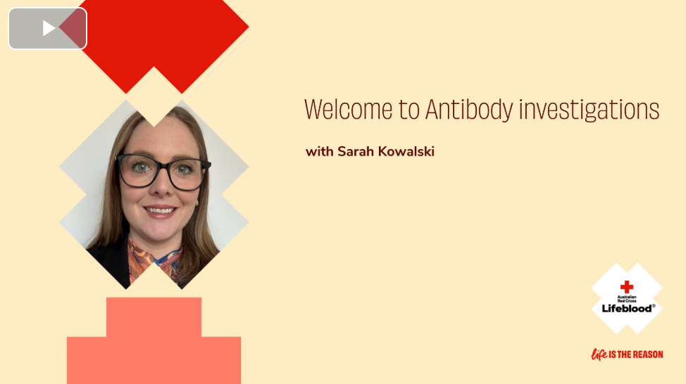
Lifeblood’s Clinical Education Team have released their latest module in their Transfusion Laboratory Essentials (TLE) course: Antibody investigations. While it’s designed for early career scientists, the modules are an accessible learning tool or refresher for all transfusion scientists.
This module introduces learners to all aspects of conducting antibody investigations, featuring comprehensive lessons, interactive activities, and practical case studies to ensure a thorough understanding of the subject.
Key Features:
- In-depth explanations of antibody investigation techniques, with a guided video on the exclusion process
- Clear guidance on interpreting antibody panels
- Interactive quizzes to test your knowledge
- Real-world case studies for practical application
- Expert insights, helpful tips, and downloadable resources
Take the time to explore this exciting new module and take full advantage of the Clinical Education Team’s resources available to support your own or your team members' learning and professional development.


Changes to eligibility criteria for donating plasma for fractionation
The donor eligibility criteria for donating plasma for fractionation no longer includes deferral periods for many sexual activities and/or the use of Pre-Exposure Prophylaxis treatment (PrEP).
This means gay and bisexual men, more transgender people, sex workers, people who have engaged a sex worker, and anyone who takes PrEP, will be able to donate plasma without a wait period - providing they meet all other eligibility criteria.
<https://www.lifeblood.com.au/>
This change to eligibility criteria, known as the ‘plasma pathway’, was approved by the TGA in 2023 and is being implemented in agreement with the National Blood Authority, CSL Behring, and governments who have legal responsibility for the donor questionnaire in their jurisdictions.
These changes to our donor eligibility criteria will enable the greatest number of people to donate plasma without compromising the safety of the blood supply.
Please refer to the attached letter for complete details and share this communication with relevant stakeholders in your organisation.

Changes to Alburex storage temperature requirements
CSL Behring has changed the storage temperature requirements of Alburex AU products:
- FROM: store below +25°C (Do not freeze)
- TO: store below +30°C (Do not freeze).
A letter from Australian Red Cross Lifeblood, providing further details is attached for your reference.
See the Product Information for details of the update:
Alburex® 5 AU – 250 mL and 500 mL
Alburex® 20 AU – 50 mL and 100 mL

Practical advice on the appropriate use of platelets
The Association for the Advancement of Blood & Biotherapies (AABB) in partnership with the International Collaboration for Transfusion Medicine Guidelines (ICTMG) have published a new set of platelet transfusion guidelines, with practical advice on the appropriate use of platelets in various clinical settings.
The guidelines are informed by a recent systematic literature review and meta-analysis. The panel concluded that the ‘evidence demonstrated that restrictive transfusion strategies probably did not cause increases in mortality or bleeding relative to liberal strategies across predefined clinical populations’.
The guidelines offer recommendations for platelet transfusion based on specific patient criteria and vary depending on patients’ needs, categorised based on the degree of evidence.
The full article and new international platelet guidelines can be found on the Lifeblood website.

National medical scientist certification
The Australian Council for Certification of the Medical Laboratory Scientific Workforce (CMLS) is a voluntary national professional certification scheme for Medical Laboratory Scientists. New applications for certification and renewals are processed by the professional bodies providing CPD. More information and links can be found at www.cmls.org.au⁵.

How can Blood Matters help you?
Blood Matters are here to assist health services and laboratories with education and provision of resources.
If you have suggestions for tools and resources please contact Rae French or the Blood Matters team via email rfrench@redcrossblood.org.au <rfrench@redcrossblood.org.au> or bloodmatters@redcrossblood.org.au <bloodmatters@redcrossblood.org.au> or phone 03 9694 3524.
To receive this document in another format, phone 03 9694 0102, using the National Relay Service 13 36 77 if required, or email Blood Matters <bloodmatters@redcrossblood.org.au>.
Authorised and published by the Victorian Government, 1 Treasury Place, Melbourne.
© State of Victoria, Australia, Department of Health, August 2025.
ISSN 2652-7278 – Online (pdf / word)
Available at Blood Matters <https://www.health.vic.gov.au/patient-care/transfusion-science-and-blood-stewardship>

< https://www.health.vic.gov.au/patient-care/blood-matters-audit-reports>
<https://learn.transfusion.com.au/login/index.php>
<https://www.ebs.tga.gov.au/ebs/picmi/picmirepository.nsf/pdf?OpenAgent=&id=CP-2020-PI-01908-1&d=20250529172310101>
<https://www.ebs.tga.gov.au/ebs/picmi/picmirepository.nsf/pdf?OpenAgent=&id=CP-2020-PI-01909-1>
<https://www.lifeblood.com.au/news-and-stories/health-professionals-news/new-international-platelet-transfusion-guidelines-now>

