

Check you are using the correct Meningococcal vaccines
National Immunisation Program age recommendations for different vaccine brands
OFFICIAL

Use this resource in conjunction with the Immunisation Schedule Victoria <https://www2.health.vic.gov.au/public-health/immunisation/immunisation-schedule-vaccine-eligibility-criteria/immunisation-schedule-victoria>
Nimenrix®  Meningococcal ACWY vaccine | 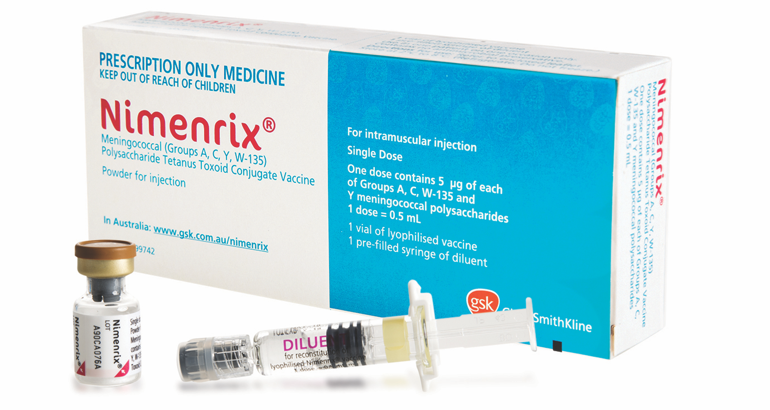
Age recommendation  - 12 months  - Catch-up <20 years  - Any age – Risk condition | Notes  - Syringe of diluent + vial  - Specified medical conditions associated with increased risk of invasive meningococcal disease <https://immunisationhandbook.health.gov.au/resources/handbook-tables/list-specified-medical-conditions-associated-with-increased-risk-of>
MenQuadfi®  Meningococcal ACWY vaccine | 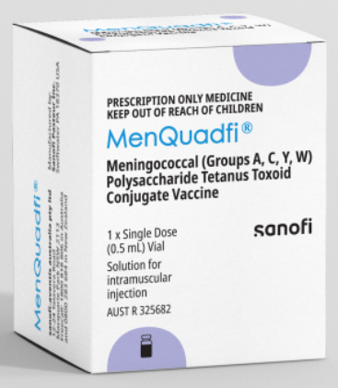
Age recommendation  - Year 10 of secondary school or  15-16 years of age  - Catch-up <20 years  - Any age – Risk condition | Notes  - Vial of liquid  - Specified medical conditions associated with increased risk of invasive meningococcal disease <https://immunisationhandbook.health.gov.au/resources/handbook-tables/list-specified-medical-conditions-associated-with-increased-risk-of>

Bexsero®  Meningococcal B vaccine | 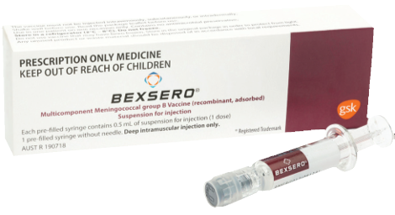
Age recommendation  - Aboriginal and Torres Strait Islander children  - 2, 4 & 12 months  - Catch-up <2 years of age  - Any age – Risk condition | Notes  - Pre-filled syringe  - Specified medical conditions associated with increased risk of invasive meningococcal disease <https://immunisationhandbook.health.gov.au/resources/handbook-tables/list-specified-medical-conditions-associated-with-increased-risk-of>

Reference
The Australian Immunisation Handbook <https://immunisationhandbook.health.gov.au/>.
Material adapted from the Australian Immunisation Handbook, Australian Government Department of Health.
Images of packaging reproduced with permission.

To receive this document in another format, email the Immunisation Program <immunisation@health.vic.gov.au>.
Authorised and published by the Victorian Government, 1 Treasury Place, Melbourne.
© State of Victoria, Australia, Department of Health, August 2025.

