

Check you are using the correct MMR containing vaccines
National Immunisation Program and Victorian Immunisation schedules
OFFICIAL

Always ensure vaccines are prepared and administered according to product information and recommendations in the Australian Immunisation Handbook https://immunisationhandbook.health.gov.au/ and the Victorian Immunisation Schedule <https://www.health.vic.gov.au/immunisation/immunisation-schedule-victoria-and-vaccine-eligibility-criteria>.

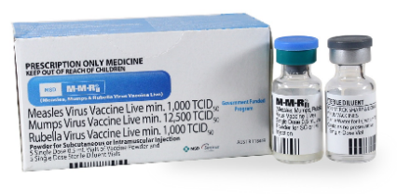
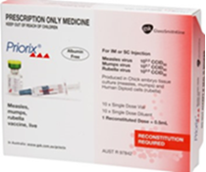
M-M-R® or Priorix®
Measles-Mumps-Rubella
- Syringe of diluent or vial of diluent + vial with pellet
- Live attenuated virus vaccines
- Contraindicated in immunocompromised individuals
- Contraindicated in pregnancy
Age recommendation | Notes
National Immunisation Program:  - 12 months  - Catch-up from 13 months | - MMR must be administered as the 1st dose for children <4 years of age
Victorian Government funded:  - Infants from 6 months to <11 months prior to travel overseas  - Persons born since 1966 with no evidence of MMR protection | - MMR must be administered as the 1st dose for children <4 years of age  - Women with low or negative rubella antibody levels who are planning pregnancy or shortly after delivery  - Vaccinated women should avoid pregnancy for 28 days after vaccination
PriorixTetra®  Measles-Mumps-Rubella-Varicella | 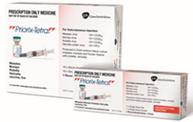
Age recommendation | Notes
- 18 months  - 19 months to 13 years - catch-up | - Syringe of diluent + vial with pellet  - Live attenuated virus vaccines  - Contraindicated in immunocompromised individuals, and in pregnancy  - Must be administered as the 2nd MMR dose for children <4 years of age due to the risk of febrile seizure if MMRV is given as a 1st dose
To receive this document in another format or email the Immunisation Program <immunisation@health.vic.gov.au>.
Authorised and published by the Victorian Government, 1 Treasury Place, Melbourne.
© State of Victoria, Australia, Department of Health, August 2024.
Available on Immunisation factsheets, consent templates and mature minor information
<https://www.health.vic.gov.au/immunisation/immunisation-fact-sheets-consent-templates-and-mature-minor-information>.

