

Check you are using the correct Pneumococcal vaccines
National Immunisation Program age recommendations for different vaccine brands
OFFICIAL

Use this resource in conjunction with the Immunisation Schedule Victoria <https://www2.health.vic.gov.au/public-health/immunisation/immunisation-schedule-vaccine-eligibility-criteria/immunisation-schedule-victoria>
Prevenar 13®  Pneumococcal conjugate (13vPCV) | 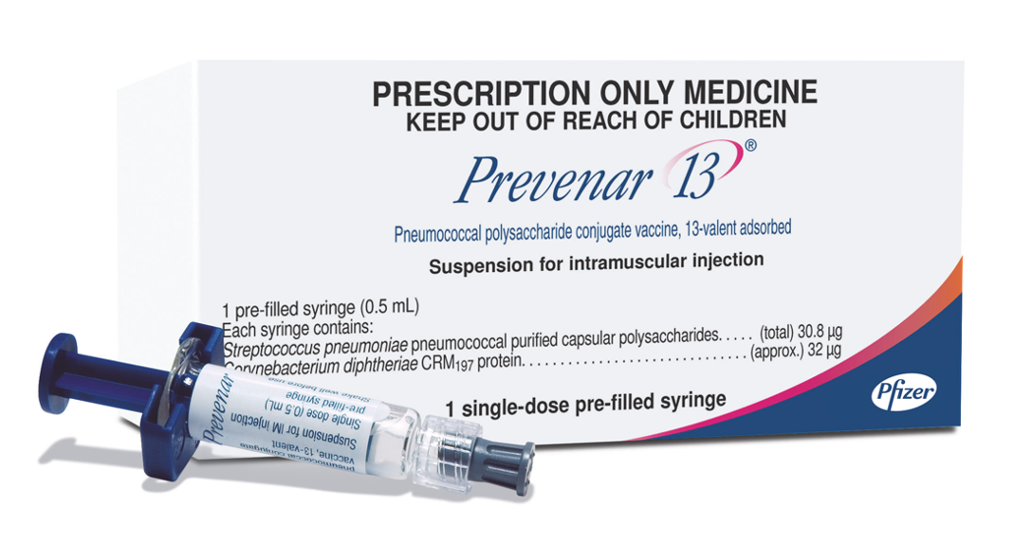
Age recommendation  - From 18 years and older - risk condition  - From 50 years - Aboriginal and Torres Strait Islander people  - From 70 years - non-Indigenous people | Notes  - Prefilled syringe  - Pneumococcal clinical decision tree <https://www.health.gov.au/resources/publications/national-immunisation-program-pneumococcal-vaccination-schedule-from-1-july-2020-clinical-decision-tree-for-vaccination-providers>
Prevenar 20®  Pneumococcal conjugate (13vPCV) | 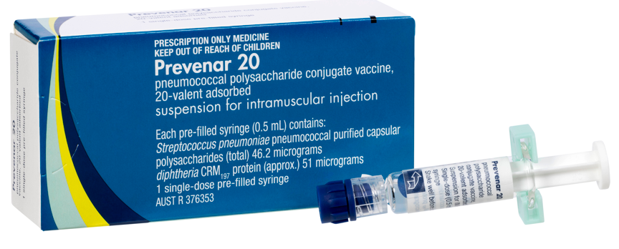
Age recommendation  - 2 (from 6 weeks), 4 & 12 months  - 6 weeks – additional dose for:  - Aboriginal and Torres Strait Islander children  - all non-indigenous children with risk conditions  - 12 months to <18 years – newly diagnosed risk condition  - Catch-up from 13 months to <5 years | Notes  - Prefilled syringe  - Pneumococcal clinical decision tree <https://www.health.gov.au/resources/publications/national-immunisation-program-pneumococcal-vaccination-schedule-from-1-july-2020-clinical-decision-tree-for-vaccination-providers>

Pneumovax23®  Pneumococcal polysaccharide (23vPPV) | 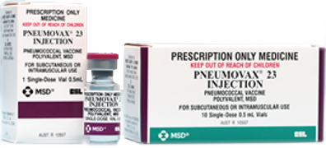
Age recommendation  - From 50 years – Aboriginal and Torres Strait Islander people  - From 4 years and older – risk condition | Notes  - Vial of liquid  - Maximum of 2 lifetime doses spaced by a minimum 5 years  - Pneumococcal clinical decision tree <https://www.health.gov.au/resources/publications/national-immunisation-program-pneumococcal-vaccination-schedule-from-1-july-2020-clinical-decision-tree-for-vaccination-providers>Pneumococcal risk conditions>

Reference
The Australian Immunisation Handbook <https://immunisationhandbook.health.gov.au/>.
Material adapted from the Australian Immunisation Handbook, Australian Government Department of Health.
Images of packaging reproduced with permission.

To receive this document in another format, email the Immunisation Program <immunisation@health.vic.gov.au>.
Authorised and published by the Victorian Government, 1 Treasury Place, Melbourne.
© State of Victoria, Australia, Department of Health, August 2025.

