

Blood Matters on the Bench and Beyond
Issue 24 – November 2025
OFFICIAL

Welcome to the Blood Matters newsletter for Scientists.

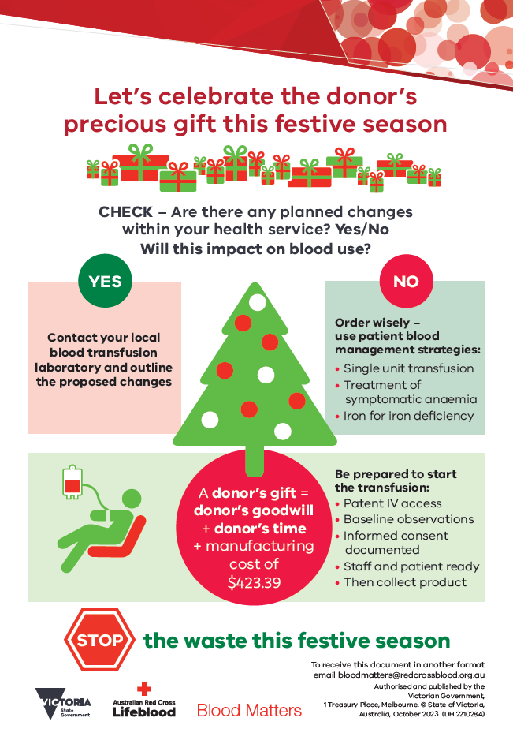
‘STOP the waste’ festive campaign 2025-26
The festive season is fast approaching, and once again it is time to consider how blood wastage can be minimised over this period.
Donated blood is a gift, and we all need to do our part to protect and manage this valuable resource.
Let’s celebrate the donor’s precious gift this festive season.
Are there anticipated changes to activity over the festive season which will impact blood use at your health service?
Adjust inventory accordingly and inform Lifeblood of any anticipated changes to your blood inventory and usage, to assist them to adjust donor collections as required. This will help to ensure sufficiency of the blood supply over the festive season.
Checklists are attached to this email, and available for download from Blood Matters’ Blood component wastage webpage.
Your continued support of the ‘STOP the waste’ campaign is appreciated.

O RhD negative RBC inventory forecast
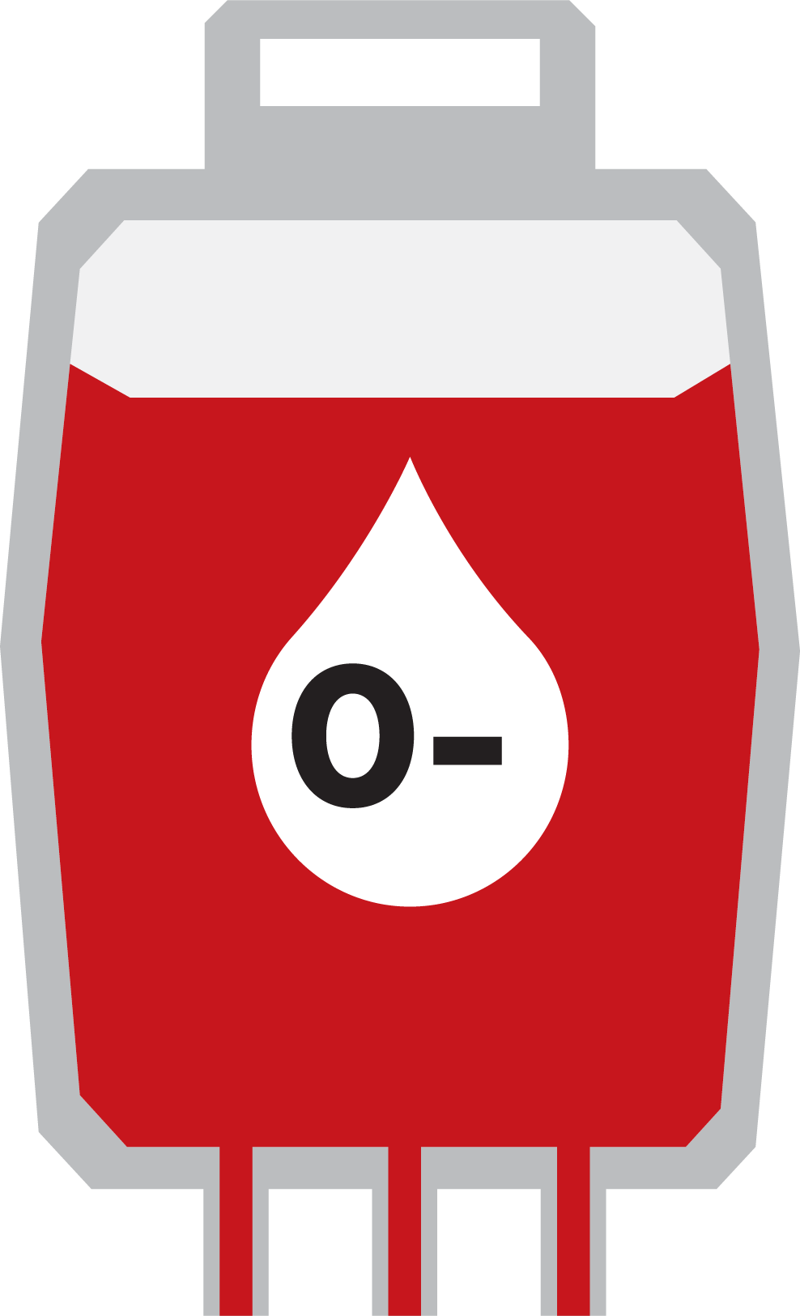
Lifeblood’s supply plan forecasting anticipates that there will be intermittent O RhD negative RBC inventory restrictions throughout November.
Actions are underway to engage donors and increase O RhD negative RBC collections, but your assistance is required to ease supply pressures:
- Review and reduce your orders for O RhD neg RBC where possible.
- Follow National Blood Authority guidance including the National Statement for the Emergency Use of Group O Red Blood Cells and National Guidance for the Management of Red Blood Cell Inventory².
- Plan for intermittent inventory restrictions on O RhD negative RBC. When on Medical Officer (MO) approval, orders will be reviewed and may be restricted in consultation with your laboratory.
To best support your inventory management during this time, Lifeblood will continue to communicate any inventory restrictions to you daily.
Lifeblood appreciates your support through this challenging period. Please contact your local Lifeblood Transfusion Scientist if you have any queries.

New guidance for cryoprecipitate dosing
An update to the 'Patient blood management guideline for adults with critical bleeding 2023 (Good Practice Statement 5)', provides guidance that a standard adult dose of fibrinogen is 3 to 4 g.
This is achievable in Australia with:
- Fibrinogen concentrate*
- Nine units of whole blood derived cryoprecipitate and/or split apheresis cryoprecipitate (both pack types are equivalent and interchangeable), or
- Three units of apheresis cryoprecipitate (large dose packs) where laboratories still have residual stock.^
For the purpose of ROTEM/TEG guided critical bleeding protocols:
- Three units of whole blood derived and/or split apheresis cryoprecipitate should be considered an equivalent dose of fibrinogen as a 1 g vial of fibrinogen concentrate.
Hospitals participating in the FEISTY II study should continue to use the trial cryoprecipitate dosing protocol.
Access the updated guideline via the MAGICapp or the NBA website.
It's advised that health services review their local cryoprecipitate dosing guidelines, including their ROTEM/TEG guided critical bleeding/major haemorrhage protocols to be consistent with this dosing guidance.
* Fibrinogen concentrate is approved in Australia for the treatment of acute bleeding episodes in patients with congenital fibrinogen deficiency. Use of fibrinogen concentrate outside these indications (including critical bleeding) is considered ‘off-label'.
^ Large volume apheresis cryoprecipitate is not currently supplied by Lifeblood. (For laboratories managing residual stock of large volume apheresis derived cryoprecipitate manufactured prior to December 2024, or dosing with mixed inventory, one large volume apheresis derived cryoprecipitate unit is equivalent to three units of whole blood and/or split apheresis cryoprecipitate)
Please share this update with all relevant stakeholders.

Consultation open: National Pathology Standard
The Australian Commission on Safety and Quality in Health Care (the Commission) is seeking your feedback on the draft National Pathology Standard (formerly known as the Requirements for Medical Pathology Services).
Help shape changes to the National Pathology Standard by:
- Providing feedback through an online survey or written submissions
- Participating in an online focus group on the draft National Pathology Standard
- Sharing the consultation resources with anyone in your network who may be interested
View the draft and share your feedback online.
The online survey and written submissions will close on 17 November 2025.
Online focus groups will run between 25 November to 8 December 2025. You can register for a focus group by clicking on the link above.
More information
Visit safetyandquality.gov.au/pathology or email pathology@safetyandquality.gov.au

National medical scientist certification
The Australian Council for Certification of the Medical Laboratory Scientific Workforce (CMLS) is a voluntary national professional certification scheme for Medical Laboratory Scientists. New applications for certification and renewals are processed by the professional bodies providing CPD. More information and links can be found at www.cmls.org.au.

How can Blood Matters help you?
Blood Matters are here to assist health services and laboratories with education and provision of resources.
If you have suggestions for tools and resources please contact Rae French rfrench@redcrossblood.org.au <rfrench@redcrossblood.org.au> or the Blood Matters team bloodmatters@redcrossblood.org.au <bloodmatters@redcrossblood.org.au> via email or phone 03 9694 3524.
To receive this document in another format, phone 03 9694 0102, using the National Relay Service 13 36 77 if required, or email Blood Matters <bloodmatters@redcrossblood.org.au>.
Authorised and published by the Victorian Government, 1 Treasury Place, Melbourne.
© State of Victoria, Australia, Department of Health, November 2025.
ISSN 2652-7278 – Online (pdf / word)
Available at Blood Matters <https://www.health.vic.gov.au/patient-care/transfusion-science-and-blood-stewardship>

https://www.health.vic.gov.au/patient-care/blood-component-wastage
https://www.blood.gov.au/blood-products/blood-product-management/inventory-management-blood-and-blood-products
https://www.safetyandquality.gov.au/newsroom/consultations/national-pathology-standard-consultation
https://www.surveymonkey.com/r/27Q6M2T
www.cmls.org.au

