
Your health
Report of the Chief Health Officer, Victoria, 2018
OFFICIAL

Your health
Report of the Chief Health Officer, Victoria, 2018

To receive this document in another format email Public Health communications <pph.communications@health.vic.gov.au>.
Authorised and published by the Victorian Government, 1 Treasury Place, Melbourne.
© State of Victoria, Australia, Department of Health, January 2026.
Except where otherwise indicated, the images in this document show models and illustrative settings only, and do not necessarily depict actual services, facilities or recipients of services. This document may contain images of deceased Aboriginal and Torres Strait Islander peoples.
In this document, ‘Aboriginal’ refers to both Aboriginal and Torres Strait Islander people. ‘Indigenous’ or ‘Koori/Koorie’ is retained when part of the title of a report, program or quotation.
ISSN 2207-3841 (online/PDF/Word)
Available at Your health - biennial report
<https://www.health.vic.gov.au/population-health-systems/your-health-biennial-report>

Contents
Message from the Chief Health Officer 7
Determinants of health 7
Global challenges: climate change and antimicrobial resistance 7
The continuing importance of public health 8
Data used in this report 9
Who we are 9
Demographic data 2018 10
Overview 16
Oral health 19
Affordability of dental care 19
Child oral health 20
Adult oral health 21
Injury prevention 22
Family violence prevention 22
Falls prevention among older Victorians 24
Mental health in Victoria 28
Suicide prevention 28
Mental illness and mental wellbeing 30
Non-communicable disease 35
Diabetes 35
Stroke 36
Heart disease 37
Non-melanoma skin cancer 38
Melanoma 40
Cancer 42
Musculoskeletal conditions 43
Immunisation in Victoria 45
Immunisation for Meningococcal disease in Victoria 45
Immunisation coverage and amendments to No Jab No Play legislation 46
Immunisation high risk groups 48
Communicable disease 51
2017 influenza outbreak 51
Advances in hepatitis C treatment 55
Improving communicable disease data management 58
Antimicrobial resistance 61
Buruli ulcer 63
Food 67
Salmonella 67
Food anaphylaxis notifications 70
Food fermentation products 71
Water 73
Safe drinking water 73
Water fluoridation 74
Aquatic facilities 75
Environmental Health 78
Air quality 78
Healthy indoor environments 82
Thunderstorm asthma 85
Climate change and public health in Victoria 86
Heat health 92
Child health 97
Allergies 97
Mental health and wellbeing 99
Overweight and obesity in children 101
Maternal and infant health 103
Improving health outcomes for Aboriginal women and babies 103
Safe sleeping of infants 104
Healthy living 106
Healthy eating 106
Active living 108
Tobacco-free living 110
Burden of disease 114
Alcohol use 114
Overweight and obesity 116
Causes of death in Victoria 119
Leading causes of disease and injury 122
Health inequalities 127
Asylum seekers and refugees 127
Rural and regional Victorians 129
Social determinants of health 132
Aboriginal and Torres Strait Islander Victorians 136
LGBTIQA+ Victorians 138

Message from the Chief Health Officer

As Victoria's Chief Health Officer, and on behalf of the Department of Health and Human Services, I acknowledge and respect Victoria's Traditional Owners as the original custodians of Victoria's land and waters. I honour Elders past and present whose knowledge and wisdom have ensured the continuation of culture and traditional practices.
Welcome to Your health: Report of the Chief Health Officer, Victoria, 2018.
This is the seventh biennial report published by the Chief Health Officer of Victoria, and the first since I commenced in this role in 2019.
This report, a requirement of the Public Health and Wellbeing Act 2008, provides a snapshot of the health of Victorians in 2018. It presents information from several sources and highlights key topics to paint a broad picture of the health of Victorians. The articles in each section are not an exhaustive examination of each topic; rather they present an overview of each topic with links to other reports if readers would like a more detailed understanding of the topic.

Determinants of health
The health of Victorians is shaped by a complex interaction between genetic inheritance, health behaviours, access to quality healthcare and the social determinants of health.
The social determinants of health are the social and economic factors - the material, social, political and cultural conditions - that shape our lives and our behaviours. Some researchers refer to the social determinants of health as the causes of the causes' - that is, the reasons behind why people experience relatively better or poorer health outcomes.
This means that, for example, a person on a low income may be more likely to choose cheaper, unhealthier food. This increases the risk of overweight and obesity compared with a person on a higher income.
These 'causes of the causes' should not, however, be mistaken for 'personal choices' or 'poor motivation'. They are structural or systemic issues that impact our health in many significant ways and are responsible for many of the health inequalities experienced by Victorians.

Global challenges: climate change and antimicrobial resistance
This Chief Health Officer report also identifies two key global challenges facing Victorians: climate change and antimicrobial resistance.
The World Health Organization rightly refers to climate change as the defining issue for public health in the 21st century'.
Victoria is already experiencing the effects of climate change, and these will increase unless significant, urgent and sustained action is taken to address greenhouse gas emissions.
The Lancet Commission on Health and Climate Change - a multidisciplinary grouping of experts in public and global health, environment, science, engineering, earth system science, agriculture and public policy - is explicit about the impacts of climate change. It states that the effects of climate change are being felt today, and future projections represent an unacceptably high and potentially catastrophic risk to human health.'
Climate change is indeed the greatest existential threat to our health and wellbeing in this era.
Antimicrobial resistance, which leads to decreasing effectiveness of antibiotics, also affects how we manage many infectious diseases.
Some micro-organisms are now resistant to several antibiotics and may even become completely resistant to antibiotics in the coming years.
This threatens routine care and important treatments to keep us well, such as surgery and chemotherapy. Treatments can become less effective, more expensive and more likely to cause side effects.
We need a comprehensive approach across human and animal health, food production and environmental health to address it.

The continuing importance of public health
Public health is not always visible. Certainly, it can struggle to be recognised for the important work is does to keep people healthy and well.
At some level this is entirely understandable - it's in the business of 'making things not happen', after all.
Immunisation, food safety measures and keeping our drinking water safe are key public health activities that we can sometimes take for granted.
At a broader level, public health strategies also aim to promote healthier eating and active living and reduce the harm caused by smoking, alcohol and drug use.
Although often unseen, public health benefits all aspects of life, and we must work hard to ensure a robust and well-resourced public health system can move forward as the world continues to face significant challenges.
I encourage readers of this Chief Health Officer report to explore the public health activities and measures outlined in the many linked reports and data sources that form part of this report.
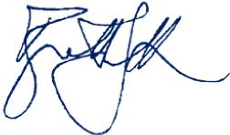
Adj Clin Prof Brett Sutton, Chief Health Officer.

Data used in this report
The Public Health and Wellbeing Act 2008 requires the Chief Health Officer to publish a comprehensive report on public health and wellbeing in Victoria every two years. The last Chief Health Officer report was the 2016 report published in 2018.
This 2018 report has used data primarily from reports published or data available to the department up to 31 December 2018. These reports relate to data collected in 2018 or earlier. In cases where limited data was available on a given topic, reports published or data available to the department in early 2019 were sourced.
As this is an online report, links to some of the sources of data have been added to provide further digital content. In some cases, these links provide content that has been updated since writing. This means that readers can obtain up-to-date data and information in greater detail.
The articles presented in this report do not represent an exhaustive examination of each topic; rather they present an overview of each topic with links to other reports for more detailed information or other topics not covered in this report.
Throughout this report, the word 'department' refers to the Victorian Department of Health and Human Services.

Who we are
Discussing population and other demographic data about Victorians.
This section of the Chief Health Officer report looks at population and other demographic data about Victorians.
It includes information about:
- age and sex distribution
- Aboriginal and Torres Strait Islander Victorians
- rural and regional Victorians
- cultural diversity
- lesbian, gay, bisexual, trans and gender diverse, intersex, queer and asexual (LGBTIQA+) Victorians.
This section also discusses income distribution and disadvantage and briefly discusses some data on refugee and asylum seekers in Victoria.
It draws on:
- information from the Australian Bureau of Statistics <https://www.abs.gov.auh>
- Korin Korin Balit-Djak: the Aboriginal health wellbeing and safety strategic plan 2017-27 <https://www.health.vic.gov.au/publications/korin-korin-balit-djak-aboriginal-health-wellbeing-and-safety-strategic-plan-2017-2027>
- the Victorian population health survey 2016 <https://www.health.vic.gov.au/population-health-systems/victorian-population-health-survey>, published by the Department of Health and Human Services in 2018.

Demographic data 2018

Key statistics 2018
- Victoria's population: 6.5 million people
- Victoria's Aboriginal population: 57,000 people
- Median age of Victorians: 37 years
- Life expectancy at birth for males and females: 81.3 years and 85.0 years respectively
- More than 80 per cent of Victorians report their health as excellent, very good or good
- Proportion of Victorians living in Greater Melbourne: 77 per cent
- Proportion of Victorians living outside Greater Melbourne: 23 per cent
- Proportion of Victorian households reporting a household annual income of less than $40,000: 22.5 per cent
- Proportion of Victorian households reporting a household annual income of greater than $100,000: 27.1 per cent
- Proportion of Victorians born overseas: 28.3 per cent
- Proportion of Victorians born overseas or having a parent born overseas: 49.1 per cent
- Number of languages and dialects spoken: 260+
- Number of religious faiths:130+

Who we are
With a population of 6.5 million in June 2018 (Australian Bureau of Statistics 2018a), Victoria is Australia's second-most populous state after New South Wales.
Victoria represents approximately 25 per cent of Australia's population.
All Australian states and territories (except the Northern Territory) experienced population growth between 2017 and 2018, with Victoria having the largest growth (139,700 people), followed by New South Wales (119,500) and Queensland (86,000) (Australian Bureau of Statistics 2018a).
Victoria and the Australian Capital Territory grew the fastest (that is, it had the strongest growth rate), increasing by 2.2 per cent (Australian Bureau of Statistics 2018a).
Victoria's capital Melbourne had the largest growth of all greater capital cities (an additional 125,400 people), as well as the fastest growth (2.7 per cent) (Australian Bureau of Statistics 2018a). 'Based on current growth patterns, Melbourne may overtake Sydney as the nation's most populous city as early as 2031 (Australian Bureau of Statistics 2018b).
By 2027, Victoria's population is expected to reach between 7.5 million and 7.9 million people - an increase from 6.5 million people in 2018 (Australian Bureau of Statistics 2018b).
When combined with the impacts of climate change, these population increases will present environmental, social and health challenges for Victorians, some of which we are already responding to.
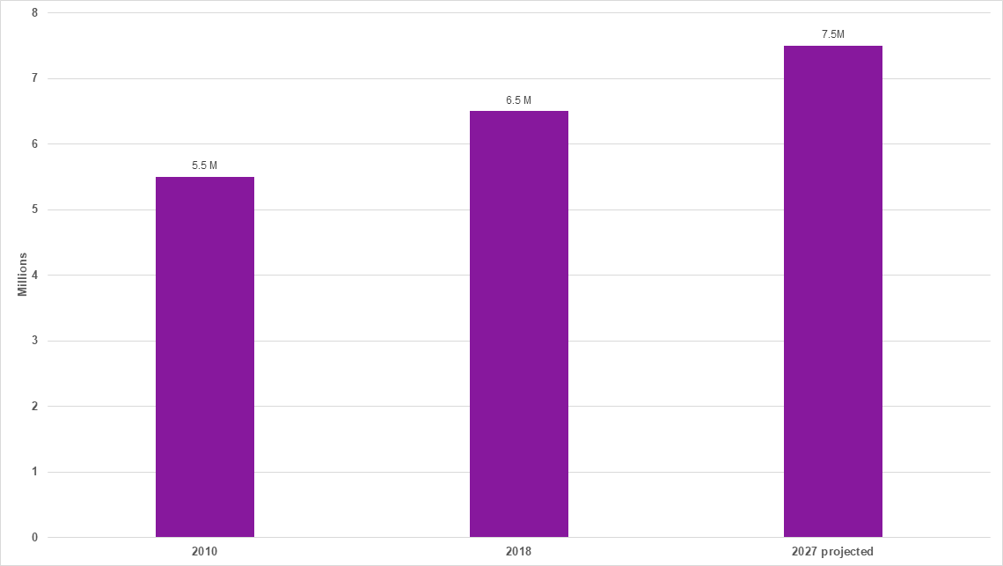
Figure 1: Population of Victoria 2010, 2018 and 2027 (projected)

Age and sex distribution
At June 2018, there were slightly more females (50.5 per cent of total Victorian population) than males (49.5 per cent).
The age breakdown of Victoria's population is shown in Figure 2:
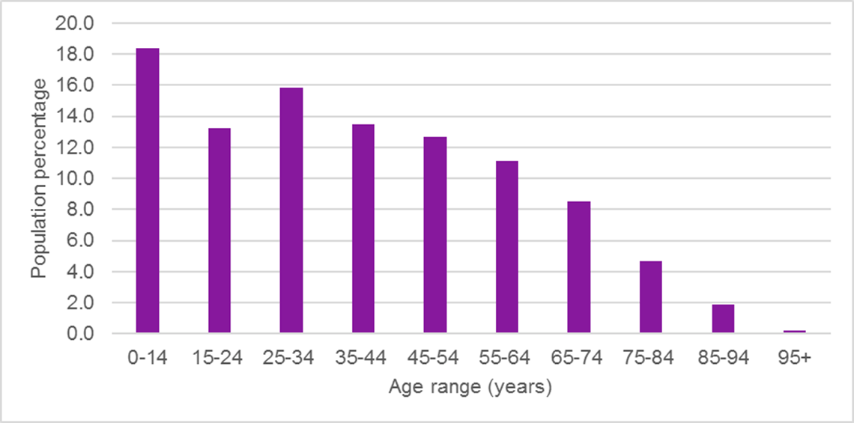
Figure 2: Age distribution of Victoria's population
The median age of Victorians at June 2018 was 37 years (Australian Bureau of Statistics 2018a).
Like many Western countries, this is projected to increase in coming years as the population ages. At June 2018,15.3 per cent of Victorians were aged 65 years and over (Australian Bureau of Statistics 2018a). By 2056, this figure is expected to reach 23.1 per cent (Australian Bureau of Statistics 2018b).
This has significant implications for health policy, service provision, planning and reform.

Aboriginal and Torres Strait Islander Victorians
At the 2016 Census, 0.9 per cent of Victorians identified as Aboriginal or
Torres Strait Islander, representing more than 57,000 Victorians (Australian Bureau of Statistics 2018).
This compares nationally to the 3.3 per cent of Australians who identify as Aboriginal or Torres Strait Islander (Australian Bureau of Statistics 2018c).
The heritage and culture of Aboriginal communities across Victoria is vibrant, rich and diverse, with nearly 40 different Aboriginal languages spoken (Department of Health and Human Services 2017).
In recent years, Aboriginal health outcomes have improved in some areas, such as in increased rates of childhood immunisation, where 96.81 per cent of Victorian Aboriginal children aged five are now age-appropriately immunised (Department of Human Services 2018). This is slightly higher than the 95.4 per cent of all Victorian five-year-olds who are age-appropriately immunised (Department of Human Services 2018).
Despite recent gains in some areas, Aboriginal Victorians continue to experience racism and discrimination that profoundly affect health and wellbeing (Department of Health and Human Services 2017).
The Chief Health Officer's Health inequalities page has more information on health and wellbeing among Aboriginal Victorians.

Rural and regional Victorians
Like most Australian states and territories, Victoria is an urbanised state, with
77 per cent of Victorians living in Greater Melbourne and 23 per cent in rural and regional Victoria (Australian Bureau of Statistics 2018a).
When it comes to social capital (the networks of relationships among people), rural Victorians fare better than metropolitan Victorians on a number of indicators (Department of Health and Human Services 2017b).
According to other indicators, however, people who live in rural and regional Victoria experience poorer health than metropolitan Victorians (Australian Bureau of Statistics 2018d; Department of Health and Human Services 2018a, 2018b and 2018c).
The Chief Health Officer's Health inequalities section has more information about health and wellbeing among rural and regional Victorians.

Cultural diversity
Victoria is one of Australia's most culturally diverse states. The 2016 Census showed that 28.3 per cent of Victorians were born overseas and 49.1 per cent were either born overseas or have a parent who was born overseas (Australian Bureau of Statistics 2017).
Victorians come from more than 200 countries, speak 260 languages and dialects and follow 135 religious faiths (Victorian Multicultural Commission 2017).
The most common countries of birth for Victorians identified in the 2016 and 2011 Censuses were (Victorian Multicultural Commission 2017):
Table 1: Common countries of birth for Victorians, 2016 and 2011
Country of birth | Victoria 2016 | per cent | Victoria 2011 | per cent
Australia | 3,845,493 | 64.9 | 3,670,934 | 68.6
England | 171,443 | 2.9 | 172,068 | 3.2
India | 169,802 | 2.9 | 111,787 | 2.1
China (excludes SARs and Taiwan) | 160,652 | 2.7 | 93,896 | 1.8
New Zealand | 93,253 | 1.6 | 80,234 | 1.5
Vietnam | 80,787 | 1.4 | 68,296 | 1.3
The table above shows changes in migration that are occurring in Victoria. The proportion of people born in England, for example, decreased from the 2011 Census to the 2016 Census. The number of people born in India, China, New Zealand and Vietnam increased in the same period (Victorian Multicultural Commission 2017).
The most common countries of birth for Victorians in the 2016 and 2011 Censuses are summarised in Table 2 below.
Table 2: Languages spoken at home in Victoria, 2016 and 2011
Languages, top responses 2016 | Victoria 2016 | per cent | Victoria 2011 | per cent
Only English spoken at home | 4,026,811 | 67.9 | 3,874,861 | 72.4
Mandarin | 191,793 | 3.2 | 103,742 | 1.9
Italian | 112,272 | 1.9 | 124,856 | 2.3
Greek | 110,707 | 1.9 | 116,802 | 2.2
Vietnamese | 103,430 | 1.7 | 86,592 | 1.6
Arabic | 79,589 | 1.3 | 68,437 | 1.3
Households where a language other than English language is spoken | 624,141 | 27.8 | 503,888 | 25.9
Table 3 shows the languages spoken at home in Victorian households and the changes that reflect changing patterns of migration.
While the number of people speaking only English at home increased from the 2011 Census to the 2016 Census, the proportion of people speaking English at home decreased (Victorian Multicultural Commission 2017).
A large increase in the number of households speaking Chinese occurred in the same period, with smaller increases in Vietnamese- and Arabic-speaking households (Victorian Multicultural Commission 2017).
In the same period, the number of people speaking Italian and Greek reduced (Victorian Multicultural Commission 2017).
Approximately 28 per cent of households spoke a language other than English.
To respond to this linguistic diversity, the Department of Health and Human Services' Language services policy supports the department and its funded services (Department of Health and Human Services 2017c).
Victorians identified with more than 130 religious faiths. The number of those identifying as religious reduced from 67.7 per cent at the 2011 Census to 59 per cent in 2016 (Victorian Multicultural Commission 2017).
Approximately 48 per cent of Victorians were Christian, 3.3 per cent were Islamic, and 3 per cent were Buddhist (Victorian Multicultural Commission 2017).
Among the Christian denominations, more than 23 per cent of Victorians were Catholic, almost 9 per cent were Anglican and more than 3 per cent were Uniting Church (Victorian Multicultural Commission 2017).

Low-income earners
In Victoria, 22.5 per cent of households reported a household income of less than $40,000 per year, while 27.1 per cent of households reported a household income greater than $100,000 (Department of Health and Human Services 2018d).
Women were more likely to report a household income of less than $40,000 and less likely to report a household income of more than $100,000 than men (Department of Health and Human Services 2018d).
Table 3: Income distribution, Victorian men, women and all people
Income | Males per cent | Females per cent | Total
< $20,000 | 5.5 | 4. | 5.1
$20,000 to < $40,000 | 15.9 | 18.8 | 17.4
$40,000 to <$60,000 | 11.2 | 11.3 | 11.2
$60,000 to < $80,000 | 11.5 | 9.2 | 10.3
$80,000 to < $100,000 | 9.5 | 8.5 | 9.0
$100,000+ | 29.2 | 25.1 | 27.1
Don't know/refused to answer | 17.2 | 22.4 | 19.1
Household income is one of the social determinants of health. See the Chief Health Officer's Social determinants of health page for more information on the social determinants of health.

Index of Relative Socio-economic Disadvantage
The Index of Relative Socioeconomic Disadvantage (IRSD) is a general socioeconomic index that summarises information about the economic and social conditions of people and households within an area (Australian Bureau of Statistics 2018e).
Unlike the other indexes, this index includes only measures of relative disadvantage (Australian Bureau of Statistics 2018e).
Each local government area in Victoria can be mapped according to most disadvantaged through to least disadvantaged.
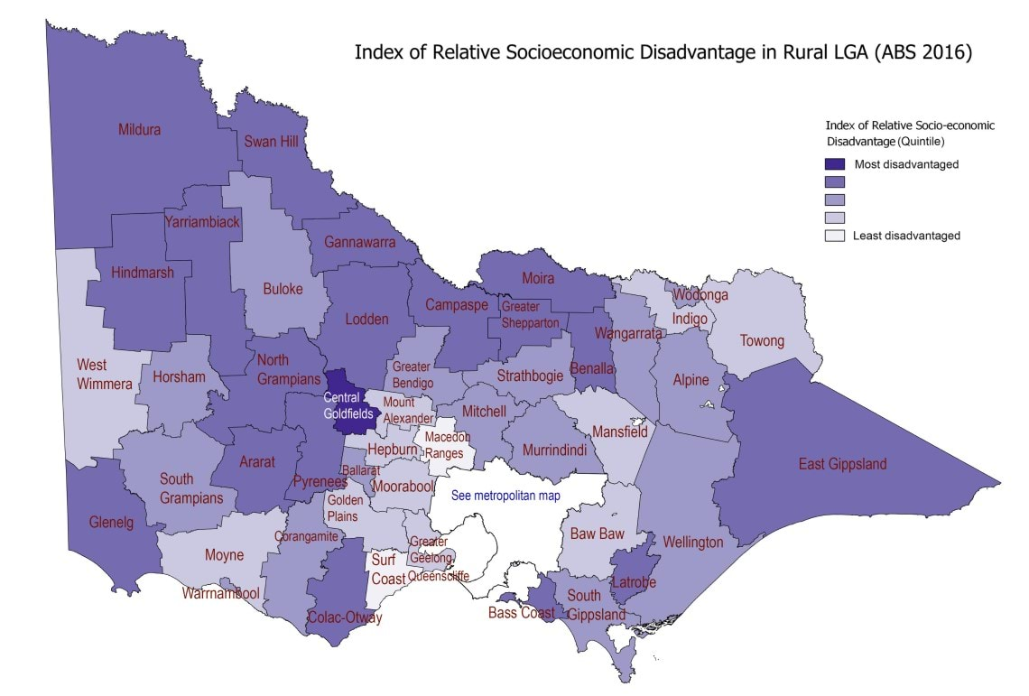
Figure 3: Index of Relative Social Disadvantage - rural and regional Victoria

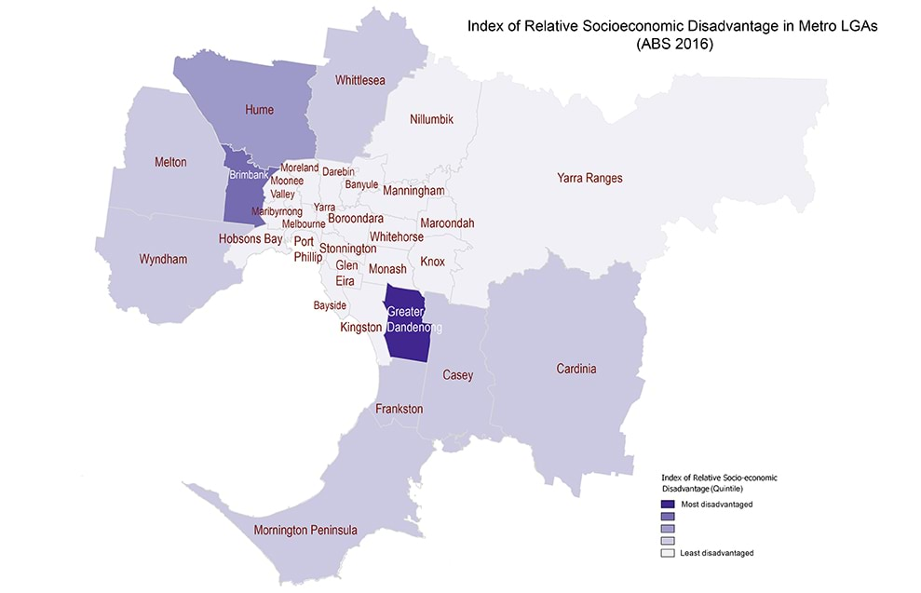
Figure 4: Index of Relative Social Disadvantage - Metropolitan Melbourne
These maps show that rural local government areas of Victoria are more likely to be classified as most disadvantaged compared with metropolitan local government areas.
See the Chief Health Officer's Social determinants of health page for more information on the social determinants of health.

References
Australian Bureau of Statistics 2017, 2071.0: Census of Population and Housing: Reflecting Australia - Stories from the Census, 2016, ABS, Canberra.
Australian Bureau of Statistics 2018a, 3101.0 - Australian Demographic Statistics, June 2018, ABS, Canberra.
Australian Bureau of Statistics 2018b, 3222.0: Population Projections, Australia, 2017 - 2066, ABS, Canberra.
Australian Bureau of Statistics. 2018c, Estimates of Aboriginal and Torres Strait Islander Australians 2016. Canberra: Australian Bureau of Statistics.
Australian Bureau of Statistics 2018d, National Health Survey: First Results 2017-18. Canberra: Australian Bureau of Statistics.
Australian Bureau of Statistics 2018e, Local government area (LGA) Index of Relative Socio-economic Disadvantage, distribution of statistical area level 1 deciles, 2016, ABS, Canberra.
Department of Health and Human Services 2017a, Korin Korin Balit-Djak Aboriginal health, wellbeing and safety strategic plan 2017-27, State Government of Victoria, Melbourne.
Department of Health and Human Services 2017b, Inequalities in the social determinants of health and what it means for the health of Victorians: findings from the 2014 Victorian Population Health Survey, State Government of Victoria, Melbourne.
Department of Health and Human Services 2017c, Languages services policy, State Government of Victoria, Melbourne.
Department of Health and Human Services 2018a, Victorian Admitted Episodes Dataset. Public hospital admissions, State Government of Victoria, Melbourne.
Department of Health and Human Services 2018b, Victorian Emergency Minimum Dataset. Public hospital admissions, State Government of Victoria, Melbourne.
Department of Health and Human Services 2018c, Victorian Health Information Surveillance System, State Government of Victoria, Melbourne.
Department of Health and Human Services 2018d, Victorian population health survey 2016, State Government of Victoria, Melbourne.
Department of Human Services 2018, Australian Immunisation Register data, Commonwealth of Australia, Canberra.
Victorian Multicultural Commission 2017, 2016 census: Victoria's diverse population brochure, State Government of Victoria, Melbourne.

Overview
On a number of indicators, Victorians have very good health. They are living longer and are improving their health status on several measures:
- Life expectancy at birth in Victoria is 84.9 (see Demographic data 2018) years for females and 80.7 years for males, which is among the highest in the world.
- Immunisation coverage for Victorian children is high, with more than 95 per cent of Victorian five-year-olds being age-appropriately immunised (see Immunisation in Victoria).
- The proportion of daily smokers in Victoria decreased by 0.3 per cent to 12.3 per cent of the population in 2016, see Burden of disease (see Leading causes of disease and injury).
- More than three quarters of Victorians say their satisfaction with life is very high or high (see Mental health in Victoria) and more than 80 per cent of Victorians report their health as excellent very good or good (see Demographic data 2018).
- Victoria's adjusted perinatal mortality rate (see Causes of death in Victoria) was 8.8 per 1,000 births and is among the lowest in Australia and in other countries of similar socioeconomic status.
- Many Victorians who suffered chronic hepatitis C infection were cured of the condition due to new direct-acting antiviral treatments (see Advances in hepatitis C treatment).
Other indicators, however, show that Victorians also experience poorer health:
- Aboriginal and Torres Strait Islander Victorians have a life-expectancy approximately 10 years lower than non-Indigenous Victorians.
- Only 50 per cent of adults undertake sufficient physical activity for health benefits (see Active living), while approximately one quarter of adults spend eight hours or more sitting on an average weekday.
- Fewer than five per cent of adults meet the dietary guidelines for vegetable consumption (see Healthy eating) and just more than 40 per cent of adults meet the guidelines for fruit consumption.
- 17 per cent of Victorians were identified as having an increased lifetime risk of alcohol-related harm (see Alcohol use) based on National Health and Medical Research Council guidelines.
When body weight is assessed, more than two-thirds of Victorian adults are overweight or obese (see Overweight and obesity) . Chronic disease is common, with more than one in five adult Victorians diagnosed with two or more chronic diseases (see Non-communicable disease), such as type 2 diabetes (6.8 per cent of Victorians), heart disease (7.3 per cent), cancer (7.8 per cent), asthma (11.5 per cent), arthritis (20.4 per cent) and depression (24.5 per cent).
Socio-economic indicators impact our health. Household income, for example, is linked to health and results in certain income groups experiencing greater levels of disease. Stroke diabetes and heart disease (see Non-communicable disease), are just some of the health conditions where people from lower-income households experience higher levels of disease. In some cases, this difference was stark: the proportion of men and women who currently smoke (see Tobacco-free living) from households with an annual income less than $40,000 was more than double the proportion from households with an annual income above $100,000.
When mental health (see Mental health in Victoria) is examined, one in five Victorians will experience a mental health condition in a given year, and 45 per cent of Victorians experience one during their lifetime. Certain groups in Victoria are more prone to mental health conditions: a study of older Victorians, for example, found ten per cent of people aged 60 or older experienced loneliness and this increased as people aged. The lifetime prevalence of self-reported doctor-diagnosed depression or anxiety increased significantly for both males and females between 2003 and 2016.
When environmental factors impacting health are assessed Victoria's air quality (see Air quality) is good by international standards, and has improved significantly over recent decades. Victoria's water authorities continue to supply Safe drinking water across the state. The impacts of climate change (see Climate change and public health in Victoria), however, increase risks to air quality with longer and harsher bushfire seasons; changing climate also presents risks to our water supply through increased likelihood of blue-green algal blooms as well as supply issues due to drought. Climate change can and will have impacts upon the mental health of Victorians (see Mental health in Victoria).
Buruli ulcer a condition that impacts Victoria more than any other state or territory - has occurred more often than previous years. Victorians are already experiencing the effects of Antimicrobial resistance and much work is required to prevent further loss of effectiveness of antibiotics, antivirals and antifungals.
Where Victorians live can also impact health outcomes: rural and regional Victorians are more likely to belong to an organised community group than those who live in metropolitan Melbourne, and less likely to feel socially isolated. Rural and regional (see Rural and regional Victorians) local government areas are, however, more likely to be classified as disadvantaged and this relative disadvantage has significant impacts upon health and wellbeing.

Opportunities
Many risk factors for these health conditions are preventable. Smoking, obesity, excessive alcohol consumption, low fruit and vegetable intake and exercise can be limited. As identified in this report, however, the social determinants of health can present significant barriers in addressing these risk factors.
While this report highlights the profound public health risks of climate change (see Climate change and public health in Victoria) and Antimicrobial resistance it also explores some of the work underway in Victoria to address these global issues.
This report also documents some of the policy changes implemented to promote the health of Victorians, such as tobacco control activities (see Tobacco-free living), the further extension of Water fluoridation in rural and regional Victoria to promote dental health food safety measures (see Food) to reduce food-borne illness and initiatives implemented by the department to reduce HIV transmission and promote cervical screening for women. Where relevant, this report provides links to health advocacy organisations which can support Victorians to live healthier lives.

Oral health
Oral health is fundamental to overall health, wellbeing and quality of life.
It is an important part of general health, affecting not only the individual, but also the broader health system and economy.
There have been significant improvements in oral health in Australia in the past 30 years. These are largely due to:
- improved access to fluoridated drinking water
- the use of fluoride toothpastes
- the provision of preventive oral health services
- the adoption of good oral hygiene practices.
This section of the Chief Health Officer report looks at child and adult dental caries (tooth decay) experience, as well as the affordability of dental care, which also impacts oral health in Victoria.
This section of the Chief Health Officer report draws on:
- The National Study of Adult Oral Health 2017-18N <https://health.adelaide.edu.au/arcpoh/our-research/our-past-research#national-surveys-of-adult-of-oral-health>, published by the Australian Research Centre for Population Oral Health in 2019
- The Victorian Population Health Survey 2016 <https://www.health.vic.gov.au/population-health-systems/victorian-population-health-survey-2016>, published by the Department of Health and Human Services in 2018
- The National child oral health study 2012-14 <https://www.adelaide.edu.au/press/titles/ncohs>, published by the University of Adelaide in 2016.

Affordability of dental care
The Victorian Population Health Survey also seeks information about avoidance or delaying a visit to a dental professional due to cost.
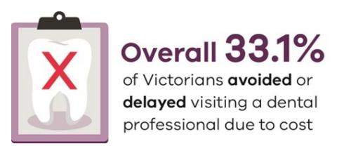
Overall, 33.1 per cent of Victorians avoided or delayed visiting a dental professional due to cost.
This proportion was significantly higher in women (35.2 per cent) compared with men (31 per cent) (Department of Health and Human Services 2018).
There was a significant decline in the proportion of adults who avoided or delayed visiting a dental professional due to cost with increasing total annual household income.
Similar findings were identified in the National Survey of Adult Oral Health 2017-18, which found that nearly four in ten Australians aged 15 years and over reported that they avoided or delayed visiting a dental professional due to cost (Australian Research Centre for Population Oral Health, 2019). Just under one quarter reported they would have a lot of difficulty paying a $200 dental bill. This study found that the strongest associations for financial barriers to accessing dental care were with dental insurance status - those without dental insurance were twice as likely to report avoiding dental care due to cost compared to those with dental insurance (Australian Research Centre for Population Oral Health, 2019).

Find out more
To find out more about adult oral health, access the Victorian population health survey <https://www.health.vic.gov.au/population-health-systems/victorian-population-health-survey>.

References
- Australian Research Centre for Population Oral Health 2019, Australia's oral health: National Study of Adult Oral Health 2017-18, The University of Adelaide, Adelaide.
- Department of Health and Human Services 2018, Victorian population health survey 2016, State Government of Victoria, Melbourne

Child oral health
Since the introduction of water fluoridation in Victoria in the 1960s (and in Melbourne in 1977), along with the widespread use of fluoridated toothpastes, the dental caries (tooth decay) experience of Victorian children has improved dramatically. Despite these advances, dental caries is one of the most prevalent diseases in Victorian children. Almost half of all children (43 per cent) have signs of dental caries (Do and Spencer, 2016).
Dental conditions are the highest cause of all potentially preventable hospitalisations in children 0 to 9 years, predominantly due to dental caries (Department of Health and Human Services, 2018).
Two key pieces of data illustrate the dental caries experience of Victorian children.
The first relates to the average number of decayed, missing or filled baby teeth (known as a dmft score) in five and six-year-old children. In 2012–14, Victorian five and six-year-olds had an average dmft of 1.3 (Do and Spencer 2016). This was only slightly lower than that reported in the late 1980s.
The second piece of data relates to the average number of decayed, missing or filled adult teeth (known as a DMFT score) in 12-year-old children. In 2012–14, Victorian 12-year-olds had an average DMFT of 0.8 (Do and Spencer 2016). This represents a significant reduction from the late 1980s, when the corresponding figure was approximately 1.8.
The data for five and six-year-old children indicates that to prevent dental caries, the department needs to:
- focus on enhancing environments that promote oral health
- increase the oral health literacy of families
- provide resources and services for pre-school children.

Causes of dental caries
Sugar in foods and drinks is the key dietary cause of dental caries. Some children are high consumers of sugary foods and drinks.
The Victorian Child Oral Health Survey identified that four in 10 Victorian children consume one or more sugary drinks on a usual day and almost half of Victorian children are eating four or more sugary foods/snacks on a usual day (Do and Spencer 2016; Dental Health Services Victoria / Department of Health and Human Services 2016).
The School Dental Program and prevention initiatives such as the Smiles 4 Miles, Healthy Families Healthy Smiles and Fluoride Varnish programs are helping to improve the oral health of children so that they will have a good foundation for lifelong oral health.
Most Victorians have access to the dental health benefits of water fluoridation. The department's extension of water fluoridation in 2017-18 to the communities of Cobram, Strathmerton and Yarroweyah further extended the benefits of this important public health initiative to more rural and regional Victorians.

Find out more
To find out more about child oral health, access the National child oral health study 2012–14 <https://www.adelaide.edu.au/press/titles/ncohs>.
For more information on water fluoridation, see Water fluoridation.

References
Dental Health Services Victoria / Department of Health and Human Services 2016, Victorian preschool oral health survey, State Government of Victoria, Melbourne.
Department of Health and Human Services 2018, Ambulatory care sensitive conditions – dental conditions 2017. State Government of Victoria, Melbourne.
Do L and Spencer A 2016, National child oral health study 2012–14, University of Adelaide Press, Adelaide.

Adult oral health
As noted in the child oral health article, water fluoridation and the widespread use of fluoridated toothpastes have led to dramatic improvements in dental caries (tooth decay) experience in children. Importantly, adults, including older adults, also receive dental health benefits from water fluoridation and fluoridated toothpastes. Despite these advances, more than 90 per cent of Victorian adults have had or currently have dental caries, with one in three (32 per cent) experiencing untreated dental caries (Australian Research Centre for Population Oral Health, 2019). Adult dental caries experience increases with age (Australian Research Centre for Population Oral Health, 2019).
Adults can also be impacted by gum diseases, which tend to effect adults more than children. In 2017-18, a total of 27.7 per cent of Victorians were found to have moderate to severe periodontitis (gum disease), with more than 70 per cent of those aged over 75 years of age experiencing moderate to severe periodontitis compared to 10.2 per cent of 15-34 year olds (Australian Research Centre for Population Oral Health, 2019).
The Victorian Population Health Survey asks respondents to rate their dental health.
In 2016, 37.1 per cent of people rated their dental health as excellent or very good, while 33.6 per cent rated their dental health as good (Department of Health and Human Services 2018).
A further 23.9 per cent rated their dental health as being fair or poor.
The proportion of people who reported having no natural teeth was 5.1 per cent.
A significantly higher proportion of women (42.9 per cent) rated their dental health as excellent or very good compared with men (31.1 per cent).
The National Study of Adult Oral Health identified that just over 57 per cent of Victorian adults reported making a visit to a dentist in the last 12 months (Australian Research Centre for Population Oral Health, 2019).
Most Victorians have access to the dental health benefits of water fluoridation. The department's extension of water fluoridation in 2017-18 to the communities of Cobram, Strathmerton and Yarroweyah further extended the benefits of this important public health initiative to more rural and regional Victorians.

Find out more
2017-18 National Study of Adult Oral Health <https://health.adelaide.edu.au/arcpoh/our-research/our-past-research#national-surveys-of-adult-of-oral-health> at the Australian Research Centre for Population Oral Health
Water fluoridation.

References
Australian Research Centre for Population Oral Health 2019, Australia’s oral health: National Study of Adult Oral Health 2017–18, The University of Adelaide, Adelaide.
Department of Health and Human Services 2018, Victorian population health survey 2016, State Government of Victoria, Melbourne.

Injury prevention
This section of the Chief Health Officer report looks at injury prevention for Victorians.
It includes discussion about falls prevention among older Victorians and family violence prevention.
It draws on:
- Free from Violence first action plan 2018–2021 <https://www.vic.gov.au/free-violence-victorias-strategy-prevent-family-violence>
- falls prevention data from the Victorian Injury Surveillance Unit <https://www.monash.edu/muarc/research/research-areas/home-and-community/visu>.

Family violence prevention
The 2015-16 Royal Commission into Family Violence recognised that preventing family violence is essential for the health and wellbeing of the Victorian community and requires long-term investment.

Impact of family violence
Family violence has far-reaching and serious impacts that include poor physical and mental health, loss of housing, loss or limited access to employment, precarious financial security, isolation and alienation of extended family and social support and, in extreme cases, death (Australia's National Research Organisation for Women's Safety 2016).
The cost to Victoria of violence against women was estimated at $5.3 billion in 2015-16 (KPMG 2017).
The 'primary prevention' of family violence means stopping violence by identifying and addressing its causes.
Sustained investment and efforts are necessary to reduce family violence and address its significant social and economic costs.
Primary prevention requires a whole-of-community approach to drive social and cultural change to address the norms, practices and systems that condone or enable violence.

Drivers of violence against women
Research indicates that factors associated with gender inequality are the most consistent predictors of violence against women (Our Watch 2015).
The gendered drivers of violence against women are:
- condoning of violence against women
- men's control of decision-making and limits to women's independence
- rigid gender roles and identities
- male peer relations that emphasise aggression and disrespect towards women.

Primary prevention work
From 2015-16 to 2020-21, the Victorian Government has committed $121 million for primary prevention of family violence and all forms of violence against women. This includes $38.8 million to implement the Free from Violence primary prevention strategy.
Through the Free from Violence primary prevention strategy's First action plan 2018-2021 <https://www.vic.gov.au/free-violence-first-action-plan-2018-2021>, the Victorian Government is investing in strategies to ensure that prevention messages and programs reach people in the places they live, work, learn and play.
Evidence-based primary prevention initiatives, such as direct participation programs, organisational development and communications, are being delivered to address the drivers of family violence (Our Watch 2015).
Key initiatives include:
- establishment of Respect Victoria, an authority for primary prevention to lead Victoria's research, public engagement and behaviour change agendas
- 'Respect Women: Call it Out' behaviour change advertising campaigns, which provide the community with tools to call out disrespectful and sexist behaviour
- antenatal and postnatal parenting programs
- respectful relationships education in schools
- primary prevention in TAFEs and universities
- partnerships with local government and women's health services
- innovative community-led initiatives, including with Aboriginal, and culturally and linguistically diverse communities, LGBTIQA+ communities, and in settings such as the arts and sport building the primary prevention workforce.
To support building the evidence base on what works to prevent violence across the community Free from violence <https://www.vic.gov.au/free-violence-victorias-strategy-prevent-family-violence> focuses on research, monitoring and evaluation.
Research is being undertaken in areas where there is less evidence and understanding, such as elder abuse, violence against people with a disability, adolescent violence and violence within LGBTIQA+ communities.

Find out more
The Public health and wellbeing progress report <https://www.health.vic.gov.au/publications/victorian-public-heaIth-and-wellbeing-progress-report> also includes information on family violence prevention in Victoria.
The Our Watch website <//www.ourwatch.org.au/> also includes information on family violence prevention in Victoria.

References
Australia's National Research Organisation for Women's Safety (ANROWS) 2016, A preventable burden: measuring and addressing the prevalence and health impacts of intimate partner violence in Australian women: Key findings and future directions <https://www.anrows.org.au/publication/a-preventable-burden-measuring-and-addressing-the-prevalence-and-health-impacts-of-intimate-partner-violence-in-australian-women-key-findings-and-future-directions/>, ANROWS, Sydney.
KPMG 2017, The cost of family violence in Victoria <https://www.vic.gov.au/about-royal-commission-family-violence#the-cost-of-family-violence-in-victoria>, summary report.
Our Watch 2015, Change the story: a shared framework for the primary prevention of violence against women and their children in Australia, Our Watch, Melbourne.

Falls prevention among older Victorians
Falls are a leading cause of unintentional injury, disability and death among older people.

Rates of falls
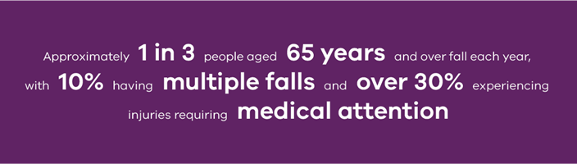
Australian and international studies have identified that approximately one and three people aged 65 years and over fall each year, with 10 per cent having multiple falls and more than 30 per cent experiencing injuries requiring medical attention.
The rates of falls and associated injuries are higher for older people in hospital settings and residential care (Hill et al. 2004).

Impact of falls
The impact of falls on the person, their family and society, as well as on the health system, can be considerable (World Health Organisation 2007).
As people age, the risk of fall-related hospitalisation increases (Ambrose et al. 2015; Australian Commission on Safety and Quality in Healthcare 2009).

Risk factors for falls
Factors that increase the risk of falls include a past history of falls, frailty, comorbidity (especially cardiac conditions, renal conditions and diabetes) and cognitive impairment.
Other factors include hazardous home environments, uneven road and footpath environments, as well as socioeconomic factors such as social isolation, living in regional and remote areas, and limited availability or access to health services and aged care (World Health Organization 2007).

Data about falls in Victoria
Data from Monash University's Victorian Injury Surveillance Unit shows that:
- From July 2017 to June 2018, 31,693 Victorian adults aged over 65 years were admitted to hospital after a fall. The admission rate was higher for females at 3,997 per 100,000 persons compared with 2,406 per 100,000 persons.
- During the period July 2017 to June 2018, falls related hospital admission rates increased with age. In the 65 to 69-year age group, the admission rate was 1,096 per 100,000 persons compared with an admission rate of 4,879 per 100,000 persons for those in the 80 to 84-year age group.
- Between July 2012 and June 2018, the falls related hospital admission rate for adults aged over 65 years increased by 20 per cent, from 2,713 per 100,000 persons in 2012–13 to 3,259 per 100,000 persons in 2017–18, as shown in Figure 1.
- Falls related hospital admissions are expected to increase as the population ages.
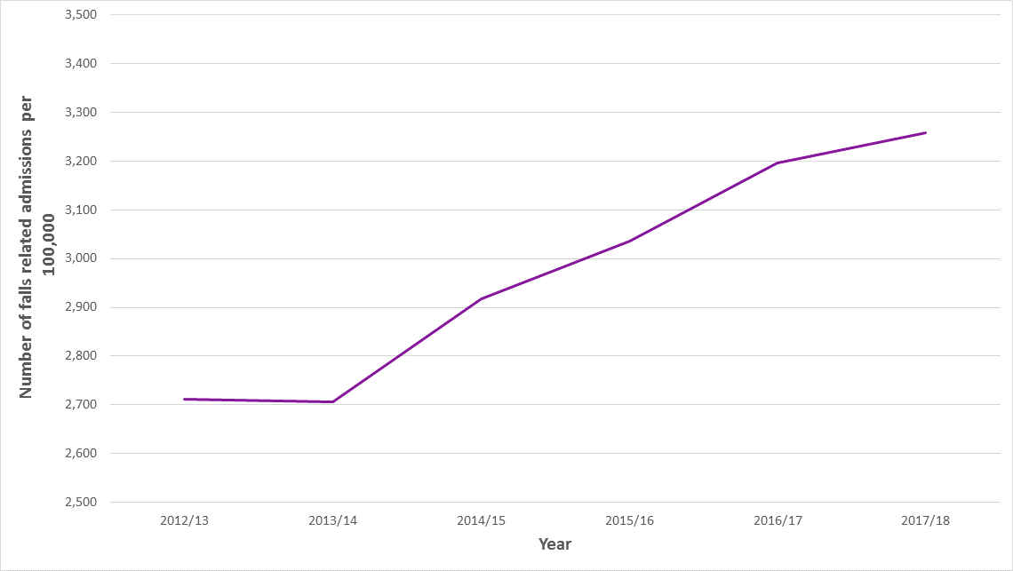
Figure 1: Falls-related hospital admission for adults aged 65+ expressed as population per 100,000 persons
Source: Victorian Injury Surveillance Unit, Monash University.

Prevention of falls
The Victorian Government adopts a strategic primary prevention approach to falls and fall-related injury prevention (Department of Health and Human Services 2015).
Falls and fall-related injury can be reduced through behavioural change and a healthy lifestyle and environmental modification.
Effective approaches include strength and balance exercises, cataract surgery, home safety assessment and modifications by occupational therapists and reducing psychotropic medications.
Healthcare providers have an important role to play in openly discussing falls risk with older people, identifying risk factors and tailoring appropriate prevention strategies and referrals.

What older people can do
Older people are encouraged to talk about all falls (including ones that didn’t cause injury) with their partners, family, carers, GPs and other health care providers, to help identify and address risk factors and to reduce the chance of repeat falls.
Older people can also maintain their strength and physical activity and participate in regular strength and balance exercises in their own home or in group exercise and recreational settings.
They should eliminate or reduce their use of ladders for home maintenance tasks and either seek assistance from friends and family, or visit MyAgedCare <https://www.myagedcare.gov.au/> for home maintenance assistance provided by local councils and local aged care service providers.

Find out more
The Victorian Injury Surveillance Unit, Monash University, provides Victorian falls data <https://www.monash.edu/muarc/research/research-areas/home-and-community/visu>.

References
Ambrose AF, Cruz L and Paul G 2015, ‘Falls and fractures: a systematic approach to screening and prevention’, Maturitas, vol. 82, no. 1.
Australian Commission for Quality and Safety in Healthcare 2009a, Preventing falls and harm from falls in older people: best practice guidelines for Australian community care, Commonwealth Government of Australia, Canberra.
Department of Health and Human Services 2015, Victorian public health and wellbeing plan 2015–2019, State Government of Victoria, Melbourne.
Hill K, Vrantsidis F, Haralambous B, Fearn M, Smith R, Murray K, Sims J and Dorevich M 2004, An analysis of research on preventing falls and falls injury in older people: community, residential care and hospital settings (2004 update), National Ageing Research Institute and Centre for Applied Gerontology, Melbourne.
Victorian Injury Surveillance Unit 2018, Victorian Admitted Episodes Data (VAED), VISU-held Cause of Death (COD) dataset, supplied by the Australian Coordinating Registry (ACR) and based on the Australian Bureau of Statistics (ABS) cause of death data.
World Health Organization 2007, WHO global report on falls prevention in older age, World Health Organization, Geneva.

Mental health in Victoria
This section of the Chief Health Officer report looks at mental health and mental wellbeing for Victorians.
It includes data on mental illness indicators, as well as the important work to help prevent suicides across the state.
It also discusses the emerging understanding of the relationships between climate change and mental health.
It draws on:
- The Victorian Population Health Survey 2016 <https://www.health.vic.gov.au/population-health-systems/victorian-population-health-survey-2016> has a section on mental health.
- the State of Victoria's children report 2016 <https://www.vic.gov.au/state-victorias-children-report>, published by the Department of Education and Training in 2018.
- Health and climate change: policy responses to protect public health <https://www.thelancet.com/journals/lancet/article/PIIS0140-6736(15)60854-6/fulltext>.

Suicide prevention
From 2010 to 2017 the suicide rate for Victorian males decreased from 15.6 per 100,000 people to 14.0 per 100,000 people.
In contrast, the suicide rate for females increased from 4.6 per 100,000 people in 2010 to 5.4 per 100,000 people in 2017 (Australian Bureau of Statistics 2018).
The Victorian suicide prevention framework 2016–25 <https://www.health.vic.gov.au/publications/victorian-suicide-prevention-framework-2016-2025>, released in July 2016, aims to halve Victoria’s suicide rate by 2025 (Department of Health and Human Services 2016).
It provides $27 million over four years to support the implementation of two flagship trial initiatives:

Place-based suicide prevention trials
Place-based suicide prevention trials are being delivered in partnership with Primary Health Networks in 12 sites across Victoria (as shown in Figure 1).
These trials support local communities to develop and implement proactive suicide prevention strategies.
Each site is actively engaging with the local community and has established governance structures, reviewed groups at risk of suicide and developed action plans.
Local activities include training to build the confidence and skills of people with lived experience in talking about suicide, supporting GPs to recognise and help people at risk of suicide and working with the community to develop a protocol for response after a suicide.

The Hospital Outreach Post-Suicidal Engagement initiative
The Hospital Outreach Post-Suicidal Engagement initiative currently operates at six health services across Victoria.
For the last 12 to 18 months the initiative has supported more than 800 people and their families in the period following a suicide attempt.
The 2018–19 State Budget allocated an additional $18.7 million to expand the Hospital Outreach Post-Suicidal Engagement initiative to another six sites in Victoria, demonstrating the commitment to innovative, person-centred and trauma-informed psychosocial responses to suicide prevention.
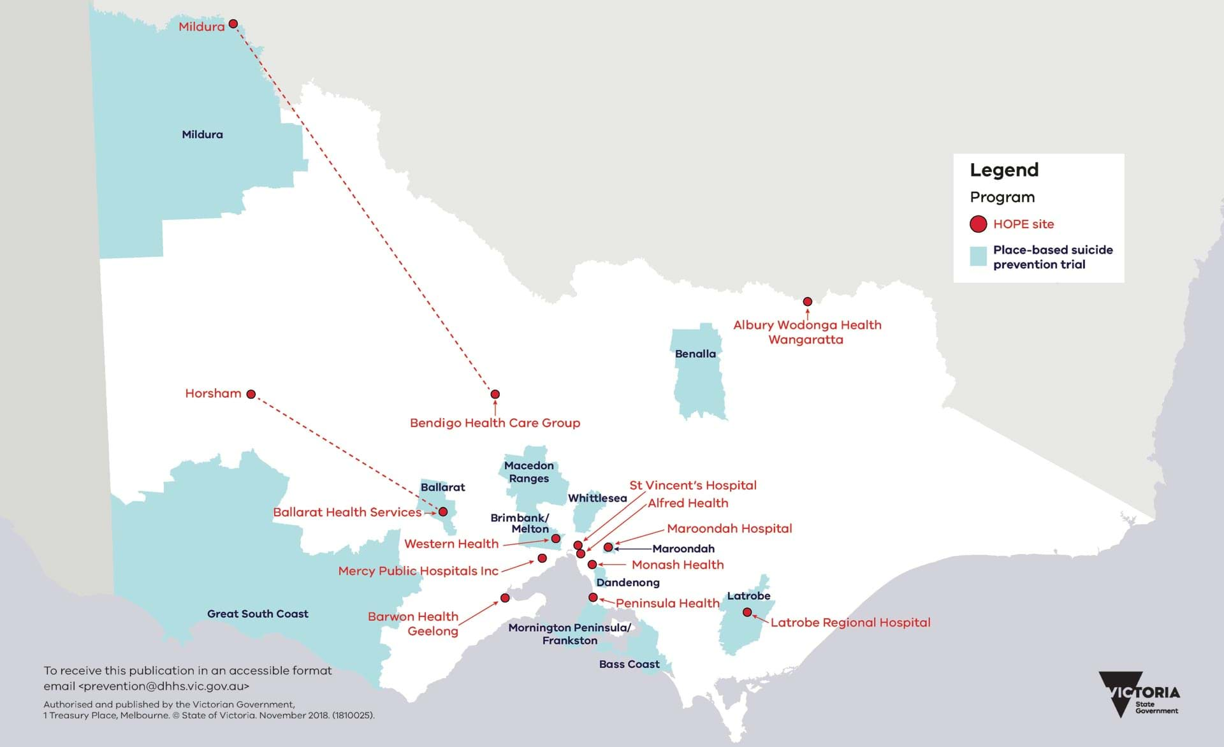
Figure 1: Victorian suicide prevention trial site locations
Source: Department of Health and Human Services
The Victorian Government is also working with partners to improve the collection and analysis of suicide-related data to support statewide and localised suicide prevention planning.

National strategy on intentional self-harm (suicides)
On behalf of all governments, Victoria is also leading the development of the new National suicide prevention implementation strategy.
This strategy will embody the collective aspiration of all governments that fewer lives are lost to suicide, and it will be supported by every health minister in Australia. It is due for release in 2020.
It is being informed by an open consultation process, including feedback from people who have attempted suicide, people with suicidal thoughts, carers, loved ones and those bereaved.

Find out more
The department has a suicide prevention webpage <https://www.health.vic.gov.au/prevention-and-promotion/suicide-prevention-response-strategy> which details additional suicide prevention strategies in Victoria.

References
Australian Bureau of Statistics 2018, Causes of death Australia 2017, Australian Bureau of Statistics, Canberra.
Department of Health and Human Services 2016, Victorian suicide prevention framework 2016–25, State Government of Victoria, Melbourne.

Mental illness and mental wellbeing
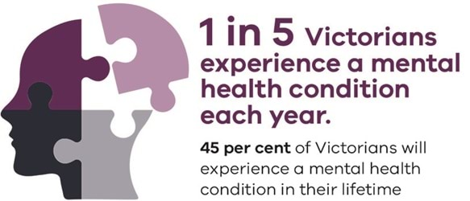
Mental health is an essential ingredient of individual and community wellbeing, and it significantly contributes to the social, cultural and economic life of Victoria.
On some indicators, many Victorians report positively on indicators which can contribute to mental wellbeing: for example, 78.1 per cent of Victorians report that they have very high or high satisfaction with life (Department of Health and Human Services 2018a).
Each year, however, one in five Victorians will experience a mental health condition, and 45 per cent of Victorians experiencing one during their lifetime (Australian Bureau of Statistics 2008).
Certain population groups are at higher risk of poor mental health and mental illness because of greater exposure and vulnerability to unfavourable social, economic and environmental circumstances.
Mental disorders are a significant cause of disability or non-fatal disease burden across Australia.
Nearly one-quarter (24.5 per cent) of Victorian adults report being diagnosed with depression or anxiety by a doctor.
About one in seven report high or very high levels of psychological distress (an important risk factor for a number of physical and mental health conditions) (Department of Health and Human Services, 2018a).
A large body of research shows that social isolation and loneliness have detrimental physical and mental health consequences (Holt-Lunstad, Smith, Baker, Harris and Stephenson 2015).
Feeling connected to others; being able to cope with the usual stresses of life; and having the opportunity and capacity to contribute to community and be productive are all critical to mental health. Adults who do not feel valued by society or do not trust other people are more likely to report psychological distress, low income and poor or fair self-reported health.

Burden of disease
Twelve per cent of Australia's disease burden is due to mental and behavioural disorders, with most of the burden being non-fatal (disability) burden (Australian Institute of Health and Welfare 2016).

Depression and anxiety
Overall, 24.5 per cent of Victorian adults in 2016 reported ever being diagnosed with depression or anxiety by a doctor. This was significantly higher in females (28.7 per cent) compared with males (20.0 per cent) (Department of Health and Human Services 2018).
The proportion of adults reporting a diagnosis of depression or anxiety was similar across ages 18 through to 84. Males aged 85 years or older, however, were less likely to report ever having been diagnosed compared with men of other age groups (Department of Health and Human Services 2018a).
The lifetime prevalence of self-reported doctor-diagnosed depression or anxiety increased significantly for both males and females between 2003 and 2016 (Department of Health and Human Services 2018a).

Psychological distress
In 2016, 14.8 per cent of Victorian adults experienced high or very high levels of psychological distress. This was significantly higher in females (16.5 per cent) compared to males (13.2 per cent) (Department of Health and Human Services 2018a).
Very high levels of psychological distress were significantly higher in men and women who had not completed high school; were not in the labour force; or had a total annual household income of less than $40,000 (Department of Health and Human Services 2018a).
Thirty per cent of Aboriginal respondents in the 2012–13 National Aboriginal and Torres Strait Islander health survey reported high or very high psychological distress, nearly three times that of the non-Aboriginal rate (Australian Bureau of Statistics 2013).
Around one in six (18 per cent) Victorian students in years 5, 8 and 11 experience psychological distress (Department of Education and Training 2017).

Social isolation and loneliness
A recent survey estimates that one in four Australian adults experience loneliness (Australian Psychological Society and Swinburne University 2018).
Social isolation and loneliness can occur across the community, but can be more prevalent in certain group, including:
- older people
- those from lower socioeconomic groups
- Aboriginal people
- people who speak a language other than English
- people living with a disability
- in housing stress or homelessness
- those who are single, childless or living alone
- those with low levels of literacy where this reduces access to information and services (Commissioner for Senior Victorians 2016).
A study of older Victorians found 10 per cent of people aged 60 or older experienced loneliness and this increased as people aged (Commissioner for Senior Victorians 2016).
This study also identified ‘life events, traumas and transitions’ as risk factors for loneliness in older Victorians.
Examples of things that could trigger loneliness or worsen existing social isolation include:
- retirement
- relocation to a new area
- adjustment to loss of a partner
- the onset of health conditions
- changes in lifestyle associated with becoming a carer
- the loss of a driver's licence.

Social and civic trust
Trust is essential within social systems to enable cooperative and altruistic behaviours that enhance collective wellbeing and the attainment of collective goals. Trust in our civic institutions and the people who run them, such as our healthcare system, is therefore essential in order to maximise an individual’s health and wellbeing.
Social trust refers to trust among casual acquaintances or strangers in everyday social interactions, while civic trust refers to trust in public institutions and the respect that citizens are accorded in their relationships with those institutions.
Overall, 26.8 per cent of Victorian adults agreed that most people could be trusted; there was no difference between men and women (Department of Health and Human Services, 2018a). A further 55.1 per cent agreed that most people could ‘sometimes’ be trusted; again, there was no difference between men and women. There was a significant increase in the proportion of men and women who definitely felt that most people could be trusted in line with increasing total annual household income (Department of Health and Human Services, 2018a).
For adults, 26.8 per cent feel most people can be trusted (Department of Health and Human Services, 2018a).

Support for Victorians with mental illness
In 2017-18, $1.38 billion was invested in mental health clinical services in Victoria, with an additional $120 million provided for Community mental health support services (Department of Health and Human Services, 2018b). Services include hospital-based care as well as a range of targeted programs for at-risk communities, including farmers, LGBTIQA+, Aboriginal and Torres Strait Islander communities, new mothers and families (Department of Health and Human Services, 2018b). Specialist training for interpreters who work in mental health settings also strengthen the care for people from diverse backgrounds (Department of Health and Human Services, 2018b).
For information about mental health services in Victoria, please visit the Better Health Channel <https://www.betterhealth.vic.gov.au/servicesandsupport/mental-health-services>. The Mental Health Foundation <https://www.mhfa.org.au/> also provides information and online support groups as well as practical tips to support mental health.

Mental health and climate change
Climate change affects the physical and mental health and wellbeing of the community through direct and indirect impacts on health and the social determinants of health (Watts et al 2015).
Natural disasters can be distressing and traumatic and for some people the stress associated with a traumatic event can impact their mental health (Watts et al 2015).
Climate change is also likely to have an adverse effect on the economy, which could lead to unemployment, stress, food insecurity and social isolation (Watts et al 2015).
Climate change disproportionally causes hardship for vulnerable populations (Watts et al 2015).
Low-income groups suffer more from natural disasters due to reduced ability to prepare for and adapt to these events. Yet all communities can be impacted by climate change and experience an adverse impact on mental health (Watts et al 2015).
Improved understanding, preparedness for, and mitigation of, the effects of climate change are needed to contribute to building resilient communities that are less affected by major climatic events such as storms and floods (Watts et al 2015).
The Victorian public health and wellbeing plan 2015–2019 emphasises the importance of adapting to climate change and building community resilience as part of the government’s long-term agenda to improve the health of Victorians (Department of Health and Human Services 2015).
In Victoria, mental health support is part of disaster response. The Victorian Bushfires Case Support program Victorian Government provides free counselling and other wellbeing support activities in fire-affected areas (Victorian Government 2018).
Support includes counselling services, community engagement activities and GP locums.
The department continues to support agricultural communities as they face drought and ongoing dry conditions, with targeted grants for outreach services to support vulnerable members of the community and to provide counselling services.

Find out more
The Victorian Population Health Survey <https://www.health.vic.gov.au/population-health-systems/victorian-population-health-survey> has more information about psychological distress in adults, as well as depression and anxiety.
Victoria's mental health services annual report 2017–18 <https://www.health.vic.gov.au/publications/victorias-mental-health-services-annual-report-2017-18> has more information about Victoria’s mental health sector.
The State of Victoria's children report <https://www.vic.gov.au/state-victorias-children-report> has more information about mental health in children.
The Commissioner for Senior Victorians report Ageing is everyone's business <https://www.seniorsonline.vic.gov.au/services-information/commissioner-senior-victorians> has more information about isolation and loneliness in senior Victorians.
The Victorian Bushfires Case Support Program <https://www.vic.gov.au/your-wellbeing-bushfire-recovery> has more information about support for fire-affected communities.

References
Australian Bureau of Statistics 2008, National survey of mental health and wellbeing 2007: summary of results, Australian Bureau of Statistics, Canberra.
Australian Bureau of Statistics 2013, Australian Aboriginal and Torres Strait Islander health survey: first results, Australia, 2012–13, Australian Bureau of Statistics, Canberra.
Australian Institute of Health and Welfare 2016, Australian burden of disease study: impact and causes of illness and death in Australia 2011, Australian Institute of Health and Welfare, Canberra.
Australian Psychological Society and Swinburne University 2018, Australian loneliness report: a survey exploring the loneliness levels of Australians and the impact on their health and wellbeing. Australian Psychological Society and Swinburne University, Melbourne.
Commissioner for Senior Victorians 2016, Ageing is everyone’s business: a report on isolation and loneliness among senior Victorians, Commissioner for Senior Victorians, Melbourne.
Department of Education and Training 2017, Victorian student health and wellbeing survey, 'About you': summary findings, Department of Education and Training, Melbourne.
Department of Health and Human Services 2015, Victorian public health and wellbeing plan 2015 – 2019, State Government of Victoria, Melbourne.
Department of Health and Human Services 2018a, Victorian population health survey 2016, State Government of Victoria, Melbourne.
Department of Health and Human Services 2018b, Victoria's mental health services annual report 2017–18, State Government of Victoria, Melbourne.
Holt-Lunstad J, Smith T, Baker M, Harris T and Stephenson D 2015, 'Loneliness and social isolation as risk factors for mortality: a meta-analytic review', Perspectives on Psychological Science, vol. 10, no. 2.
Victorian Government 2018, Victorian Bushfires Case Support Program, State Government of Victoria, Melbourne.
Watts N 2015, 'Health and climate change: policy responses to protect public health', The Lancet, vol. 386, no. 7.

Non-communicable disease
This section of the Chief Health Officer report looks at selected non-communicable diseases:
- cancer and skin cancers
- heart disease
- stroke
- diabetes
- musculoskeletal conditions.
Heart disease, stroke, diabetes and musculoskeletal conditions usually present as chronic diseases, which means they tend to be long lasting and have persistent effects. Chronic diseases have a range of potential impacts on a person’s individual circumstances, including quality of life and broader social and economic effects. Chronic diseases are the leading cause of fatal burden of disease (the amount of life lost due to people dying early) in most age and sex groups in Australia. In Victoria, more than 22 per cent of adults have been diagnosed with two or more chronic conditions.
It draws on:
- Cancer in Victoria 2017 <https://www.cancervic.org.au/research/registry-statistics/statistics-data> published by the Cancer Council Victoria in 2018
- The Victorian population health survey 2016 <https://www.health.vic.gov.au/population-health-systems/victorian-population-health-survey-2016> published by the Department of Health and Human Services in 2018.
It includes data on the most common cancers in Victoria, people at most risk of heart disease, diabetes, and the musculoskeletal conditions of arthritis and osteoporosis.

Diabetes
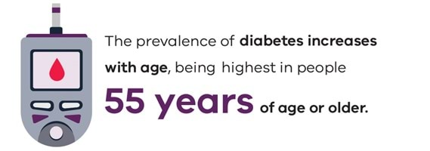
Diabetes mellitus (also called diabetes) is a common chronic condition characterised by high blood glucose (sugar) levels (Department of Health and Human Services 2018).
The two main types of diabetes are type 1 (insulin-dependent) diabetes and type 2 diabetes (Department of Health and Human Services 2018).
Gestational diabetes is another form of the condition that affects women during pregnancy, although they have had no prior diagnosis of diabetes (Department of Health and Human Services 2018).
This condition usually abates after birth but is a risk factor for developing type 2 diabetes later in life (Department of Health and Human Services 2018).

Type 1 diabetes
Type 1 diabetes is an autoimmune disease in which the body’s immune system destroys the insulin-producing cells of the pancreas.
This means the affected individual is unable to produce enough insulin, which is an essential hormone for controlling glucose levels in the blood.
Type 1 diabetes most commonly begins in those under the age of 30 years. People with type 1 diabetes require replacement insulin injections several times a day for life.
Unlike type 2 diabetes (see below) it is not caused by lifestyle factors.
Type 1 diabetes accounts for approximately 10–15 per cent of cases of diabetes Victoria (Department of Health and Human Services 2018).

Type 2 diabetes
Type 2 diabetes is the most common form of diabetes, which occurs mostly in people 50 years of age or older.
Risk factors for type 2 diabetes include being overweight or obese and having a family history of the condition.
Type 2 diabetes accounts for around 85 per cent of all cases of diabetes. It is caused by insufficient production of insulin and/or the body becoming resistant to insulin levels in the blood.
In some cases of type 2 diabetes, appropriate diet and exercise can control the condition. More severe cases require treatment with medications, insulin injections or a combination of these (Department of Health and Human Services 2018).
In Victoria, 6.8 per cent of people have self-reported doctor-diagnosed diabetes (Department of Health and Human Services 2018).
The prevalence of diabetes increases with age, being highest in people 55 years of age or older. The prevalence decreases significantly with increasing total annual household income in men but not in women (Department of Health and Human Services 2018).

Find out more
The Victorian Population Health Survey 2016 <https://www.health.vic.gov.au/population-health-systems/victorian-population-health-survey-2016> has a section on diabetes.
Access the Australian Institute of Health and Welfare’s <https://www.aihw.gov.au/reports-data/health-conditions-disability-deaths/diabetes/overview> diabetes pages.
Diabetes Australia <https://www.diabetesaustralia.com.au/> has information on diabetes and its prevention

References
Department of Health and Human Services 2018, Victorian population health survey 2016, State Government of Victoria, Melbourne.

Stroke
Stroke occurs when a blood vessel supplying blood to the brain either becomes blocked - known as an ischaemic stroke - or ruptures and begins to bleed- known as a haemorrhagic stroke - (Stroke Foundation 2018).
Either may result in part of the brain dying, leading to sudden impairment that can affect a number of bodily functions.
Stroke often causes paralysis of parts of the body normally controlled by the area of the brain affected by the stroke. It can also cause speech problems and other symptoms, such as difficulties with swallowing, vision and thinking (Australian Institute of Health and Welfare 2018).
In 2017, stroke was the third leading cause of death in Victoria and responsible for more than six per cent of all deaths in the state, with females more likely to die from stroke than males (Australian Bureau of Statistics 2018).
The prevalence of self-reported doctor-diagnosed stroke in Victorians was 2.7 per cent in 2016 (Department of Health and Human Services 2018).
This data source also identified that the prevalence of stroke decreased significantly with increasing total annual household income for females. No significant trend was observed, however, for males.

Find out more
The Victorian Population Health Survey 2016 <https://www.health.vic.gov.au/population-health-systems/victorian-population-health-survey-2016> has a section on stroke.
The Stroke Foundation <https://strokefoundation.org.au/> has information on stroke and its prevention.

References
Australian Bureau of Statistics 2018 Causes of Death, Victoria, 2017 ABS Canberra.
Australian Institute of Health and Welfare 2018 Australia's health 2018 Australian Institute of Health and Welfare, Canberra.
Department of Health and Human Services 2018, Victorian Population Health Survey 2016, State Government of Victoria, Melbourne
Stroke Foundation 2018, What is a stroke?, Stroke Foundation, Melbourne.

Heart disease
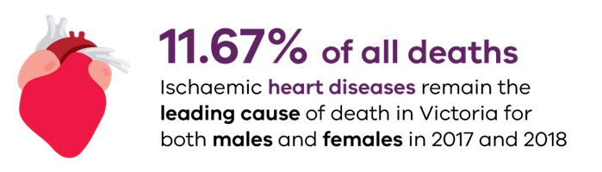
Heart disease is one of the leading causes of death in Australia and Victoria.
Ischaemic heart disease, which includes angina, blocked arteries of the heart and heart attacks, remains the leading cause of death in Victoria for both males and females. It accounts for 11.67 per cent of all deaths (Australian Bureau of Statistics 2018).
Several heart disease risk factors are modifiable and include:
- smoking
- high cholesterol
- high blood pressure
- inactivity
- overweight and obesity
- unhealthy diet
- depression and social isolation (Heart Foundation 2018).
Overall, people in lower socioeconomic groups, Aboriginal and Torres Strait Islander peoples and those living in remote areas have higher rates of hospitalisation and death resulting from heart disease than other Australians (Heart Foundation 2018).
Prevalence of heart disease is higher among the lowest socioeconomic group and Aboriginal and Torres Strait Islander people (Heart Foundation 2018).
The prevalence of self-reported doctor-diagnosed heart disease in Victorians was 7.3 per cent, with significantly higher prevalence observed in males at 9.0 per cent than in females at 5.8 per cent. (Department of Health and Human Services 2018).

Find out more
The Victorian Population Health Survey 2016 <https://www.health.vic.gov.au/population-health-systems/victorian-population-health-survey-2016> has a section on cancer.
The Heart Foundation <https://www.heartfoundation.org.au/> has information on heart disease and its prevention.

References
Australian Bureau of Statistics 2018, Causes of death, Victoria, 2017, Australian Bureau of Statistics, Canberra.
Heart Foundation 2018 Heart attack risk factors Heart Foundation, Melbourne.
Department of Health and Human Services 2018 Victorian population health survey 2016 State Government of Victoria, Melbourne.

Non-melanoma skin cancer
Non-melanoma skin cancer is the most commonly treated cancer in Australia. It includes basal cell carcinoma and squamous cell carcinoma.

Prevalence of non-melanoma skin cancer
Australian population surveys estimate Non-melanoma skin cancer incidence is more than five times the incidence of all other cancers combined (Staples et al. 2006).
Due to the large numbers of lesions and people affected, Non-melanoma skin cancer is not routinely reported to cancer registries like other types of cancers. This makes it challenging to accurately estimate Non-melanoma skin cancer incidence.
To overcome this, datasets such as Medicare item codes for skin cancer treatments (that is, excisions, curettage, laser or liquid nitrogen cryotherapy treatments) are used as a proxy measure.
Between 1997 and 2010, there was a substantial increase in the number of Non-melanoma skin cancer treatments in Victoria – from 53,992 to 99,077 (Franson et al. 2012).
In 2017 in Victoria, 141,269 Non-melanoma skin cancer were treated – roughly 387 treatments every day (Medicare Australia 2017).

Cost of treatment
Non-melanoma skin cancer places a substantial cost burden on the health system. It accounts for 8.1 per cent of all health system spending on cancer in Australia – excluding cancer screening (Australian Institute of Health and Welfare 2016).
The risk of Non-melanoma skin cancer increases with age, and the ageing of the Victorian population is likely to have contributed to an increase in the number of cancers treated and the economic burden of Non-melanoma skin cancer.
This burden falls not only on primary care, but also on hospitals through admissions and outpatient services.
In 2012–13, there were 12,700 Victorian public hospitals admissions for treating both melanoma and Non-melanoma skin cancer.
The cost was $29 million for Non-melanoma skin cancer alone.
Additionally, there were 14,000 outpatient treatments for managing skin cancer in Victoria.
In total, it is estimated to cost about $50 million ($49.3 to $55.7 million) annually to treat skin cancer in Victorian public hospitals, with the cost rising to between $121 to $127 million when private hospital admissions are also considered (Shih et al. 2017).

Cost-effectiveness of prevention
Nearly all Non-melanoma skin cancer in Australia can be attributed to high exposure to ultra violet radiation, making it largely preventable with sun protective behaviours (Cancer Australia 2018).
Yet the cost per person to treat all skin cancer types is 30 times the current expenditure on skin cancer prevention in Victoria.
Economic evaluations show prevention programs are highly cost effective, with the Victorian SunSmart program returning $2.20 for every dollar invested.
From 1988 to 2011, it is estimated that SunSmart Victoria prevented more than 43,000 cases of skin cancer, including 32,200 Non-melanoma skin cancer, and 1,400 skin cancer deaths.
This demonstrates its effectiveness in saving money and lives (Shih et al. 2017).

Find out more
Find out more about skin cancer <https://www.betterhealth.vic.gov.au/health/ConditionsAndTreatments/skin-cancer> on the Better Health Channel website.

References
Australian Institute of Health and Welfare 2016, Skin cancer in Australia, Australian Institute of Health and Welfare, Canberra.
Franson M, Karahalios A, Sharma N, English D, Giles G and Sinclair R 2012, ‘Non-melanoma skin cancer in Australia’, Medical Journal of Australia, vol. 197, no. 10, pp. 565–68.
Cancer Australia 2018, UV Radiation and cancer in Australia, Cancer Australia, Strawberry Hills, NSW.
Shih S, Carter R, Heward S and Sinclair C 2017, ‘Skin cancer has a large impact on our public hospitals but prevention programs continue to demonstrate strong economic credentials’, Australian New Zealand Journal of Public Health, vol. 41, no. 4, pp. 371–76.
Staples M, Elwood M, Burton R, Williams J and Giles G 2006, ‘Non-melanoma skin cancer in Australia: the 2002 national survey and trends since 1985’, Medical Journal of Australia, vol. 184, no. 1, pp. 6–10.

Melanoma
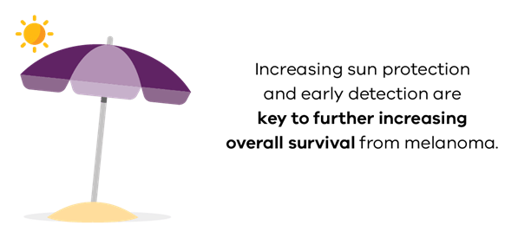
Melanoma is a type of skin cancer that usually occurs on parts of the body that have been overexposed to the sun (Cancer Council Victoria 2018).
Rare melanomas can occur inside the eye or in parts of the skin or body that have never been exposed to the sun.

Incidence
Australia has one of the highest rates of melanoma in the world.
In Victoria in 2017, there were 2,993 cases of melanoma. In the same year, there were 270 deaths due to the disease (Cancer Council Victoria 2018).
While most Victorians (90 per cent) diagnosed with cutaneous (skin) melanoma had only a single primary lesion, 8 per cent of Victorians had two melanomas and 2 per cent had three or more primary lesions. Twenty Victorians had 10 or more separate primary melanomas (Cancer Council Victoria 2018).
In both men and women, melanoma incidence rates increase with age, starting at around 20, with rates higher in women between the ages of 20 and 50 years (see figure below).
At 50 years, rates are almost equal, but thereafter male rates increase more rapidly to become twice those for females by 80 years (Cancer Council Victoria 2018).
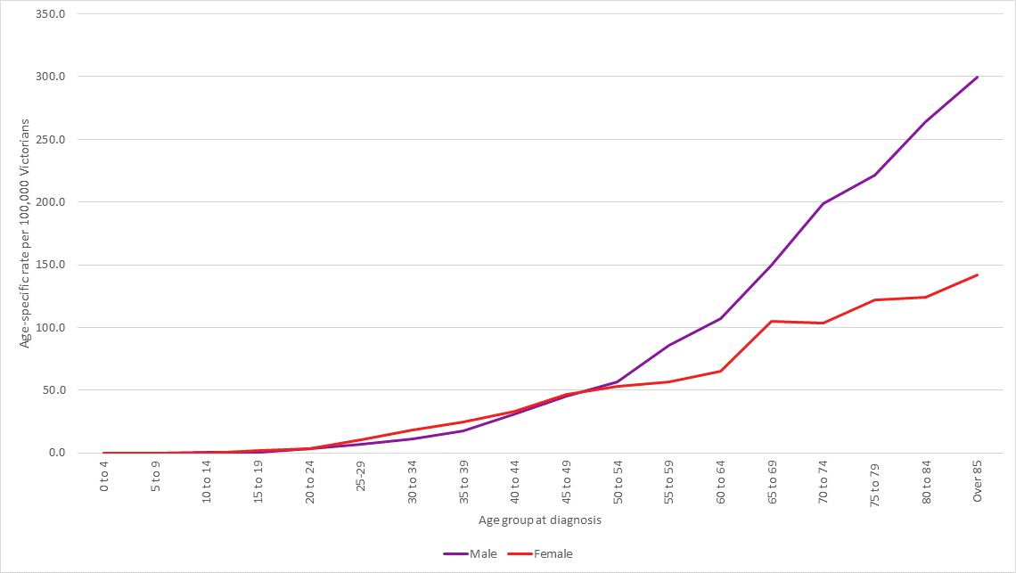
Figure 1 shows the age-specific incidence rates for melanoma for Victorian men and women 2014–16.
Source: Cancer Council of Victoria 2018

Survival rates
Overall, five-year survival from melanoma has increased from 83 per cent to 91 per cent over the period 1982–86 to 2012–16 (Cancer Council Victoria 2018).
Increasing sun protection and early detection are key to further increasing overall survival from melanoma.

Find out more
For more information about melanoma in Victoria, please visit: Cancer in Victoria: Statistics and Trends (PDF) <https://www.cancervic.org.au/downloads/cec/cancer-in-vic/Cancer in Victoria 2017.pdf> on the Cancer Council Victoria website.
The Victorian Population Health Survey 2016 <https://www.health.vic.gov.au/population-health-systems/victorian-population-health-survey-2016> has a section on cancer.

References
Cancer Council Victoria 2018 Cancer in Victoria: Statistics and Trends (PDF) Cancer Council Victoria, Melbourne.

Cancer
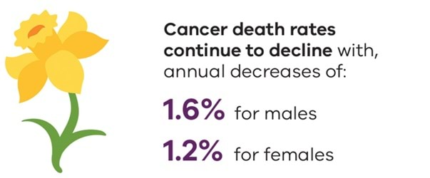
Cancer is a leading contributor to the burden of disease in Victoria. There are 95 new diagnoses each day (or one every 15 minutes) in our state. In 2017, 34,557 Victorians were diagnosed with cancer (Cancer Council Victoria 2018).
Since 1982, cancer incidence has steadily increased, with annual rate increases of 0.6 per cent for both men and women (Cancer Council Victoria 2018).
While the increase in cancer rates is small, the growth and ageing of the Victorian population result in a much larger annual increase (3 per cent) in actual numbers of cancers diagnosed (Cancer Council Victoria 2018).
Nearly half (46 per cent) of cancers diagnosed are in Victorians aged over 70 years, and less than 2 per cent are in those people aged under 30 years (Cancer Council Victoria 2018).
The five most common cancers in Victoria are prostate, breast, bowel, melanoma and lung, collectively accounting for 57 per cent of all new cancers and 46 per cent of cancer deaths (Cancer Council Victoria 2018).
While an average of 30 people die from cancer every day in Victoria, death rates continue to decline. Since 1982, annual decreases of 1.6 per cent for males and 1.2 per cent for females have been recorded.
These reductions reflect earlier detection of cancers through screening, reductions in tobacco use – especially in males – and improvements in treatment.
Overall, from 1982 to 2016, five-year survival rates for cancer increased from 46 per cent to 68 per cent (Cancer Council Victoria 2018).

Find out more
Access the Cancer Council Victoria statistics and data website <https://www.cancervic.org.au/research/registry-statistics/statistics-data>.
The Victorian Population Health Survey 2016 <https://www.health.vic.gov.au/population-health-systems/victorian-population-health-survey-2016> has a section on cancer.
For more information about melanoma in Victoria, Cancer in Victoria: Statistics and Trends (PDF) <https://www.cancervic.org.au/downloads/cec/cancer-in-vic/Cancer in Victoria 2017.pdf> on the Cancer Council Victoria website.
For more information about non-melanoma skin cancer in Victoria, please see the non-melanoma skin cancer article Cancer in Victoria: Statistics and Trends (PDF) <https://www.cancervic.org.au/downloads/cec/cancer-in-vic/Cancer in Victoria 2017.pdf> on the Cancer Council Victoria website.

References
Cancer Council Victoria 2018 Cancer in Victoria: Statistics and Trends (PDF) <https://www.cancervic.org.au/downloads/cec/cancer-in-vic/Cancer in Victoria 2017.pdf> Cancer Council Victoria, Melbourne.

Musculoskeletal conditions
Arthritis is an umbrella term for a range of inflammatory conditions affecting the bones, muscles and joints.
These conditions include osteoarthritis, rheumatoid arthritis, juvenile arthritis and gout. They often result in pain, stiffness, swelling and redness in affected joints.
Arthritis is a common condition, particularly among older Australians, and is a large contributor to illness, pain and disability (Australian Institute of Health and Welfare 2018).
In Victoria, the prevalence of self-reported doctor-diagnosed arthritis is 20.4 per cent, with a significantly higher prevalence observed in females (25.9 per cent) compared with males (15.6 per cent) (Department of Health and Human Services 2018).
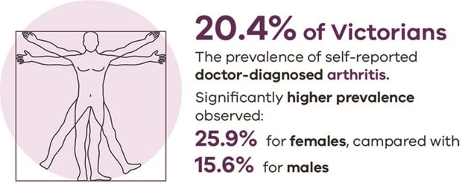
There is also an age-related increase in the prevalence of arthritis, with males and females 55 years of age or older having a significantly higher prevalence compared with all Victorian males and females (Department of Health and Human Services 2018).
Osteoporosis is a disease that makes bones become brittle, leading to a higher risk of bone fracture than in normal bone (Osteoporosis Australia 2014). This disease affects more than one million Australians (Osteoporosis Australia 2014).
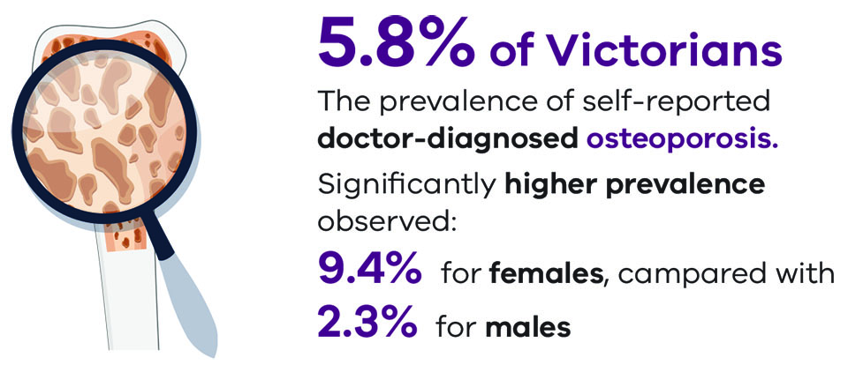
In Victoria the prevalence of self-reported doctor-diagnosed osteoporosis is 5.8 per cent, with a significantly higher prevalence observed in females at 9.4 per cent compared with males at 2.3 per cent (Department of Health and Human Services 2018).
As for arthritis, there is an age-related increase in the prevalence of osteoporosis in both males and females, with a significantly higher prevalence observed in males 65 years of age or older and females 55 years of age or older compared with all Victorian males and females, respectively (Department of Health and Human Services 2018).

Find out more
The Victorian Population Health Survey 2016 <https://www.health.vic.gov.au/population-health-systems/victorian-population-health-survey-2016> has a section on cancer.
Access the Australian Institute of Health and Welfare's <https://www.aihw.gov.au/reports-data/health-conditions-disability-deaths/chronic-musculoskeletal-conditions/overview> musculoskeletal pages.
Arthritis Australia <https://arthritisaustralia.com.au/> has information on arthritis and its prevention.
Osteoporosis Australia has information on osteoporosis and its prevention.

References
Australian Institute of Health and Welfare 2018, Arthritis snapshot Australian Institute of Health and Welfare, Canberra.
Department of Health and Human Services 2018, Victorian population health survey 2016 State Government of Victoria, Melbourne.
Osteoporosis Australia 2014 About osteoporosis: What is it?, Osteoporosis Australia, Sydney.

Immunisation in Victoria
Immunisation prevents many illnesses in children and adults.
It provides benefits not only for individuals but also for the health of the wider community – when enough people are immunised, disease spread is reduced.
Immunisation saves lives.
Many immunisations also help limit serious consequences, such as preventing some cancers through vaccination against human papillomavirus (HPV).
This vaccine not only prevents genital warts but can also reduce the risk of cervical cancer in women and cancers of the genital area, mouth and throat in men.
This section of the Chief Health Officer report provides information on:
- the extent of immunisation coverage among Victorian children aged five years and under
- amendments to the No Jab No Play Legislation
- meningococcal disease in Victoria
- the immunisation focus on two high-risk groups: gay, bisexual and other men who have sex with men, and refugees and asylum seekers.

Immunisation for Meningococcal disease in Victoria
Meningococcal disease is a blood infection or infection of the membranes covering the brain and spinal cord (Meningitis).
Since 2014, a gradual increase in the number of cases of meningococcal disease has been detected in Victoria, due to a particular strain of bacteria known as ‘serogroup W’ (Department of Health and Human Services 2017a).
In response to this emerging strain, the department issued an advisory to health professionals to raise awareness of this serious condition.
In 2017, the Victorian Government announced funding of $7.1 million to deliver a one-year vaccination program for 15 to 19-year-olds (Department of Health and Human Services 2017b).
Additional funding in early 2018 allowed vaccination of pupils in year 10 at secondary school and those adolescents aged 15 and 16 not at school (Department of Health and Human Services 2018).
To the end of 2018, almost 300,000 doses of the vaccine had been distributed and cases of meningococcal disease decreased following the peak in 2017.

Find out more
The department has a meningococcal page (see Immunisation for Meningococcal disease in Victoria) for information about meningococcal disease and its public health management.

References
Department of Health and Human Services 2017a, Media release: Protecting Victorians from Meningococcal W, State Government of Victoria, Melbourne.
Department of Health and Human Services 2017b, Health alert: Vaccination campaign to combat meningococcal disease in gay men, State Government of Victoria, Melbourne.
Department of Health and Human Services 2018, Immunisation Newsletter February 2018, State Government of Victoria, Melbourne.

Immunisation coverage and amendments to No Jab No Play legislation
All vaccinations administered are reported to the Australian Immunisation Register.
Quarterly figures from the Register provide a snapshot of the proportion of Victorian children in three age cohorts who are immunised for that age, as shown in Figure 1 below.
This demonstrates the improving trend in coverage rates among young Victorian children.
Importantly, more than 95 per cent of Victorian five-year-old children are now immunised for their age (Department of Human Services 2018).
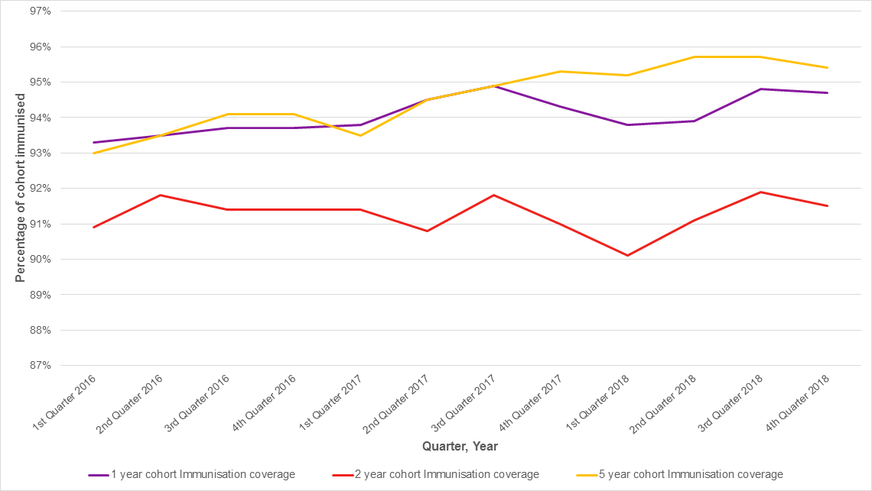
Figure 1: Victorian immunisation coverage rate by quarter and age cohort
Source: Australian Immunisation Register
Note: there were changes to the National Immunisation Program Schedule in July 2018, which resulted in a change to the definition of ‘fully immunised’. This has resulted in a slight fall in immunisation coverage rates due to errors in reporting.

Why is 95 per coverage important?
Vaccinating all children is important to protect their health and the health of their families, friends and communities. If people are vaccinated or immune to a disease, then non-immune people are much less likely to meet an infected person and catch the disease (this is often called ‘herd immunity’). Non-immune people include people who cannot be vaccinated because of their age (too young or too old) or because their immune systems do not work as well (Department of Health, 2018).
To achieve herd immunity for infectious diseases, coverage needs to be high. Australia’s national aspirational coverage target is 95 per cent. Reaching this aspirational target will give us enough herd immunity to stop the spread of measles and other vaccine-preventable diseases (Department of Health, 2018).

Find out more
The department has an Immunisation page <https://www.betterhealth.vic.gov.au/healthyliving/immunisation> on the Better Health Channel.

No Jab No Play Legislation
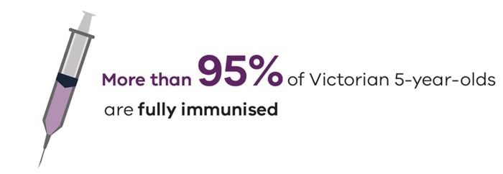
Under the Public Health and Wellbeing Act 2008, an early childhood service may not confirm the enrolment of a child unless it has certification the child is age-appropriately immunised or has an approved exemption.
The No Jab No Play legislation, which came into effect on 1 January 2016, provides an exemption from immunisation requirements for children with a medical contraindication to a vaccine, while conscientious objection to vaccination was no longer exempt (Department of Health and Human Services 2018a).
There is provision to allow enrolment of children whose immunisation documentation has not been provided if they are experiencing vulnerability and disadvantage (Department of Health and Human Services 2018a).
Services are required to follow up with those families following enrolment, to seek certification of immunisation (Department of Health and Human Services 2018a).
Following the commencement of this legislation, Victoria's immunisation rates steadily increased.
Victoria now has the second highest immunisation coverage nationally for five-year-olds, with 95.4 per cent fully immunised by the end of 2018 (Department of Human Services 2018).
This compares with the Australian average of 94.7 per cent (Department of Human Services 2018).
Victoria has now reached the 95 per cent ‘herd immunity’ target, which is necessary to halt the spread of dangerous and virulent diseases such as measles.
In 2018, Parliament passed the Health and Child Welfare Legislation Amendment Bill 2018 to address issues created by a self-admitted anti-vaccination medical practitioner who assisted families to avoid Victorian and Commonwealth immunisation requirements (Department of Health and Human Services 2018b).
These amendments removed the option of a doctor’s letter as acceptable evidence of immunisation status. An immunisation history statement from the Australian Immunisation Register is now required.
The Bill also included provisions that require parents to provide early childhood services with evidence that their child continues to be up-to-date with their immunisations after enrolment and for the duration of attendance at the service (Department of Health and Human Services 2018b).
Early childhood services now remind parents of this obligation twice a year. This additional prompt helps keep children's immunisations up to date (Department of Health and Human Services 2018b).

Find out more
The department has a No Jab No Play page <https://www.health.vic.gov.au/immunisation/no-jab-no-play> for information about this important public health initiative.

References
Department of Health 2018, Questions about vaccination, Commonwealth Government of Australia, Canberra.
Department of Health and Human Services 2018a, No Jab No Play information, State Government of Victoria, Melbourne.
Department of Health and Human Services 2018b, Amendments to the No Jab No Play legislation, State Government of Victoria, Melbourne.
Department of Human Services 2018, Australian Immunisation Register, Commonwealth Government of Australia, Canberra.

Immunisation high risk groups
When disease outbreaks occur, containing the spread of disease is a key part of keeping the entire community safe.
This means that efforts must be directed at high-risk groups to help limit the spread of disease.
The following two immunisation initiatives help keep Victorians safe from infectious disease.

Time to Immunise program
In late 2017, there was an outbreak of hepatitis A in late 2017 among gay, bisexual and other men who have sex with men (MSM) (Department of Health and Human Services 2018a). This mirrored similar outbreaks across Europe, the United States and other parts of Australia.
In response, the Victorian Government funded a free hepatitis A vaccine program for these high-risk groups – the Time to Immunise program (Department of Health and Human Services 2018b).
In partnership with the Victorian Aids Council (now Thorne Harbour Health), gay, bisexual and other men who have sex with men were also encouraged to take advantage of another free vaccination program against meningococcal disease, hepatitis B and human papillomavirus program (HPV) (Department of Health and Human Services 2017 and 2018b).
The promotional campaign included social media advertising, posters, radio and activities at key LGBTIQA+ events – such as the Midsumma Festival.
These vaccines help prevent serious infections.
Hepatitis A and B can lead to liver disease and liver cancer (Department of Health and Human Services 2018b).
Meningococcal C can lead to septicaemia (infection in the blood) and meningitis (inflammation of the membrane covering the brain) Department of Health and Human Services 2017.
Some types of HPV can lead to genital warts, while other types of HPV can lead to certain cancers of the genital area, mouth and throat in men.
In total, funding of $2.9 million was provided for these four free vaccine programs, which distributed more than 77,000 free vaccines in Victoria.
Linked to the same outbreak of hepatitis A noted above, free vaccines against hepatitis A were funded for people who inject drugs, homeless rough sleepers and adult prisoners. People who inject drugs were also offered free hepatitis B vaccine Department of Health and Human Services 2018a).

Refugee, asylum seeker immunisation program
Refugees and asylum seekers in Victoria are a significant group who may not be appropriately vaccinated (Victorian Refugee Health Network, 2017).
In recognition of the difficulties many refugees and asylum seekers experience in accessing medical care, the 2016–17 State Budget provided an additional $10.9 million over four years to support the increasing number of refugees settling in Victoria (Department of Health and Human Services, 2016).
This funding focused on several health initiatives, including immunisation.
Of this funding, more than $23 2 million was set aside to help refugees and asylum seekers in Victoria complete vaccine schedules according to Australian recommendations (Department of Health and Human Services, 2016).

Find out more
The department has information on meningococcal disease <https://www.health.vic.gov.au/chief-health-officer/immunisation-for-meningococcal-disease-in-victoria>, hepatitis A <https://www.health.vic.gov.au/infectious-diseases/hepatitis-a> and hepatitis B <https://www.health.vic.gov.au/infectious-diseases/hepatitis-b>.
Refugee and asylum seeker health and wellbeing <https://www.health.vic.gov.au/populations/refugee-and-asylum-seeker-health-and-wellbeing>

References
Department of Health and Human Services 2016, 2016-17 State Budget: Refugee and asylum seeker health and wellbeing in Victoria, State Government of Victoria, Melbourne.
Department of Health and Human Services 2017, Health alert: Vaccination campaign to combat meningococcal disease in gay men, State Government of Victoria, Melbourne.
Department of Health and Human Services 2018a, Chief Health Officer alert: Hepatitis A outbreak, State Government of Victoria, Melbourne.
Department of Health and Human Services 2018b, Better Health Channel: Time to Immunise Program, State Government of Victoria, Melbourne.
Victorian Refugee Health Network, 2017, Catch-up vaccinations for refugees and asylum seekers in Victoria, State Government of Victoria, Melbourne.

Communicable disease
Previous Chief Health Officer reports have provided health data for Victorians on the following communicable diseases:
- notified cases of laboratory-confirmed influenza and rates of influenza-like illness from sentinel general practice surveillance
- the number and notification rate of cases of pertussis and the age-specific notification rates of pertussis
- the number and notification rate of cases of meningococcal disease and the age-specific notification rates of meningococcal disease
- the number and notification rate of cases of tuberculosis over time
- the number and notification rate of Buruli ulcer over time
- the number of cases and rate of notification of HIV and the sex, sex of sexual partner and age-specific notification rates
- the number and notification rate of hepatitis B cases and the sex and age-specific notification rates
- the number and notification rate of hepatitis C cases and the sex and age-specific notification rates
- the number of cases and rate of notification of syphilis and the sex, sex of sexual partner and age-specific notification rates
- the number and notification rate of cases of legionellosis over time
- the number of notified cases of salmonellosis, expressed as a rate per 100,000 population, by age group, over time.
All of this health information on these and other notifiable conditions can now be accessed through the department's interactive communicable disease reports <https://www.health.vic.gov.au/infectious-diseases/interactive-infectious-disease-reports>.
The communicable disease component of this Chief Health Officer report highlights some of the improved ways the department is undertaking surveillance of communicable disease to help keep Victorians safe.
It also examines key topics that have had a significant impact on communicable disease experience in Victoria – Buruli (Bairnsdale) ulcers (see Buruli ulcer), the significant 2017 influenza outbreak and improvements in treatment of hepatitis C (see Advances in hepatitis C treatment).
Another communicable disease article on the ground-breaking PrEPX study to reduce HIV transmission is covered on the Sexual and reproductive health page of this Chief Health Officer report.

2017 influenza outbreak
Influenza is a notifiable condition in Victoria, and data for this article is taken from this notification data.

What happened
The severe 2017 influenza season resulted in unprecedented demand for health services throughout Victoria.
Increased numbers of people presented to general practices and hospitals with influenza-like illnesses.
The very young and the very old were particularly affected. Most children hospitalised with influenza were aged under five years, and there was a record number of respiratory outbreaks due to influenza reported in aged care facilities.
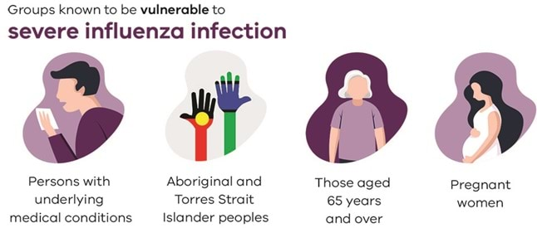
There were 48,200 laboratory-confirmed cases of influenza notified to the department in 2017, which was nearly five times higher than the previous five-year average, as shown in Figure 1 (Department of Health and Human Services 2018a).
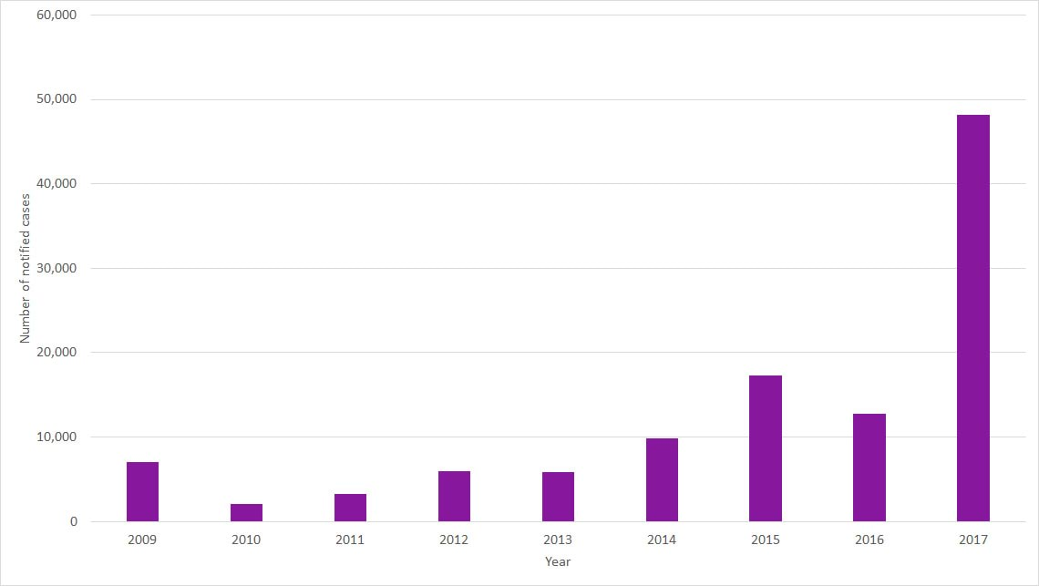
Figure1: Notifications of laboratory-confirmed influenza, Victoria 2009–2017
Source: Department of Health and Human Services
Notifications began to rise in mid-July, peaked in early September, and did not drop down to usual inter-seasonal levels until late November.
Laboratory testing indicated the early peak was due to influenza type A (Figure 2), with the later, slightly lower peak due to influenza type B.
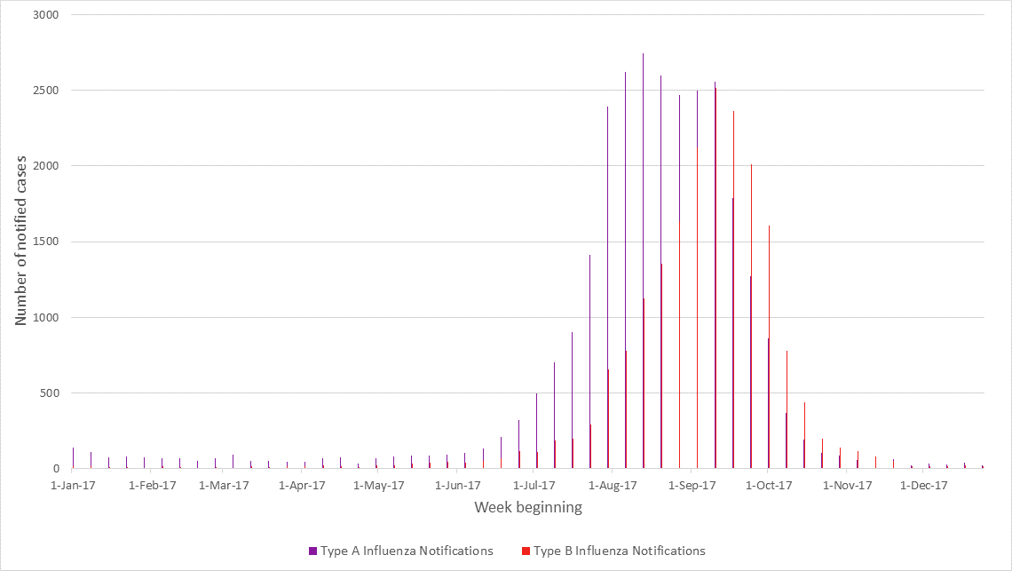
Figure 2: Notifications of laboratory-confirmed influenza by influenza type and week, Victoria, 2017
Source: Department of Health and Human Services
These types affected different age groups, with most type A from those under five years of age and those aged 65 years and older. Type B was most common in those aged five to nine years old (Figure 3).
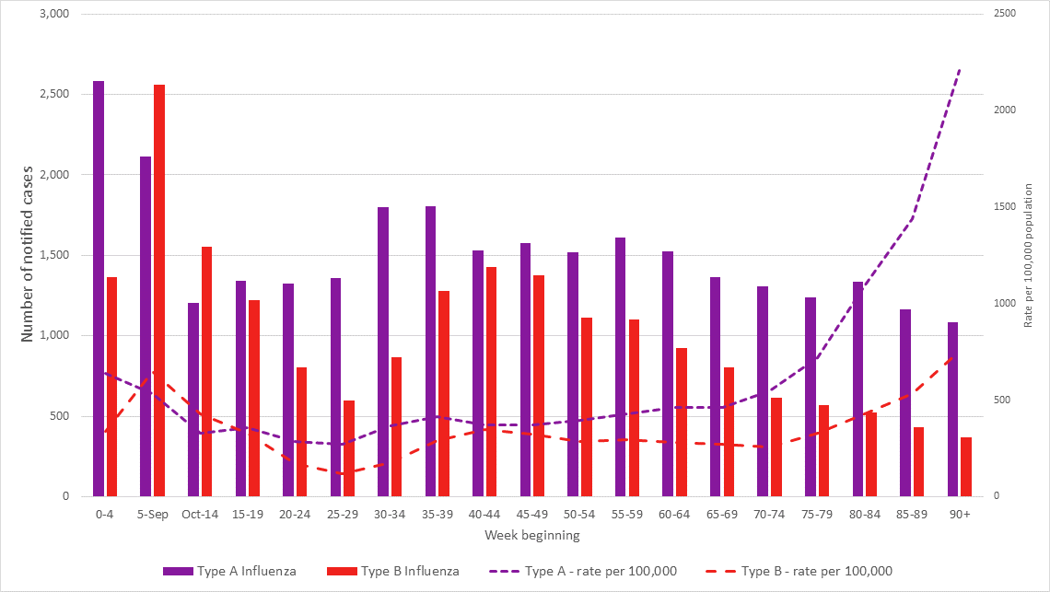
Figure 3: Notifications of laboratory-confirmed influenza by influenza type and age group, Victoria, 2017
Source: Department of Health and Human Services

Hospitalisations and deaths
Between May and October 2017, the number of hospitalisations due to influenza was four times higher than the average for the previous five years (Department of Health and Human Services 2018b).
While there were more people admitted to intensive care units (ICUs) with influenza, ICU admissions for influenza as a percentage of all hospital admissions was 6.4 per cent, which was lower than the average for 2012–2016 of 9.3 per cent.
There were increased deaths in hospitalised influenza cases reported in 2017 (229 deaths) compared with an average of 53 deaths in each year from 2012–16.
These deaths in 2017 were mainly in elderly patients, which is consistent with years when this strain of influenza predominates.

Why did it happen
Findings from the World Health Organization Collaborating Centre for Reference and Research on Influenza indicated unusually poor effectiveness of the influenza vaccine used in 2017.
In particular, the vaccine had low effectiveness against the predominant influenza Type A strain, which was the main strain circulating throughout Australia in 2017 (Department of Health 2017).
This strain contained within the vaccine was replaced for the 2018 southern hemisphere influenza season.

Responding to the outbreak
The National Immunisation Program (NIP) includes free vaccination for groups known to be vulnerable to severe influenza infection.
This includes:
- people with underlying medical conditions
- Aboriginal and Torres Strait Islander peoples
- those aged 65 years and older
- pregnant women (Department of Health 2018).
Following the severe 2017 influenza season, several additional targeted vaccination programs were introduced.
From May 2018, Australian Government-subsidised providers of residential aged care were required to offer free influenza vaccination to all staff and volunteers.
Two new vaccines were added to the National Immunisation Program for people aged 65 years and older.
To help provide further community protection, the Victorian government implemented a special vaccine program in 2018 for children aged from six months up to five years.
The prolonged, high peak of influenza infections throughout the community in 2017 placed pressure on all areas of the Victorian health system.
Data collection from influenza surveillance systems has been enhanced to ensure early warning and appropriate resource allocation for future influenza seasons.

Find out more
Find out more about influenza <https://www.health.vic.gov.au/infectious-diseases/influenza>.

References
Department of Health 2017, 2017 Influenza Season in Australia: a summary from the National Influenza Surveillance Committee, Commonwealth Government, Canberra.
Department of Health 2018, National immunisation program schedule, Commonwealth Government, Canberra.
Department of Health and Human Services 2018a, Notifications of influenza to Department of Health and Human Services, State Government of Victoria, Melbourne.
Department of Health and Human Services 2018b, Victorian admitted episodes dataset for influenza. State Government of Victoria, Melbourne.

Advances in hepatitis C treatment
Hepatitis C has been a significant public health concern in Australia and Victoria for nearly three decades. Increasing numbers of Victorians have been living with hepatitis C, estimated to be more than 48,000 at the end of 2016 (Kirby Institute for Infection and Immunity in Society 2017).
Liver cancer, for which hepatitis C is the leading cause, is increasingly common in Victoria (Council Victoria 2018).

About hepatitis C
Hepatitis C is a blood-borne virus that causes inflammation of the liver.
This virus is present in the blood of a person living with hepatitis C and can be spread through blood-to-blood contact. It is commonly spread through sharing unsterile needles, syringes and other injecting drug equipment.
There is a higher prevalence of hepatitis C among key populations such as people who inject drugs, people in custodial settings (prisons), people from high-prevalence countries (where hepatitis C is often acquired through use of unsafe injections and other medical and dental procedures) and HIV-positive men who have sex with men (Falade-Nwulia, Sulkowski, Merkow, Latkin and Mehta 2018).
In more than 90 per cent of cases, initial infection with hepatitis C virus does not cause symptoms or only causes mild symptoms. Approximately three quarters of those infected go on to develop a chronic (long-term) infection. Of those who develop a chronic infection, a significant proportion will develop cirrhosis or cancer of the liver, typically decades after initial infection (American Public Health Association 2008).

Preventing hepatitis C
There is no vaccine currently available to prevent hepatitis C infection.
However, access to harm reduction services (such as needle and syringe exchange programs, opiate replacement therapy, and peer-based support) are proven, effective ways of reducing transmission of hepatitis C, which also have other health benefits for people who inject drugs (Kirby Institute for infection and Immunity in society 2018).

Hepatitis C surveillance
For surveillance purposes hepatitis C is classified as ‘newly acquired’ or ‘unspecified’.
- Newly acquired hepatitis C is defined as infection acquired in the last 24 months prior to diagnosis.
- Unspecified hepatitis C is defined as an infection acquired more than 24 months prior to diagnosis or unknown duration. Unspecified hepatitis C is generally considered a chronic infection.
In Victoria, hepatitis C is a notifiable condition under the Public Health and Wellbeing Regulations 2019. Notification rates of newly acquired hepatitis C infections and unspecified (most of which are chronic) hepatitis C infections have reduced in Victoria in the last decade by 75 per cent and 28 per cent respectively, as shown in Figure 1.
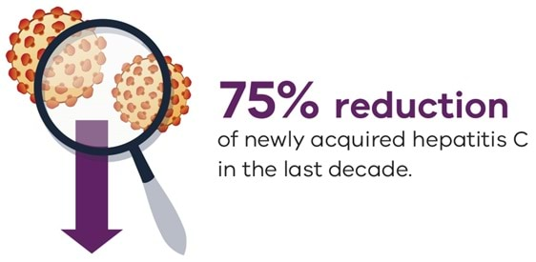
The increase in notification rates of unspecified hepatitis C in Victoria in 2016 may reflect increased testing due to people accessing new, direct-acting antivirals that can cure hepatitis C in almost all people being treated. (Falade-Nwulia, Sulkowski, Merkow, Latkin and Mehta 2018).
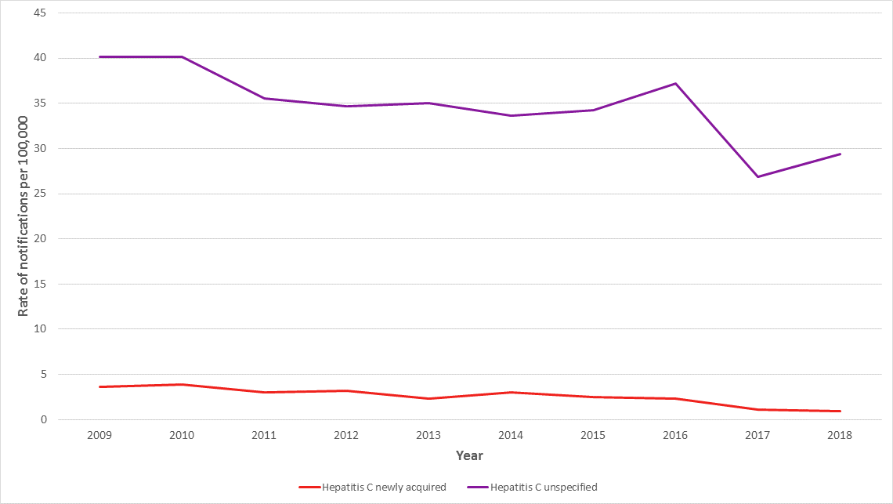
Figure 1: Notification rate (per 100,000 population) of hepatitis C newly acquired and unspecified cases, Victoria, 2009-2018

Treatment for hepatitis C
The advent of new direct-acting antivirals is the most significant advance in clinical management of hepatitis C (Falade-Nwulia, Sulkowski, Merkow, Latkin and Mehta 2018).
Previously, hepatitis C was treated with a combination of injected and oral medications for 6–12 months, which were associated with significant side effects and cured infection in around half of those treated (Friedman and Contente 2010).
The new direct-acting antivirals are oral tablets, typically administered for 12 weeks with minimal side effects, and lead to cure in around 95 per cent of people treated (Falade-Nwulia, Sulkowski, Merkow, Latkin and Mehta 2018).
Since these became available on the Pharmaceutical Benefits Scheme in March 2016, uptake of treatment for hepatitis C has increased markedly.
In addition to curing hepatitis C, successful treatment reduces inflammation and scarring in the liver and helps prevent the long-term risk of health problems including chronic liver disease and liver cancer.
This means that people newly diagnosed with chronic hepatitis C (i.e. have had the infection for more than six months), as well as those who have been living with chronic hepatitis C for many years, now have access to a fast, effective and well-tolerated curative treatments.
People are also eligible for re-treatment if they become infected with a new hepatitis C infection or if the initial treatment was not successful. All general practitioners can now prescribe hepatitis C treatments.

Uptake of treatment
Monitoring of hepatitis C treatment uptake data in Australia shows that an estimated 32,550 individuals initiated direct-acting antiviral treatment between in 2016 in Australia, representing 14.3 per cent of the total living with chronic hepatitis C in Australia (Kirby Institute for Infection and Immunity in Society 2017).
During this period, the treatment uptake in Victorians with chronic hepatitis C was 15 per cent, which is above the national average.
This indicates that Victoria is heading in the right direction and has achieved close to a third of Victoria’s 2030 target of 90 per cent of people living with chronic hepatitis C being cured of the disease within the first two years of direct-acting antivirals being available (Department of Health and Human Services 2016a).

International, national and state targets
International, national and state targets are set out in:
- The World Health Organization's Global health sector strategy on viral hepatitis 2016–2021 <https://apps.who.int/iris/handle/10665/246177>
- Australia's Fifth national hepatitis C strategy 2018–2022 <https://www1.health.gov.au/internet/main/publishing.nsf/Content/ohp-bbvs-1>
- The Victorian hepatitis C strategy 2016–2020 <https://www.health.vic.gov.au/publications/victorian-hepatitis-c-strategy-2016-2020>.
Meeting these targets is a critical part of Victoria’s response to eliminate hepatitis C as a public health threat and eliminate stigma and discrimination associated with the disease by 2030 (Department of Health and Human Services 2016a).
In addition, the Victorian cancer plan 2016–2020 <https://www.health.vic.gov.au/publications/victorian-cancer-plan-2016-2020> seeks to reduce hepatitis-related cancers as one of its key focus areas (Department of Health and Human Services 2016b).
Realising the potential of the new direct-acting antivirals is an important part of our response to hepatitis C and key to the success of the Victorian hepatitis C strategy.

References
American Public Health Association 2008, Control of communicable diseases manual, ed. Heymann D, American Public Health Association, Washington DC.
Cancer Council Victoria 2018, Cancer in Victoria - Statistics and Trends 2017
Department of Health and Human Services 2016a, Victorian hepatitis C strategy 2016–2020, State Government of Victoria, Melbourne.
Department of Health and Human Services 2016b, Victorian cancer plan 2016–2020: improving cancer outcomes for all Victorians, State Government of Victoria, Melbourne
Department of Health and Human Services 2018, Hepatitis C notification data, accessed from Public Health Event Surveillance System, State Government of Victoria, Melbourne.
Falade-Nwulia O, Sulkowski M, Merkow A, Latkin C and Mehta S 2018, ‘Understanding and addressing hepatitis C reinfection in the oral direct acting antiviral era’, Journal of Viral Hepatitis, vol. 25, no. 3.
Friedman R and Contente S 2010, ‘Treatment of Hepatitis c infections with Interferon: a historical perspective’, Hepatitis Research and Treatment.
Kirby Institute for Infection and Immunity in Society 2017, HIV, viral hepatitis and sexually transmissible infections in Australia: annual surveillance report 2017, Kirby Institute, Sydney.

Improving communicable disease data management

Improving access to surveillance data
The department's Health Protection Branch has been producing more than 200 reports on notifiable conditions every day for almost 20 years.
These daily reports provide surveillance data on communicable diseases and other conditions notifiable under public health and wellbeing legislation at statewide and local government levels.
During 2018, the branch launched the first interactive communicable disease report, powered by Microsoft's Power BI platform.
This new platform allows the branch to publish content directly to the web more efficiently and in a manner that report users can interact with.
The reports have provided an enhanced user experience for health sector, local government, researchers and students who use this data.
In 2019, the branch will fully transition from the 200 fixed PDF and Excel reports to the new interactive reporting.
Visit the interactive communicable disease reports <https://www.health.vic.gov.au/infectious-diseases/interactive-infectious-disease-reports>.

Improving processes for notifiable conditions
Infectious diseases and other conditions of public health concern still occur frequently throughout the world, so constant vigilance is required to minimise their spread.
Notification is a vital step in efforts to prevent or control the spread of infection and to prevent further harmful exposures.
Medical practitioners and pathology services play a vital role in protecting public health by notifying cases of specific infectious diseases and other conditions to the Department of Health and Human Services.
Notification for all notifiable diseases:
- provides a crucial early warning of a potential threat to public health
- enables the department to respond to prevent or control the spread of disease
- allows for the identification of emerging trends and the implementation of appropriate policy responses and public health interventions.
In Victoria, the Public Health and Wellbeing Act 2008 requires medical practitioners and pathology services to notify the department of cases of specific infectious diseases and other medical conditions. These 70+ 'notifiable conditions' are prescribed in the Public Health and Wellbeing Regulations 2009.
Until mid-2018, the regulations prescribed the same list of notifiable conditions for both medical practitioners and pathology services, which meant that cases were typically notified to the department twice.
The department reviewed the prescribed notifiable conditions to identify which conditions could have the requirement for medical practitioner notification removed.
The requirement for medical practitioners to notify the department of 10 conditions was removed.
These conditions continue to be notified by pathology services.
Other changes were also made which further simplified notification requirements for medical practitioners.
Medical practitioners still play a critical role in notifications where clinical, occupational, and other information is key to determining an appropriate public health response.
During 2019–20 the department will progressively roll out electronic reporting of notifiable conditions for pathology services.
These electronic notifications will provide prompt notification supporting the move to near real-time surveillance and monitoring of potential health threats to the Victorian population.
This system simplifies the process for pathology services to fulfil their current legal requirement to notify positive pathology findings to the department.

Advances in whole genomic sequencing
Microbial genomic sequencing is revolutionising the conduct of surveillance and outbreak detection among communicable diseases.
Whole genome sequencing (WGS) enables faster, more precise surveillance, allowing rapid outbreak detection and response.
Traditional surveillance and outbreak detection require many tests to be performed to determine the type of an organism and whether it is related to other organisms.
The advantage of WGS is that organisms need only be sequenced once, and that sequence information is stored in perpetuity.
Laboratories do not need to regrow and retest an organism for further testing, saving time and money.
This one sequence replaces the many traditional tests required for public health surveillance and response.
Most results from traditional tests can be predicted by bioinformatic analysis of the microbial genomic sequence, allowing comparison with microorganisms tested in previous years.
Outbreak detection is more precise, as the sequences of isolates from the same type of organism are compared through genomic analysis to determine how related the organisms are.
As an example, when people have eaten the same food product contaminated with Salmonella and become unwell, the organisms from their clinical samples are highly related.
When the genomic analysis detects this relatedness, an outbreak investigation is conducted within the Communicable Disease Unit.
By using genomic technology, outbreaks are detected earlier, the response is faster, and fewer people consume the contaminated product as it is removed from the market.
In Victoria, WGS is also used to detect transmission of the multi-drug resistant organism, carbapenemase-producing Enterobacterales (CPE), within and across healthcare facilities.
These organisms can be carried in the gastrointestinal tract causing no harm, but some people who carry the organism, particularly the young, the elderly and the immunocompromised, can become very unwell if the organism causes an infection.
With very few choices of antimicrobials to treat these patients, their prognosis can be poor.
The department established guidelines in 2015 to ensure the capability to detect, characterise and control CPE using WGS.
When transmission is detected, healthcare facilities are required to conduct screening of ward contacts of CPE cases and enhance infection prevention and control measures in wards where there has been transmission.
These measures are helping to control CPE within Victoria.

Find out more
To find out more about genomic sequencing, please see Doherty Applied Microbial Genomics <https://www.doherty.edu.au/genomics> on the Doherty Institute website.

Antimicrobial resistance
Antimicrobials are medicines that kill or attack germs such as viruses, bacteria, parasites and fungi that cause infections. They include antibiotics, which are commonly used against bacteria, as well as other medicines including antivirals and antifungals.
Antimicrobial resistance occurs when the germs that cause infections develop defences against these medicines. This means the medicines are less effective at stopping infections.
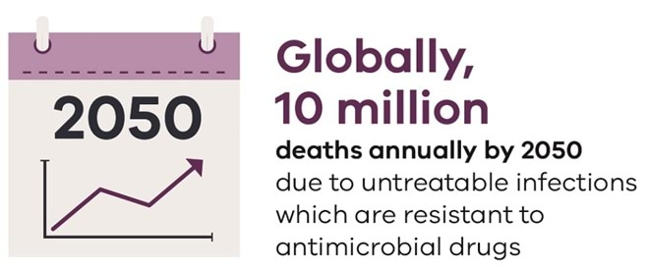

A growing problem
Antimicrobial resistance is not a new threat.
Germs (or microorganisms) have been developing resistance to antimicrobials since the first antibiotics were created in the early 1900s (O'Neill 2014).
However, we depend on antimicrobials to treat the bacterial, viral, fungal and parasitic infections that cause disease and death among millions of people around the world each year.
The rising number of infections which are resistant to antimicrobials is a serious threat to the health of humans worldwide. A United Kingdom review predicts that by 2050, there will be more than 10 million deaths every year around the world due to infections that are untreatable due to Antimicrobial resistance (O'Neill 2014).
There is a very real possibility we will return to a pre-antibiotic era, where even simple infections can prove fatal.
The threat of Antimicrobial resistance extends beyond the inability to treat patients who develop infections.
Many of the greatest advances in modern medicine rely on effective antibiotics to be safely undertaken.
In a world where antibiotics are no longer effective, we would also not be able to treat cancer, perform major operations and organ transplantations or save the lives of many premature infants (O'Neill 2014).

Causes of Antimicrobial resistance
The increase of Antimicrobial resistance is caused in part by overuse of antimicrobials among humans, animals and the environment (Department of Health/Department of Agriculture, Water and Environment, 2017).
In humans, over-prescribing of antimicrobials has provided an ideal opportunity for microorganisms, which naturally evolve over time, to develop resistance. In some cases, these microorganisms are completely resistant to all available treatment options (Department of Health/Department of Agriculture, Water and Environment, 2017).
This resistance is also partly due to the lack of new antimicrobials in production.
Investment in research and development of antimicrobials is limited because developing new antimicrobials is extremely complex, expensive, prone to failure, and has largely been left to profit-focused private industry (World Health Organization 2017).
And at the end of this complex process to develop a new, effective, inexpensive antimicrobial class of medicines, we would try to use it as little as possible. This is because these medicines may only be effective for a short period before resistance again emerges.
In Australia, as elsewhere, there is a clear consensus and urgent need to address AMR as one of public health’s highest priorities.

Tackling Antimicrobial resistance
In 2015, the Commonwealth Government's Department of Health and Department of Agriculture released Australia's first National antimicrobial resistance strategy. This outlines a joint approach to address antimicrobial resistance (Department of Health / Department of Agriculture 2015).
The strategy provides seven objectives:
- communication
- antimicrobial stewardship
- surveillance of Antimicrobial resistance and antibiotic usage
- infection prevention and control
- research and development
- international engagement and partnerships
- governance.
An implementation plan was released in 2016, and a report of achievements for the strategy’s first two years of implementation identified improvements across all seven objectives, but also that there is much more to be done at both the state/territory and national level (Department of Health / Department of Agriculture and Water Resources 2016).
In Victoria, the Department of Health and Human Services focuses on surveillance and responding to Antimicrobial resistance. We have developed guidelines for two highly resistant microorganisms that spread within and between healthcare facilities, along with standard operating procedures for notifiable diseases identified in community settings that have developed resistance:
The first carbapenemase-producing Enterobacterales guideline was developed for Victoria in 2015 and updated in 2018 following an outbreak of Klebsiella pneumoniae within a metropolitan healthcare facility (Department of Health and Human Services 2018).
The Department of Health and Human Services has also developed Antimicrobial resistance standard operating procedures for two of the notifiable conditions that have developed resistance in community settings worldwide, namely gonorrhoea and shigellosis.
The response to these Antimicrobial resistant cases requires communication and education and the need for further antimicrobial testing to ensure the risk of further transmission between people is controlled.
The department, in conjunction with the Department of Jobs, Precincts and Regions, the Environmental Protection Agency and OneHealth sector representatives is currently developing a Victorian strategy and action plan to address Antimicrobial resistance that will be released in 2020.

Find out more
Access the UN Interagency Coordination Group on Antimicrobial Resistance final report No time to wait: securing the future from drug resistant infections <https://www.who.int/publications/i/item/no-time-to-wait-securing-the-future-from-drug-resistant-infections> for more on the global response to AMR.

References
Department of Health/Department of Agriculture 2015, Responding to the threat of antimicrobial resistance: Australia's first national antimicrobial resistance strategy 2015–19, Commonwealth Government of Australia, Canberra.
Department of Health/Department of Agriculture and Water Resources 2016, Australia's first national antimicrobial resistance strategy 2015–19: implementation plan, Commonwealth Government of Australia, Canberra.
Department of Health and Human Services 2018, Victorian guideline on carbapenemase-producing Enterobacteriaceae: for health services, State Government of Victoria, Melbourne.
Department of Health/Department of Agriculture, Water and Environment 2017, Antimicrobial Resistance, Commonwealth Government of Australia, Canberra.
World Health Organization 2017, Global Framework for Development & Stewardship to Combat Antimicrobial Resistance, World Health Organization, Geneva.
O'Neill J 2014, Antimicrobial resistance: tackling a crisis for the health and wealth of nations, UK Government, London.

Buruli ulcer
Buruli ulcer (also known as Bairnsdale ulcer) is an infection of skin and soft tissue caused by the bacterium Mycobacterium ulcerans.
The toxin made by the bacteria attacks fat cells under the skin. This leads to localised redness and swelling or the formation of a nodule (lump) and then an ulcer.
Although Buruli ulcer is not fatal, the infection can often leave people with significant cosmetic deformity and sometimes functional damage to limbs.

Where Buruli ulcer occurs
In Australia, Buruli ulcer most commonly occurs in localised coastal areas of Victoria. In recent years, Victoria has been experiencing a record number of Buruli ulcer cases (Figure 1)
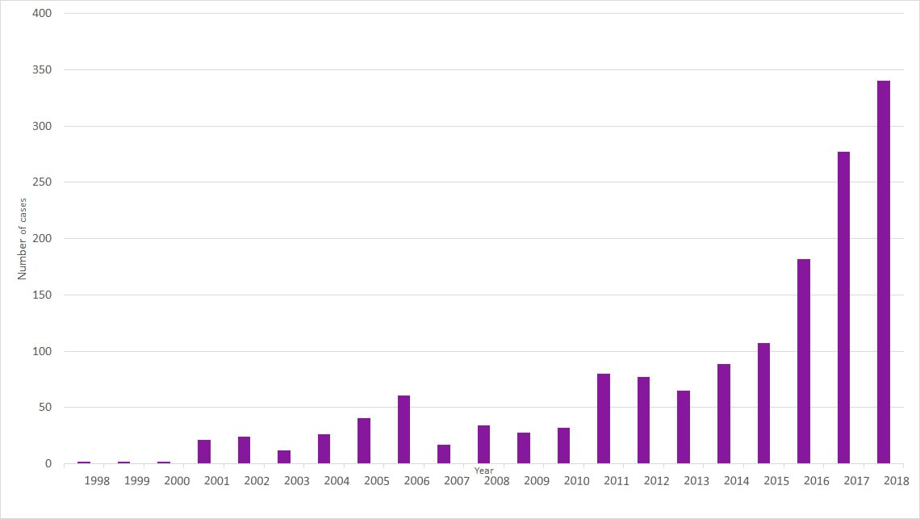
Figure 1: Number of Buruli ulcer cases in Victoria, 1998 to 2018
Note: Buruli ulcer (Mycobacterium ulcerans infection) became a notifiable condition in Victoria in 2004. Notifications prior to 2004 were voluntary. Data source: Public Health Events Surveillance System, Department of Health and Human Services
Buruli ulcer was first diagnosed in the Bairnsdale area of East Gippsland in the 1940s and later seen in Phillip Island (Johnson, Veitch, Leslie, Flood and Hayman 1996). Since then, a growing number of cases have been reported on the Bellarine Peninsula (Boyd et al. 2012).
Since 2012, there has been a significant increase in Buruli ulcer on the Mornington Peninsula and the south-eastern bayside suburbs of Melbourne, as shown in Figure 2 (Loftus et al. 2018).
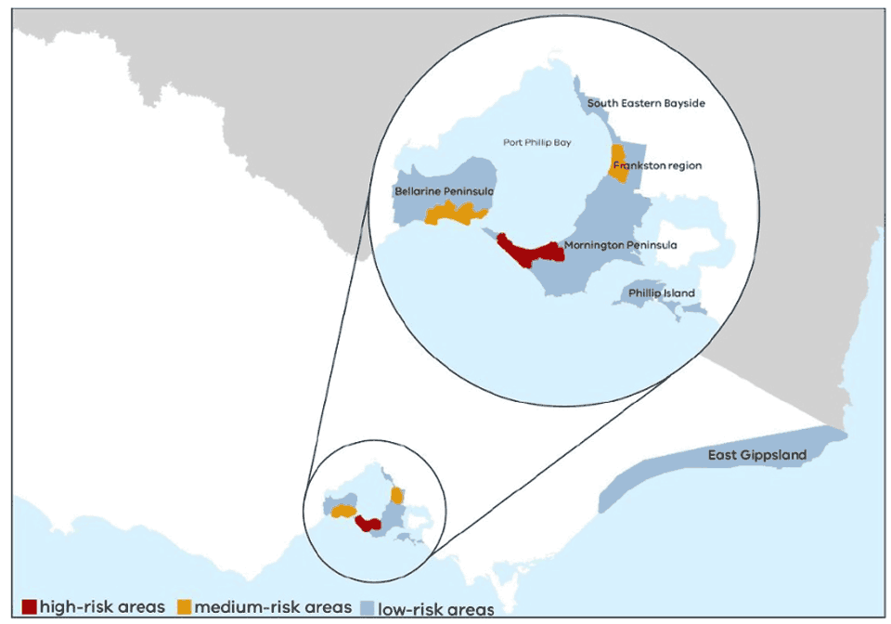
Figure 2: Map of areas affected by Buruli ulcer in Victoria

How Buruli ulcer is transmitted
How Buruli ulcer is transmitted is not fully understood.
In Victoria, possums may be an important reservoir of the disease (Fyfe et al. 2010; Carson, et al., 2014; O'Brien et al, 2014).
Mosquitoes may play a role in transmitting it to humans (Johnson, et al., 2007; Quek, et al., 2007; Lavender, et al., 2011; Wallace, et al., 2017).

Responding to Buruli ulcer
The department funded substantial research from 1997 to 2010 that has improved our understanding of how the disease is transmitted, and we now have a test that can rapidly diagnose Buruli ulcer.
In the past few years, the department has also promoted awareness among health practitioners, including developing a learning module for general practitioners.
The department has supported improvements to human and non-human surveillance with genetic sequencing of samples from human cases to better understand the spread of infections.
Ongoing sampling of possum excrement helps to provide insights into the environmental presence of the bacteria in particular regions.
Most recently in 2018, through a substantial National Health and Medical Research grant, the department is a partner in a large research project to investigate how the disease is transmitted and identify effective ways to prevent and reduce infections.

The Beating Buruli in Victoria project
The Beating Buruli in Victoria project was developed in partnership with the Doherty Institute of Infection and Immunity, Barwon Health, Austin Health, CSIRO, Agriculture Victoria, the University of Melbourne and Mornington Peninsula Shire.
The project is being conducted over two years from September 2018 in areas affected by Buruli ulcer in Victoria.
One major area of the project will focus on investigating a range of risk and protective factors associated with Buruli ulcer.
Another major area consists of a mosquito control study that will target specific areas along the Mornington Peninsula.
The findings from the research will inform future policies and programs to halt the rise in Buruli ulcer cases in Victoria.

References
Boyd S, Athan E, Friedman N, Huges A, Walton A, Callan P and O'Brien D 2012, ‘Epidemiology, clinical features and diagnosis of Mycobacterium ulcerans in an Australian population’, Medical Journal of Australia, vol. 196, no. 5.
Carson C, Lavender C, Handasyde K, O'Brien C, Hewitt N and Johnson P 2014, ‘Potential wildlife sentinels for monitoring the endemic spread of human Buruli ulcer in South-East Australia’, PLOS Neglected Tropical Diseases, vol. 8, no. 1, e2668.
Fyfe J, Lavender C, Handasyde K, Legione A, O'Brien C and Stinear T 2010, ‘A major role for mammals in the ecology of Mycobaceterium ulcerans’, PLOS Neglected Tropical Diseases, vol. 4, no. 8, e791.
Johnson P, Azuolas J, Lavender C, Wishart E, Stinear T and Hayman J 2007, ‘Mycobacterium ulcerans in mosquitoes captured during outbreak of Buruli ulcer, South-Eastern Australia’, Emerging Infectious Diseases, vol. 13, no. 11.
Johnson P, Veitch M, Leslie D, Flood P and Hayman J 1996, ‘The emergence of Mycobacterium ulcerans infection near Melbourne’, Medical Journal of Australia, vol. 164.
Lavender C, Fyfe J, Azuolas J, Brown K, Evans R and Ray L 2011, ‘Risk of Buruli ulcer and detection of Mycobacterium ulcerans in mosquitoes in South-Eastern Australia’, PLOS Neglected Tropical Diseases, vol. 5, no. 9, e1305.
Loftus M, Tay E, Globan M, Lavender C, Crouch S and Johnson P 2018, ‘Epidemiology of Buruli ulcer infections, Victoria, Australia, 2011–2016’, Emerging Infectious Diseases, vol. 24, no. 11.
O'Brien C, Handasyde K, Hibble J, Lavender C, Legione A and McCowan C 2014, ‘Clinical, mecrobiological and pathological findings of Mycobacerium ulcerans infection in three Australian Possum species’, PLOS Neglected Tropical Disease, vol. 8 no. 1, e2666.
Quek T, Athan E, Henry M, Pasco J, Redden-Hoare J and Hughes A 2007, ‘Risk factors for Mycobacterium ulcerans infection, South-Eastern Australia’, Emerging Infectious Diseases, vol. 13, no. 11.
Wallace J, Mangas K, Porter J, Marcsisin R, Pidot S and Howden B 2017, ‘Mycobacerium ulcerans low infectious dose and mechanical transmission support insect bites and puncturing injuries in the spread of Buruli ulcer’, PLOS Neglected Tropical Diseases, vol. 11, no. 4, e0005553.

Food
Food safety is a key part of public health. Food-borne illness can cause significant harm.
The Food Act 1984 provides the regulatory framework for the food industry to ensure that food sold in Victoria is safe, suitable and correctly labelled.
The department shares responsibility for developing and administering food regulation with the Commonwealth Government, the Victorian Department of Jobs, Precincts and Regions, its statutory authorities PrimeSafe and Dairy Food Safety Victoria, and local governments. Together, these bodies promote consistent regulatory requirements in a widely dispersed and varied food industry.
The department publishes an annual Food Act report <https://www.health.vic.gov.au/food-safety/food-safety-library>.
This report outlines key food safety activities undertaken by the department, including:
- the new food safety reporting process for local government
- training and professional development activities for food safety stakeholders
- an update of the Salmonella strategy
- enforcement activities undertaken by the department to help keep food safe for Victorians.
The topics in this section highlight three important areas:
- work undertaken regarding the food poisoning bacteria Salmonella,
- the new allergen reporting requirements for hospital emergency departments
- activities to address an emerging issue of food safety of fermented products.

Salmonella
Since 2010, notifications of human Salmonella infection have been steadily increasing in Australia and Victoria (Department of Health 2018). Salmonella infection is also known as salmonellosis.

About salmonellosis
Salmonellosis generally affects the intestinal tract. It causes diarrhea and abdominal pain with fever.
It can occasionally spread to the bloodstream and other body sites, causing severe illness.
Anyone can become sick from salmonellosis, but children 0 to five years, adults older than 65 and people with a compromised immune system are more likely to have severe illness and infection.

Preventing salmonellosis
Nationally coordinated activities at all levels of the food supply chain are underway to address the increase in notifications (Australia and New Zealand Ministerial Forum on Food Regulation 2018).
Alongside these national efforts, Victoria continues to undertake work to address the increase in cases and has developed the Salmonella reduction strategy: Victoria 2017–2020, to reduce human salmonellosis in this state.
The strategy aims to reduce the incidence of human salmonellosis in Victoria by implementing a series of initiatives, including:
- working with all Victorian food sectors to develop and implement Salmonella reduction interventions at all levels of the food supply chain
- development and implementation of food safety literacy programs for Victorian consumers, food retailers, processors and producers
- improving the consistent application of food safety regulatory actions in Victoria through greater consultation, training and implementation of independent audit processes
- using improved laboratory technologies, such as whole genomic sequencing <see Communicable disease> to identify outbreaks and clusters of illness sooner, facilitating more rapid response and reducing cases
- developing and implementing procedures and processes to communicate findings and lessons learned from investigations of incidents and outbreaks involving Salmonella
- integrating all available data on Salmonella from non-human sources with human salmonellosis data to better understand the epidemiology of salmonellosis in Victoria
- fostering research that will reduce or fill knowledge gaps to improve regulatory practice and reduce disease incidence.

Cross-government cooperation
The strategy was developed by the cross-departmental Salmonella Working Group, which includes representatives of the Department of Health and Human Services, the Department of Economic Development, Jobs, Transport and Resources (Agriculture and Food Industries Policy), PrimeSafe and Dairy Food Safety Victoria, and draws on the resources of the industry and scientific communities of Victoria.
In late 2017, the department established the Integrated Salmonella Surveillance Steering Committee, which includes representatives from the Department of Jobs, Precincts and Regions and the Microbiological Diagnostic Unit Public Health Laboratory.
The committee aims to develop an integrated surveillance system that will routinely use whole genomic sequencing between Salmonella bacteria isolated from humans, foods and animals in Victoria to investigate Salmonella infection.
The pilot project will improve our ability to identify sources of outbreaks and enhance our current understanding of Salmonella transmission across the food supply chain in Victoria.

Case study of a Salmonella outbreak
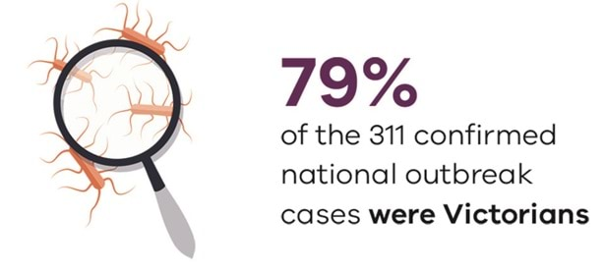
An increase in cases was first noted in Victoria, where a local investigation commenced on 8 January 2016 (Department of Health and Human Services 2016).
Other jurisdictions also noted increasing case numbers throughout January 2016.
On 8 February 2016, OzFoodNet, which undertakes surveillance of foodborne diseases across Australia, officially commenced a multi-jurisdictional outbreak investigation (Health Protection NSW 2017).
The source of this cluster was identified in early February, when routine company testing of bagged salads detected Salmonella in the product. Due to mandatory notification, the Victorian Department of Health and Human Services was alerted, and the pathogen was identified as Salmonella Anatum (Department of Health and Human Services 2016).
Multiple bagged salads were the subject of a national food recall on 4 February 2016.
During this outbreak, whole genome sequencing determined the relatedness of case isolates.
This was the first time whole genome sequencing had been used in Australia during a Salmonella outbreak (Department of Health and Human Services 2016; Health Protection NSW 2017).
It proved invaluable in being able to differentiate outbreak and non-outbreak cases, and also to compare the human samples with non-human samples from the implicated food source.
Of the 311 confirmed outbreak cases identified nationally, the majority (247, 79 per cent) were Victorian residents.
In order to provide additional supportive evidence for the hypothesis that bagged salads were the source of this outbreak, a further study was conducted in Victoria.
This analysis demonstrated links between the bagged salads and the Salmonella Anatum as the source of this outbreak (Department of Health and Human Services 2016).
The investigation was declared over on 11 May 2016 when case numbers had returned to background levels.

Find out more
The department has a Salmonella information <https://www.health.vic.gov.au/infectious-diseases/salmonellosis> page.
Whole genomic sequencing <https://www.health.vic.gov.au/infectious-diseases/salmonellosis>

References
Australia and New Zealand Ministerial Forum on Food Regulation 2018, Australia's foodborne illness reduction strategy 2018–2021+, Australia and New Zealand Ministerial Forum on Food Regulation, Canberra.
Department of Health 2018, National notifiable diseases surveillance system, Commonwealth Government, Canberra.
Department of Health and Human Services 2016, Product recall notice: Salmonella outbreak associated with some types of salad leaf products, State Government of Victoria, Melbourne.
Health Protection NSW 2017, NSW OzFoodNet Annual Surveillance Report: 2016. Health Protection NSW, Sydney.

Food anaphylaxis notifications
From 1 November 2018, all anaphylaxis presentations to hospital emergency departments in Victoria must be notified to the Department of Health and Human Services.
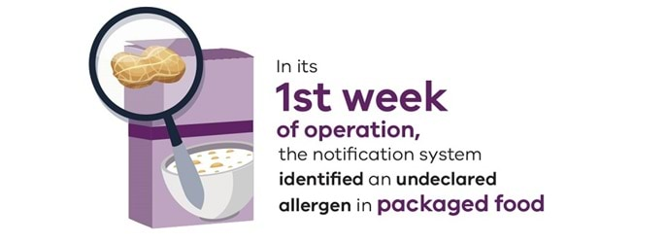
This is in response to a recommendation in a Victorian coronial report on the death of a child from anaphylaxis.
The cause of anaphylaxis in this case was a food product that did not declare the presence of dairy products, despite being required to under food labelling legislation.
Food authorities were not alerted to the product, and it remained on the market for a further six weeks.
The Public Health and Wellbeing Act 2008 and associated regulations were amended to require these notifications of anaphylaxis presentations (all causes) to hospital emergency departments.
Approximately 60 per cent of these presentations are food related.
In its first week of operation, the notification system identified an undeclared allergen in packaged food.
The department's Food Safety Unit was able to conduct a food recall, promptly removing this product from the market and reducing the risk to community members with allergies.
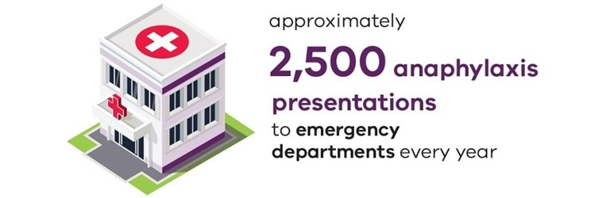
With approximately 2,500 presentations of anaphylaxis to emergency departments every year (and increasing at 15 per cent per year), the system is expected to assist in reducing the risk of undeclared allergens in food in the marketplace.
It will also provide a rich source of data to support future activities to address the growing public health issue of allergies.

Find out more
For more information about allergies in children, visit the Child health page.
Find out more about the department's anaphylaxis notification system <https://www.health.vic.gov.au/public-health/anaphylaxis-notifications>.
Real-time data is available publicly through the departments' interactive infectious disease surveillance reporting system <https://www.health.vic.gov.au/infectious-diseases/interactive-infectious-disease-reports>.

Food fermentation products
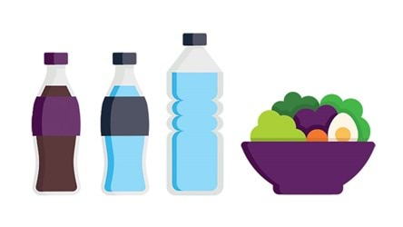
One of the department's responsibilities under the Food Act 1984 is to ensure that food and drinks sold in Victoria are safe, suitable and correctly labelled.
In late 2016, the Department of Health and Human Services identified a risk associated with the emerging trend for fermented soft drinks such as kombucha and fermented foods such as kimchi and sauerkraut.
The department found that some of these products could contain excessive amounts of alcohol, over and above the amount declared on their labels.

Analysing the problem
A small testing program analysed the alcohol content of fermented soft drinks manufactured in Victoria. The testing revealed:
- all the samples were labelled stating that they contained 0.5 per cent alcohol by volume or less
- 48 per cent contained undeclared alcohol in excess of 0.5 per cent alcohol by volume
- 34 per cent contained between 0.5 per cent and 1.15 per cent alcohol by volume, still meeting the definition of a brewed soft drink under the Australia New Zealand Food Standards Code (the Code) but labelled incorrectly
- 14 per cent contained greater than 1.15 per cent alcohol by volume, not meeting the definition of a brewed soft drink in the Code, nor complying with labelling requirements for beverages containing alcohol
- the alcohol strength of drinks sampled from retail were significantly higher than those sampled from manufacturers, suggesting shelf-life determination and alcohol testing were inadequate.
These findings showed that there were inadequate control points in the manufacturing process and supply chain used by some manufacturers to control the production of alcohol in their products.
In consultation with small- and medium-sized Victorian food businesses, we developed further information to complement food safety programs.
This additional information identifies the potential alcohol content risks with fermented food products and sets out food labelling requirements for alcohol content in brewed soft drinks.
These changes help Victorians consume fermented food products safely.
Following Victoria's lead, a national survey is now underway in the other states and territories to identify potential alcohol content risks for fermented food products.

References
Department of Health and Human Services 2019, The Food Act report 2017: Prioritising food safety and strengthening regulation, State Government of Victoria, Melbourne.

Water
Safe drinking water and recreational water are vital for public health.
This section looks at safe drinking water, water fluoridation and the issue of preventing and controlling potential public health impacts from microorganisms that can cause human illness in aquatic facilities (swimming pools).
This section draws on the Annual report on drinking water quality in Victoria 2017-18 <https://www.health.vic.gov.au/water/drinking-water-quality-annual-reports>

Safe drinking water
Access to safe, good quality drinking water is fundamental to community and individual health and wellbeing.
Approximately 95 per cent of Victorians continue to receive the benefits of safe, good-quality drinking water (Department of Health and Human Services 2019).
Highlights reported in the Annual report on drinking water quality in Victoria 2017–18 include
- performance against Victoria's safe drinking water regulatory framework remains strong
- water fluoridation has been introduced to Cobram, Strathmerton and Yarroweyah
- the Better Regulatory Practice Framework is increasing regulator efficiency and effectiveness, and bringing a systemic, risk-based approach to regulatory activities.

Managing risks
Managing risks to drinking water is a continuous, complex process. Challenges to safeguarding drinking water quality include:
- threats to source water protection from climate change
- recreational pressures and land use intensification
- managing the issue of lead in some plumbing products.
In some parts of Victoria, algal bloom events (see Climate change and public health in Victoria) are becoming more frequent and/or more intense – often linked to periods of reduced rainfall and warmer weather.
With climate change, the risk of algal bloom events increases and poses significant challenges to drinking water quality.
A concerted proactive catchment-to-tap risk management approach is required to ensure the ongoing provision of safe drinking water, now and for future generations.
Access the Climate change and public health in Victoria section of the Chief Health Officers report for more about climate change and its impacts on health.

Find out more
To find out more about drinking water in Victoria <https://www.health.vic.gov.au/water/drinking-water-in-victoria>.

Reference
Department of Health and Human Services 2019, Annual report on drinking water quality in Victoria 2017–18: Delivering quality drinking water to Victorians, State Government of Victoria, Melbourne.

Water fluoridation
The introduction of water fluoridation has been described as one of the top 10 public health achievements of the 20th century for its role in helping prevent dental decay (Centers for Disease Control and Prevention 1999).
Ninety per cent of Victorians now receive the benefits of drinking water that is optimally fluoridated.
In August 2017, the communities of Cobram, Strathmerton and Yarroweyah received fluoridated drinking water for the first time.
Ten per cent of Victorians, however, do not have access to water fluoridation, with almost all of these from rural and regional areas of the state.

Benefits for oral health
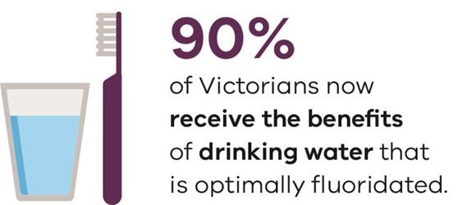
This difference between access to fluoridated and non-fluoridated drinking water leads to differences in oral health outcomes.
This is especially so for young children in non-fluoridated communities, who experience higher rates of hospital admission for the treatment of dental decay.
In 2017–18, the standardised admission rate per 1,000 children aged 0 to 9 years in rural areas (which includes children from both fluoridated and non-fluoridated communities) was higher than that for children in metropolitan fluoridated communities, as shown in the following Figure 2 below.
Notably, the gap in admission rates has reduced as more rural areas have had access to fluoridated water.
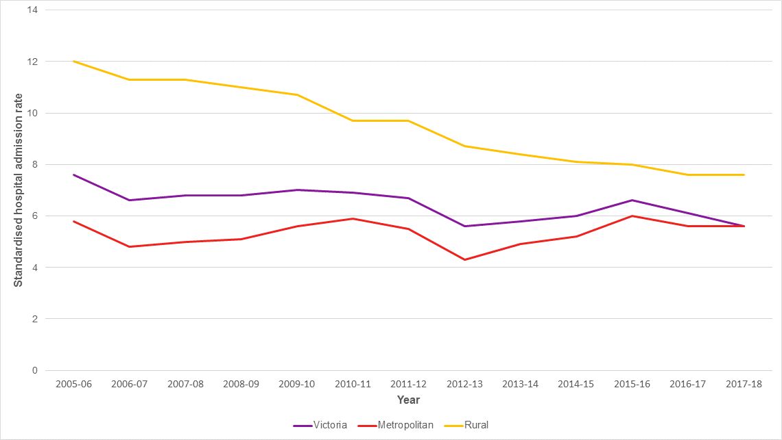
Figure 2: Standardised hospital admission rate trend for treatment of dental decay in Victorian children 0–9 years of age in rural and metropolitan communities and for Victoria
Source: Victorian Health Information Surveillance System (VHISS)
Dental conditions are the highest cause of all potentially preventable hospitalisations for Victorians under 10 years of age, and the third highest for all Victorians (Department of Health and Human Services 2019).
The predominant cause of these potentially preventable dental hospitalisations in children is dental decay.
The benefits of water fluoridation can be seen in Figure 2, where the extension of water fluoridation to a number of rural and regional communities in 2006–09 led to a steady decline in the number of rural children requiring hospital admission for the treatment of dental decay.
Access the Oral health page of the Chief Health Officer's report for more on oral health.

Find out more
To find out more about water fluoridation in Victoria, please see the Water fluoridation page.

References
Centers for Disease Control and Prevention 1999, Achievements in public health, 1990-1999: fluoridation of drinking water to prevent dental caries, Centers for Disease Control and Prevention, Atlanta, Georgia.
Department of Health and Human Services 2018, Victorian Health Information Surveillance System data on preventable hospitalisations for Victorians, State Government of Victoria, Melbourne.

Aquatic facilities
Victoria's public aquatic facilities (swimming pools) are regulated to prevent and control potential public health impacts from microorganisms that can cause human illness.
Aquatic facilities have the potential to amplify illnesses, with the risk of illness being transmitted increased if pool water is not properly treated or if the aquatic facility is not well managed.
Cryptosporidium is responsible for most outbreaks of illness associated with aquatic facilities.
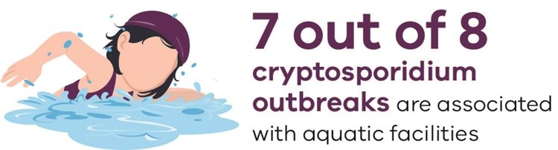
In 2017–18 there were eight outbreaks caused by Cryptosporidium in Victoria. Seven of those were associated with aquatic facilities (Department of Health and Human Services 2018).
Cryptosporidiosis is especially debilitating for people with compromised immunity – such as young children, the elderly and people on immunosuppressive medications.
With population growth and more people using aquatic facilities, the risk of developing cryptosporidiosis increases.

Reviewing the Regulations
While the Regulations manage public health risks from microorganisms such as bacteria and viruses, they are not designed to address public health risks from microorganisms such as Cryptosporidium.
As part of a current review of regulations, the department is reviewing aquatic facility requirements and providing clarity on the roles and responsibilities of aquatic facilities and local government.
The department is also supporting aquatic facilities in the safe maintenance of facilities. The department has published Water quality guidelines for public aquatic facilities – managing public health risks <https://www.health.vic.gov.au/water/water-quality-guidelines-for-public-aquatic-facilities>.
The department continues to promote the Healthy Swimming initiative to educate the public on healthy swimming behaviours to maintain pool water quality.
Further work is required to address issues relating to the growing demand for access to aquatic facilities through population growth and policies such as the inclusion of pool safety in the Victorian school curriculum.
This requires planning and design to support safe access and address emerging water quality issues related to population growth and climate change.

Find out more
The department has a cryptosporidium in pools page <https://www.health.vic.gov.au/water/cryptosporidium> for information about cryptosporidium and its public health management.

References
Department of Health and Human Services 2018, Communicable disease epidemiology and surveillance cryptosporidium data, State Government of Victoria, Melbourne.

Environmental Health
Environmental health helps prevent disease and create health-supportive environments.
It includes the aspects of human health that are determined by physical, chemical, biological and social factors in the environment. Environmental health works to assess and control these factors.
This section of the Chief Health Officer report looks at the issue of climate change, which the World Health Organization has described as the defining health issue of the 21st century.
Other key issues include air quality – both ambient (outdoor) and the emerging issue of indoor air quality – as well as heat health, which is an important issue related to climate change.
It also discusses the significant thunderstorm asthma event of late 2016.
This section draws on several climate change reports, including: Health and climate change: policy responses to protect public health <https://www.thelancet.com/journals/lancet/article/PIIS0140-6736(15)60854-6/fulltext>, published by the Lancet Commission on Health and Climate Change in 2015, and Climate-ready Victoria, published by the Department of Environment, Land, Water and Planning in 2015.
It also draws on:
- a 2016 speech from the Director General of the World Health Organization, Climate change is the defining issue for public health in the 21st century <https://www.who.int/director-general/speeches/detail/who-director-general-addresses-event-on-climate-change-and-health>.
- Air pollution in Victoria – a summary of the state of knowledge <https://www.epa.vic.gov.au/about-epa/publications/1709>, published by the Environment Protection Authority Victoria (EPA)
- Air monitoring report 2018, also published by the EPA
- Thunderstorm asthma <https://www.health.vic.gov.au/chief-health-officer/thunderstorm-asthma>
- Heat health resources <https://www.health.vic.gov.au/environmental-health/extreme-heat-and-heatwaves>.

Air quality
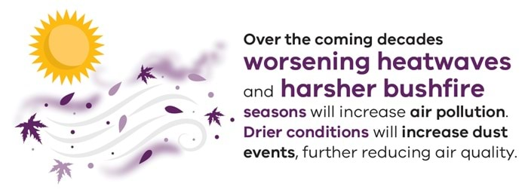
Victoria's air quality is generally good, but sometimes air pollution occurs at concentrations that affects the environment and human health.

Effects of air pollution on health
Air pollution can cause symptoms immediately upon exposure, such as coughing, watering eyes, difficulty breathing and angina.
It may also cause long-term harm that is more subtle. You might not realise how long-term exposure affects your health, or worsens medical conditions over time (Environment Protection Authority 2018).

Causes of poor air quality
A range of natural and human sources of air pollution affect air quality.
Primary air pollutants are directly emitted through mechanical or combustion processes.
They are measured in microns according to the size of the particles.
Examples include:
- PM10 (10 microns) in wind-blown dust from unpaved roads
- PM2.5 (2.5 microns) in smoke from bushfires, and sulfur dioxide from burning coal or diesel fuel.
Secondary air pollutants are formed from chemical reactions in the atmosphere.
Ozone, for example, is formed in sunlight from the reaction of volatile organic compounds with nitrous oxides.

Air monitoring in Victoria
Highlights from Air pollution in Victoria – a summary of the state of knowledge August 2018 <https://www.epa.vic.gov.au/about-epa/publications/1709> (Environment Protection Authority Victoria 2018) include:
PM10 fine particles
- The higher trend in PM10 fine particles in Melbourne (2003 to 2009) occurred during a period of drought and bushfires. Since then, the number of exceedance days has decreased, excluding Brooklyn which is influenced by localised sources of dust.
- In 2017, the PM10 fine particle 24-hour standard was exceeded in Melbourne for five days - two of those days were attributed to dust and three were due to fires.
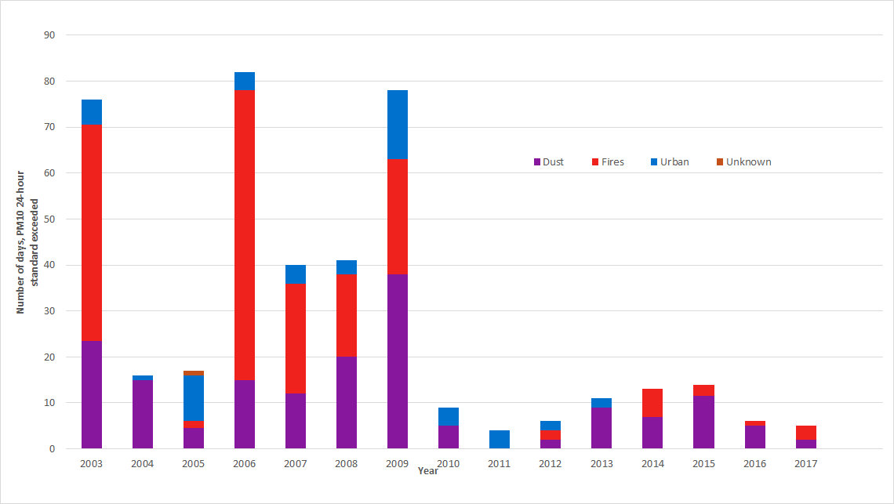
Figure 1. Number of exceedance days for PM10 standard- average for Port Phillip region

PM2.5 fine particles
- Compared with earlier years, and since 2014, the number of days exceeding the PM2.5 fine particle 24-hour standard in Melbourne has increased. This is partly due to changes in monitoring technology, with data available every day instead of once every three days.
- In 2017, the PM2.5 fine particle 24-hour standard was exceeded for 19 days - 6.5 of those days were attributed to land burns and 12.5 were due to urban sources (domestic wood heaters).
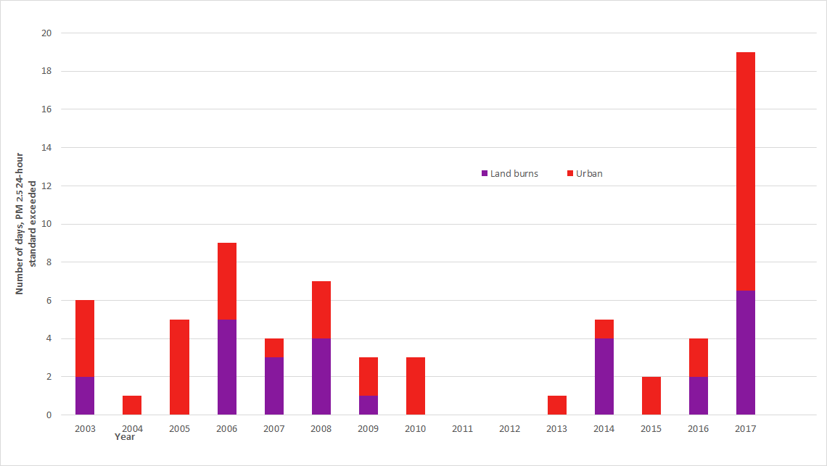
Figure 2. Number of exceedance days for PM 2.5 standard – average for Port Phillip region

Ozone (ground-level)
- High ozone concentrations are most likely to occur on days over 30°C with light winds and in the presence of precursor pollutants to react in the atmosphere.
- Long-term trends (1979 to 2018) show the peak one-hour ozone concentration at a Melbourne station for each year has decreased.
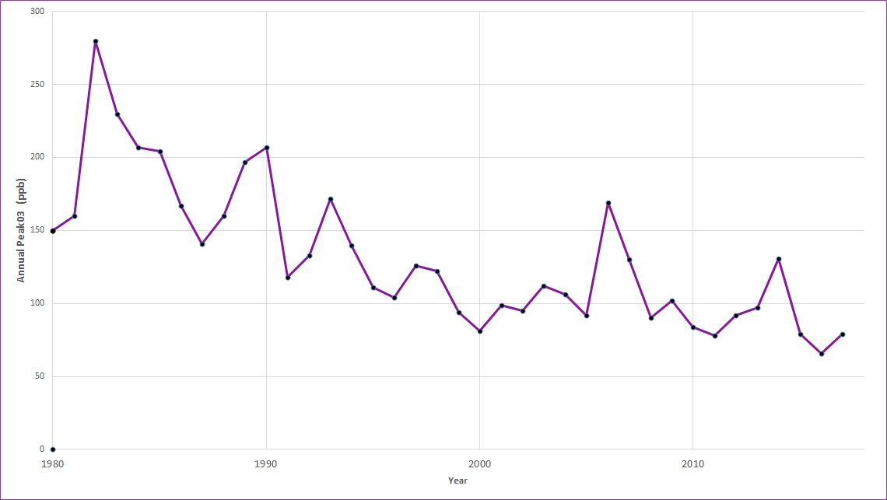
Figure 3. Peak maximum one-hour ozone concentrations for Port Phillip
- The annual average concentration of ozone is increasing.
- Predictions for hotter, drier conditions increase the risk of higher ozone concentrations in the future.
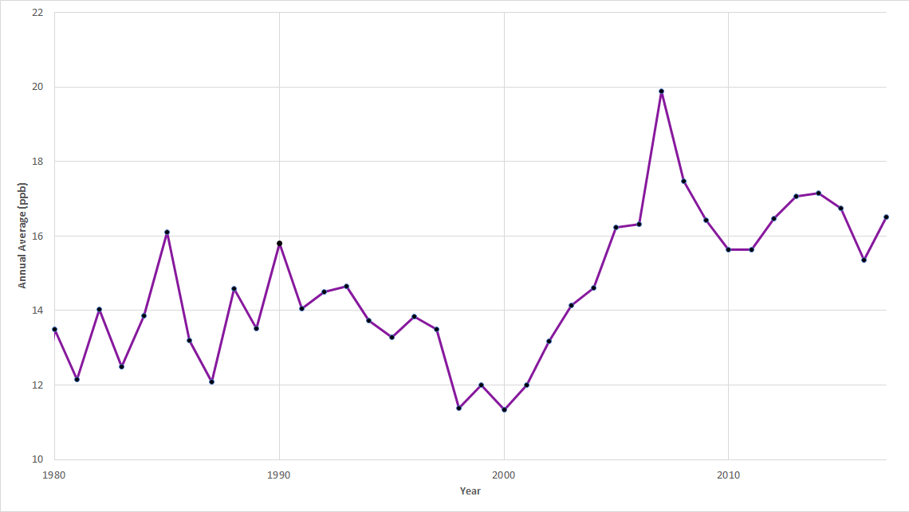
Figure 4. Long-term trend: annual average ozone concentrations for Port Phillip region

Future outlook for air quality in Victoria
While Victoria's air quality is good by international standards, and has improved significantly over recent decades, there remain challenges ahead.
Projected large population growth in Melbourne and regional centres comes with an associated increase in registered vehicles, infrastructure and industries. These all affect sources of air pollution and the population’s exposure to air pollution (Environment Protection Authority Victoria 2018).
In addition to overall population size, there will be potential changes to the proportion of groups more sensitive to air pollution. This includes people over 65 years, people with heart or lung conditions, and children under 14 years of age (Environment Protection Authority Victoria 2018).
Climate change is also predicted to affect future air quality by altering the meteorological variables that influence the development, chemical transformation, dispersion and deposition of air pollutants (Environment Protection Authority Victoria 2018).
Over the coming decades Victorians are likely to experience:
- worsening heatwaves and more frequent single days of extreme heat
- longer and harsher bushfire seasons
- increased periods of drought or drier conditions (Watts 2015).
These are all related to the changing climate, and all impact on the type and scale of exposure to air pollution (Environment Protection Authority Victoria 2018).
Extended dry conditions may also cause large-scale dust events, further reducing air quality (Environment Protection Authority Victoria 2018).

Find out more
The Environment Protection Authority’s air quality in Victoria page <https://www.epa.vic.gov.au/>

References
Environment Protection Authority Victoria 2018, Air pollution in Victoria: a summary of the state of knowledge August 2018, Environment Protection Authority Victoria, Melbourne.
Watts N, Adger W, Agnolucci P, Blackstock J, Byass P, Cai W … Costello A 2015, ‘Health and climate change: policy responses to protect public health’, The Lancet, vol. 386, no. 7.

Healthy indoor environments
'Home' means refuge and security, a place to which we turn to replenish our energies (Ryd 1991).
Having good-quality indoor environments in our homes is important for our health.

Housing a growing population
By 2051, Victoria's population is projected to double to 10.1 million people (over 40 years).
This increase in population size is estimated to be due to natural population increase of 1.8 million people and net migration of 2.8 million people (Department of Environment, Land, Water and Planning 2016).
The quality of housing has major implications for people’s health. Population growth increases the demand for housing.
Therefore, improving housing conditions and reducing health risks in the home is essential for protecting public health and maintaining wellbeing (World Health Organization, 2018).
And of course, housing affordability and accessibility are central to supporting wellbeing.

Guidelines on housing and health
The World Health Organization's Housing and health guidelines (2018) strongly recommend that countries consider strategies for preventing or reducing household crowding, accessibility for people with functional impairments, home safety and injuries.
The guidelines also recommend safe and well-balanced indoor temperatures to protect people in climate zones with a cold season.
The guidelines also recommend that where populations are exposed to high ambient temperatures, there are strategies to protect people from excess indoor heat.

Time spent indoors
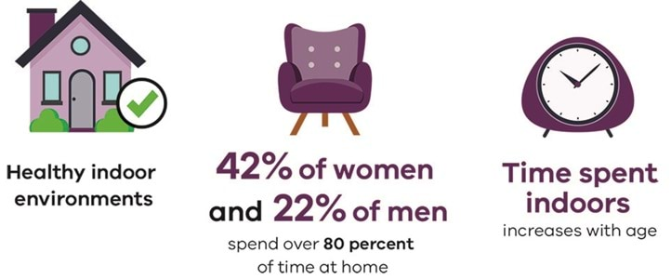
Research shows that
- Australians spend 80 to 100 per cent of their time indoors (at work and at home)
- 42 per cent of women and 22 per cent of men spend more than 80 per cent of their time at home
- time spent indoors increases with age (enHealth, 2012).

Indoor air quality
Air is a mixture of gases and small particles.
Indoor air can contain synthetic and naturally occurring substances – pollutants or allergens – that may affect health.
Whether a source of indoor air pollution is a problem or not for health and wellbeing depends on:
- the type of air pollutant (or allergen)
- the amount and rate at which it is released from its source
- the degree of available ventilation to remove it from indoors (Department of Environment and Energy, 2012).
- Common sources of indoor air pollutants include various human indoor activities, household products, environmental conditions – building construction materials, ventilation, and heating and cooling systems – and external factors (from outdoors).
Indoor air pollutant levels:
- can sometimes be higher than levels found outdoors
- if high enough, can affect people’s health, and in some cases safety
- in the workplace, are managed through workplace health and safety legislation for workers and visitors to a workplace
- from household appliances are generally regulated by manufacturing design, compliance with instructions for use including maintenance and consumer legislation
- from use of consumer products are minimised by following safe use instructions on the product label
- due to personal hobbies or behaviours, including the potential misuse of materials or products can also affect indoor air quality and expose inhabitants to health hazards. This can be prevented or minimised with community information and guidance.

Vulnerability to air pollutants
Some people in the community are more vulnerable to air pollutants.
This includes the very young, older people, those with pre-existing respiratory or cardiovascular disease and those who are sensitised to a substance (allergen).
Symptoms associated with poor indoor air quality can range from acute to chronic, and from mild or generally non-specific effects (eye, nose and throat irritation, and headaches and dizziness) to more severe (asthma, allergic responses).
Exposure to some indoor air pollutants can increase the risk of developing cancer.
Victoria differs from other states and territories in that the use of unflued gas heating is limited and even prevented in vulnerable-use settings including childcare centres, schools, universities, community health centres, residential care services and hospitals.
This has been in place since 2008, as this type of heating releases water vapour, nitrogen dioxide and other air pollutants which can exacerbate respiratory conditions, including asthma (Victorian Government 2018).

Indoor air quality in Victoria
A CSIRO and Bureau of Meteorology study of indoor air pollutants in 40 typical homes in Melbourne (in temperate urban areas) in 2008 and 2009 found concentrations of indoor air pollutants lower or comparable to concentrations found in previous Australian studies (Commonwealth of Australia 2011; Cheng et al. 2011).
Weekly average concentrations of carbon dioxide, carbon monoxide, nitrogen dioxide, formaldehyde, other carbonyls, BTEX (benzene, toluene, ethylbenzene and xylene) and total volatile organic compounds were higher indoors than outdoors, whereas PM10 fine particles, ozone and fungi concentrations were higher outdoors.
In dwellings using gas appliances for cooking, levels of carbon dioxide, carbon monoxide, nitrogen dioxide, PM2.5, formaldehyde, benzene and total volatile organic compounds were higher than in households that solely used electric cooking appliances.
In addition, the effect of proximity to major roads on indoor air quality accounted for around 20 per cent of indoor nitrogen dioxide in these situations.
Only a general comparison of indoor and outdoor air pollutant concentrations occurs, since Australia does not have indoor air quality guideline values.

References
Cheng M, Galbally I, Gillett R, Keywood M, Lawson S, Molloy S and Powell J 2011, Indoor air project: part 1 main report: indoor air in typical Australian dwellings, Commonwealth Government of Australia, Department of the Environment, Water, Heritage and the Arts, Canberra.
Commonwealth Government of Australia 2011, Indoor air quality: Australian state of the environment report, Commonwealth Government of Australia, Canberra.
Department of Environment and Energy 2012, Your home: Australia's guide to environmentally sustainable homes, Commonwealth Government of Australia, Canberra.
Department of Environment, Land, Water and Planning 2016, Victoria in future 2016: population and household projections to 2051, State Government of Victoria, Melbourne.
enHealth 2012, Australian exposure factor guidance: guidelines for assessing human health risks from environmental hazards, Commonwealth Government of Australia, Canberra.
Ryd H 1991, 'My home is my castle: psychological perspectives on "sick buildings"', Building and Environment, vol. 26, no. 2.
State Government of Victoria 2018, Gas Safety (Gas Installation) Regulations, State Government of Victoria, Melbourne.
World Health Organization 2018, Housing and health guidelines, World Health Organization, Geneva.

Thunderstorm asthma
Epidemic thunderstorm asthma is thought to be triggered by an uncommon combination of high pollen levels and a certain type of thunderstorm, causing a large number of people to develop asthma symptoms over a short period of time.

2016 thunderstorm asthma event
This phenomenon occurred in Victoria on the evening of Monday 21 November 2016 and led to thousands of people developing breathing difficulties in a very short period of time.
While other events have been recorded in Melbourne and in other parts of the world, the November 2016 event was unprecedented in size, severity and impact, and was the largest incident of its type ever recorded in the world.
In the 30 hours from 6 pm on 21 November, there was a 672 per cent increase in respiratory-related presentations to Melbourne and Geelong public hospitals (3,365 more presentations than expected based on the three-year average).
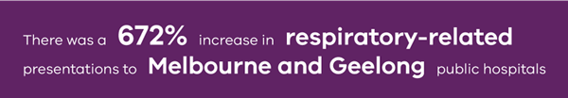
Tragically, the event also led to 10 deaths, which have been investigated by the State Coroner.
The response to the November 2016 epidemic thunderstorm asthma event was reviewed by the Inspector-General for Emergency Management (IGEM) <https://www.igem.vic.gov.au/publications/igem-reports/review-of-response-to-the-thunderstorm-asthma-event-of-21-22-november-0>
IGEM has also monitored the progress of the implementation of the recommendations from the review <https://www.igem.vic.gov.au/publications/publications/implementation-of-recommendations-from-the-review-of-response-to-the>

Thunderstorm Asthma Program
Since the November 2016 event, the department has worked closely with a wide range of stakeholders to develop and implement a comprehensive Thunderstorm Asthma Program to minimise the impact that any future epidemic thunderstorm asthma events may have on the community and the Victorian health system.
As part of the Program, the department has:
- implemented a public health campaign <https://www.betterhealth.vic.gov.au/thunderstorm-asthma> and education programs for the Victorian community and health professionals <https://www.nationalasthma.org.au/health-professionals>
- updated its public communications and warnings including integration with Victoria's warning system <https://www.emv.vic.gov.au/responsibilities/victorias-warning-system>
- developed expert clinical guidelines <https://www.nationalasthma.org.au/living-with-asthma/resources/health-professionals/information-paper/thunderstorm-asthma> to identify and manage those at increased risk
- revised the State Health Emergency Response Plan <https://www.health.vic.gov.au/emergencies/state-health-emergency-response-arrangements> and improved how we plan, communicate and work with our health services and emergency management sector partners during emergencies
- hosted an epidemic thunderstorm asthma symposium with experts from across Australia
- published an extensive epidemic thunderstorm asthma literature review, and published a detailed assessment of the known environmental conditions and the health impacts of the event
- implemented a Real-time Health Emergency Monitoring System to alert the department to significant demands on public hospital emergency departments and ensure early responses to actual or potential health emergencies
- built and implemented the first Victorian epidemic thunderstorm asthma forecasting system <https://www.health.vic.gov.au/environmental-health/epidemic-thunderstorm-asthma-risk-forecast>.

Reference
Department of Health and Human Services 2017, Response to the November 2016 thunderstorm asthma event <https://www.health.vic.gov.au/publications/the-november-2016-victorian-epidemic-thunderstorm-asthma-event-an-assessment-of-the>.

Climate change and public health in Victoria
Climate change is the defining health issue of the 21st century (World Health Organization 2016).
It has significant human, environmental and economic impacts (World Health Organization 2003).

What is climate change?
Climate change is change in the world’s weather systems that occurs over decades. Recent changes in our climate are mostly caused by human activity (Department of Environment, Land, Water and Planning 2015).
Carbon dioxide and other greenhouse gases – such as methane and nitrous oxide – are generated by fossil fuel use and human agricultural practices (Watts et al. 2015).
These greenhouse gases drive heating of the atmosphere, land surface and ocean (Watts et al. 2015).
The impacts of this heating will vary across the globe but are already being seen in Australia and Victoria (Department of Environment, Land, Water and Planning 2015).
Future projections show that climate change poses an unacceptably high and potentially catastrophic risk to human health (Watts et al. 2015).

How climate change affects health
Climate change affects health directly due to more intense and frequent extreme events including heatwaves, floods, drought and bushfires (Watts et al. 2015).
It also affects health indirectly in multiple ways, such as through deteriorating air quality, changes in the spread of infectious diseases, risks to food safety and drinking and recreational water quality, and mental ill health (Watts et al. 2015).
Climate change will very likely negatively affect certain parts of the economy with increased unemployment, financial stress, food insecurity and rising social inequalities (Garnaut 2008).
Climate change will disproportionality affect the elderly, young children, pregnant women, people with a chronic disease, mental illness or disability, and people from culturally and linguistically diverse backgrounds and from low-income households (Watts et al. 2015).
The ability of infrastructure, such as hospitals, to deliver health services to the community will be increasingly affected by climate change through more frequent and extreme weather events, such as heatwaves, bushfires, floods, soil movement and sea level rise (Victorian Health and Human Services Building Authority 2018).
Public housing, housing in general, and many features of the urban environment will very likely be affected by extreme weather events (Victorian Health and Human Services Building Authority 2018).
The likely distribution of extreme heat experienced by residents in Melbourne will disproportionately affect low-income households because of poorer housing quality and reduced natural shade (Victorian Council of Social Services 2013).
While climate change itself presents a fundamental threat to health, many of the actions we can take as individuals and organisations to reduce greenhouse gas emissions can bring health benefits.
For example, increasing use of 'active transport' (such as walking and cycling) can not only reduce greenhouse gas emissions, but also help to reduce rates of obesity, diabetes, heart disease, some cancers, and musculoskeletal conditions (Department of Health and Human Services 2015).
Eating a healthy sustainable diet rich in plant-based foods, including fruits, vegetables, nuts, seeds and whole grains, and with fewer animal-based and processed foods also has improved health and environmental benefits (United Nations Food and Agriculture Organization 2006).

Climate change in Victoria
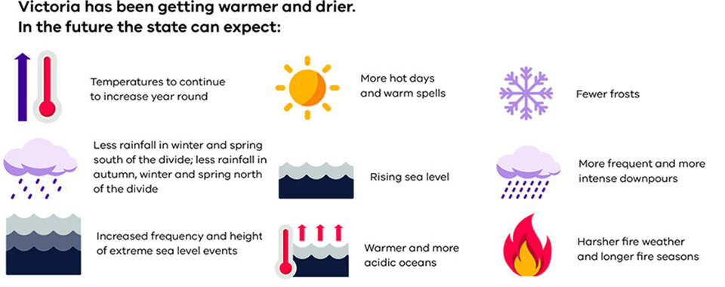
Victoria has already become warmer and drier – and these trends are likely to continue for some time into the future (Department of Environment, Land, Water and Planning 2015).
Climate-ready Victoria (PDF) summarises these changes.
These Victorian climate trends will have severe impacts (Department of Health and Human Services, 2014).
For example, temperature increases lead to more frequent heatwaves, which in turn can cause heat stress, heat stroke and even death of vulnerable individuals (Department of Health and Human Services, 2014).
Increased temperatures can also result in increased risk of bushfires, with loss of life, habitat and negative impacts upon air quality (Department of Environment, Land, Water and Planning 2015; Environment Protection Authority Victoria 2018).
More frequent and more intense downpours can cause flooding, with increased risk of water-borne and vector-borne disease, infrastructure damage and loss of homes and businesses (Department of Environment, Land, Water and Planning 2015).
Less rainfall across seasons, both north and south of the Great Dividing Range, can cause drought across the state, especially in regional communities (Department of Environment, Land, Water and Planning 2015).
Drought impacts farming and food production, and increases risks to water supplies, such as through production of toxins by blooms of blue-green algae.
All of these impacts can pose serious risks to the mental and physical health of individuals and challenge the resilience of communities (Watts et al. 2015).
Victoria has already experienced significant health impacts from extremes in climate.
For example:
- the 2009 Victorian heatwave resulted in 374 excess estimated deaths and a 12 per cent increase in public hospital emergency department presentations (compared with the 5-year average) (Department of Health and Human Services 2009).
- the 2014 Victorian heat waves resulted in 167 excess estimated deaths, and resulted in a five-fold increase in heat-related public hospital emergency department presentations compared to what was expected (Department of Health and Human Services 2014)
- following the 2016–17 Victorian floods, there was a large increase in mosquitos, which resulted in a 10-fold increase in the mosquito-borne disease known as Ross River virus infection (discussed below).

Ross River virus outbreak 2016–17
In September 2016, above-average rainfall led to widespread flooding across large parts of Victoria, particularly in the north-east and north-west of the state (Lynch 2017).
Above-average rainfall was also recorded the following month in October 2016, causing the flooding to persist or reoccur in some areas (Lynch 2017).
Persistent standing water, coupled with warmer weather in the ensuing months, led to ideal mosquito breeding conditions in large parts of the state.
On-field reports from selected local government areas indicated that mosquito abundance was high (Lynch 2017).
The Department of Health and Human Services implemented an enhanced public health action plan to mitigate and manage the anticipated Ross River Virus outbreak.
This included disease surveillance and control measures, advisories for health professionals and a public messaging campaign ‘Beat the Bite’ to inform the public about the risks of mosquito-borne diseases, and to provide health advice relating to personal protective measures to avoid mosquito bites (Department of Health and Human Services 2017a and 2017b).
Despite implementing an extensive public health action plan in response to the flooding event, Victoria experienced the largest Ross River virus outbreak since 1993.
Between October 2016 and April 2017, extensive activity was documented, including 1,974 human cases (Department of Health and Human Services 2017c), seven confirmed cases in horses and several Ross River virus detections in trapped mosquitoes.
The number of human cases exceeded was nearly 10 times higher than the historical mean of 204 cases per year.
The true number of cases is thought to be several times the notified number, with each case representing a significant illness, typically characterised by joint inflammation and pain, muscle aches and fatigue, lasting weeks to months (Department of Health and Human Services 2017d).

Blue-green algal bloom 2016
Victoria is also experiencing significant impacts on its water resources.
For example, in 2016 Victoria experienced a significant blue-green algal bloom in the Murray River which lasted for 115 days (from February through to the middle of July). At its peak, the bloom spanned more than 1,330 kilometres from the Hume Dam in the East to Mildura in the West, affecting 26 drinking water treatment plans and six Victorian water agencies. (Department of Health and Human Services 2017a)
It impacted 41 Victorian townships and affected access to water for livestock and crops, as well as the tourism industry and on drinking water supplies. (Department of Health and Human Services 2017a)
In areas where drinking water-treatment plants were not capable of removing the blue-green algae, water had to be carted into the towns. Several other towns introduced Stage 4 water restrictions (Department of Health and Human Services 2017d).

The Climate Change Act
Doing nothing to address climate change will cost more than acting, and the longer the delay in acting, the more expensive the cost will become (Organisation for Economic Co-operation and Development 2015).
Victoria’s Climate Change Act 2017 provides the state with a legislative foundation to manage climate change risks and drive transition to a climate resilient community and economy.
The Act includes requirements for the Victorian Government to:
- contribute to whole of government emissions reduction in order to meet net zero emissions by 2050
- endeavour to ensure that any decision made by the Victorian Government and any policy, program or process developed or implemented appropriately takes account of climate change
- develop and implement adaptation action plans including risks and impacts on systems.

How Victoria is responding
Victoria's Climate Change Framework (PDF) sets out the government’s long-term vision for climate change action (Department of Environment, Land, Water and Planning 2016).
This includes actions for all Victorian Government departments, including the Department of Health and Human Services (Department of Environment, Land, Water and Planning 2016).
The Department of Health and Human Services is undertaking comprehensive climate change planning and is preparing a climate change strategy for the department, which comprises:
- an emissions reduction plan, which will detail the scope and direction for emissions reduction in the health and human services sector
- an adaptation action plan, which will outline risks to public health and the health and human services and which identifies actions to address those risks.
The department's Environmental sustainability strategy 2018-19 to 2022–23 <https://www.health.vic.gov.au/publications/environmental-sustainability-strategy-2018-19-to-2022-23> sets out the department’s commitment for the next five years to improve further the environmental sustainability of the health system (Department of Health and Human Services 2016).
It also includes actions to adapt the health system so it is resilient in the face of climate change (Victorian Health and Human Services Building Authority 2018).

Climate change and Victorian Public housing
The department is also implementing several initiatives intended to optimise thermal comfort and energy efficiency within public housing.
This includes upgrades of 1,500 low-rise public housing properties under the Energy Smart Public Housing program (Department of Health and Human Services 2017e).

7-star new build
In 2016, the Director of Housing design guidelines were updated to stipulate a preference for all-electric building designs with solar and improved energy efficiency to 7-Star NATHERS rating in new builds, where feasible (Department of Health and Human Services 2016).
This means that new public housing is being built to a higher standard than the 6-star requirement in Victoria.
The guidelines seek to optimise thermal comfort and energy efficiency for the occupants of new public housing dwellings (Department of Health and Human Services 2016).
They recommend that thermal comfort and utility costs should be considered when proposing dwelling designs, as these are key determinants of health and social outcomes for occupants.
Departmental research demonstrated that such designs increase occupant comfort, improve the environmental performance of the dwelling and reduce operating costs (Department of Health and Human Services 2016).

Climate change and the 2018 Chief Health Officer Report
In preparing this report, the Chief Health Officer seeks to highlight the significant risks to public health posed by climate change.
Wherever relevant in the report, the links between climate change and public health are explained.

Find out more
Access The Lancet article 'Health and climate change: policy responses to protect public health' <https://www.thelancet.com/journals/lancet/article/PIIS0140-6736(15)60854-6/fulltext>.
The Non-communicable disease overview contains more information about the impacts of climate change on mental health.
The department has a Climate change and health webpage <https://www.betterhealth.vic.gov.au/health/healthyliving/climate-change-and-health> on the Better Health Channel. The page includes information and animated videos on the topics of climate change and health, extreme weather events, staying healthy in a changing climate, and actions which we can all take to reduce our impact while also improving our health.
Find out more about Ross River Virus in Victoria <https://www.health.vic.gov.au/infectious-diseases/ross-river-virus-disease>
Find out more about blue-green algae <https://www.health.vic.gov.au/water/blue-green-algae-cyanobacteria>.

References
Department of Environment, Land, Water and Planning 2015, Climate-ready Victoria, State Government of Victoria, Melbourne.
Department of Environment, Land, Water and Planning 2016, Victoria's climate change framework, State Government of Victoria, Melbourne.
Department of Health and Human Services 2009, January 2009 heatwave in Victoria: an assessment of health impacts, State Government of Victoria, Melbourne.
Department of Health and Human Services 2014, The health impacts of the January 2014 heatwave in Victoria, State Government of Victoria, Melbourne.
Department of Health and Human Services 2015, Victorian Public Health and Wellbeing Plan 2015-2019, State Government of Victoria, Melbourne.
Department of Health and Human Services 2016, Environmental sustainability strategy - Department of Health and Human Services, State Government of Victoria, Melbourne.
Department of Health and Human Services 2017a, Chief Health Officer Advisory: Health warning on mosquitoes and Ross River virus, 4 January 2017, State Government of Victoria, Melbourne.
Department of Health and Human Services 2017b, Beat the Bite information campaign, Better Health Channel, State Government of Victoria, Melbourne.
Department of Health and Human Services 2017c, Communicable disease epidemiology and surveillance Ross River virus data, State Government of Victoria, Melbourne.
Department of Health and Human Services 2017d, Annual report on drinking water quality in Victoria 2015-16, State Government of Victoria, Melbourne. Department of Health and Human Services 2017e, EnergySmart public housing project, State Government of Victoria, Melbourne.
Environment Protection Authority Victoria 2018, Air pollution in Victoria: a summary of the state of knowledge August 2018, Environment Protection Authority Victoria, Melbourne.
Garnaut R 2008, The Garnaut climate change review: final report, Cambridge University Press, Cambridge.
Gibney K 2017, Clinical and public health aspects of Ross River Virus, presentation at the Doherty Institute’s Ross River Virus Infections - current concepts event, Melbourne.
Lynch S 2017, Victorian Arbovirus Disease Control Program: vector population dynamics and arbovirus detections in the summer of 2016/17, presentation at the Doherty Institute’s Ross River Virus Infections - current concepts event, Melbourne.
Organisation for Economic Co-operation and Development 2015, the economic consequences of climate change, OECD Publishing, Paris.
United Nations Food and Agriculture Organization 2006, Livestock's long shadow: environmental issues and options, United Nations Food and Agriculture Organization, Rome.
Victorian Council of Social Service 2013, Feeling the heat: heatwaves and social vulnerability in Victoria, VCOSS, Melbourne.
Victorian Health and Human Services Building Authority 2018, Environmental sustainability strategy 2018–19 to 2022–23, State Government of Victoria, Melbourne.
Watts N, Adger W, Agnolucci P, Blackstock J, Byass P, Cai W and Costello A 2015,’ Health and climate change: policy responses to protect public health’, The Lancet, vol. 386, no. 7.
World Health Organization 2003, Health impacts of climate extremes, World Health Organization, Geneva.
World Health Organization 2016, Climate change is the defining issue for public health in the 21st century, World Health Organization, Geneva.

Heat health
Since 1900, extreme heat events have killed more people in Australia than the sum of all other natural hazards (Coates et al, 2014).
A heatwave is a period of three or more consecutive days of extreme heat. Heatwaves are likely to increase in frequency and intensity due to climate change.

Frequency of heatwaves
Across Australia, heatwaves are becoming hotter, longer and more frequent (Bureau of Meteorology, 2018).
Since 1910, the number and frequency of days of extreme heat have increased, as shown in Figure 1.
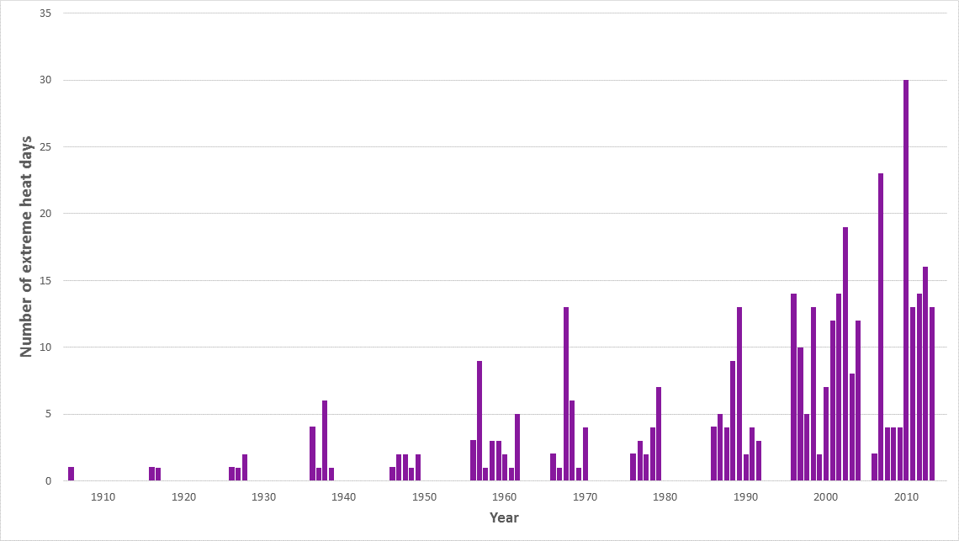
Figure 1: The number and frequency of extreme heat events in Australia from 1910 to 2010
By the 2050s, if the current rate of global warming continues, Victoria could experience around double the number of very hot days each year compared with the 1986–2005 average (Department of Environment, Land, Water and Planning 2019).
Figure 2 shows the 2050 projections for the number of very hot days per year in three selected cities: Melbourne, Bairnsdale and Mildura compared with the 1986–2005 average.
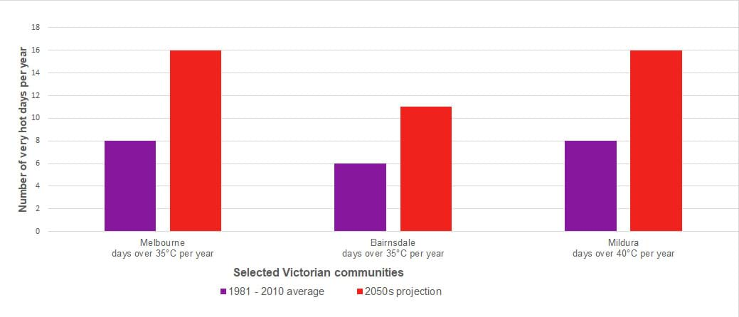
Figure 2: Number of very hot days per year in three Victorian cities comparing the 1981–2010 average with projections for 2050s.
There are also reports that Victoria is tracking towards the worst end of climate projections, with potentially devastating impacts on Victorians, the economy and society (Department of Environment, Land, Water and Planning 2019).

Health impacts
While anyone can be affected by heatwaves, people particularly susceptible include the elderly and very young, people with existing chronic health conditions, low-income households, people who are socially isolated and those who are required to be physically active for employment (Department of Health and Human Services 2018a).
The health impacts of extreme heat and heatwaves can be significant. Extreme heat increases the incidence of illness, most commonly in the form of:
- heat cramps, heat exhaustion and heat stroke
- dehydration
- exacerbation of a pre-existing medical condition
- gastroenteritis, in connection with poor food handling (Department of Health and Human Services, 2018a).
Heatstroke is a medical emergency that can result in permanent damage to vital organs, or even death, if not treated immediately (Department of Health and Human Services 2018a).
Extreme heat can also exacerbate pre-existing medical conditions, including heart and kidney disease, asthma and other respiratory illnesses (Department of Health and Human Services 2018a).
In 2009 and again in 2014, major heatwaves resulted in catastrophic impacts upon the health of Victorians. In both instances, heatwaves resulted in loss of life, with an estimated 374 excess deaths in 2009 and 167 in 2014 (Department of Health and Human Services 2018a).
Extreme heat affects all parts of the health system, with ambulance, emergency departments and community health sectors particularly affected (Natural Capital Economics 2018).

Economic impacts
In 2018, it was estimated that heatwaves cost Victoria $87 million annually, with these costs projected to increase significantly as climate change increases the severity and frequency of heatwaves (Natural Capital Economics, 2018).
These economic impacts are felt across the Victorian economy, including in the construction, electricity, health, manufacturing, mining, tourism, transport, agriculture and water sectors, with the greatest impact experienced by the agriculture sector (Natural Capital Economics 2018). The impact on agriculture will lead to higher food production costs for Victoria.
Increased frequency and severity of heatwaves affects the ability of individuals to pay energy bills.
Many Victorians already struggle to pay energy bills (Victorian Council of Social Service, 2017), and the number of people expected to experience ‘bill stress’ during summer will increase as heatwave frequency and severity increase.

Extreme heat days in Victoria
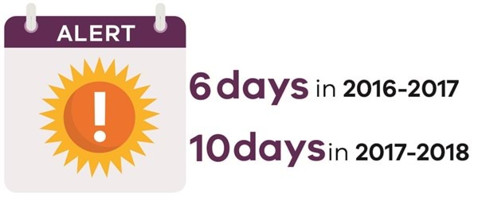
The Chief Health Officer issues a heat health alert when the heat health temperature threshold is reached for a specific weather forecast district.
Victoria’s heat health temperature thresholds are based on academic research, past experience and practice.
Heat health temperature thresholds are the average temperature above which substantial increases in mortality in weather forecast districts can be expected (Department of Health and Human Services, 2018b).
For the 2016–17 summer season, the Chief Health Officer issued heat health alerts for six days, three of which were consecutive from 8–10 February 2017 (Department of Health and Human Services, 2018b).
Observed temperatures from the Bureau of Meteorology indicate that extreme heat occurred on all six of these days.
For the 2017–18 summer season, heat health alerts were issued for 10 days. Eight of these actually experienced extreme heat (Department of Health and Human Services, 2018b). This is shown in Figure 3.
There were two periods of heatwave with three or more days of extreme heat forecast: 18–21 January 2018 and 26–28 January 2018.
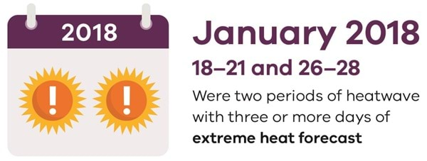
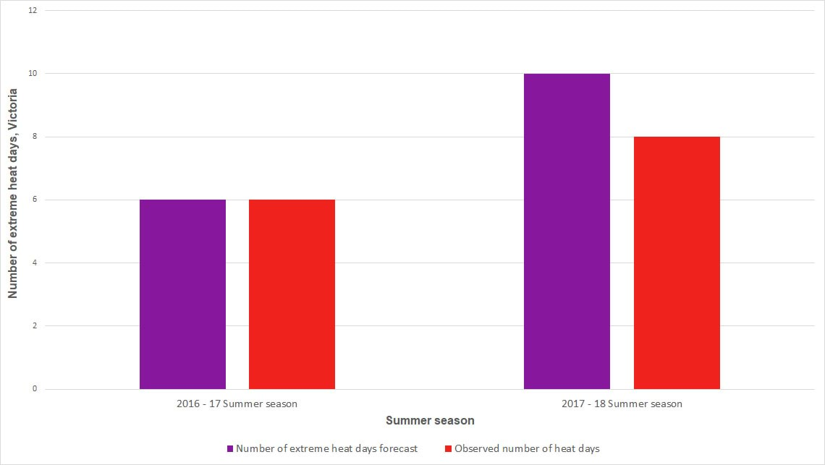
Figure 3: Number of forecast and observed extreme heat days in Victoria during summer seasons 2016–17 and 2017–18 as indicated by heat health alerts

Find out more
For more information about climate change and its impacts upon health, access the Chief Health Officer's Climate change and public health in Victoria content.

References
Bureau of Meteorology 2018, Understanding heatwaves, Bureau of Meteorology, Canberra.
Coates L, Haynes K, O'Brien J, McAneney J and Dimer de Oliveira F 2014, 'Exploring 167 years of vulnerability: An examination of extreme heat events in Australia 1844-2010', Environmental Science & Policy, vol 42, Oct 2014.
Department of Health and Human Services 2018a, Extreme heat, retrieved from Better Health Channel.
Department of Health and Human Services 2018b, Heat health alerts. State Government of Victoria, Melbourne.
Department of Environment, Land, Water and Planning 2019, Victoria’s climate science report 2019. State Government of Victoria, Melbourne.
Natural Capital Economics 2018, Heatwaves in Victoria: a vulnerability assessment, unpublished report prepared for Victorian Department of Environment, Land, Water and Planning, Melbourne.
Victorian Council of Social Service 2017, Power struggles: everyday battles to stay connected. Victorian Council of Social Service, Melbourne.

Child health
This section of the Chief Health Officer report looks at child health in Victoria.
It references The State of Victoria's Children Report 2016 (PDF) <https://www.education.vic.gov.au/Documents/about/research/The_State_of_Victorias_Children_Report_2016.pdf>, published by the Department of Education and Training in 2017. This report provides data on Victoria's children, families and the physical and mental health of children.
There are three key issues for child health in Victoria outlined in this section: obesity and overweight; mental health and wellbeing; and childhood allergies.
Further health data on children can be accessed through the Department of Education and Training's Victorian Child and Adolescent Monitoring System <https://www.vic.gov.au/victorian-child-and-adolescent-monitoring-system>.

Allergies
Almost 20 per cent of the Australian population has an allergic disease, and it is predicted that by 2050, the number of patients affected by allergic diseases in Australia will increase by 70 per cent to 7.7 million (Australasian Society of Clinical Immunology and Allergy Limited 2013).
Australian children have the highest prevalence of food allergy in the world (Prescott et al. 2013). A Melbourne-based study showed that 40–50 per cent of their population-based study participants experienced symptoms of an allergic disease in the first four years of their life (Peters et al. 2017).
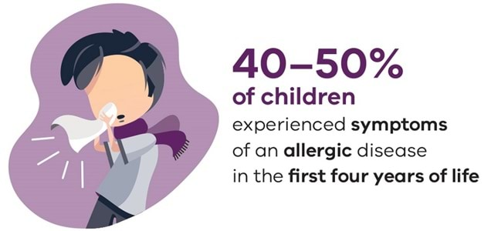

Anaphylaxis
The most sudden and severe form of an allergic reaction is anaphylaxis, which can be fatal if untreated. Medication, food and insect venom are the three main causes of anaphylaxis. Food allergies are the most common cause of anaphylaxis in children, responsible for more than 80 per cent of hospital presentations (Department of Health 2013).
Hospital data shows more Victorian children are affected by anaphylaxis than has previously been the case. In 2016–17, there were 687 hospitalisations of children due to anaphylaxis in Victoria, up from 200 in 2005–06 (Victorian Agency for Health Information 2018).
While in the past, children under four years were more likely than children in other age groups to be hospitalised for anaphylaxis, this is no longer the case.
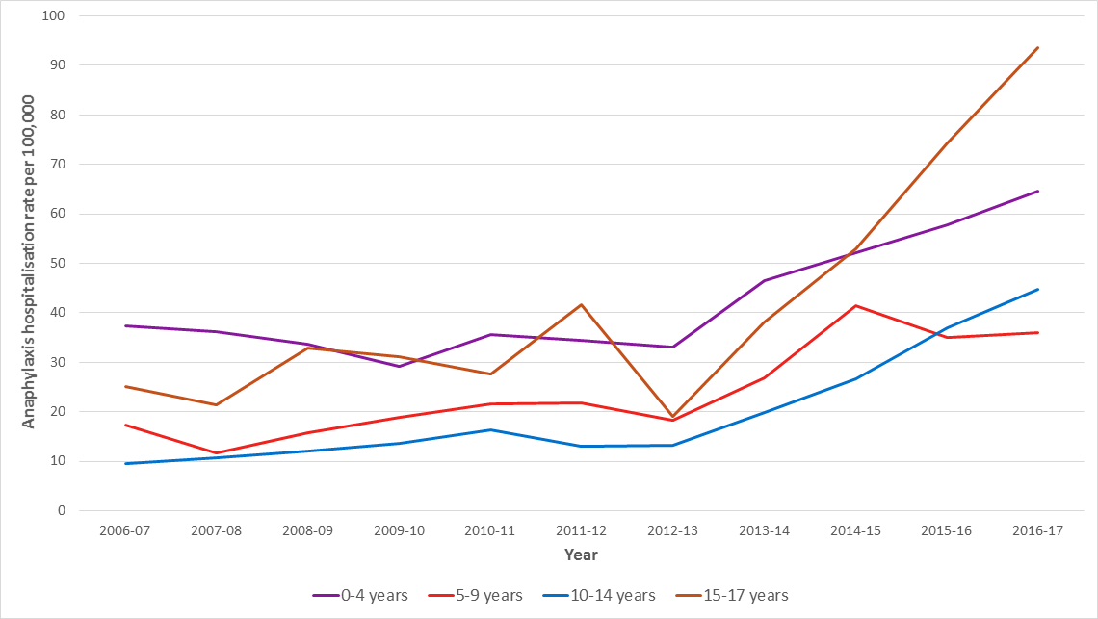
Figure 1 shows that the rate per 100,000 population for children aged between 15 and 17 years has increased much faster than any other age group during the past four years (Victorian Agency for Health Information 2018)
Children aged between 15 and 17 years have a much higher rate of hospitalisation for anaphylaxis than other age groups.
While the number of hospitalisations remains low, the growth in the rate of hospitalisations for children aged between 15 and 17 years is concerning.

Find out more
The State of Victoria's children report <https://www.vic.gov.au/state-victorias-children-report> has more information on allergies.
The Chief Health Officer's Food allergens page <https://www.health.vic.gov.au/food-safety/food-allergen-awareness> also discusses allergies.
The State of Victoria's Children Report 2016 <https://www.vic.gov.au/state-victorias-children-report>, published by the Department of Education and Training in 2017.

References
Australasian Society of Clinical Immunology and Allergy 2013 Allergy and immune diseases in Australia, Australasian Society of Clinical Immunology and Allergy, Sydney.
Department of Health 2013, Anaphylaxis: key messages for health professionals, State Government of Victoria, Melbourne.
Peters R, Koplin J, Gurrin L, Dharmage S, Wake M, Ponsonby A, Tang M et al. 2017 ‘The prevalence of food allergy and other allergic diseases in early childhood in a population-based study: HealthNuts age 4-year follow-up’, Journal of Allergy and Clinical Immunology, vol. 40, 1.
Prescott S, Pawankar R, Allen K, Campbell D, Sinn J, Fiocchi A, Ebisawa M, Sampson H, Beyer K, and Lee B 2013, ‘A global survey of changing patterns of food allergy burden in children’, World Allergy Organization Journal, vol. 6, no. 1.
Victorian Agency for Health Information 2018, Anaphylaxis hospitalisation data (unpublished). Victorian Agency for Health Information, Melbourne.

Mental health and wellbeing
Among children and young people, mental health and substance use disorders are the leading cause of disability worldwide (Erskine et al. 2015).
Mental ill-health contributes to nearly half of the burden of disease in young people (Headspace 2011). A recent study found six of the top 10 reasons for referring a child to a paediatrician were mental health issues (Hiscock, et al. 2017).
Half of mental health disorders start by age 14 and three quarters by age 24 (Department of Education and Training 2017). This indicates the importance of identifying and addressing mental health issues in children (Department of Education and Training 2017).
A major study in 2015 found that the most common mental disorder in Australian children and adolescents was attention deficit hyperactivity disorder (ADHD), followed by anxiety disorders, major depressive disorder and conduct disorder (Lawrence et al. 2015).
Victorian schools have a number of strategies to promote healthy minds and positive mental health, including creating safe environments, teaching social and emotional learning and recognising the important role that families play in promoting mental health (Department of Education and Training 2017).
Approximately $200 million dollars is invested annually in schools and other settings to fund a range of services, including social workers and psychologists, to promote mental health in children (Department of Education and Training 2017).

Intentional self-harm in young people
Intentional self-harm includes a range of behaviours that cause direct and deliberate harm to oneself, including non-suicidal self-injury, suicidal behaviour and suicide.
Common motivations for deliberate self-injury include self-punishment and difficulties with emotion regulation (Centre for Suicide Prevention Studies 2010).
Measuring the problem, however, is challenging because there are difficulties in identifying intentional self-harm cases in hospital data.
Some people may choose not to disclose that their injuries from intentional self-harm, or they may be unable to do so because of the nature of their injuries or because their motives were ambiguous (Australian Institute of Health and Welfare 2014).
Higher rates of self-harm occur in women, and intentional self-injury rates are particularly high for young women aged 15–24 years (Victorian Injury Surveillance Unit 2017).
The 2015 Child and Adolescent Health Survey found self-harm was markedly higher in young people with major depressive disorder (Department of Health 2015).
There has been a marked increase in rates of Victorian children and young people presenting for self-harm at emergency departments (Victorian Injury surveillance Unit 2017). This may in part be due to improved awareness of self-harm among hospital staff and the community more broadly.

Find out more
The Chief Health Officer's Causes of death in Victoria content discusses intentional self-harm in adults.
The Chief Health Officer's Mental illness and mental wellbeing content discusses mental health in adults.
The State of Victoria's Children Report 2016 <https://www.vic.gov.au/state-victorias-children-report#2016>, published by the Department of Education and Training in 2017.

References
Australian Institute of Health and Welfare 2014, Suicide and hospitalised self-harm in Australia: trends and analysis, Injury research and statistics, Australian Institute of Health and Welfare, Canberra.
Centre for Suicide Prevention Studies 2010, The Australian national epidemiological study of self-injury, Centre for Suicide Prevention Studies, Brisbane.
Department of Education and Training 2017, The state of Victoria's children 2016: why place matters, State Government of Victoria, Melbourne.
Department of Health 2015, The mental health of children and adolescents: report on the second Australian Child and Adolescent Survey of Mental health and Wellbeing, Commonwealth Government of Australia, Canberra.
Erskine H, Moffitt T, Copeland W, Costello E, Ferrari A, Patton G, Degenhardt L, Vos T, Whiteford H and Scott J 2015, ‘A heavy burden on young minds: the global burden of mental and substance abuse disorders in children and youth’, Psychological Medicine, vol. 45, no. 7.
Headspace 2011, Position paper: young people's mental health, National Youth Mental Health Foundation.
Hiscock H, Danchin M, Efron D, Gulenc A, Hearps S, Freed G, Perera P and Wake M 2017, ‘Trends in paediatric practice in Australia: 2008 and 2013 national audits from the Australian Paediatric Research Network’, Journal of Paediatrics and Child Health, vol. 53.
Lawrence D, Johnson S, Hafekost J, Boterhoven de Haan K, Sawyer M, Ainley J and Zubrick S 2015 ‘The mental health of children and adolescents: report on the second Australian Child and Adolescent Survey of Mental Health and Wellbeing, Commonwealth Government of Australia, Canberra.
Victorian Injury Surveillance Unit 2017, Hazard, Monash University Accident Research Centre, Melbourne.

Overweight and obesity in children
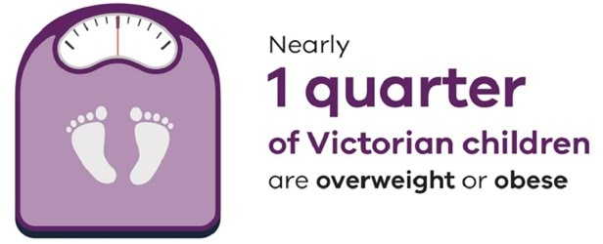
Weight issues for children and young people have short and long-term effects on physical and mental health and wellbeing.
Overweight and obese young people are at increased risk of developing physical problems, including chronic disease, while the impacts on mental health extend to social isolation, discrimination, bullying and peer problems (Department of Education and Training 2017).
Overweight or obese children are at increased risk of adult obesity; about 80 per cent of obese adolescents will become obese adults (Simmonds et al. 2016).
Nearly a quarter of Victorian children are overweight or obese (Australian Bureau of Statistics 2018).
This is a concerning trend as obese children and adolescents are five times more likely to be obese in adulthood than those who are not obese (Simmonds, Llewellyn et al. 2016).
As with many other health and wellbeing issues, overweight and obesity are more common in children living in more disadvantaged areas (Australian Institute of Health and Welfare 2018).
Children with a major depressive disorder are significantly more likely to be either underweight or obese.
In 2013–14, a survey of Australian children found:
- 10.6 per cent of Australians with a major depressive disorder aged 11 to 17 years were underweight (compared with 5.3 per cent of children with no disorder in this age group)
- 25.8 per cent were overweight (compared with 20.5 per cent of children with no disorder)
- 16.7 per cent were obese (compared with 5.8 per cent with no disorder) (Department of Health 2015).
Several factors can increase weight and obesity in children. These include reductions in physical activity, which have been reported in Victorian children, along with increases in sedentary behaviours (Department of Education and Training 2017).
The significant promotion of less nutritious and energy dense foods – often targeting children in a variety of settings – is a significant driver in encouraging children to want these foods (Nutrition Australia 2017).
The World Health Organization states there is clear evidence that children’s exposure to unhealthy food marketing contributes to increasing rates of overweight and obesity in children (World Health Organization 2010).

Find out more
The Chief Health Officer's Overweight and obesity content discusses obesity in adults.
The Department of Education and Training's Victorian Child and Adolescent Monitoring System (VCAMS) <https://www.vic.gov.au/victorian-child-and-adolescent-monitoring-system-vcams> contains data about children and young people across a range of health and wellbeing indicators. You can view data at local government area (LGA) level as well as at state level.
The Department of Education and Training also publishes The State of Victoria’s Children Report 2016 <https://www.vic.gov.au/state-victorias-children-report>. This report focuses on health and wellbeing of children.

References
Australian Bureau of Statistics 2018, National health survey 2017–18, Australian Bureau of Statistics, Canberra.
Australian Institute of Health and Welfare 2018, Data tables: children's headline indicators, Australian Institute of Health and Welfare, Canberra.
Department of Education and Training 2017, The State of Victoria's Children Report 2016, State Government of Victoria, Melbourne.
Department of Health 2015, The mental health of children and adolescents: report on the second Australian Child and Adolescent Survey of Mental health and Wellbeing, Commonwealth Government of Australia, Canberra.
Nutrition Australia 2017, Tipping the scales: we must halt obesity to save Australian lives, Nutrition Australia.
Simmonds M, Llewellyn A, Owen C and Woolacott N 2016, ‘Predicting adult obesity from childhood obesity: a systematic review and meta-analysis’, Obesity Reviews, vol.174, no. 2, pp. 95–107.
World Health Organization 2010, Recommendations on the marketing of foods and non-alcoholic beverages to children, World Health Organization, Geneva.

Maternal and infant health
This section of the Chief Health Officer report looks at maternal and infant health in Victoria.
It draws on Victoria's mothers, babies and children 2016, published by the Department of Health and Human Services in 2017, which provides data on perinatal, maternal and infant health.
It also discusses two key issues for maternal and infant health in Victoria:
- safe sleeping of infants
- ways to improve health outcomes for Aboriginal women and babies.
The Chief Health Officer notes that reducing smoking during pregnancy and promotion of breastfeeding are key interventions to improve health outcomes for both mother and child.

Improving health outcomes for Aboriginal women and babies
Although the mortality rate for babies born to Aboriginal women has decreased in recent years, Aboriginal mothers and babies continue to have poorer outcomes than non-Aboriginal mothers and babies (Department of Health and Human Services 2017).
A gap still exists between Aboriginal and non-Aboriginal women on two key issues: smoking during pregnancy and breastfeeding.

Smoking during pregnancy
There are many risks associated with smoking during pregnancy, including miscarriage, early labour and growth and developmental problems for babies.
Victorian data indicates that 36.9 per cent of Aboriginal women smoked in the first half of pregnancy compared with 8.2 per cent of non-Aboriginal women (Department of Health and Human Services 2017).
Further effort is required to strengthen the effectiveness of smoking cessation programs available to Aboriginal mothers to improve smoking cessation rates.
This includes better promotion, accessibility, affordability and cultural appropriateness of programs.
Any improvements in smoking rates will achieve better health outcomes for Aboriginal mothers and infants (Department of Health and Human Services 2017).

Breastfeeding
Breastfeeding promotes and supports the healthy development and growth of infants (Department of Health and Human Services 2017).
It is one of the most highly effective preventive measures a mother can take to protect the health of her infant and herself. It offers protection against several childhood health concerns such as infections, diabetes, childhood obesity and asthma.
Breastfeeding also contributes to better health outcomes for mothers and promotes opportunities for bonding between mother and baby.
Aboriginal women are less likely to initiate breastfeeding than non-Aboriginal women: 87 per cent compared with 94.6 per cent respectively (Department of Health and Human Services 2017).
In addition, the 2010 Australian National Infant Feeding Survey found the rates of Aboriginal infants exclusively breastfed (less than one month) to be 59 per cent compared with non-Aboriginal infants at 61 per cent (Australian Institute of Health and Welfare 2011).
The Department of Health and Human Services is continuing to work to improve the health outcomes of all women and babies, including those from the Aboriginal community.

Find out more
Access the Chief Health Officer's page on Aboriginal and Torres Strait Islander Victorians.
The Better Health Channel’s pregnancy and smoking page <https://www.betterhealth.vic.gov.au/health/HealthyLiving/pregnancy-and-smoking>.
The Better Health Channel’s breastfeeding page <https://www.betterhealth.vic.gov.au/health/healthyliving/breastfeeding>.

References
Australian Institute of Health and Welfare 2011, Australian national infant feeding survey: indicator results, AIHW, Canberra.
Better Health Channel 2018, Pregnancy and smoking, State Government of Victoria, Melbourne.
Department of Health and Human Services 2017, Victoria's mothers, babies and children 2017, State Government of Victoria, Melbourne.

Safe sleeping of infants
It is vital for all parents, carers and service providers to ensure infants are safe when they sleep.
In 2016 in Victoria, there were 23 sudden unexpected deaths in infancy (Department of Health and Human Services 2017).
The safest place for babies to sleep is in their own cot, located in the same room as an adult caregiver, for the first 6–12 months of the infant’s life (Department of Health and Human Services 2017).
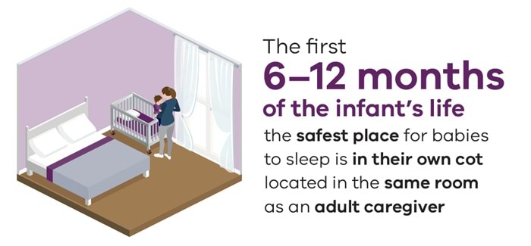
Babies should also sleep in a lightweight sleeping bag of the correct size that has a fitted neck, armholes or sleeves and no hood (Department of Health and Human Services 2017).
Factors that contribute to the risk of sudden unexpected death in infancy include:
- exposure to smoke (both before and after birth)
- sharing a bed with an adult (especially if the adult is affected by alcohol or drugs)
- an unsafe sleeping environment and/or position (Better Health Channel).
The risk of unexpected death during sleep in infants can be minimised by following safe sleeping guidelines, outlined in:
- the Better Health Channel <http://www.betterhealth.vic.gov.au/health/healthyliving/babies-and-safety>
- the publication Keeping baby safe: A guide to infant and nursery products <https://www.productsafety.gov.au/about-us/publications/keeping-baby-safe-a-guide-to-infant-and-nursery-products>.

References
Department of Health and Human Services 2017, Victoria’s Mothers, Babies and Children 2016, State Government of Victoria, Melbourne.

Healthy living
This section of the Chief Health Officer report looks at three key areas that can help keep Victorians healthy:
- tobacco-free living
- active living
- healthy eating.
It draws on
- Victorian population health survey 2016 <https://www.health.vic.gov.au/population-health-systems/victorian-population-health-survey>, published by the Department of Health and Human Services in 2018.
- the State of Victoria’s Children report 2016, published by the Department of Education and Training in 2017.
- Australian Bureau of Statistics 2018, National health survey: first results 2017–18 <https://www.abs.gov.au/ausstats/abs@.nsf/mf/4364.0.55.001>, Australian Bureau of Statistics, Canberra.
This section of the report provides information on how many serves of fruit and vegetables we should eat every day and how much physical activity we should undertake to stay healthy.
It also discusses how important it is for smokers to quit.

Healthy eating
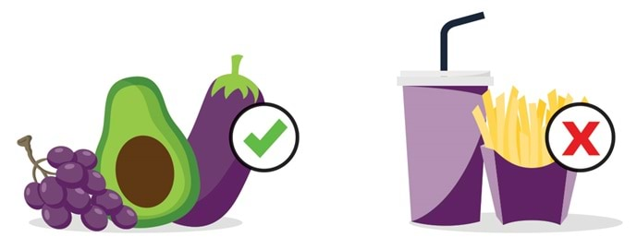
Poor diet is a leading contributor to chronic disease and premature death in Victoria.
Good nutrition is essential to maintain a healthy weight, mental and physical health, resistance to infection and to protect against chronic disease.
Poor diet increases the risk of cardiovascular disease, type 2 diabetes and some cancers, which are also associated with Overweight and obesity.

Dietary recommendations
Many Victorians are not consuming enough of the foods and drinks they need to stay healthy and well.
Dietary recommendations for health focus on encouraging a wide variety of nutritious foods from the five food groups every day. These recommendations are outlined in the 2013 Australian dietary guidelines <https://www.eatforhealth.gov.au/guidelines>.
Fruits and vegetables are important core foods that should form the foundation of a healthy diet.
These foods provide essential vitamins, minerals and dietary fibre. They are critical for the prevention of many chronic diseases.
It is important to reduce discretionary food and drinks – that is, 'junk food' that is outside the five food groups, including sugar-sweetened beverages.
Sugar-sweetened beverages in particular are associated with lower intakes of various nutrients, as well as an increased risk of weight gain and obesity, diabetes and tooth decay (National Health and Medical Research Council 2013).

The state of healthy eating in Victoria
The following data relates to measures based on nationally agreed standards, including:
- the proportion of adults, adolescents and children who reported consuming the recommended serves of fruit and vegetables to meet the 2013 Australian dietary guidelines
- the proportion of adults, adolescents and children who consume sugar-sweetened beverages daily.

Fruit and vegetable intake
Despite the well-known health benefits, fruit and vegetable intake for children and adults continues to remain low and falls short of recommendations.
In 2016, only 3.3 per cent of adults in Victoria met the recommended minimum daily serves for both vegetables and fruit (Department of Health and Human Services 2018).
When looking at fruit and vegetable intake separately, 4.8 per cent of adult Victorians met vegetable guidelines and 41.4 per cent met fruit guidelines.
Women were significantly more likely to meet both fruit and vegetable guidelines compared with men (Department of Health and Human Services 2018).
Amongst Victorian children, only one in ten are eating the minimum recommended daily serve of fruit and vegetables (Department of Education and Training 2017).

Sugar sweetened beverages
Ten per cent of Victorian adults consume sugar-sweetened beverages daily (Department of Health and Human Services 2018).
A significantly higher proportion of men (13.4 per cent) were daily consumers of sugar-sweetened beverages compared with women (6.7 per cent) (Department of Health and Human Services 2018).
Daily consumption of sugar-sweetened beverages also varied significantly between population subgroups, indicating differences across the population (Department of Health and Human Services 2018).
For children aged two to 17 years, one in 20 (5.1 per cent) consume sugar-sweetened drinks daily, and almost one-third (31.0 per cent) consume them one to three days per week (Australian Bureau of Statistics 2018).

What the Victorian Government is doing
Victorian Government actions to address healthy eating include:
- promoting the Healthy Choices guidelines <https://www.health.vic.gov.au/preventive-health/healthy-choices> to increase provision and promotion of healthy foods and drinks, and reduce unhealthy food and drinks in hospitals, health services, sport and recreation centres, parks and workplaces, supported by the Healthy Eating Advisory Service <https://heas.health.vic.gov.au/>
- the Achievement Program <https://www.achievementprogram.health.vic.gov.au/>, which provides early childhood services, schools and workplaces with a whole-of-organisation framework to address health and wellbeing, including healthy eating.
Through VicHealth, the Victorian Government also funds programs and initiatives that contribute to obesity prevention <https://www.vichealth.vic.gov.au/media-and-resources/publications/obesity-consensus>.

Find out more
For more information on healthy eating, please visit the department’s Healthy eating page <https://www.health.vic.gov.au/preventive-health/healthy-eating-nutrition>.

References
Australian Bureau of Statistics 2018, National health survey: first results 2017–18, Australian Bureau of Statistics, Canberra.
Department of Education and Training 2017, The State of Victoria’s children report 2016, State Government of Victoria, Melbourne.
Department of Health and Human Services 2018, Victorian population health survey 2016, State Government of Victoria, Melbourne.
National Health and Medical Research Council 2013, Australian dietary guidelines, National Health and Medical Research Council, Canberra.

Active living
Leading an active life improves your health and wellbeing.
By moving more and sitting less, you can reduce the risk of ill health and death from any cause.
Regular physical activity helps to prevent and treat many diseases such as:
- heart disease
- some cancers
- diabetes
- musculoskeletal conditions
- depression (Booth, Roberts and Laye 2012; Pedersen and Saltin 2015).
Being physically active and having a healthy diet reduces other risk factors for disease, such as high blood pressure and over-weight and obesity (Australian Institute of Health and Welfare 2017).

How much physical activity is enough?
The definition of sufficient physical activity depends on how old you are, as shown in this table:
Physical activity category | Age 18–64 | Age 65 or over
- Sedentary | - 0 minutes of moderate or vigorous intensity physical activity and 0 muscle strengthening exercises | - 0 minutes
- Insufficient | - Less than 150 minutes of moderate intensity or 75 minutes of vigorous intensity physical activity, or an equivalent combination of both moderate and vigorous activities and/or less than 2 days muscle strengthening activities each week | - Less than 30 minutes of moderate intensity physical activity every day
- Sufficient | - 150 minutes of moderate intensity or 75 minutes of vigorous intensity physical activity, or an equivalent combination of both moderate and vigorous activities and muscle strengthening activities on at least 2 days each week | - 30 minutes of moderate intensity physical activity every day

Physical activity in Victoria
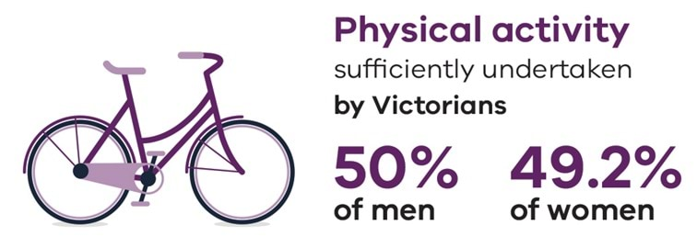
In Victoria, 50 per cent of men and 49.2 per cent of women did sufficient physical activity. Approximately one quarter of adults spend eight hours or more sitting on an average weekday (Department of Health and Human Services 2018).
There were no significant differences between rural and regional Victorians and those from metropolitan areas.
There was, however, a significantly higher proportion of adults aged 65–84 years who did adequate physical activity compared with all other Victorian adults (Department of Health and Human Services 2018).
By contrast, only 23 per cent of young people (10–17 years) did sufficient physical activity and completed 60 minutes or more of activity every day.
Furthermore, 68 per cent of young people exceeded the recommended two hours per day of screen time, which can be associated with increased levels of sedentary behaviour (Department of Education and Training 2017) and negative health effects.

Find out more
For more information measures to increase active living, please visit the department’s active living page <https://www.health.vic.gov.au/health-strategies/active-living-guidance>.
For more information on physical activity in adults, see the ‘Physical activity’ section in the Victorian population health survey 2016 <https://www.health.vic.gov.au/population-health-systems/victorian-population-health-survey-2016>.
For more information on physical activity in children, see the Victorian student health and wellbeing survey 2016 <https://www.vic.gov.au/victorian-student-health-and-wellbeing-survey>.

References
Australian Institute of Health and Welfare 2017, Risk factors to health. Canberra: Australian Institute of Health and Welfare.
Booth F, Roberts C and Laye M 2012, ‘Lack of exercise is a major cause of chronic diseases’, Comprehensive Physiology, vol. 2, no. 2.
Department of Education and Training 2017, Victorian Student Health and Wellbeing Survey, 'About You' - Summary Findings 2016, State Government of Victoria, Melbourne.
Department of Health and Human Services 2018, Victorian Population Health Survey 2016, State Government of Victoria, Melbourne.
Pedersen B and Saltin B 2015, ‘Exercise as medicine: evidence for prescribing exercise as therapy in 26 different chronic diseases’, Scandanavian Journal of Medicine, Science and Sports, vol. 25.

Tobacco-free living
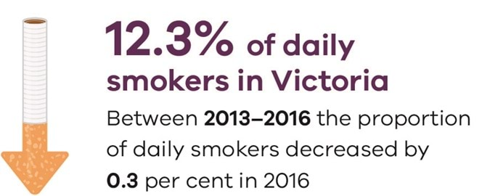
Smoking is a significant cause of preventable illness and death in Australia.

The harms of tobacco use
Tobacco use is the leading contributor to disease and death burden.
It is responsible for nine per cent of disease burden, and almost 13 per cent of deaths in Australia (Institute for Health Metrics and Evaluation 2017).
In Victoria, smoking claims about 4,400 lives each year (Department of Health and Human Services 2018a). These deaths are entirely avoidable and cause considerable distress for individuals, families and communities.
Smoking increases the risk of lung cancer, cardiovascular disease, chronic obstructive pulmonary disease and many other illnesses, and evidence suggests that smoking kills almost two in three regular users (Banks, et al. 2015).
The health burden of tobacco use does not just affect smokers.
Children who live in a smoking household are significantly more likely to suffer from bronchiolitis and other respiratory conditions (Jones, et al. 2011) and infants are at greater risk of sudden infant death syndrome (SIDS).

The economic cost of smoking
In addition to the devastating health impacts, smoking has a significant economic impact.
It costs the Victorian economy $3.7 billion in tangible costs such as health care, and $5.8 billion in intangible costs associated with the loss of life every year (Creating Preferred Futures 2018).

Reducing the smoking rate
While progressive tobacco control efforts have reduced smoking rates in Victoria over the past few decades, recent data suggests that these reductions are slowing. Between 2013 and 2016, the proportion of daily smokers in Victoria only decreased by 0.3 per cent to 12.3 per cent in 2016 (Australian Institute of Health and Welfare 2017).

At-risk cohorts
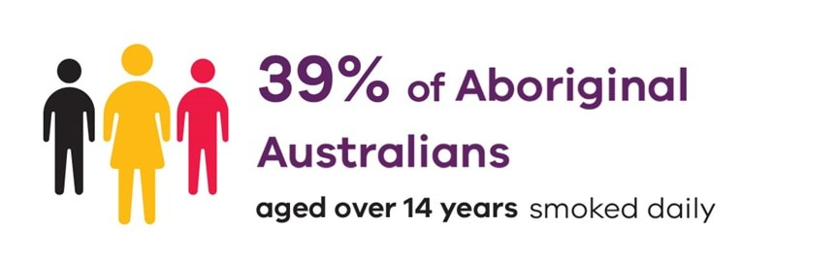
Nor have reductions in smoking rates been achieved equally across the population.
In 2016, 39 per cent of Aboriginal Australians aged over 14 years smoked daily (Australian Bureau of Statistics 2016).
Aboriginal women are significantly more likely to smoke during pregnancy. Almost 40 per cent of Aboriginal women in Victoria smoked at any time during pregnancy, which was more than four times higher than non-Aboriginal pregnant women (Consultative Council on Obstetric and Paediatric Mortality and Morbidity 2017).
Socioeconomically disadvantaged individuals are also more likely to be current smokers.
In Victoria, both males and females in the lowest household income group are twice as likely to be smokers compared to the highest household income group (Department of Health and Human Services 2018b).
Continued and renewed focus on tobacco-free living is essential to further reduce Victoria's smoking rates and the devastating health effects of tobacco use on the Victorian community.

Key statistics

Smoking prevalence
12.3 per cent of Victorian adults smoke daily (Department of Health and Human Services 2018b).
4 per cent of Victorian students aged 12 – 17 years currently smoke (Centre for Behavioural Research in Cancer 2018).
39 per cent of Aboriginal and Torres Strait Islander people aged over 14 years smoke daily (Australian Bureau of Statistics 2016).

Burden of disease
Tobacco use contributed to 13 per cent of all Australian deaths in 2017 (Institute for Health Metrics and Evaluation 2017).
9 per cent of disease and injury burden in Australia is attributable to tobacco smoking (Institute for Health Metrics and Evaluation 2017).
80 per cent of lung cancer disease burden and 75 per cent of chronic obstructive pulmonary disease burden in Australia is caused by tobacco use (Australian Institute of Health and Welfare 2016).

Efforts to support tobacco-free living
The department's activities to support tobacco-free living include:
- developing of resources, training, policies, procedures and guidelines on best practice for embedding smoking cessation as routine care in health services
- developing training materials and resources for the health and human services workforce
- strengthening and expanding existing interpretation and enforcement guidance documents for local council related to the Tobacco Act 1987
- the tobacco information line
- smoking cessation services through the Victorian Quitline
- funding anti-smoking campaigns, integrated across television, radio, print and social media
- funding of the Tobacco Education and Enforcement Program.
For more information on these and other reforms, please visit the department's tobacco reforms page <https://www.health.vic.gov.au/public-health/tobacco-reforms>.

Find out more
Tobacco use is discussed in the following links:
- Victorian population health survey 2016 <https://www.health.vic.gov.au/population-health-systems/victorian-population-health-survey-2016>
- Cancer Council Victoria's 'Statistics and data' page <https://www.cancervic.org.au/research/registry-statistics/statistics-data>
- Korin Korin Balit-Djak: Aboriginal health, wellbeing and safety strategic plan 2017–27 <https://www.health.vic.gov.au/health-strategies/korin-korin-balit-djak-aboriginal-health-wellbeing-and-safety-strategic-plan-2017>
- Victorian Student Health and Wellbeing Survey, 'About you' <https://www.vic.gov.au/victorian-student-health-and-wellbeing-survey>
- The State of Victoria’s Children Report 2016 (PDF) <https://www.education.vic.gov.au/Documents/about/research/The_State_of_Victorias_Children_Report_2016.pdf>
For information and support to quit smoking, please visit Quit Victoria <https://www.quit.org.au/>.

References
Australian Bureau of Statistics 2016, National Aboriginal and Torres Strait Islander social survey 2014–15, ABS, Canberra.
Australian Institute of Health and Welfare 2016, Australian burden of disease study: impact and causes of illness and death in Australia 2011, Australian Institute of Health and Welfare, Canberra.
Australian Institute of Health and Welfare 2017, National drug strategy household survey 2016: detailed findings, Australian Institute of Health and Welfare, Canberra.
Banks E, Joshy G, Weber M, Liu B and Grenfell R 2015, ‘Tobacco smoking and all-cause mortality in a large Australian cohort study: findings from a mature epidemic with current low smoking prevalence’, BMC Medicine vol. 13, no. 1.
Centre for Behavioural Research in Cancer 2018, Victorian secondary school students' use of licit and illicit substances in 2017: results from the 2017 Australian Secondary Students' Alcohol and Drugs (ASSAD) Survey, Cancer Council Victoria, Melbourne.
Consultative Council on Obstetric and Paediatric Mortality and Morbidity 2017, Victoria's mothers, babies and children report 2016, State Government of Victoria, Melbourne.
Creating Preferred Futures 2018, An analysis of the social costs of smoking in Victoria 2015–16, Creating Preferred Futures, Hobart.
Department of Health and Human Services 2018a, The contribution of risk factors to disease burden in Victoria, 2011: findings from the 2011 Australian Burden of Disease Study, State Government of Victoria, Melbourne.
Department of Health and Human Services 2018b, Victorian population health survey 2016: selected survey findings, State Government of Victoria, Melbourne.
Institute for Health Metrics and Evaluation 2017, Global burden of disease, Institute for Health Metrics and Evaluation, Seattle.
Jones L, Hashim A, McKeever T, Cook D, Britton J and Leonardi-Bee J 2011, ‘Parental and household smoking and the increased risk of bronchitis, bronchiolitis and other lower respiratory infections in infancy: systematic review and meta-analysis’, Respiratory research, vol. 12, no. 1.

Burden of disease
This section of the Chief Health Officer’s report looks at some of the disease groups that have a significant impact on Australians. It draws on:
- the Australian burden of disease study: impact and causes of illness and death in Australia 2015 <https://www.aihw.gov.au/reports/burden-of-disease/burden-disease-study-illness-death-2015/contents/table-of-contents>, published by the Australian Institute of Health and Welfare in 2019
- the Victorian population health survey 2016 <https://www.health.vic.gov.au/population-health-systems/victorian-population-health-survey-2016>, published by the Department of Health and Human Services in 2018.
It also discusses major risk factors which play a role in the disease burden.
It notes that a large proportion of the disease burden can be prevented.

Issues discussed
Smoking is the leading individual contributor to the disease burden in Australia.
However, when overweight and obesity, dietary risks and high blood glucose are taken together, their combined contribution to the total disease burden is much greater than that of smoking.
This section of the Chief Health Officer report thus includes discussion of overweight and obesity and alcohol use – key issues in the disease burden of Victoria.

Alcohol use
The consumption of alcohol is a major cause of preventable disease and illness in Australia.
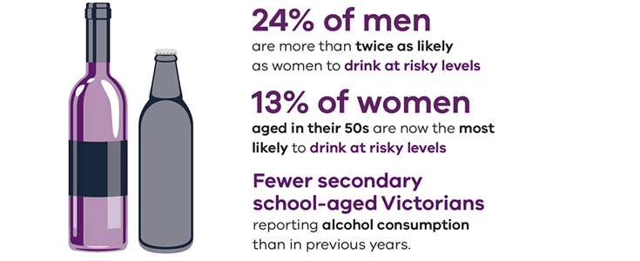

Prevalence of alcohol consumption
While overall alcohol consumption is declining, prevalence of risky drinking remains high, with 17 per cent of Australians consuming alcohol at levels placing them at lifetime risk of an alcohol-related disease or injury (Australian Institute of Health and Welfare 2018).
Some cohorts are drinking at riskier levels than others:
- men are twice as likely as women to drink at risky levels (24 per cent and 10 per cent, respectively), with men in their 40s being the most likely (29 per cent) to drink at risky levels (Australian Institute of Health and Welfare 2017)
- among women, those aged in their 50s are now the most likely (13 per cent) to drink at risky levels (Australian Institute of Health and Welfare 2018).
There have been some improvements in recent years, with fewer secondary school-aged Victorians reporting alcohol consumption than in previous years. In 2017, 66 per cent of students had ever had alcohol, compared with 74 per cent in 2011 (Department of Health 2018).

Harm caused by alcohol
In Victoria, a third of people presenting to our specialist alcohol and other drug treatment system list alcohol as their primary drug of concern (Turning Point 2017c).
Harms caused by excessive alcohol consumption are not limited to alcohol dependence.
For example, anywhere between 2,182 and 6,620 cases of cancer (or 1.9–5.8 per cent of all cancers) are attributable to long-term, chronic use of alcohol each year in Australia (Cancer Council Australia 2018).
The link between alcohol and age-related diseases is of particular concern given the increasing profile of older Australians reporting risky drinking practices.
In addition, alcohol is associated with increased:
- risky behaviour, with 17.4 per cent of respondents to a national 2016 survey saying that they recently put themselves or others at risk of harm while under the influence of alcohol (Australian Institute of Health and Welfare 2017)
- injury and violence, including family violence – for example, in 2016–17 in Victoria, alcohol was involved in 11,497 ‘definite or possible’ family violence incidences (Turning Point 2017b)
- pressure on our emergency health system, with alcohol intoxication accounting for 28.3 per cent of all ambulance attendances in 2017–18 (Turning Point 2017b).

Responding to alcohol harms
In 2018, the Victorian Government invested $259.9 million in alcohol and other drug services, an increase of 57 per cent through the past four state budgets.
Responding to the challenges posed by alcohol misuse, however, requires effective management not only through the specialist alcohol and other drug treatment system, but also in primary care.
The Department of Health and Human Services has identified alcohol and other drug health as a priority area of focus through a new collaborative approach with Primary Health Networks.
Three key domains for action are:
- prevention and early intervention
- demand management and flow
- co-commissioning for better results – together, the department and Primary Health Networks will introduce shared goals for specialist alcohol and other drug services.

Find out more
For more information on alcohol treatment services, please visit the department’s Alcohol and other drug treatment services page <https://www.health.vic.gov.au/alcohol-and-drugs/alcohol-and-other-drug-treatment-services>.
For more information on links between alcohol and cancer, please see visit the Cancer Council Australia's Impact: cancer and alcohol page <https://wiki.cancer.org.au/policy/Alcohol/Impact:_Alcohol_and_cancer#_ga=2.153393851.2034685423.1555048939-1873530676.1555048939>.

References
Australian Institute of Health and Welfare 2017, National drug strategy household survey (NDSHS) 2016: key findings, Australian Institute of Health and Welfare, Canberra.
Australian Institute of Health and Welfare 2018, Alcohol, tobacco and other drugs in Australia, Australian Institute of Health and Welfare, Canberra.
Cancer Council Australia 2018, Impact: alcohol and cancer, Cancer Council Australia, Sydney.
Department of Health 2018, Secondary school students' use of tobacco, alcohol and other drugs in 2017, Department of Health, Canberra.
Turning Point 2017a, Specialist alcohol and drug treatment, Turning Point, Melbourne.
Turning Point 2017b, Alcohol and family violence, Turning Point.
Turning Point 2017c, Ambulance and alcohol and drug statistics, Turning Point, Melbourne.

Overweight and obesity
Obesity is defined as having a body mass index (BMI) equal to or greater than 30.
The latest data from the National Health Survey 2017–18 suggests that almost a third of Australian and Victorian adults are obese (Australian Bureau of Statistics 2018).
Another third of adults are overweight, with a BMI between 25 and 30 (Australian Bureau of Statistics 2018).
By these estimates, 68 per cent (over two-thirds) of Victorian adults are overweight or obese, which is an estimated 3.3 million people (Australian Bureau of Statistics 2018), see Table 1.
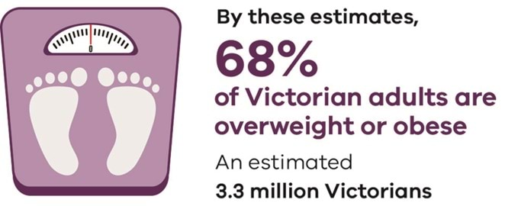
Table 1: Proportion of adults (aged 18 and over) overweight and obese, Australian Bureau of Statistics 2018
Measured body mass index | Victoria | Australia
Overweight | 36.6 | 35.6
Obese | 31.5 | 30.8
Overweight and obese | 68.1 | 66.4
Data are age-standardised
In addition, nearly a quarter of our children are also overweight or obese (Australian Bureau of Statistics 2018).
This is a concerning trend, as obese children and adolescents are five times more likely to be obese in adulthood than those who are not obese, with 80 per cent of obese adolescents going on to be obese in adulthood (Simmonds, et al. 2016).

Burden of disease
Overweight and obesity has become the second-leading modifiable cause of the disease burden in Australia, responsible for 8.4 per cent of the total disease burden and 19.3 per cent of the cardiovascular burden (Australian Institute of Health and Welfare 2019).
Overweight and obesity are among the greatest risk factors driving death and disability in Australia.
They are significant risk factors for hypertension, cardiovascular disease, type 2 diabetes, gallbladder disease, musculoskeletal disorders, some cancers (endometrial, breast and bowel), psychological disorders and breathing difficulties (World Health Organization 2013).
Ultimately, being obese can lead to disability and premature death (Department of Health and Human Services 2018).
Victorian data indicates that factors such as presence of psychological distress, doctor-diagnosed hypertension and self-reported fair or poor health are positively associated with being overweight (Department of Health and Human Services 2018).

The national context
More than 21,000 people are surveyed nationally by the Australian Bureau of Statistics, with body mass index measured for two-thirds of respondents.
For the remaining third, height and weight were imputed using a range of information, including their self-reported height and weight.
This puts Australia in the top quarter of Organisation for Economic Cooperation and Development (OECD) countries for measured obesity, ahead of the United Kingdom (26.2 per cent of the population) and Ireland (23 per cent), on a par with New Zealand (31.6 per cent), but behind the United States of America (40 per cent).
In the last decade, two things have occurred:
- more people are overweight and obese (68 per cent of the population compared to 61 per cent in 2007–08)
- and the proportion who are obese has increased to 32 per cent of the population from 25 per cent in 2007–08.
The changes in body mass of Victorians mirror Australian data.
The obesity rate has been trending up in the last decade and in 2017–18 surpassed 30 per cent for the first time.
Table 2: Proportion of adult population obese
 | 2007–08 | 2011–12 | 2014–15 | 2017-18
Victoria | 24.6 | 25.6 | 26.0 | 31.5
Australia | 24.4 | 27.2 | 27.5 | 30.8
Over the last two decades, the average Australian man and woman has gained 5 kilograms in weight.
In 2017–18 the average Australian man weighed 87 kilograms compared with 82 kilograms in 1995.
The average Australian woman weighed 72 kilograms compared with 67 kilograms in 1995.
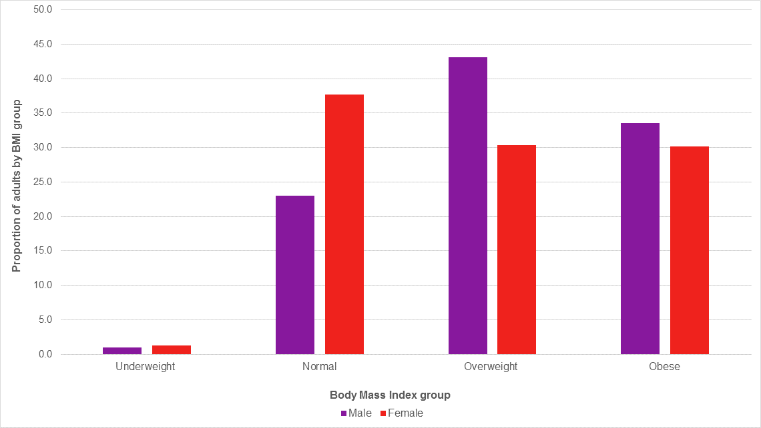
Figure 1: Sex distribution of body mass index, Victoria 2017–18
Source: Department of Health and Human Services
Figure 1 shows that around three-quarters of Victorian males are overweight and obese compared to 60 per cent of females.
Fewer than a quarter of males are now in the normal weight range. This difference between males and females is due to a lower proportion of females being overweight, but the proportion of females who are obese is almost the same as for males.
Figure 2 shows the proportion of the Victorian population overweight or obese by age. A quarter of children aged 2–17 years are overweight or obese.
This age group is already overweight or obese by the time they start school. The rate then stays around this level through the school years with small fluctuations, before accelerating sharply during the late teen/young adulthood period.
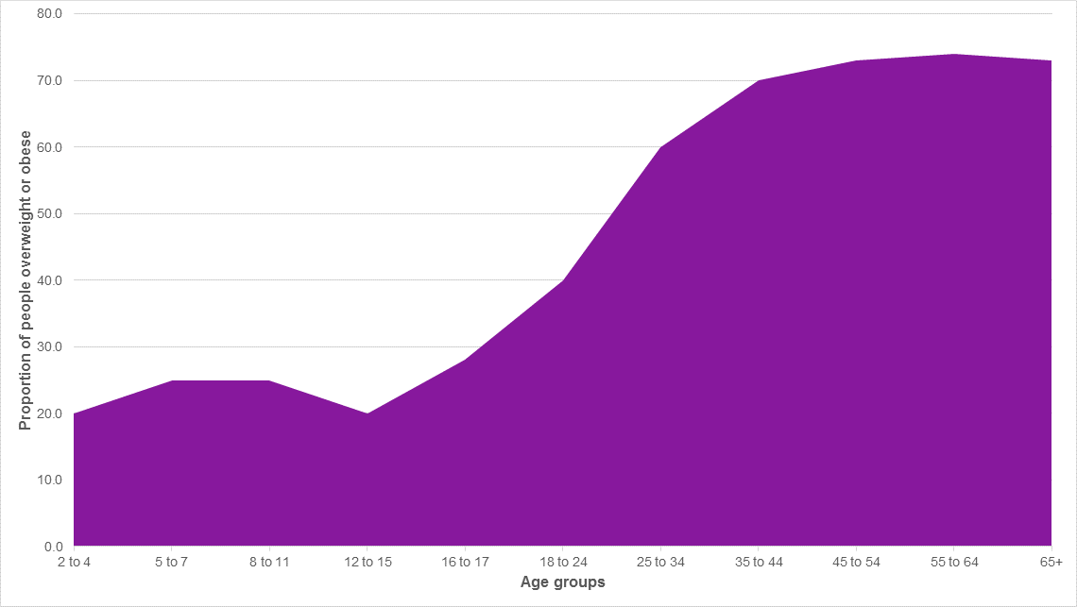
Figure 2: Proportion of population overweight or obese by age group, Victoria
Source: Department of Health and Human Services
Data averaged over last three surveys (2011–12, 2014–15, 2017–18) to minimise fluctuations due to the small sample sizes per age group.

What the Victorian Government is doing
In addition to measures to support Healthy eating the Victorian Government through VicHealth also funds programs and initiatives that contribute to obesity prevention <https://www.vichealth.vic.gov.au/media-and-resources/publications/obesity-consensus>.

References
Australian Bureau of Statistics 2018, National health survey 2017–18, Australian Bureau of Statistics, Canberra.
Australian Institute of Health and Welfare 2019, Australian burden of disease study: impact and causes of illness and death in Australia 2015, Australian Institute of Health and Welfare, Canberra.
Department of Health and Human Services 2018, Victorian population health survey 2016. Melbourne: Victorian Government.
Simmonds M, Llewellyn A, Owen C and Woolacott N, 2016, 'Predicting adult obesity from childhood obesity: a systematic review and meta-analysis', Obesity Reviews, vol. 174, no. 2.
World Health Organization 2013, Overweight and obesity fact sheet number 311, World Health Organization, Geneva.

Causes of death in Victoria

Leading causes of death in 2017
In 2017, there were 39,791 deaths in Victoria, of which 19,856 were male and 19,935 were female (Australian Bureau of Statistics 2018).
Ischaemic heart diseases remained the leading cause of death in Victoria for both males and females, accounting for 11.67 per cent of all deaths.
This was followed by 'malignant neoplasms of digestive organs' (including pancreatic, intestinal, liver, gastric and oesophageal cancers), accounting for 8.5 per cent of all deaths.
'Cerebrovascular diseases' (stroke) was the third leading cause of death in Victoria, accounting for 6.17 per cent of all deaths.
Table 1 shows the 10 leading causes of death in 2017 in Victoria.
Table 1: Causes of death, Victoria 2017
Causes of death | Males | Females | Persons | Percentage of all deaths
Ischaemic heart diseases | 2,602 | 2,040 | 4,642 | 11.67
Malignant neoplasms of digestive organs | 1,891 | 1,492 | 3,383 | 8.50
Cerebrovascular diseases | 1,010 | 1,444 | 2,454 | 6.17
Other forms of heart disease | 1,073 | 1,326 | 2,399 | 6.03
Organic, including symptomatic, mental disorders | 793 | 1,451 | 2,244 | 5.64
Malignant neoplasms of respiratory and intrathoracic organs | 1,225 | 827 | 2,052 | 5.16
Chronic lower respiratory diseases | 996 | 1,041 | 2,037 | 5.12
Other degenerative diseases of the nervous system | 534 | 940 | 1,474 | 3.70
Influenza and pneumonia | 529 | 632 | 1,161 | 2.92
Diabetes mellitus | 594 | 563 | 1,157 | 2.91
Source: Australian Bureau of Statistics, 2018.

Perinatal mortality
In 2016, 80,233 babies were born in Victoria. Of these there were:
- 839 perinatal deaths
- 626 stillbirths
- 213 neonatal deaths up to 28 days of age (Department of Health and Human Services, 2017).
Victoria's adjusted perinatal mortality rate was 8.8 per 1,000 births. This is among the lowest in Australia and other countries of similar socioeconomic status (Department of Health and Human Services 2017).
The leading cause of adjusted stillbirth was congenital anomalies. Unexplained fetal deaths, where a definitive cause could not be established, remained the second most common classification in 2016. Specific perinatal conditions (including twin-to-twin transfusion syndrome, fetomaternal haemorrhage, cord accidents and birth trauma), preterm birth and fetal growth restriction remain among the next most common causes (Department of Health and Human Services 2017).

Find out more
Access the report on Victoria's Mothers, Babies and Children 2017 <https://www.bettersafercare.vic.gov.au/reports-and-publications/victorias-mothers-babies-and-children-report-2017>.
For more on infant safe sleeping, visit the Chief Health Officer's Maternal and infant health content.

Intentional self-harm (suicides)

2017
In 2017, there were 618 deaths in Victoria due to intentional self-harm (suicides). Males accounted for 443 of these deaths (72 per cent of all intentional suicides deaths) and females accounted for 175 (28 per cent of all intentional suicides deaths) (Australian Bureau of Statistics 2018).
For males, the death rate from suicide was 14.0 per 100,000 persons in 2017, compared with a rate of 5.4 per 100,000 persons for females.
The combined figure for total persons was 9.6 per 100,000 persons.
Figure 1 shows this data.
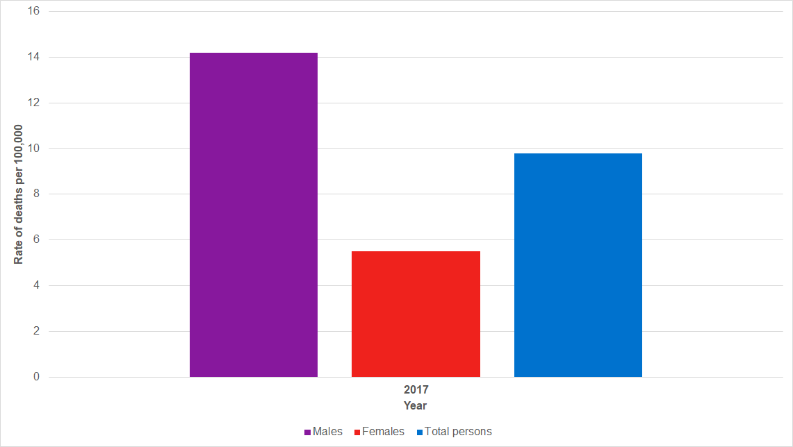
Figure 1 Rate of deaths per 100,000 due to intentional self-harm (suicide) in Victoria by sex, 2017
Source: Australian Bureau of Statistics, 2018
Since 2015, there has been a slight reduction in the rate of deaths for all persons due to intentional suicides in Victoria, as shown in Figure 2 below.
This reduction seen in Figure 2 is largely due to fewer intentional suicides deaths among males in Victoria, as shown by the changes to the rate of deaths among males and females in Victoria between 2008 and 2017.
In this time period, there has been a steady increase in the rate of intentional suicides deaths among females in Victoria.
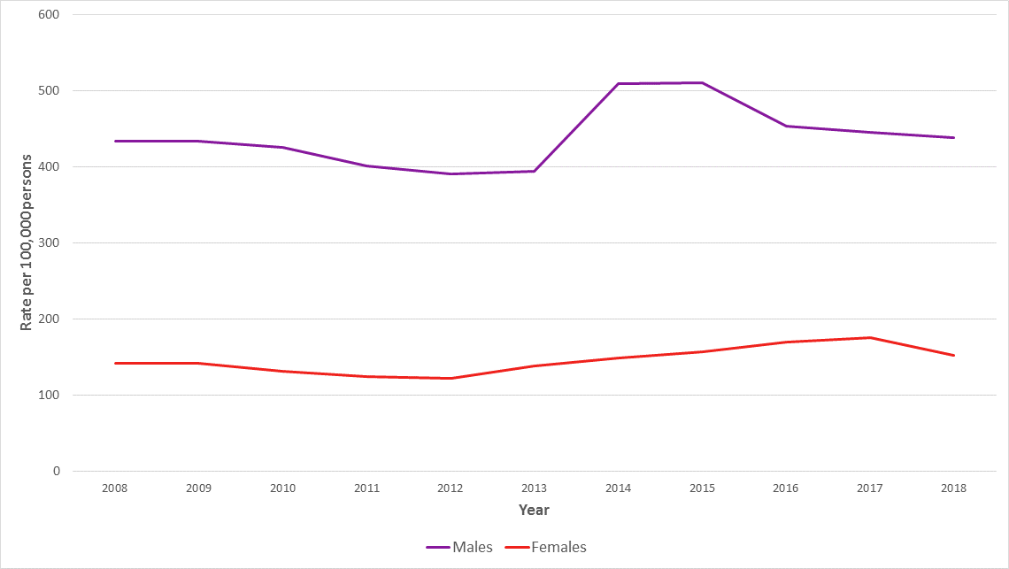
Figure 2: Rate of deaths among males and females due to intentional self-harm (suicide) Victoria, 2008-2017
Source: Australian Bureau of Statistics, 2018
For every suicide, there are many more people deeply affected including families, friends and colleagues.
For more information on suicide prevention initiatives in Victoria, access the Chief Health Officer's Suicide prevention content.

References
Australian Bureau of Statistics 2018, Causes of death, Victoria, 2017, Australian Bureau of Statistics, Canberra.
Department of Health and Human Services 2017, Victoria’s Mothers, Babies and Children 2016, State Government of Victoria, Melbourne.

Leading causes of disease and injury
Burden of disease is an indication of the impact of living with illness and injury and dying prematurely. It is measured using disability-adjusted life years (DALY), which is the number of years of healthy life lost due to death and illness. See also 'A note on DALYs' below.

Leading causes of disease, injury and death
In Australia, most of the total burden of disease in 2015 was from chronic diseases and injury (Australian Institute of Health and Welfare 2019).
Figure 1 shows the proportion of total burden by disease group in Australia in 2015.
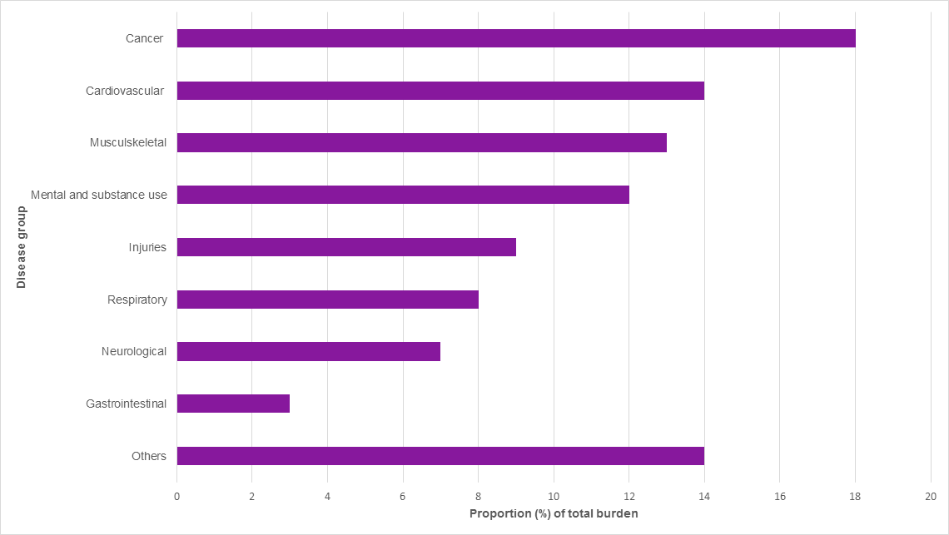
Figure 1: Proportion (%) of total burden by disease group, 2015, Australia
In 2015, 50.4 per cent of the burden was due to living with illness and 49.6 per cent was due to dying prematurely. This is the first time that the burden from living with illness has surpassed the fatal burden.
Chronic diseases and injuries made up most of the burden, with 65 per cent of it coming from the top five categories of cancer, cardiovascular diseases, musculoskeletal conditions, mental and substance use disorders and injuries.
In terms of specific diseases, the five leading causes of the total burden in Victoria in 2015 were coronary heart disease (heart attack or angina), back pain and back problems, dementia, chronic obstructive pulmonary disease (lung diseases) and anxiety disorders.

Some population groups face a greater burden than others
There is considerable variation in deaths and years of life lost across population groups.
People in remote areas face a burden 1.4 times higher than those in major cities.
People in low socioeconomic groups face a burden 1.5 times higher than the rate of the highest socioeconomic groups.
In 2011, Aboriginal Australians experienced twice the rate of disease burden compared with non-Aboriginal Australians.

Modifiable risk factors
A large proportion of disease burden could be prevented.
Thirty-eight per cent of the total burden of disease experienced by Australians in 2015 could have been prevented by reducing exposure to lifestyle risk factors such as:
- tobacco use
- overweight and obesity
- poor diet
- physical inactivity
- alcohol use
- high blood pressure (Australian Institute of Health and Welfare 2019).
The five risk factors that caused the most burden in 2015 were tobacco use (responsible for 9.3 per cent of total burden), overweight and obesity (8.4 per cent), dietary risks (7.3 per cent), high blood pressure (5.8 per cent) and high blood plasma glucose including diabetes (4.7 per cent). These are summarised in the table below with their impact on selected disease groups.
Table: Proportion of total burden (DALY) attributable to the leading risk factors, for selected disease groups, 2015
Disease group | Tobacco use | Overweight and obesity | Dietary risks | High blood pressure | High blood plasma glucose
All diseases | 9.3% | 8.4% | 7.3% | 5.8% | 4.7%
Cancer | 22.1% | 7.8% | 4.2% | - | 2.9%
Cardiovascular | 11.5% | 19.3% | 40.2% | 38.0% | 4.9%
Neurological | 1.5% | 9.0% | 0.2% | 1.8% | 2.9%
Respiratory | 41.0% | 8.0% | 0.3% | - | -
Endocrine | 3.7% | 44.6% | 34.2% | - | -
Kidney/urinary | - | 35.6% | 7.7% | 34.1% | 53.7%
Source: Australian Institute of Health and Welfare 2019
Notes: Estimates for diet are based on an analysis of the joint effects of all dietary risk factors included in the study following methods used in recent global burden of disease studies. Blank cells indicate the risk factor has no associated diseases or injuries in the disease group.

Trends in risk factors in Victoria
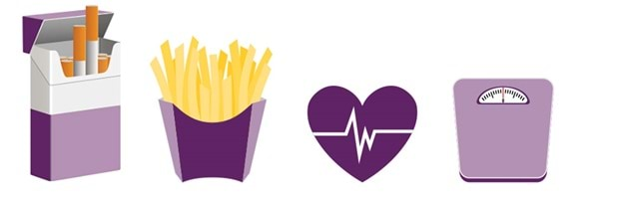
Smoking is still the single greatest contributor to the disease burden in Australia, responsible for 9.3 per cent of the disease burden in Australia.
However, when all dietary factors are considered together – overweight and obesity, dietary risks and high blood plasma glucose – their combined proportion of the total disease burden is 20.4, compared with smoking’s contribution of 9.3 per cent. This shows how important it is to address diet-related factors when discussing efforts to reduce the disease burden in Australia.

Smoking
Smoking is responsible for 9.3 per cent of the disease burden in Australia, and also contributes 22 per cent to the cancer burden and 41 per cent to the respiratory burden. The overall smoking rate is declining, with 12.3 per cent of Victorian adults identified as daily smokers in 2016.
However, the rate of decrease has slowed, and rates remain high among certain groups.
Visit the Chief Health Officer's report Tobacco-free living content for more information.

Overweight and obesity
Overweight and obesity has become the second leading cause of the disease burden, responsible for 8.4 per cent of the total burden and 19.3 per cent of the cardiovascular burden.
Victoria (and Australia) has one of the highest rates of overweight and obesity in the world. Nearly a third of Victorian adults – 31.5 per cent or 1.5 million people – are obese. Another third are overweight, meaning two-thirds of the adult population are overweight or obese – around 2.3 million Victorians.
More than one in five children aged two to 17 years is overweight or obese (Australian Bureau of Statistics 2018).
Overweight and obesity are also linked to the high blood plasma glucose burden.
Visit the Chief Health Officer's report Overweight and obesity content for more information.

High blood plasma glucose burden
The rate of type 2 diabetes has been steadily rising in recent decades, particularly among older people.
In 2016, 5.9 per cent of Victorians reported having the condition.
Visit the Chief Health Officer's Overweight and obesity content and the Chief Health Officer's Healthy eating content for more information.

Dietary factors
Dietary factors account for 7.3 per cent of the total burden of disease in Australia.
Only one in 20 adults in Victoria meets the recommended guidelines for vegetables, which is five to six serves per day (Department of Health and Human Services 2018).
Adults on average eat less than half the recommended amount of vegetables.
Around 40 per cent of adults meet the guidelines for fruit, which is two serves per day.
Visit the Chief Health Officer's Healthy eating content for more information.

Physical inactivity
Physical inactivity accounted for 2.5 per cent of the disease burden in Australia.
These estimates reflect the amount of disease burden that could have been avoided if all people in Australia were sufficiently physically active.
Half of adults in Victoria do not undertake the recommended amount of physical activity per week, and three-quarters of adolescents do not do the one hour of exercise recommended for their age group (Department of Health and Human Services 2018). Lifestyles are also becoming increasingly sedentary.
A quarter of adults spend seven hours or more a day sitting, while two-thirds of adolescents spend two hours or more per day on electronic devices (Department of Education and Training 2017).
Visit the Chief Health Officer's Active living content for more information.

Preventing or modifying risk factors
The good news is that many of these risk factors can be prevented or modified.
You can work towards quitting smoking, reducing alcohol intake, exercising more and eating more fruit and vegetables if these are relevant for you.
However, according to the social determinants of health framework, some groups in society have greater access to the resources needed to address these risk factors than others.
Visit the Chief Health Officer's Social determinants of health content for more information.

A note on DALYs
Disability-adjusted life years (DALYs) is a summary measure of disease burden.
One DALY is one year of healthy life lost due to illness and/or premature death – the higher the metric, the greater the burden of that disease (Australian Institute of Health and Welfare 2019).
The proportion of total burden attributable to each risk factor is listed in the table above.
For example, more than 9 per cent of the disease burden for Australians in 2015 was due to tobacco use.

References
Australian Bureau of Statistics 2018. National health survey: first results, 2017–18, Australian Bureau of Statistics, Canberra.
Australian Institute of Health and Welfare 2017, Impact of overweight and obesity as a risk factor for chronic conditions, Australian Burden of Disease study series, no. 11, Australian Institute of Health and Welfare, Canberra.
Australian Institute of Health and Welfare 2018a, Australia's health 2018, Australian Institute of Health and Welfare, Canberra.
Australian Institute of Health and Welfare 2018b. Risk factors and disease burden, Australian Institute of Health and Welfare, Canberra.
Australian Institute of Health and Welfare 2019, Australian burden of disease study: impact and causes of illness and death in Australia 2015, Australian Institute of Health and Welfare, Canberra.
Department of Education and Training 2017, About You: Victorian student health and wellbeing survey 2016, State Government of Victoria, Melbourne.
Department of Health and Human Services 2018, The Victorian Population Health Survey 2016, State Government of Victoria, Melbourne.

Health inequalities
This section of the Chief Health Officer report looks at health inequalities that exist in Victoria, and some of the reasons behind these inequalities.
It draws on:
- Inequalities in the social determinants of health and what it means for the health of Victorians <https://www.health.vic.gov.au/population-health-systems/victorian-population-health-survey-2014>, published by the Department of Health and Human Services in 2017
- Korin Korin Balit-Djak: the Aboriginal health, wellbeing and safety strategic plan 2017–27 <https://www.health.vic.gov.au/health-strategies/korin-korin-balit-djak-aboriginal-health-wellbeing-and-safety-strategic-plan-2017>, published by the department in 2017
- the Victorian Population Health Survey 2016 <https://www.health.vic.gov.au/population-health-systems/victorian-population-health-survey-2016>, published by the department in 2018
- Victorian Government package for people seeking asylum <https://www.health.vic.gov.au/publications/victorian-government-package-for-people-seeking-asylum>, published by the department in 2017
- The health and wellbeing of the lesbian, gay, bisexual, transgender, intersex, queer, asexual population in Victoria – a short summary, published by the Victorian Agency for Health Information (unpublished).
This section covers the social issues that have a profound impact on health. It also discusses how disadvantage can sometimes become entrenched in successive generations of families – referred to as intergenerational disadvantage.
Finally, the section includes discussion of four groups for whom health inequalities can be marked:
- Aboriginal and Torres Strait Islander Victorians
- rural and regional Victorians
- lesbian, gay, bisexual, trans and gender diverse, intersex, queer and asexual (LGBTIQA+) Victorians
- people from refugee and asylum seeker backgrounds.

Asylum seekers and refugees
Many refugees and people seeking asylum arrive in Australia after extended periods living in conditions that have serious impacts on their physical and/or mental health.
This includes:
- experiences of trauma and torture
- deprivation and prolonged poverty
- periods in immigration detention
- poor access to healthcare (Department of Health and Human Services 2014).
Around 4,000 refugees settle in Victoria each year through the Humanitarian Programme. Another 10,000 people who arrived as asylum seekers live in the Victorian community on bridging visas while they wait for the determination of their refugee status. Victoria typically has the largest refugee intake and highest numbers of asylum seekers in Australia.

Health needs of asylum seekers and refugees
Compared with the general population, refugees and people seeking asylum tend to have complex health needs, including:
- nutritional deficiencies
- under-immunisation
- poor dental and eye health
- poorly managed chronic disease
- delayed development and growth in children (Milosevic, Cheng and Smith 2012).
They may also experience higher levels of psychological distress and increased risk of mental illness, including post-traumatic stress disorder, depression and anxiety (Davidson and Carr 2010).
Refugees and people seeking asylum are more likely than the general Australian population to have a high risk of a serious mental illness. More than 50 per cent of people seeking asylum living in the community are estimated to be living with major depression or post-traumatic stress disorder (Hocking, Kennedy and Sundram 2015).

People on temporary visas
While many refugees arrive in Australia as part of the off-shore humanitarian program on permanent visas, a number of refugees and people seeking asylum reside for extended periods of time in the community on temporary visas (Department of Home Affairs 2018).
In addition to the physical and mental health challenges outlined above, people on temporary visas can experience the mental health impacts of:
- prolonged uncertainty
- indefinite separation from family in precarious circumstances
- barriers to accessing services due to their visa, Medicare, or income status (Australian Red Cross 2013).
In Victoria, all refugees and people seeking asylum can access state-funded healthcare regardless of visa or Medicare status.

Find out more
Find out more about Refugee and asylum seeker health and wellbeing <https://www.health.vic.gov.au/populations/refugee-and-asylum-seeker-health-and-wellbeing>.

References
Australian Red Cross 2013, Inaugural vulnerability report: Inside the process of seeking asylum in Australia, Australian Red Cross, Canberra.
Davidson G and Carr S 2010, 'Forced migration, social exclusion and poverty: introduction', Journal of Pacific Rim Psychology, vol. 4, no. 1.
Department of Health and Human Services 2014, The Victorian refugee and asylum seeker health action plan 2014–2018, State Government of Victoria, Melbourne.
Department of Home Affairs 2018, Visa statistics, Commonwealth Government of Australia, Canberra.
Hocking D, Kennedy G and Sundram S 2015, ‘Mental disorders in asylum seekers: the role of the refugee determination process and employment’, The Journal of Nervous and Mental Disease, vol. 203, no. 1.
Milosevic D, Cheng IH and Smith M 2012, ‘The NSW Refugee Health Service: improving refugee access to primary care’, Australian Family Physician, vol. 41, no. 3.

Rural and regional Victorians
Nearly one-quarter (23 per cent) of Victorians live in rural and regional Victoria.

Rural Victorians fair better on some mental and physical health indicators
When it comes to social capital (the networks of relationships among people), rural Victorians fare better than metropolitan Victorians on a number of indicators associated with mental and physical health.
Indicators show that adults who live in rural Victoria (20 per cent) are more likely to belong to an organised community group than those who live in metropolitan Melbourne (18 per cent) (Department of Health and Human Services 2017).
Indicators of social isolation show that adults living in rural Victoria are more likely to not be socially isolated (39 per cent) than all Victorian adults (36 per cent) (Department of Health and Human Services 2017).
Rural residents are also more likely to feel safe walking alone down their street after dark (65 per cent) compared with all Victorian adults (61 per cent) (Department of Health and Human Services 2017).
Find out more about the Social determinants of health.

Indicators of poorer health in rural and regional Victoria
According to other indicators, however, people who live in rural and regional Victoria experience poorer health than metropolitan Victorians.
The Index of Relative Socioeconomic Disadvantage shows that rural local government areas of Victoria are more likely to be classified as most disadvantaged, and that this relative disadvantage is having a significant impact upon health and wellbeing.
Some of the profound differences in health outcomes for rural and regional Victorians compared to metropolitan Victorians, have existed for many years.
Indicators that show poorer health experienced by rural and regional Victorians compared with metropolitan Victorians, include:

Cancer
In 2017-18, there were 22,764 cases admitted to regional public hospitals and 40,680 cases admitted to metropolitan public hospitals. This represents a higher rate of cancer cases admitted per 100,000 population in regional Victoria (1,273 cases per 100,000) compared with metropolitan Melbourne (996 cases per 100,000) (Department of Health and Human Services 2018a).

Cardiovascular Disease
In 2017-18, there were 33,259 cases admitted to regional public hospitals and 65,881 cases admitted to metropolitan public hospitals. This represents a higher rate of cardiovascular disease cases admitted per 100,000 population in regional Victoria (1,868 cases per 100,000) compared with metropolitan Melbourne (1,604 cases per 100,000) (Department of Health and Human Services 2018a).

Chronic Obstructive Pulmonary Disease
In 2017-18, there were 6,100 cases admitted to regional public hospitals and 8,813 cases admitted to metropolitan public hospitals. This represents a higher rate of chronic obstructive pulmonary disease cases admitted per 100,000 population in regional Victoria (329 cases per 100,000) compared with metropolitan Melbourne (219 cases per 100,000) (Department of Health and Human Services 2018a).

Diabetes
In 2017-18, there were 62,217 cases admitted to regional public hospitals and 131,509 cases admitted to metropolitan public hospitals. This represents a higher rate of diabetes cases admitted per 100,000 population in regional Victoria (3,470 cases per 100,000) compared with metropolitan Melbourne (3,231 cases per 100,000) (Department of Health and Human Services 2018a).

Mental and behavioural disorders due to substance abuse
In 2017-18, there were 37,917 cases admitted to regional public hospitals and 92,032 cases admitted to metropolitan public hospitals. This represents a higher rate of mental and behavioural disorders due to substance abuse cases admitted per 100,000 population in regional Victoria (2,367 cases per 100,000) compared with metropolitan Melbourne (2,143 cases per 100,000) (Department of Health and Human Services 2018a).

Admissions to emergency departments
In 2017-18, the rate of all emergency department presentations per 100,000 population was higher in regional Victoria (34,109 presentations per 100,000) compared with metropolitan Melbourne (27,161 presentations per 100,000). An examination of the rate for selected conditions shows a higher rate of emergency department presentations in regional Victoria, compared with metropolitan Melbourne, for asthma (380 compared with 303), influenza and pneumonia (355 compared with 278), injury (7,522 compared with 5,171), and mental and behavioural disorders (262 compared with 238) (Department of Health and Human Services 2018b).

Ambulatory care sensitive conditions
Ambulatory care sensitive conditions are conditions for which hospitalisation is thought to be avoidable with the application of public health interventions and early disease management.
In 2017-18, there were relatively higher rates of hospital admissions in regional Victoria compared with metropolitan Melbourne for the following ambulatory care sensitive conditions (Department of Health and Human Services 2018c):
- Angina (1.4 per 1,000 persons compared with 1.2)
- Cellulitis (3.3 per 1,000 persons compared with 2.9)
- Chronic Obstructive Pulmonary Disease (3.2 per 1,000 persons compared with 2.3)
- Congestive cardiac failure (2.3 per 1,000 persons compared with 2.7)
- Convulsions and epilepsy (1.7 per 1,000 persons compared with 1.4)
- Dental conditions (3.3 per 1,000 persons compared with 2.5)
- Diabetes complications (2.5 per 1,000 persons compared with 2.1)
- Ear, nose and throat infections (2.0 per 1,000 persons compared with 1.7)
- Iron deficiency anaemia (4.0 per 1,000 persons compared with 3.7)
- Pneumonia and influenza (3.2 per 1,000 persons compared with 2.3).

Improving health for rural and regional Victoria
At a whole-of-Victorian government level, nine Regional Partnerships were established in 2016. The Regional Partnerships recognise that local communities are in the best position to understand the challenges and opportunities faced by their region (Regional Development Victoria 2015).
Through ongoing consultation, the Regional Partnerships ensure regional communities have a greater say about what matters to them, and that the voices of these communities are heard directly at the heart of government.
These Regional Partnerships are providing advice on a range of issues – from transport, education, health and economic opportunities – that all have health and wellbeing impacts.
As noted in other parts of this report, climate change will have impacts across Victoria, but especially in rural and regional areas: the higher risk of drought, blue-green algal outbreaks and bushfires, for example, will tend to be experienced more in rural and regional areas of Victoria.

Find out more
Access Regional Development Victoria's Regional partnerships page <https://www.rdv.vic.gov.au/regional-partnerships>.

References
Department of Health and Human Services 2017, Inequalities in the social determinants of health and what it means for the health of Victorians: findings from the 2014 Victorian Population Health Survey, State of Victoria, Melbourne.
Department of Health and Human Services 2018a, Victorian Admitted Episodes Dataset. Public hospital admissions, State Government of Victoria, Melbourne.
Department of Health and Human Services 2018b, Victorian Emergency Minimum Dataset. Public hospital admissions, State Government of Victoria, Melbourne.
Department of Health and Human Services 2018c, Victorian Health Information Surveillance System, State Government of Victoria, Melbourne.
Regional Development Victoria 2015, Victoria’s Regional Statement, State Government of Victoria, Melbourne.

Social determinants of health
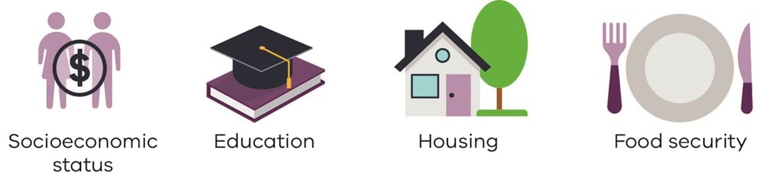
Health is determined by a complex interaction between genetic inheritance, health behaviours, access to quality healthcare and the social determinants of health.
While our genetic makeup, our health behaviours and our access to healthcare impact our health, they are outweighed by the overwhelming impact of social and economic factors – the material, social, political and cultural conditions that shape our lives and our behaviours (Australian Institute of Health and Welfare 2017; Department of Health and Human Services 2017a; Marmot and Allen 2014).
Moreover, the social determinants are largely responsible for inequalities in health outcomes across populations (Department of Health and Human Services 2017a; Marmot and Allen 2014).
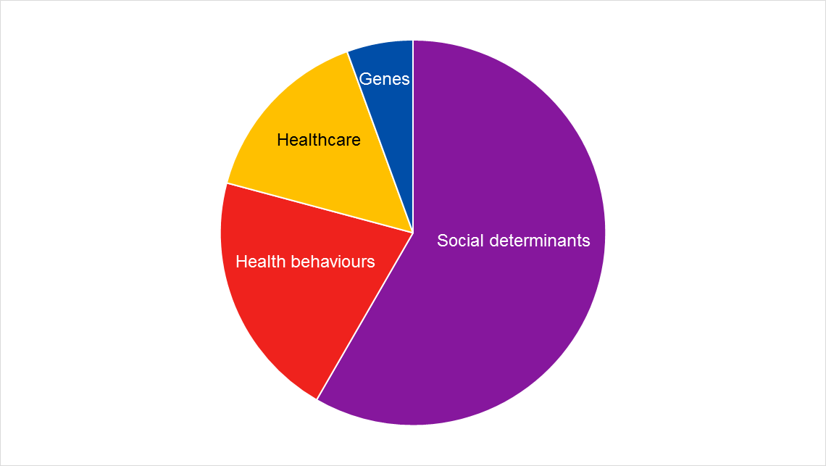
Figure 1: The determinants of health and their relative impact
Source: Marmot and Allen 2014

The problem with focusing on individual behaviour
In Australia and internationally, primary prevention of ill-health can sometimes be dominated by a focus on addressing the health behaviours of individuals.
This approach largely ignores the social determinants of health. While individual behaviours such as smoking, diet, exercise and alcohol and drugs are important issues to address, concentrating our efforts too much on individual behaviours may come at the expense of addressing the social determinants of health – the ‘causes of the causes’ (Department of Health and Human Services 2017a; Marmot and Allen 2014).

What are the social determinants of health?
The social determinants of health are shaped by the distribution of money, power and resources and are mostly responsible for health inequities – the health inequalities that are unfair and avoidable.
Social determinants include but are not limited to:
- socioeconomic status
- education
- housing
- transportation
- food security
- psychosocial risk factors
- the social environment
- social support networks
- community and civic engagement
- social and civic trust
- the physical environment, including the natural environment (Department of Health and Human Services 2017a).
Social determinants such as socioeconomic status have long been well-understood to have significant impacts on an individual's health status – the lower the socioeconomic status, the worse the health status (Department of Health and Human Services 2017).
The 20 per cent of Australians living in the lowest socioeconomic areas in 2014–15 were 1.6 times as likely as the highest 20 per cent to have at least two chronic health conditions, such as heart disease and diabetes (Australian Institute of Health and Welfare 2016).
Mothers in the lowest socioeconomic areas were 30 per cent more likely to have a low birthweight baby than mothers in the highest socioeconomic areas in 2013 (Australian Institute of Health and Welfare 2016).
Aboriginal and Torres Strait Islander Australians – who can experience significant social and economic disadvantage - have a life-expectancy approximately 10 years lower than non-Indigenous Australians (Department of Health and Human Services 2017b).

Social connectedness
In many cases, the relationship between social determinants of health and poor health is obvious. It is easy to comprehend how an individual who lives in insecure housing interspersed with periods of homelessness would have poorer health due to the stress and anxiety of unstable accommodation.
Similarly, many people can understand the connection between low income leading to poor nutrition and poorer health outcomes.
Yet the social determinants of health can also lead to outcomes that may not be readily identified as linked.
Social connectedness is now considered to play a significant role in health outcomes, particularly in relation to heart health.
A 2001 study showed that the risk of cardiac death among adults with coronary heart disease was 2.4 times greater for those who were socially isolated compared with those who were socially connected (Brummett, et al. 2001).
Another example of links between social determinants and health that may not be readily identified is found in people who are intolerant of diversity having higher risk of psychological distress than those who are tolerant (Department of Health and Human Services 2017).

Climate change
Climate change has also been identified as another social determinant of health, through its influence on people’s daily living conditions and their access to resources (World Health Organization 2009).
The impacts of climate change are being experienced now in Australia, and they are likely to become greater in coming years.
Victoria has already become warmer and drier and this is likely to continue into the future (Department of Environment, Land, Water and Planning 2015).
As these changes occur, they in turn can impact the social determinants of health by influencing food and water security, the ability to respond to natural disasters, and changing disease distribution (World Health Organization 2009).

Improving the social determinants of health
Much can be done to improve health.
Some of this comes from Australia’s universal health system, designed to allow equitable access to health services.
Changes must also come, however, from wider social and economic changes.
This means all levels of government, along with non-government organisations and others, must work together to make social and economic changes in order to have real impact on the social determinants of health (Marmot and Allen 2014).

Intergenerational disadvantage
In some communities, there are groups of people who have a disproportionate need for welfare support, including successive generations of individual families.
This entrenched disadvantage is often associated with significantly worse health and wellbeing (Australian Institute of Health and Welfare 2017; Public Health Association of Australia, 2018).
Households experiencing intergenerational disadvantage tend to experience limited mobility across income distribution ranges. They remain in the lowest income levels (Australian Institute of Health and Welfare 2017).
This persistent and recurrent poverty, especially in families with long-term parental unemployment, can impact the health and wellbeing of adults and children, and risks entrenching the disadvantage (Public Health Association of Australia, 2018).
Certain groups are more likely to experience persistent disadvantage – defined as experiencing a measurable socioeconomic score for four or more years (Australian Institute of Health and Welfare 2017). They include:
- people living in public housing
- people dependent on income support
- the unemployed
- single parents
- people with a long-term health condition or disability
- Aboriginal Australians
- those with educational attainment of Year 11 or below.
Within these groups, some have a higher risk of passing on that disadvantage than others. For example, children are 1.8 times more likely to receive social assistance if their parents receive single parent payments or disability payments (Cobb-Clark et al 2017). In contrast, other forms of disadvantage, such as parental unemployment seem to be easier for young people to overcome (Cobb-Clark et al 2017).
A number of authors conclude that individuals experiencing persistent disadvantage also experience higher rates of ill-health (Australian Institute of Health and Welfare 2017; Baxter 2012; Productivity Commission 2017).
This further highlights the need to address the social determinants of health if the health of Victorians is to be sustainably and equitably improved.

Find out more
Access the Victorian population health survey <https://www.health.vic.gov.au/population-health-systems/victorian-population-health-survey-2016> for more on the social determinants of health in Victoria.
Access the department's Inequalities in the social determinants of health and what it means for the health of Victorians report <https://www.health.vic.gov.au/population-health-systems/victorian-population-health-survey-2014>.

References
Australian Institute of Health and Welfare 2016, Australia's health 2016, Australian Institute of Health and Welfare, Canberra.
Australian Institute of Health and Welfare 2017, Australia's welfare 2017, Australia's welfare series, no. 13, AIHW, Canberra.
Baxter 2012, 'Family joblessness and child well-being in Australia', in Haskins and Chesters Kalil, eds, Investing in children: work, education and social policy in two rich countries, Brookings Institution Press, Washington DC.
Brummett B, Barefoot J, Siegler I, Clapp-Channing N, Lytle B, Bosworth H, Williams R and Mark D 2001, ‘Characteristics of socially isolated patients with coronary artery disease who are at elevated risk for mortality’, Psychosomatic Medicine, vol. 63, no. 2.
Cobb-Clark D, Dahmann S, Salamanca N and Zhu A 2017, ‘Intergenerational disadvantage: Learning about equal opportunity from social assistance receipt’, Life Course Centre Working Paper Series, University of Queensland, Brisbane.
Department of Environment, Land, Water and Planning 2015, Climate-ready Victoria, State Government of Victoria, Melbourne.
Department of Health and Human Services 2017a, Inequalities in the social determinants of health and what it means for the health of Victorians: findings from the 2014 Victorian Population Health Survey, State Government of Victoria, Melbourne.
Department of Health and Human Services 2017b, Korin Korin Balit-Djak Aboriginal Health, wellbeing and safety strategic plan 2017–27, State Government of Victoria, Melbourne.
Marmot M and Jessica Allen 2014, 'Social determinants of health equity', American Journal of Public Health, vol. 104, no. S4.
Productivity Commission 2017, Rising inequality? A stocktake of the evidence, Productivity Commission, Canberra.
Public Health Association of Australia 2018, Submission to the House of Representatives Select Committee on Intergenerational Welfare Dependence, PHAA, Canberra.
World Health Organization 2009, Natural and unnatural synergies: climate change policy and health equity, World Health Organization, Geneva.

Aboriginal and Torres Strait Islander Victorians
In recent years, Aboriginal health outcomes have improved in some areas.
In particular, rates of childhood immunisation for Victorian Aboriginal children aged five-years-old are now slightly higher than all Victorian five-year-olds (96.73 per cent of Victorian Aboriginal five-year-olds compared with 95.25 per cent of all Victorian five-year-olds).
However, despite some gains, Aboriginal Victorians continue to experience racism and discrimination that profoundly affects their health and wellbeing (Department of Health and Human Services 2017).
Aboriginal and Torres Strait Islander Australians have a life-expectancy approximately 10 years lower than non-Indigenous Australians (Department of Health and Human Services 2017).
In addition, they disproportionately experience several negative social indicators that also affect health. These and other factors contribute to Aboriginal and Torres Strait Islander Victorians having a median age of 23 years – compared with 37 years for all Victorians (Australian Bureau of Statistics 2017).
Some key points about Aboriginal Victorians’ health, wellbeing and safety include the following:
- Almost twice as many babies of Victorian Aboriginal mothers are born with a low birthweight compared with those of non-Aboriginal mothers.
- Victorian Aboriginal women are 45 times more likely to experience family violence than non-Aboriginal women.
- Aboriginal children are more than eight times more likely than non-Aboriginal children to be the subject of a child protection substantiation in Victoria.
- Aboriginal Victorians are four times more likely to be homeless than non-Aboriginal Victorians.
- Tobacco use by Aboriginal Victorians aged over 18 years is more than three times the rate of non-Aboriginal people.
- Aboriginal Victorians present at emergency departments for alcohol-related causes at more than four times the rate of other Victorians.
- Aboriginal Victorians are approximately three times more likely to experience high or very high levels of psychological distress than other Victorians.
- Rates of diabetes are three times higher in Aboriginal Victorians than non-Aboriginal Victorians.
- Aboriginal children in Victoria have 1.6 times more decayed tooth surfaces than non-Aboriginal children.
- Dementia is more common among Aboriginal older people and occurs at a younger age than for non-Aboriginal Victorians (Department of Health and Human Services 2017).
The Victorian Government is working with Aboriginal community-controlled organisations to address these ongoing health disparities. Korin Korin Balit-Djak: the Aboriginal health, wellbeing and safety strategic plan 2017–27 commits the Victorian Government to achieving the best health, wellbeing and safety for Aboriginal Victorians (Department of Health and Human Services 2017).

Improving self-determination
Korin Korin Balit-Djak explicitly states that self-determination is the only policy approach that has produced effective and sustainable outcomes for Indigenous peoples according to international and Australian evidence (Department of Health and Human Services 2017).
Victoria aims to increase Aboriginal involvement in leadership and strategic government decision making, as well as prioritising funding to Aboriginal organisations, including Aboriginal community-controlled organisations (Department of Health and Human Services 2017).
It also seeks to further reform the health and human services sector to eliminate racism and increase recruitment and retention of the Aboriginal workforce (Department of Health and Human Services 2017).
At the state level, the Victorian Government is establishing Australia’s first Treaty with Aboriginal Victorians – a process that has been underway since February 2016 (Aboriginal Victoria 2018).
This treaty will support the realisation of Korin Korin Balit-Djak’s underlying principle of Aboriginal self-determination.
It will build on the work and activities currently underway by strengthening governance structures and enhancing accountability to improve Aboriginal health outcomes across Victoria.
Visit the Aboriginal Victoria Treaty website <https://www.aboriginalvictoria.vic.gov.au/treaty> for more information about Treaty.

Find out more
For more information on Aboriginal women and babies, see the Chief Health Officer's Improving health outcomes for Aboriginal women and babies content.
For more information on Aboriginal Health, see the department’s Aboriginal Health page <https://www.health.vic.gov.au/health-strategies/aboriginal-health>.

References
Aboriginal Victoria 2018, What is a treaty? State Government of Victoria, Melbourne.
Australian Bureau of Statistics 2017, 2071.0 - Census of Population and Housing: Reflecting Australia - Stories from the Census, 2016, ABS, Canberra.
Department of Health and Human Services 2017, Korin Korin Balit-Djak Aboriginal health, wellbeing and safety strategic plan 2017–27, State Government of Victoria, Melbourne.

LGBTIQA+ Victorians
Proportion of population who identify as LGBTIQA+
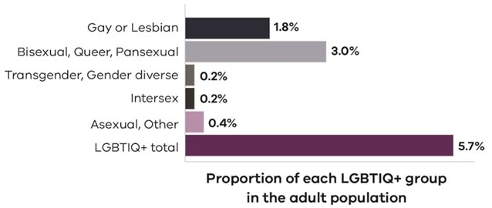
In the 2017 Victorian Population Health Survey, 5.7 per cent of respondents identified as lesbian, gay, bisexual, trans and gender diverse, intersex, queer and asexual (Victorian Agency for Health Information - unpublished), with the relative proportion of each subgroup summarised in Table 1:
Table 1: Proportion (%) of the adult population, by LGBTIQA+ status, Victoria, 2017
LGBTIQA+ group | Sample size (n) | Proportion (%) of adult population by LGBTIQA+ status
Gay or Lesbian | 458 | 1.8
Bisexual, Queer, Pansexual | 616 | 3.0
Transgender, Gender diverse | 41 | 0.2
Intersex | 57 | 0.2
Asexual, Other | 128 | 0.4
TOTAL LGBTIQA+ | 1,300 | 5.7

Health and wellbeing indicators for LGBTIQA+ Victorians
Data from the survey shows that LGBTIQA+ Victorian adults experience poorer health and wellbeing than heterosexual, non-LGBTIQA+ Victorians (Victorian Agency for Health Information - unpublished).
A summary of indicators for LGBTIQA+ Victorians shows that a significantly higher proportion of LGBTIQA+ adults:
- had low to medium life satisfaction and a feeling of life being worthwhile, compared with the heterosexual, non-LGBTIQA+ adult population
- had moderate, high or very high levels of psychological distress, compared with the heterosexual, non-LGBTIQA+ adult population
- were diagnosed with anxiety or depression, compared with the heterosexual, non-LGBTIQA+ adult population
- had an experience of family violence, compared with the heterosexual, non-LGBTIQA+ adult population
- had an experience of discrimination, compared with the heterosexual, non-LGBTIQA+ adult population.
In addition, a significantly lower proportion of LGBTIQA+ adults could get help from relatives or friends in an emergency, or from family and neighbours when required, compared with the heterosexual, non-LGBTIQA+ adult population.

Victorian Government initiatives
Since late 2014, the Victorian Government has invested more than $60 million in initiatives that make the community fairer and promote equality for LGBTIQA+ Victorians.
This includes $15 million towards Australia's first Pride Centre, $4 million in grants for LGBTIQA+ community organisations and $5.3 million to support LGBTIQA+ people experiencing, or at risk of, family violence.
Funding has been provided to statewide LGBTIQA+ support service Switchboard Victoria to pilot suicide prevention programs across the state. Victoria has also boosted LGBTIQA+ family counselling services.
Laws to prohibit LGBTIQA+ conversion practices will be enacted, ending the practice that has caused trauma to many Victorians.

Find out more
The State of Victoria’s children reports <https://www.vic.gov.au/state-victorias-children-report> have more information on bullying experienced by young LGBTIQA+ Victorians and their mental health.
Access the Chief Health Officer page on PrEPX and HIV for information about pre-exposure prophylaxis and HIV.

References
Victorian Agency for Health Information - unpublished, The health and wellbeing of the lesbian, gay, bisexual, transgender, intersex, queer population in Victoria: a short summary, Victorian Agency for Health Information, Melbourne.

