

Blood Matters report for blood management (or equivalent) committee
February 2026
OFFICIAL

The Blood Matters Program is a Victorian State Government program run in collaboration with the Australian Red Cross Lifeblood.
The program aims to support best practice in all areas related to blood management, safety and governance.

Blood stewardship

Red blood cell (RBC) wastage
Inventory management over the festive period
In January, Lifeblood requested support in additional inventory management strategies to assist with red cell wastage reduction due to the overwhelming national response to donate blood following the tragic events that occurred in Bondi in December 2025.
Lifeblood had asked transfusion laboratories to consider the use of older red cells (>21 days of cold storage) as ‘irradiation equivalent’ as per the Australian and New Zealand Society of Australia Blood Transfusion Guidelines for the prevention of transfusion-associated graft-versus-host-disease. Where an ‘irradiated equivalent' red cell is issued where irradiation is a transfusion requirement, the laboratory must tag the bag to indicate that it is “Considered irradiation equivalent for the prevention of graft versus host disease” or similar wording.
While inventory has now returned to the usual age at issue, it is worth considering implementing transfusion laboratory and health services policies allowing for future provision of ‘irradiation equivalent’ RBC in contingency situations or extenuating circumstances.
Inventory management will be vital in ensuring minimisation of blood component wastage.
Whilst inventory management is a shared responsibility, it may be useful to appoint an ‘inventory champion’ to oversee stock rotation to optimise blood component prioritisation and appropriate ordering.
Blood Matters’ Blood component wastage webpage may assist with identifying initiatives to help identify and prioritise soon-to-expire blood components.

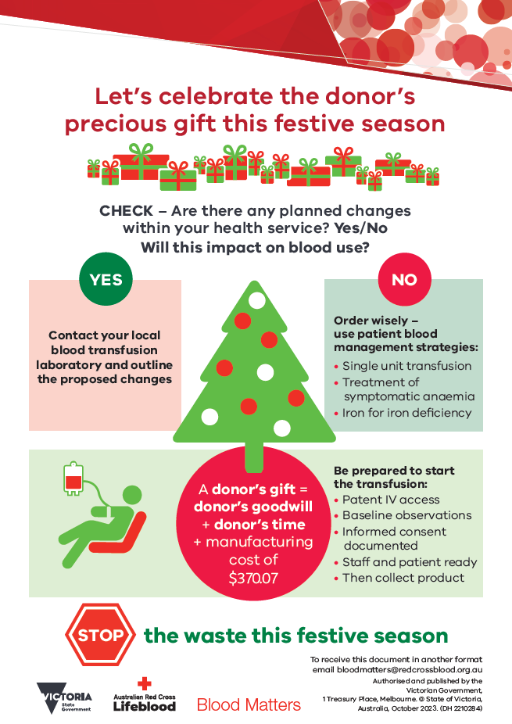
‘STOP the waste’ festive campaign 2025-2026
The 2025-2026 Festive campaign has seen a positive response in the first 3 months, with wastage rates remaining low during November, December and January.
Wastage rates over this period have traditionally peaked during February.
A summary of the 2025-2026 Festive campaign will be sent to health services and transfusion laboratories after its completion.
Your continued support of the ‘STOP the waste’ campaign is appreciated.

Audits

2025 Audit: Positive patient identification and the pre-transfusion checking procedure
This audit was conducted in two parts:
- Part 1: Policy survey – to determine if health services have a policy or policy statement that includes all the elements required for double independent checking of the patient and the blood component.
- Part 2: An observational audit of up to 20 transfusions to determine if the practice undertaken by clinical staff is consistent with the requirements for a double independent check of the patient and blood component.
Each health service has received their individual results, and the final report can be found on the Blood Matters audit reports webpage <https://www.health.vic.gov.au/patient-care/blood-matters-audit-reports>. An updated final report was published in December to incorporate a minor improvement in the overall results; however, this did not change the key messages and recommendations within the report. The results highlight the need for health services to improve the double independent checking process as it relates to the pretransfusion patient and product identification.

2026 Audit: Pretransfusion specimen collection and rejection
Errors in specimen collection most notably wrong blood in tubes (WBITs) events can be a significant patient safety risk. WBIT continues to be the most common procedural adverse event reported to the Serious Transfusion Incident Reporting (STIR) System, with a peak incidence of 36 events in FY24. As such specimen collection, in particular positive patient identification and labelling is an area of concern and represents an opportunity for practice improvement.
The Blood Matters 2026 audit will focus on pretransfusion specimen collection and rejection to:
    - determine if health services have pretransfusion specimen collection procedures, incorporating positive patient identification and alignment with the Australian and New Zealand Society of Blood Transfusion Guidelines for the administration of blood products (2024) and the Australian and New Zealand Society of Blood Transfusion Guidelines for transfusion and immunohaematology laboratory practice (2025)
    - establish baseline pretransfusion specimen collection and rejection rates
    - understand the underlying reasons and identify trends in pretransfusion specimen rejection
    - understand governance frameworks in place for managing WBIT events.
Blood Matters aims to distribute the audit in February, with data entry to be open during March 2026.

Serious Transfusion Incident Reporting (STIR) system
STIR has 119 health services in Victoria, Tasmania, Northern Territory and Australian Capital Territory registered, with almost 40 percent reporting adverse events in financial year 2025 (FY25). Data analysis and report writing is currently underway for the FY25 annual report and will be available on the Blood Matters webpage when completed. Health services will receive their individual data for FY25 and the link to the full report when available.
In this last year the STIR Expert group reviewed investigation forms to ensure relevant data collection to enhance incident validation, while remaining easy to complete. Any questions or concerns with completion of forms, please contact the Blood Matters team at: Bloodmatters@redcrossblood.org.au.
STIR bulletin No.13 related to Transfusion associated circulatory overload (TACO) and mitigation strategies. It can be found on the Blood Matters webpage <https://www.health.vic.gov.au/patient-care/serious-transfusion-incident-reporting-system-stir>.
This year the STIR Expert group has submitted two abstracts to the International Haemovigilance Network (IHN) symposium, to be held in March in Rome. The first abstract outlines the work of the STIR Expert group in validating adverse events, providing feedback to health services, and the development of educational materials; the second abstract discussed the history of STIR and its importance to haemovigilance in Australia.

Subcutaneous immunoglobulin (SCIg)

SCIg patient numbers
The number of patients receiving treatment with SCIg continues to increase.
In Victoria (Q1 2025-2026) there are:
• 21 sites with active programs
• 769 Victorian patients receiving treatment with SCIg (21.6% of eligible patients)
• 3555 Victorian patients eligible for treatment with SCIg by medical diagnosis.

SCIg forums
The dates for the 2026 SCIg forums are:
- Tuesday 24 March 2026
- Tuesday 7 July 2026
- Tuesday 10 November 2026
The March forum will feature a presentation from Melanie Meneghetti-Tabone from Peter MacCallum Cancer Centre titled “SCIg collection workflow for Peter MacCallum patients living regionally”. There will also be the regular SCIg updates and an opportunity for questions and discussion.

SCIg resources
SCIg implementation tools, resources, and health service SCIg contacts are available at: Subcutaneous immunoglobulin (SCIg) access program | health.vic.gov.au <https://www.health.vic.gov.au/patient-care/subcutaneous-immunoglobulin-scig-access-program>If you would like further information on SCIg or assistance with commencing or expanding a SCIg program, please contact Anne Graham, Blood Matters Nurse Consultant (SCIg), via email at: angraham@redcrossblood.org.au

Education
Education continues to be a focus of the Blood Matters program. In November 2025, we held our first full-day, virtual Blood Management study day. There were over 400 registrations and over 200 attendees on the day. The post session feedback was very positive and as a result we have 4 full day virtual education days planned for 2026.

The first two education events in our calendar are:
Education events 2026 | Date
Graduate nurse education (virtual) | March 17 (2 hours)
Blood study day (virtual) | March 31 (all day)
Details of these events and how to register have been sent to Directors of Nursing and the Transfusion Practitioners across Victoria, Tasmania, Australian Capital Territory and Northern Territory.
Please contact the Blood Matters team (Bloodmatters@redcrossblood.org.au) for more information

Transfusion Practitioner (TP) forums
There will be four virtual and one face-to-face TP forums in 2026.
Dates for the 2026 Forums are:
- 10 February(virtual)
- 21 April (virtual)
- 16 July (virtual
- 18 August (virtual)
- 16 November (face-to-face)

Blood Matters staff
Program Manager: Clare Hennessy email: clhennessy@redcrossblood.org.au
Transfusion Nurse: Christine Akers email: cakers@redcrossblood.org.au
PBM Education Coordinator: Kaylene Bastin email: kbastin@redcrossblood.org.au
Data and Information Managers: Peter Beard/Bridget Glazebrook email: pbeard@redcrossblood.org.au, email: bglazebrook@redcrossblood.org.au
Blood Matters Nurse Consultant (SCIg): Anne Graham email: angraham@redcrossblood.org.au
Scientist: Rae French email: rfrench@redcrossblood.org.au

To receive this document in another format, phone 03 9694 0102, using the National Relay Service 13 36 77 if required, or email Blood Matters < bloodmatters@redcrossblood.org.au>.
Authorised and published by the Victorian Government, 1 Treasury Place, Melbourne.
© State of Victoria, Australia, Department of Health, February 2026.
ISSN 2981-8710 - Online (pdf/word)
Available at Blood Matters Program <https://www.health.vic.gov.au/patient-care/blood-matters-program>

https://anzsbt.org.au/guidelines/prevention-of-transfusion-associated-graft-versus-host-disease-ta-gvhd/
https://www.health.vic.gov.au/patient-care/blood-component-wastage

