

Pretransfusion specimen collection and rejection
Blood Matters audit 2026
OFFICIAL
Contents
Background 1
Aims 2
Objectives 2
Method 3
Definitions 3
References 5

Background
The Blood Matters Program assists health services to ensure blood and blood products are administered to patients appropriately and safely in accordance with best practice guidelines.
The Serious Transfusion Incident Reporting (STIR) system continues to receive notifications for wrong blood in tube (WBIT) and incorrect blood component transfused (IBCT) (see Table 1 below). A WBIT can result in an IBCT, the most serious being an incompatible blood transfusion with the potential for significant morbidity and mortality.
Health services need to investigate how the WBIT occurred, follow up with staff involved and review processes to mitigate the risk of recurrence. These incidents must also be reported via internal incident management systems and externally to STIR or other haemovigilance systems.
The STIR WBIT definition changed in financial year 2015-16 (FY16) to:
• the sample is taken from the wrong patient but labelled as per the intended patient, or
• the sample is taken from the intended patient but labelled as per another patient.
WBITs continue to be the most common procedural adverse event reported to STIR, with a peak incidence of 36 in FY24.

Table 1: Number of Wrong Blood in Tube (WBIT) events reported to STIR FY16-FY25
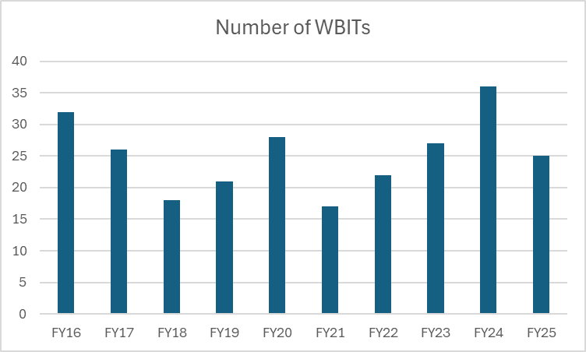
The National safety and quality health service (NSQHS Standards), specifically the Blood Management Standard action 7.06 states that health service organisations support clinicians to prescribe and administer blood and blood products appropriately, in accordance with national guidelines and national criteria.
The Australian and New Zealand Society of Blood Transfusion (ANZSBT) Guidelines for the administration of blood products 3rd edition (2024), Section 4 and Guidelines for transfusion and immunohaematology laboratory practice (2025), Section 1.6.2 cover pretransfusion specimen collection. Health service policies and procedures for pretransfusion testing should be aligned with these national guidelines.
It is vital that health service policy and procedures are up to date, accessible and reflect current national guidelines. They should also be followed when collecting pretransfusion specimens (blood group and antibody screen or a crossmatch) to ensure the correct patient receives the correct blood component.

Aims
To identify if health service and laboratory policies and procedures for pre transfusion testing are consistent with the ANZSBT Guidelines for the administration of blood products 3rd edition (2024) and Guidelines for transfusion and immunohaematology laboratory practice 2nd edition (2025).

Objectives
    - To determine if health services have pretransfusion specimen collection procedures, incorporating positive patient identification and alignment with the ANZSBT Guidelines for the administration of blood products (2024) and the ANZSBT Guidelines for transfusion and immunohaematology laboratory practice (2025)
    - To establish baseline pretransfusion specimen collection and rejection rates
    - To understand the underlying reasons and identify trends in pretransfusion specimen rejection
    - To understand governance frameworks in place for managing WBIT events

Method
Audit of health service procedures in relation to:
- Pretransfusion specimen collection and labelling requirements
- Specimen rejection criteria, follow up and reporting processes
- WBIT identification and investigation processes
In addition, health services will be requested to report the following data for the month of October 2025:
- number of pretransfusion specimens collected
- number of pretransfusion specimens rejected
- reason for pretransfusion specimen rejection
- where and when the specimen rejection occurred.
Data entry is open and available for completion between 1 March and 31 March 2026.
Data entry is electronic using REDCap .
For all inquiries including problems with data entry please contact Blood Matters on 03 9694 0102 or email bloodmatters@redcrossblood.org.au
Victorian health services are expected (as outlined in the Victorian Department of Health Policy and Funding agreement) to complete this audit.

Definitions
Element | How it is defined
ANZSBT | Australia and New Zealand Society of Blood Transfusion
Crossmatch | Test to assess compatibility between a blood component and the intended recipient
DOB | Date of birth
EMR | Electronic medical record
Family name | Surname or last name
Given names | First name (and middle name if applicable)
G&S | Blood group and antibody screen
ID | Identification
MRN | Medical record number
NSQHS | National Safety and Quality Health Service
NUM | Nurse Unit Manager
Positive patient identification | ‘Positive patient identification’ is correctly identifying a patient to ensure that the right person receives their intended care. This involves the following:  - Ask the patient (if conscious and competent) to state and spell their family name and given name in full, and their date of birth (DOB).  - ensure that the stated family name and given names and DOB are identical to those on the identification band.  - If the patient is unable to state and spell their name, a parent, guardian or carer (if present and able to do so) can verify the patient’s identity as above;
Pretransfusion specimen | Specimen collected for blood group and antibody screen and/or crossmatch
STIR | Serious Transfusion Incident Reporting system
Zero tolerance | Strict policy where pretransfusion specimens or request forms with insufficient or incorrect patient identification or labelling are immediately rejected and not processed.
WBIT | Wrong blood in tube  • the sample is taken from the wrong patient but labelled as per the intended patient, or  • the sample is taken from the intended patient but labelled as per another patient.

References
Australian Commission on Safety and Quality in Health Care. National Safety and Quality Health Service Standards. 2nd ed. – version 2. Sydney: ACSQHC; 2021. Accessed Nov. 12, 2024. [Online] Available: https://www.safetyandquality.gov.au/sites/default/files/2021-05/national_safety_and_quality_health_service_nsqhs_standards_second_edition_-_updated_may_2021.pdf
Australian commission on safety and quality in health care. National Safety and Quality Health Services Standards. Blood Management Standard. Accessed Sep. 25, 2024. [Online]. Available: https://www.safetyandquality.gov.au/standards/nsqhs-standards/blood-management-standard
Australian commission on safety and quality in health care. National Safety and Quality Health Services Standards. Communicating for Safety Standard Accessed Sep. 25, 2024. [Online]. Available: https://www.safetyandquality.gov.au/standards/nsqhs-standards/communicating-safety-standard
Australian and New Zealand Society of Blood Transfusion. Guidelines for the administration of blood products. 3rd Ed. (2024) [Online]. Accessed Sep. 25, 2024. Available: https://anzsbt.org.au/wp-content/uploads/2024/02/Guidelines-for-the-Administration-of-Blood-Products-revised-Feb-2024.pdf
Australian and New Zealand Society of Blood Transfusion. Guidelines for transfusion and immunohaematology laboratory practice (. 2nd Ed. (2025) [Online]. Accessed Jul. 25, 2025. Available: https://anzsbt.org.au/wp-content/uploads/2025/06/Guidelines-for-transfusion-and-immunohaematology-laboratory-practice_June-2025-PUBLISHED-1.pdf

To receive this document in another format, phone 03 9694 0102, using the National Relay Service 13 36 77 if required, or email Blood Matters, <bloodmatters@redcrossblood.org.au>.
Authorised and published by the Victorian Government, 1 Treasury Place, Melbourne.
© State of Victoria, Australia, Department of Health, February 2026.
Except where otherwise indicated, the images in this document show models and illustrative settings only, and do not necessarily depict actual services, facilities or recipients of services.
ISBN 978-1-76131-721-7 (pdf/online/MS word)
Available at Blood Matters Program <https://www.health.vic.gov.au/patient-care/blood-matters-program>

<https://www.safetyandquality.gov.au/standards/nsqhs-standards/blood-management-standard>
<https://anzsbt.org.au/guidelines/guidelines-for-the-administration-of-blood-products/>
<https://anzsbt.org.au/guidelines/guidelines-for-transfusion-and-immunohaematology-laboratory-practice/>

