

Blood Matters on the Bench and Beyond
Issue 25 – February 2026
OFFICIAL

Welcome to the Blood Matters newsletter for Scientists.

Save the date: Blood Management Summit for Scientists


Wednesday 18 November 2026
10.00am – 3.30pm (time TBC)
Australian Red Cross Lifeblood, Melbourne Processing Centre, West Melbourne
Mark the date in your calendar, further details to follow later in the year.

Blood ordering: Routine, Urgent and Life-threatening requests
Australia is fortunate to have a world-class supplier of blood and blood products.
Lifeblood order fulfilment processes are complex. When workflows are interrupted to service orders outside of scheduled routine dispatches there is a flow-on effect which can lead to delays to other customers.
Routine orders placed in BloodNet are for “when the products can be delivered via your facility's standard delivery schedule.” Wherever possible, all non-urgent/non-life-threatening orders should have the delivery time aligning with your next scheduled routine dispatch time (see screenshot below).
Inventory management is a balance between ensuring blood and blood products are available to meet patient needs, appropriate use, and minimising wastage.
Suggested actions:
- Review internal processes if your facility places a high volume of out-of-run routine or urgent orders.
- Use your scheduled routine dispatches for all non-urgent clinical orders.
- Educate clinical teams (especially high-use areas) and laboratory staff about:
  - BloodNet ordering cut-off times.
  - Routine dispatch scheduled delivery times.

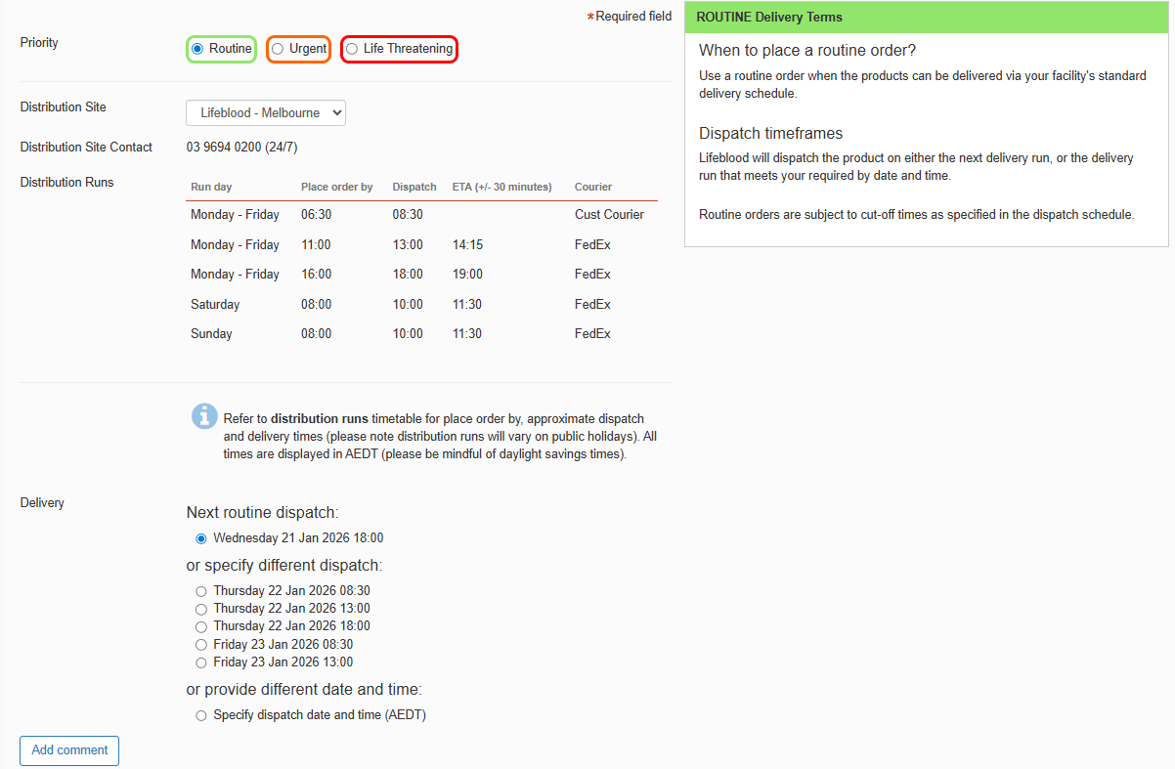
Above: BloodNet Training Site screenshot accessed 21/1/2026. Below: BloodNet order definitions¹
 | Routine | Urgent | Life-threatening
When | When the products can be delivered via your facility's standard delivery schedule. | When the products are required prior to the next routine delivery by the earliest available standard transport mode. | When there is a critical (life-threatening) need for immediate delivery of a product by the most rapid transport mode available.  Assistance from emergency services may be sought to facilitate rapid delivery. Misuse of this order priority is not acceptable.
Dispatch timeframes | Lifeblood will dispatch the product on either the next delivery run, or the delivery run that meets your “required by” date and time.  Routine orders are subject to cut-off times as specified in the dispatch schedule. | Lifeblood will have the product ready for dispatch within 60 minutes of the order being received, or at a later time if requested, where the product is available in the inventory.  ALL URGENT and LIFE-THREATENING orders MUST be immediately followed up with a telephone call to Lifeblood.  *Please note that any air freight deliveries will be dispatched to meet the first available flight time. | Lifeblood will have the product ready for dispatch within 30 minutes of the order being received where the product is available in inventory.  ALL URGENT and LIFE-THREATENING orders MUST be immediately followed up with a telephone call to Lifeblood.  *Please note that any air freight deliveries will be dispatched to meet the first available flight time.

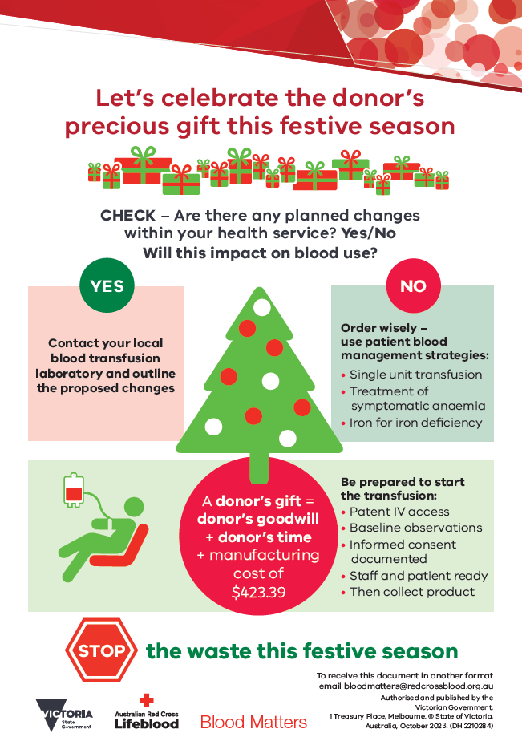
‘STOP the waste’ festive campaign 2025-26
The 2025-2026 festive campaign has begun strongly, with wastage rates remaining low during November, December and January.
Wastage rates over this period have traditionally peaked during February.
Please remain vigilant in minimising wastage, particularly as the age of red cells issued increase after the influx in donations in December.
A summary of the 2025-2026 Festive campaign will be sent to health services and transfusion laboratories after its completion.
Your continued support of the ‘STOP the waste’ campaign is appreciated.

Optimising red cell inventory
In January, Lifeblood requested support in additional inventory management strategies to assist with red cell wastage reduction. While the usual age at issue of red cells is anticipated to return in early February, it is worth considering implementing transfusion laboratory and health services policies allowing for future provision of ‘irradiation equivalent’ RBC in contingency situations or extenuating circumstances.

Supply of ‘irradiation equivalent' red cells
As per Lifeblood correspondence, the use of irradiation equivalent red cells is a safe and equivalent substitute for irradiated red cells in most patient groups. Where a red cell product is not irradiated, it is considered irradiation equivalent if >21 days of cold storage as per the ANZSBT Guidelines for the prevention of transfusion-associated graft-versus-host-disease.
Where an ‘irradiated equivalent' red cell is issued where irradiation is a transfusion requirement, the laboratory must tag the bag to indicate that it is “Considered irradiation equivalent for the prevention of graft versus host disease” or similar wording.

Use of Group AB red cells
In line with NBA messaging, AHPs (particularly larger sites) should routinely stock all blood groups, including a small number of Group AB red cells. Prioritising ABO identical RBC transfusions benefits recipients and inventory management.

National medical scientist certification
The Australian Council for Certification of the Medical Laboratory Scientific Workforce (CMLS) is a voluntary national professional certification scheme for Medical Laboratory Scientists. New applications for certification and renewals are processed by the professional bodies providing CPD. More information and links can be found at www.cmls.org.au.

How can Blood Matters help you?
Blood Matters are here to assist health services and laboratories with education and provision of resources. If you have suggestions for tools and resources please contact Rae French rfrench@redcrossblood.org.au <rfrench@redcrossblood.org.au> or the Blood Matters team bloodmatters@redcrossblood.org.au <bloodmatters@redcrossblood.org.au> via email or phone 03 9694 3524.
To receive this document in another format, phone 03 9694 0102, using the National Relay Service 13 36 77 if required, or email Blood Matters <bloodmatters@redcrossblood.org.au>.
Authorised and published by the Victorian Government, 1 Treasury Place, Melbourne.
© State of Victoria, Australia, Department of Health, February 2026.
ISSN 2652-7278 – Online (pdf / word)
Available at Blood Matters <https://www.health.vic.gov.au/patient-care/transfusion-science-and-blood-stewardship>

https://training.blood.gov.au/BloodNet5/Web/order
https://anzsbt.org.au/guidelines/prevention-of-transfusion-associated-graft-versus-host-disease-ta-gvhd/
www.cmls.org.au

